Project 2 – Robot drawing using a fixed manipulator with a pen-shaped end-effector
Description: A Franka Emika Panda robot welded to the world at its base is equipped with a pen-shaped end-effector to draw shapes or initials on a fixed whiteboard. The task requires controlling both position and interaction forces during contact with the board.
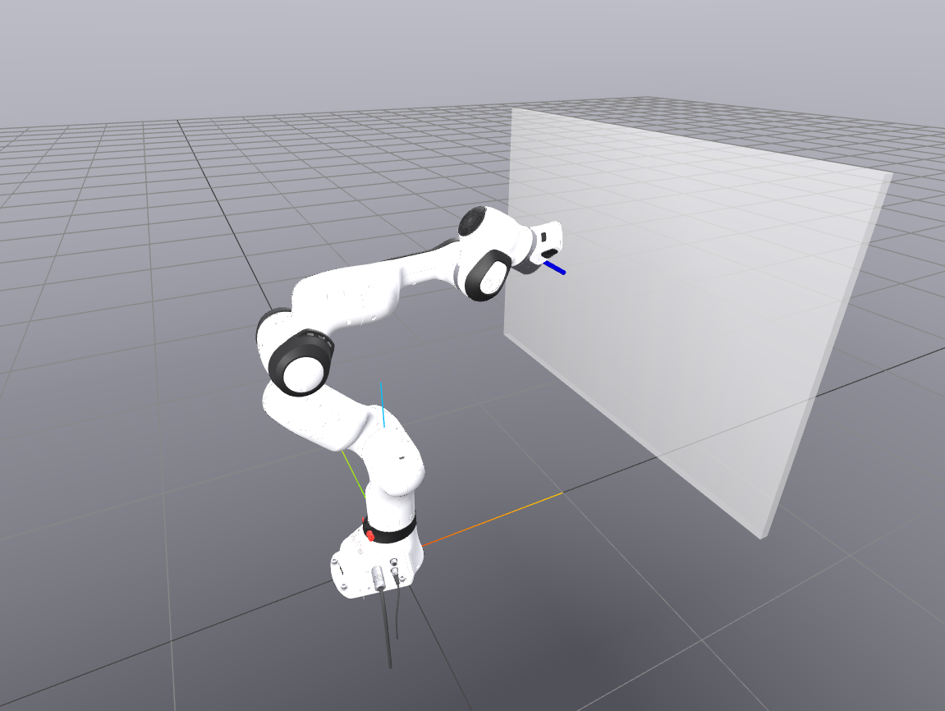
Objective: Develop a control framework that maintains a stable contact with the whiteboard while accurately following a desired drawing path. Students may choose the path to represent letters, shapes, or trajectories of their choice.
Provided material: an SDF containing: 1) A Franka Emika Panda robot with a pen-shaped end-effector, 2) A fixed whiteboard mounted on a wall.
Expected Implementation:
- Load and visualize the provided SDF world using Drake.
- Define a desired end-effector trajectory in task space.
- Implement a hybrid position/force controller that maintains a constant normal force on the whiteboard while tracking a trajectory in the interaction plane (i.e, the board).
- Validate and visualize the drawn paths either in real-time or from logged data.
Requirement: Show at least one reference drawing (e.g., initials or a shape) and plot the tracked vs. desired path.

Notes
- Visualization can either be done during the simulation or after the simulation using the logged measurements from the position in a plot.

Contact person: Mohayad.Abdelmonim.Mahmoud.Omer@vub.be

