Project 3 – Mobile manipulator boxes stacking.
Description: A Franka Emika manipulator mounted on a base that can only move linearly along the x-axis (along the table length). Multiple cubic objects are placed on a table near the robot’s workspace and the goal is to grab and stack the blocks on top of each others while ensuring that the robotic manipulator is stably controlled.
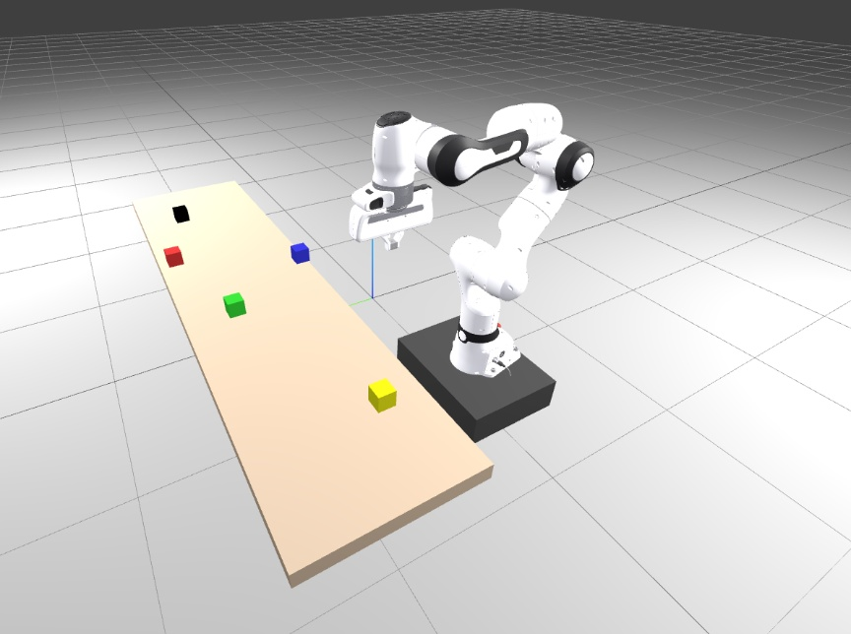
Objective: Develop a control strategy that coordinates the manipulator and the base motion to sequentially pick and stack all objects into a vertical tower. The system should maintain stable motion coordination between the arm and the base.
Provided material: an SDF containing: 1) A Franka manipulator fixed to a linear base, 2) A table with five movable objects.
Expected Implementation:
- Load and visualize the provided SDF world using Drake.
- Implement coordinated control of the base (translation along the x-axis) and the arm (for grasping and stacking).
- Generate a motion plan for stacking all objects while maintaining smooth motion transitions.
- Validate the stacking task visually and verify that all objects remain stable during placements.
Requirement: Demonstrate a full stacking sequence of all objects into a single stable tower.
Notes
- You can randomize the position of the objective at startup in your py script.
- You can add more objects to your world scene.

Contact person: zemerart.asani@vub.com

