Project 4 – Open a door with a mobile manipulator
Description: The robotic platform consists of an omnidirectional mobile base capable of planar motion (translation in x, y, and rotation in θ), and a 7-DoF Franka Emika Panda robotic arm mounted on top. The scene consists of the robot manipulator, a door and a wall. The task involves establishing a stable grasp on the door handle, coordinating the arm and base to open the door along its constrained rotational motion, and planning a trajectory to safely move through the doorway once the door is fully open.
Objective: The objective of this project is to design and implement a motion planning and control strategy that allows a mobile manipulator to open a door and pass through it while avoiding collisions
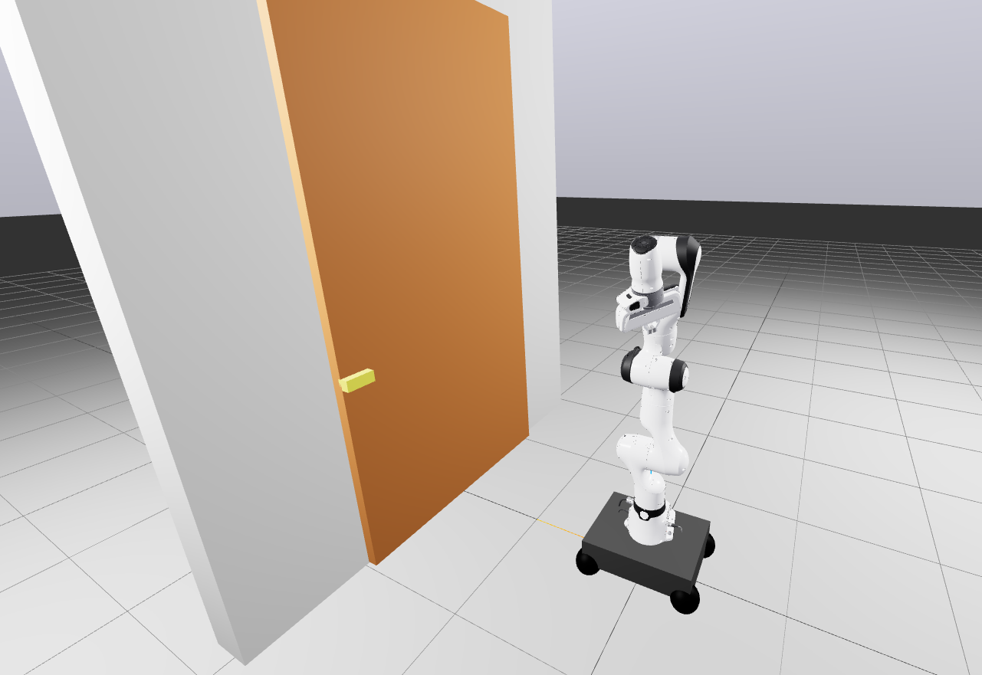
Provided material: an SDF containing the mobile manipulator (the robotic arm and the mobile base), the door, and the walls.
Expected implementation:
- Stabilize the system (basic base/arm controllers). Design a task-space trajectory to reach the door handle.
- Establish a stable grasp on the door handle using precise end-effector positioning and grip control (investigate also recovery motions if grasp is lost). Force control of the gripper after contact is established.
- Open the door by coordinating the arm and base motion (e.g., position-force control) while maintaining reasonable realistic interaction forces and joint torques.
- Navigate the robot through the doorway while avoiding collisions with the door and surrounding walls (can be simply moving the mobile base).
Notes: You can decide whether to design separate controllers for the base and arm or a combined controller; justify your design.
Contact person: zemerart.asani@vub.com

