Project 5 – Multi-agent object transportation
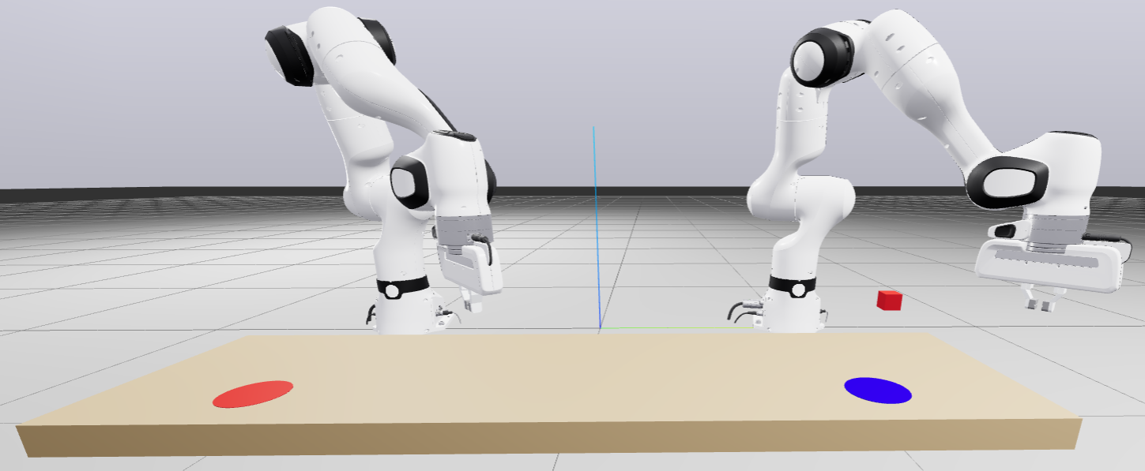
Description: Two Franka Panda robotic manipulators are positioned side-by-side within a shared workspace. The goal is to transport a red cube from its initial location on a cylindrical platform to a designated red target surface. The target is intentionally placed outside the reachable workspace of the first robot, making single-robot manipulation impossible. Therefore, cooperation and interaction between the two robots are essential for successful task execution.
Objective: Design a decentralized multi-agent control framework in which each manipulator is controlled independently. You are free to choose a strategy for transporting the object, such as:
- Robot-to-robot object handover,
- Sequential multi-step pick-and-place operations,
- Cooperative pushing or guided motion,
- Or any other physically feasible collaborative method.
Your proposed solution should be robust to variations in the cube’s initial position.
Provided material: an SDF containing: 1) Two Franka Panda robot manipulators, 2) A red cube, 3) Initial and target supporting surfaces.
Expected Implementation
- Load and visualize the provided SDF world using Drake.
- Implement a decentralized control architecture such that each robot’s controller operates independently.
- Execute a cooperative transportation strategy that successfully places the cube onto the red target surface. The exact method of transfer is left to your design. Example as a discrete, multi-phase problem: 1) Approach the object, 2) Achieve a stable grasp, 3) Move and hand off the cube, 4) Place the cube on the target.
Notes
- Do not modify the base poses of the robots or workspace objects.
- Purely precomputed paths and configurations (hard-coded joint sequences) are not acceptable; some level of online decision-making or feedback control is expected.
- Implementing a state-checking can help determine which phase should be active based on the current configuration of the robots and object.
Contact person: Mehran.raisi.hatmabadi@vub.be

