Project 6 – Task and Motion Planning (TAMP)
Description: The purpose of this project is to introduce the concept of Task and Motion Planning (TAMP) in robotic manipulation. Three colored cubes (red, green, blue) are initially stacked on a blue platform in the order red (bottom), green (middle), blue (top). The goal is to transfer these cubes to a red target surface and re-stack them in a new, user-defined order.
Target stacking constraints are provided using abstract relations of the form:
- On ?(A) ?(B) meaning cube A must be placed on top of cube B.
For example:
- On ?(red cube) ?(green cube)
- On ?(blue cube) ?(red cube)
would require a final stack (from bottom to top): green → red → blue.
Achieving such target configurations typically requires intermediate placements because some cubes may be blocked by others. Therefore, the robot must temporarily relocate obstructing objects to make them accessible, illustrating the fundamental principles of task-level reasoning combined with motion-level control.
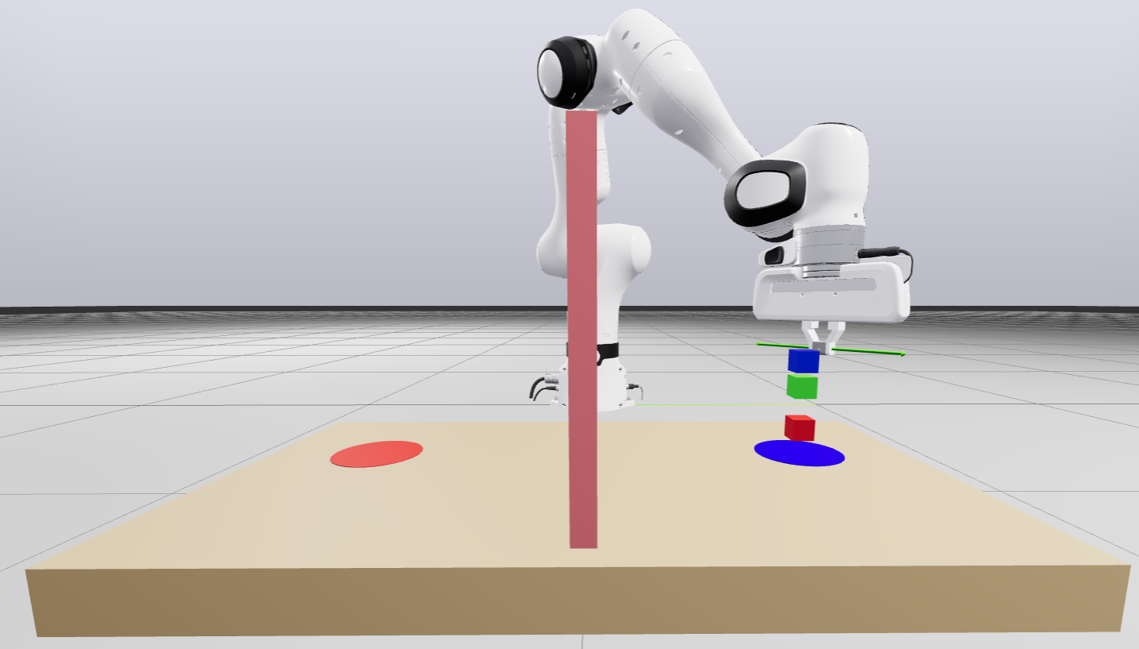
Objective: Design a control framework capable of:
- Computing a logical task plan to satisfy given On ?(A) ?(B) relations.
- Executing corresponding motion plans with the robot to realize the task physically.
- Managing intermediate placements when necessary.
- Remaining robust to variations in the cubes’ initial positions, and abstract target relationships.
Provided material: an SDF containing: 1) A Franka Panda robotic manipulator, 2) A red cube, a green cube, and a blue cube, 3) Initial and target markers, 4) A wall and a table.
Expected Implementation
- Load and visualize the provided SDF world using Drake.
- Implement a task-level reasoning component that: 1) Interprets desired On ?(A) ?(B) constraints, 2) Generates a feasible sequence of operations (pick, place, unstack, restack, etc.), 3) Accounts for obstructions and necessary intermediate placements.
- Integrate task planning with motion-level execution to physically rearrange the cubes on the red target surface.
Requirement: solution should be conceptually extensible to more than three objects and should handle different feasible stacking combinations.

Notes
- Do not modify the base pose of the robot or fixed workspace geometry.
- Define a logical planner that can determine a valid sequence of steps for object placement. You may find PDDLStream or PDDL frameworks helpful for conceptual guidance.
- Begin experimenting with two objects to simplify the logic, then extend to three.
- Minor execution imperfections (e.g., accidental cube drops) are acceptable; the focus is on demonstrating the reasoning process and planning architecture, not perfect motion control.

Contact person: Mehran.raisi.hatmabadi@vub.be

