Project 7 – Multi-agent object Handover
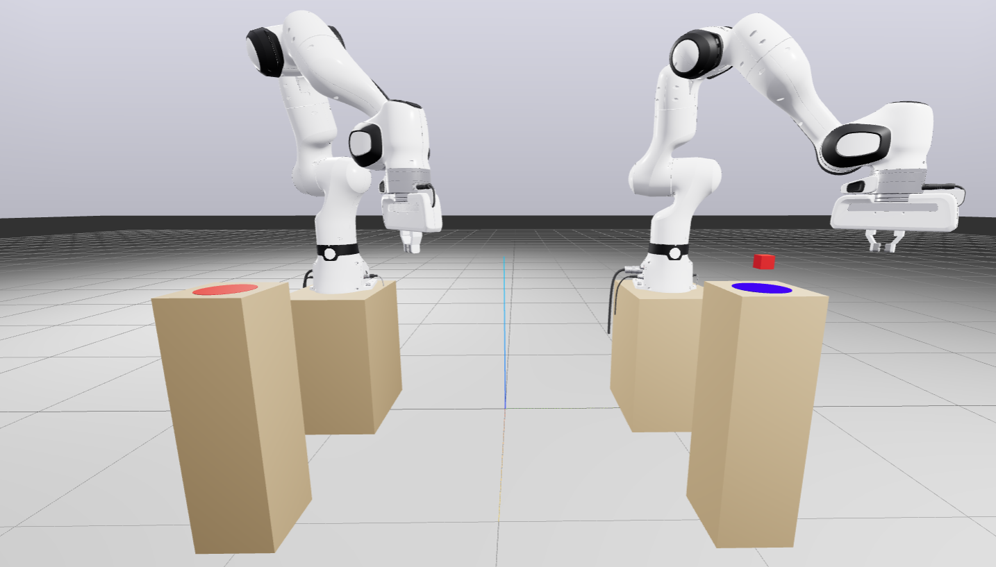
Description: Two Franka Panda robotic manipulators are positioned side-by-side on separate small tables, and the objects (including the red cube) are also placed on isolated, elevated surfaces. The goal is to move the red cube from its initial cylindrical platform to the red target surface. Because of the table gaps and reach limits, the only feasible strategy is a robot-to-robot handover; pushing, sliding, or single-robot pick-and-place to the target is not possible. Successful execution therefore requires coordinated cooperation between the two robots.
Objective: Design a decentralized multi-agent control framework in which each manipulator is controlled independently, yet cooperates to:
- Grasp the cube with Robot A,
- Transfer the cube via mid-air handover to Robot B across the table gap,
- Place the cube on the red target surface.
Your solution should be robust to small variations in the cube’s initial pose and should not rely on modifying the environment.
Provided material: an SDF containing: 1) Two Franka Panda manipulators, 2) One red cube, 3) Initial and target supporting surfaces (on separate tables).
Expected Implementation
- Load and visualize the provided SDF world using Drake.
- Implement a decentralized control architecture so that each robot has its own controller.
- Implement a handover pipeline that successfully places the cube on the target surface.
Requirement: The transportation must be completed via handover. Methods such as pushing, sliding across surfaces, or single-robot placement are not allowed.
Notes
- Do not modify the base poses of the robots or workspace objects.
- You can implement separate controllers and connect both to the same multibody plant in Drake.
- Treat the task as a discrete multi-phase process (finite-state machine or behavior tree): reach → grasp → move-to-handover → exchange → move-to-place → place.
- A state-checking module should gate transitions based on conditions (pose tolerances, grasp confirmation, proximity thresholds, contact/force cues).
- Consider handover pose selection (precomputed candidate poses within both robots’ reachable sets is acceptable).
Contact person: Mehran.raisi.hatmabadi@vub.be

