WRITING TASK 1
Dynamic Charts
Line graphs, Tables, Bar charts, Pie Charts
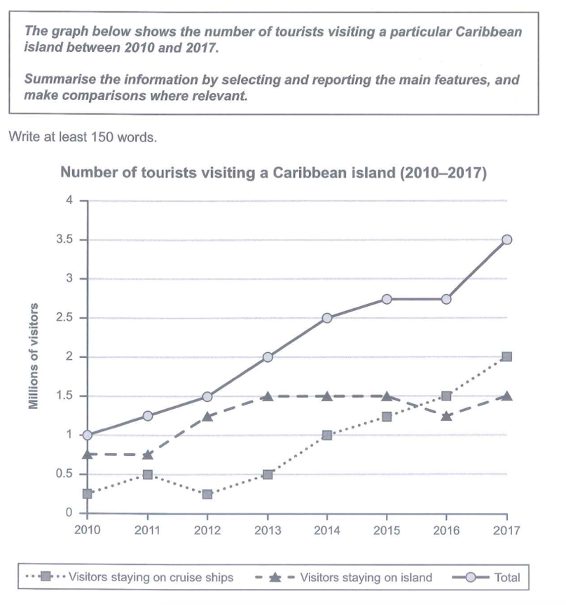

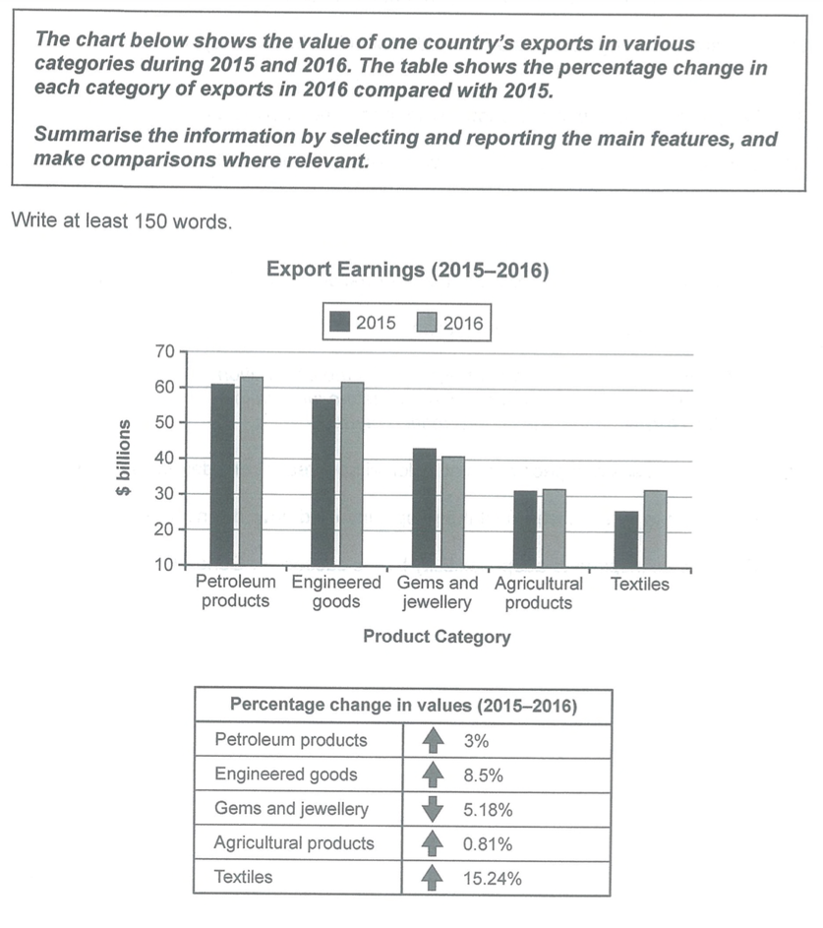

Introduction
- The line graph provides a breakdown of + Noun/ Noun phrase in … (Meanwhile, the line graph illustrates …)
- The graph compares … in terms of + Noun/ Noun phrase
- between … and …/ from … to …/ in the … to … period
Overview
- Looking from an overall perspective, a noticeable feature is that while … follows an upward trend, the reverse is true for …
- Looking from an overall perspective, a noticeable feature is that while … follows an upward trend, … remains relatively stable.
- What is more, … is always/consistently/invariably the most substantial/modest.
- Notably, …
- a positive/negative correlation between … and …
Body 1
Commencing at 1 million visitors, the number/proportion of … increases … before …
This is followed by …
Body 2
In contrast, there is a general diminution in …

MUST-REMEMBER PHRASES AND STRUCTURES

Follow/experience an upward trend/pattern | Follow/experience a downward trend/pattern
Swell  Increase  Rise (to a high of …)  Climb  Grow | Diminish  Decrease  Decline (to a low of …)  Drop  Dip  Fall
soar/ rocket (to a high of …)  surge/ leap | plummet/ plunge (to a low of …)
Reach a peak of  Peak at | Reach a trough of
Experience some fluctuations
Undergo a period of volatility
Fluctuate from … to …
Oscillate between … and …
Alternate back and forth (C2)

Remain/ stay stable/unchanged at
Reach a plateau of
Plateau out
Hover at
Rebound (n,v)
Bounce back (v)
2.
Modest / slight (a): nhẹ, ít | Substantial  Significant  Sharp mạnh, nhiều  Steep  considerable  remarkable
Negligible (a): rất ít | Progressive  Steady đều đặn  gradual

- With the exception of/ except (for)
- The reverse is true for/ The rever is the case for
- Comparable (a) similar
- Range … from … (v) nằm trong khoảng
- This is followed by + a/an + adj + noun
- There is a substantial diminution in …
- The figure/ the statistic/ the data/ the value
- Gap / difference / discrepancy
- Be projected/ anticipated/ predicted to
- The year 2020 witnessed a modest rise in …
- (to be) double/ triple/ quadruple/ five times higher than
- Rank second/ third
- The former / the latter
- Well below
- Shy of less than
Example: The bill was just shy of $1 million.
We're only $100 shy of the total amount.
- a shade / a touch a little / slightly
Example: The journey took us a shade over/under three hours.

Static Charts
Bar charts, Pie charts, Tables
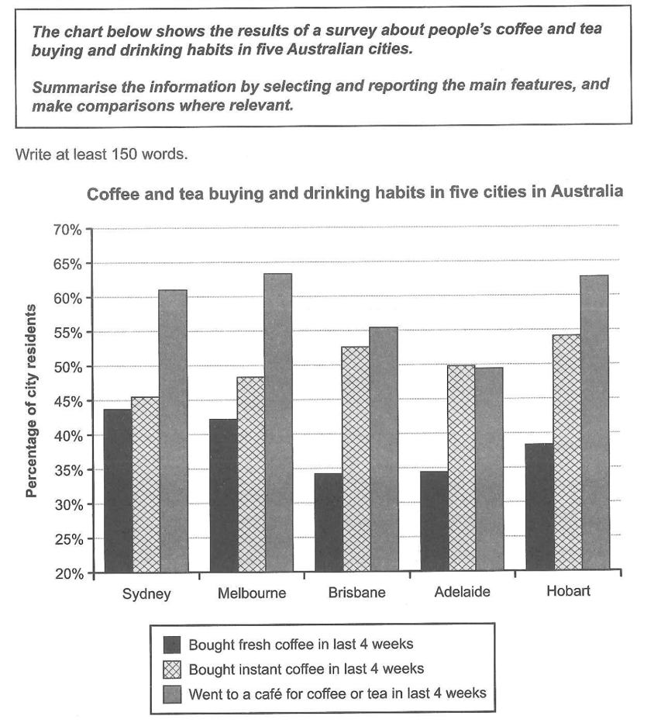

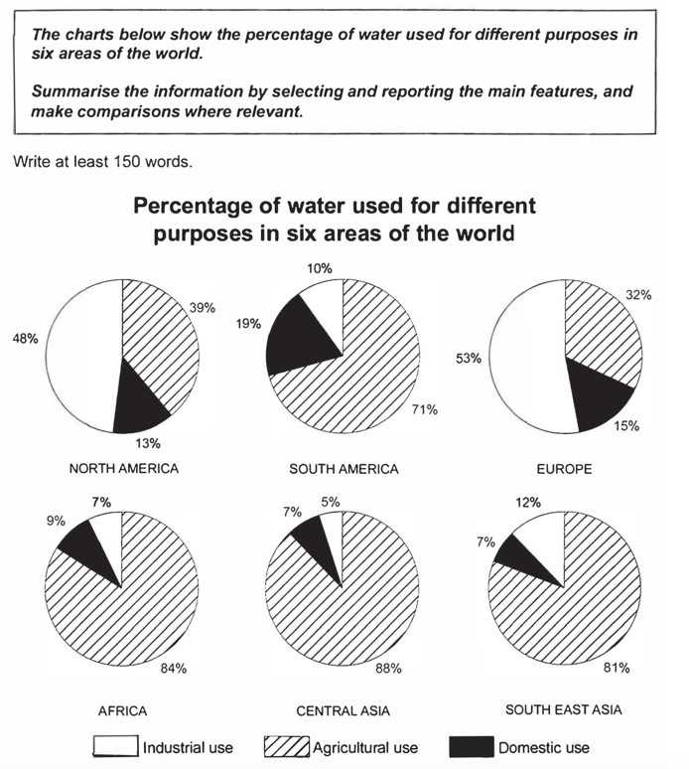

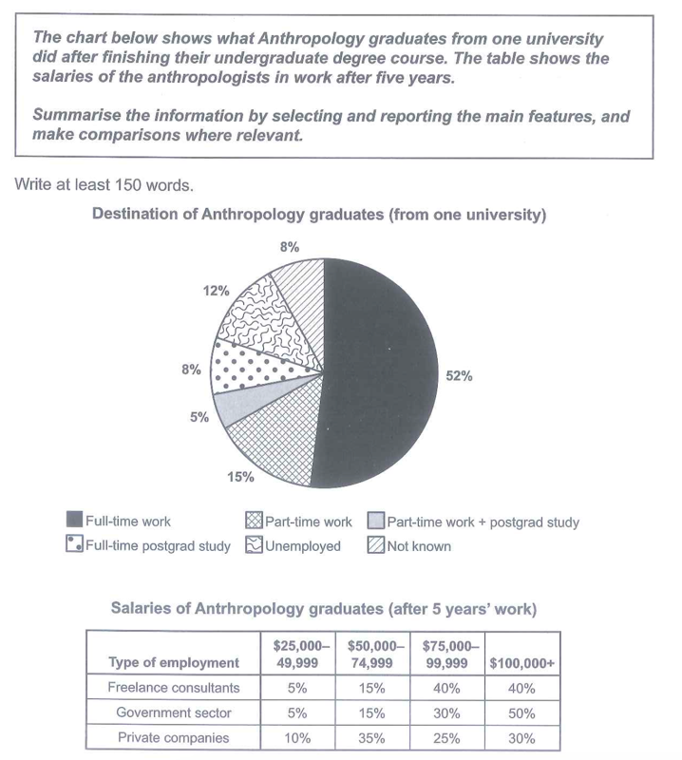

Introduction
- The line graph provides a breakdown of + Noun/ Noun phrase in … (Meanwhile, the line graph illustrates …)
- The graph compares … in terms of + Noun/ Noun phrase
- between … and …/ from … to …/ in the … to … period
Overview
- Looking from an overall perspective, … takes the lead/ ranks first in the number/ percentage of ...
- Looking from an overall perspective, … occupies the lion’s share of ...
- What is more, … is always/consistently/invariably more substantial/modest than …
Body 1

Body 2

MUST-REMEMBER PHRASES AND STRUCTURES
- Occupy/ constitute/ make up/ account for/ represent
- The percentage/proportion/share of
- The lion’s share of / The vast majority of

WRITING TASK 1 - MAPS
- INTRODUCTION
The maps illustrate the layout/blueprint of + [Name of the Place] in [Year 1] and how it looks/looked/will look in [Year 2].
*look = alter = transform
- OVERVIEW
Looking from an overall perspective, it is apparent/noticeable that [Name of the Place] undergoes/underwent/has undergone/ will undergo a number of substantial transformations/alterations, with …
- an increase/ a decrease in …
- the conversion of … into
- the addition/expansion of …
facility/ amenity/ infrastructure
green space
Example: Looking from an overall perspective, it is noticeable that Stokeford will undergo a number of substantial transformations, with an increase in infrastructures /facilities/amenities and accommodation and a decrease in green spaces.
- BODY 1 – Map 1
- BODY 2 – Map 2
USEFUL STRUCTURES
Describing the PRESENT map
1. Introducing the current layout
- At present, the area consists of…
- Currently, the site features…
- The existing layout shows…
2. Describing locations (present)
- in the northern/southern/eastern/western area
- in the northeast/southwest corner
- along the main road / beside the river
- in the centre of the site
3. Useful verbs (present simple)
- There is / There are…
- A footpath runs through…
- A car park occupies…
- The buildings are situated…
4. Present-state relationships
- adjacent to / next to
- surrounded by
- located between X and Y
- opposite the entrance
Describing the FUTURE map (planned changes)
1. Introducing future developments
Use “will” + passive”
- According to the future plan, the area will be redeveloped into…
- Several major changes will take place in the coming years.
- The site is expected to undergo significant transformation.
- By the time the redevelopment is complete, the area will have been modernised.
2. Additions (future)
- A new shopping centre will be built in the northern area.
- A cycle path will be constructed alongside the road.
- Additional housing will be added in the east.
- A sports complex is planned to be built in the southwest.
3. Removals (future)
- The current car park will be demolished.
- The woodland area will be cleared to make room for…
- The existing shops will be replaced by…
4. Replacements (future)
- The old café will be converted into a restaurant.
- The playground will be replaced with an indoor activity centre.
- The farmland will be redeveloped into residential buildings.
5. Upgrades/expansions
- The main road will be extended to connect to the new entrance.
- The park area will be enlarged to include more green space.
- The car park will be expanded to accommodate additional vehicles.
6. Showing unchanged areas
- Despite the planned developments, the river will remain unchanged.
- The central square will be retained.
- The existing footpath will be preserved.
7. Future spatial linking
- Meanwhile, the southern section will feature…
- In contrast, the northern area will undergo more extensive changes.
- Additionally, the eastern side will be redesigned to include…

PROCESS
INTRODUCTION
The diagram illustrates the steps involved in the procedure of manufacturing/producing …
OVERVIEW
Looking from an overall perspective, the process comprises a total of [number] distinct stages, commencing with [starting point] and progressing through a sequence of steps before culminating in [final stage/outcome].
BODY 1
- The process begins when S+V.
The process begins when the raw materials are gathered.
- This is followed by + N/NP.
- The next/following step involves + V-ing/NP.
The next step involves the extraction of raw materials.
BODY 2
- The process proceeds with + N/NP.
The procedure proceeds with the cooling of the material.
- Once the […] has been completed, […] takes place.
- Following this, S + V.
- Subsequent to this / Subsequently, …
Subsequently, the material is compressed into blocks.
USEFUL VOCABS & PHRASES
- Proceed with sth (v): tiếp tục với
- Be transferred to [name of the machine] where S+V.
The mixture is transferred to a furnace where it is melted.
- Be subjected to sth: bị chịu / bị đưa vào / bị tác động bởi điều gì đó
The water is subjected to a filtration process.
- Undergo (v): trải qua
Subsequently, the combination undergoes a freezing process.

