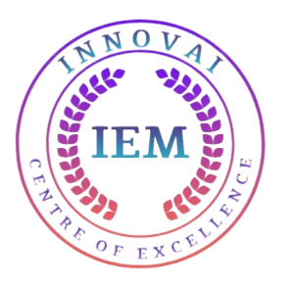
Workshop Report

Report on Day 1 of the Workshop: "Demystifying Artificial Intelligence"
Organized by: Department of Computer Science and IT, in collaboration with InnovAI Centre of Excellence
Venue: 10th Floor, Godrej Genesis Building
Date: Day 1
Duration: 9:30 AM to 4:30 PM
Program Length: 3 Days 11th September to 13th September, 2024

The "Demystifying Artificial Intelligence" workshop, organized by the Department of Computer Science and IT in collaboration with the InnovAI Centre of Excellence, began today on the 10th floor of the Godrej Genesis Building. This unique workshop, a revenue-generative initiative by the InnovAI Centre of Excellence, has attracted a total of 55 students. Spanning three days, the workshop runs from 9:30 AM to 4:30 PM daily and offers a blend of expert lectures and hands-on sessions on the latest developments in AI.

Session 1: Keynote by Prof. Bhabotosh Chanda

The day started with a keynote address by Prof. Bhabotosh Chanda, a retired professor from the Electronics and Communication Sciences (ECS) Unit of the Indian Statistical Institute (ISI), Kolkata, and currently the Pro Vice-Chancellor (Academics) at Brainware University. Prof. Chanda discussed the advancements and challenges in AI, drawing on his distinguished career, which includes honors such as the Young Scientist Medal from the Indian National Science Academy (1989), the Vikram Sarabhai Research Award (2002), and the IETE-Ram Lal Wadhwa Gold Medal (2007). He is a fellow of several prestigious organizations, including the Institute of Electronics and Telecommunication Engineers, the National Academy of Sciences, India, and the International Association of Pattern Recognition.
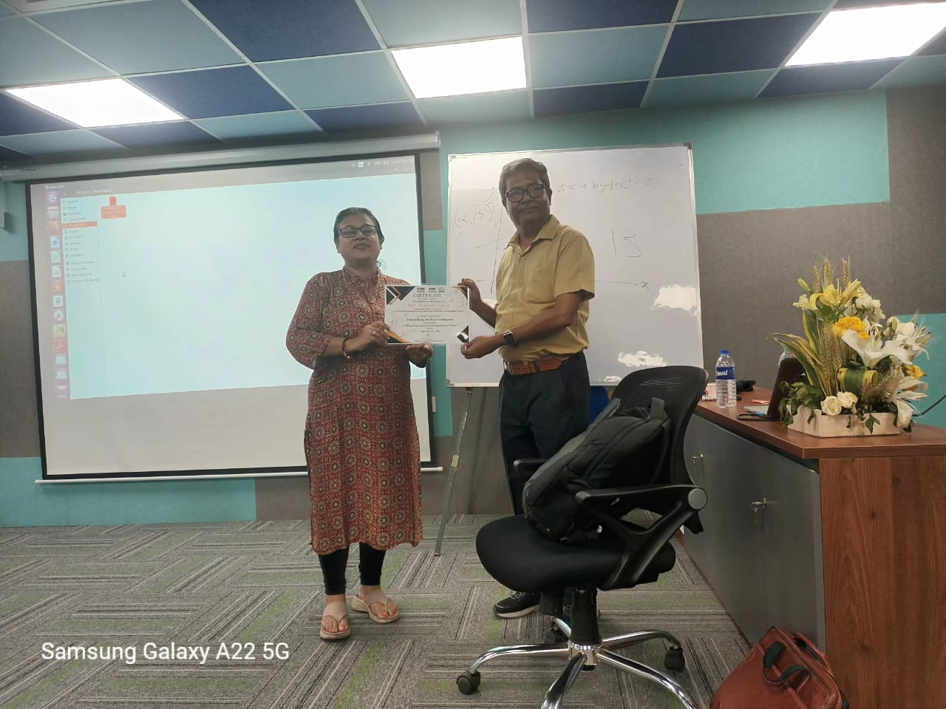

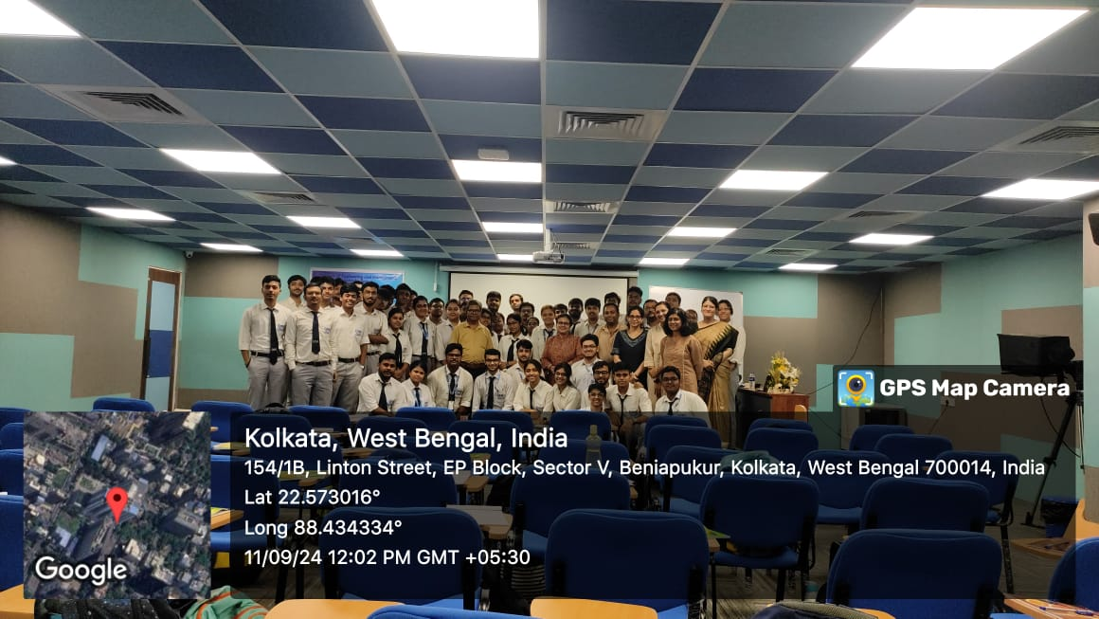

Session 2: Insights by Prof. Narayan Changder

The second session featured Prof. Narayan Changder, an Assistant Professor at the Institute of Advancing Intelligence at TCG CREST. Prof. Changder, who has served in various academic and research roles, including a Visiting Scientist position at the Electronics and Communication Sciences Unit, ISI Kolkata, and a Visiting Researcher role at the University of Southampton, UK, provided a detailed analysis of AI trends and innovations. His talk focused on the current and future applications of AI in diverse industries.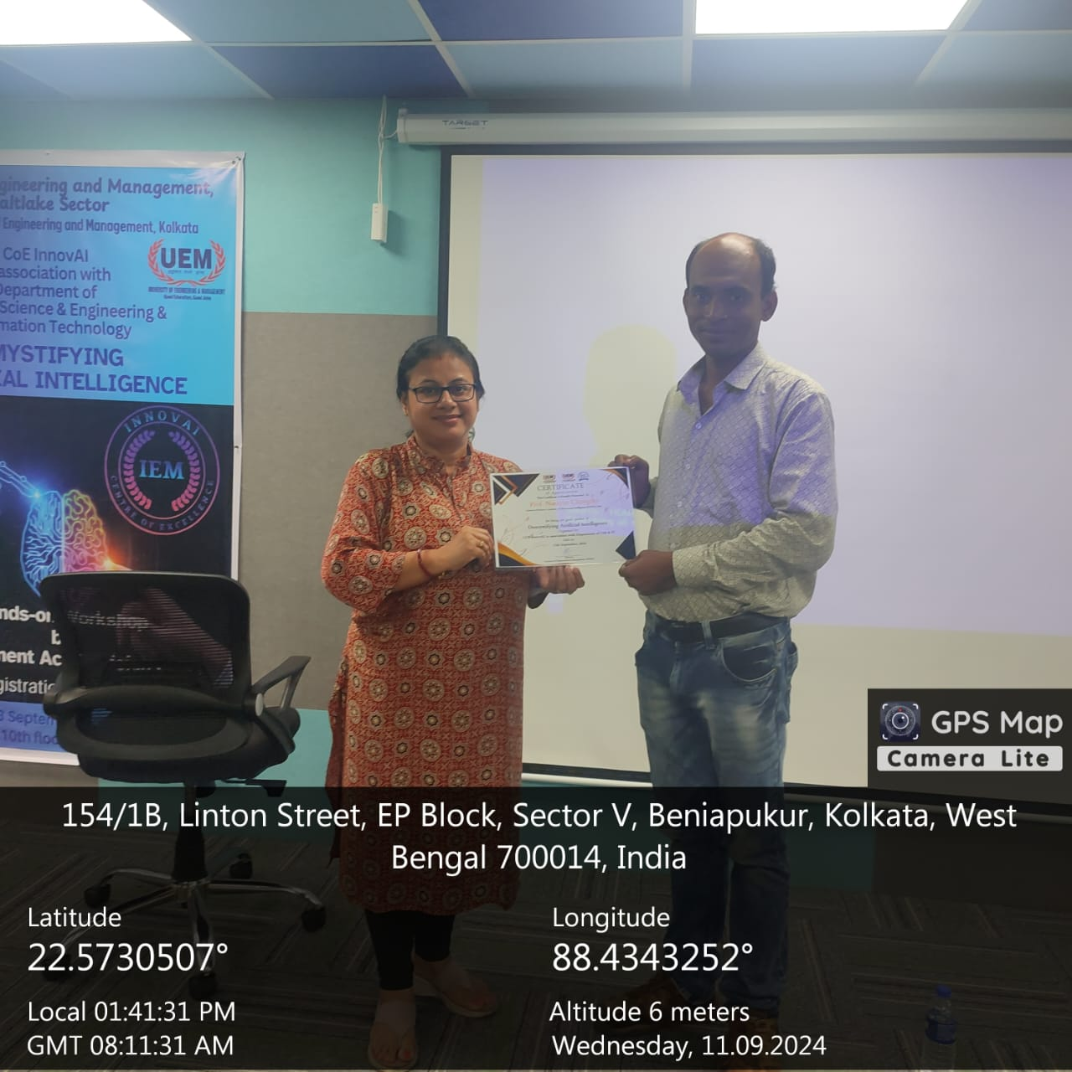

Session 3: Hands-on Workshop by Prof. Debapriya Roy
The final session of the day was a hands-on workshop on image processing and noise removal strategies using Python, conducted by Prof. Debapriya Roy, a faculty member in the Computer Science and Engineering (CSE) Department and a Ph.D. holder from ISI Kolkata. The session allowed participants to engage in practical exercises, exploring Python-based techniques for digital image noise reduction, and applying AI concepts to solve real-world problems.

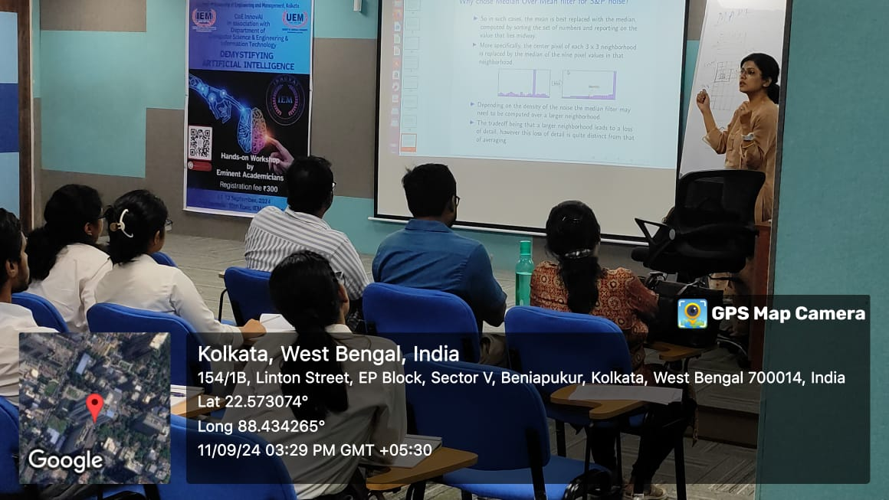

The first day of the workshop was highly successful, providing a comprehensive learning experience that combined theoretical knowledge with practical application. As a revenue-generative initiative by the InnovAI Centre of Excellence, this workshop not only enriches the students' understanding of AI but also contributes to the department's sustainability. The participants eagerly anticipate the next two days of learning and exploration.

Report on Day 2 of the Workshop: "Demystifying Artificial Intelligence"
Organized by: Department of Computer Science and IT, in collaboration with InnovAI Centre of Excellence
Venue: 10th Floor, Godrej Genesis Building
Date: Day 2
Duration: 9:30 AM to 4:30 PM
Program Length: 3 Days

Day 2 Workshop Report
On Day 2 of the workshop, the sessions commenced promptly at 9:30 AM, with distinguished speakers presenting various topics in the field of medical imaging, hyperspectral imaging, and machine learning applications.

Session 1: Medical Imaging
The first session of the day was led by Prof. Dr. Malay Bhattacharyya, who delivered an in-depth lecture on Medical Imaging. Prof. Bhattacharyya holds multiple distinguished positions:

Associate Professor, Machine Intelligence Unit, Indian Statistical Institute, Kolkata
Associate Member, Centre for Artificial Intelligence and Machine Learning
Associate Member, Technology Innovation Hub, Indian Statistical Institute
Member, Assessment & Search Committee, ACM Publications Board
Member, MetaSUB Consortium
Fellow, climaTRACES Lab, University of Cambridge
Former Member, The Lancet COVID-19 Commission: India Task Force
Prof. Bhattacharyya's session covered the evolving landscape of medical imaging technologies, their applications in healthcare, and the role of artificial intelligence in improving diagnostics. His interactive presentation highlighted the use of machine learning algorithms to detect patterns in medical images, showcasing practical implementations.

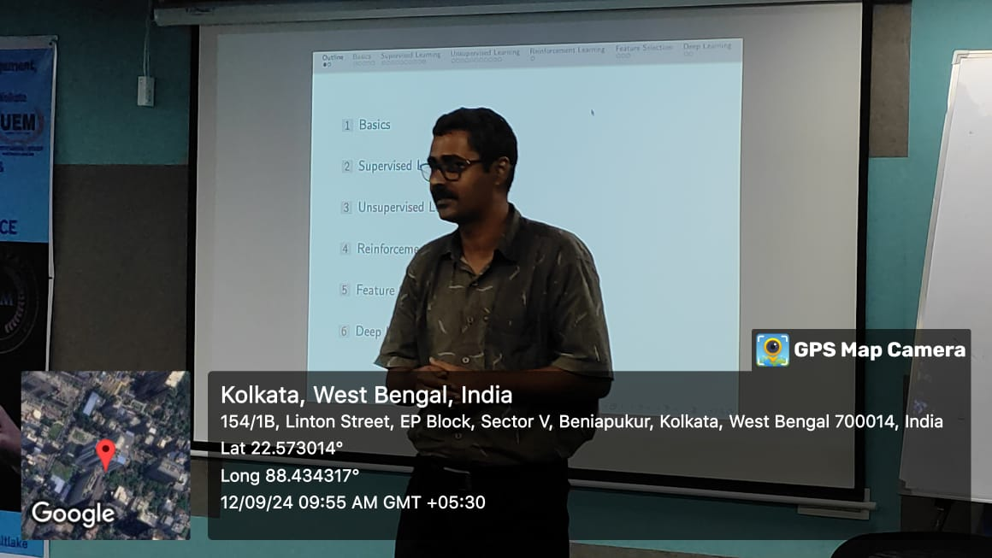
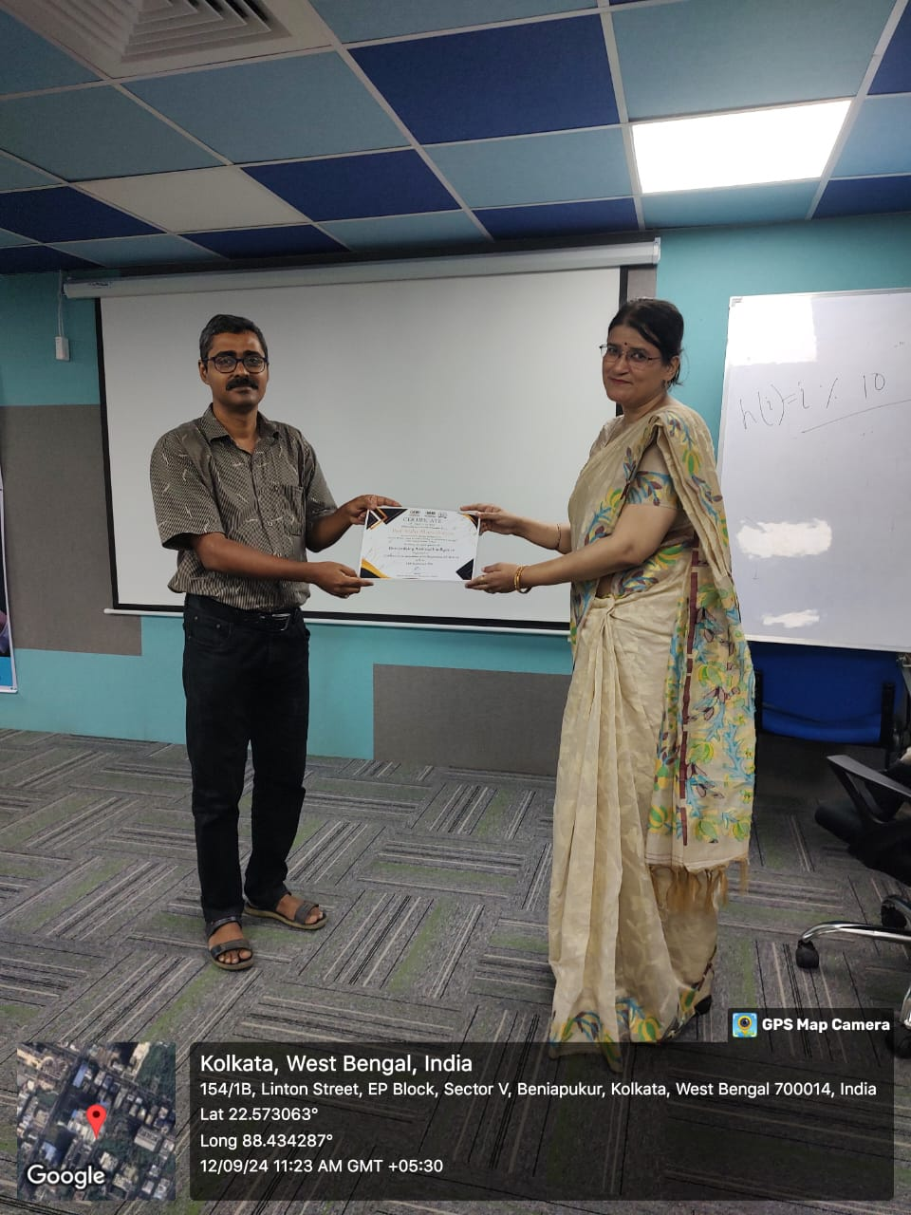
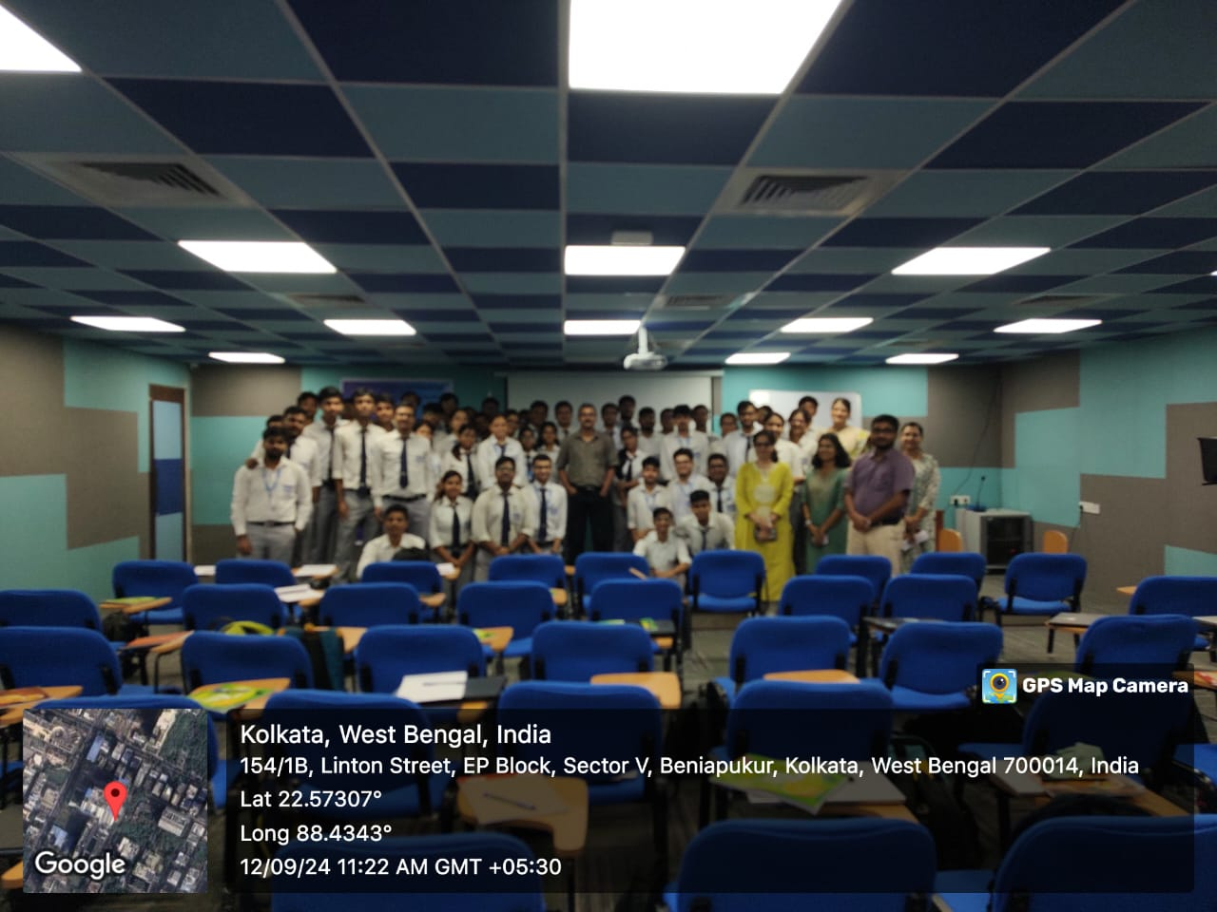

Session 2: Hyperspectral Imaging and Remote Sensing
The second session, starting at 11:00 AM, was conducted by Prof. Angshul Majumder. He provided a comprehensive overview of Hyperspectral Imaging and Remote Sensing. Prof. Majumder is renowned for his contributions to signal processing and holds the following positions:

Professor, IAI, TCG CREST, Kolkata
Professor, IIIT Delhi (on lien)
Senior Member, IEEE Signal Processing Society
Associate Editor, IEEE OJSP, IEEE TCSVT, Neurocomputing
Area Chair, IEEE ICASSP 2020, IEEE ICIP 2020
Member-at-large, IEEE SPS Education Board (2020)
Director of Student Services, IEEE SPS Membership Board (2022-)
Chair, IEEE SPS Education Committee (2019)
Chair, IEEE SPS Chapters Committee (2016-18)
Founding Chair, IEEE Signal Processing Society, Delhi Chapter
Finance Chair, IEEE ISBA 2017
His session focused on the processing and analysis of hyperspectral data, emphasizing the role of signal processing techniques in improving remote sensing applications. Prof. Majumder also explored the potential of these technologies in environmental monitoring, agricultural assessment, and urban planning.
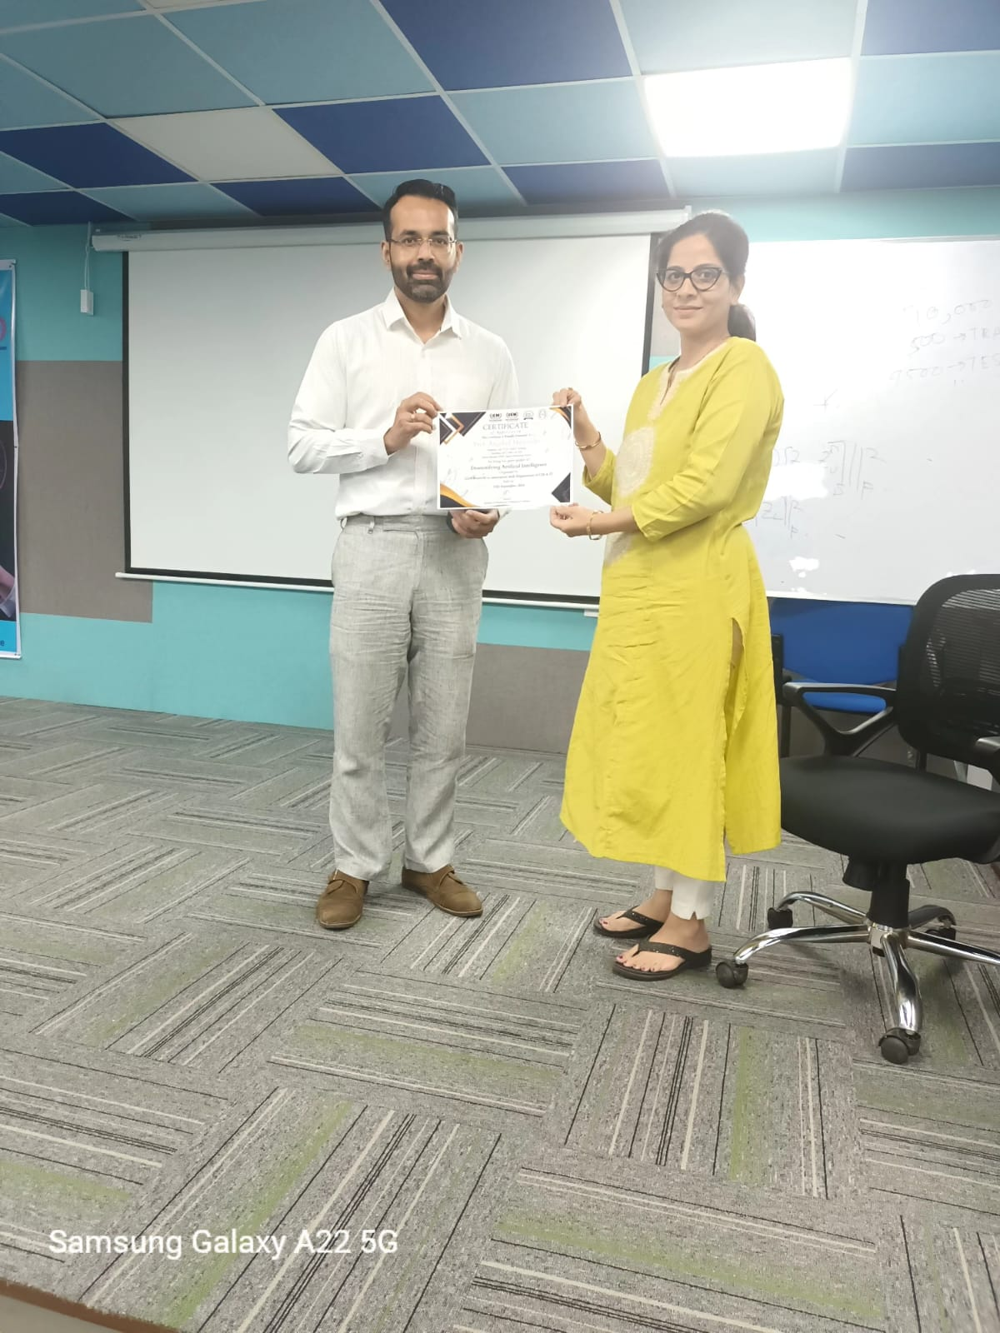

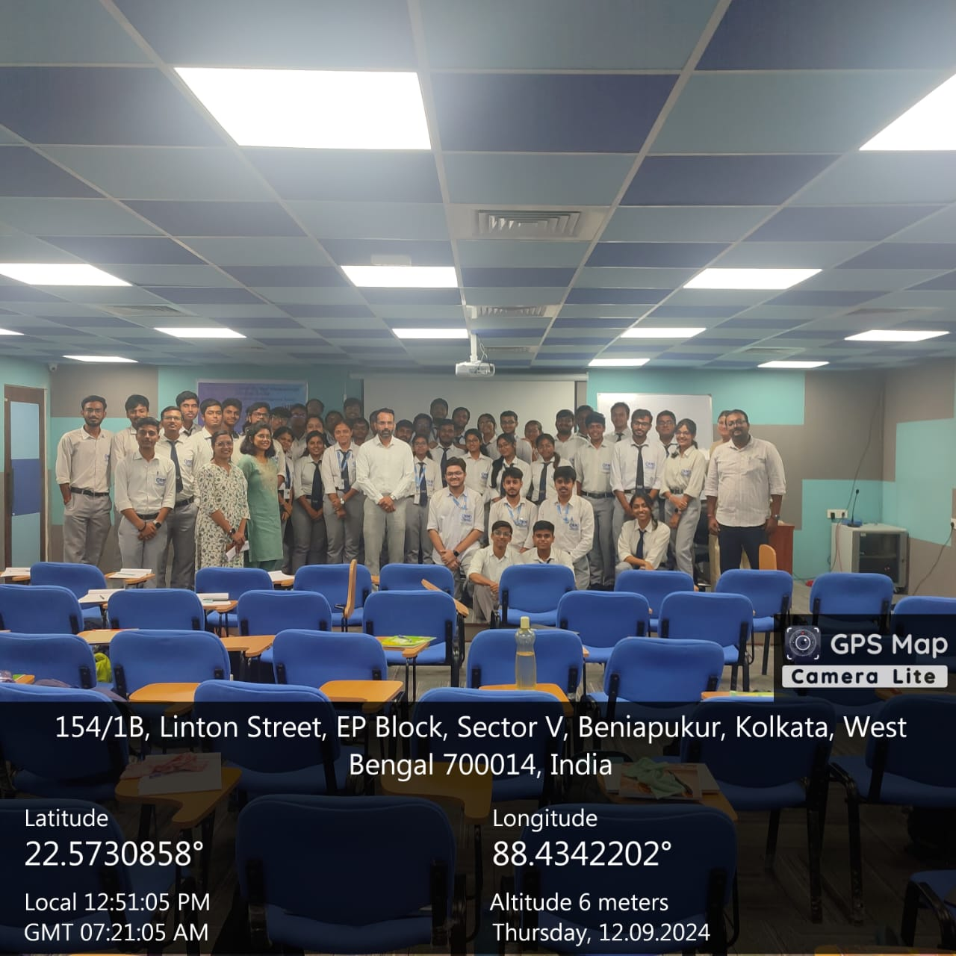

Session 3: Hands-On Session on Machine Learning for Computer Vision
The afternoon session, held from 1:45 PM to 4:10 PM, was a practical hands-on session led by Prof. Anindita Das Bhattacharjee. This session was dedicated to the implementation of machine learning models, specifically tailored for computer vision applications. Participants were guided through various preprocessing mechanisms used in computer vision, allowing them to apply machine learning techniques to real-world datasets.

Prof. Bhattacharjee’s interactive approach helped participants get a practical understanding of how preprocessing techniques, such as normalization and data augmentation, are essential for training robust machine learning models. The session was well-received, as participants engaged in coding exercises, contributing to a deeper understanding of machine learning pipelines in computer vision.
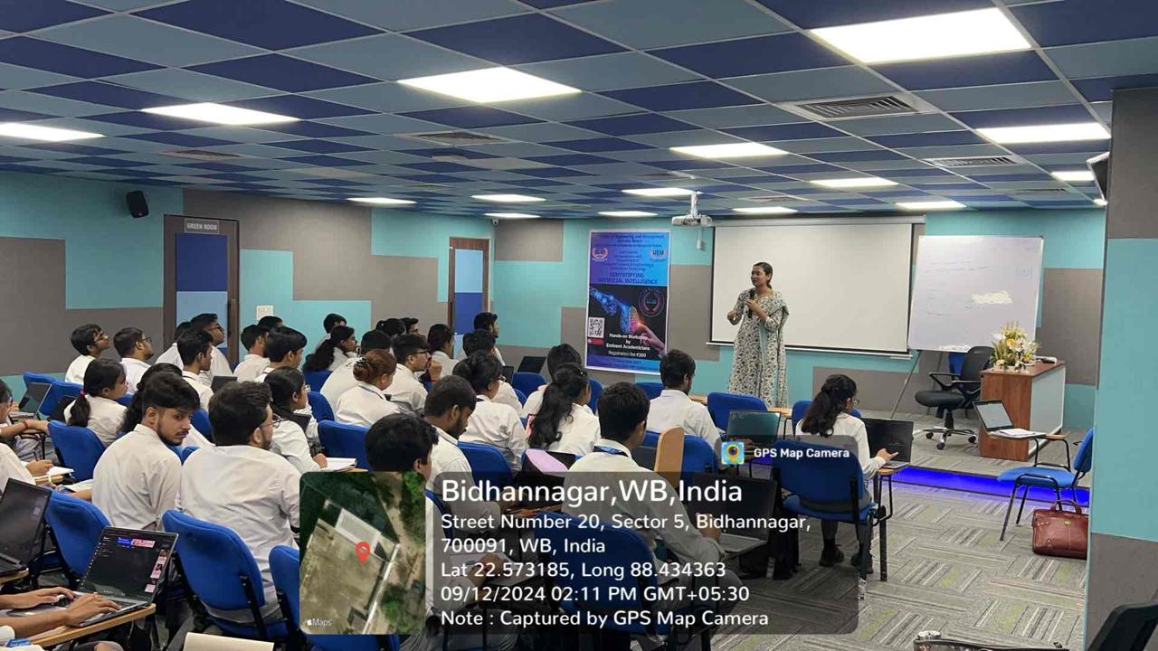

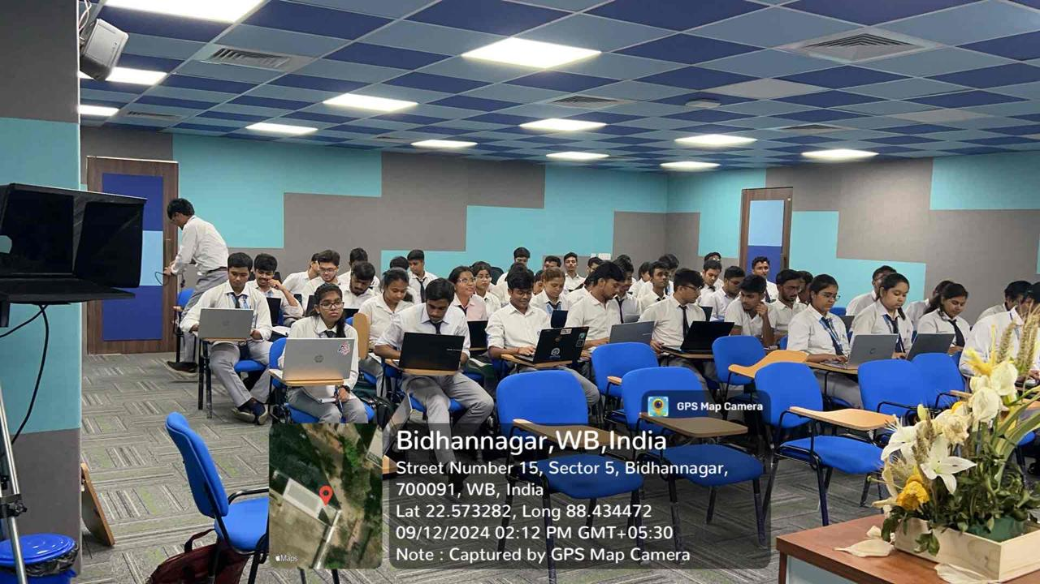

Workshop Report: Day 3 - "Demystifying Artificial Intelligence"
Organized by: Department of Computer Science and IT, in collaboration with InnovAI Centre of Excellence
Venue: 10th Floor, Godrej Genesis Building
Date: 13th September
Duration: 9:30 AM to 4:30 PM
Program Length: 3 Days

Day 3 Highlights:

The final day of the workshop, titled "Demystifying Artificial Intelligence", was both engaging and informative, featuring student presentations, prize distributions, and a valedictory session. Here's a detailed overview of the day's activities:

Morning Session: Project Presentations
Time: 9:30 AM - 1:00 PM

In the first half of the day, students showcased their projects which involved analyzing data acquired from Amazon. The students were divided into groups and each group presented their findings on data analysis, demonstrating their analytical skills and insights gained from their projects.

Highlights:

Project Topics: Ranged from sentiment analysis of product reviews to trend analysis of sales data.
Presentation Format: Each group presented their project findings using slides and demonstrated their analysis using various data visualization tools.
Audience Engagement: The presentations were followed by Q&A sessions, where students answered questions from peers and faculty, fostering an interactive environment.

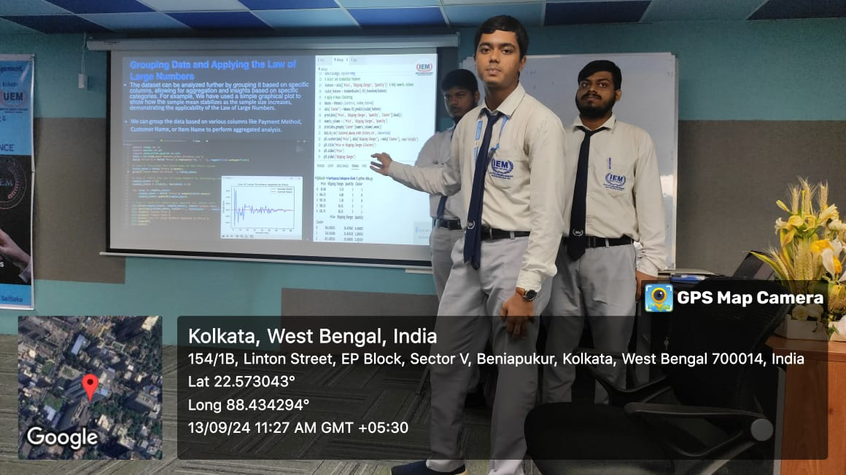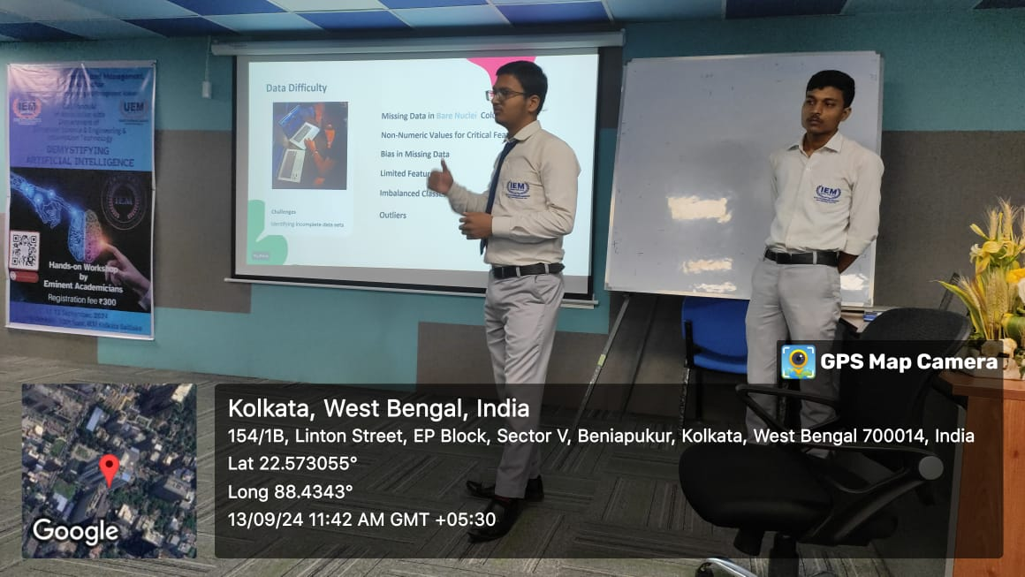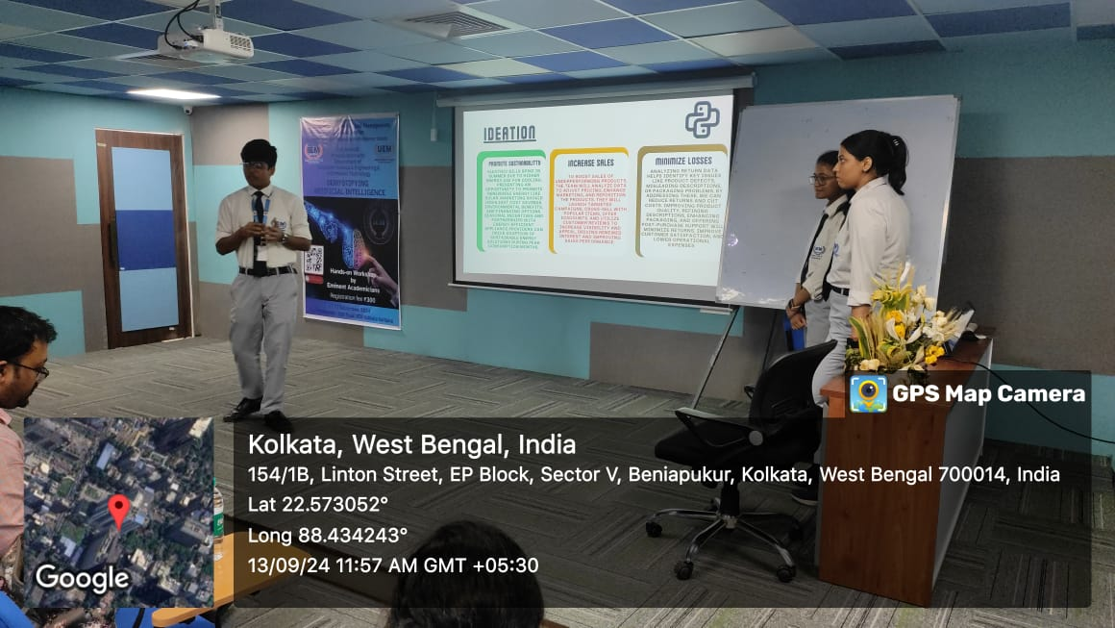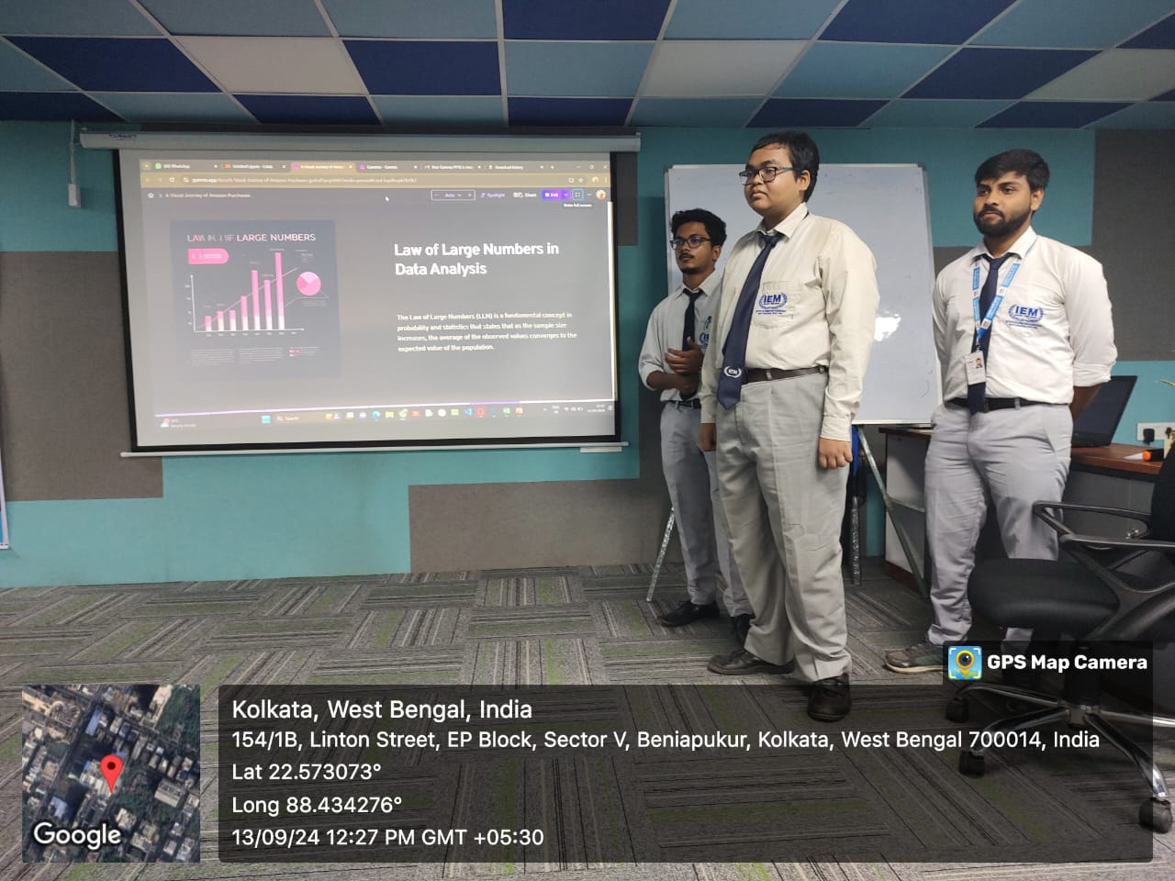

Afternoon Session: Prize Distribution and Certificate Ceremony
Time: 1:45 PM - 4:10 PM

The second half of the day was dedicated to recognizing and rewarding outstanding projects.
Certificate Format
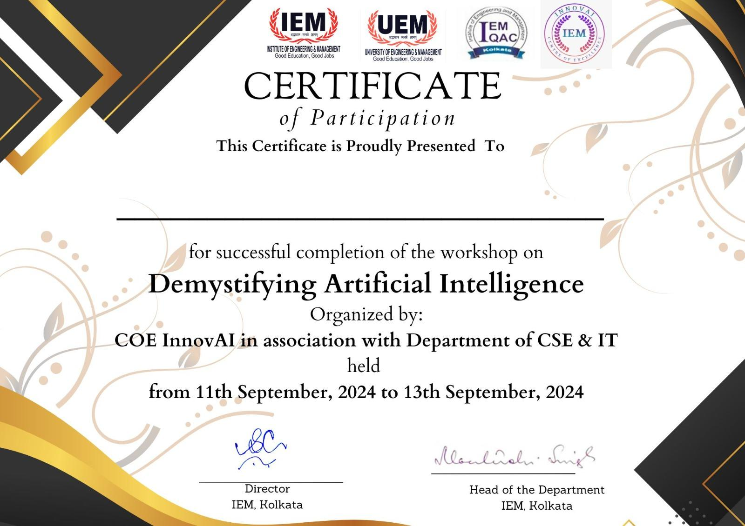

Valedictory Session:

Time: 4:10 PM - 4:30 PM
Remarks: The valedictory session included speeches from the workshop organizers , summarizing the achievements of the workshop and expressing gratitude to the participants and faculty.
Prize Distribution:

Awards: Prizes were given to the groups that demonstrated superior analytical skills and innovative approaches in their projects.
Criteria: Evaluation was based on the depth of analysis, clarity of presentation, and practical applications of the insights.
Certificate Distribution:

Certificates: All participating students were awarded certificates of participation, acknowledging their effort and contributions throughout the workshop.
Special Recognition: Certificates were also presented for notable achievements and exceptional performance.

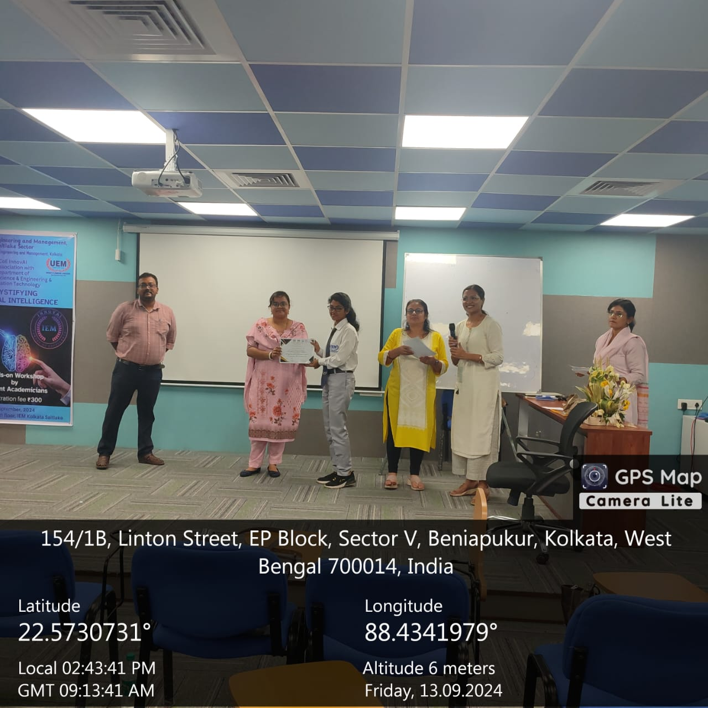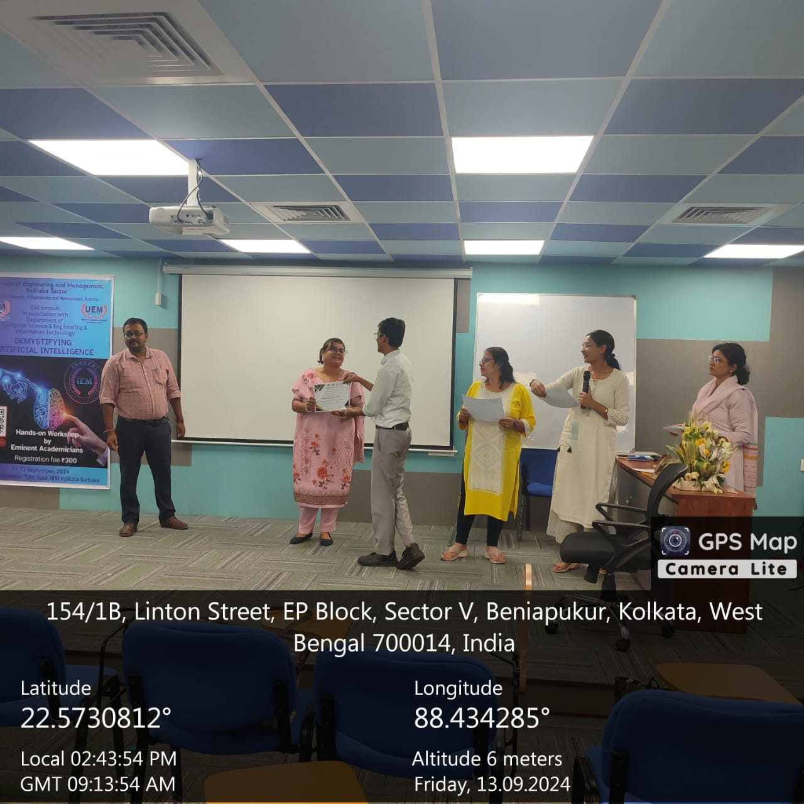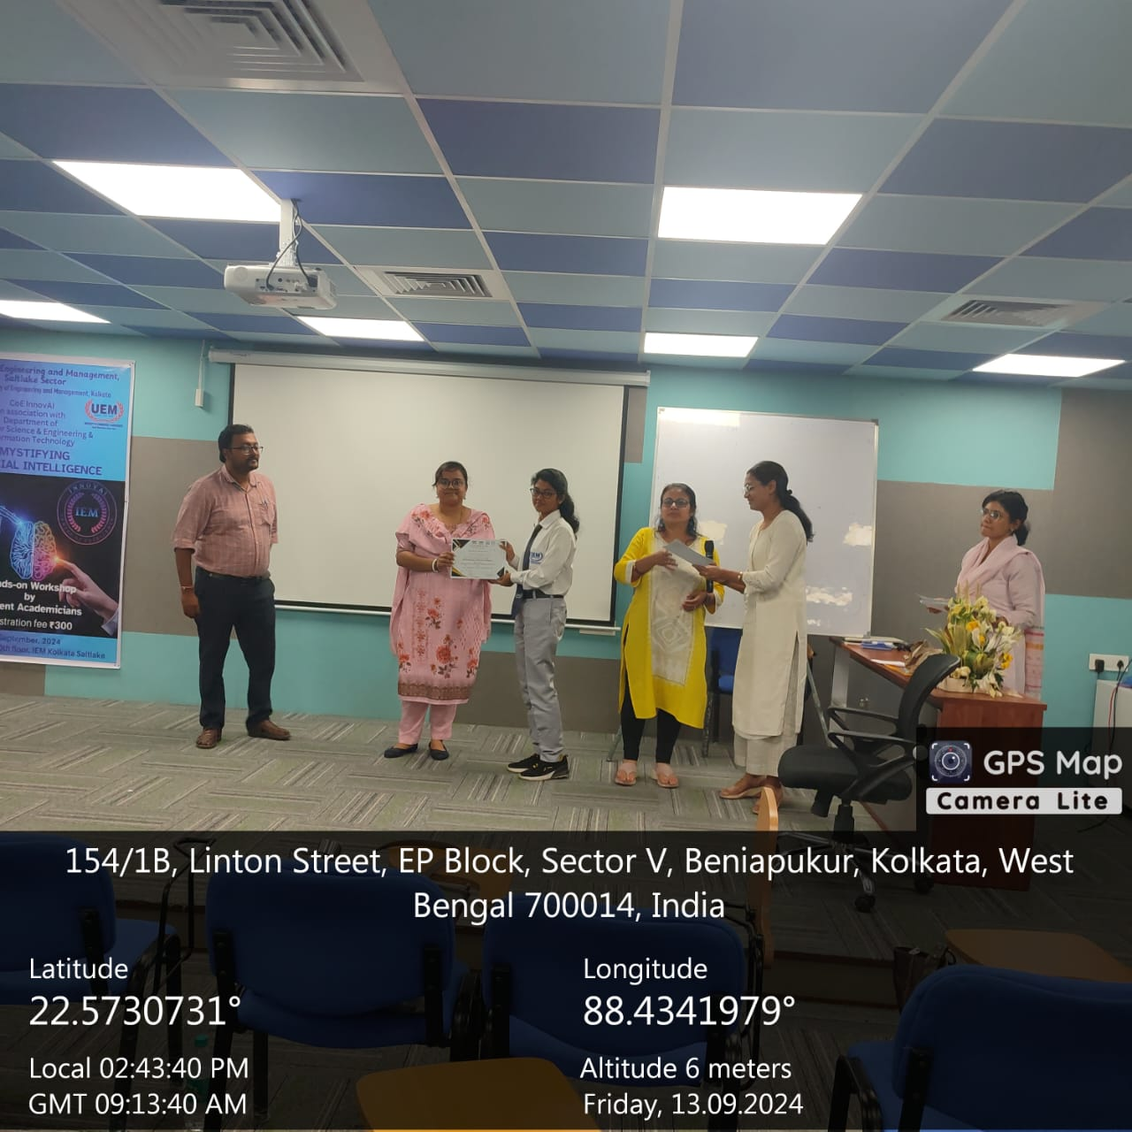
Closing: The session concluded with a reflection on the learning experiences and key takeaways from the workshop.

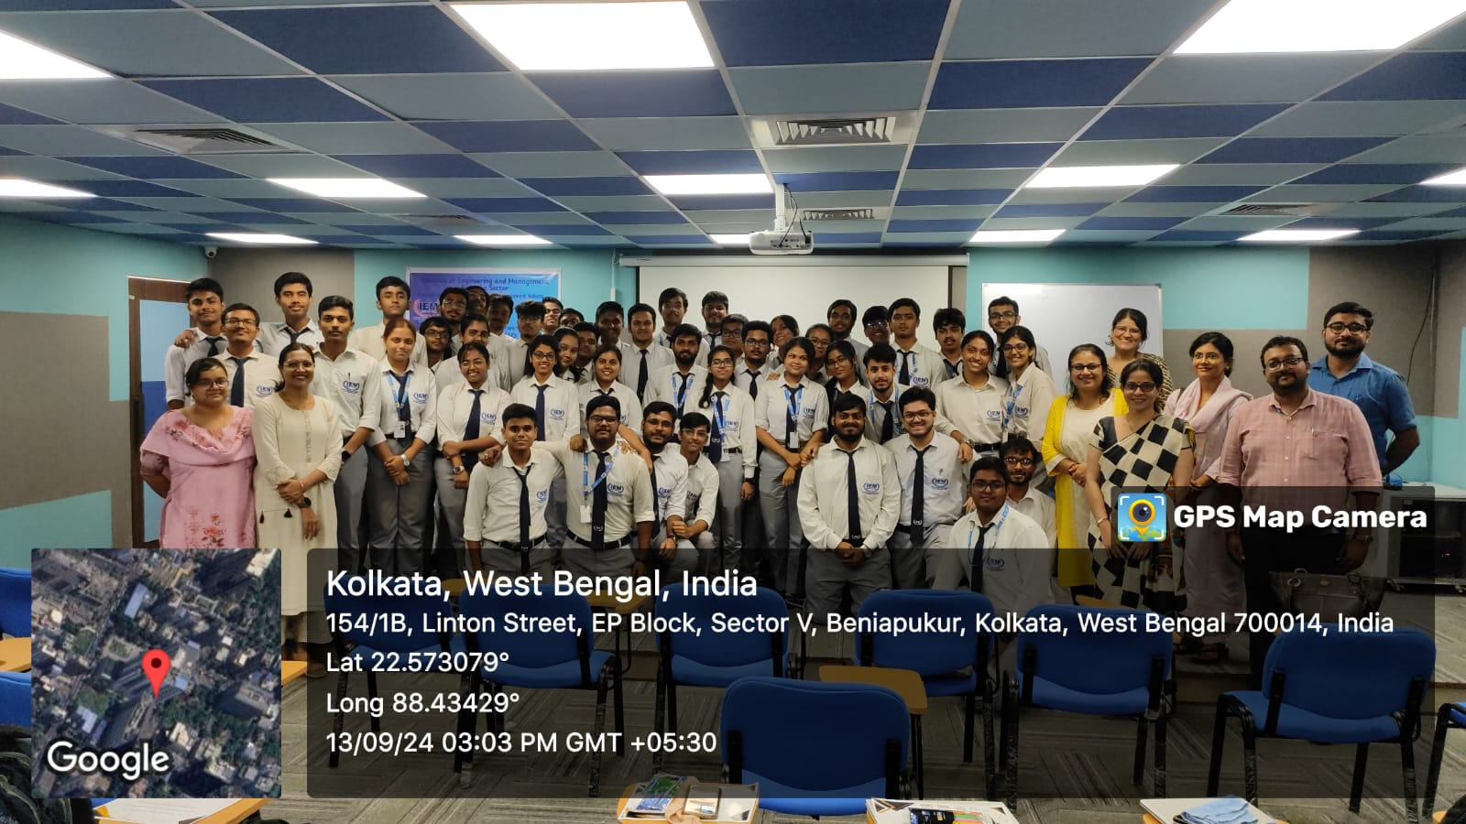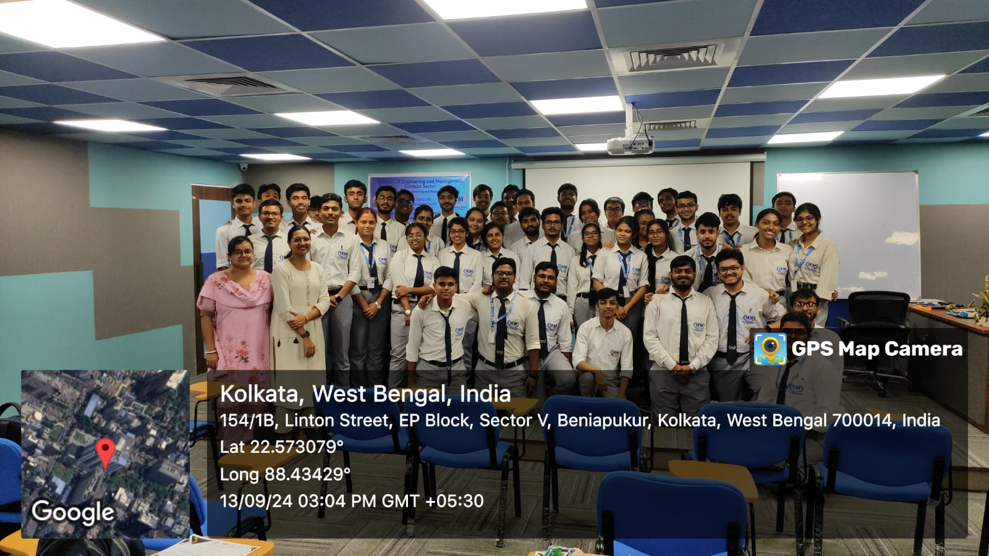

Anonymous feedback was collected to gauge student interests for upcoming workshops.

Workshop Brochure
