MiniArm Project

# Introduction

For a Mechatronics student, thorough knowledge of robotics is a must. To truly appreciate robotics, one must implement their knowledge in hands-on experiments. This project is an experiment in implementing knowledge of hobby robotics.

MiniArm incorporates a multi-disciplinary approach by bringing together concepts from mechanics, electronics, and programming.

# Aim/Problem statement

To build a simple, yet scalable robotic MiniArm that could serve variety of applications such as object carrying, performing human-bot handovers, material handling and much more.

This MiniArm project looks to achieve the key functioning of a robotic arm that is, its ability to learn motions and the ability of its arms to be programmed by the user.

# Components used

1. Arduino Mega Board
2. NRF24L01 radio transceiver module
3. SG90 servo motors
4. MG995 servo motors
5. Breadboard
6. Jumper wires
7. Joystick modules
8. L298N motor drivers
9. potentiometer
10. 9V battery
11. 18650 Li-ion battery
12. Motor/Wheel kit
13. Chassis
14. SPST switch
15. Brackets
16. LM7805 voltage regulator

# Model Drawing

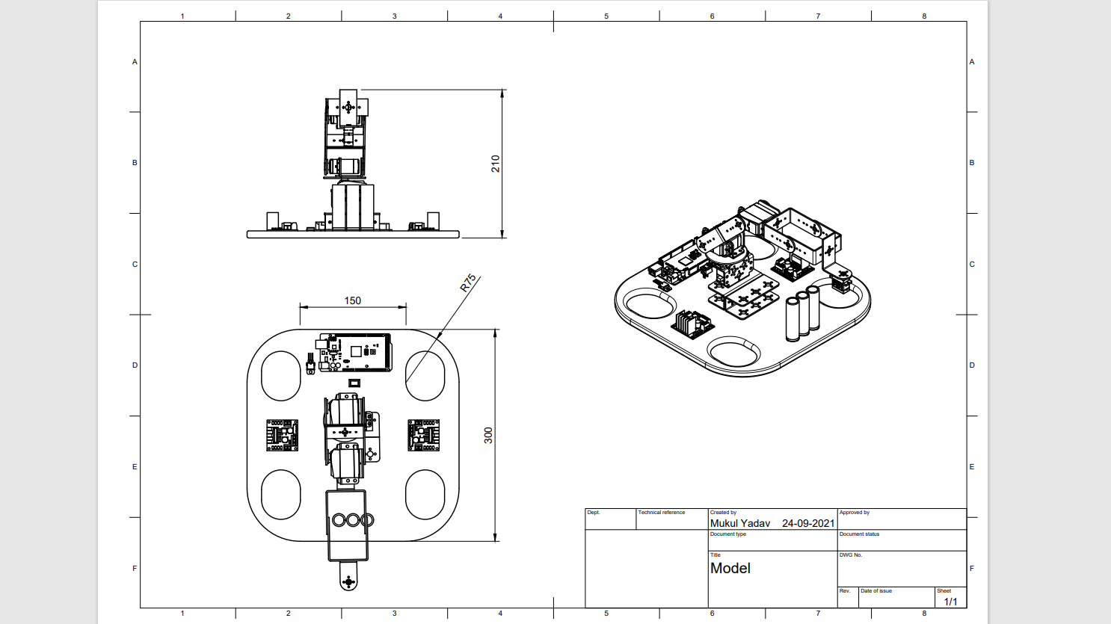

# Working

Broadly, the MiniArm is a simple manipulator attached to a mobile base to be used for pick and place operations.

## Hardware:

The base will be cut out of Hardboard or Acrylic to resemble the dimensions shown in the drawing. 2 pairs of DC motor/wheel kits will fit in the holes. The manipulator will make use of steel brackets attached to servo motors with appropriate horns. The end effector will be used to grip small articles and transport them.

The MiniArm will be controlled wirelessly with a couple of joysticks and a pair of radio transceiver modules on either end.

## Electronics:

For power, we will use the 18650 rechargeable Li-Ion cells to achieve a total of 14.8 volts. The microcontroller requires 7-12 volts of input, which can be extracted through a custom circuit board.

A pair of L298N motor drivers would receive the full 14.8 volts from the cells.

The servo motors would receive power from the cells since doing so from the microcontroller would most likely damage it.

As for the controller, we need nothing more than a small microcontroller paired with a couple of joysticks and a radio transceiver module. To power the controller, we would use a 9V battery.

Both sides have switches to turn the power on and off. The servo motors on the manipulator link to the joysticks through which we can implement any control scheme we wish.

# Circuit

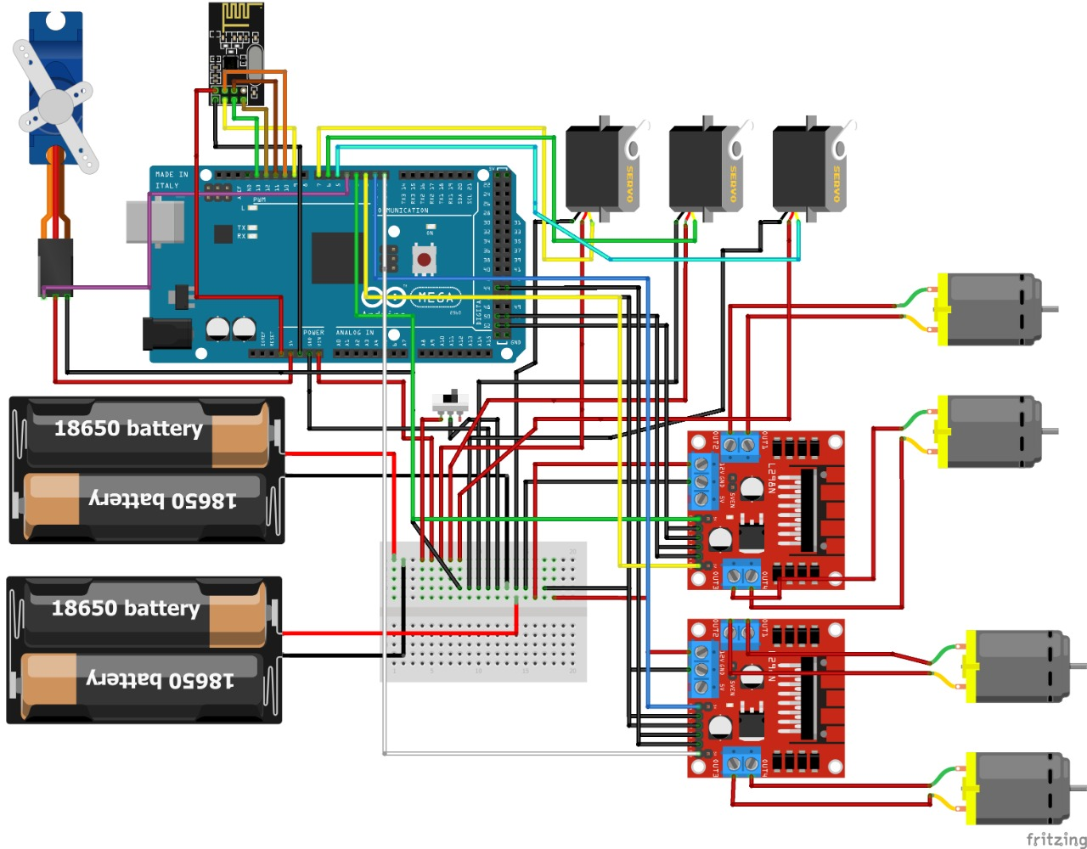

* Receiver side

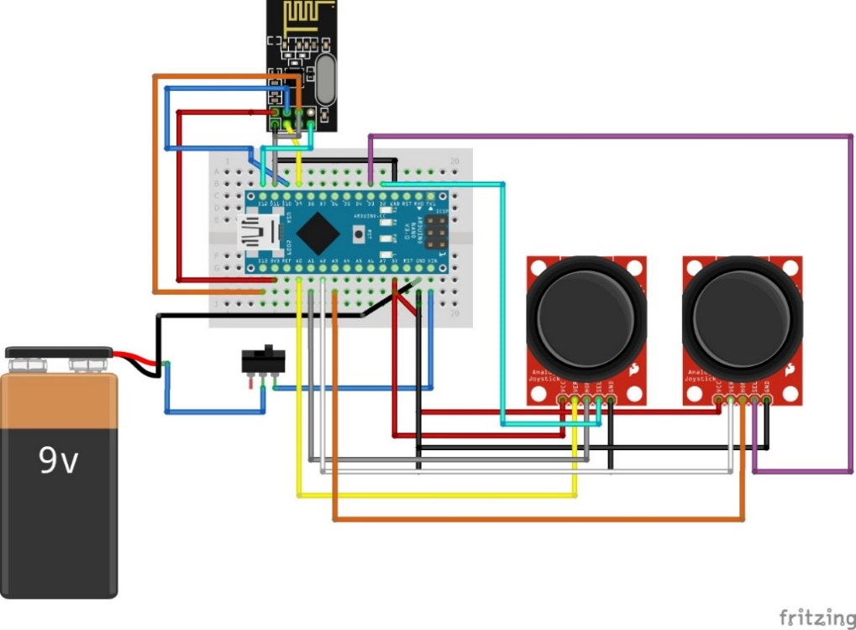

* Transmitter side

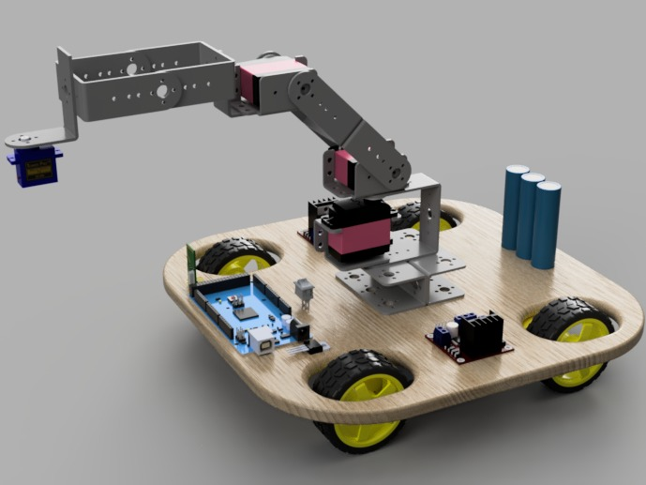 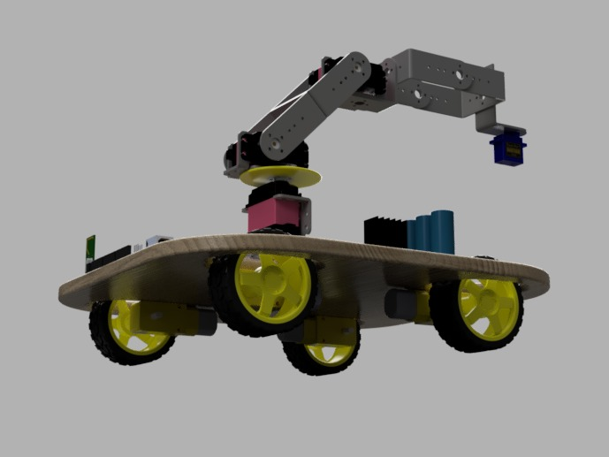

* 3D model

## Code Snippet that Links the NRF Radio Modules:

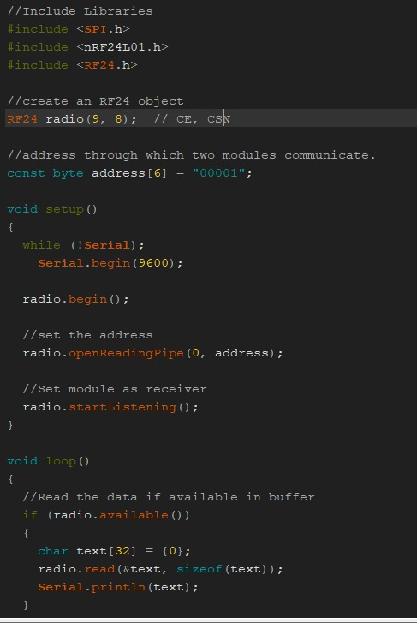

* Receiver

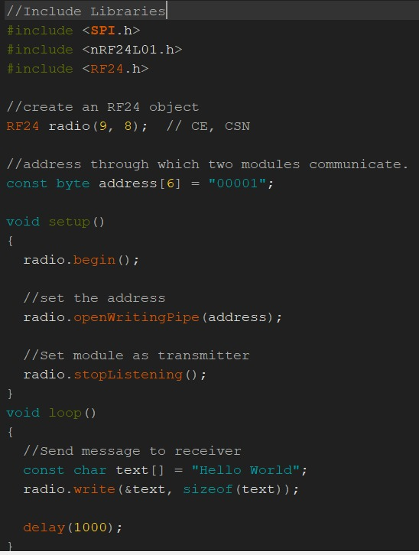

* Transmitter

# Challenges and Uncertainties

Having never worked with hardware before, getting an idea of how everything fits together is a point of contention. The initial plan was to simply glue the links to the servos and each other but a quick search reveals a bunch of brackets specifically built for attaching to each other like Legos.

Furthermore, it is difficult to predict how the mechanism would behave when put together and it is imperative to ensure it does not collapse under its own weight. Thus, some room for trial and error is expected as we figure out the optimal number of motors and links to ensure smooth operation.

Coming to electronics, the transceiver modules have been known to have great performance, but it must be ensured that genuine modules are being used, since they are not highly reliable and seldom work properly.

Given that we have just one joystick to control the servo motors, we may have to use additional potentiometers to accommodate a higher number of servos, at least until we can implement inverse kinematics.

# Near Future Development:

This bot offers a wide scope to implement knowledge of Robotics. While starting out, the simplest of components are being used. However, the team behind this project plans to keep on implementing new and more sophisticated components and control systems once we are comfortable with its working.

For example, instead of the Arduino, we would use the STM32 MCU, which is much faster and also compels us to learn about microcontrollers in depth. A custom PCB could also be built to facilitate all the components in the circuit diagram. Most importantly, this project gives us a chance to implement the concepts we have brushed over in Robotics Lab such as ROS and Raspberry Pi’s. (All these ancillary components would be obtained by the team's monetary contribution and will be replaced as needed.)

# Conclusion

The MiniArm is one of the first projects where we figure out all aspects of its build. It serves as a starting point to further our knowledge of robotics.

After further exploration of the MiniArm's capabilities, new features like object detection, inverse kinematics and dynamics could be added to increase its working efficiency.