**Experiment No: 9**

***Title :***

• Study and Implementation of Database Backup & Recovery Commands. • Study and Implementation of Rollback, Commit, Save point.

***Objective*:**

To understand the concept of administrative commands

***Theory*:**

A transaction is a logical unit of work. All changes made to the database can be referred to as a transaction. Transaction changes can be made permanent to the database only if they are committed a transaction begins with an executable SQL statement & ends explicitly with either rollback or commit statement.

1. **COMMIT:** This command is used to end a transaction only with the help of the commit command transaction changes can be made permanent to the database.

***Syntax:*** SQL> COMMIT;

***Example:*** SQL> COMMIT;

1. **SAVE POINT**: Save points are like marks to divide a very lengthy transaction to smaller once. They are used to identify a point in a transaction to which we can latter role back. Thus, save point is used in conjunction with role back.

***Syntax:*** SQL> SAVE POINT ID;

***Example:*** SQL> SAVE POINT xyz;

1. **ROLLBACK:** A role back command is used to undo the current transactions. We can role back the entire transaction so that all changes made by SQL statements are undo (or) role

37 back a transaction to a save point so that the SQL statements after the save point are role back.

***Syntax:*** ROLLBACK (current transaction can be role back)

ROLLBACK to save point ID;

***Example:*** SQL> ROLLBACK;

SQL> ROLLBACK TO SAVE POINT xyz;

**LAB PRACTICE ASSIGNMENT:**

1. Write a query to implement the save point.

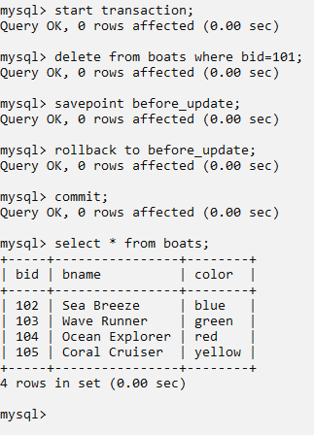

1. Write a query to implement the rollback.

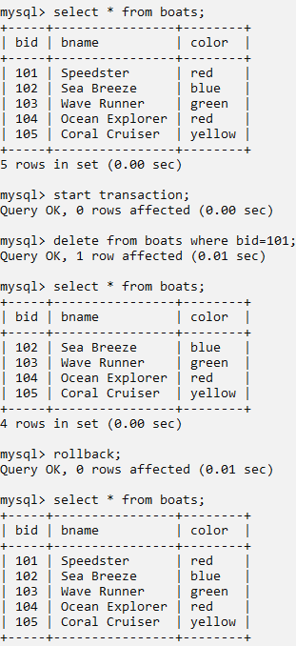

1. Write a query to implement the commit.

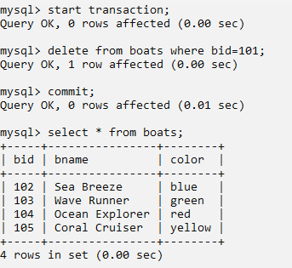

38