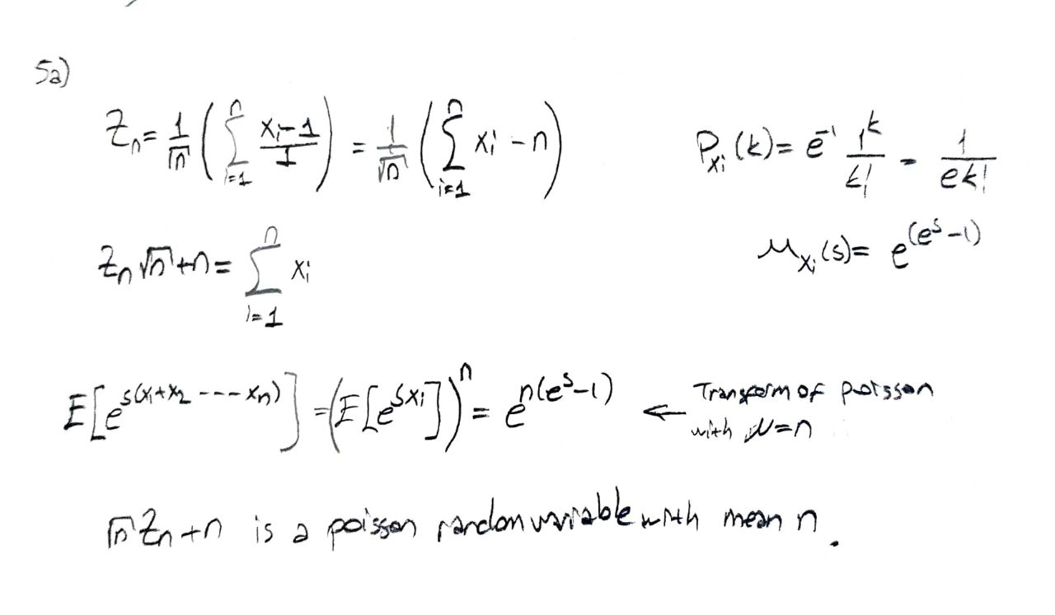
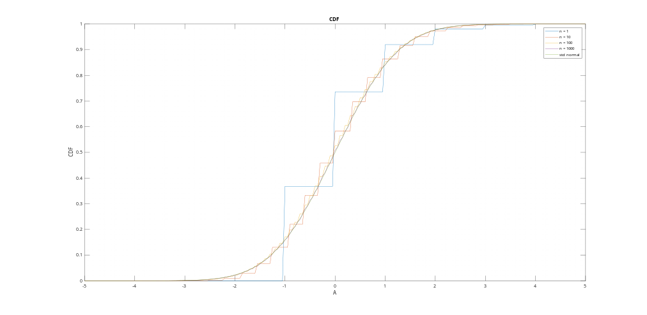Figure 1: CDF of Zn for n = {1, 10, 100, 1000} and standard normal

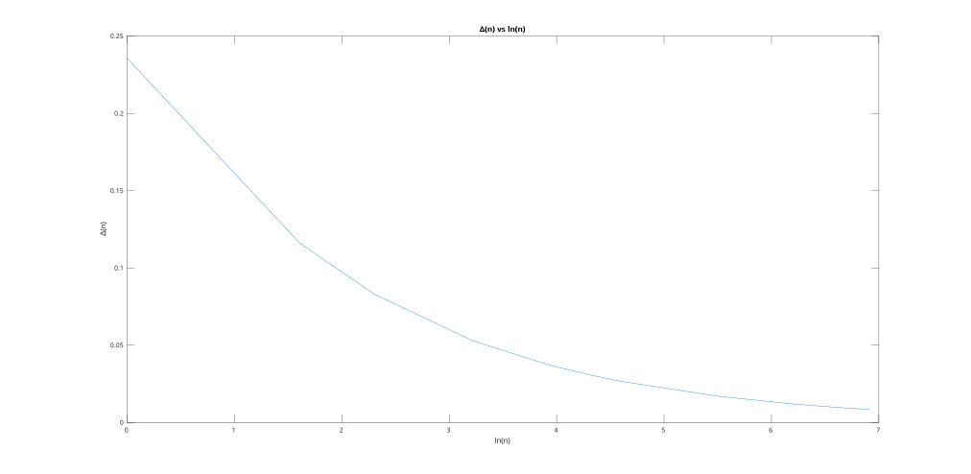Figure 2: Graph of delta(n) vs ln(n)
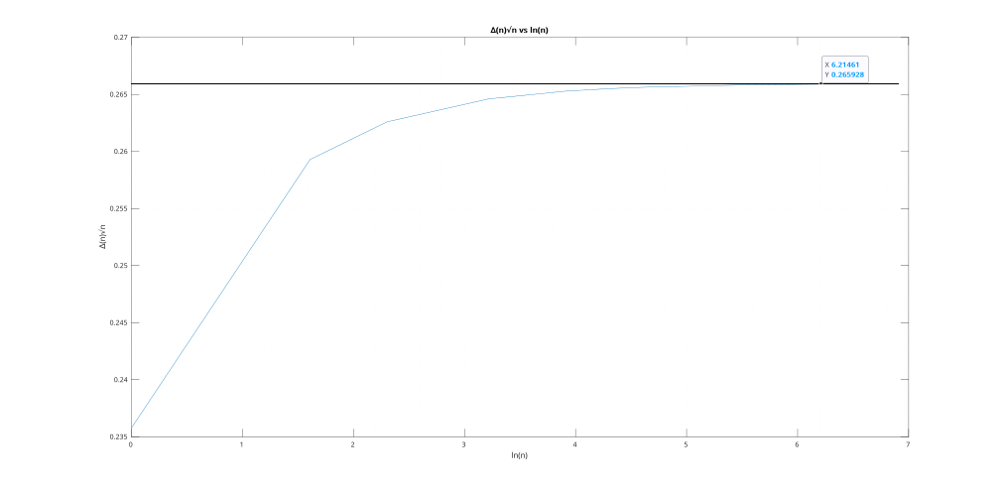Figure 3: Graph of delta(n)*sqrt(n) vs ln(n)
From figure 1, we can see that as n approahes to infinity, cdf of Zn approaches to cdf of standard normal.
From figure 2, we can see that the maximum difference between cdf of Zn and cdf of standard normal for the values of A decreases as n increases.
From figure 3, we can see that one can find a K > 0.27 that satisfies the condition stated in step h for the values of n considered.

