**4)**

The MSE vs ρ curves obtained both theoretically and in simulation are plotted in the figure below.

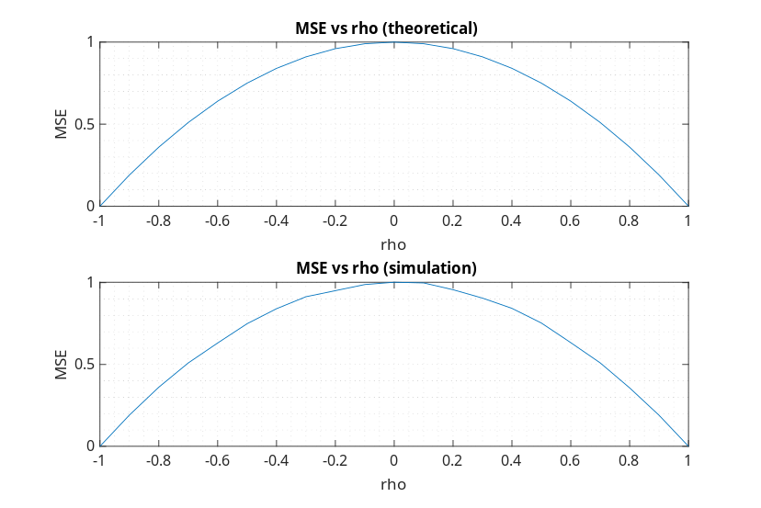Figure 1: The graphs of MSE vs ρ curves (theoretical and in simulation)

We obtained similar graphs for analytical and numerical results. Since we used too many samples (N = 1E5) to calculate MSE numerically, we obtained almost smooth curve. From graph, we can observe that the MSE becomes smaller as ρ becomes greater in magnitude.