Automating CI/CD Pipeline for Spring Boot Application Deployment on AWS
Course-end Project 1
Author: Ieng Lao
Description
To implement a CI/CD pipeline using AWS services for automating the deployment of a Spring Boot application on Amazon ECS with Docker, integrating CodePipeline, CodeBuild and ECR for seamless updates

Real-time scenario: Imagine a retail company that has a Spring Boot-based inventory management system. The system is used by several departments and is hosted in containers to ensure scalability.
The company wants to reduce the manual intervention required to deploy updates by automating the build and deployment process. By setting up a CI/CD pipeline, developers can push updates to a GitHub repository, automatically triggering a sequence of actions that build, containerize, and deploy the application without downtime. This ensures faster and more reliable system updates, minimizing operational delays.

Here's a detailed step-by-step guide:

CI/CD Pipeline for Spring Boot on AWS ECS
Phase 1: Prepare Your Spring Boot App on GitHub
Step 1: Make sure your repo has these files
- Your Spring Boot project (with pom.xml)
- Dockerfile in the root directory
- buildspec.yml in the root directory

Dockerfile:
FROM public.ecr.aws/docker/library/maven:3.9-eclipse-temurin-17 AS build
WORKDIR /app
COPY pom.xml .
COPY src ./src
RUN mvn package -DskipTests

FROM public.ecr.aws/docker/library/eclipse-temurin:17-jre-jammy
WORKDIR /app
COPY --from=build /app/target/*.jar app.jar
EXPOSE 8080
ENTRYPOINT ["java", "-jar", "app.jar"]

buildspec.yml:
version: 0.2

phases:
pre_build:
commands:
- echo Logging in to ECR...
- aws ecr get-login-password --region $AWS_DEFAULT_REGION | docker login --username AWS --password-stdin $AWS_ACCOUNT_ID.dkr.ecr.$AWS_DEFAULT_REGION.amazonaws.com
build:
commands:
- echo Building Docker image...
- docker build -t springboot-app .
- docker tag springboot-app:latest $AWS_ACCOUNT_ID.dkr.ecr.$AWS_DEFAULT_REGION.amazonaws.com/springboot-app:latest
post_build:
commands:
- echo Pushing image to ECR...
- docker push $AWS_ACCOUNT_ID.dkr.ecr.$AWS_DEFAULT_REGION.amazonaws.com/springboot-app:latest
- printf '[{"name":"springboot-container","imageUri":"%s"}]' $AWS_ACCOUNT_ID.dkr.ecr.$AWS_DEFAULT_REGION.amazonaws.com/springboot-app:latest > imagedefinitions.json
artifacts:
files:
- imagedefinitions.json
Phase 2: Create ECR Repository
- Go to AWS Console → ECR → Create Repository
- Set:
  - Visibility: Private
  - Repository name: springboot-app
- Click Create Repository
- Note the URI (you'll need it later)
  - Format: 123456789.dkr.ecr.us-east-1.amazonaws.com/springboot-app

Phase 3: Set Up ECS Cluster
Step 1: Create ECS Cluster
- Go to ECS → Clusters → Create Cluster
- Cluster name: springboot-cluster
- Infrastructure: AWS Fargate (serverless, simpler)
- Click Create

Step 2: Create Task Definition
- Go to ECS → Task Definitions → Create new task definition
- Set:
  - Family name: springboot-task
  - Launch type: Fargate
  - CPU: 0.5 vCPU, Memory: 1 GB (enough for homework)
  - Task role: create or select an ecsTaskExecutionRole
- Under Container:
  - Name: springboot-container (must match CONTAINER_NAME in buildspec.yml)
  - Image URI: paste your ECR URI from Phase 2
  - Port mappings: 8080
- Click Create
Step 3: Create ECS Service
- Go to your cluster → Services → Create
- Set:
  - Launch type: Fargate
  - Task definition: springboot-task
  - Service name: springboot-service
  - Desired tasks: 1
- Networking:
  - Select your VPC and subnets
  - Security group: allow inbound port 8080
  - Auto-assign public IP: Enabled (avoids NAT Gateway cost)
- Click Create

Phase 4: Set Up IAM Roles
Step 1: CodeBuild Role
- Go to IAM → Roles → Create Role
- Trusted entity: CodeBuild
- Attach these policies:
  - AmazonEC2ContainerRegistryPowerUser (ECR push access)
  - AmazonECS_FullAccess
  - CloudWatchLogsFullAccess
- Name it: CodeBuildServiceRole
Step 2: CodePipeline Role
- Create another role, trusted entity: CodePipeline
- Attach:
  - AWSCodePipelineFullAccess
  - AWSCodeBuildAdminAccess
  - AmazonECS_FullAccess
  - AmazonS3FullAccess (for pipeline artifacts)
- Name it: CodePipelineServiceRole

Phase 5: Create CodeBuild Project
- Go to CodeBuild → Build Projects → Create
- Set:
  - Project name: springboot-build
  - Source: GitHub → connect your account → select your repo
  - Environment:
    - Managed image: Amazon Linux 2
    - Runtime: Standard
    - Image: aws/codebuild/amazonlinux2-x86_64-standard:5.0
    - Privileged: ✅ Enable (required for Docker builds)
  - Service role: CodeBuildServiceRole
- Under Environment Variables add:
  - AWS_ACCOUNT_ID = your 12-digit account ID
  - AWS_DEFAULT_REGION = e.g. us-east-1
- Buildspec: Use buildspec.yml from repo
- Artifacts: No artifacts (CodePipeline handles this)
- Click Create

Phase 6: Create CodePipeline
- Go to CodePipeline → Pipelines → Create Pipeline
- Pipeline settings:
  - Name: springboot-pipeline
  - Service role: CodePipelineServiceRole
  - Artifact store: Default location (S3)
- Source Stage:
  - Source provider: GitHub (Version 2)
  - Click Connect to GitHub → authorize → select your repo
  - Branch: main
  - Detection: GitHub webhooks (auto-triggers on push)
- Build Stage:
  - Build provider: AWS CodeBuild
  - Project name: springboot-build
- Deploy Stage:
  - Deploy provider: Amazon ECS
  - Cluster name: springboot-cluster
  - Service name: springboot-service
  - Image definitions file: imagedefinitions.json
- Click Create Pipeline
  - It will automatically run for the first time

Phase 7: Test the Pipeline
Step 1: Watch the pipeline run
- Go to CodePipeline → springboot-pipeline
- Watch Source → Build → Deploy stages turn green
Step 2: Verify deployment
- Go to ECS → Clusters → springboot-cluster → Services
- Click springboot-service → Tasks
- Click the running task → find the Public IP
- Open browser: http://<public-ip>:8080
Step 3: Test the CI/CD trigger
- Make a small change in your GitHub repo (e.g., edit a controller)
- Push to main
- Watch CodePipeline automatically trigger and redeploy
Phase 8: Cleanup (After You're Done!)
In this order:
- ECS → Service → update desired count to 0, then delete service
- ECS → Delete cluster
- CodePipeline → Delete pipeline
- CodeBuild → Delete project
- ECR → Delete repository (delete images first)
- S3 → Delete the pipeline artifacts bucket
- IAM → Delete the two roles you created
- VPC → Delete if you created a new one

Screenshots to Take Now (Before Cleanup)

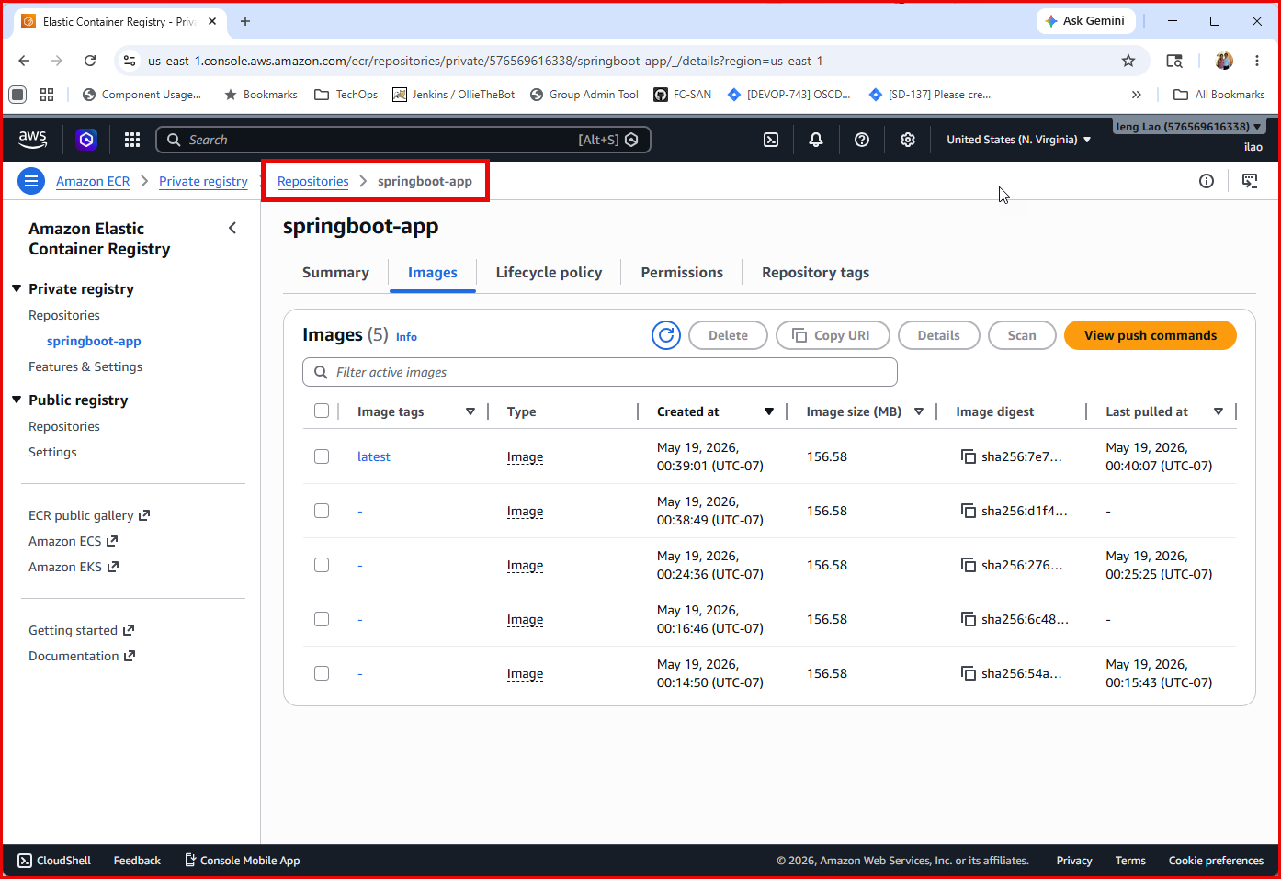

CodeBuild
- Build project overview
- Latest build history showing all phases green

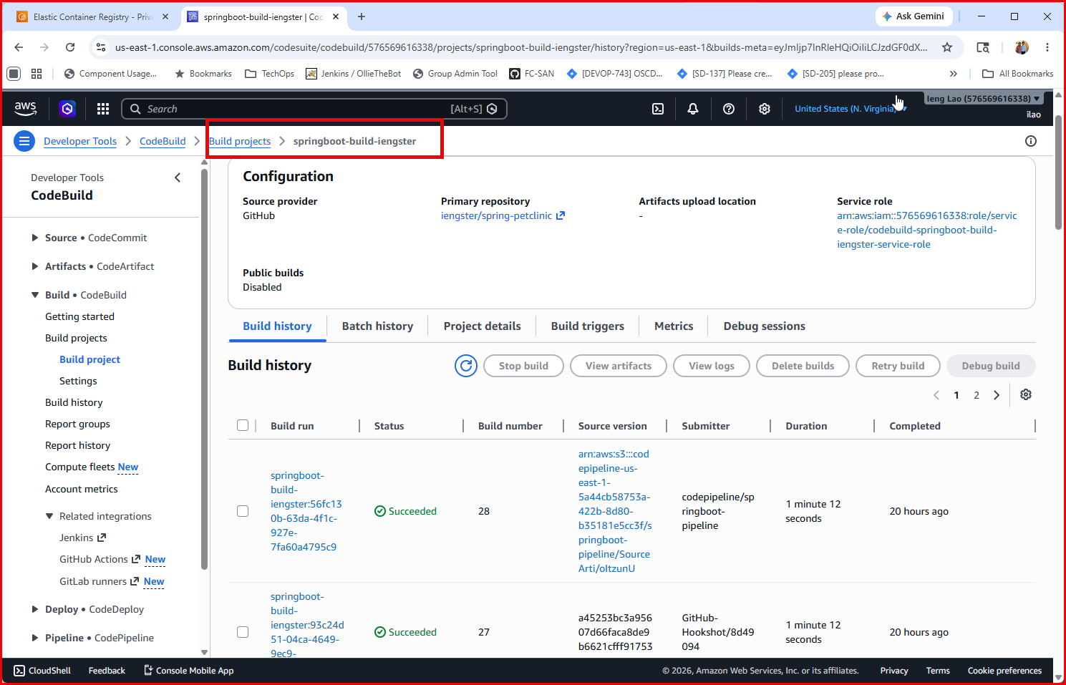

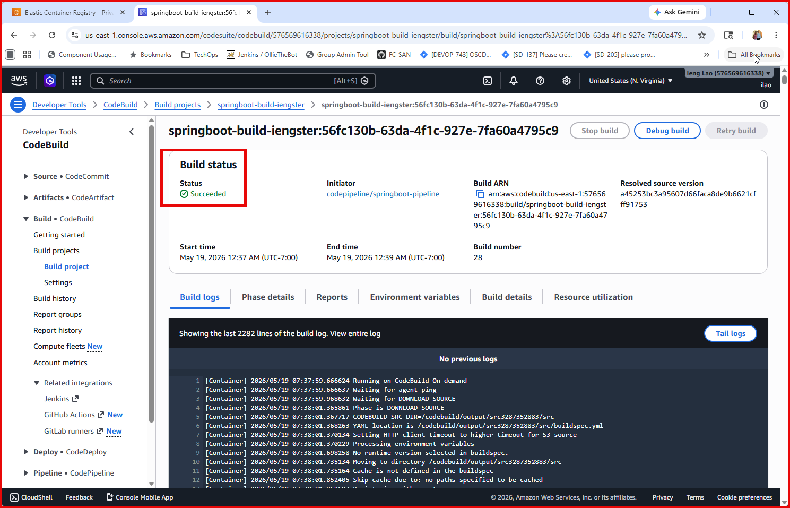
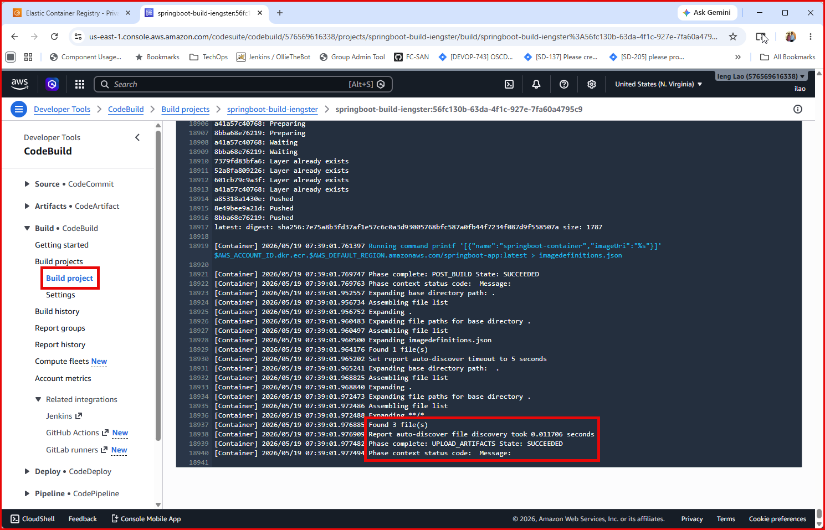

CodePipeline
- Pipeline view showing Source → Build → Deploy all green
- The auto-triggered run from your test push

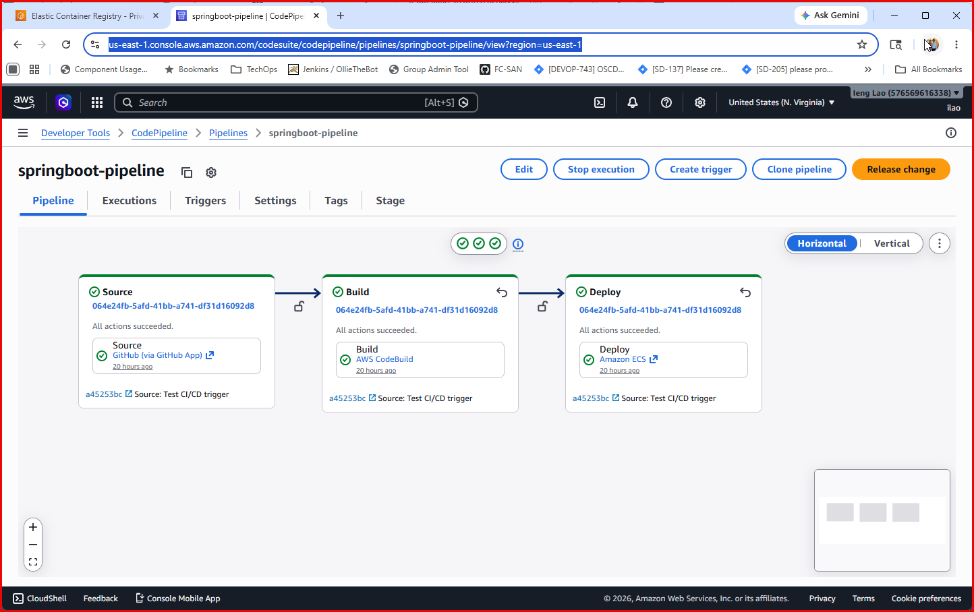
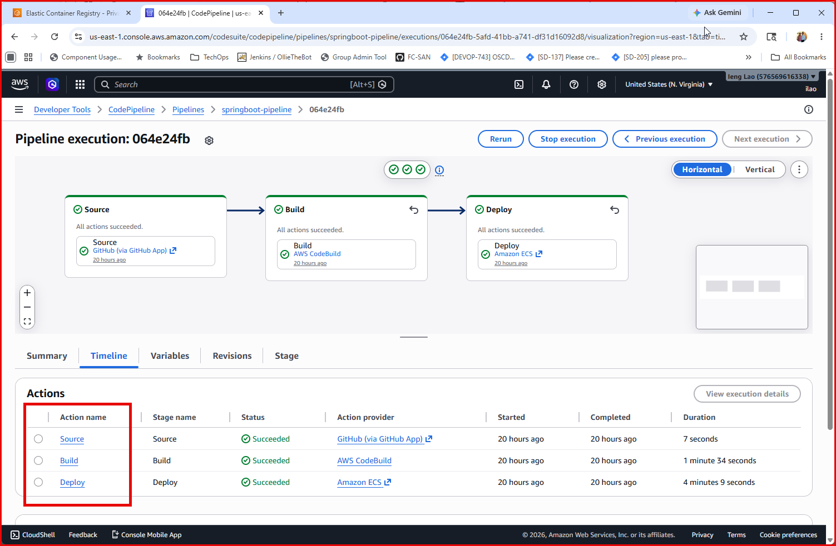

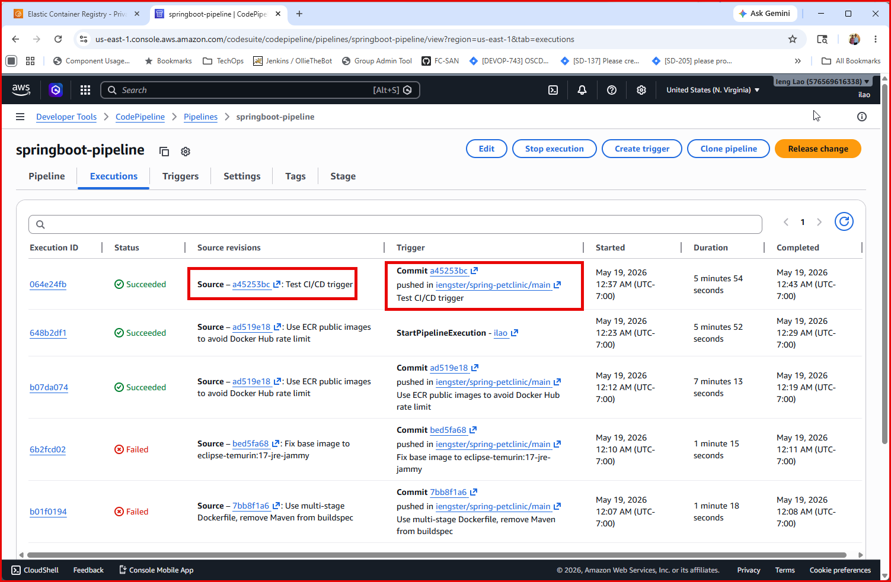
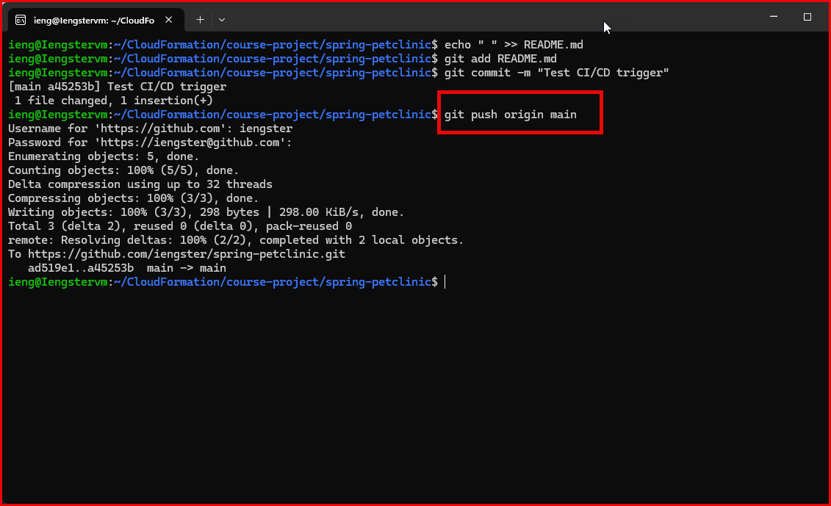

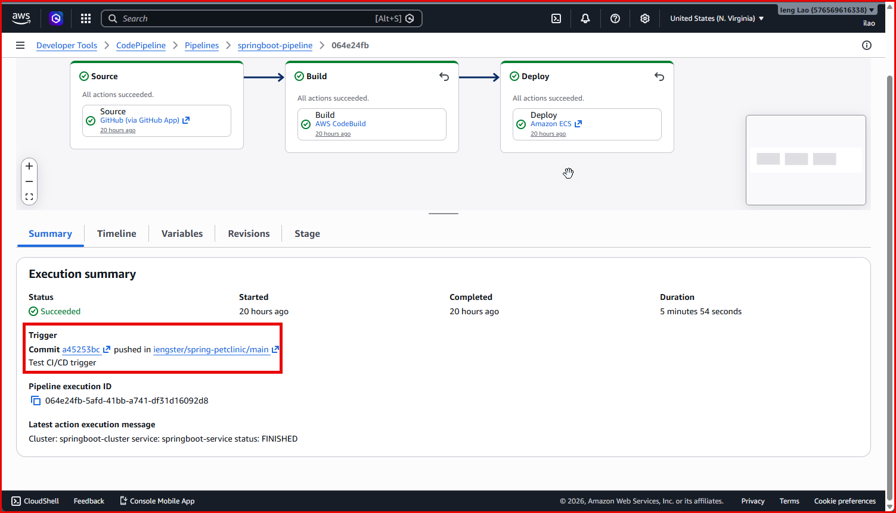

ECS
- Cluster overview
- Running service and task
- Task details showing public IP

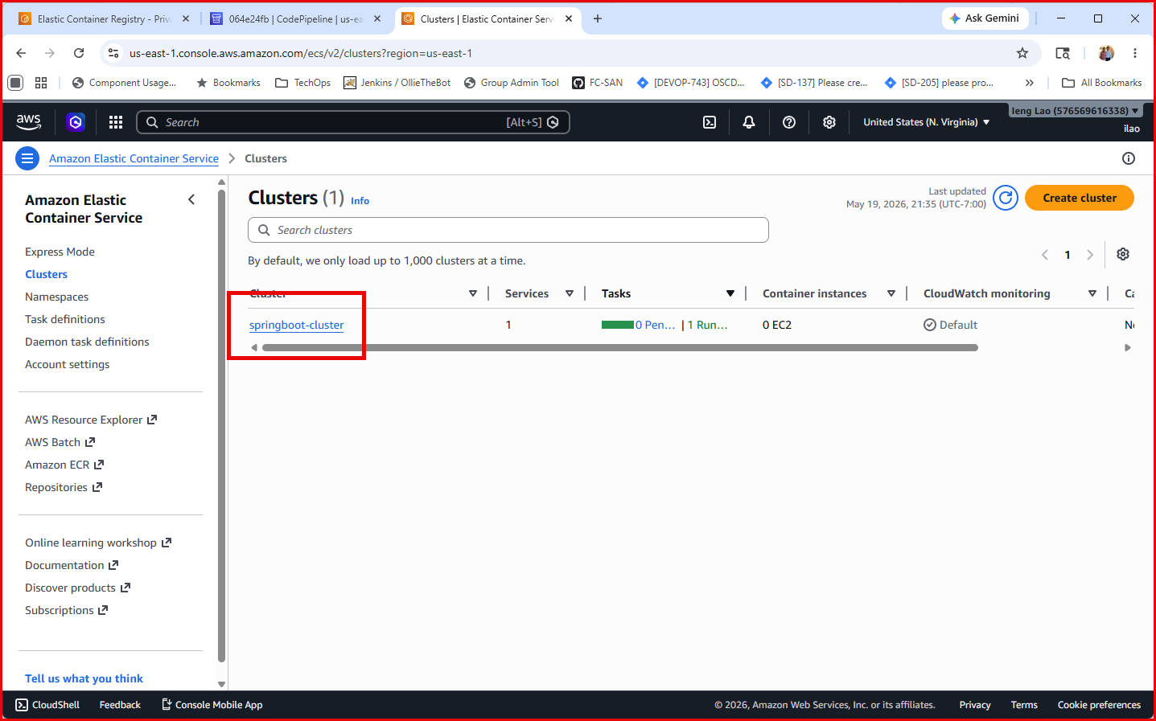

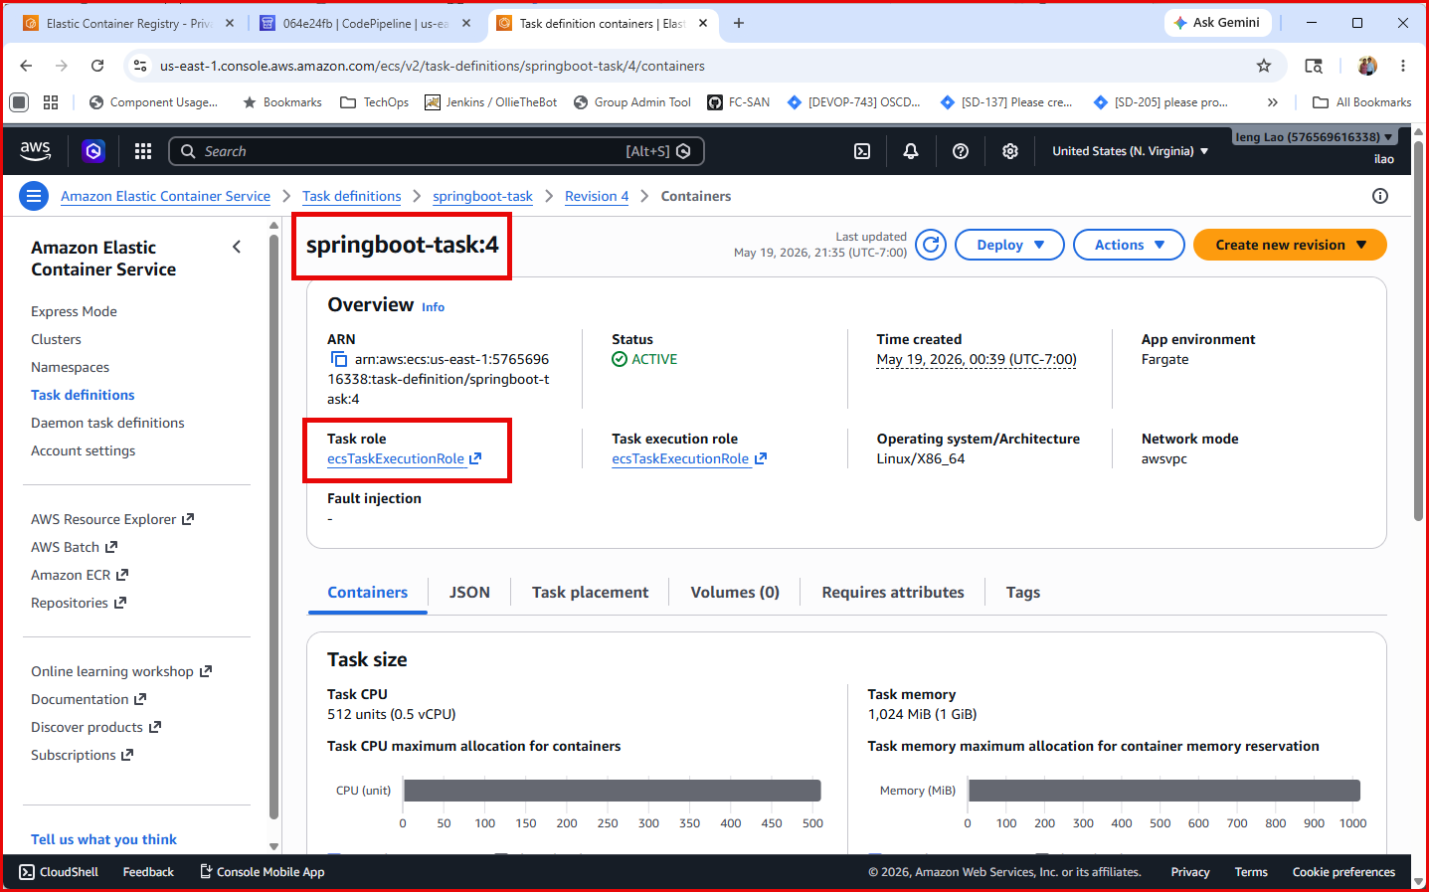

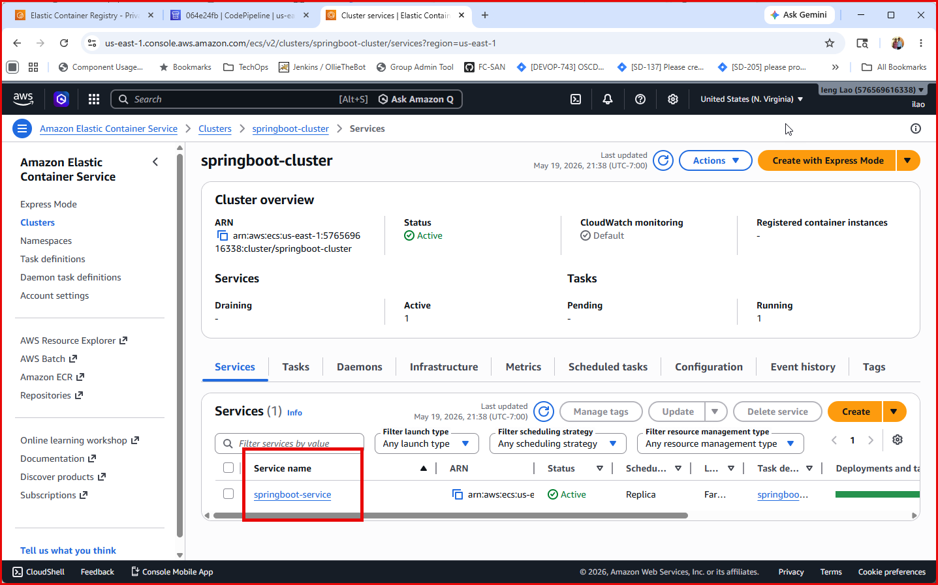

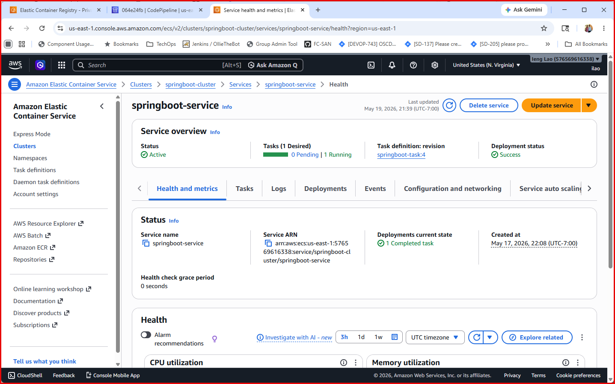
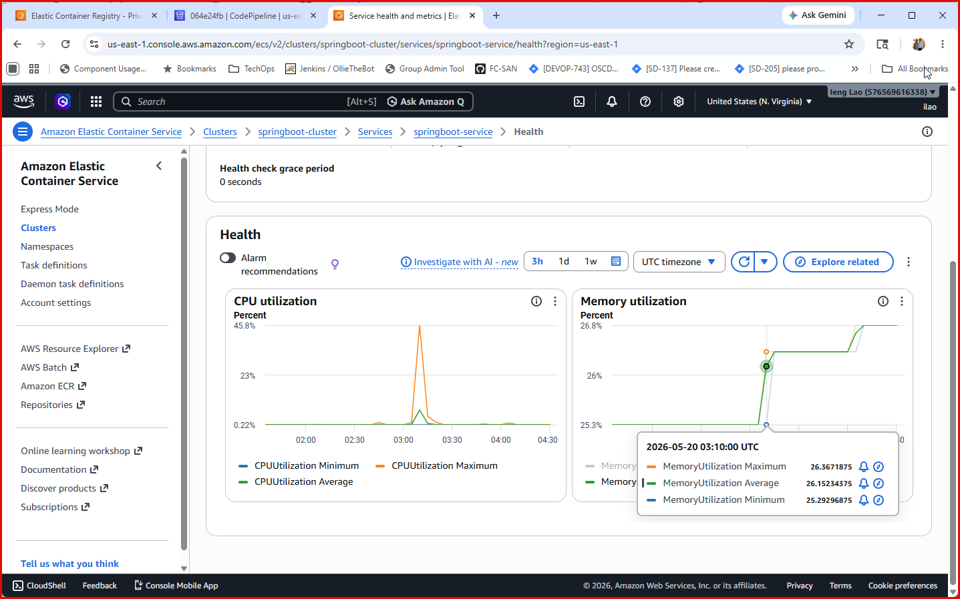

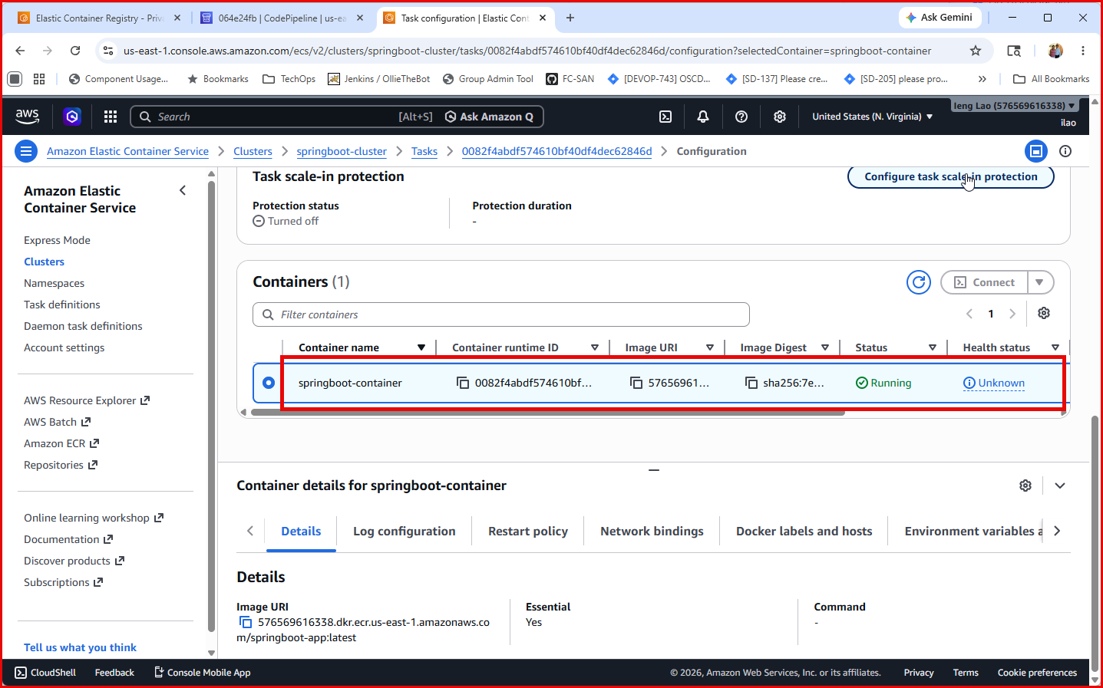

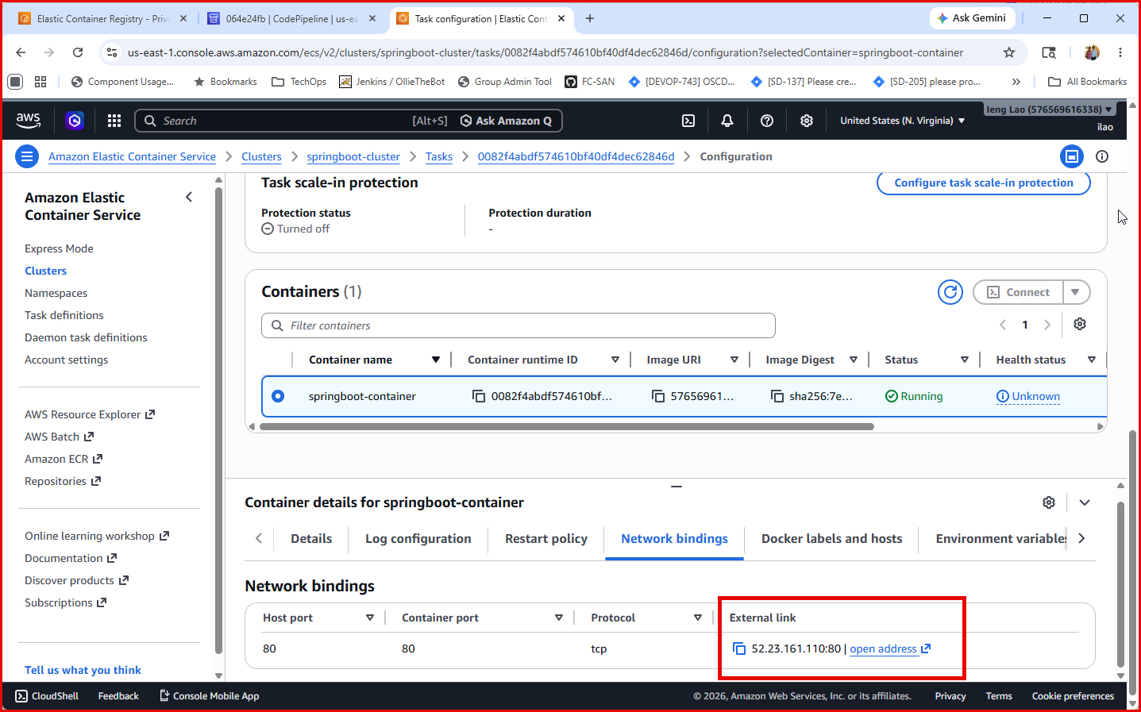

App Running
- Browser showing Spring Petclinic at http://<PUBLIC_IP>:8080

