Author: Ieng Lao
CI/CD Pipeline Implementation for a Software on AWS EC2
Course-end Project 1
Description
To build a CI/CD pipeline with Jenkins for deploying a pet clinic's software on AWS EC2

Real-time scenario:
Dr. Shawn runs a pet clinic. He needs to record the visits and other details associated with the pets and their owners visiting his clinic. He has software developed by Bella Solutions to manage it.
Bella Solutions aims to host the software solution for Dr. Shawn on an AWS EC2 instance to have online access from anywhere by building a CI/CD pipeline on AWS EC2.
This assignment is designed to help you understand how to plan and develop the back end of a given problem, gain hands-on experience building the CI/CD pipeline using Jenkins, and containerize the application on the AWS cloud platform.

Industry Relevance:
The tools used in this project each serve specific purposes within the industry:
- Jenkins: It is a leading automation tool for CI/CD, streamlining the build, test, and deployment process in DevOps workflows. It is widely adopted across industries due to its extensibility through plugins and robust community support.
- Git: It is the industry standard for version control, enabling efficient collaboration, code tracking, and integration in CI/CD pipelines. Its versatility and open-source nature make it essential for modern software development.
- AWS and EC2 : AWS is one of the most popular cloud platforms for managing different applications and projects of any scale. EC2 is one of the simplest ways to get an application deployed.

Below are the outlines of what I have done:
🖥️ Phase 1 — EC2 & Jenkins Setup
- ✅ Launched AWS EC2 instance (ubuntu@ip-172-31-33-244)
- ✅ Reinstalled Jenkins on Ubuntu EC2
- ✅ Fixed GPG key issue for Jenkins apt repository
- ✅ Configured EC2 Security Group to open ports:
  - Port 8080 — Jenkins
  - Port 9090 — Application
- ✅ Installed required tools:
  - Java (OpenJDK 17)
  - Jenkins
  - Maven
  - Ansible
  - Docker
  - AWS CLI
📦 Phase 2 — Java Maven Application
- ✅ Created Pet_Clinic_App from scratch
- ✅ Project structure:
Pet_Clinic_App/
├── pom.xml
├── Dockerfile
├── deploy.sh
└── src/
├── main/
│ ├── java/com/petclinic/
│ │ └── WelcomeServlet.java
│ └── webapp/
│ ├── WEB-INF/
│ │ └── web.xml
│ └── index.jsp
└── test/
└── java/com/petclinic/
└── WelcomeServletTest.java
- ✅ Built Java Servlet (WelcomeServlet.java)
- ✅ Created JSP welcome page (index.jsp)
- ✅ Configured web.xml
- ✅ Written unit tests (WelcomeServletTest.java)
  - testGetMessage() ✅
  - testMessageNotEmpty() ✅

🔨 Phase 3 — Maven Build & Goals
Successfully ran all Maven goals:
bash
mvn clean # ✅ Deleted target folder
mvn compile # ✅ Compiled source code
mvn test # ✅ Tests run: 2, Failures: 0
mvn package # ✅ Built WAR file
mvn install # ✅ Installed to local repo
mvn deploy # ⏭️ Skipped (requires remote repo)
- ✅ Created deploy.sh script for Docker build and deploy
- ✅ Added deploy Maven profile to pom.xml
- ✅ mvn install -P deploy runs full build and deploymen

🐳 Phase 4 — Docker
- ✅ Created Dockerfile:
dockerfile
FROM tomcat:8
RUN rm -rf /usr/local/tomcat/webapps/ROOT
COPY target/Pet_Clinic_App.war /usr/local/tomcat/webapps/ROOT.war
EXPOSE 8080
CMD ["catalina.sh", "run"]
- ✅ Built Docker image (mavenbuild)
- ✅ Ran Docker container (dockercontainer)
- ✅ Fixed Docker permission issue:

bash
sudo usermod -aG docker jenkins
sudo systemctl restart jenkins
```
- ✅ App running on port 9090

---

### 🐙 Phase 5 — GitHub Integration
- ✅ Created GitHub repository (`iengster/Pet_Clinic_App`)
- ✅ Pushed code to GitHub
- ✅ Configured GitHub webhook:
- URL: `http://54.81.99.135:8080/ghprbhook/`
- Events: Pull requests + Pushes
- ✅ Created multiple PR branches following naming convention:
```
usr/ienglao/JIRA-XXXX-School-Project

⚙️ Phase 6 — Jenkins CI/CD Pipeline
- ✅ Installed GitHub Pull Request Builder plugin
- ✅ Configured Jenkins Freestyle job (Pet_Clinic_App)
- ✅ Fixed webhook URL (/ghprbhook/ not /github-webhook/)
- ✅ Configured Merge before build:
  - Checks out PR branch
  - Merges into main
  - Builds merged code
- ✅ Build triggers working:
  - Open PR → Jenkins triggered automatically
  - Merge before build → tests merged code
  - Reports status back to GitHub PR
- ✅ Jenkins Execute Shell runs:

mvn clean install
mvn install -P deploy
```

---

🚀 Phase 7 — Full Pipeline Working
```
Developer pushes code to branch
↓
Opens Pull Request on GitHub
↓
GitHub webhook → Jenkins triggered
↓
Jenkins checks out PR branch
↓
Merges PR into main branch
↓
mvn clean install
Tests run: 2, Failures: 0 ✅
↓
WAR file built ✅
↓
deploy.sh executes:
- Docker stop/rm old container
- Docker build new image
- Docker run new container
↓
App live at http://54.81.99.135:9090 ✅
↓
"Welcome To Pet_Clinic_App" 🎉

🔧 Issues Fixed Along the Way
Issue | Fix
Jenkins GPG key error | Imported key by ID from keyserver
Port 8080 conflict | Used port 9090 for app
File corruption (cat EOF) | Used nano to create files
web.xml parse error | Fixed duplicate servlet mapping
Docker permission denied | Added jenkins to docker group
Webhook not triggering | Changed to /ghprbhook/ URL
Branch specifier wrong | Changed to ${ghprbActualCommit}
Deploy profile not found | Added profile to pom.xml

Phase I - Screen Shots
Created EC2 instance
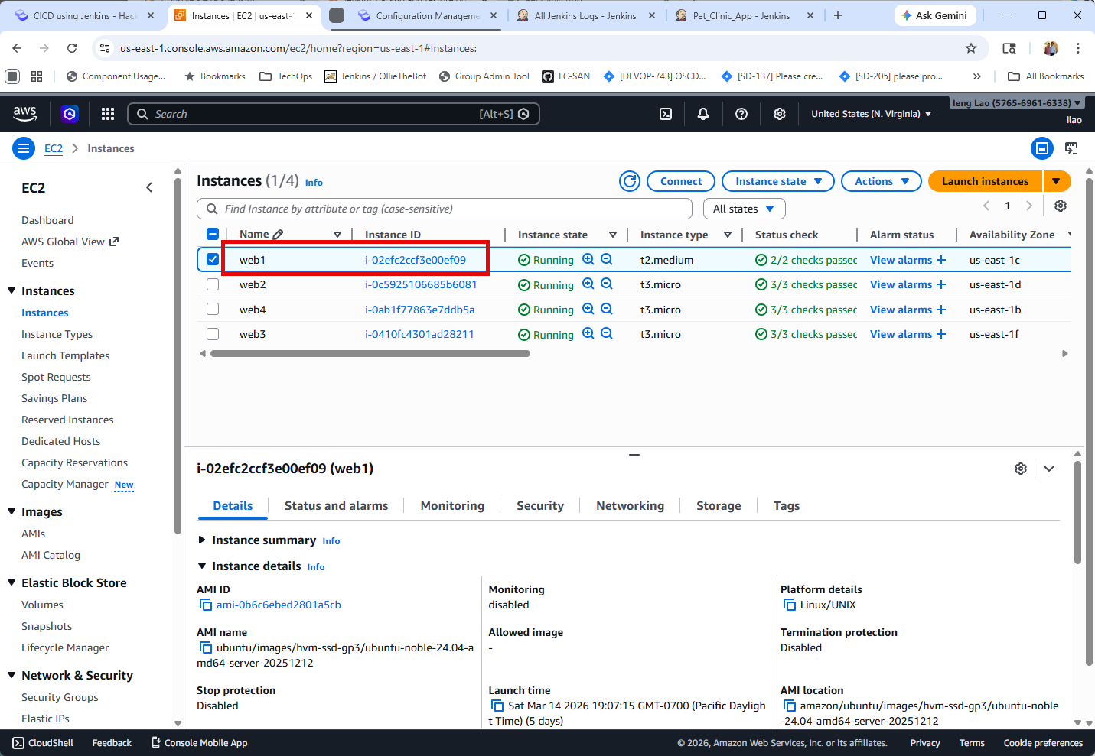

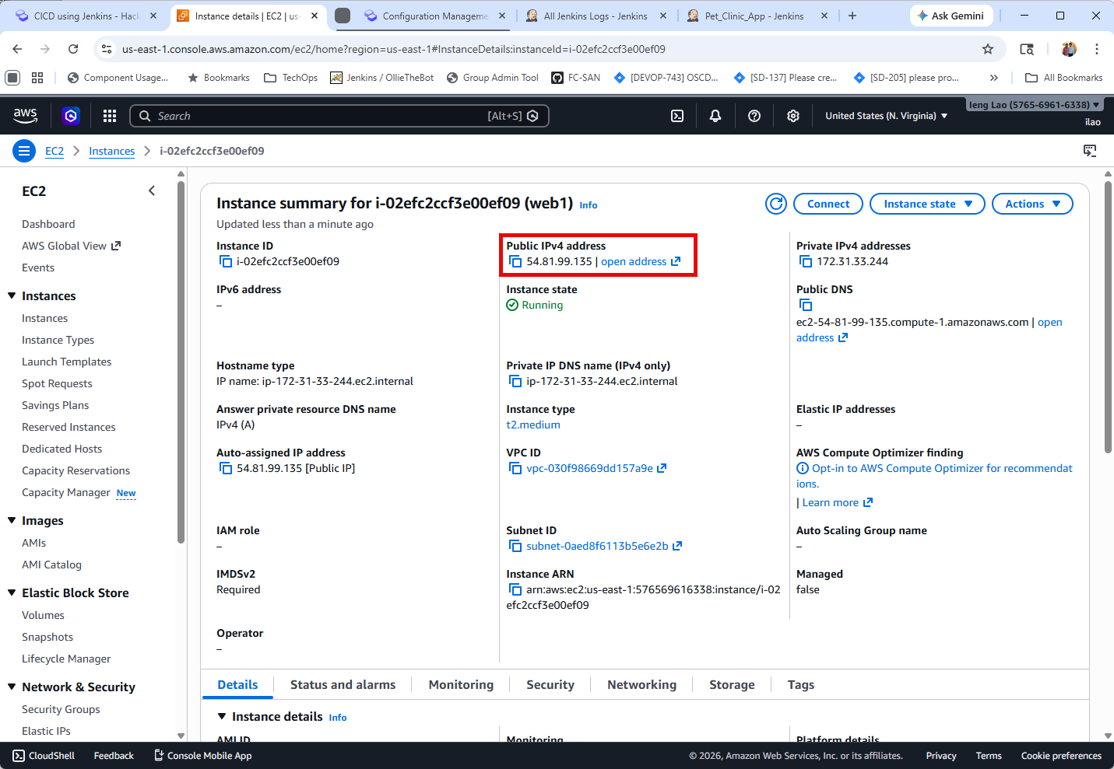
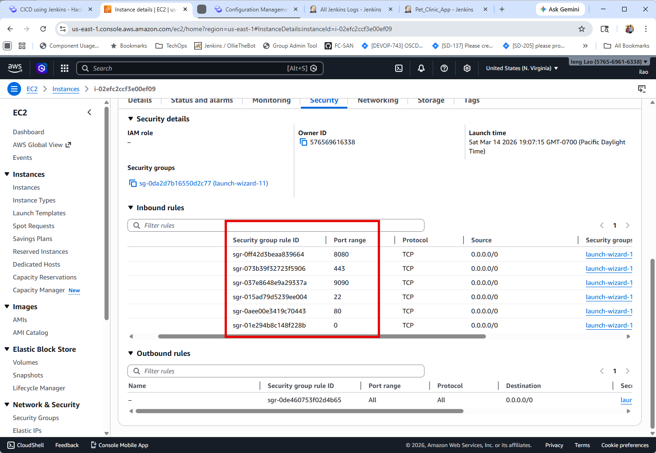

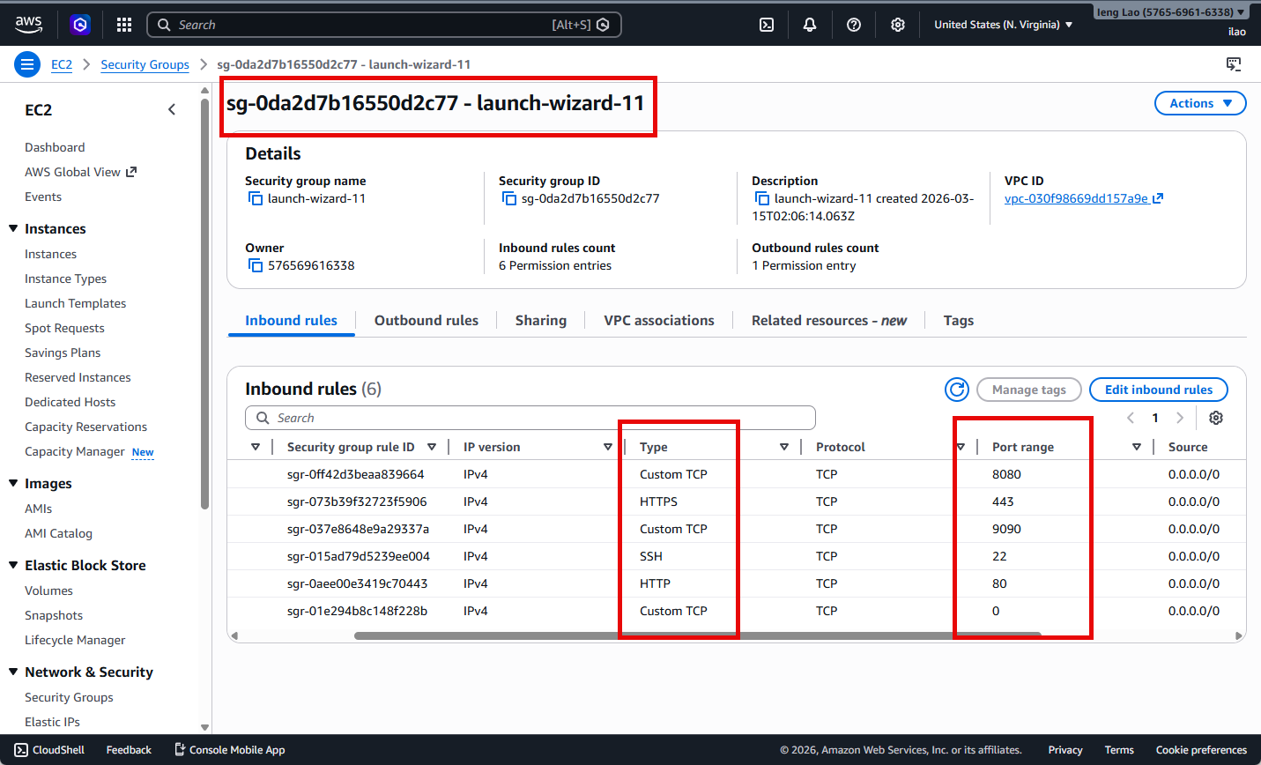
✅ Installed required tools:
Java (OpenJDK 17)
Jenkins
Maven
Ansible
Docker

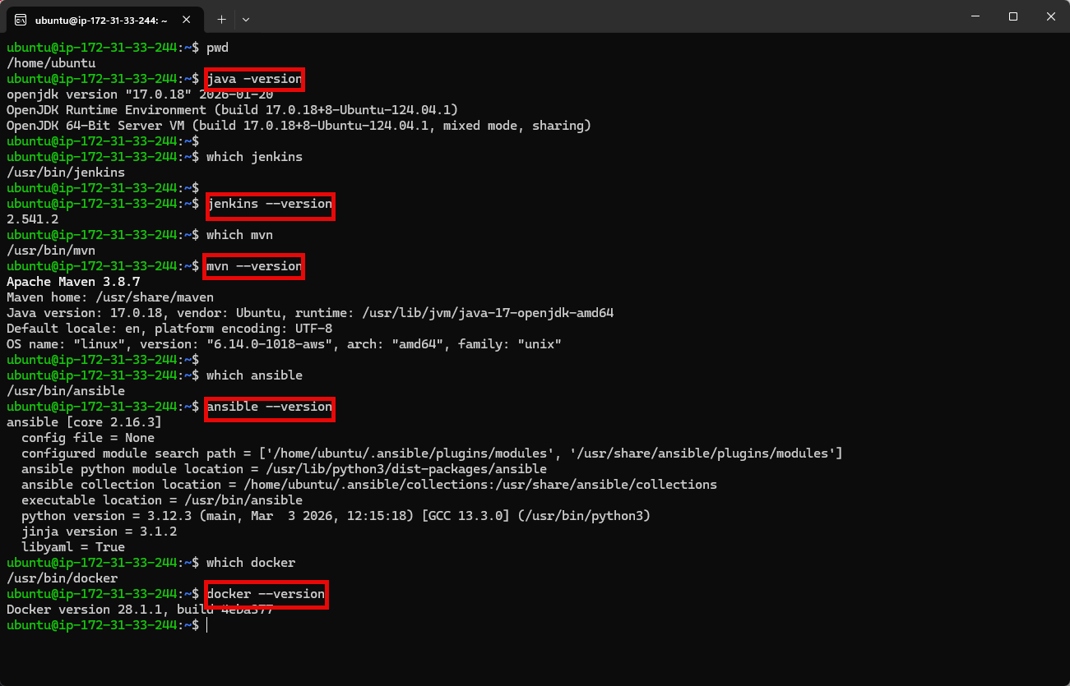

Jenkins main portal:
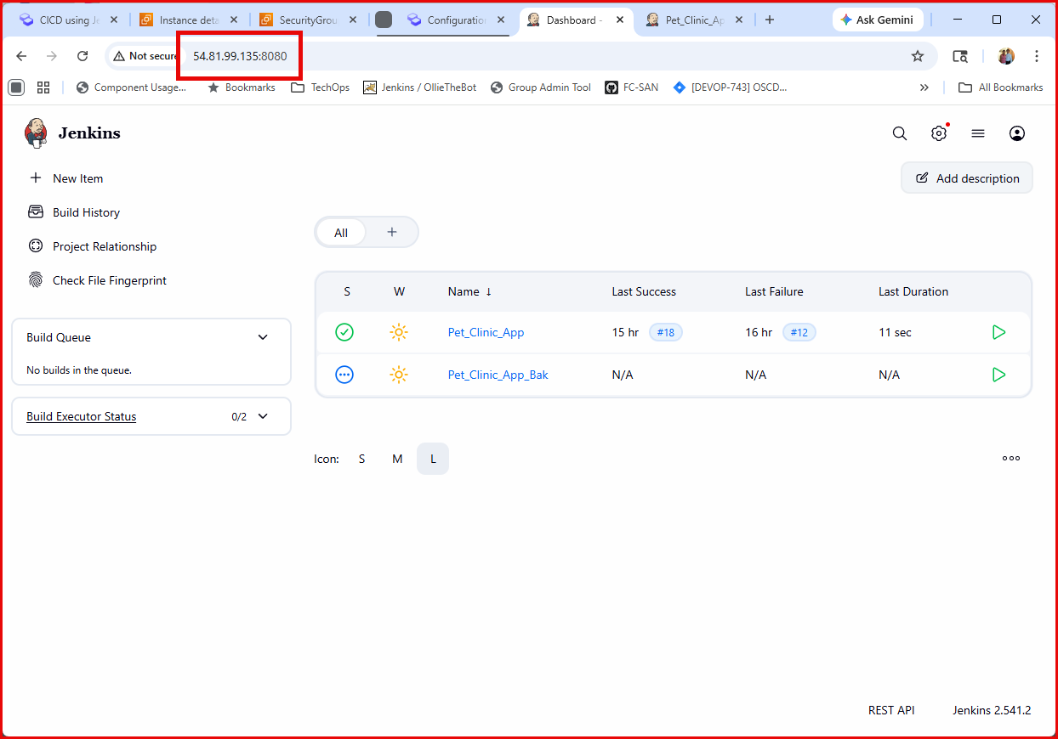

Pull Request Plugin: Github Pull Request Builder
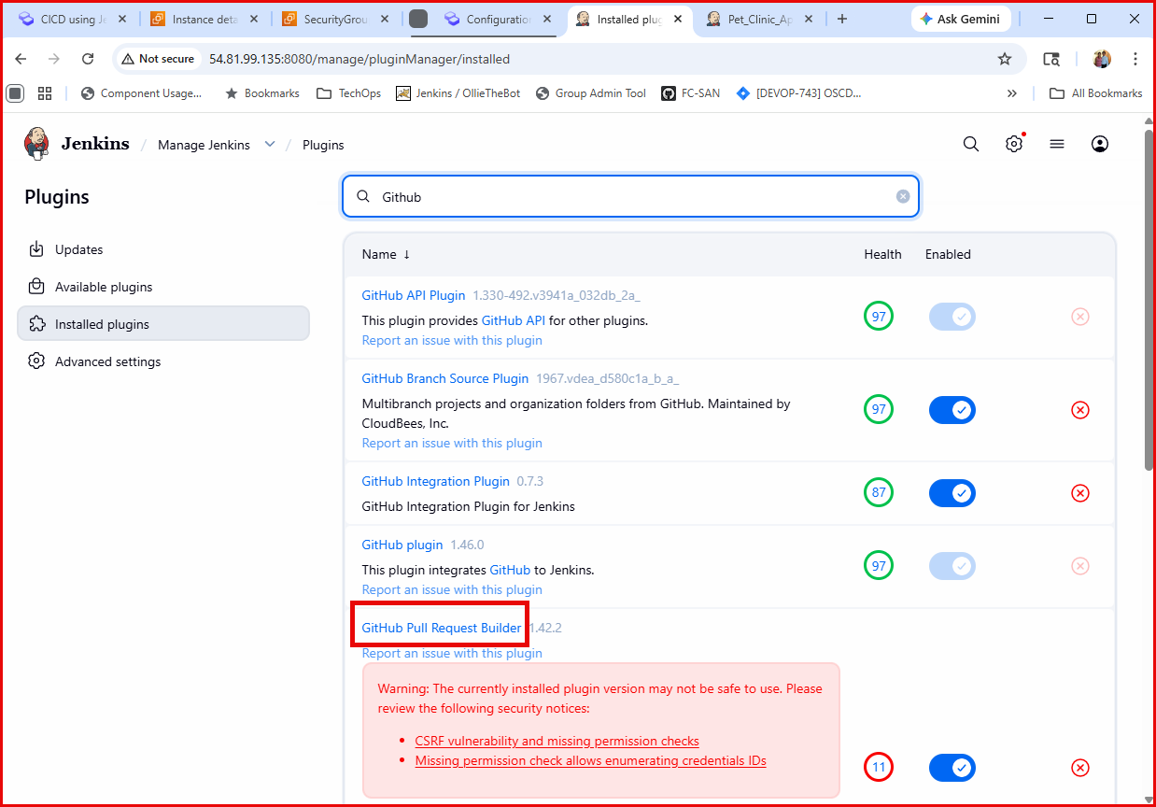

Phanse 2 – Screen Shots
Github URL: https://github.com/iengster/Pet_Clinic_App.git
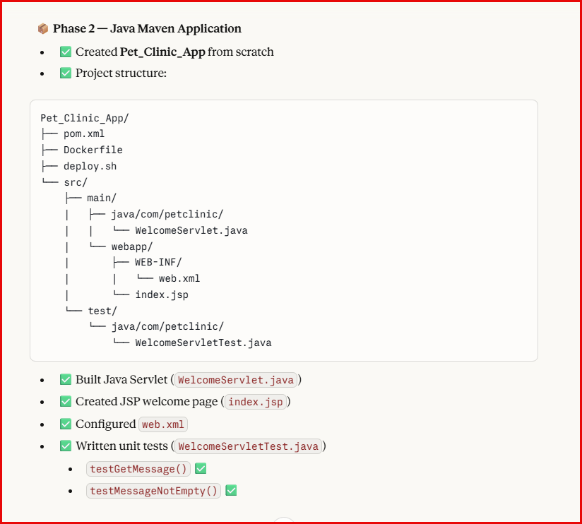

Phanse 3 – Screen Shots
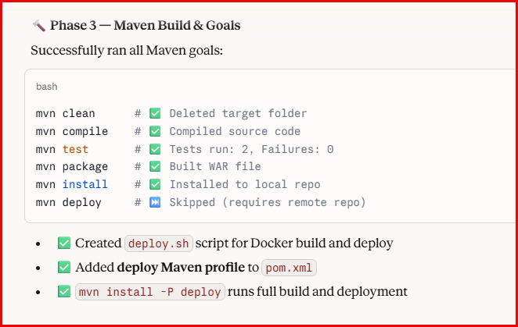

Phanse 4 – Screen Shots
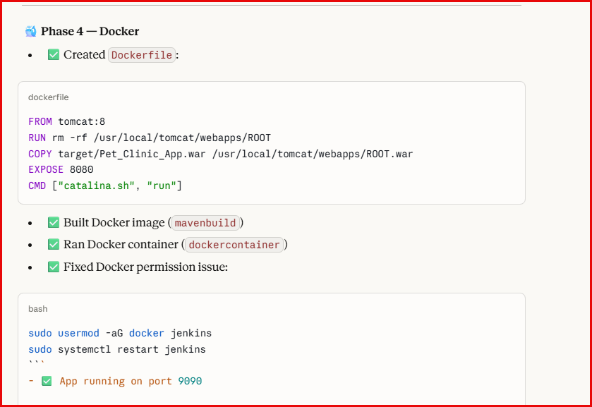
Phanse 5 – Screen Shots
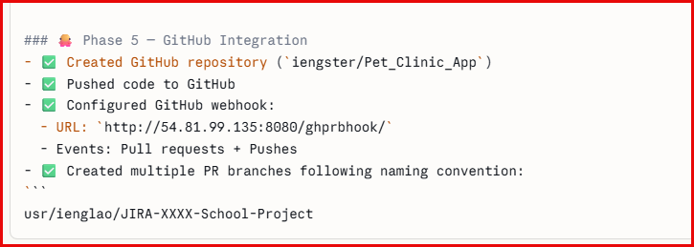

Configuring Webhook
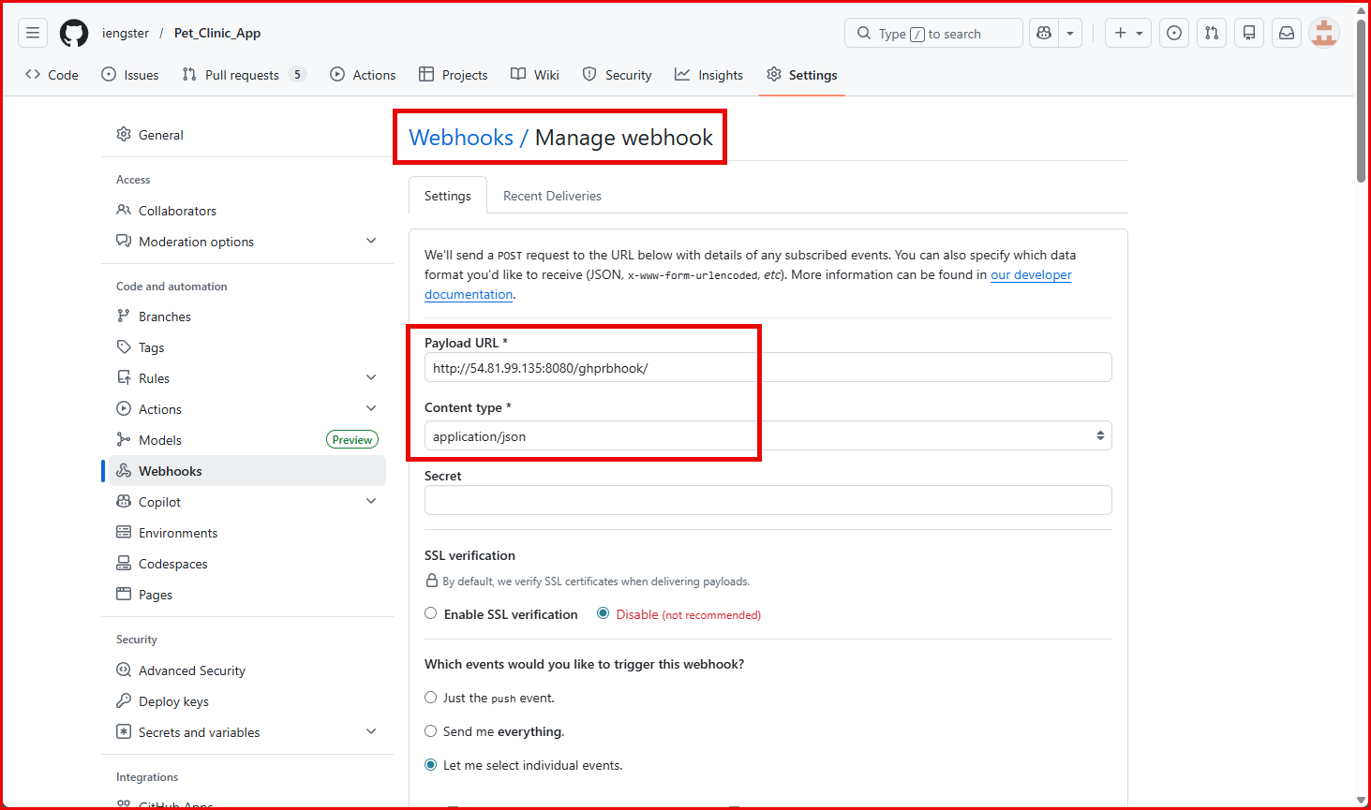

Select the desired events.
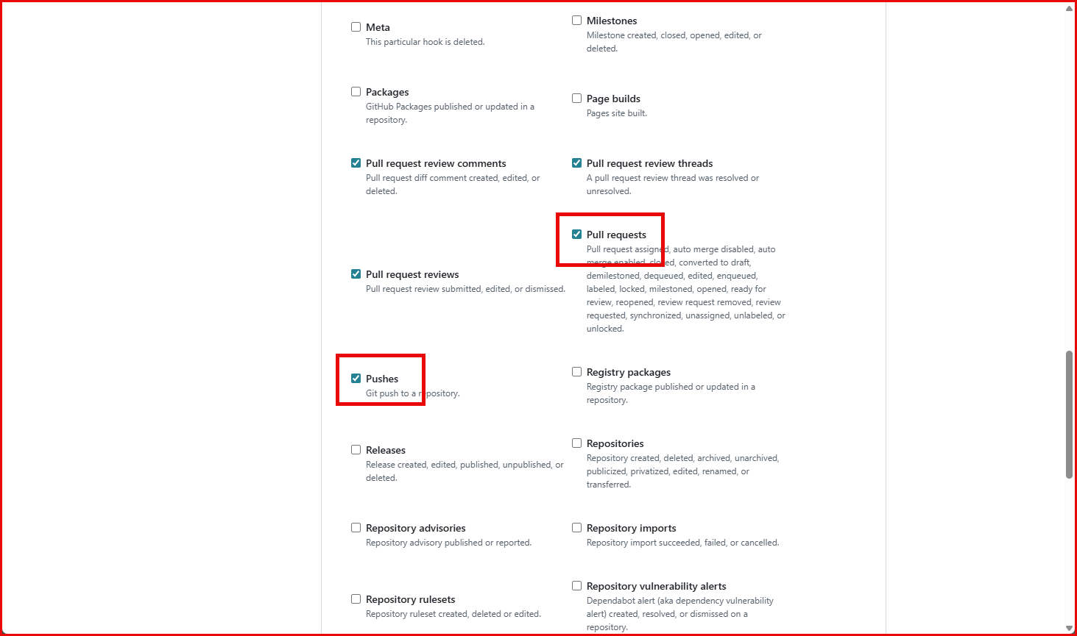

Recent Deliveries
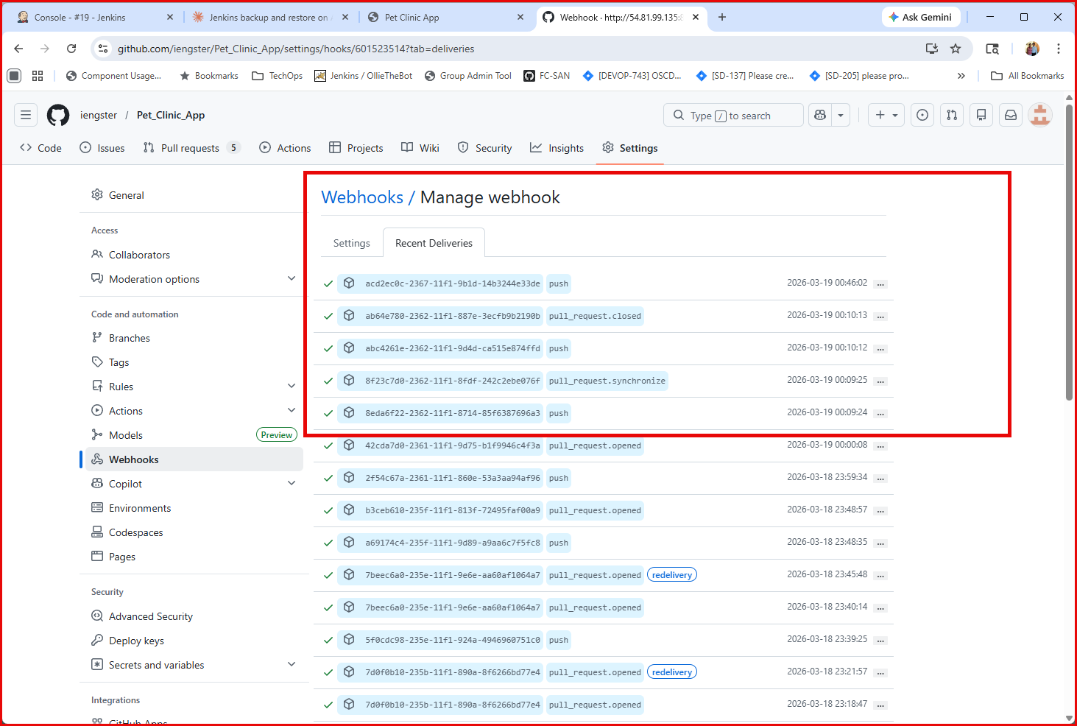

Phase 6 – Screen Shots
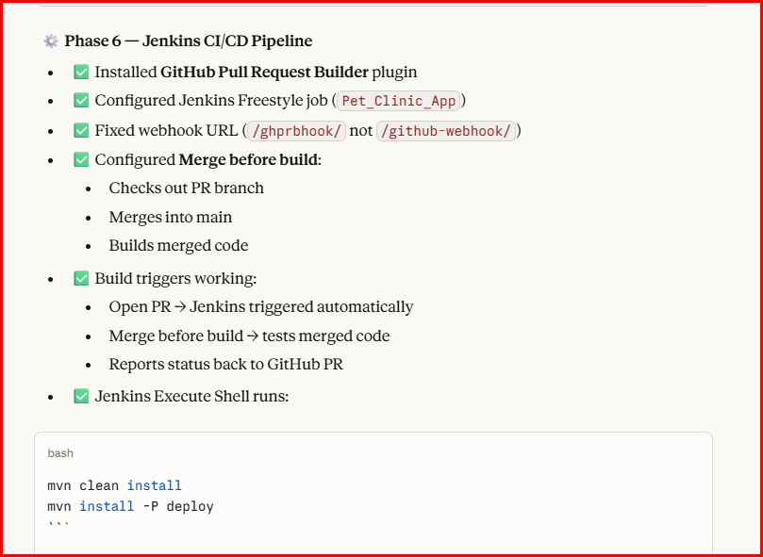

Configuring Jenkins Job:
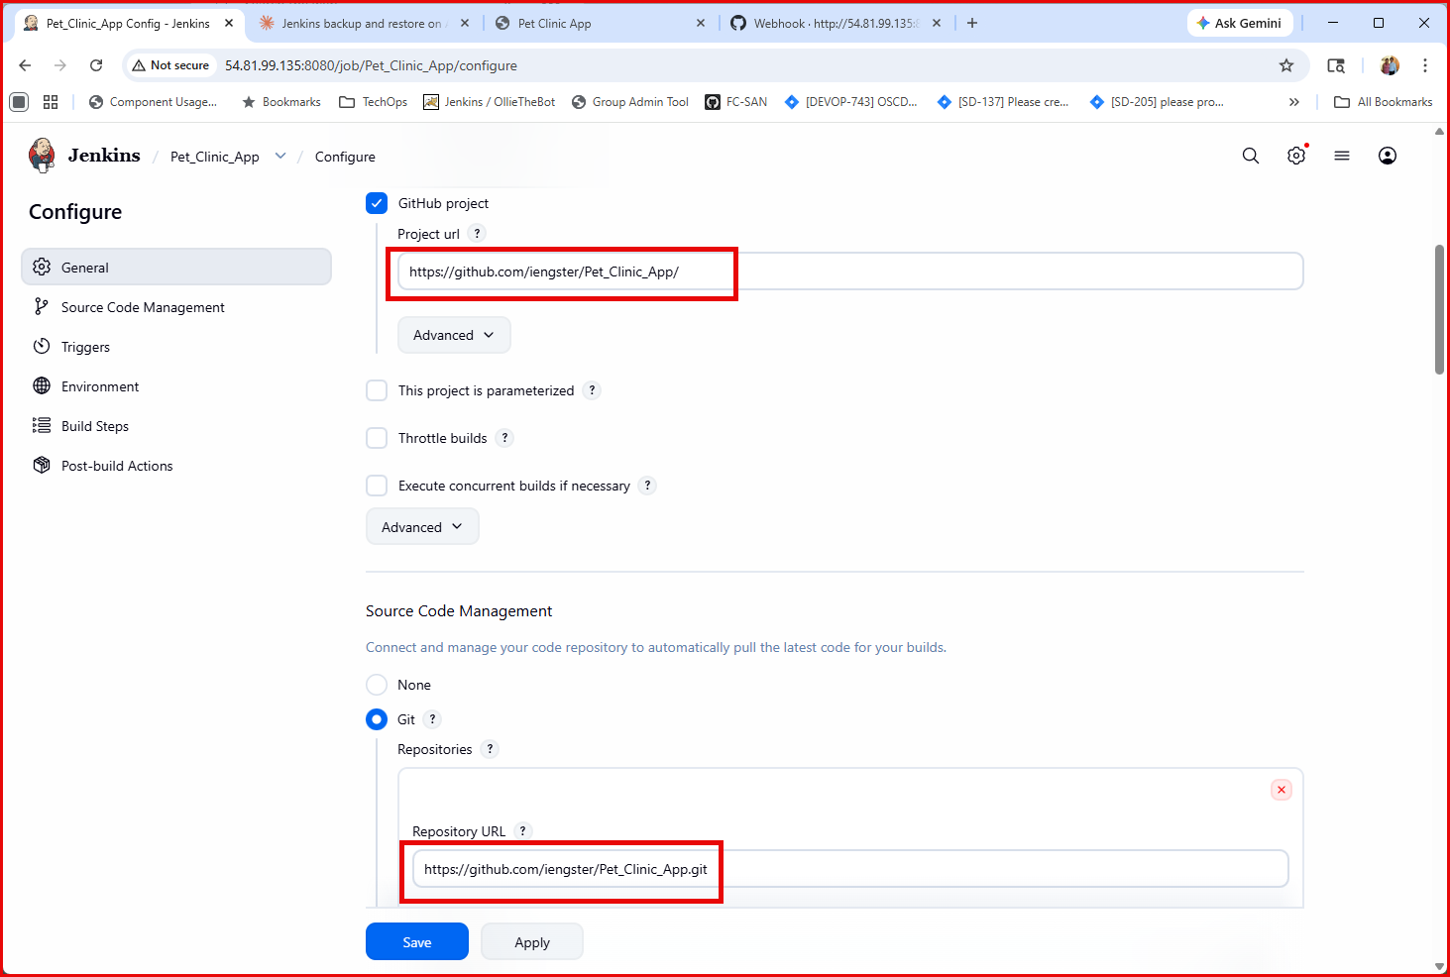

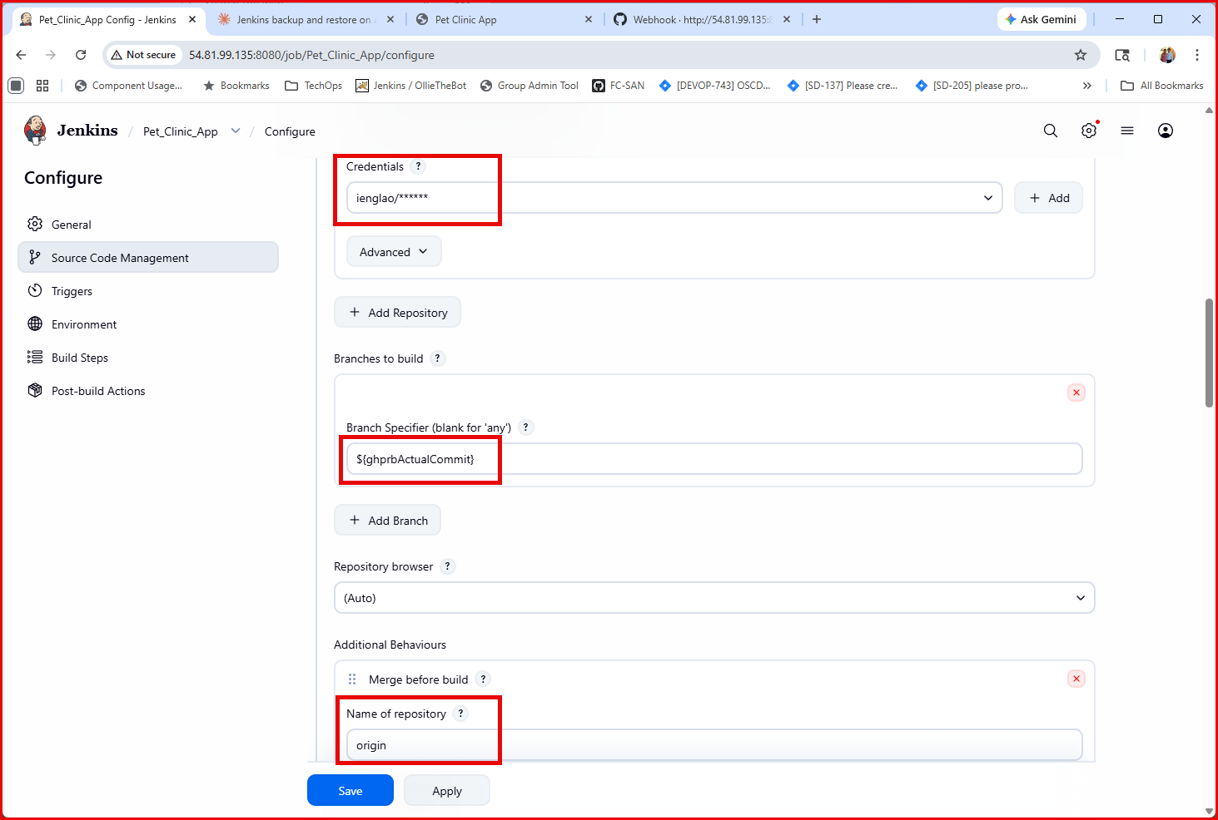
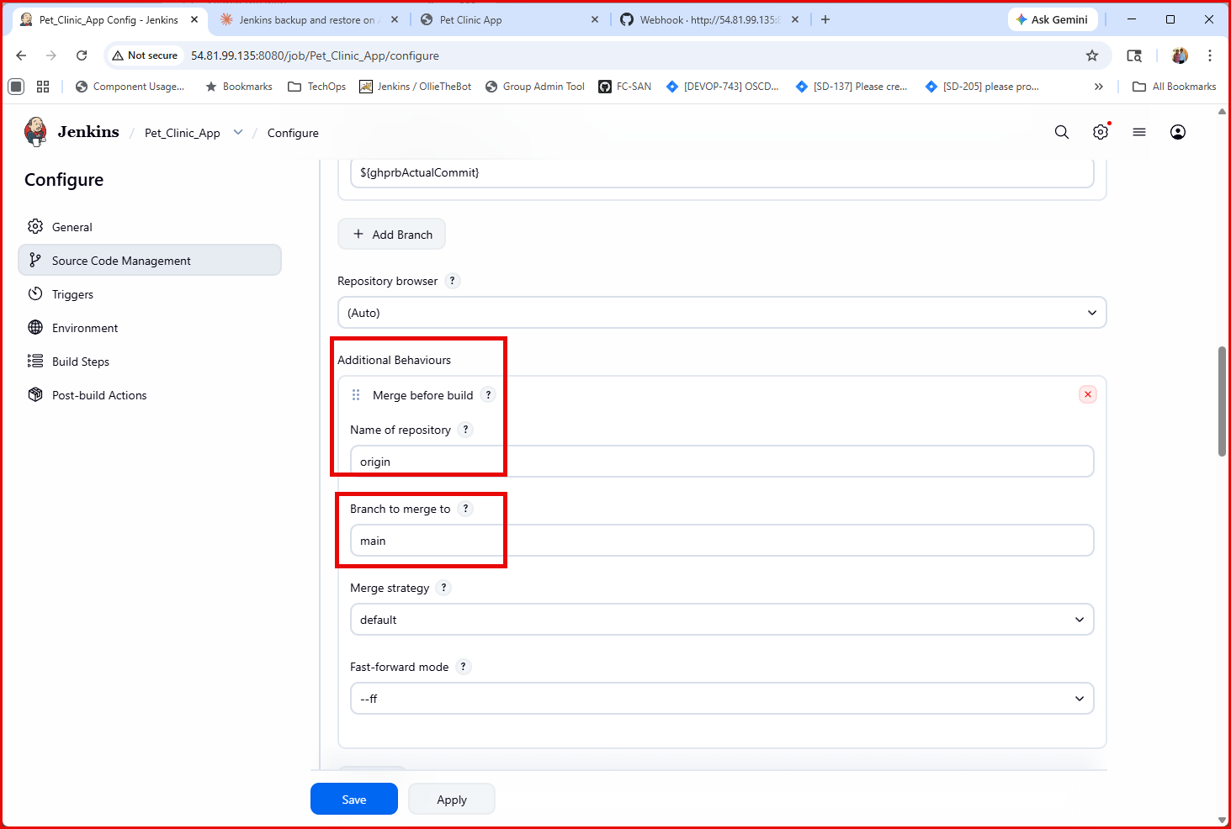
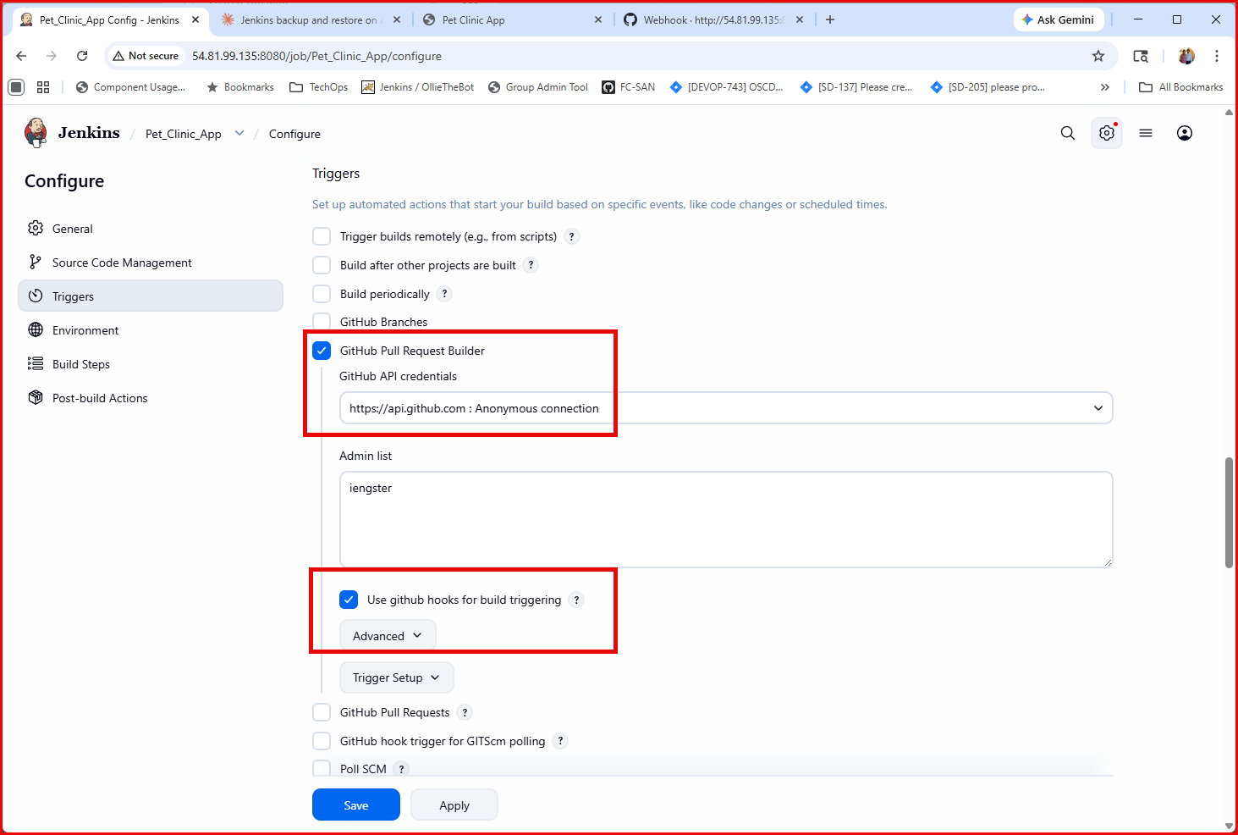
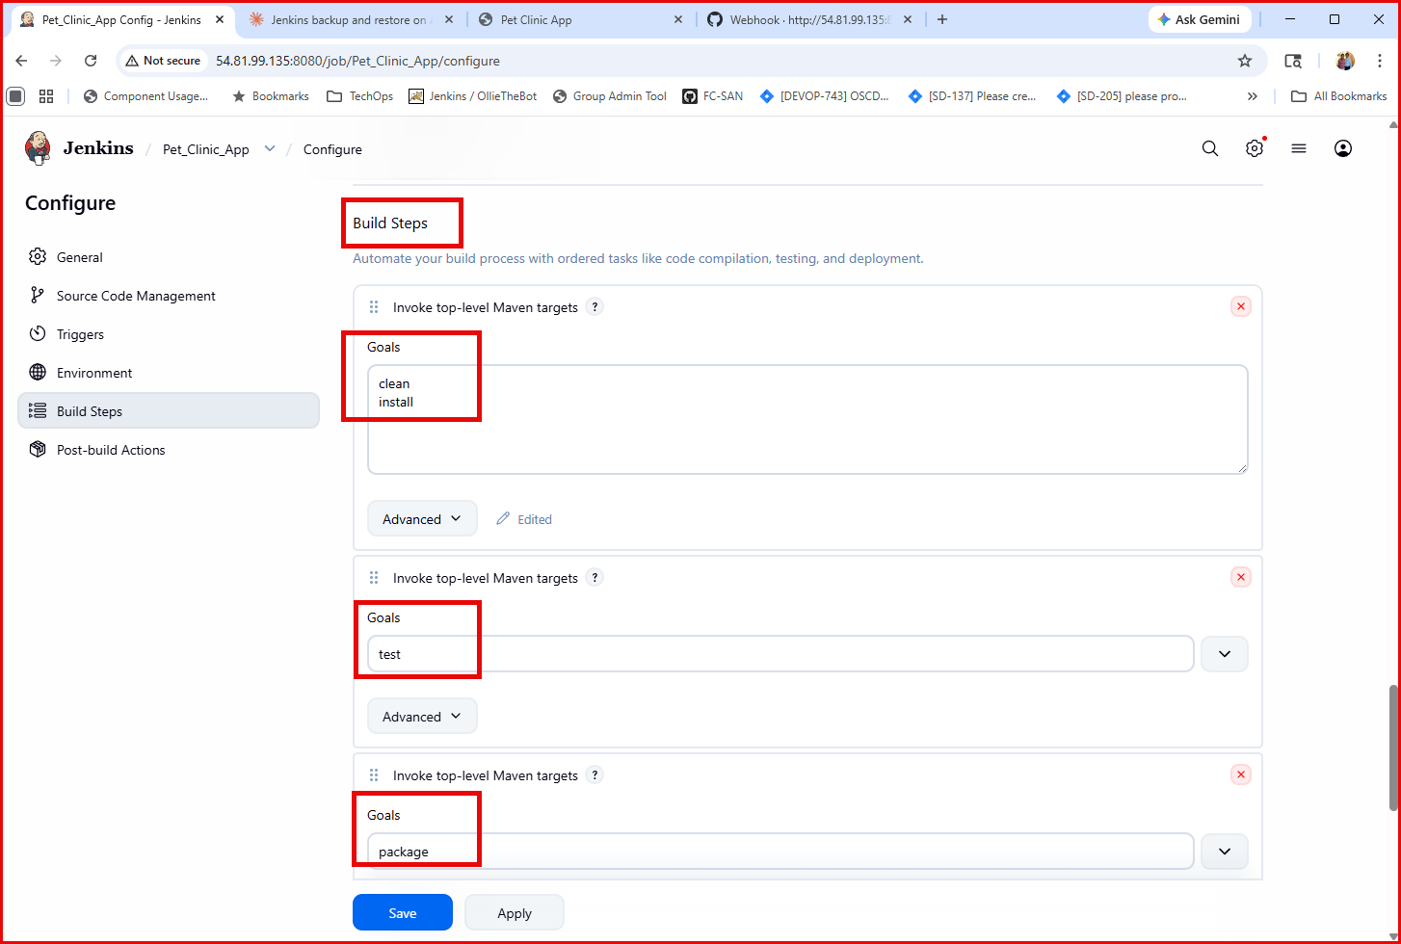
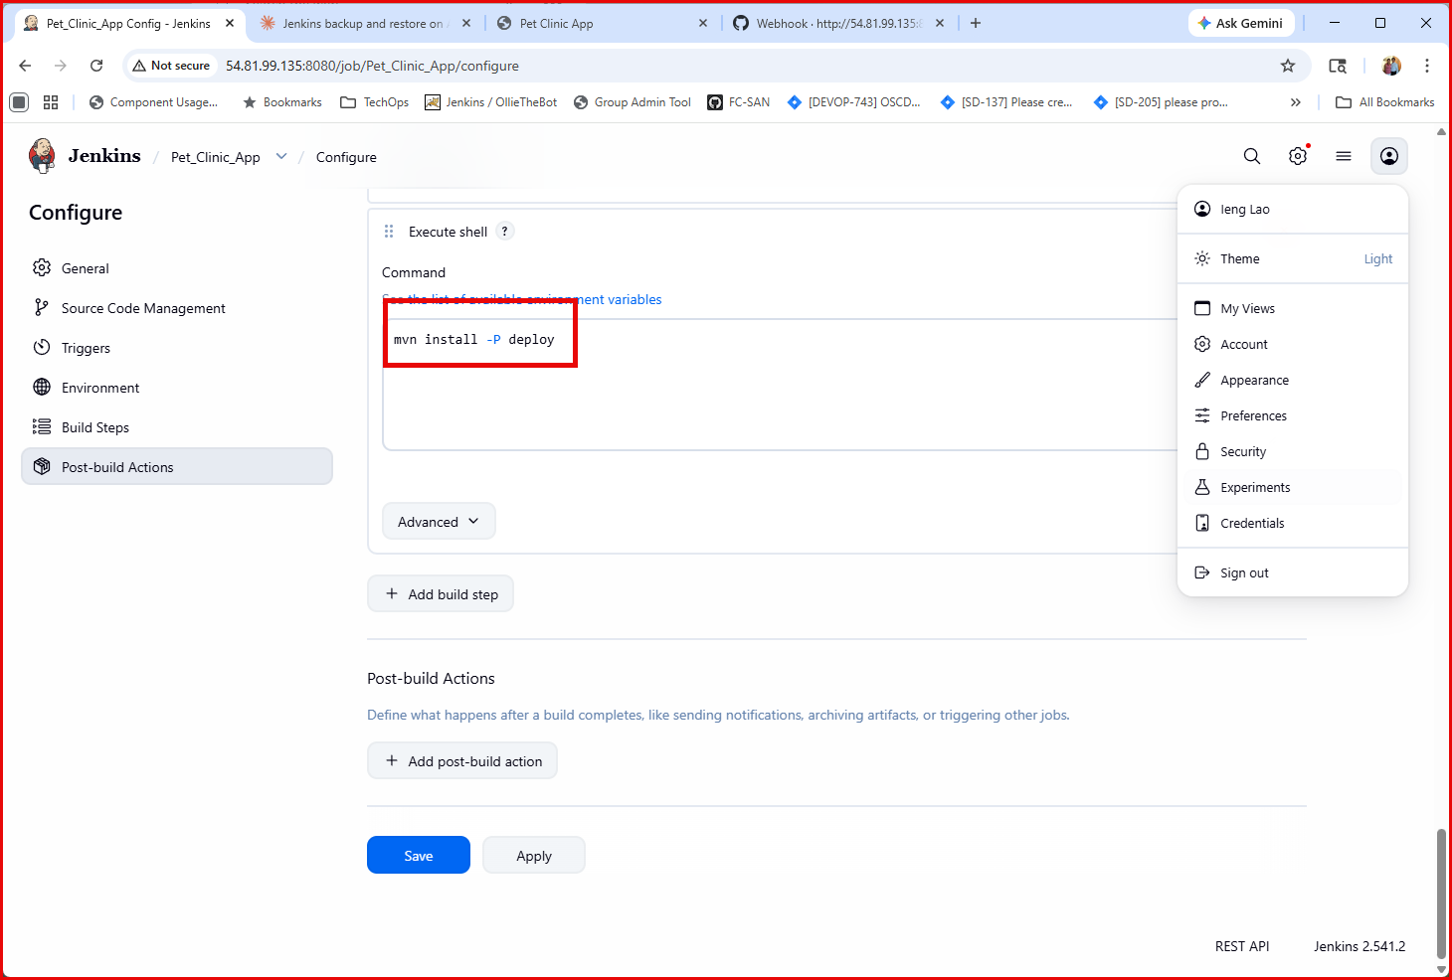
Create a Pull Request
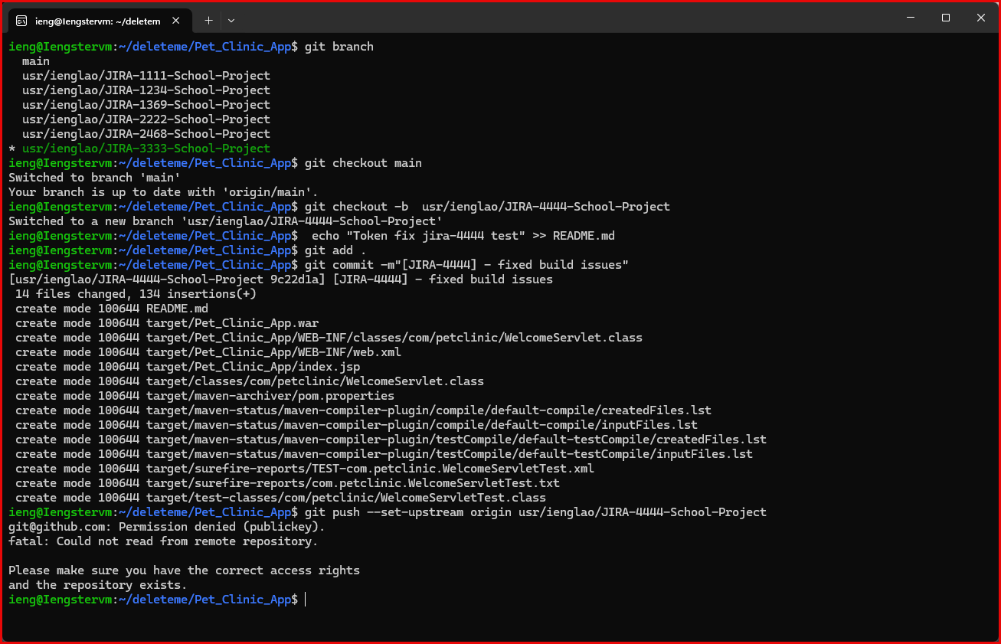
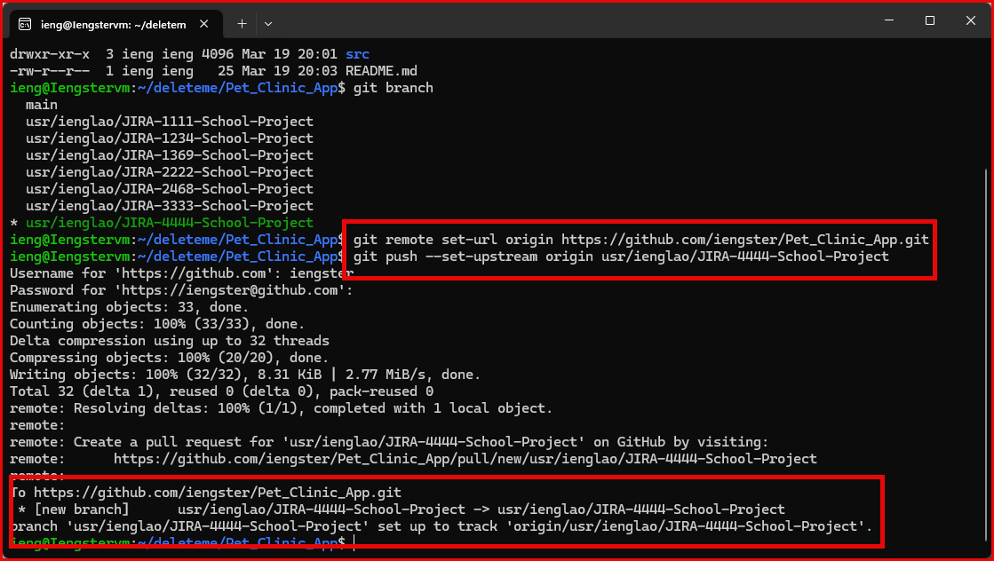

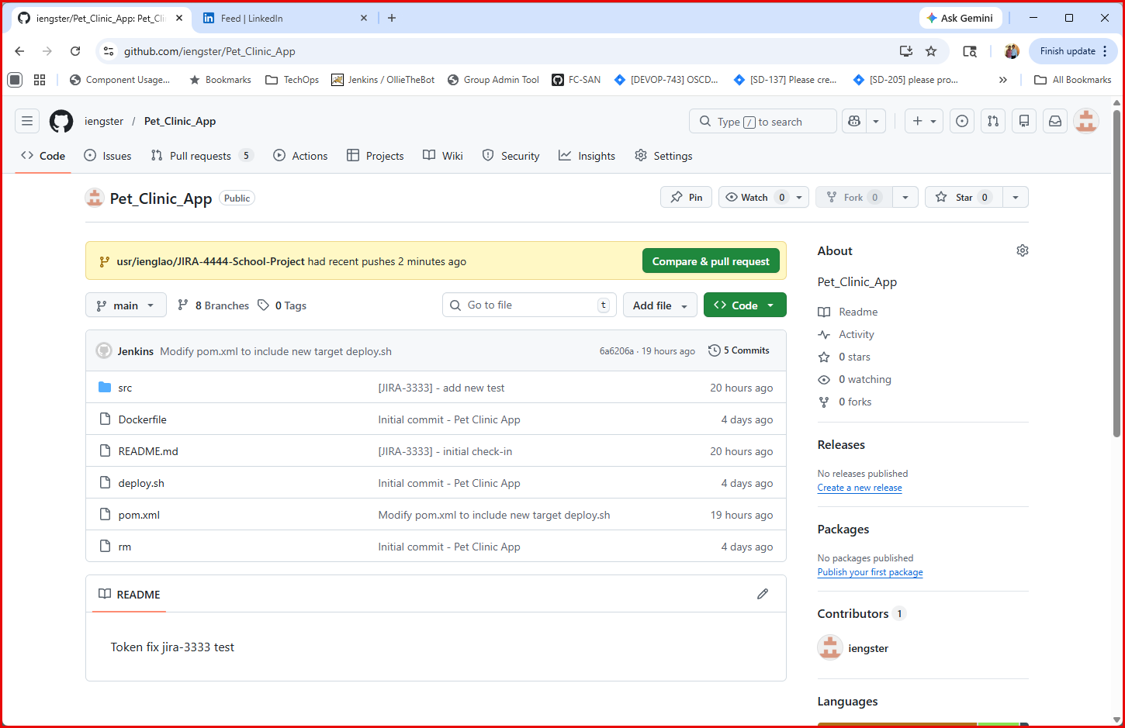
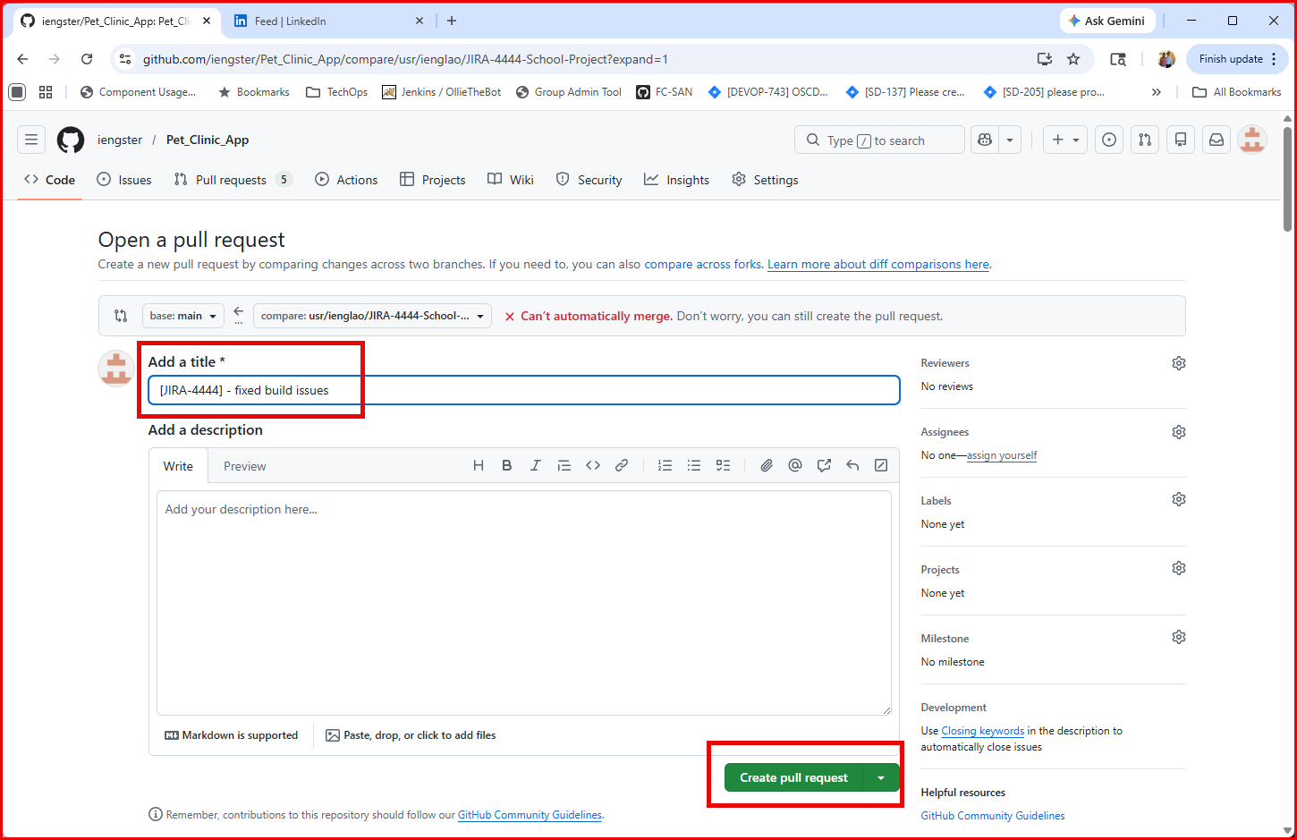

Trigger Jenkins Build
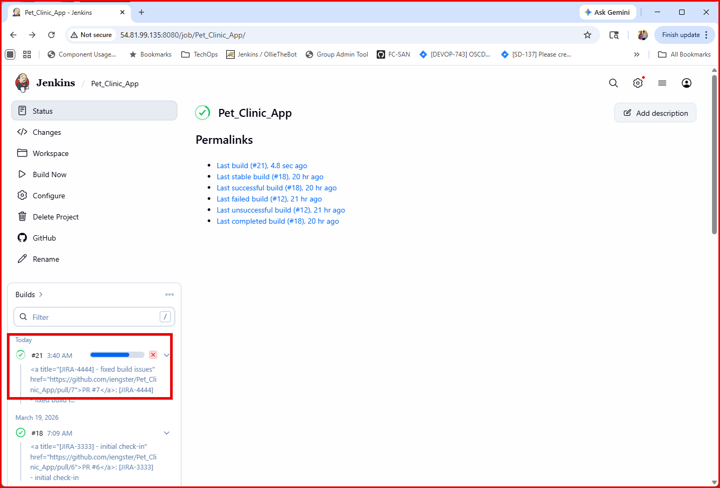
The PR attempted to merge to main branch build workspace, then built, and deployed.
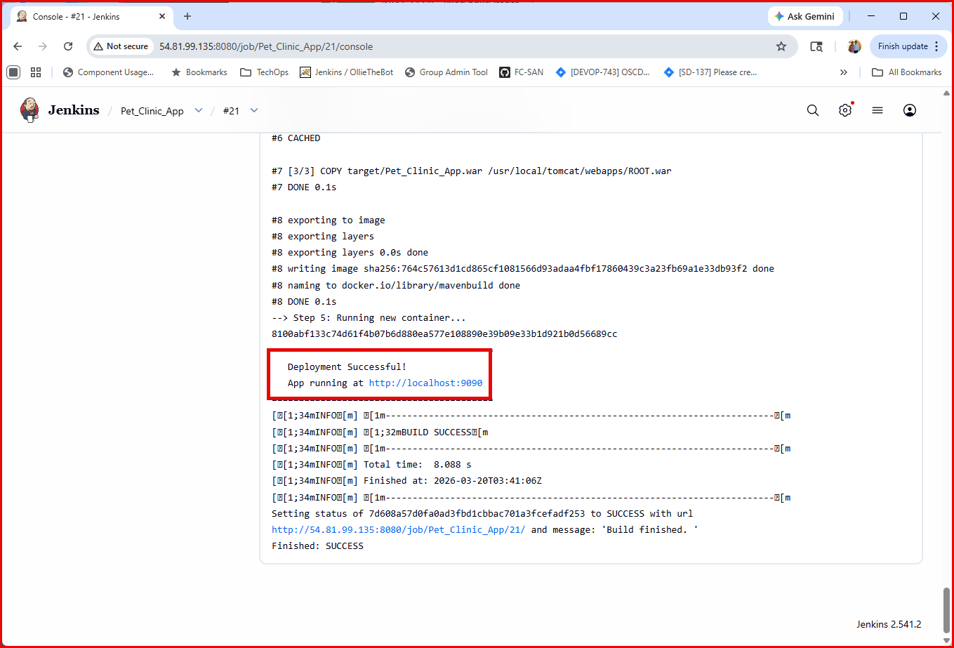
The App is running without any issue
