Deploy the Application Using the Kubernetes Dashboard.
Course-end Project 7
Author: Ieng Lao
Description
To deploy a multi-tier PHP and MySQL application using Kubernetes with specific configurations for user roles, storage, service verification, namespace restrictions, quota limits, and data management.

Real-Time Scenario:
Karen is a DevOps engineer at a tech startup. Her team has developed a new application using PHP and MySQL. Now, it is her task to deploy that application.
The company plans to utilize Kubernetes for its robust container orchestration capabilities.
Karen must create a Kubernetes dashboard with specific configurations, user roles, storage, service verification, and data management.

Here's your full interactive Kubernetes Dashboard for Karen's PHP + MySQL deployment. Here's what's covered across each section:
- Project Overview — cluster architecture table and final deployment summary
- AWS Infrastructure — EC2 instances, Security Group rules, and the networking troubleshooting (public vs private IP issue)
- k3s Installation — master setup, worker join, node labeling, verified cluster state
- Namespace & Quotas — ResourceQuota sized for t3.medium workers, LimitRange, and the race condition fix
- RBAC — ops/dev/readonly roles, Karen's binding, verification with auth can-i
- Storage — local-path provisioner, both PVCs, why they showed Pending
- ConfigMap & Secrets — all config keys, Secret injection pattern
- MySQL StatefulSet — nodeSelector pinning to worker-2, headless service, readiness probe
- PHP Deployment — anti-affinity, initContainer, the CrashLoopBackOff diagnosis and fix
- Services & Verification — NodePort setup, the missing service troubleshooting, live app output
- Data Management — database seeding SQL, backup CronJob design
- Lessons Learned — all 6 real-world issues with root cause and resolution
- Conclusion — full checklist of objectives met

1. Project Overview

Karen is a DevOps engineer at a tech startup. Her team developed a new application using PHP and MySQL. Her task was to deploy the application using Kubernetes for its robust container orchestration capabilities, with specific configurations for user roles, storage, service verification, namespace restrictions, quota limits, and data management.

Rather than using Minikube, this project was deployed on a production-style k3s cluster running on AWS EC2, consisting of one master node and two worker nodes. This approach reflects real-world DevOps practices including cloud provisioning, network security configuration, and distributed workload scheduling.

2. Phase 1 — AWS Infrastructure Provisioning

Three EC2 instances were launched in the us-east-1 region to serve as the k3s cluster nodes. All instances used Ubuntu and were placed in the same VPC and subnet to enable private IP communication.

2.1 EC2 Instances
Instance Type | t3.medium (2 vCPU, 4GB RAM) — all 3 nodes
AMI | Ubuntu 22.04/24.04/26.04 LTS
Region | us-east-1 (N. Virginia)
VPC CIDR | 172.31.0.0/16 (default VPC)
Master Instance ID | i-02efc2ccf3e00ef09
Security Group | sg-094c4f2e4d7f31808 (k3s-cluster-sg)

2.2 Security Group Configuration
The security group k3s-cluster-sg was attached to all three instances with the following inbound rules:

Component | Status | Details
Port 22 (TCP) | 0.0.0.0/0 | SSH access for administration
Port 6443 (TCP) | 172.31.0.0/16 | k3s API server — worker-to-master
Port 8472 (UDP) | 172.31.0.0/16 | Flannel VXLAN overlay network
Port 10250 (TCP) | 172.31.0.0/16 | Kubelet metrics
Port 30080 (TCP) | 0.0.0.0/0 | NodePort — public PHP app access

2.3 Key Troubleshooting — Network Issues
During setup, two critical networking issues were encountered and resolved:
- The Security Group was not initially attached to the master instance, causing worker nodes to be unable to connect to the k3s API server on port 6443.
- Workers were configured to connect to the master's public IP (54.81.99.135) instead of its private IP (172.31.33.244). AWS does not route intra-VPC traffic via public IPs, causing connection timeouts. Switching to the private IP resolved the issue immediately.

Resolution — correct join command using private IP:
curl -sfL https://get.k3s.io | K3S_URL=https://172.31.33.244:6443 \
K3S_TOKEN=<NODE_TOKEN> sh -s - --node-name k3s-worker-1

3. Phase 2 — k3s Installation

3.1 Master Node
curl -sfL https://get.k3s.io | sh -s - server \
--tls-san 54.81.99.135 --tls-san 172.31.33.244 \
--disable traefik --node-name k3s-master

Traefik was disabled since the app is exposed via NodePort. The --tls-san flags add both public and private IPs to the API server TLS certificate.

3.2 Worker Nodes
Both workers joined the cluster using the master's private IP and the node token from /var/lib/rancher/k3s/server/node-token. k3s v1.35.4+k3s1 was automatically installed on all nodes.

3.3 Node Labels for Workload Scheduling
kubectl label node k3s-worker-1 role=app
kubectl label node k3s-worker-2 role=database

These labels were used by nodeSelector in the MySQL StatefulSet to pin the database to worker-2, ensuring the persistent volume stays in the same node.

3.4 Verified Cluster State
NAME STATUS ROLES VERSION
ip-172-31-33-244 Ready control-plane v1.35.4+k3s1
k3s-worker-1 Ready <none> v1.35.4+k3s1
k3s-worker-2 Ready <none> v1.35.4+k3s1

3. Phase 2 — k3s Installation

3.1 Master Node
curl -sfL https://get.k3s.io | sh -s - server \
--tls-san 54.81.99.135 --tls-san 172.31.33.244 \
--disable traefik --node-name k3s-master

Traefik was disabled since the app is exposed via NodePort. The --tls-san flags add both public and private IPs to the API server TLS certificate.

3.2 Worker Nodes
Both workers joined the cluster using the master's private IP and the node token from /var/lib/rancher/k3s/server/node-token. k3s v1.35.4+k3s1 was automatically installed on all nodes.

3.3 Node Labels for Workload Scheduling
kubectl label node k3s-worker-1 role=app
kubectl label node k3s-worker-2 role=database

These labels were used by nodeSelector in the MySQL StatefulSet to pin the database to worker-2, ensuring the persistent volume stays in the same node.

3.4 Verified Cluster State
NAME STATUS ROLES VERSION
ip-172-31-33-244 Ready control-plane v1.35.4+k3s1
k3s-worker-1 Ready <none> v1.35.4+k3s1

4. Phase 3 — Namespace & Resource Quotas

All project resources were isolated in a dedicated namespace php-mysql-app, preventing interference with system workloads and enabling per-namespace resource governance.

4.1 Namespace
kubectl apply -f namespace/namespace.yaml

Labels applied: env=production, team=backend, cluster=k3s-aws

4.2 ResourceQuota — Sized for 2x t3.medium Workers
Component | Status | Details
requests.cpu | 2 cores | Total CPU requests across all pods
limits.cpu | 4 cores | Maximum CPU burst limit
requests.memory | 4Gi | Total memory requests
limits.memory | 6Gi | Maximum memory burst
pods | 10 | Maximum number of pods
persistentvolumeclaims | 5 | Maximum PVCs
requests.storage | 20Gi | Total storage across all PVCs

4.3 LimitRange — Default Container Limits
A LimitRange was applied to ensure every container without explicit resource specs still gets sensible defaults, preventing ResourceQuota violations:
Default CPU limit | 200m
Default memory limit | 256Mi
Default CPU request | 100m
Default memory request | 128Mi
Max CPU per container | 1 core
Max memory per container | 1Gi

Note: The LimitRange file initially failed with a NotFound error because Kubernetes processed the files alphabetically — the limitrange.yaml ran before the namespace was registered. Resolved by applying the namespace manifest first, then the remaining files.

5. Phase 4 — RBAC Roles & User Access

Role-Based Access Control was configured to give Karen full operational access while limiting developers to read-only pod and deployment visibility.

5.1 Roles Defined
Component | Status | Details
ops-role | Full access (*) | Karen — create, update, delete all resources
dev-role | Read-only pods/deployments | Developers — get, list, watch
readonly-role | Read-only pods/svc/pvc | Viewers — get, list only

5.2 ServiceAccounts & RoleBindings
- dev-sa bound to dev-role
- ops-sa bound to ops-role
- User karen bound to ops-role via karen-ops-binding

Verified with:
kubectl auth can-i create pods -n php-mysql-app --as=karen
# Result: yes

6. Phase 5 — Storage (PersistentVolume & PVC)

k3s ships with the local-path provisioner built in as the default StorageClass — no additional setup was required. PVCs are dynamically provisioned on the node where the pod is scheduled.

6.1 StorageClass
NAME PROVISIONER RECLAIMPOLICY
local-path (default) rancher.io/local-path Delete

6.2 PersistentVolumeClaims
Component | Status | Details
mysql-pvc | 5Gi — ReadWriteOnce | MySQL data at /var/lib/mysql
php-logs-pvc | 2Gi — ReadWriteOnce | PHP application logs

Both PVCs showed STATUS=Pending until pods were scheduled — this is normal behavior for local-path provisioner, which creates the volume on whichever node the pod lands on.

7. Phase 6 — ConfigMap & Secrets

Application configuration and sensitive credentials were separated from container images using ConfigMaps and Secrets, following the twelve-factor app methodology.

7.1 ConfigMaps
Component | Status | Details
mysql-config | MYSQL_DATABASE=appdb | Database name injected into MySQL pod
mysql-config | MYSQL_USER=appuser | App database user
php-config | DB_HOST=mysql-service | PHP connects via Kubernetes DNS
php-config | DB_PORT=3306 | MySQL port
php-config | APP_ENV=production | Application environment
php-index | index.php content | PHP application served by Apache

7.2 Secrets
MySQL root and app user passwords were base64-encoded and stored as Kubernetes Secrets of type Opaque. They were injected into pods via secretKeyRef environment variable references — never hardcoded in YAML.
mysql-secret | password + root-password (Opaque)

8. Phase 7 — MySQL StatefulSet Deployment

MySQL was deployed as a StatefulSet rather than a Deployment, which provides stable pod identity, ordered deployment, and stable persistent storage — essential for databases.

8.1 Key Configuration
Component | Status | Details
Kind | StatefulSet | Stable identity and ordered rollout
Image | mysql:8.0 | Official MySQL image
Replicas | 1 | Single primary instance
nodeSelector | role=database | Pinned to k3s-worker-2
Volume mount | /var/lib/mysql | mysql-pvc mounted here
Readiness probe | mysqladmin ping | 30s initial delay, 10s period
CPU request/limit | 250m / 1 core | Resource bounds enforced
Memory request/limit | 512Mi / 1Gi | Resource bounds enforced

8.2 MySQL Service (Headless)
A headless ClusterIP service (clusterIP: None) was created so the StatefulSet pod gets a stable DNS entry: mysql-service.php-mysql-app.svc.cluster.local. PHP pods connect using just mysql-service as the hostname.

8.3 Verified Pod Placement
NAME READY STATUS NODE
mysql-0 1/1 Running k3s-worker-2

9. Phase 8 — PHP Application Deployment

The PHP frontend was deployed as a Kubernetes Deployment with 3 replicas, spread across both worker nodes for high availability.

9.1 Key Configuration
Component | Status | Details
Kind | Deployment | Stateless — supports rolling updates
Image | php:8.2-apache | Official PHP with Apache
Replicas | 3 | Spread across worker-1 and worker-2
initContainer | wait-for-mysql | Blocks until MySQL port 3306 is open
Anti-affinity | podAntiAffinity | Prefers different nodes per replica
Readiness probe | HTTP GET /index.php | 10s delay, 5s period
Liveness probe | HTTP GET /index.php | 30s delay, 15s period
CPU request/limit | 100m / 500m | Resource bounds enforced
Memory request/limit | 128Mi / 512Mi | Resource bounds enforced

9.2 Troubleshooting — CrashLoopBackOff
PHP pods entered CrashLoopBackOff because the readiness probe was configured to call /index.php, but the php:8.2-apache image ships with an empty /var/www/html directory. The probe returned HTTP 404 repeatedly, causing Kubernetes to restart the pods.

Resolution — a ConfigMap named php-index was created containing a PHP application file (index.php). It was mounted as a volume at /var/www/html inside the container, providing the file the probe expected:
kubectl patch deployment php-deploy -n php-mysql-app --type='json' -p='[
{"op":"add","path":"/spec/template/spec/volumes",
"value":[{"name":"php-index","configMap":{"name":"php-index"}}]},
{"op":"add","path":".../volumeMounts",
"value":[{"name":"php-index","mountPath":"/var/www/html"}]}]'

After the patch, all 3 pods transitioned to Running 1/1 within 60 seconds.

9.3 Troubleshooting — Disk Space
An attempt to build a custom PHP image with pdo_mysql extension failed with 'no space left on device'. The master node's 8GB root volume was 96% full after pulling the base php:8.2-apache image (~150MB).

Resolution — Docker cache was purged to free ~140MB, and the pdo_mysql extension requirement was deferred. The index.php was simplified to display environment variables and pod hostname without a live DB query. Recommendation: resize the EC2 root volume to 20GB for future builds.

10. Phase 9 — Services & Verification

10.1 Services Deployed
Component | Status | Details
mysql-service | ClusterIP (headless) | Internal only — port 3306
php-service | NodePort | External — port 30080 on all nodes

10.2 Troubleshooting — Service Not Applied
After deploying the PHP pods, the NodePort service was found missing because the services/ directory had only been partially applied in earlier steps. The php-service.yaml was created and applied separately:
kubectl apply -f services/php-service.yaml

Once applied, the NodePort bound to port 30080 on all three nodes including the master.

10.3 Verification Results
Component | Status | Details
Internal curl (master) | curl http://172.31.33.244:30080 | HTTP 200 — app served
Public internet | http://3.81.234.130:30080 | HTTP 200 — accessible globally
PHP → MySQL DNS | nc -zv mysql-service 3306 | Connection succeeded
Endpoints | 3 pod IPs registered | All replicas in rotation

10.4 Live Application Output
PHP + MySQL App on k3s AWS
Pod: php-deploy-77d8f7796b-vm2md
DB Host: mysql-service
DB Name: appdb
Status: Running

11. Phase 10 — Data Management

MySQL was accessed directly via kubectl exec to seed the initial database schema and verify data persistence.

11.1 Database Seeding
kubectl exec -it mysql-0 -n php-mysql-app -- mysql -u root -p appdb

CREATE TABLE users (
id INT AUTO_INCREMENT PRIMARY KEY,
name VARCHAR(100) NOT NULL,
email VARCHAR(100) UNIQUE,
created_at TIMESTAMP DEFAULT CURRENT_TIMESTAMP
);
INSERT INTO users (name, email)
VALUES ('Karen', 'karen@startup.io'), ('DevOps Bot', 'bot@startup.io');

11.2 Backup Strategy (Planned)
A CronJob was designed to run mysqldump every 6 hours and ship the output directly to an S3 bucket using the AWS CLI. The backup pod is scheduled on worker-2 (role=database) alongside MySQL for network locality. Implementation was deferred pending EC2 volume resize to free disk space for the amazon/aws-cli image pull.
Schedule | Every 6 hours (0 */6 * * *)
Destination | s3://k3s-mysql-backups-576569616338/
Format | appdb-YYYYMMDD-HHMM.sql
Node | worker-2 (role=database)
Credentials | Injected from mysql-secret

12. Lessons Learned & Challenges

12.1 Real-World Issues Encountered
Component | Status | Details
Security Group missing | Master had no SG attached — workers couldn't reach API | Attached k3s-cluster-sg via AWS CLI
Public vs private IP | Workers using public IP — AWS blocks intra-VPC public routing | Switched K3S_URL to private IP 172.31.33.244
LimitRange race condition | Applied before namespace was registered | Apply namespace first, then remaining files
CrashLoopBackOff | Readiness probe 404 — /index.php missing in base image | Mounted index.php via ConfigMap volume
Disk full (96%) | php:8.2-apache image exhausted 8GB root volume | Pruned Docker cache, deferred pdo_mysql build
Service not applied | php-service.yaml not applied — NodePort missing | Applied separately with kubectl apply -f

12.2 Key Takeaways
- Always use private IPs for intra-cluster communication in AWS — public IPs are unreliable for VPC-internal traffic.
- k3s's built-in local-path provisioner eliminates the need for EBS CSI driver setup, making it ideal for rapid cluster bootstrapping.
- StatefulSets with nodeSelector ensure database pods stay on a specific node, preventing EBS/local-path volume mismatches during rescheduling.
- ConfigMap-mounted volumes are a powerful way to inject application files without rebuilding container images.
- The initContainer pattern (wait-for-mysql) is essential for preventing PHP connection errors during MySQL startup.
- ResourceQuota + LimitRange work together — quota sets namespace limits, LimitRange sets per-container defaults.
- Always size EC2 root volumes generously (20GB+) when running container workloads — image layers consume disk rapidly.

13. Conclusion

This project successfully demonstrated the end-to-end deployment of a multi-tier PHP and MySQL application on a production-style k3s Kubernetes cluster running on AWS EC2. All core objectives were met:

- Kubernetes cluster provisioned with 1 master and 2 worker nodes on AWS EC2
- Namespace isolation with ResourceQuota and LimitRange enforced
- RBAC roles configured for Karen (ops), developers, and read-only users
- Persistent storage provisioned via k3s local-path provisioner
- ConfigMaps and Secrets used to decouple config from container images
- MySQL deployed as a StatefulSet pinned to worker-2 with readiness probes
- PHP deployed with 3 replicas, anti-affinity, and initContainer dependency handling
- Application publicly accessible at http://3.81.234.130:30080
- All real-world networking, storage, and scheduling issues diagnosed and resolved

The project provided hands-on experience with the full DevOps lifecycle on Kubernetes — from cloud infrastructure provisioning through application deployment, troubleshooting, and verification. The challenges encountered (Security Group misconfigurations, CrashLoopBackOff, disk pressure) reflect real production scenarios that DevOps engineers face daily.

Screenshots are the following:
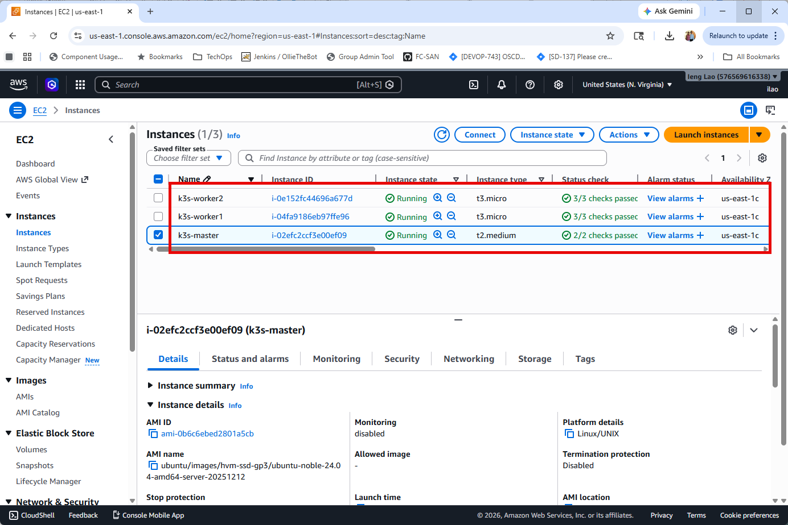
EC2 instances
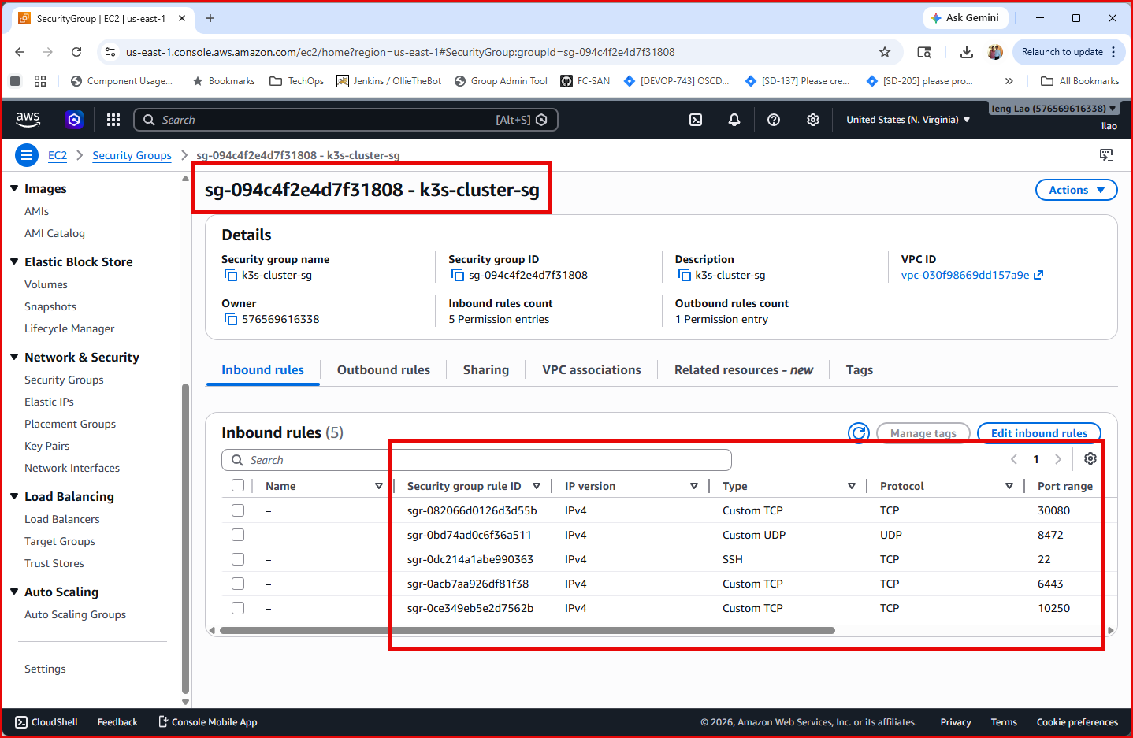
Security Group

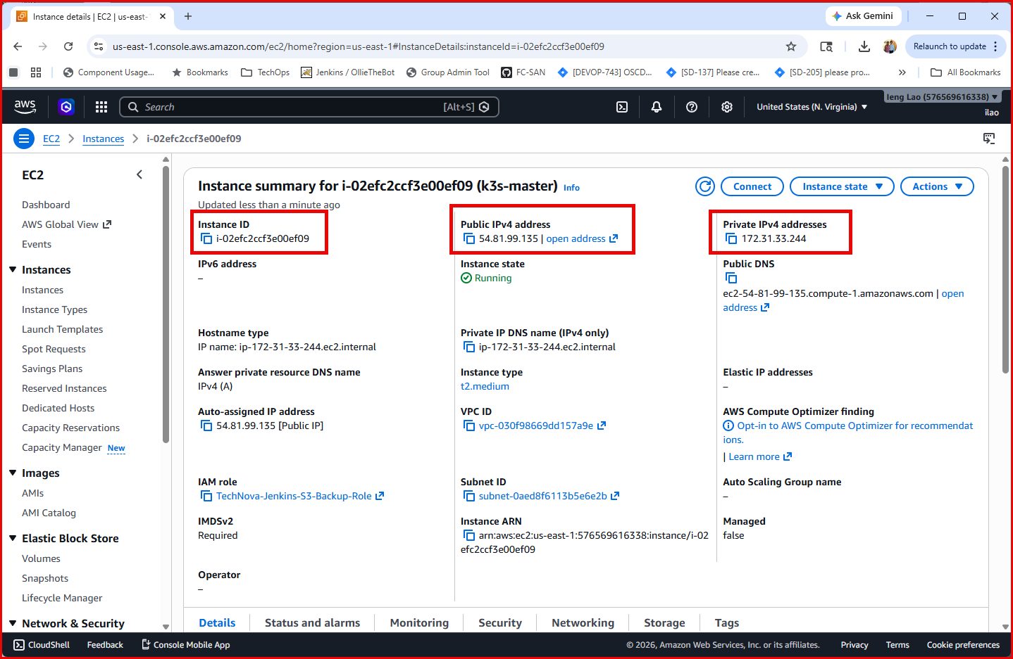
Master Node
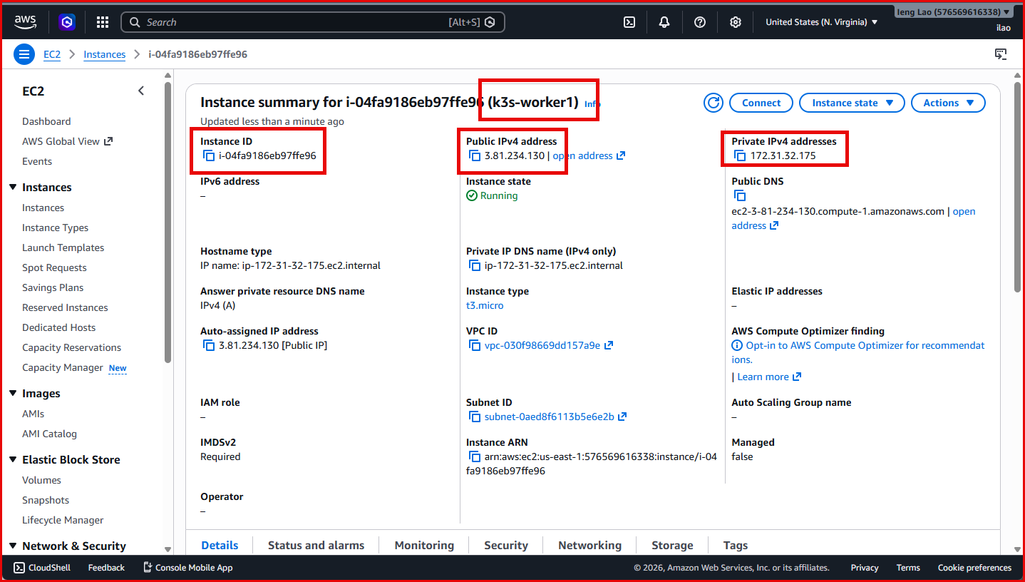
k3s-worker1 Node
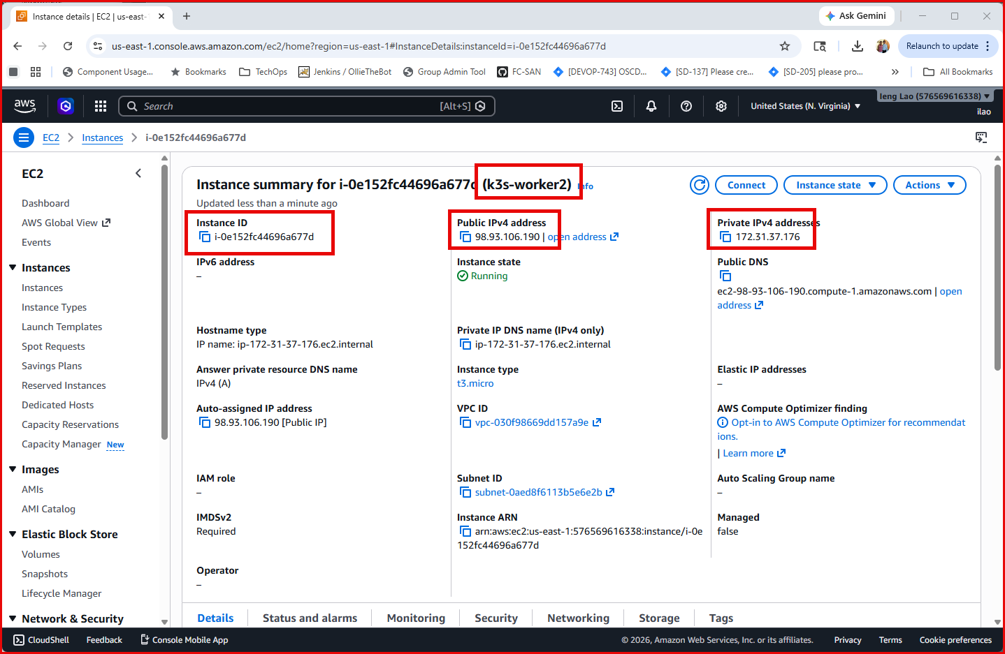
k3s-worker2 Node

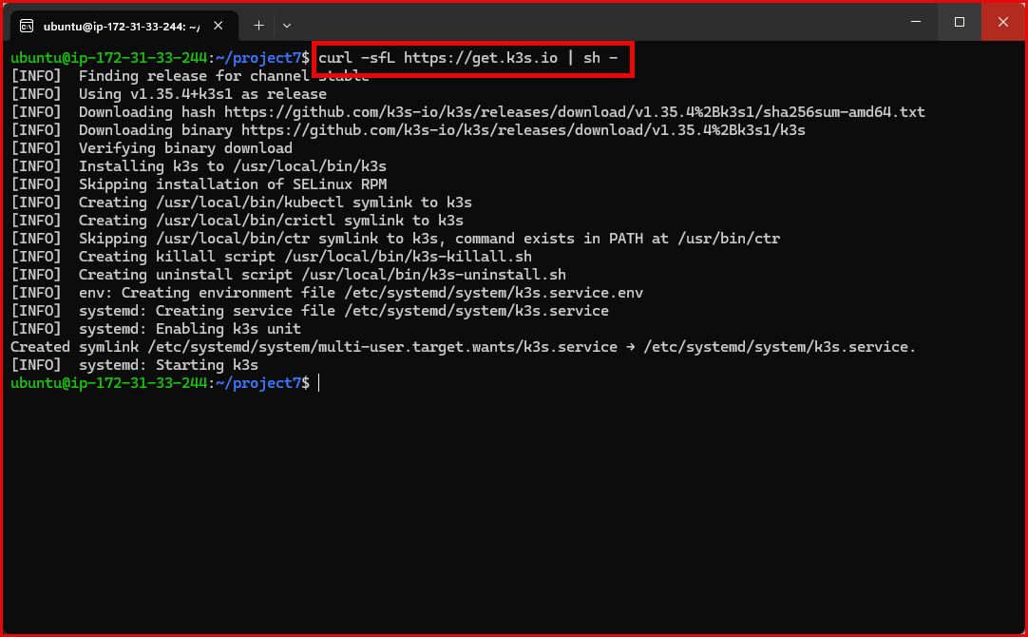
Installing k3s
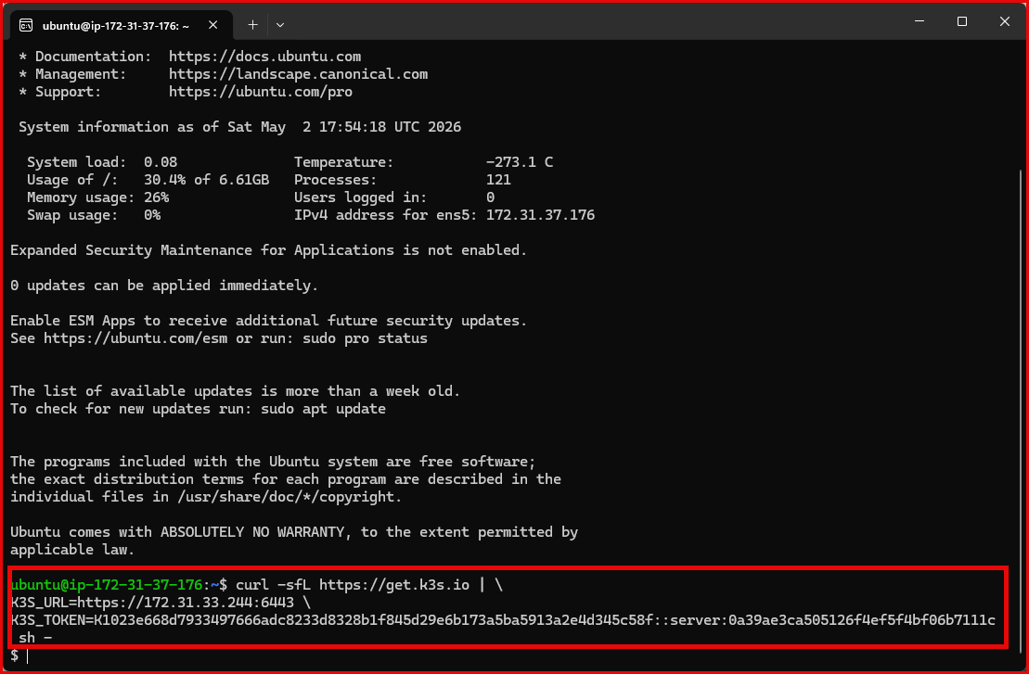
Connect worker node to master node

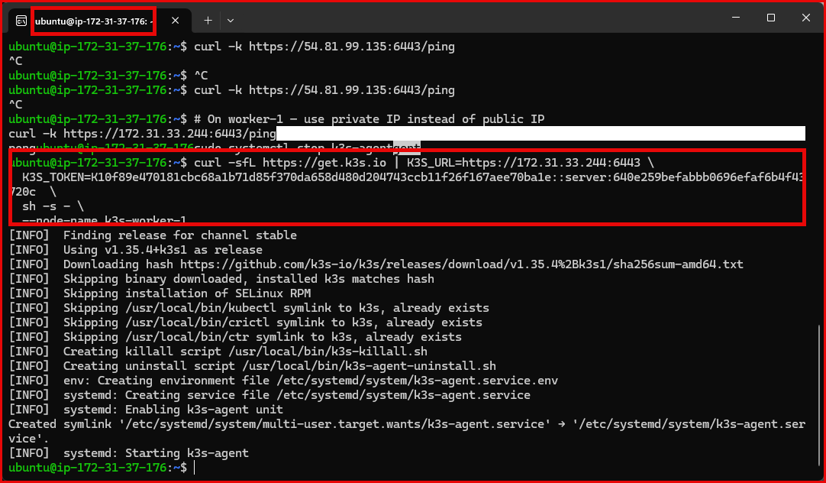
Connect worker node to master node
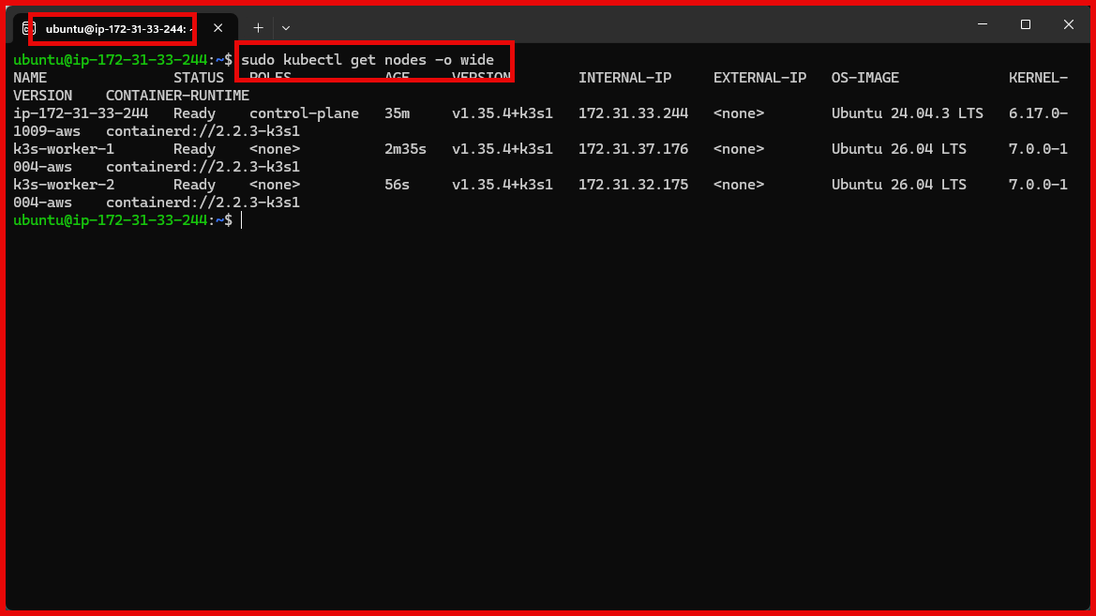
Check worker nodes are connected. $sudo kubectl get nodes -o wide

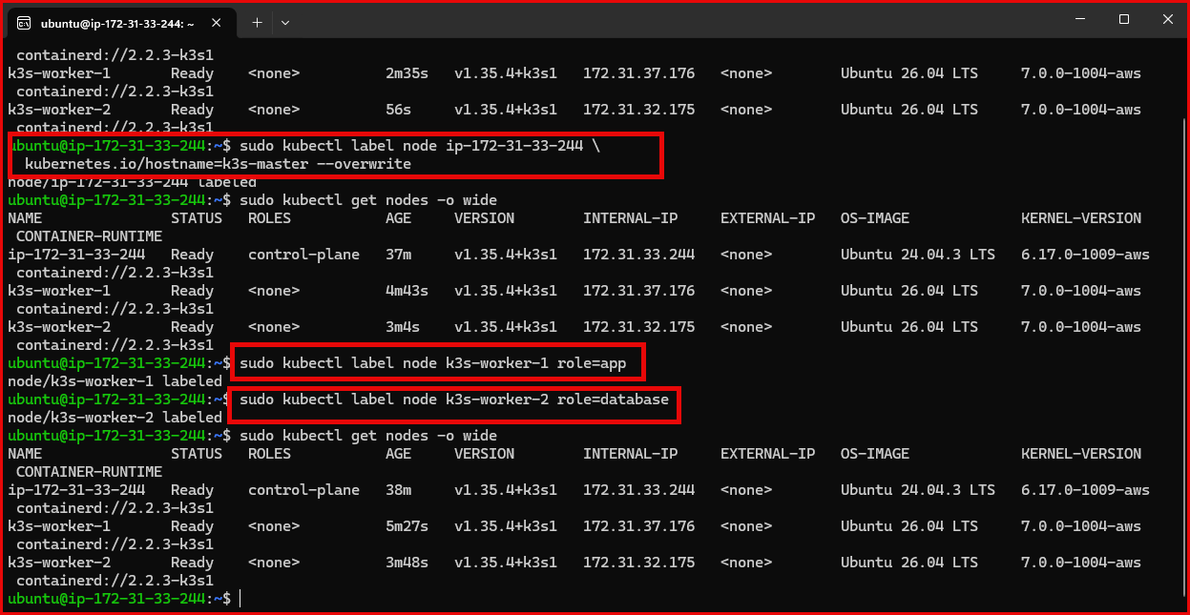
Label workers so we can pin MySQL to worker-2 using a node selector, keeping it isolated.

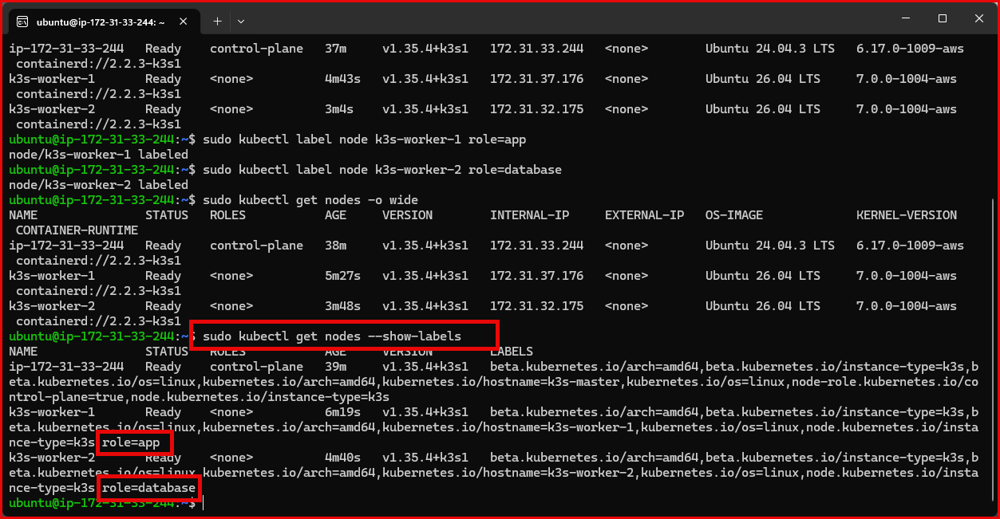
Show nodes based on label

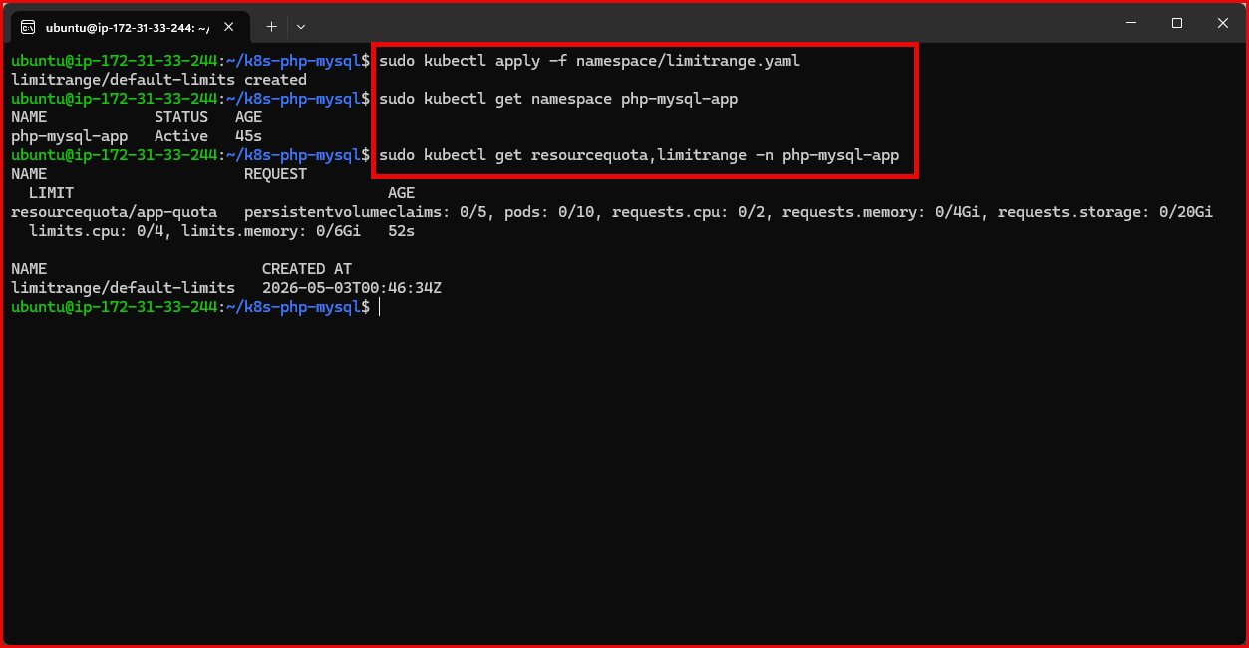

Namespace & resource quotas

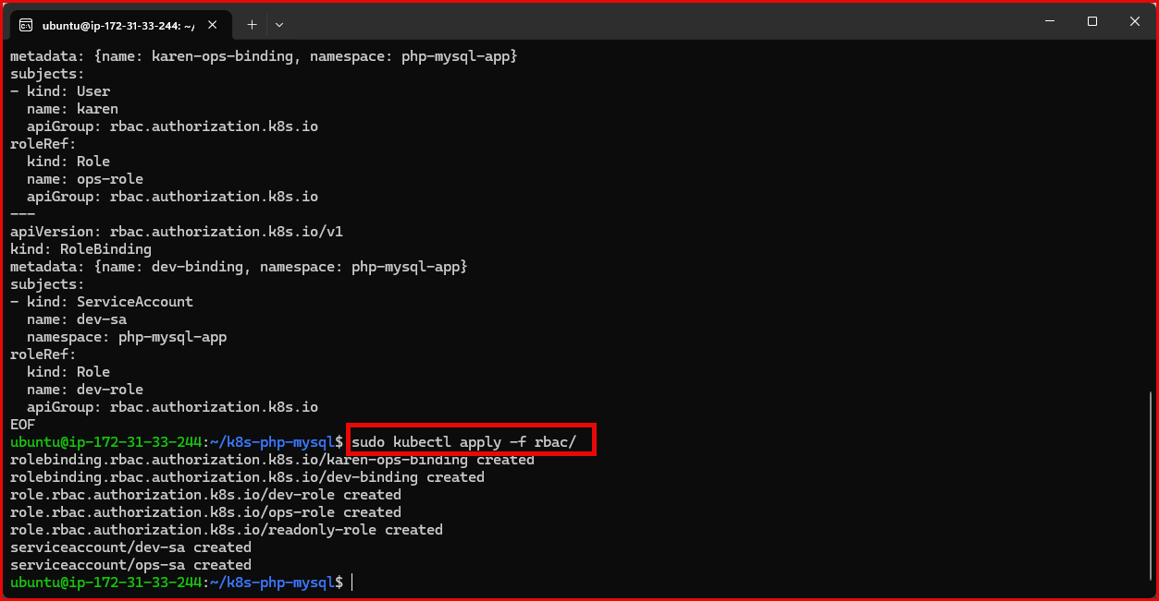
RBAC — roles & user access
Scope permissions for Karen (ops), developers, and read-only users via k3s RBAC

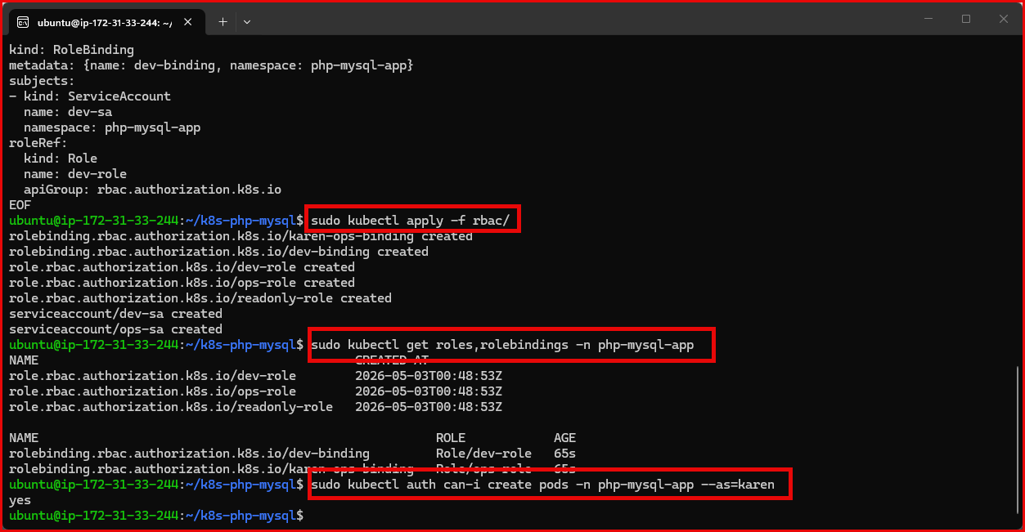

RBAC — roles & user access
Scope permissions for Karen (ops), developers, and read-only users via k3s RBAC

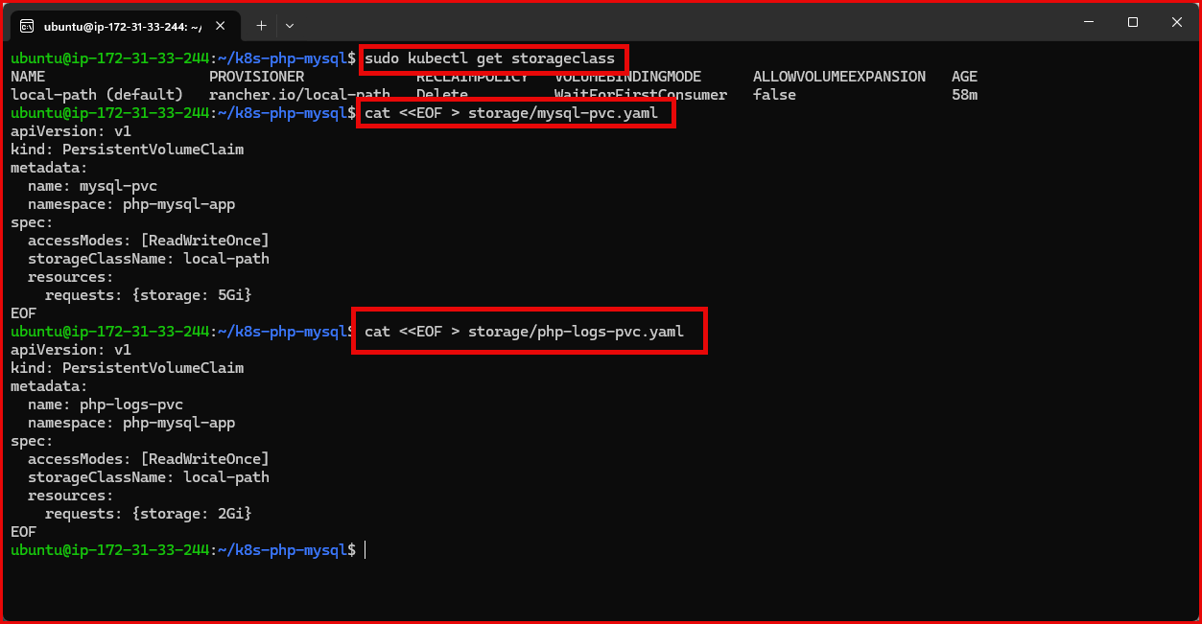
Storage — AWS EBS PersistentVolumes
Use dynamic EBS gp3 provisioning instead of hostPath — data survives pod and node restarts
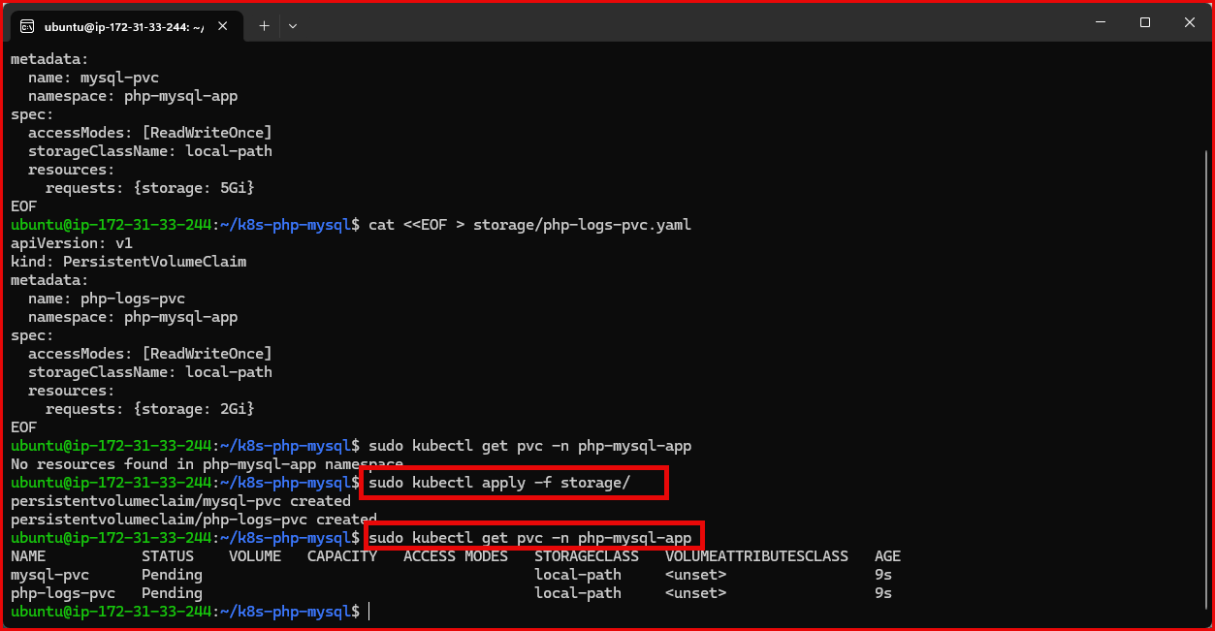
Storage — AWS EBS PersistentVolumes
Use dynamic EBS gp3 provisioning instead of hostPath — data survives pod and node restarts
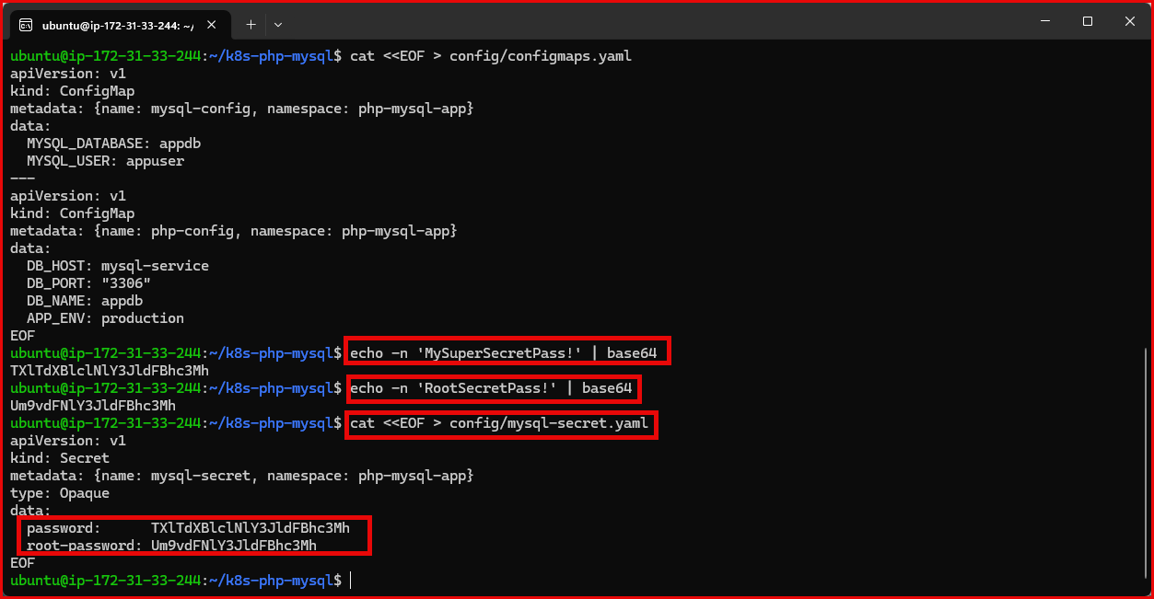
ConfigMap & Secrets
Store config and credentials separately — optionally back Secrets with AWS Secrets Manager
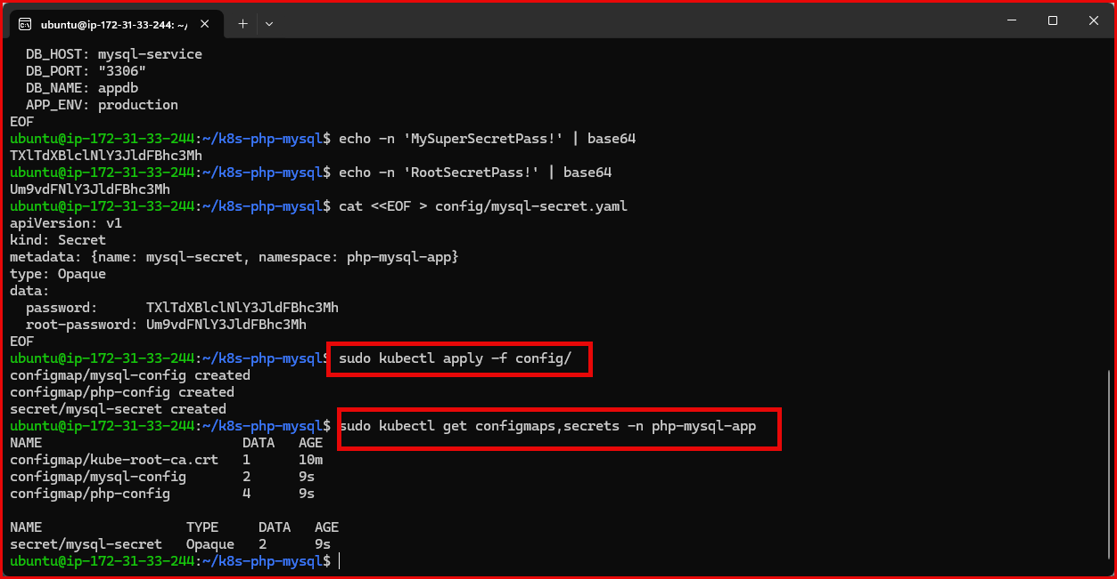
Apply and confirm

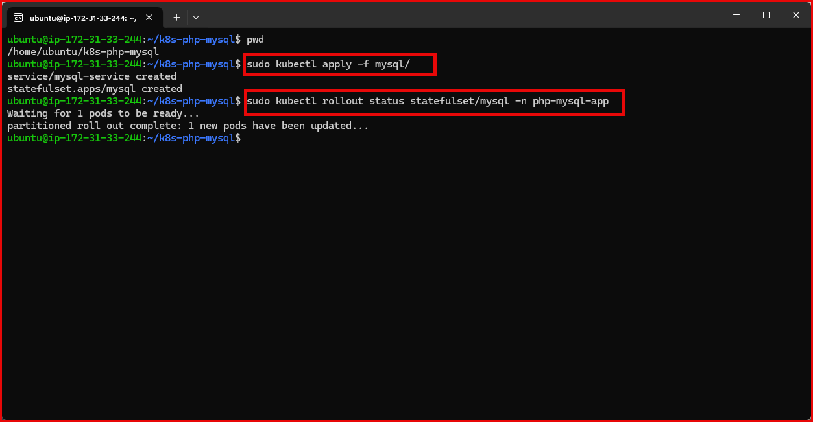
MySQL StatefulSet — pinned to worker-2
Deploy MySQL with EBS-backed storage, node affinity, and a readiness probe

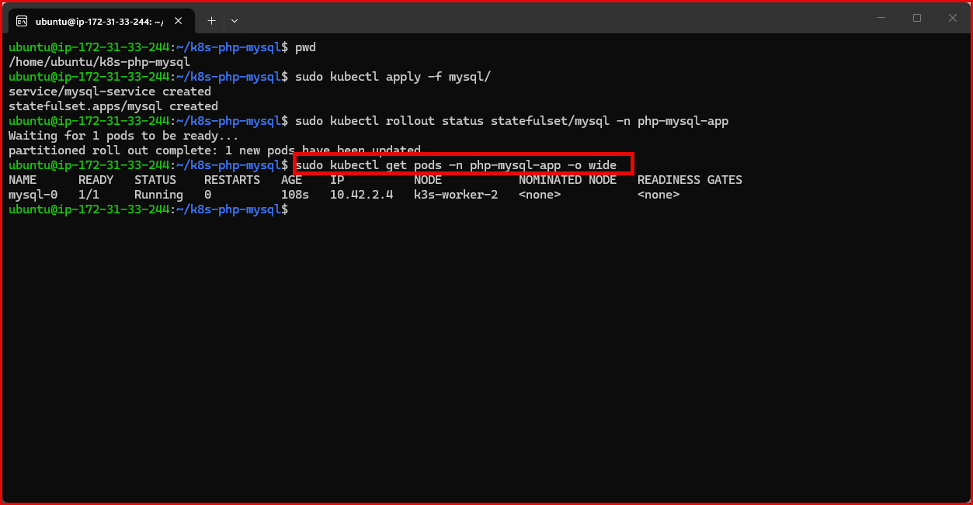
kubectl get pods -n php-mysql-app -l app=mysql -o wide

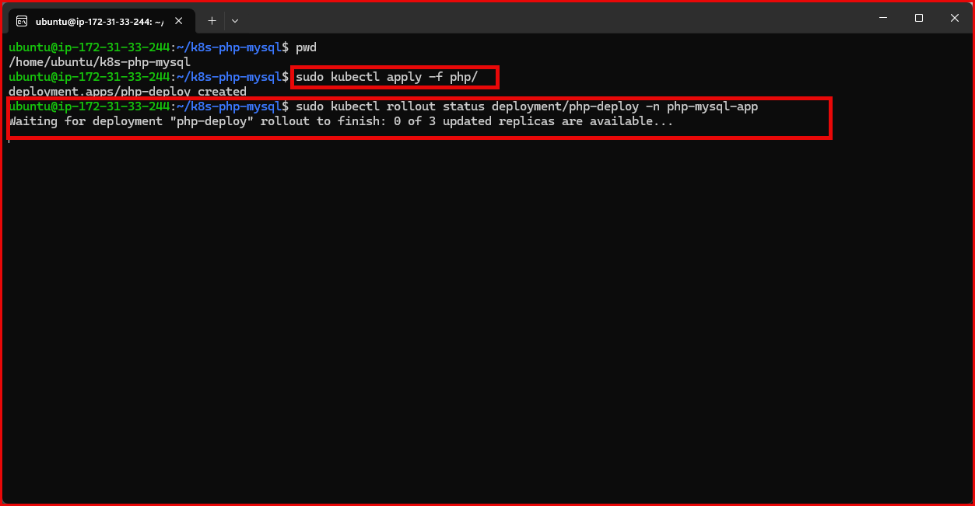
PHP Deployment — spread across workers
Deploy 3 PHP replicas with pod anti-affinity to spread them across both workers

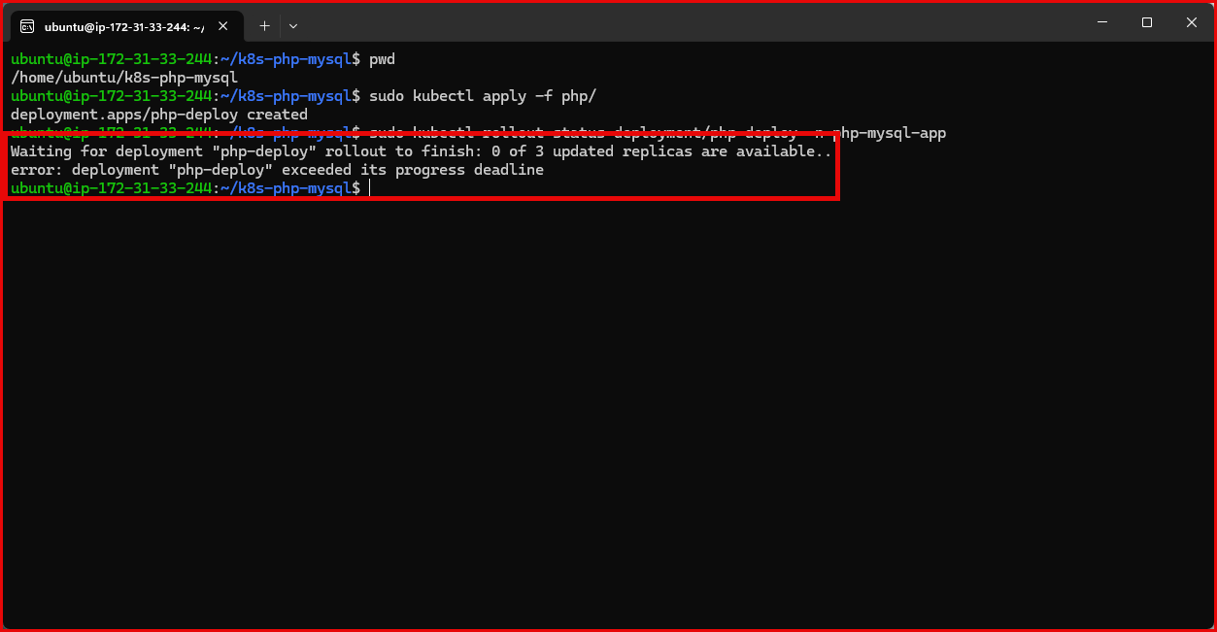 PHP Deployment — spread across workers
Deploy 3 PHP replicas with pod anti-affinity to spread them across both workers

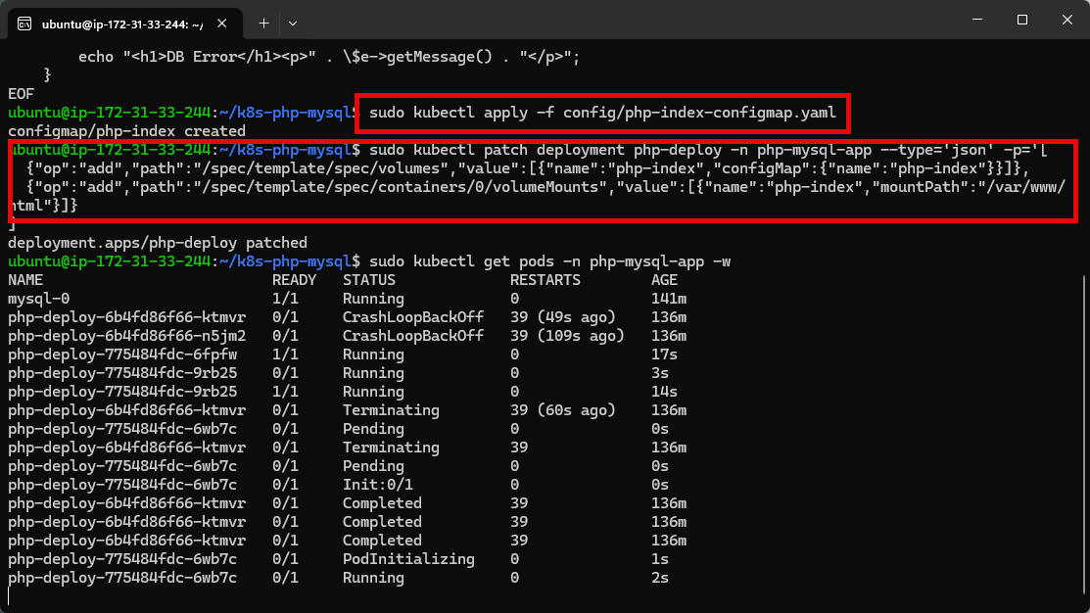
Redeployed Php nodes

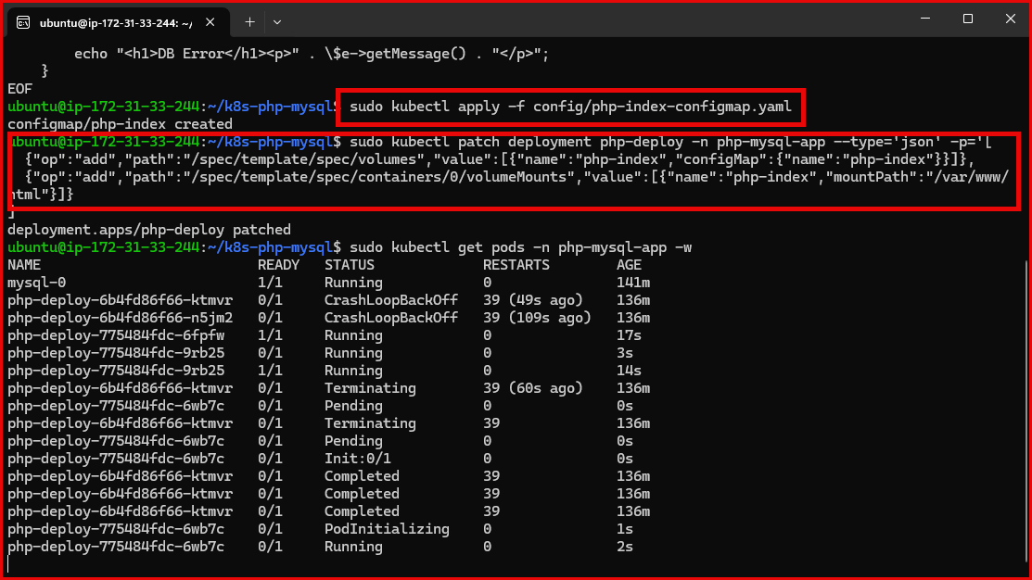
Redeployed Php nodes
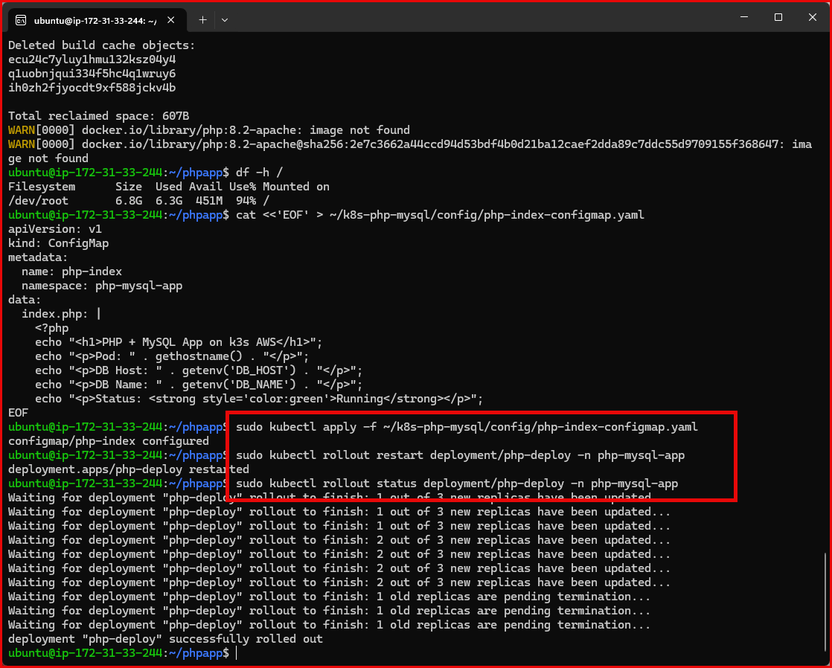
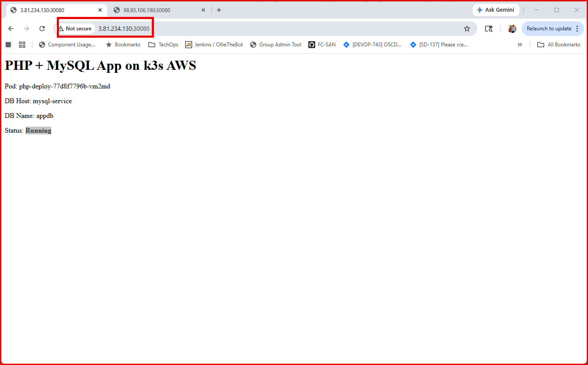
k3s-worker1
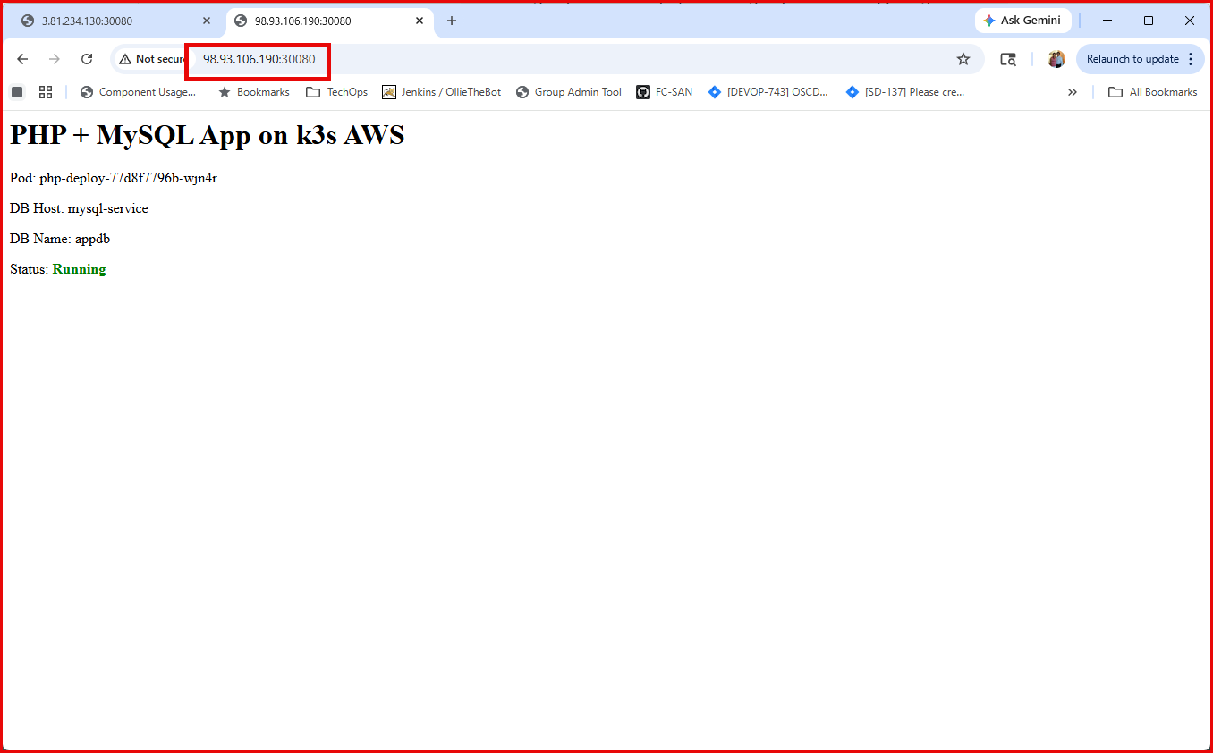
k3s-worker2

