Author: Ieng Lao
Course-end Project 4
Description
To create an automation script to deploy an application using Ansible
Real-time scenario:
You have joined as a DevOps engineer in XYZ Pvt. Ltd. It is a platform where individuals can create their profile and start blogging on various topics. The application is ready to be hosted on a server. You are tasked with implementing an Ansible script to deploy this application on a remote Nginx server.

Industry Relevance
The following tools used in this project serve specific purposes within the industry: 1. Ansible: Ansible automates IT tasks, streamlining configuration management, application deployment, and orchestration. It uses simple, human-readable YAML files called playbooks, allowing easy setup and management of complex IT environments.

Architecture Overview
(Local Machine)
|
| Ansible (SSH)
v
(Remote Server)
├── Nginx (Web Server)
├── App Files (HTML / Node / Python)
└── Running Service

Project Structure
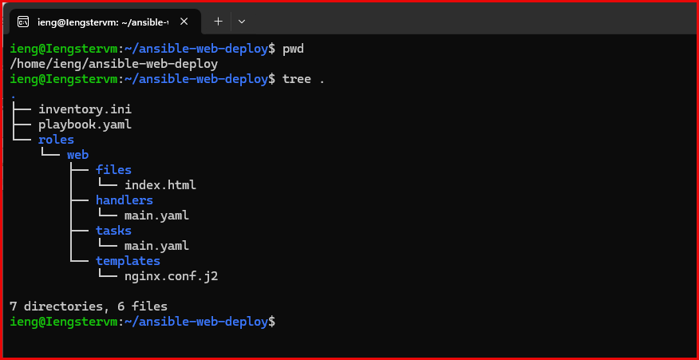

1 – Inventory File
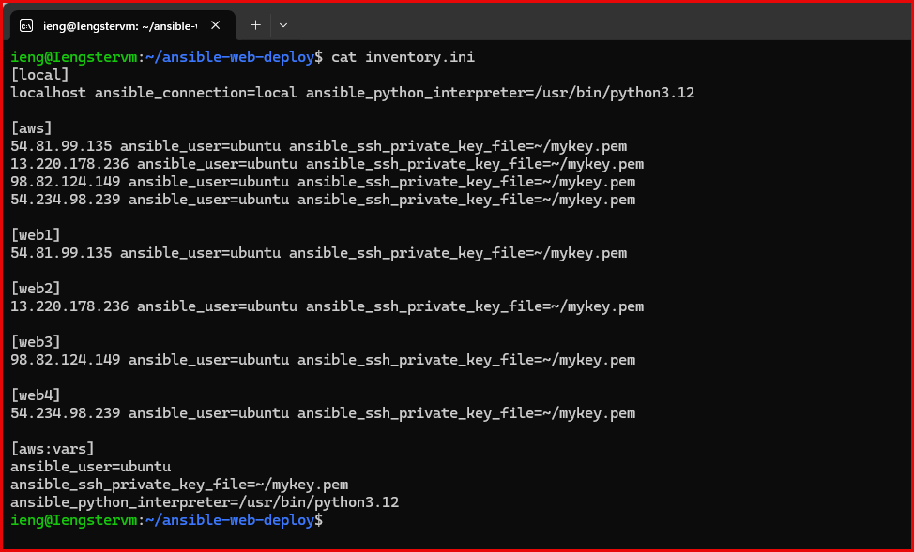

2 - Main Playbook
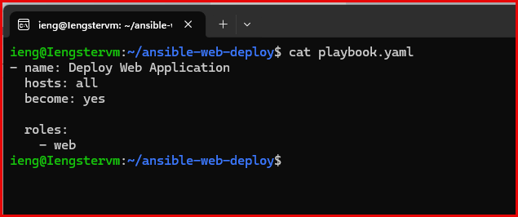

3 - Role: tasks/main.yml
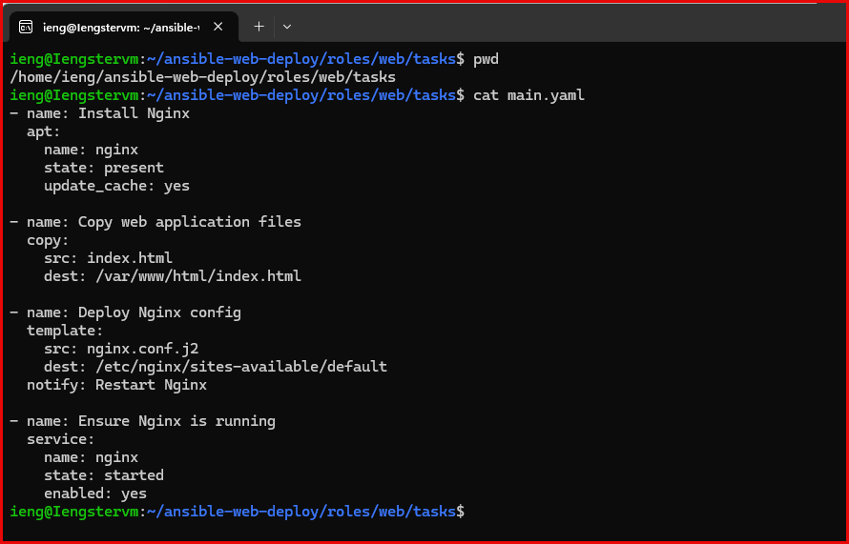

4 - Application File (Simple Demo)
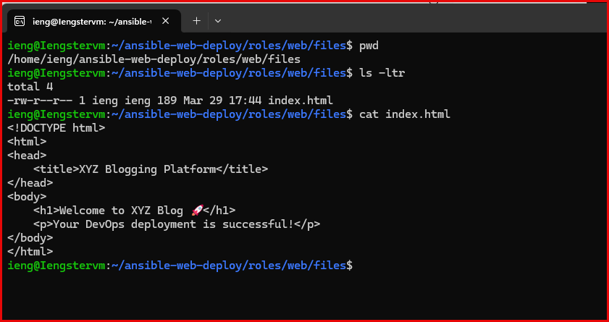

5 - Nginx Template
roles/web/templates/nginx.conf.j2
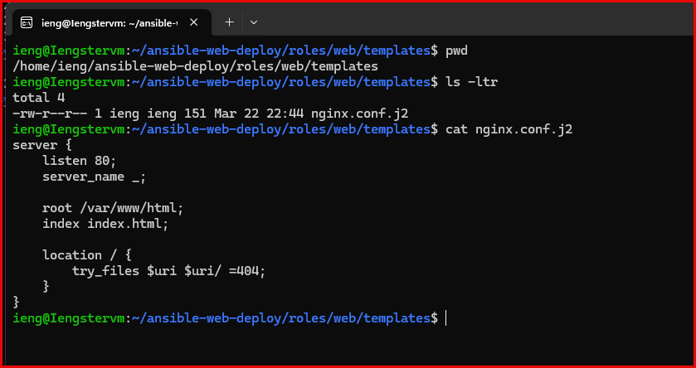

6 – Handlers
/roles/web/handlers/main.yaml
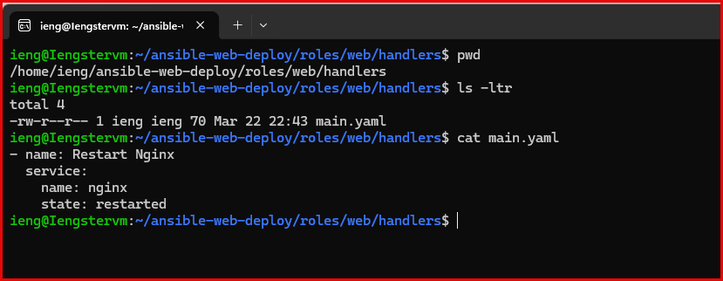

7 – Run the Playbook
$ ansible-playbook -i inventory.ini playbook, yaml —limit web2

Screen shots from the console outputs:
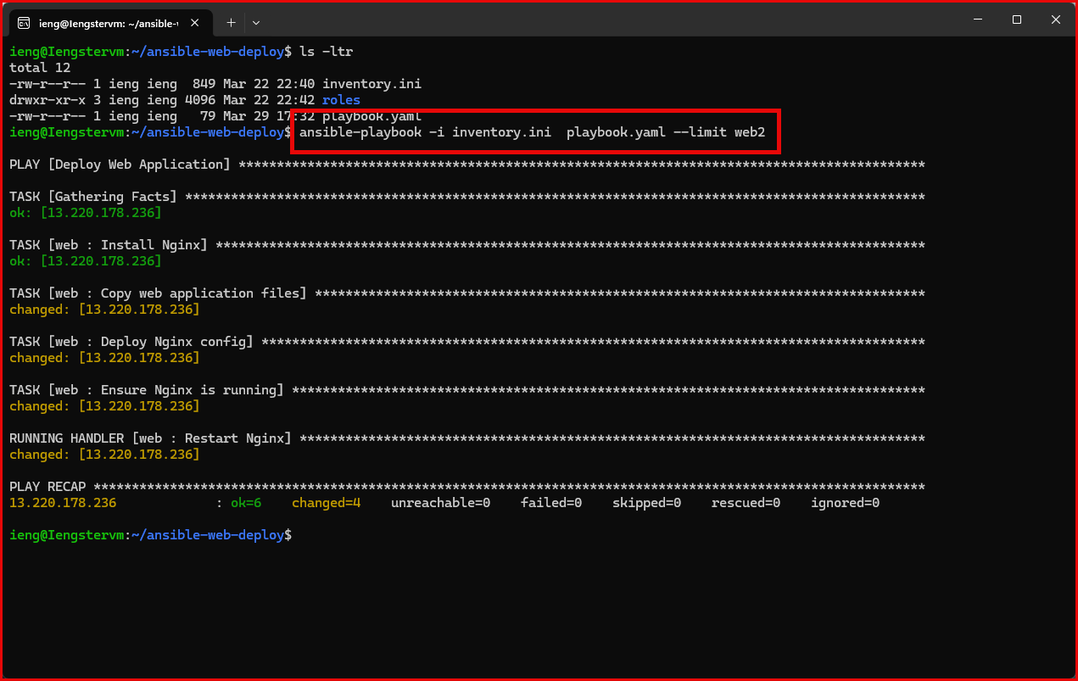

Application Output:
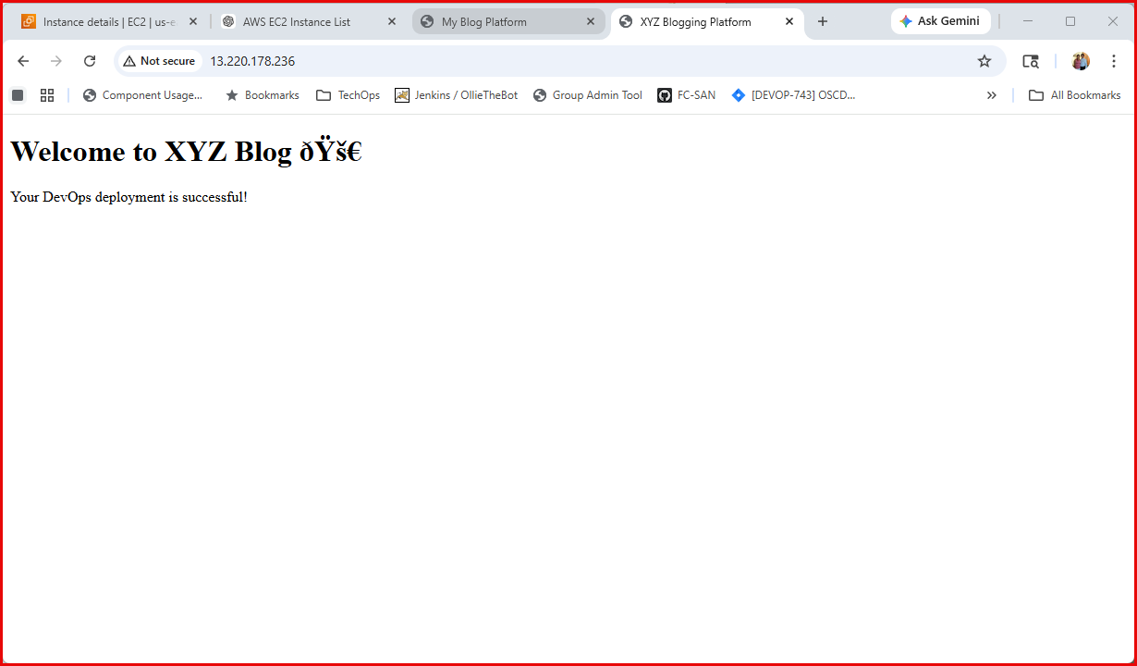

EC2 instance used for this project
