Author:Ieng Lao
Jenkins Backup and Restore on AWS S3
Course-end Project 2
Description
To implement a reliable backup and restore process for an application data using Jenkins servers and AWS S3, ensuring data protection and easy recovery
Real-time scenario:
You are a DevOps Engineer at TechNova Inc., which relies heavily on Jenkins for continuous integration and deployment of its various applications. The company recently experienced a critical incident where the Jenkins server crashed, resulting in the loss of important build configurations and job data.
To mitigate the risk of future data loss and ensure business continuity, you are tasked with implementing a backup and restore solution for Jenkins using AWS S3. This solution must securely store Jenkins data in S3, automate backups, and facilitate a quick restore process in case of server failure.
Your tasks include setting up automated scripts for backups, configuring IAM roles for secure access, and testing the restore process to ensure that Jenkins can be rapidly restored with minimal downtime.
Industry Relevance
The tools used in this project each serve specific purposes within the industry:
- Jenkins: It is a leading automation tool for CI/CD, streamlining the build, test, and deployment process in DevOps workflows. It is widely adopted across industries due to its extensibility through plugins and robust community support.
- Git: It is the industry standard for version control, enabling efficient collaboration, code tracking, and integration in CI/CD pipelines. Its versatility and open-source nature make it essential for modern software development.
- AWS: It is the top cloud service provider, offering scalable and secure cloud infrastructure for businesses of all sizes. It supports high availability, compliance, and a wide range of services that drive innovation and operational efficiency

Below are the outlines of what I have done:
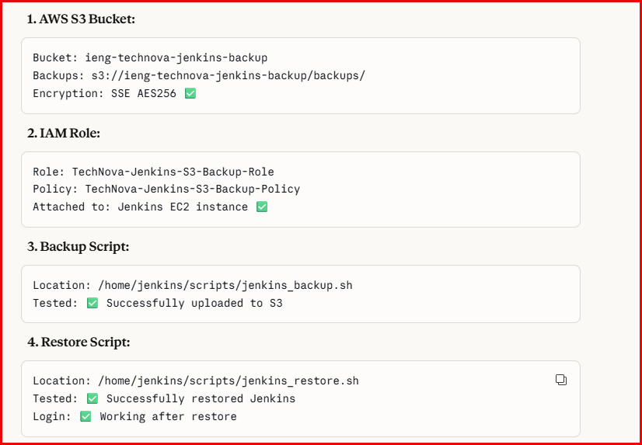

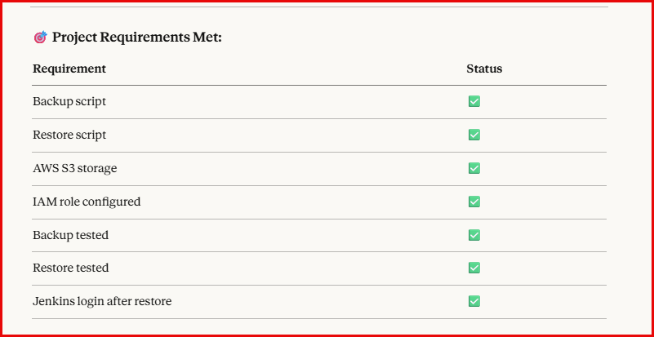
Part 1 – Screenshots
Create S3 Bucket
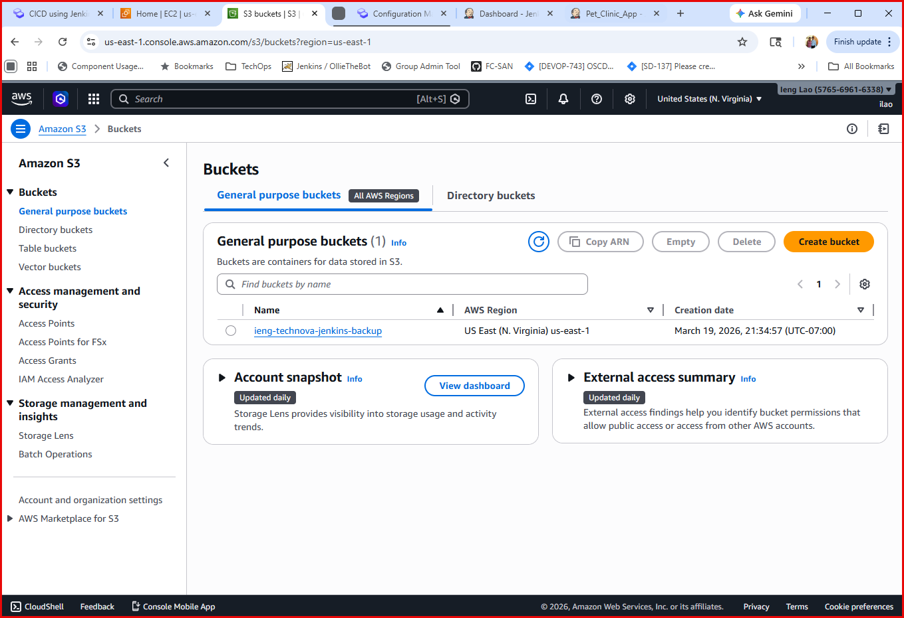
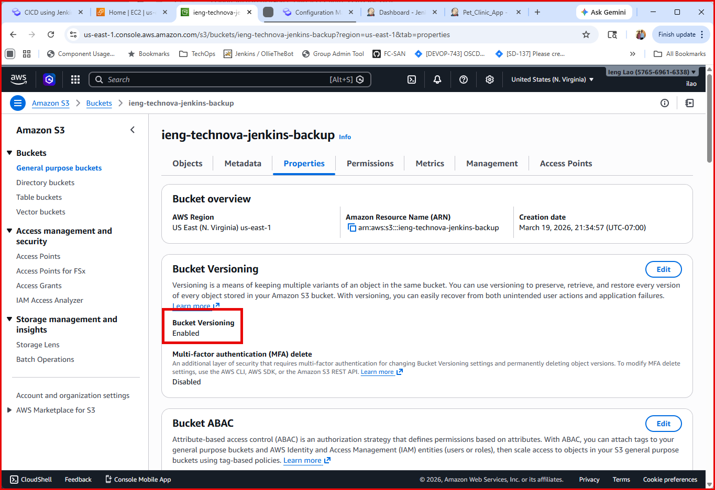
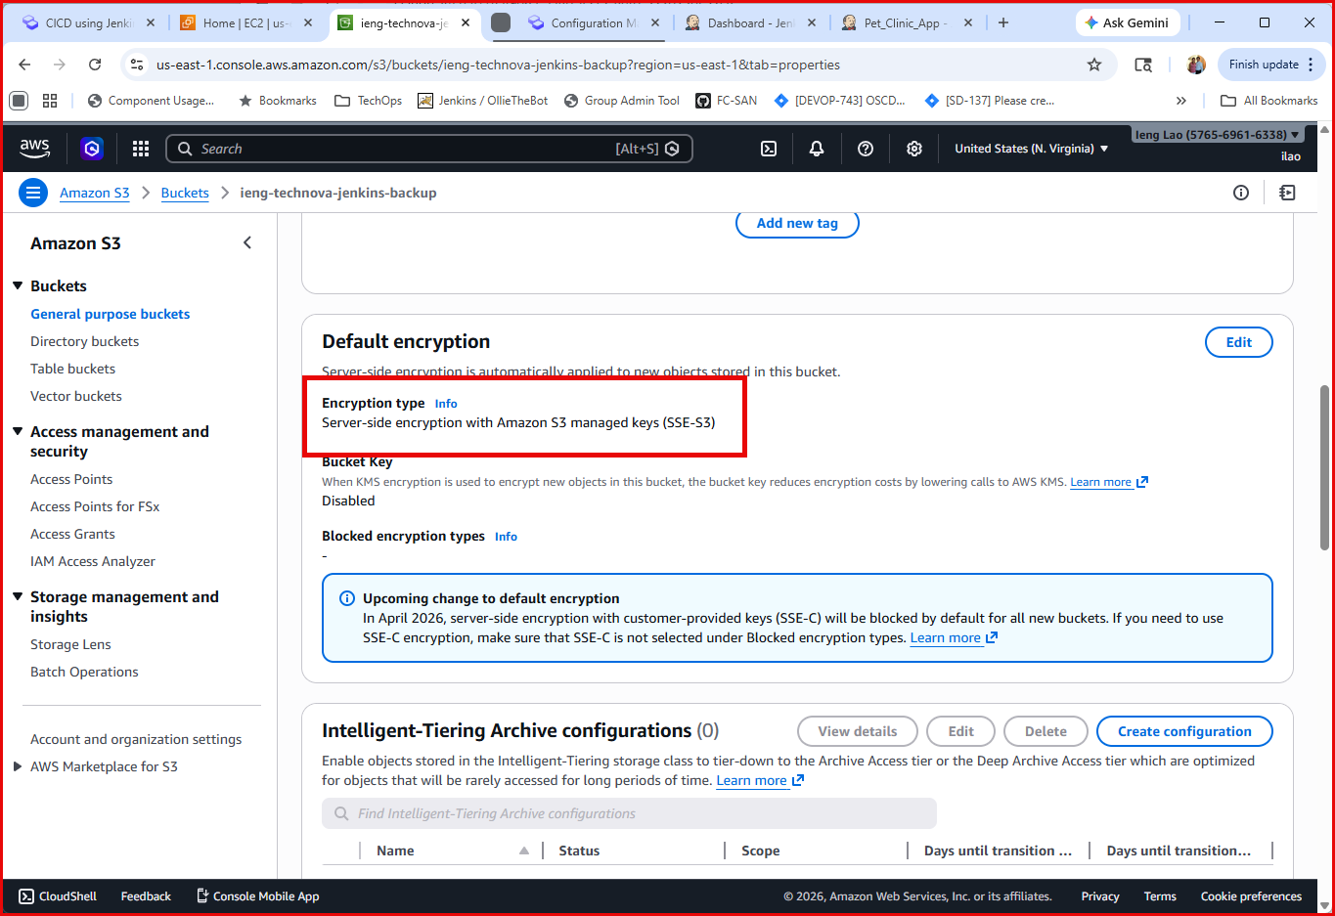

Create Access Policy
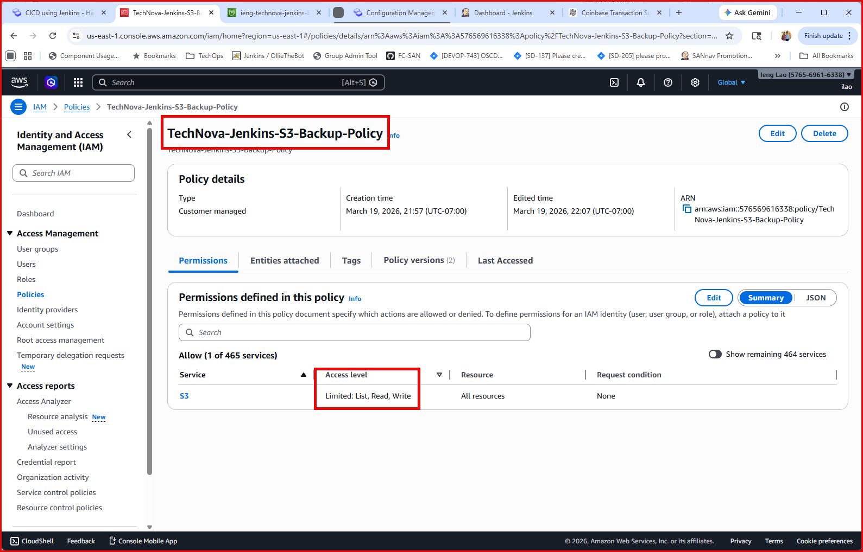
Create A New Role - TechNova-Jenkins-S3-Backup-Role and assigned policy
TechNova-Jenkins-S3-Backup-Policy to it.

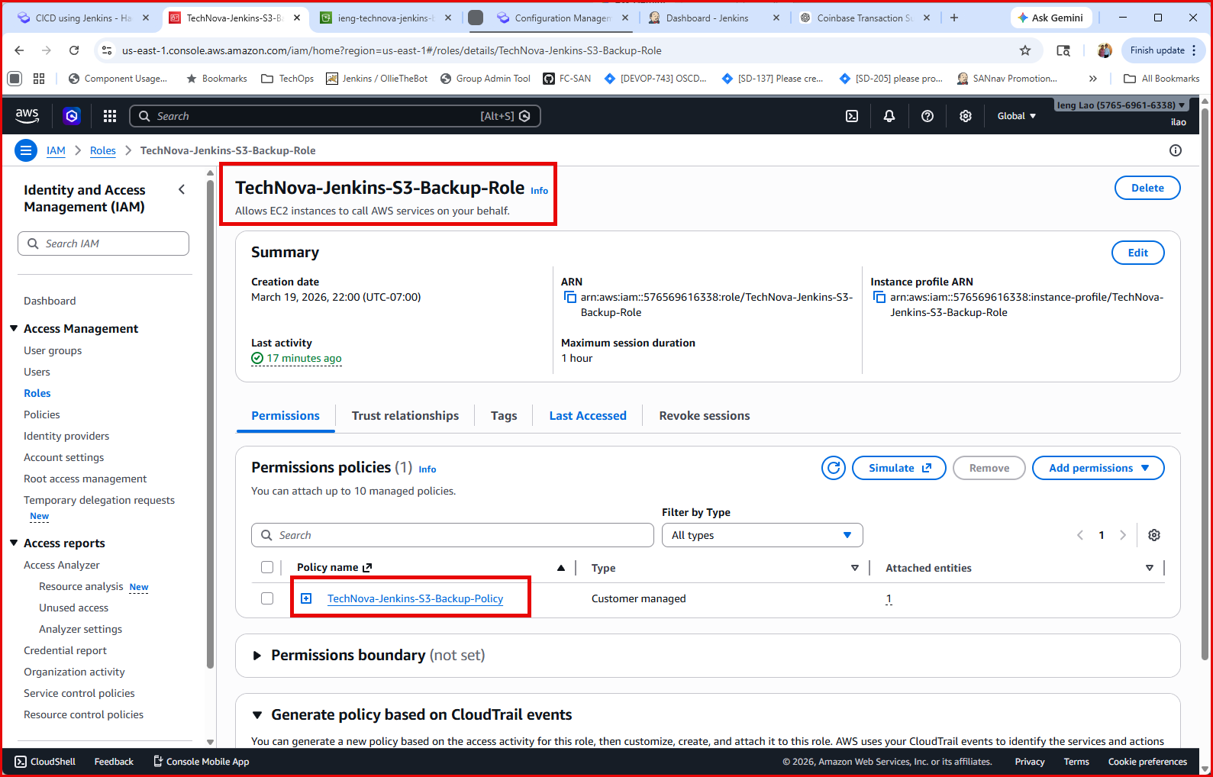

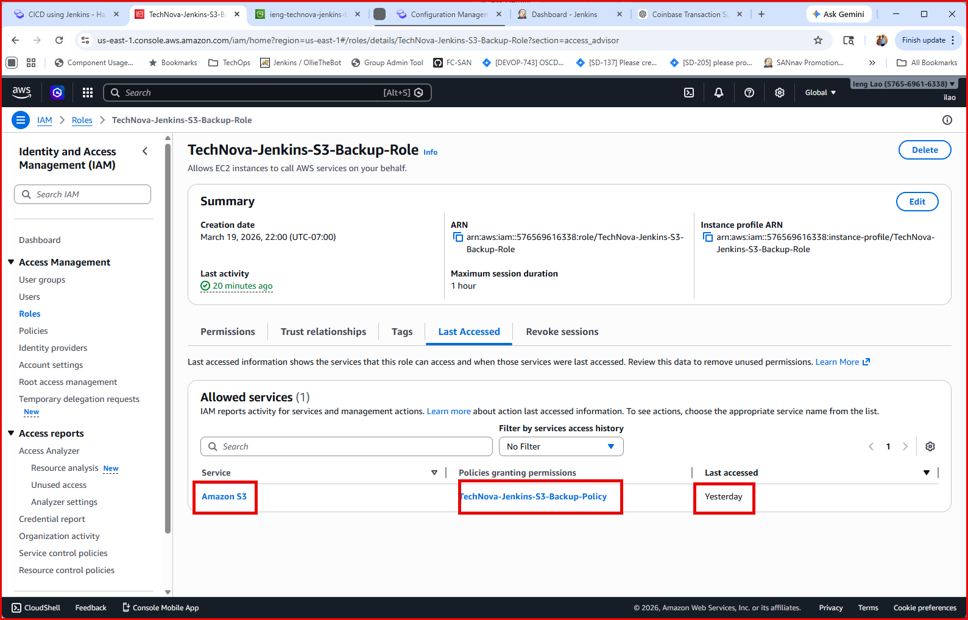
Attached Role to EC2 Jenkins instance
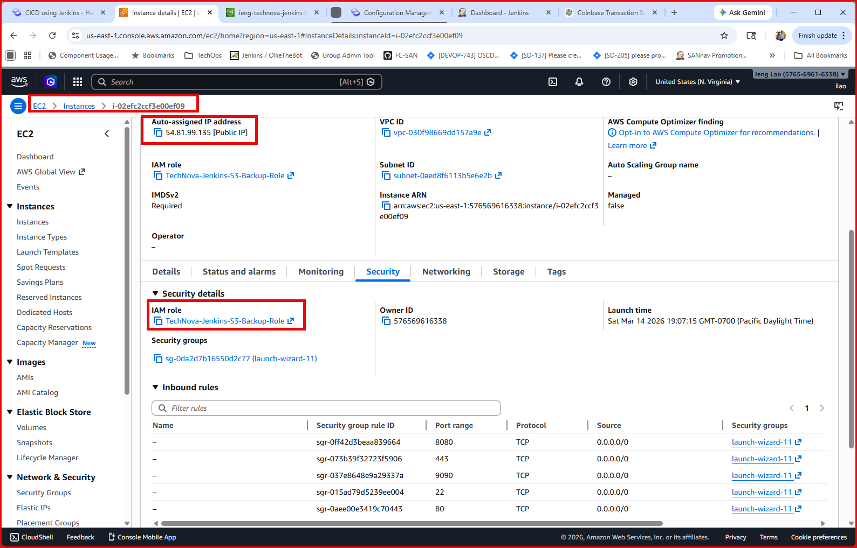

Run Backup Script – jenkins_backup.sh
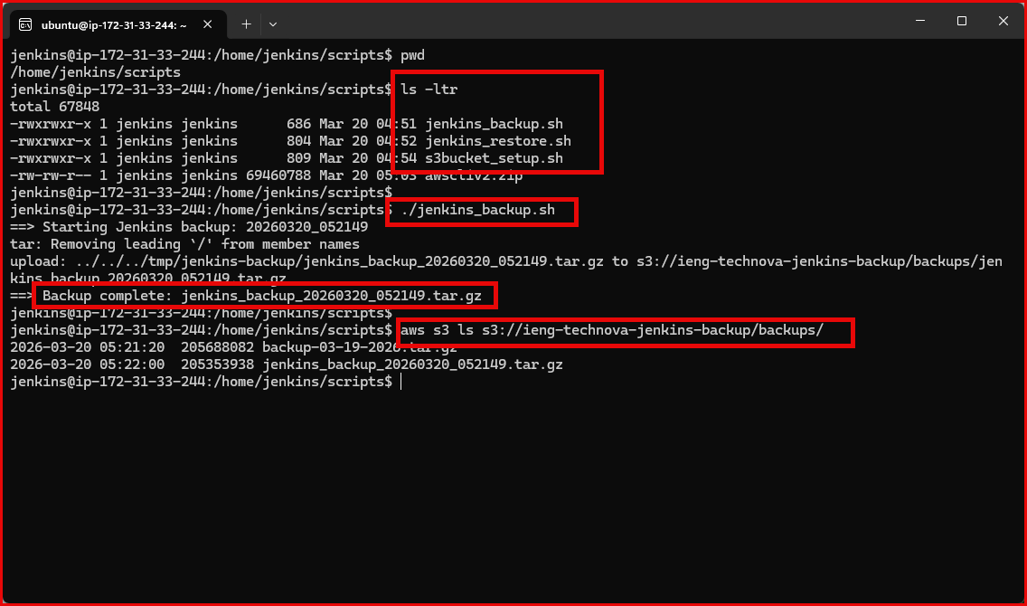

Run Restore Script – Jenkins_restore.sh
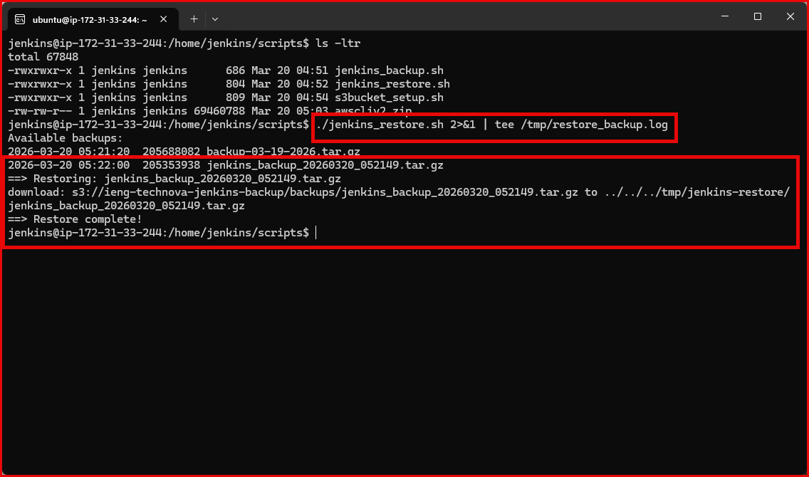
Jenkins System Back Online
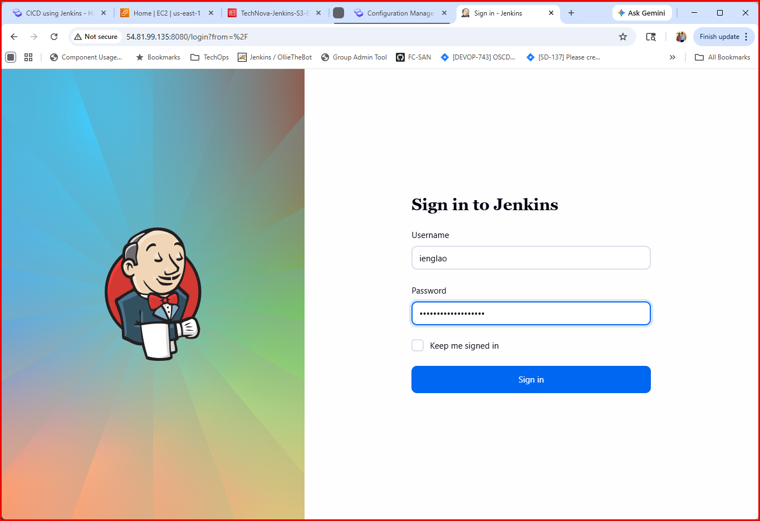

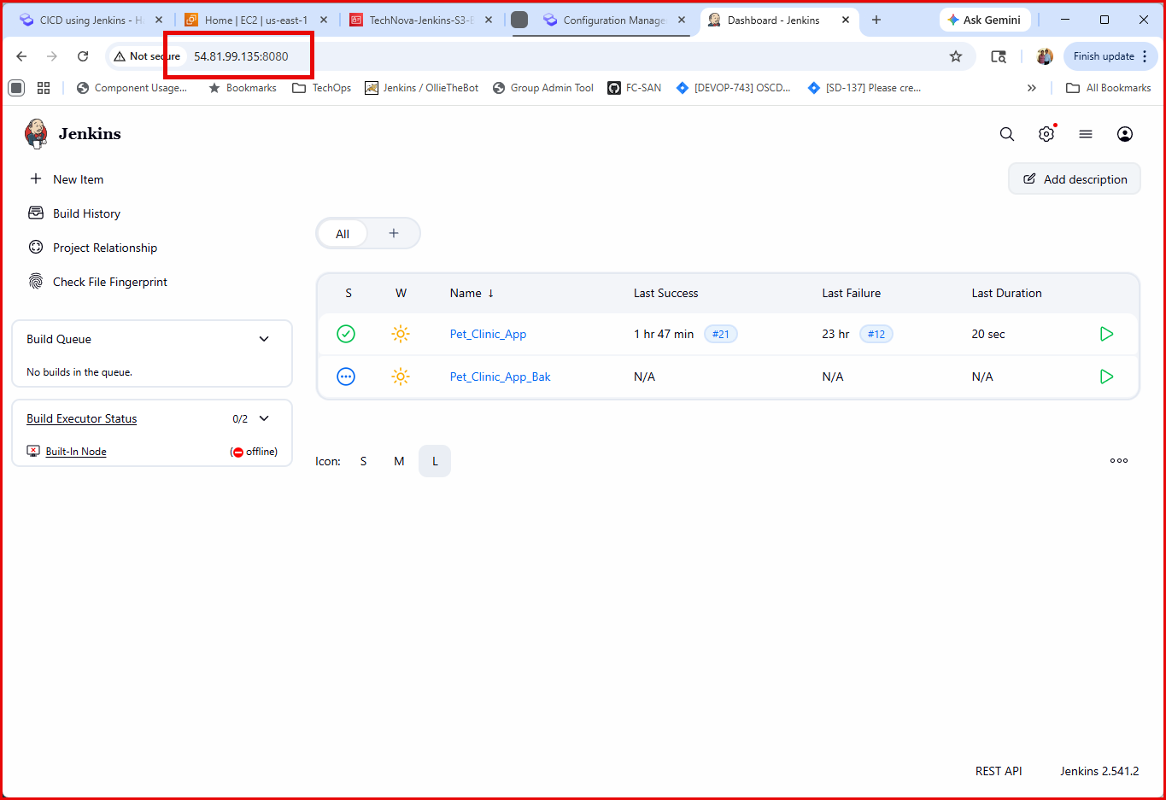
Backup File Copied to S3 Bucket
