Deploying Multi-Tier Application
Course-end Project 5
Author: Ieng Lao
Description
To demonstrate the deployment of a multi-tier application using Docker compose, including configuring public IP addresses and setting up necessary security group rules for accessing the frontend, API, and database services.

Real-time scenario: A user is tasked to deploy a multi-tier application on a cloud-based virtual machine using Docker Compose. After installing Docker, Docker Compose, and Git, they clone the application repository and update configuration files with the machine's public IP to ensure proper communication between the frontend, API, and backend components.
Post these updates, the user runs docker compose to bring up the application, adjust the security group settings to allow traffic on specific ports (8080, 5000), and verify the deployment by accessing the application via the public IP. This confirms that all components are accessible and functional.
Multi-Tier Application Deployment
Docker Compose · Cloud VM · Frontend + API + Database
Course-End Project 5 Docker Compose 3-Tier Architecture

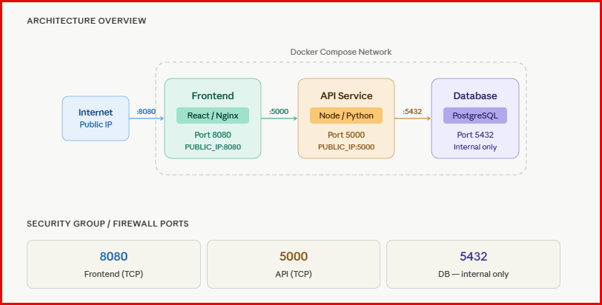

Below are the steps to implement this project:
1 - • Provisioning and SSH into the cloud VM or AWS
2 - Installing Docker, Docker Compose, and Git
3 - Cloning the application repo
4 - Updating config files with the public IP (including sed one-liners)
5 - Reviewing the docker-compose.yml structure
6 - Running docker compose up -d --build and checking logs
7 - Configuring security group rules (ports 8080, 5000 open; 5432 internal only)
8 - Verifying all three tiers are accessible and healthy

1 - • Provisioning and SSH into the cloud VM or AWS
In this step, I choose to provisioning an AWS instance instead of VM.
Step 1: Launch EC2 Instance
- Go to AWS Console → EC2 → Launch Instance
- Configure:
Basic settings
- Name: multi-tier-app-server
- AMI: Ubuntu 20.04 or 22.04
- Instance type: t2.micro (free tier)
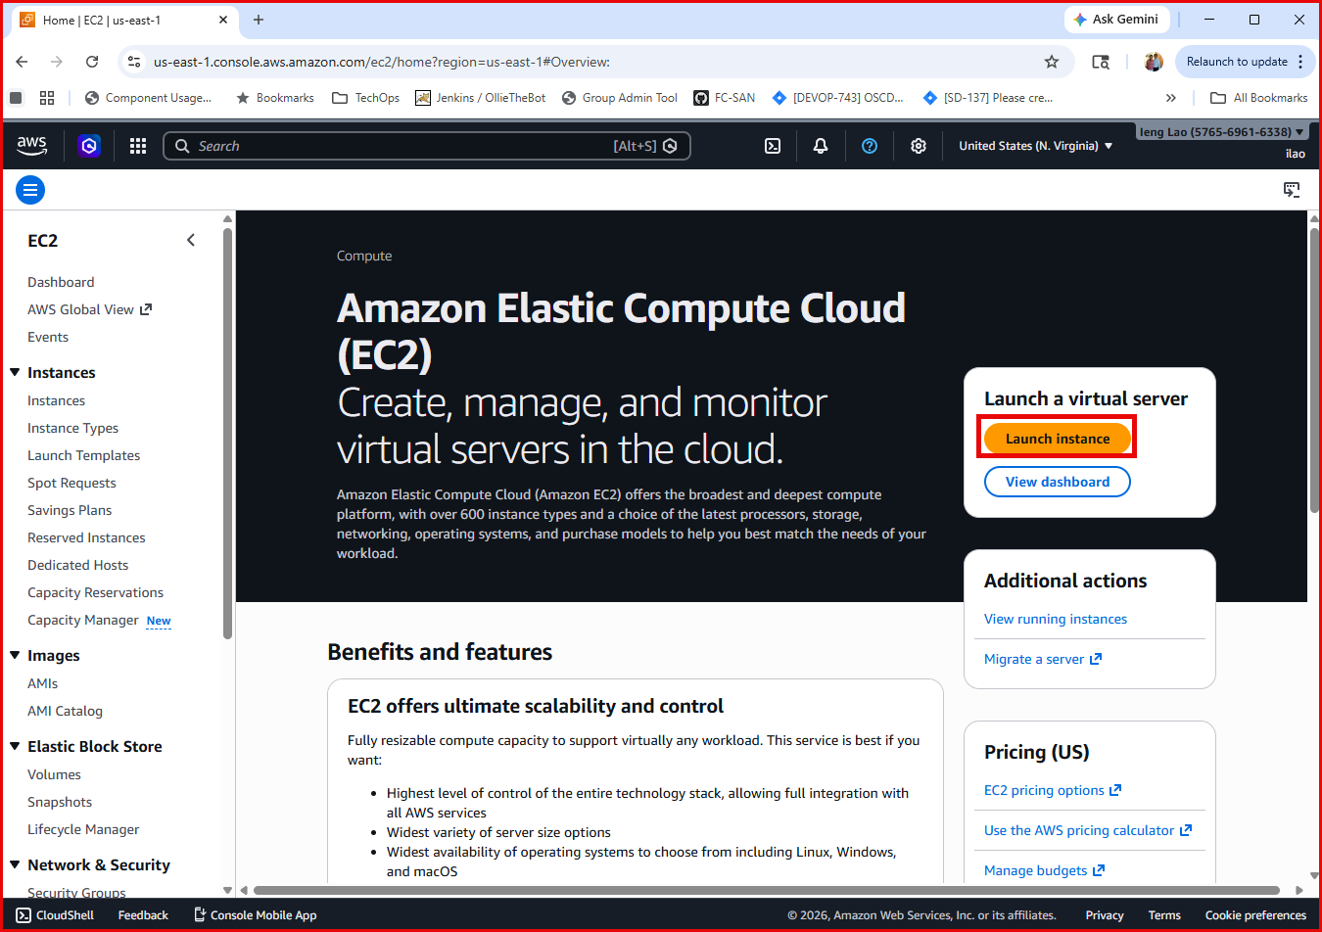
Login to AWS instance

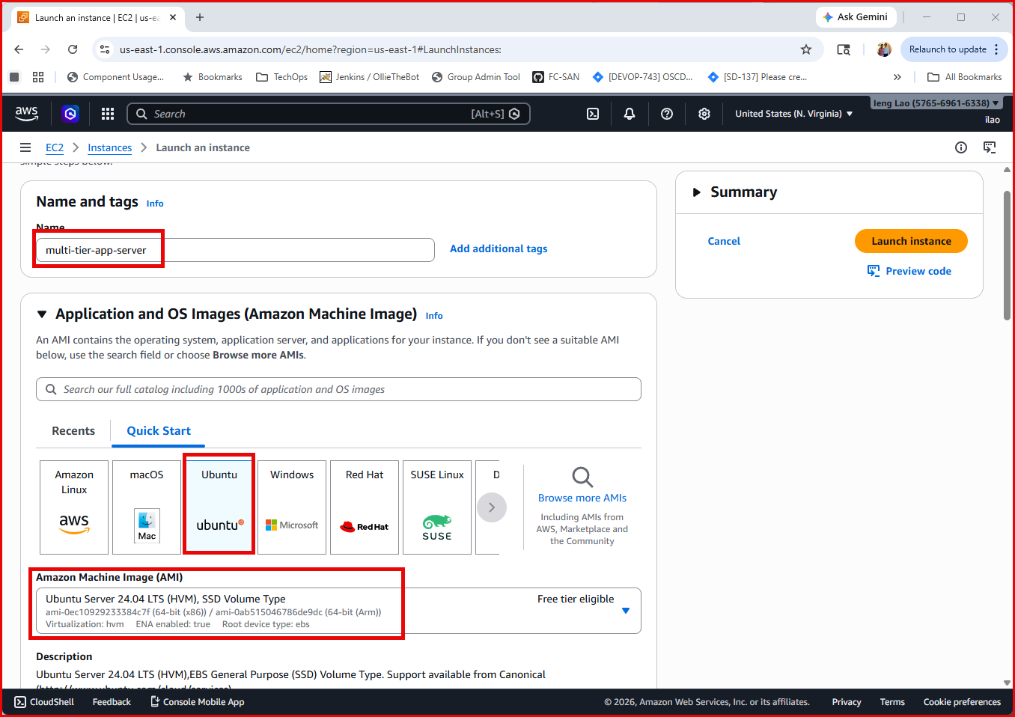
Launch Create Instance
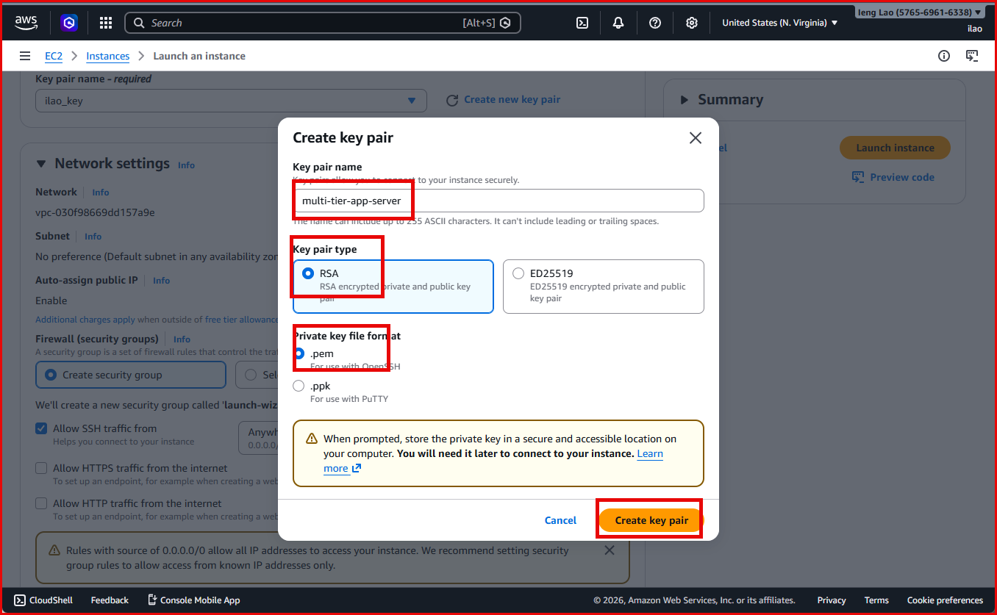
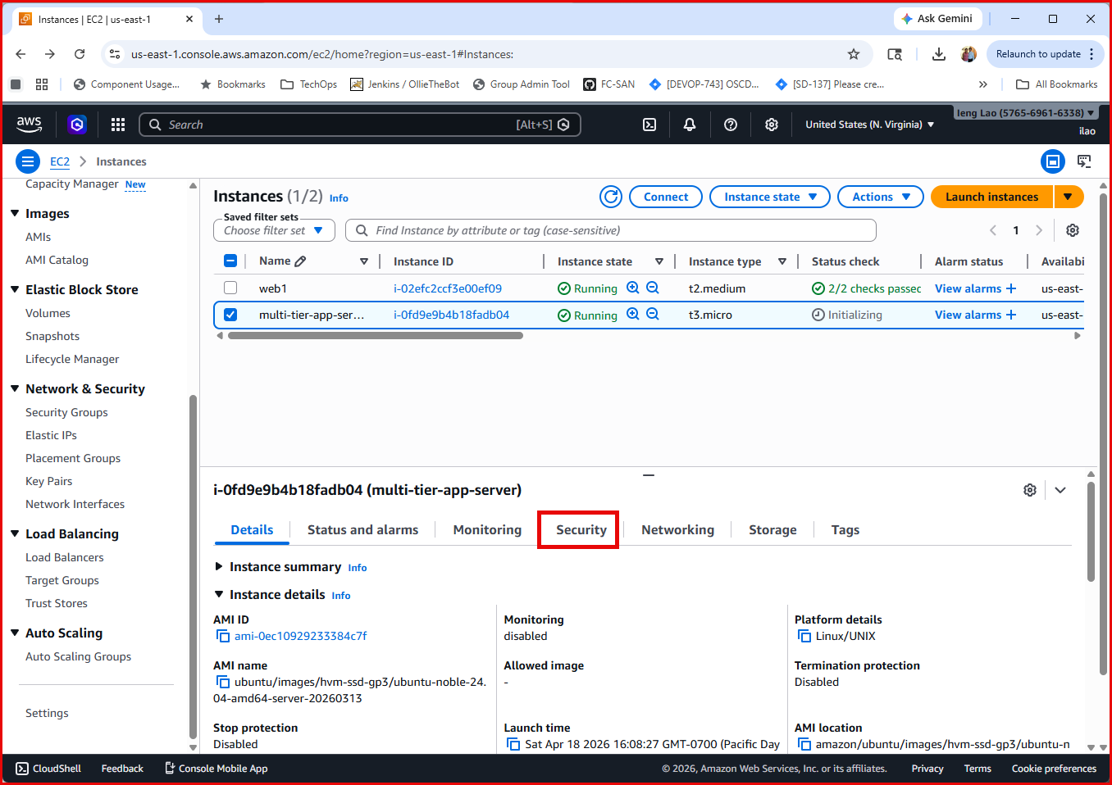
Create new key pair, download .pem file, and keep it safe

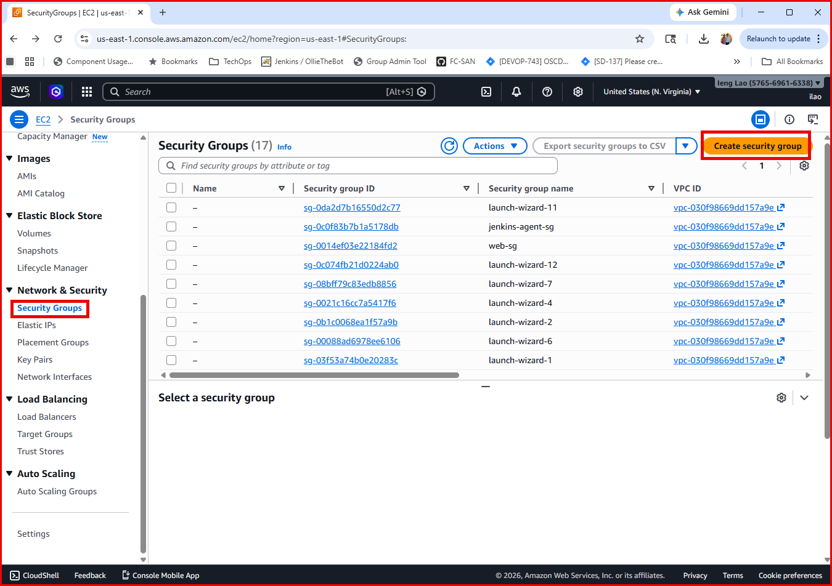
Select Security Groups & Click on Create security group
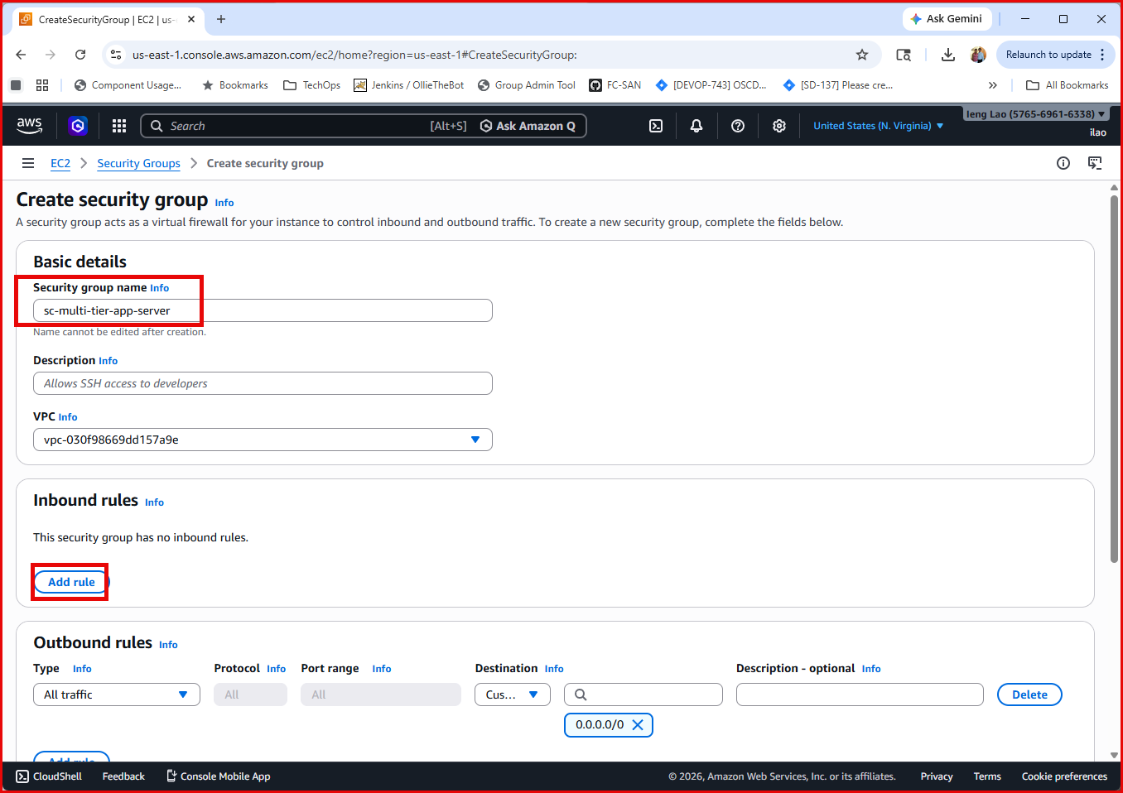
Enter sc-multi-tier-app-server for the security group name. Click Add Inbound rules.

These are the Inboud rules and ports settings:
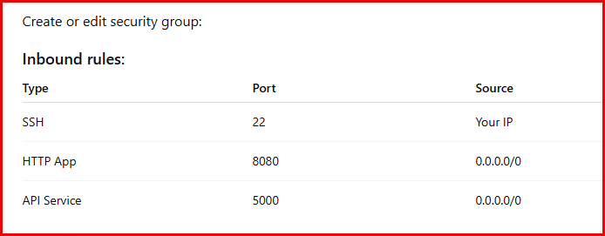

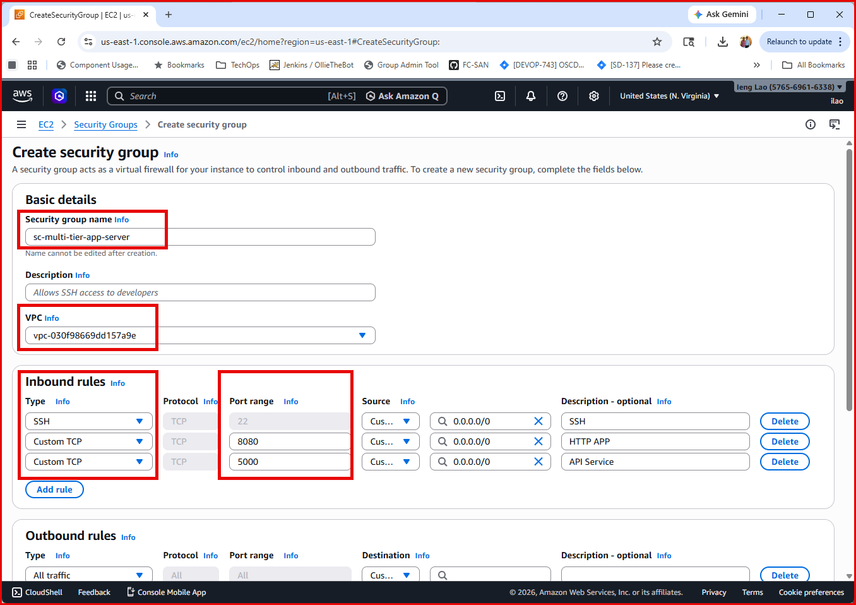
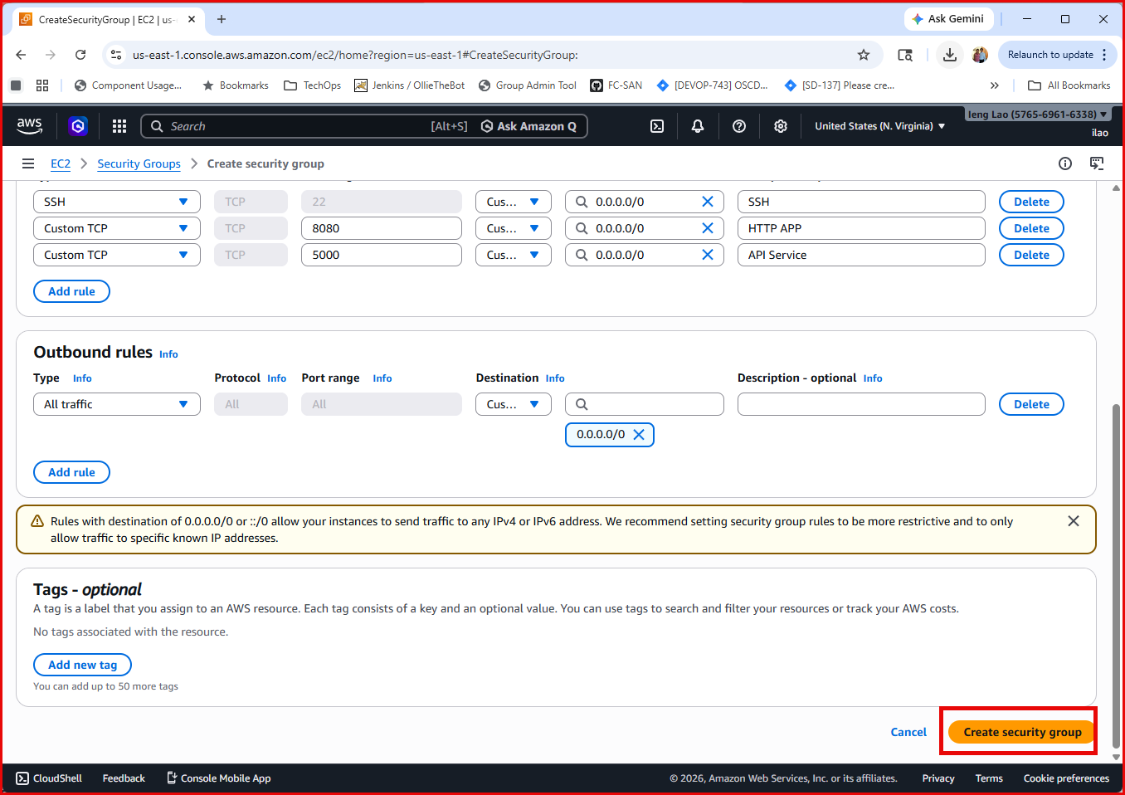
Scroll down and click on Create security group button.
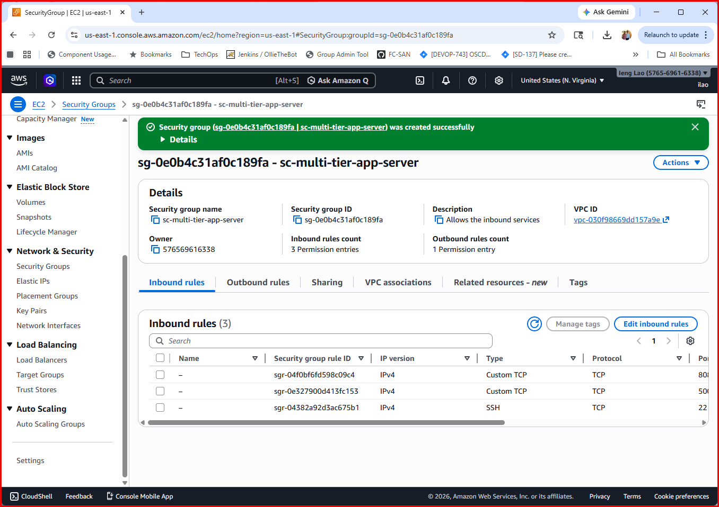
Security group created successfully.
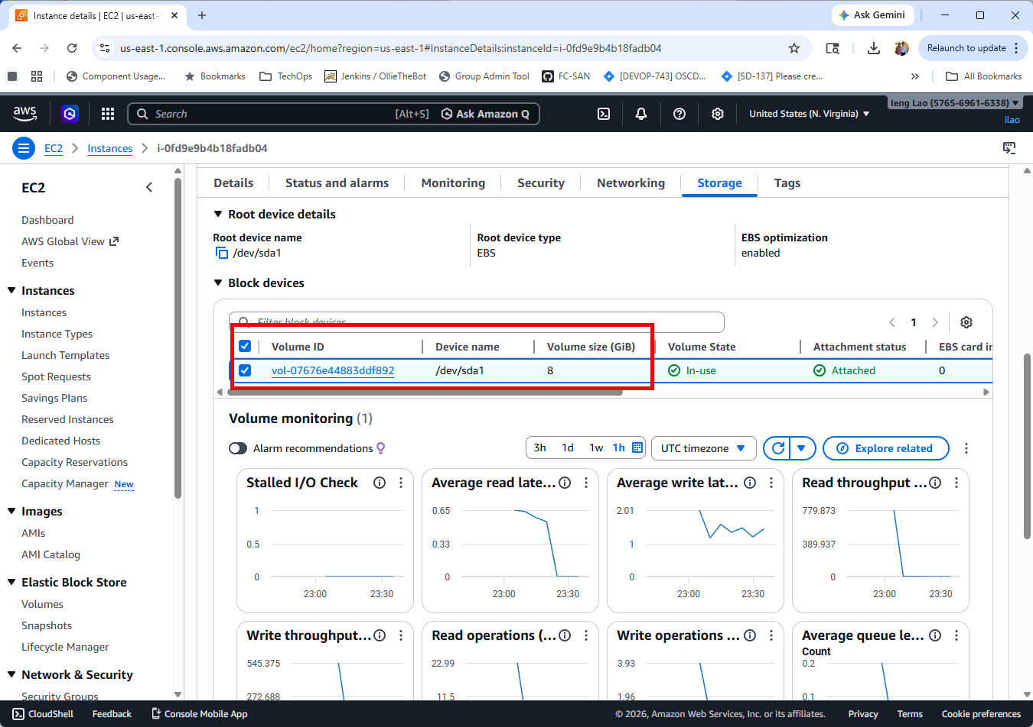
Default: 8 GB is fine

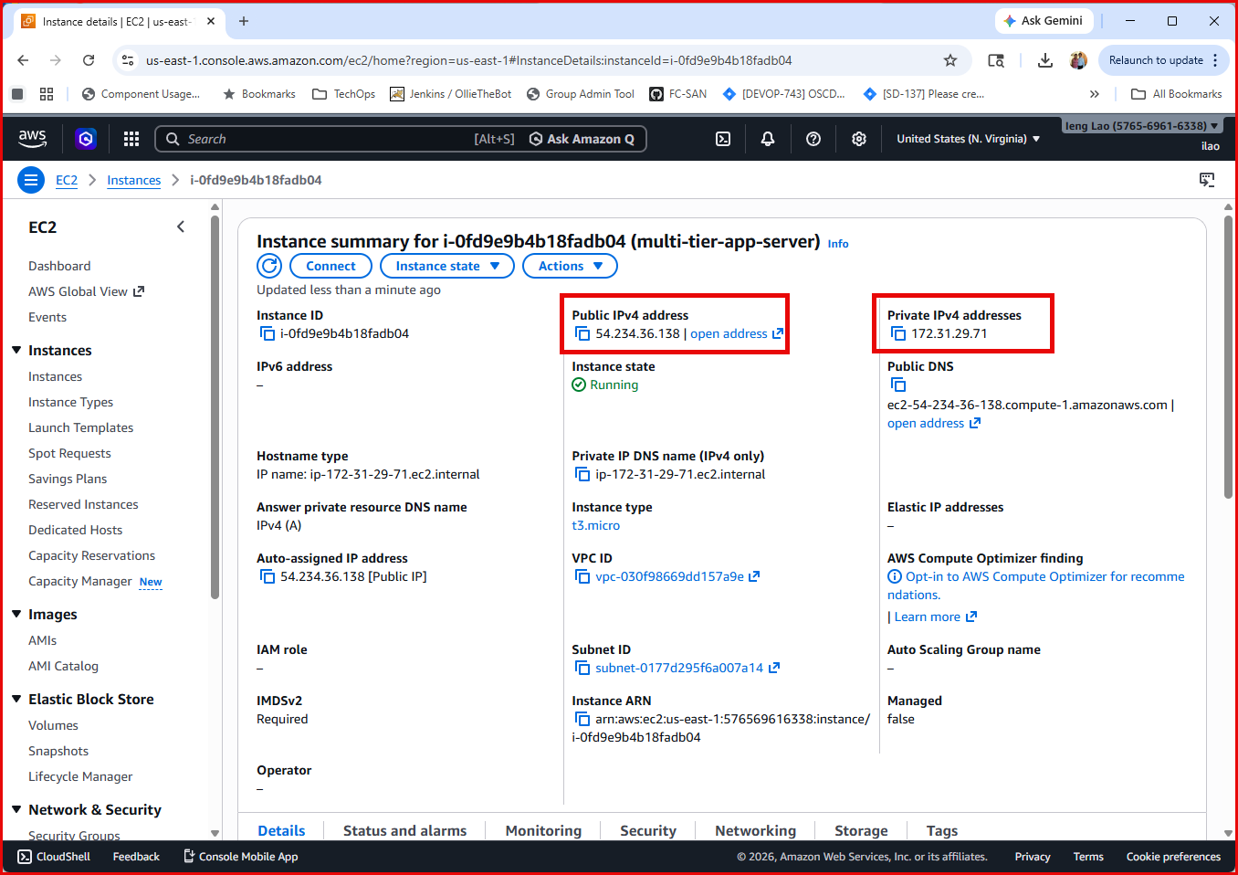
Public IPv4 address: 54.234.36.138
Private IPv4 addresses: 172.31.29.71
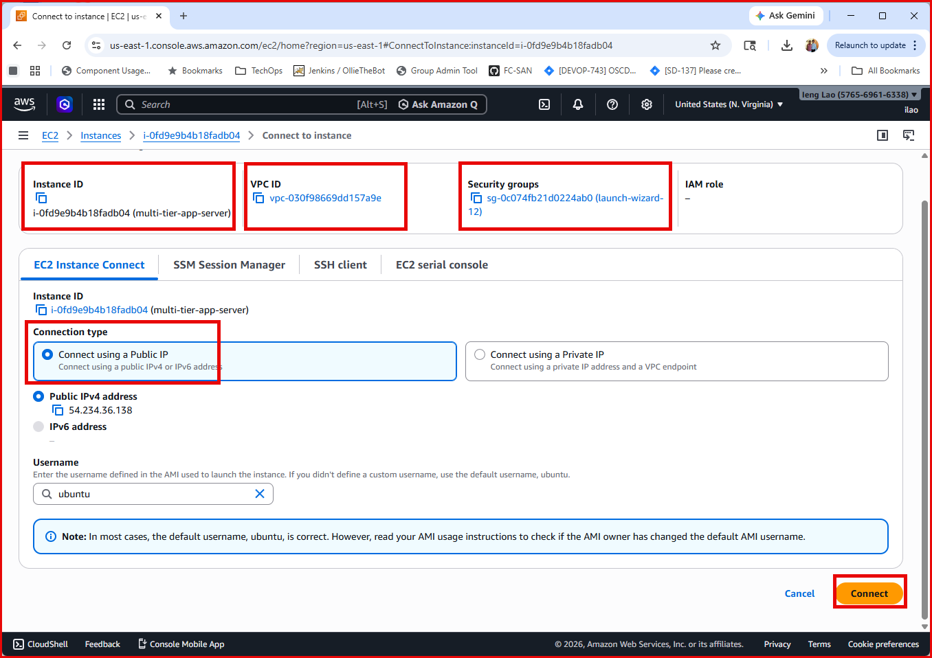
Connect to your EC2 instance.

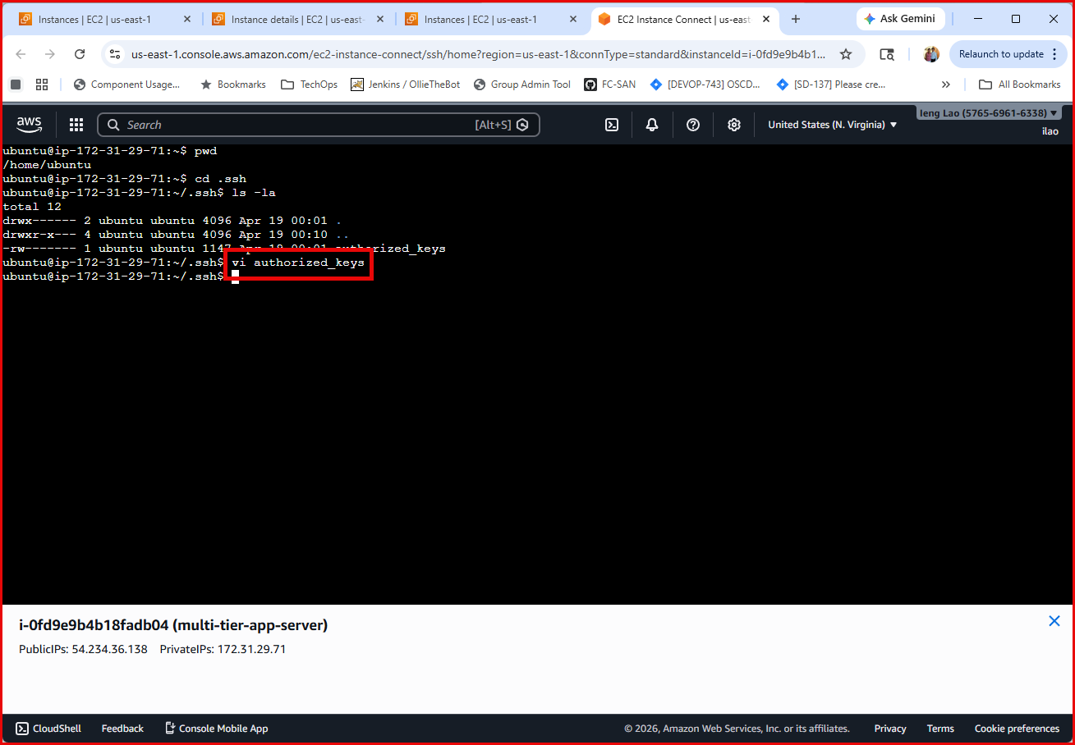
Vi ~/.ssh/ authorized_keys and add your personal public key from your local Ubuntu machine.

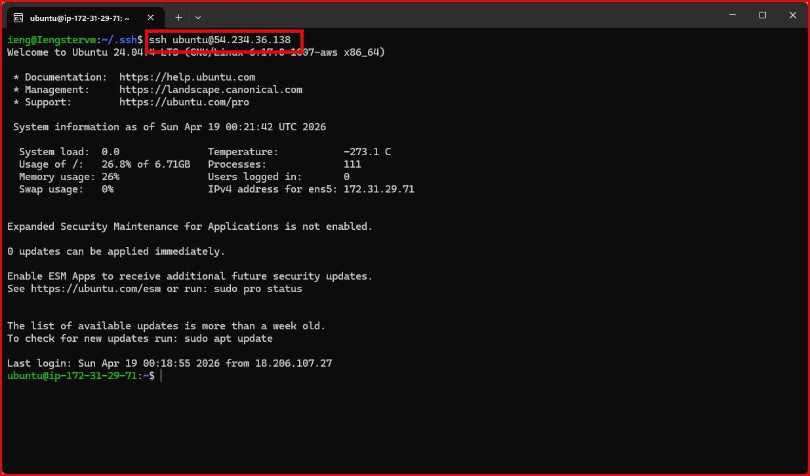
Now, I can ssh from my Windows Subsystem for Linux (WSL).

2 - Installing Docker, Docker Compose, and Git
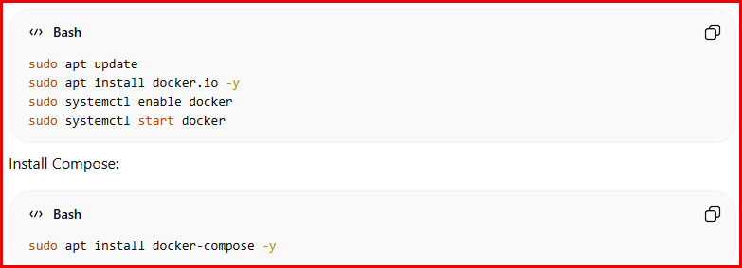
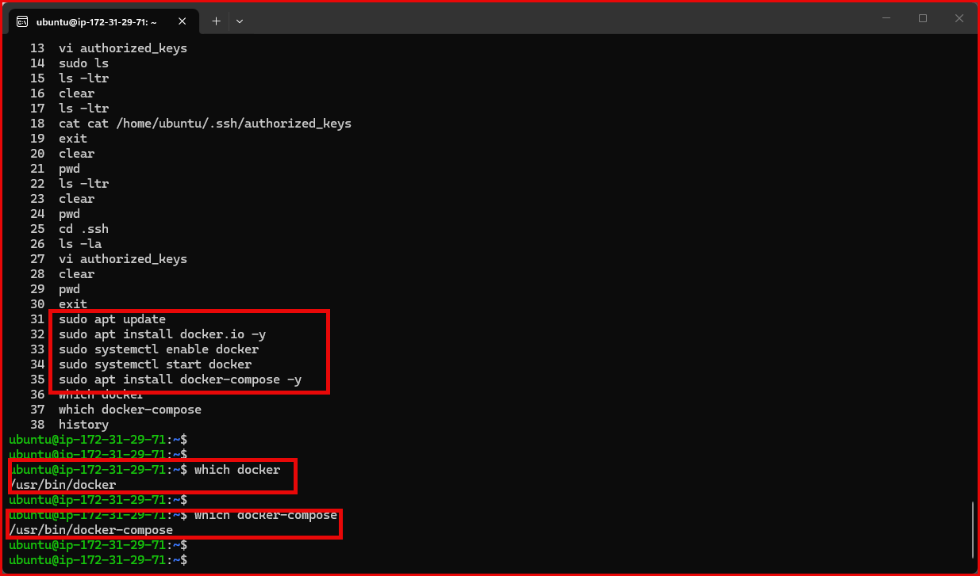
I have installed docker and docker-compose.

3 - Cloning the application repo
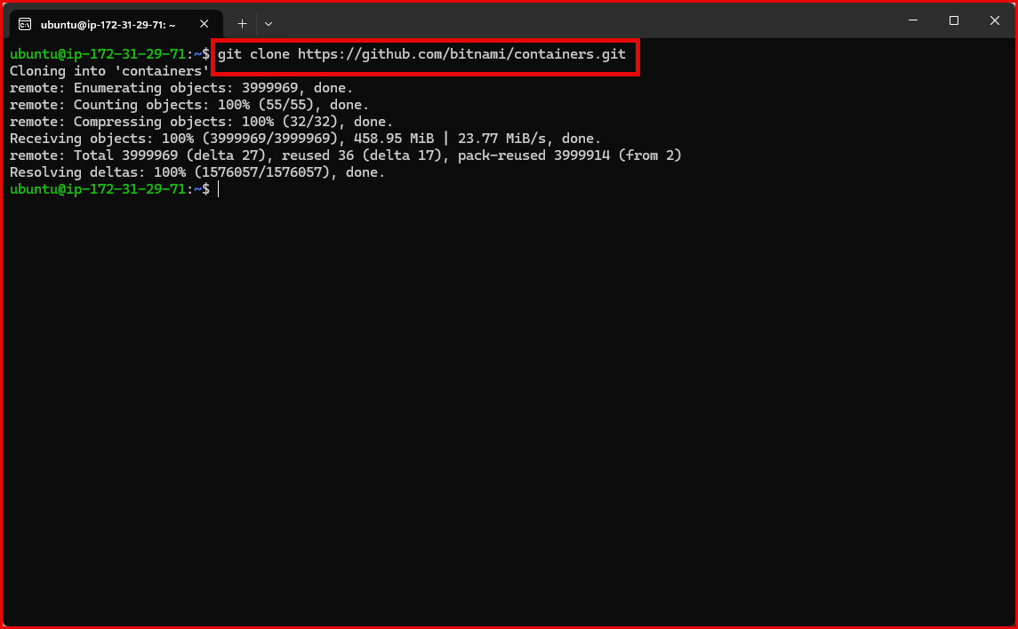
$git clone https://github.com/docker/awesome-compose.git
$cd awesome-compose/nginx-flask-mysql
4 - Updating config files with the public IP (including sed one-liners)
🧱 Step 1: Go to project
$cd ~/awesome-compose/nginx-flask-mysql
Step 2: Fix Backend (Flask)
$vi backend/hello.py
🔄 Change LAST line
From server.run()
To: server.run(host="0.0.0.0", port=5000)
✔ Save and exit
Step 3: Fix Nginx (Frontend)
$vi proxy/conf
🔄 Change LAST line
From; proxy_pass http://backend:8000;
To: proxy_pass http://3.120.xx.xx:5000;
Step 4: Fix Docker Compose
$cd /home/ubuntu/awesome-compose/nginx-flask-mysql
$vi nano compose.yaml
🔄 Change
From: ports:
- 8000:8000
To: ports:
- 5000:5000

$cd /home/ubuntu/awesome-compose/nginx-flask-mysql/proxy
$vi conf
🔄 Change
From: proxy_pass http://backend:8000;
To: proxy_pass http://54.234.36.138:5000;

🚀 Step 3: Rebuild

$sudo docker-compose down
$sudo docker-compose up -d --build

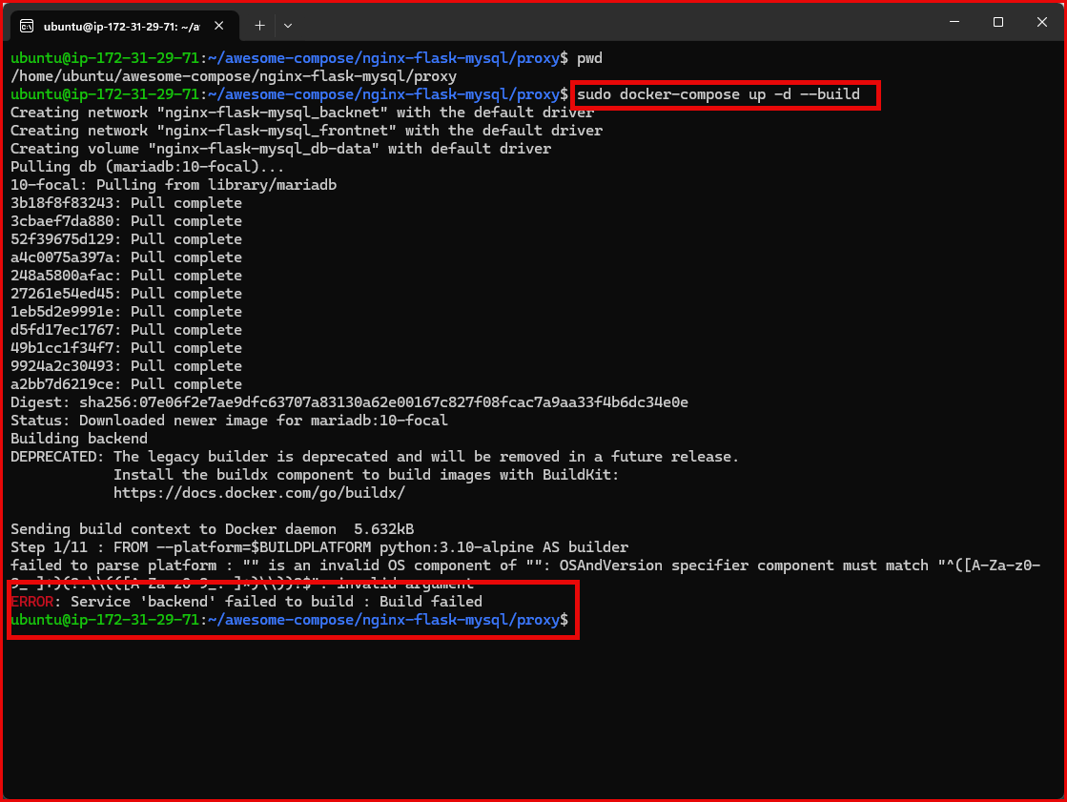
Problem:
failed to parse platform : "" is an invalid OS component

Simple Fix: Edit backend Dockerfile

$cd /home/ubuntu/awesome-compose/nginx-flask-mysql/backend
$vi Dockerfile

Replace
From: FROM --platform=$BUILDPLATFORM python:3.10-alpine AS builder
To: FROM python:3.10-alpine AS builder
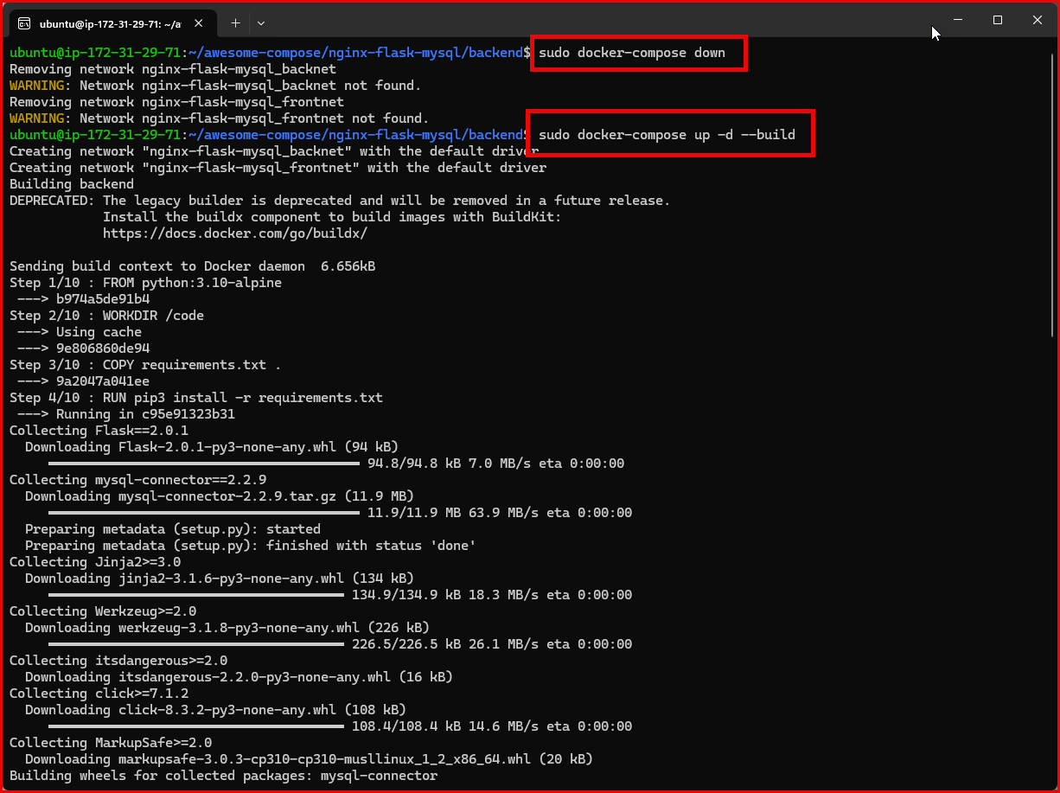
$ sudo docker-compose down
$ sudo docker-compose up -d --build

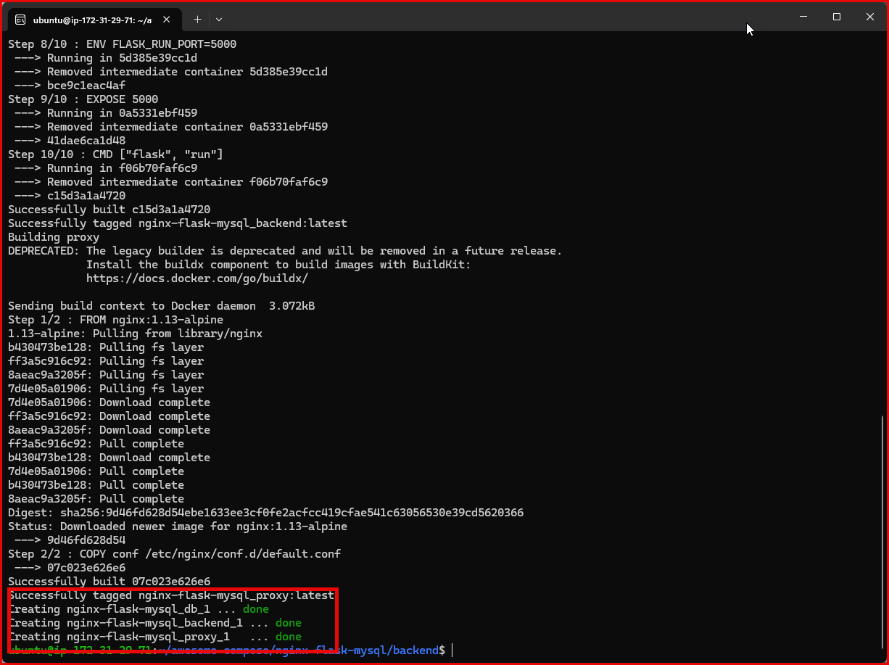
After I spent the next one hour fixing the codes which are outdated. It turned out
the requirement.txt contains the old version of the packages. It needs to change:
From:
ieng@Iengstervm:~/class-project/awesome-compose/nginx-flask-mysql/backend$ $cat requirements.txt
Flask==2.0.1
mysql-connector==2.2.9

TO:
ubuntu@ip-172-31-29-71:~/awesome-compose/nginx-flask-mysql/backend
$ cat requirements.txt
Flask==2.0.3
Werkzeug==2.0.3
mysql-connector-python

ubuntu@ip-172-31-29-71:~/awesome-compose/nginx-flask-mysql/backend$ sudo docker-compose down -v
Stopping nginx-flask-mysql_proxy_1 ... done
Stopping nginx-flask-mysql_backend_1 ... done
Stopping nginx-flask-mysql_db_1 ... done
Removing nginx-flask-mysql_proxy_1 ... done
Removing nginx-flask-mysql_backend_1 ... done
Removing nginx-flask-mysql_db_1 ... done
Removing network nginx-flask-mysql_backnet
Removing network nginx-flask-mysql_frontnet
Removing volume nginx-flask-mysql_db-data
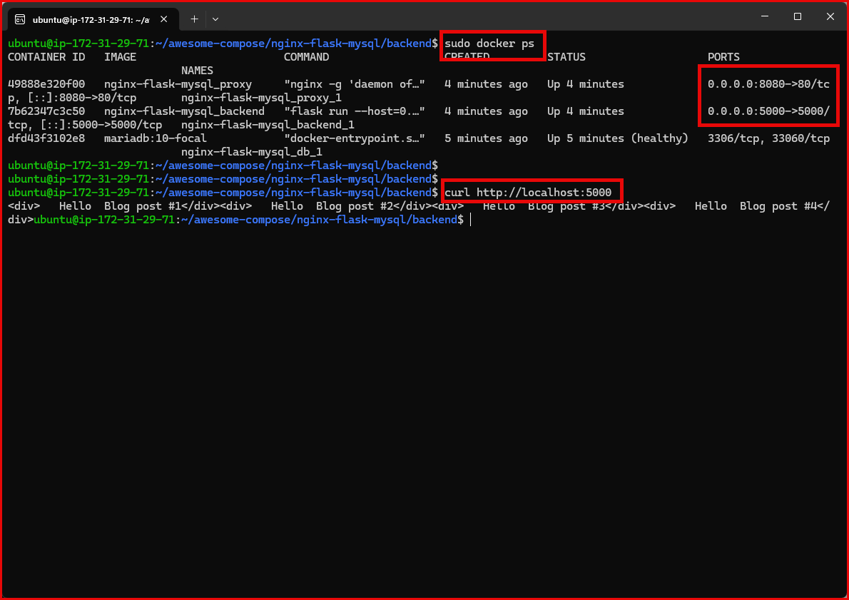

Verify backend

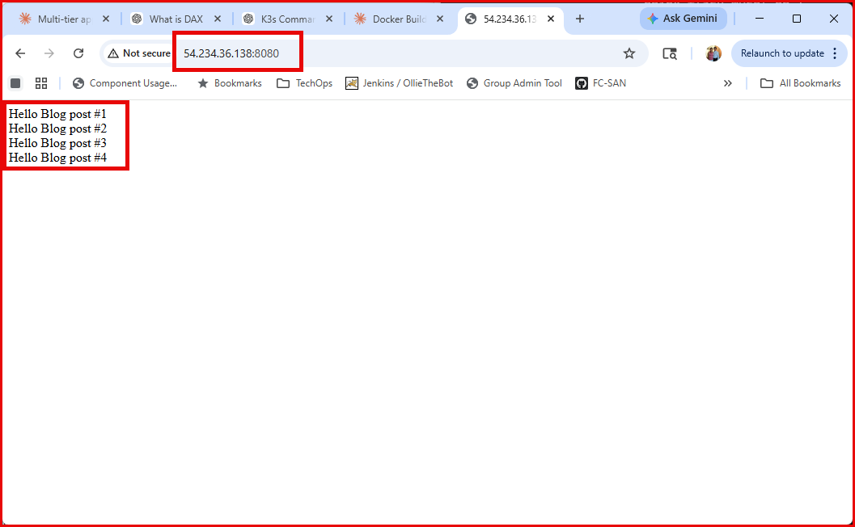

Test frontend
