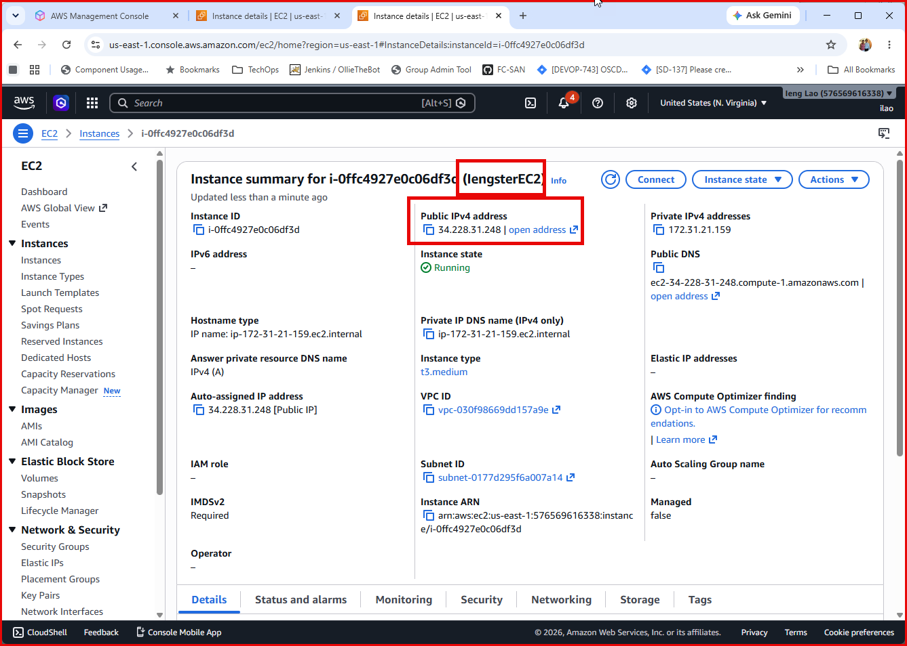

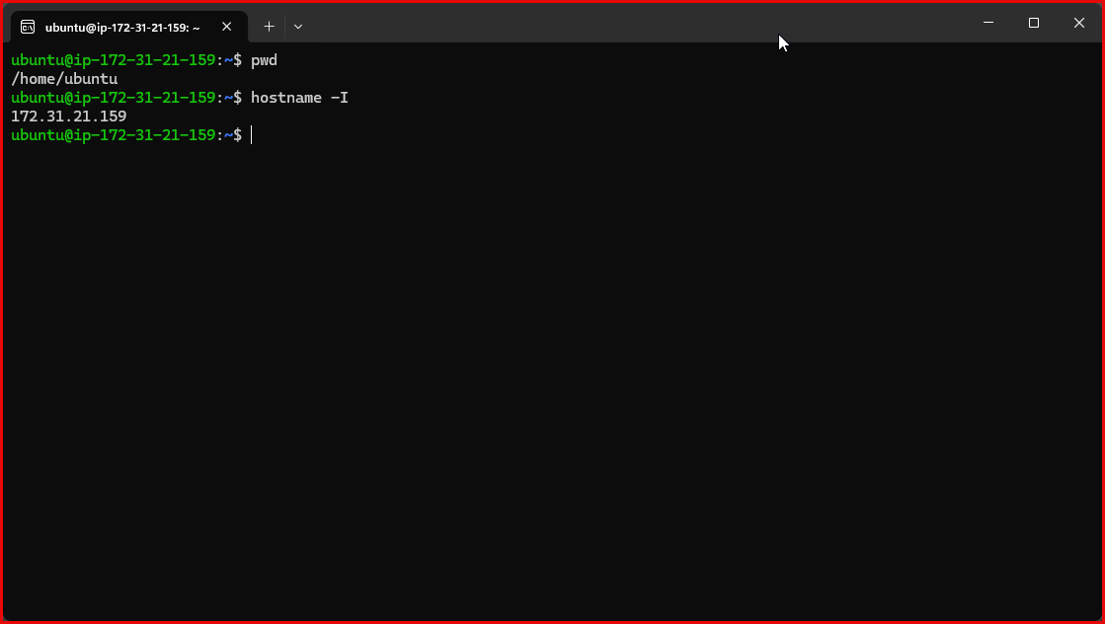
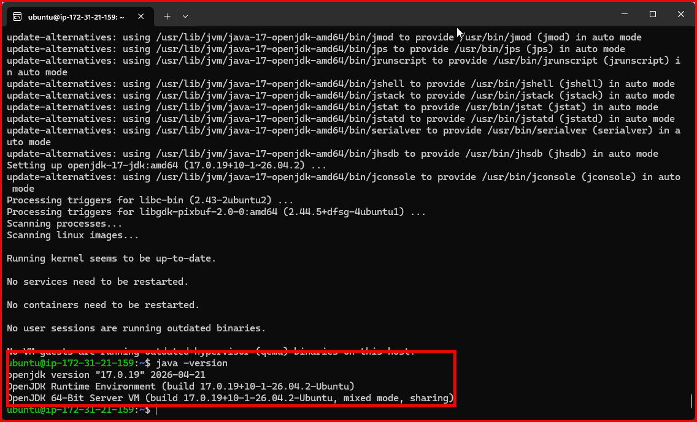

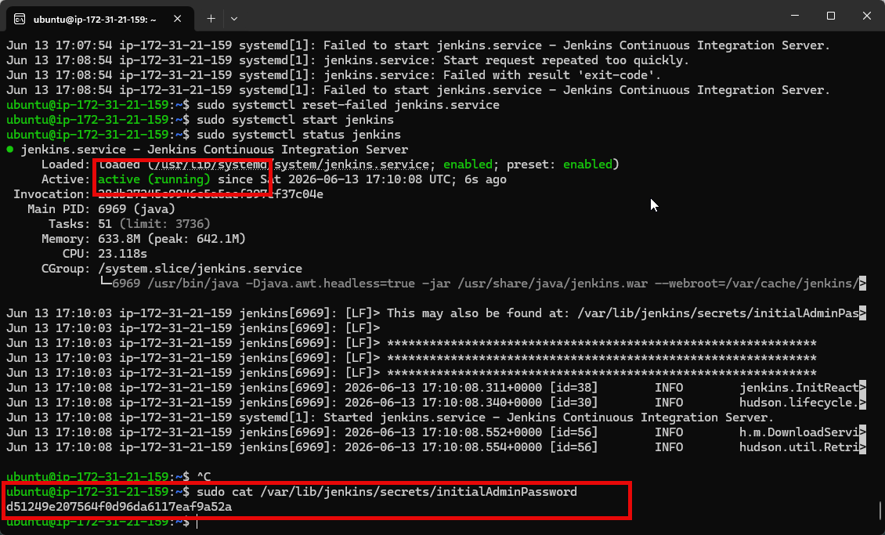
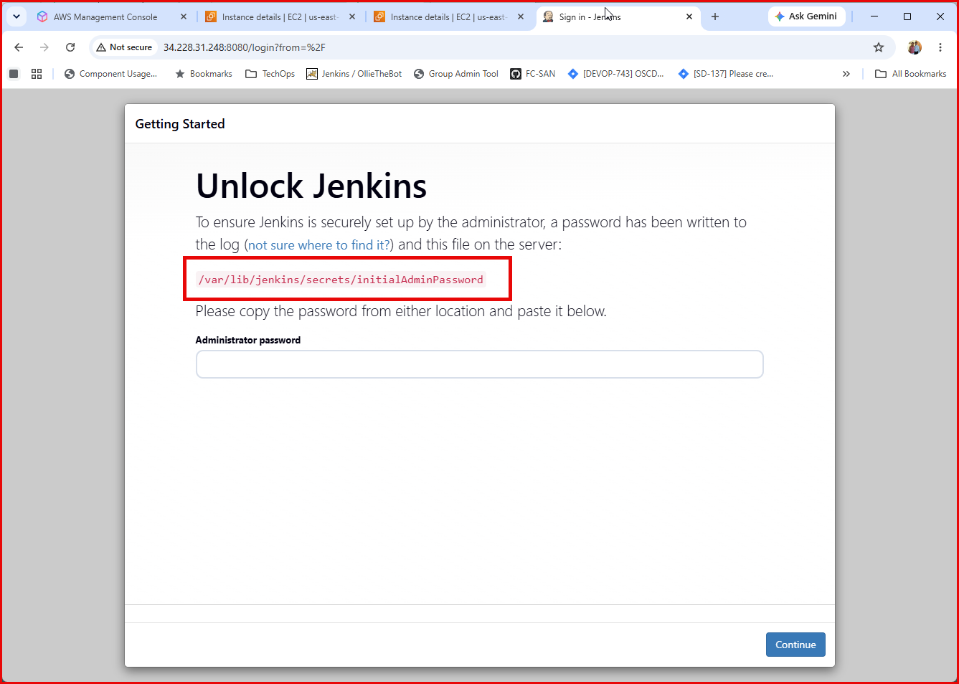

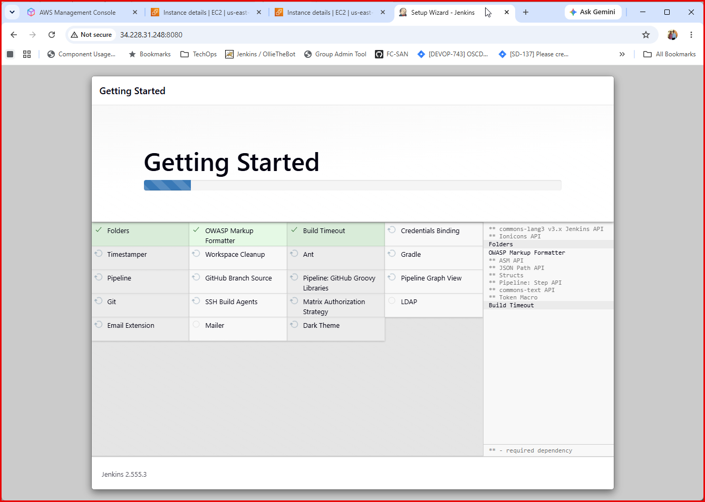
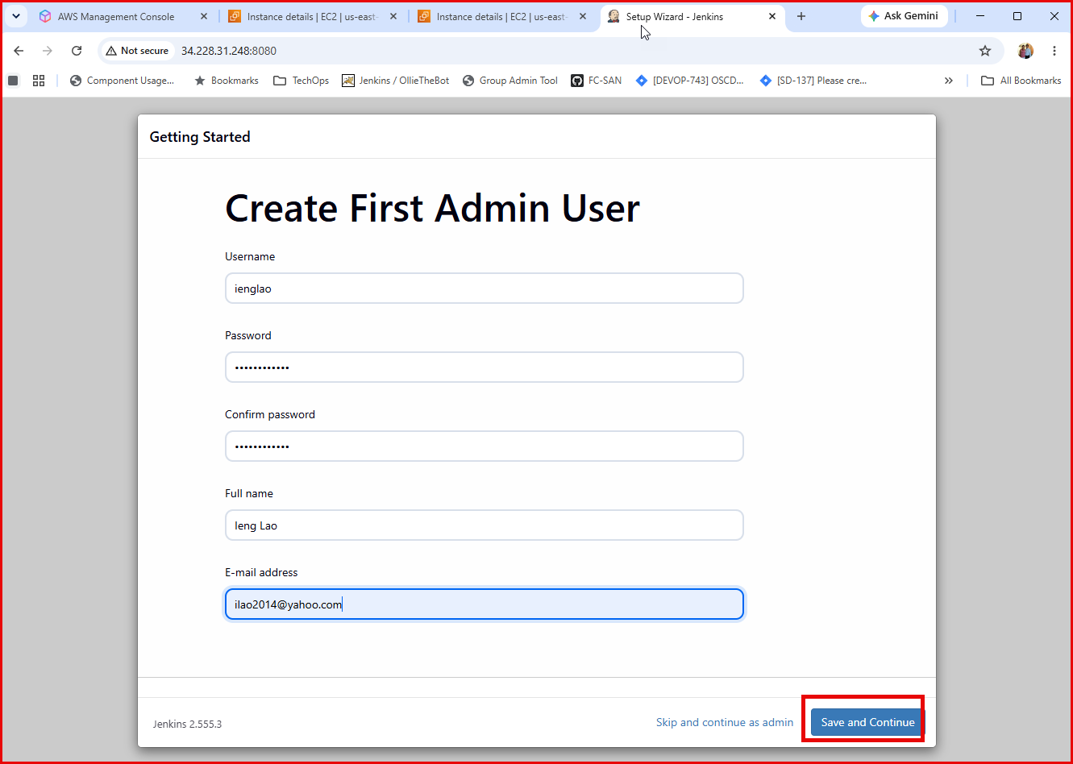

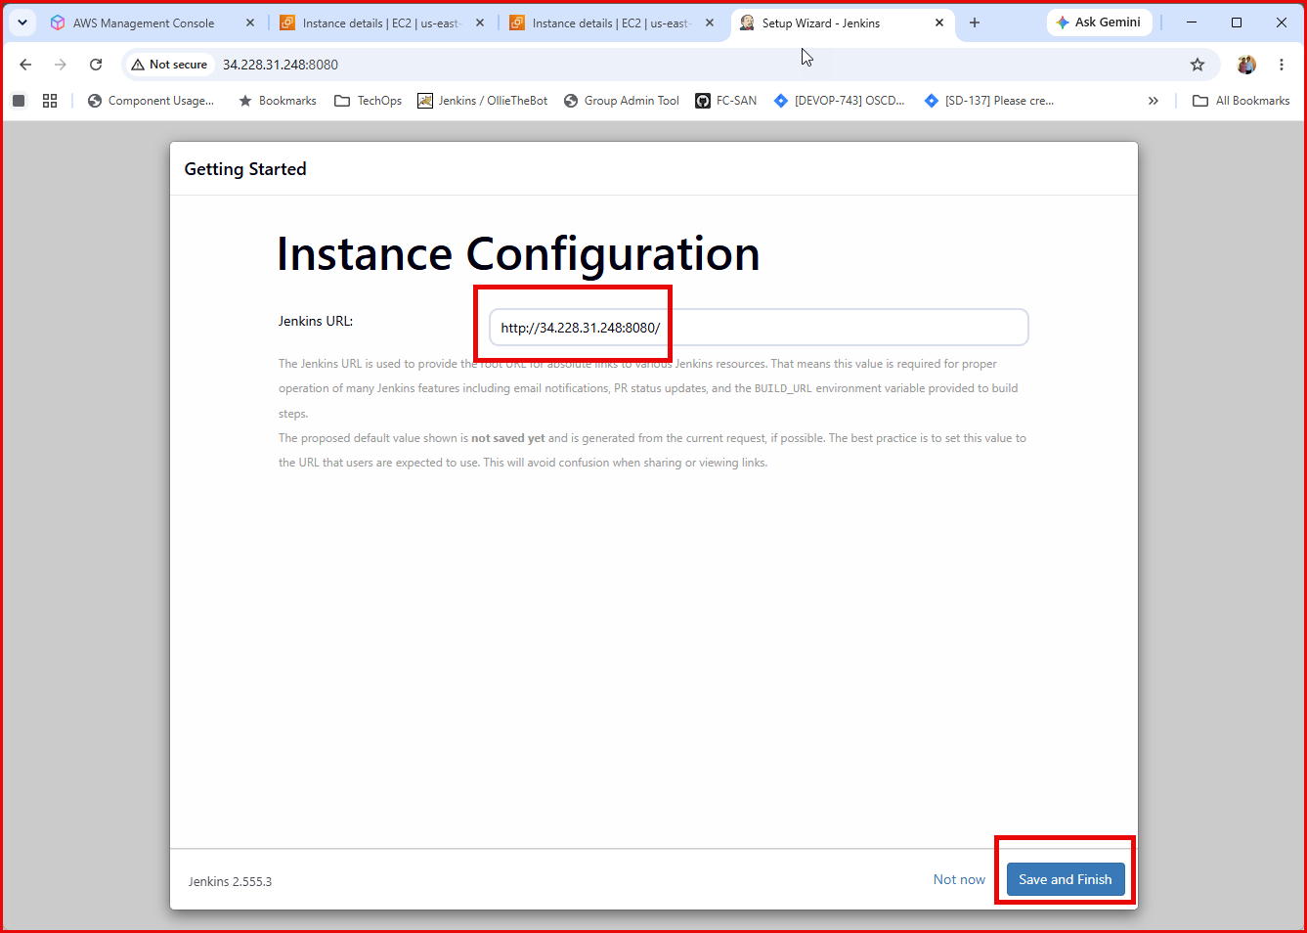
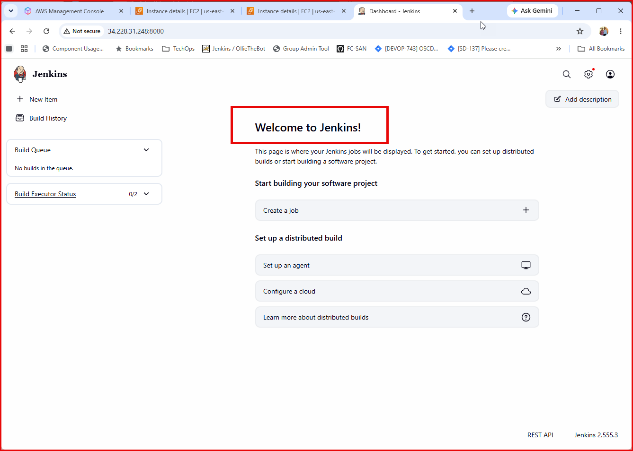
Jenkins is up running.
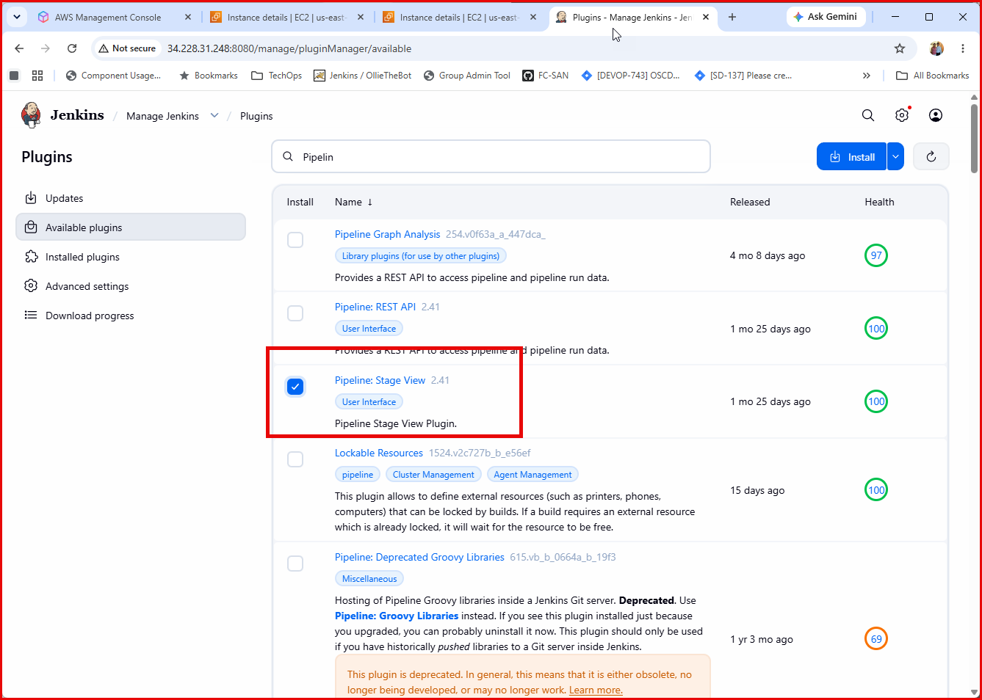
Installing Jenkins plugins: • Docker Pipeline, Pipeline: Stage View, SSH Agent, Ansible, Githug Integration, and Maven Integration.
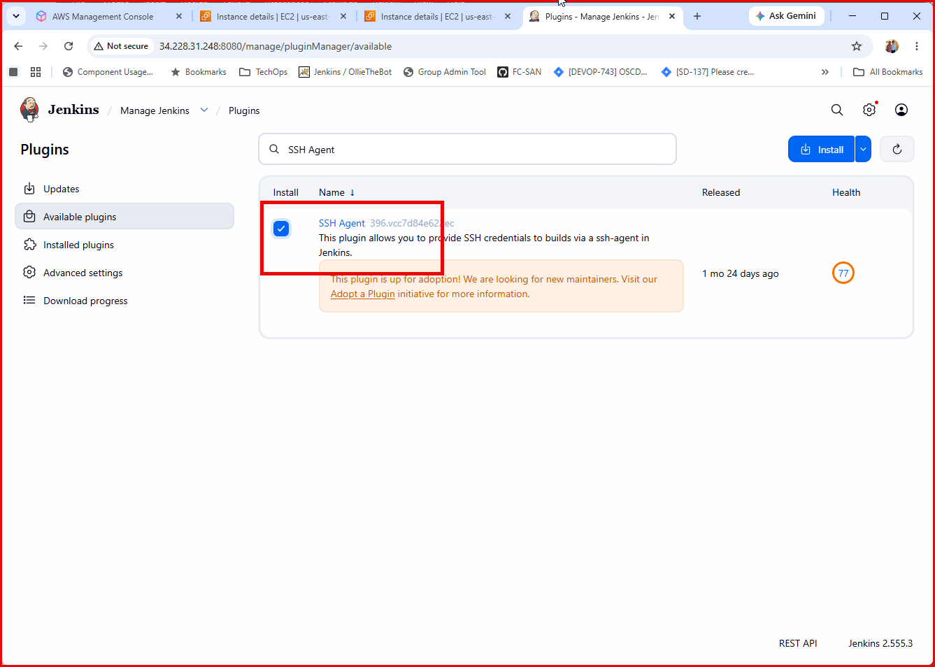



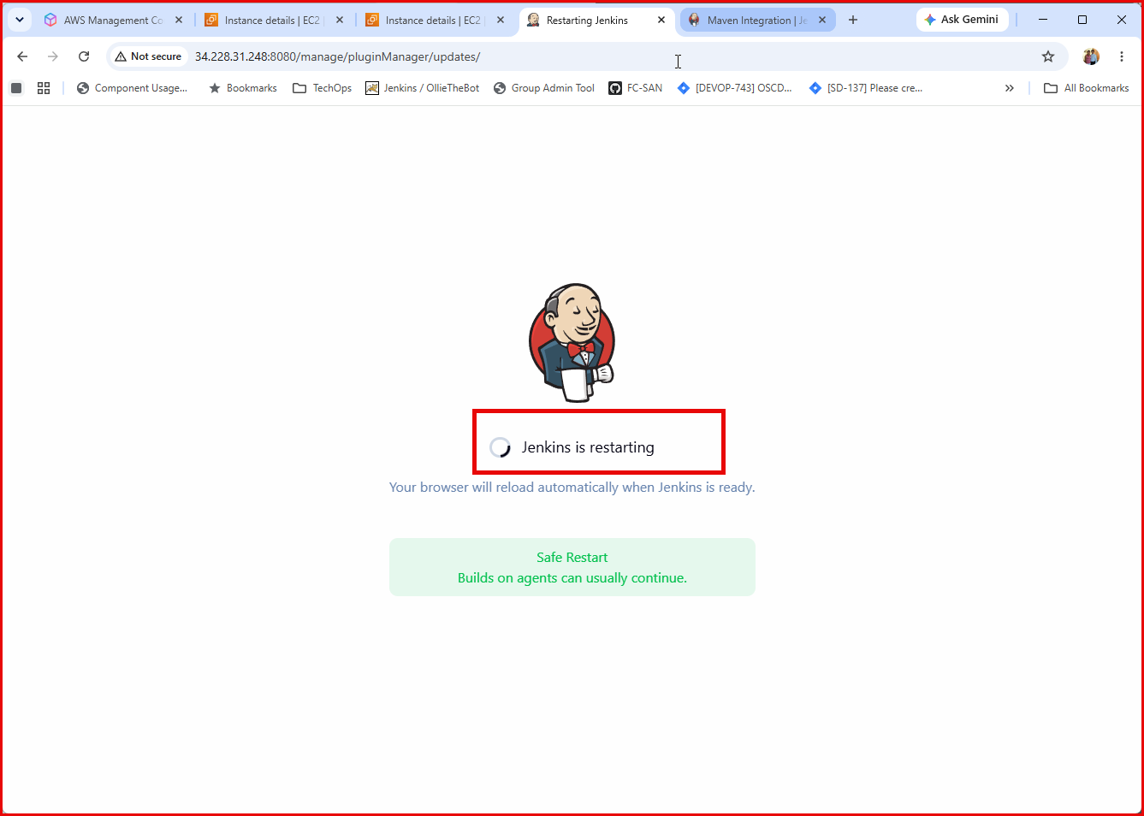
Restarting Jenkins after all plugins are installed.

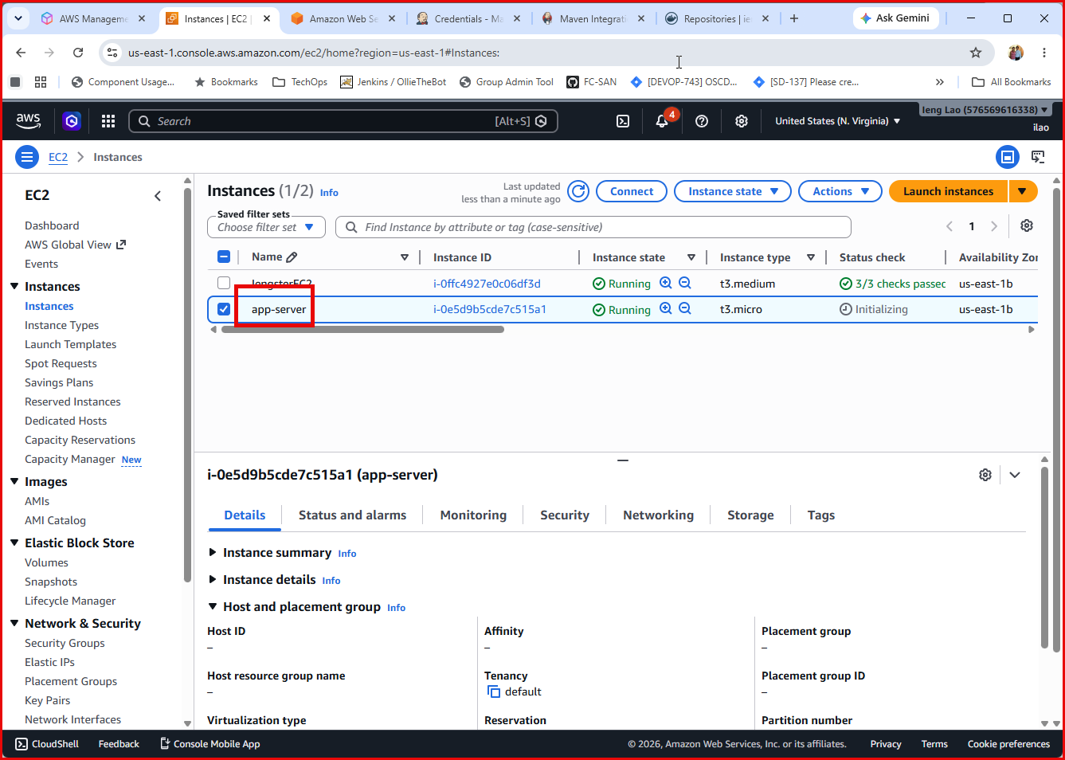
Create an app-server EC2 instance.
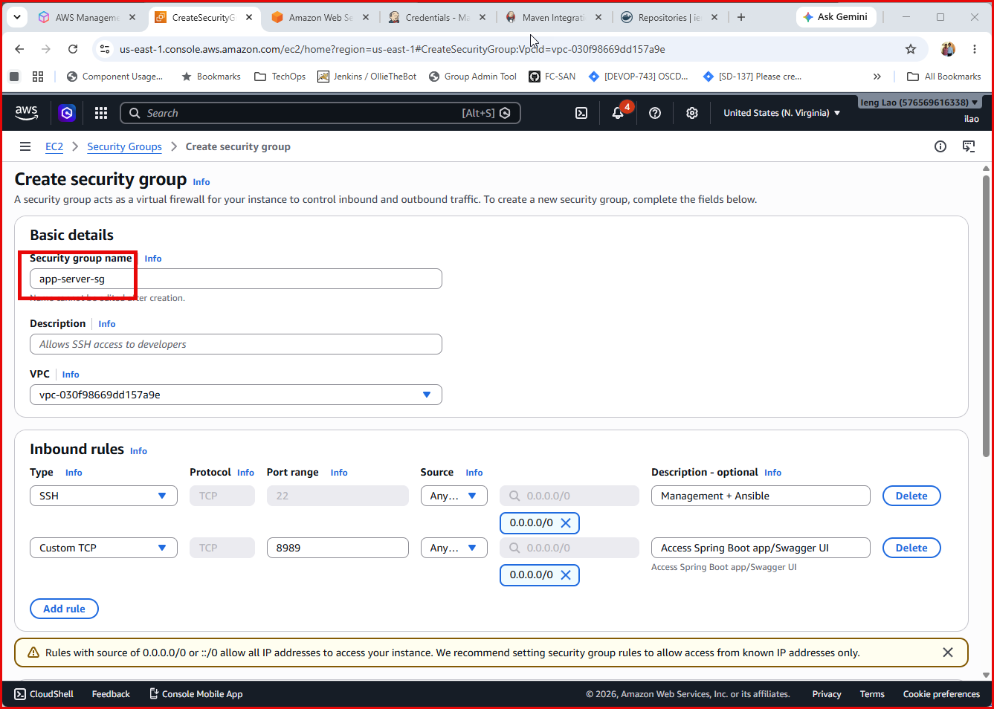
Create new security group.
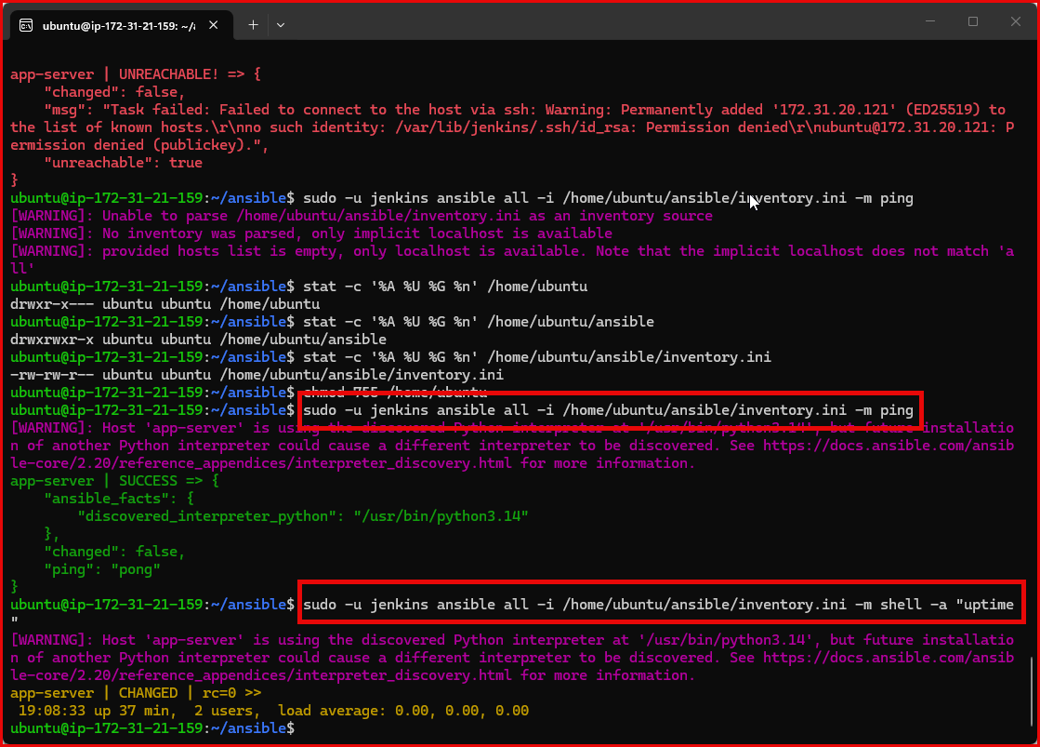
Verify that ansible can talk to app-server.
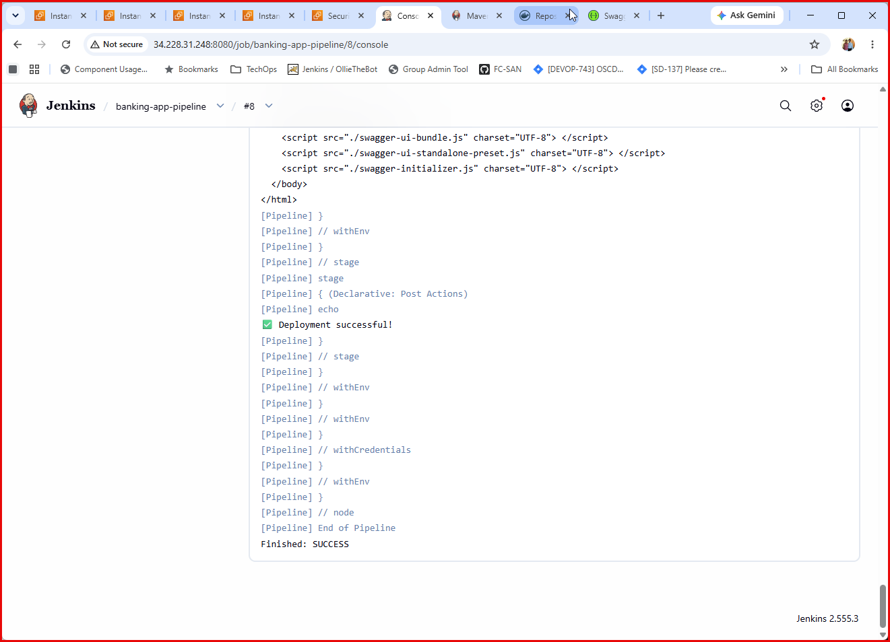
Verify manually click Build Now
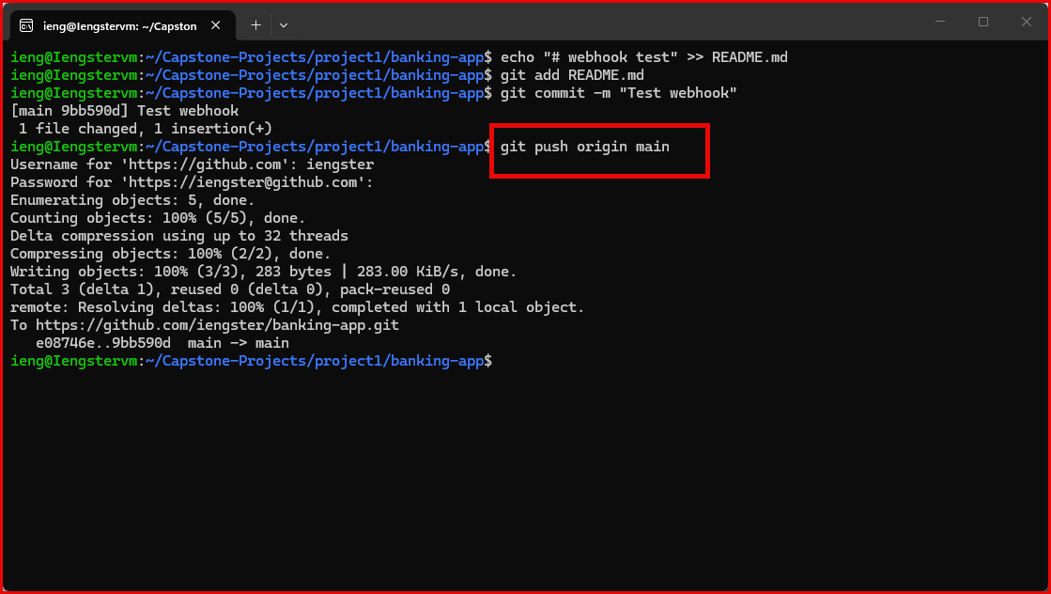
Verify Webhook receiving new push event, and trigger Jenkins to build.
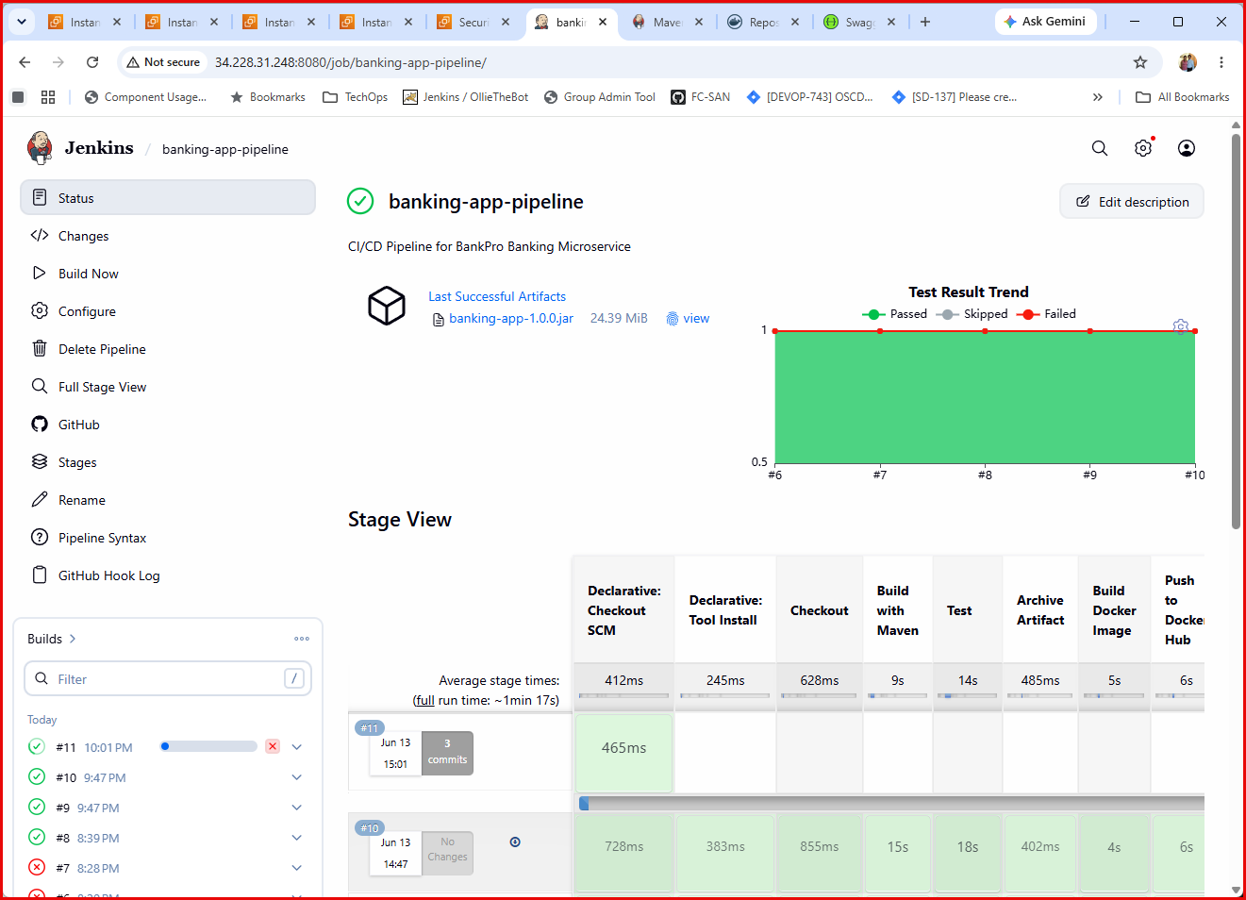
Newly push did trigger Jenkins build.
Jenkins did trigger new build due to recent push. 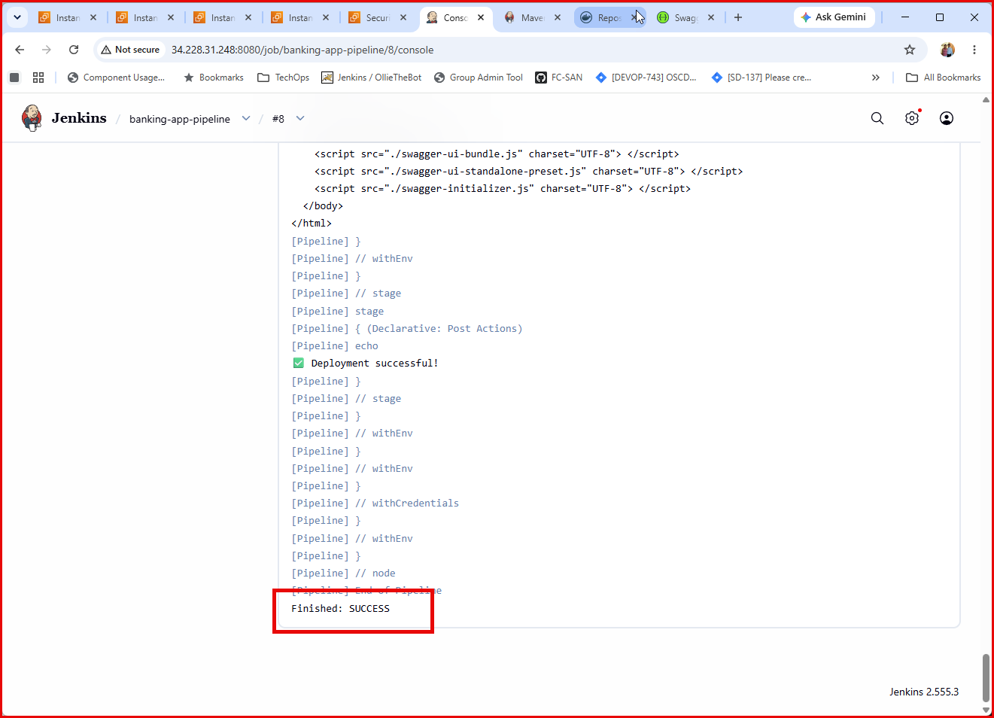
The build finished without any error.

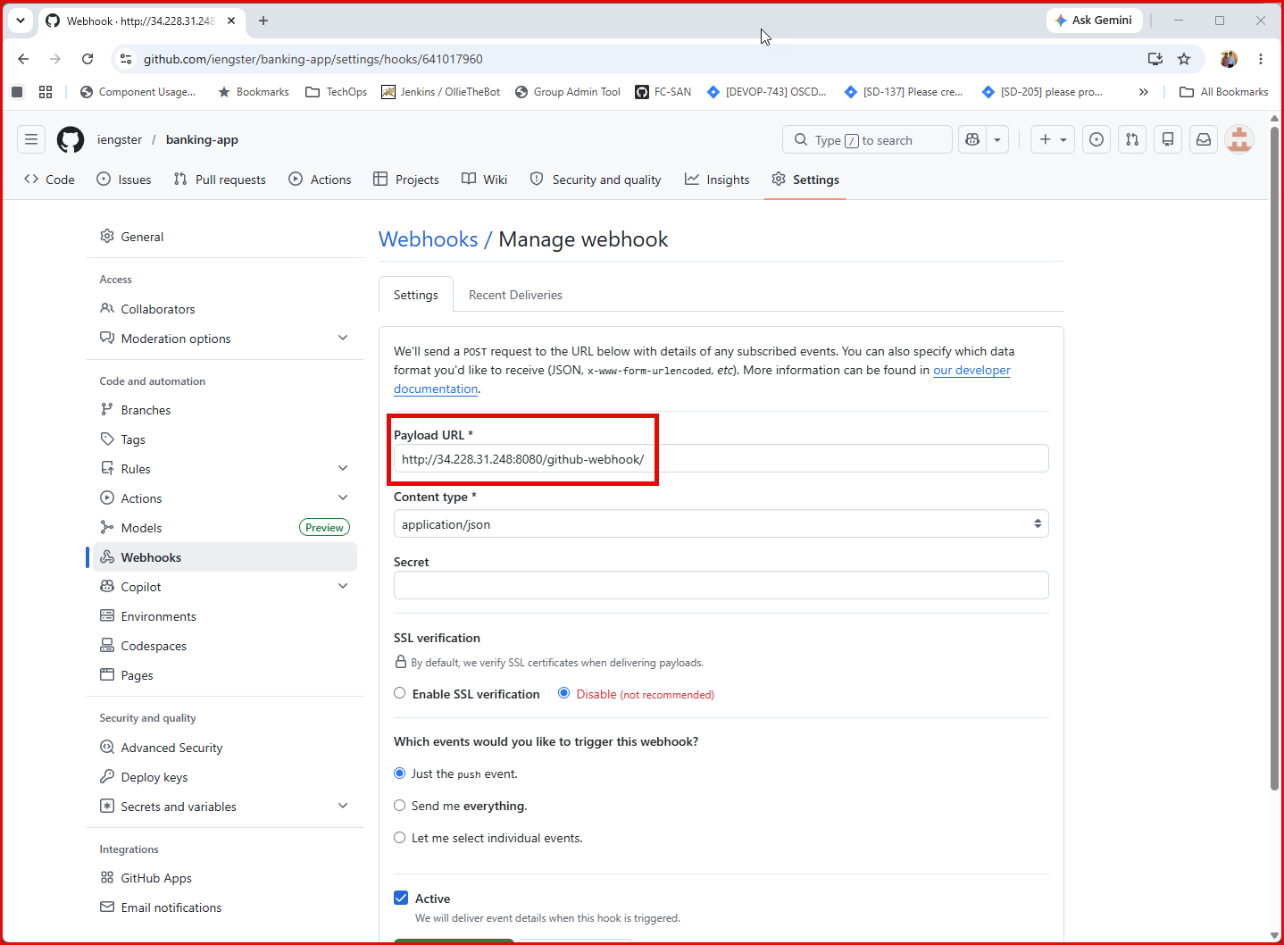
Webhook setting
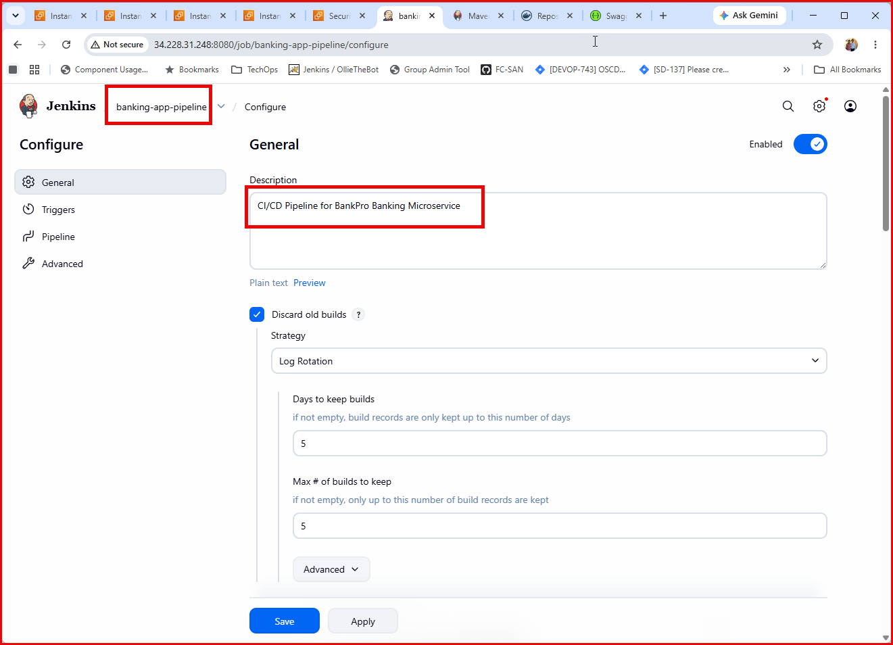
Jenkins Pipeline Job Settings.
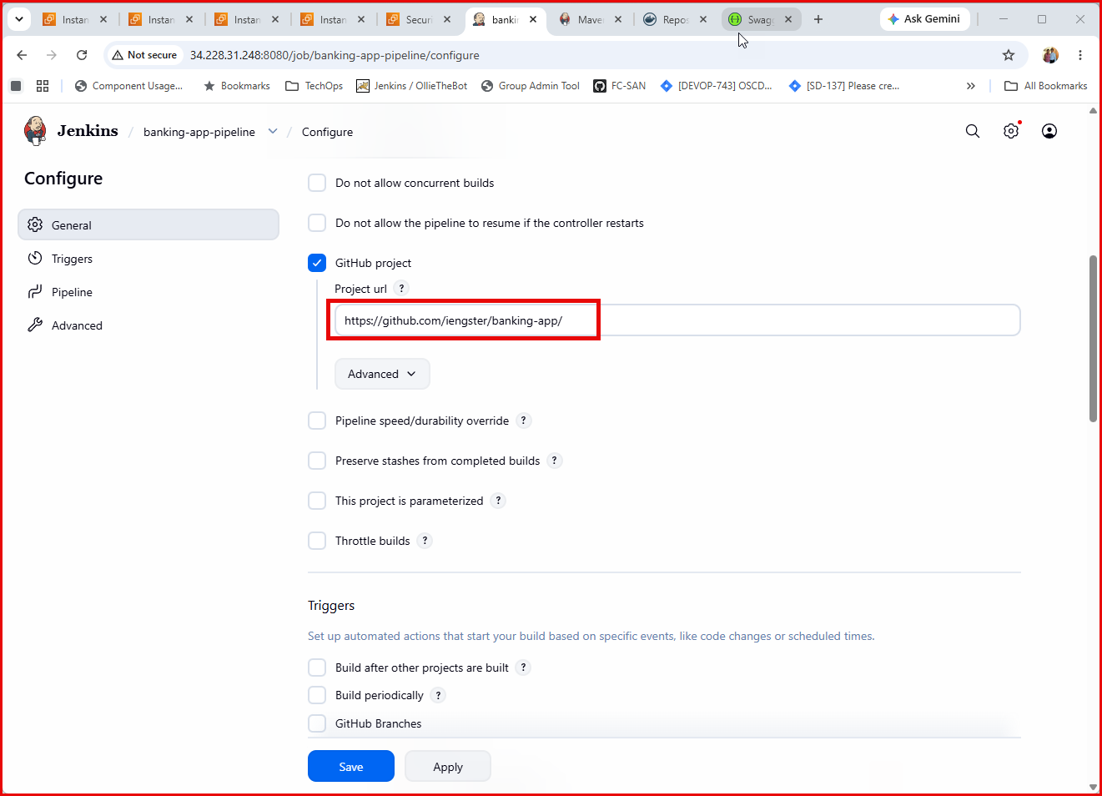
Settings cont:
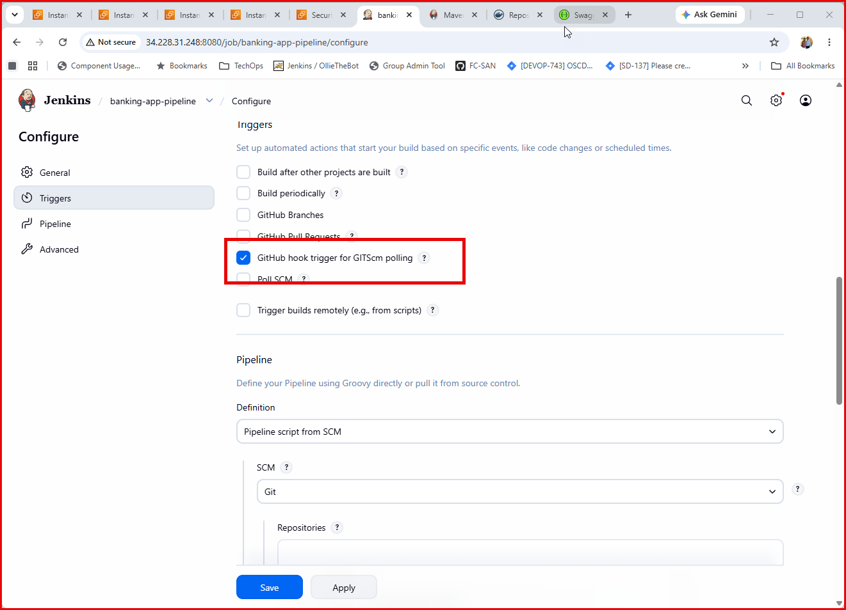
Settings cont:
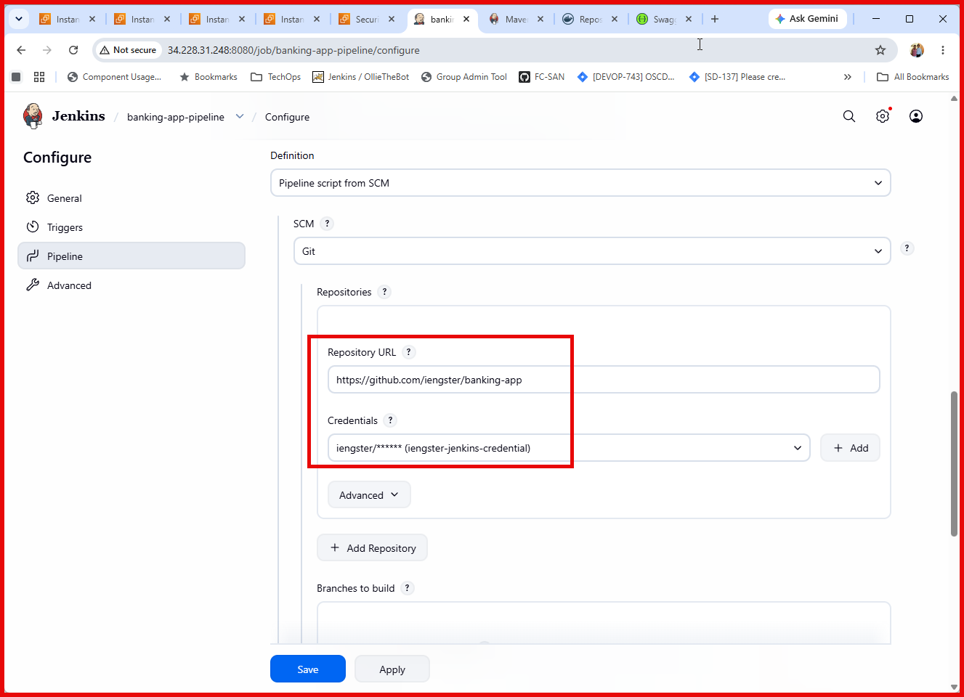
Settings cont:
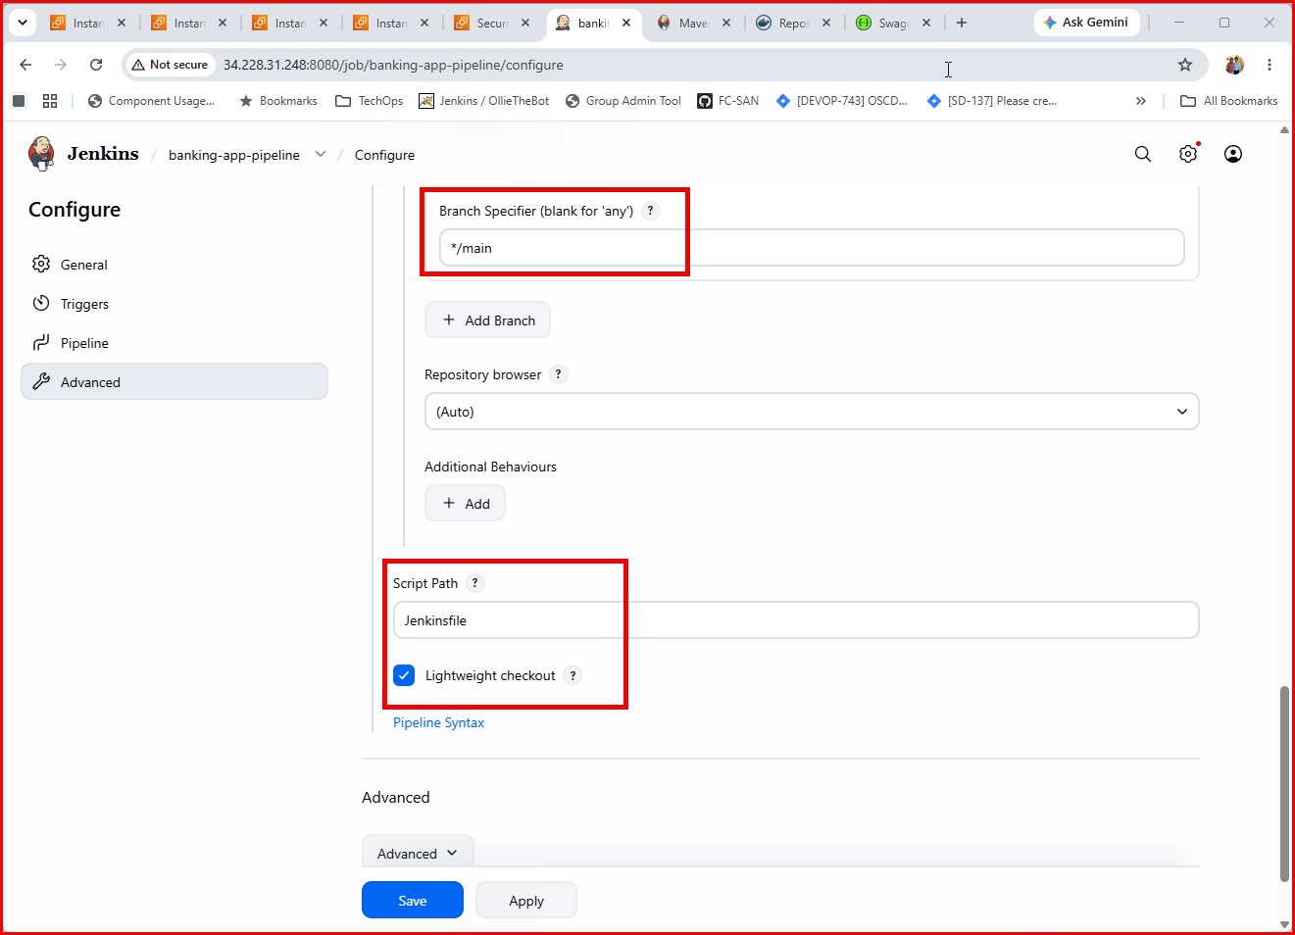
Settings cont:
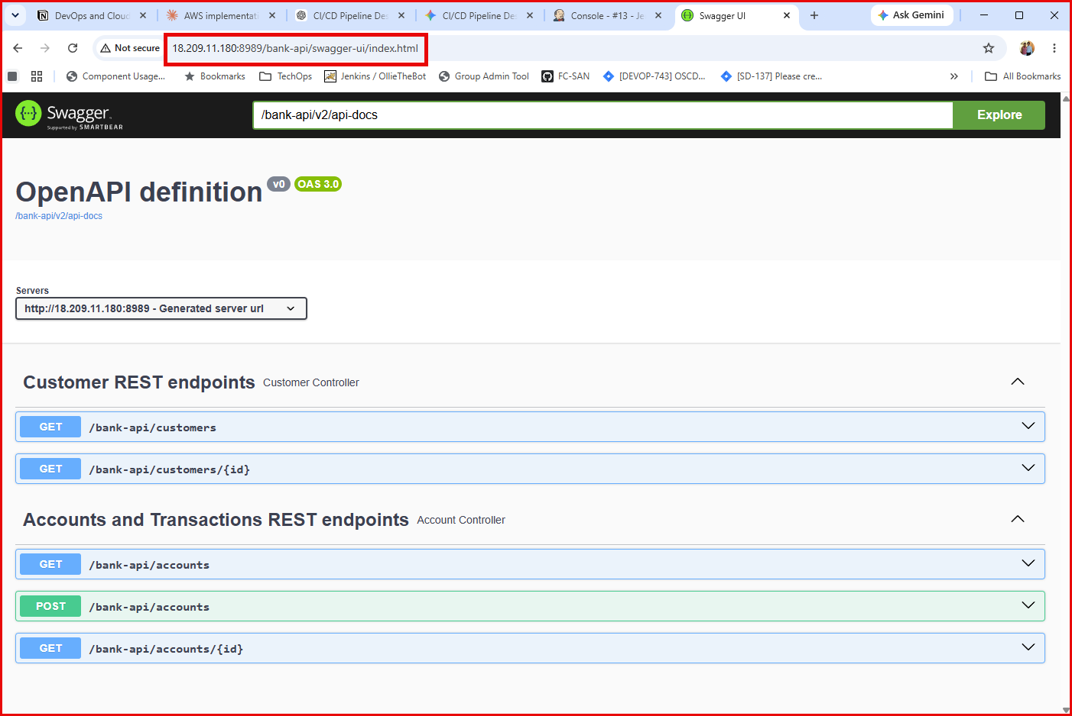
The App is running: http://18.209.11.180:8989/bank-api/swagger-ui/index.html
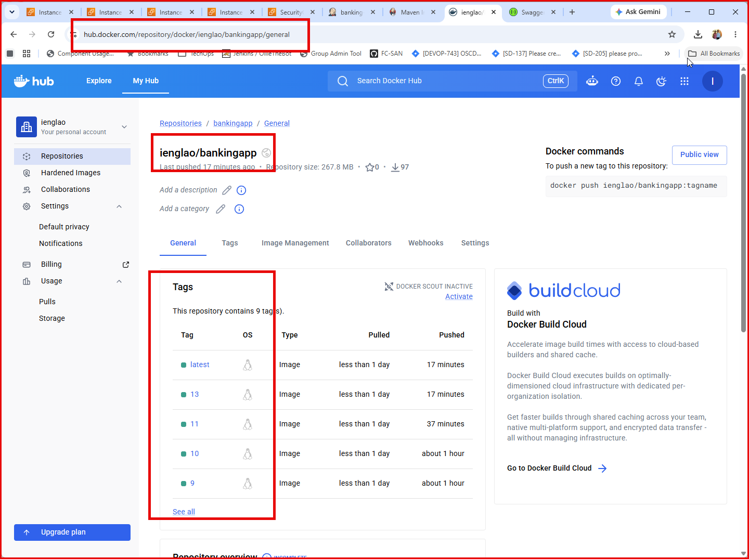
Docker hub serves as packaging and runtime isolation for deployment

Conclusion:
This project successfully demonstrates a complete, automated CI/CD pipeline for a Spring Boot banking microservice, integrating GitHub, Jenkins, Maven, Docker, Docker Hub, and Ansible to deploy to an AWS EC2 environment. Each push to the main branch automatically triggers the pipeline: the application is built and tested, packaged into a Docker image, pushed to a container registry, and deployed to the target server using Ansible, with an automated verification step confirming the application is reachable via its Swagger UI. This workflow reduces manual deployment effort, shortens release cycles, and provides a repeatable, auditable process — directly addressing BankPro's goal of improving reliability, scalability, and service availability for its banking and payment platform.

