**NCRMP BMU QA/QC notes Spring 2024**

Header naming made consistent. For instance (massEpoxiedPre): 1. what it is (mass), 2. modifiers (Epoxied), 3, time point (Pre) - 3/11/2024

NAs to blank cells in both Pacific and Atlantic datasheets - 3/13/2024

All macroboring values changed to negative = 4/13/2024

Grazing formula standardized to *grazing = (volumeBlockPost - macroboring) - volumeBlockPre* which results in a negative grazing volume - 3/14/2024

Changed sites mislabeled as “PRIAs” to “PRIA” - 4/19/2024

Outlier BMU check: 3/19/2024 and 3/20/2024

* High delta mass for how long it's been deployed:
  + 1022 was not collected in 2017 with the rest of the BMUs deployed at the site in 2014. It was collected in 2022 with a batch of BMUs that were deployed at the same site in 2017. The BMU was deployed from 4/20/2014 to 6/19/2022.
* Barely any change in volume, big change in mass:
  + 1076 - Post-scan looks ok, lots of accretion but not out of the ordinary. Post volumes recorded correctly.

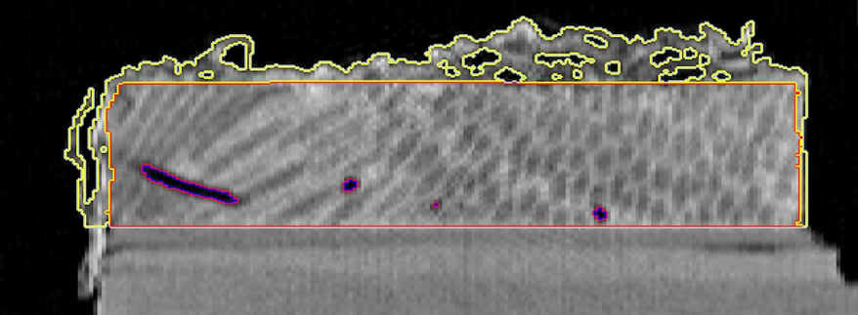

BMU 1076

* + 1089 - Lots of heavy accretion, little erosion. Post volumes recorded correctly. I don't think that this is an error.

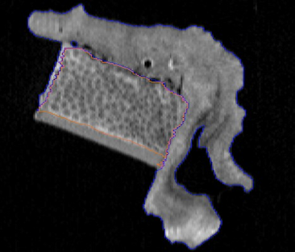

BMU 1089 view 1

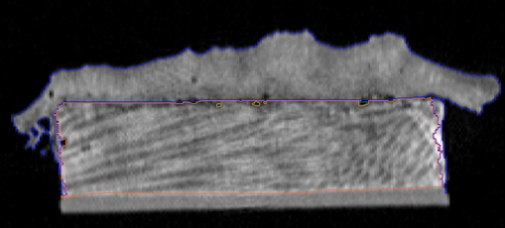

BMU 1089 view 2

* + 1091 - Significant heavy coral accretion. Decent amount of erosion. Post volumes recorded correctly. I don't think that this is an error.

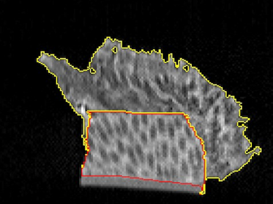

BMU 1089

* + 1099 - Particularly large amount of heavy coral accretion and very little erosion. Post volumes recorded correctly. Material grown on the block counted as accretion, This should be corrected.

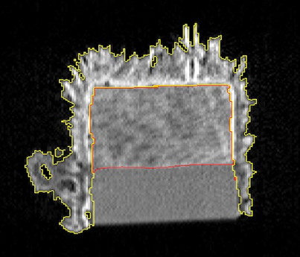

BMU 1099 view 1

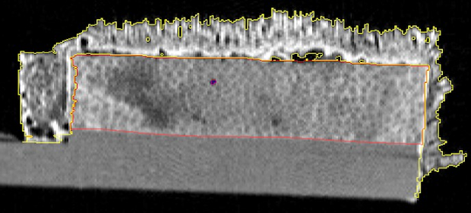

BMU 1099 view 2

* + 3206 -Significant heavy coral accretion. Decent amount of erosion. Post volumes recorded correctly. I don't think that this is an error.

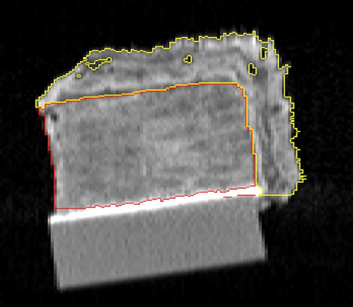

BMU 3206 view 1

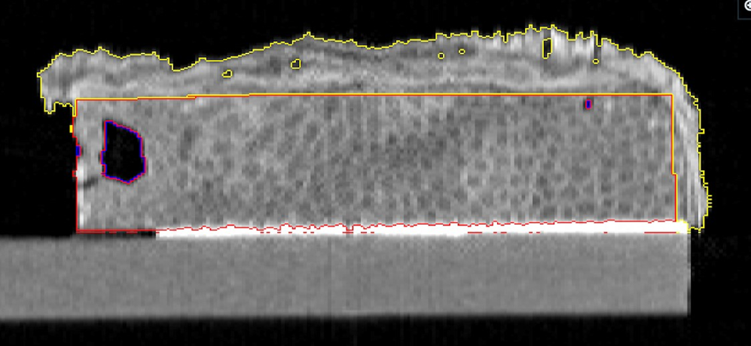

BMU 3206 view 2

* + 3209 - Lots of heavy accretion. Some of the plate was counted as coral block, adding to its volume. Needs correction. This will affect the volumeBlockPost and densityCTPost for the BMU.

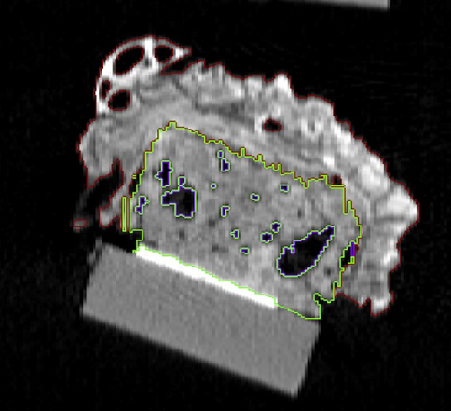

BMU 3209

* + 3212 - Lots of heavy coral accretion, not very much erosion. Some accretion on the right of the block missed and was included in the volume of the block. Should be corrected but there is no recording error.

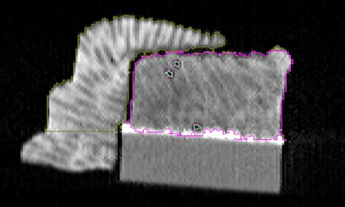

BMU 3212

* + 3261 - Significant heavy accretion. Very little erosion. Post volumes recorded correctly. I don't think that this is an error.

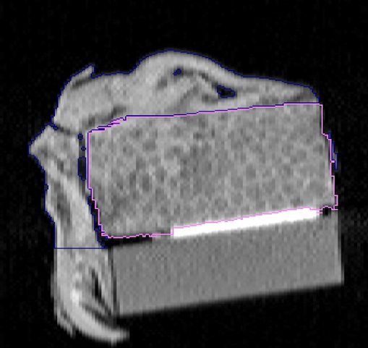

BMU 3261 view 1

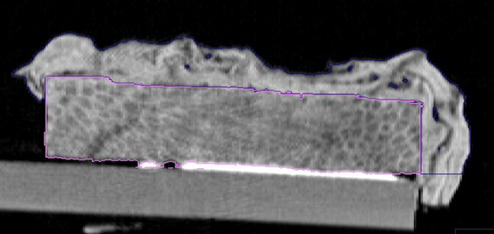

BMU 3261 view 2

* + 6570 - Not too much erosion. Really big/heavy chunk of accretion on the side. Post volumes recorded correctly. I don't think that this is an error.

Problematic BMUs listed above corrected or eliminated - 3/20/2024