FPGA Design Specs on Clarke Transform, Rev. 0
Effective Date: Nov 07, 2023

This document has been reviewed and determined not to contain export-controlled information.

The information contained in this document is confidential or proprietary in nature. The Government is furnished electronic access to JPL Rules! for informational purposes only. The documents contained in JPL Rules! may not be integrated into the Government’s record keeping system. Caltech retains control over the documents contained in JPL Rules! and the JPL Rules! database and the Government may not, except as required by law, release the documents or permit access to the database without the consent of Caltech.


Jet Propulsion Laboratory
California Institute of Technology
4800 Oak Grove Drive
Pasadena, California 91109-8099

Paper copies of this document may not be current and should not be relied on for official purposes. The current version is in the JPL Rules! Information System at http://rules.jpl.nasa.gov/
FPGA Design Specification Template
Table of Contents
1. Introduction 2
1.1. Scope 3
1.2. Purpose 3
1.3. Applicable Documents 4
2. Requirements 4
2.1. System Requirements 4
3. General Design Description 4
3.1. Clarke Transform 4
3.2. Top Level Block Diagram 5
3.3. IO Interfaces 6
4. Functional Design Description 7
4.1. Fixed Point Addition and Multiplication 7
4.2. Simulation 7

Introduction
The behavior of three-phase machines is usually described by their voltage and current equations. The coefficients of the differential equations that describe their behavior are time varying (except when the rotor is stationary). The mathematical modeling of such a system tends to be complex since the flux linkages, induced voltages, and currents change continuously as the electric circuit is in relative motion. For such a complex electrical machine analysis, mathematical transformations are often used to decouple variables and to solve equations involving time varying quantities by referring all variables to a common frame of reference.
In a three-phase motor, the sum of three phase voltages or currents at any instant is equal to zero. Hence, it is sufficient to have only two currents or voltages to represent the motor behavior. However, the actual three-phase quantities are displaced by 120° and therefore, they are not completely decoupled. In order to decouple the two-phases that are used to represent the motor dynamics, Clarke transformation is applied to a, b phases and transform them to alpha–beta vectors. Clarke transform preserves the magnitude vectors while transforming them from three-phase a, b, c to two-phase alpha–beta.

Scope
Jpl_foc_clarke.sv is a single SystemVerilog RTL and this module implements Clarke transform for motor controller. The main features are the following:
- Computes Clarke transformation
- Asserts Clarke_done signal HIGH at the end of the computation when outputs alpha and beta is are valid
- Detects over current fault on output beta, which can be used to alarm to a user immediately.

Purpose
This document is intended to describe the requirements, design, and as-built properties of the jpl_foc_clarke.sv. jpl_foc_clarke is needed to compute two orthogonal current phase alpha, beta by transforming three current phases a,b. For doing so, it requires fixed points addition and multiplication.

Applicable Documents
The applicable technique is referenced from the existing document.
- FOC transformation User Guide, Microchip.
- https://ww1.microchip.com/downloads/aemDocuments/documents/FPGA/ProductDocuments/UserGuides/ip_cores/directcores/foc_transformations_ug.pdf

Requirements

System Requirements
This module should support the functions which transforms a,b,c current input to alpha, beta output. In order for that, it should entail several features:
- Compute fixed point addition and multiplication
- Detect any abnormal fault and thus protects a motor control system which interfaces with this design

General Design Description

Clarke Transform
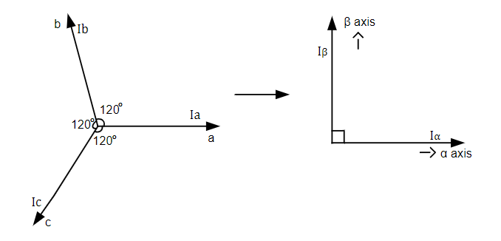
Figure. Clarke transformation
The general equation for Clarke transformation is:
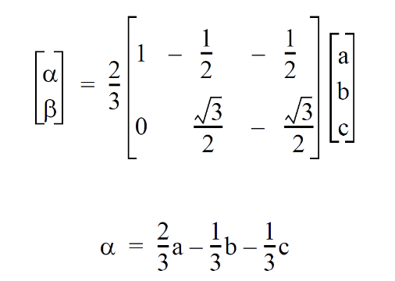
where,
Ia, I b , and Ic are three-phase quantities. Iα and Iβ are stationary orthogonal reference frame quantities. When Iα is superposed with Ia and Ia + I b + I c is zero, I a, Ib, and I c can be transformed to Iα and Iβ as
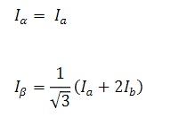

Top Level Block Diagram
This block describes the input and output of Clarke transform. Once Input data are provided, this module automatically computes the two outputs, alpha and beta current phase, during transformation, and asserts completion of it once transformation is done by the transformation equation. If there is any fault event, it flags fault alarm.
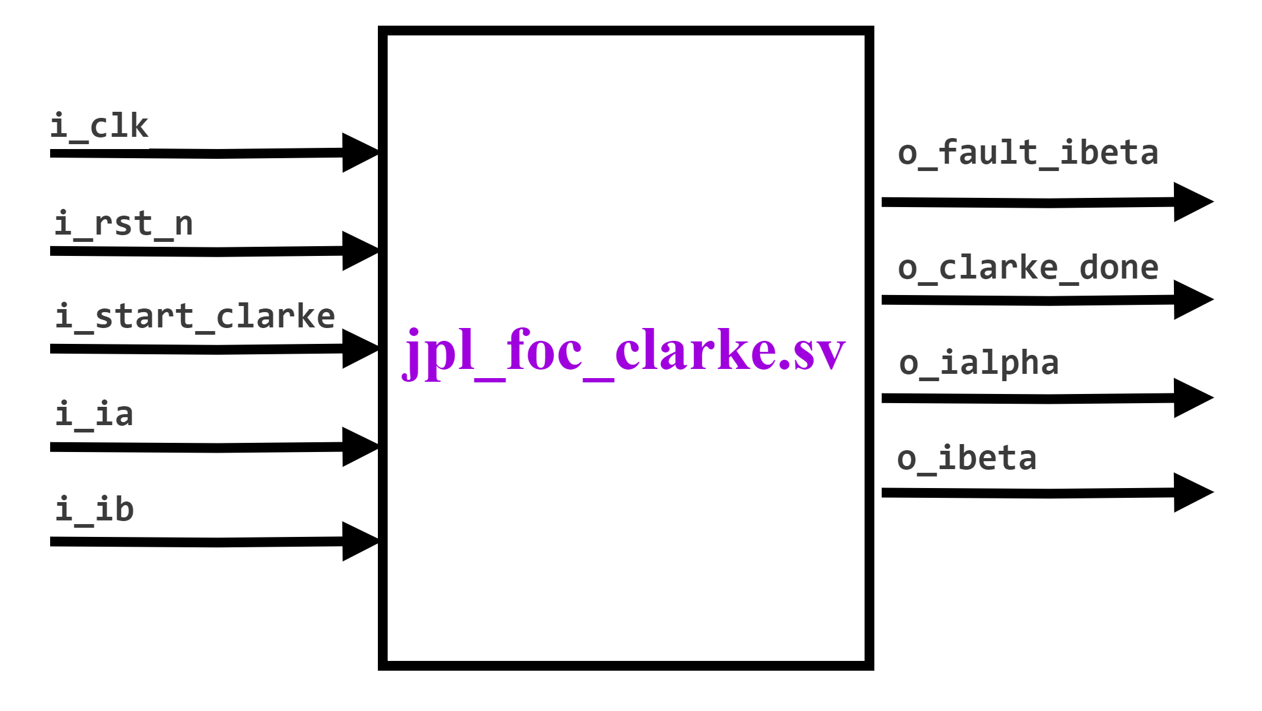
Figure 1. System Level Block Diagram

IO Interfaces
There are several inputs and output signals, and parameters which configure the bit information about how signal should be behaves in communication.
- Parameters
The following table lists the description of the configuration parameters used in the hardware implementation of ADC scaling. These are generic parameters and can be varied as per the requirement of the application.
Signal  Name | Type | Bit width | Description
B | parameter | - | Bit width of raw input data.
Table 1. Parameters
- Input and Output
The following table lists the input and output ports of ADC scaling.
Signal  Name | Type | Bit width | Description
i_clk | Input | 1 | Module clock
i_rst_n | Input | 1 | Active-low module reset
i_ia | Input | [B-1:0] | Raw input data for each current phase a. Signed.
i_ib | Input | [B-1:0] | Raw input data for each current phase b. Signed.
i_start_clarke | Input | 1 | Assert for one clock to start transformation
o_clarke_done | Output | 1 | Asserts for one clock when calibration is complete.
o_ialpha | Output | [B-1:0] | Raw output data for each current phase alpha. Signed.
o_ibeta | Output | [B-1:0] | Raw output data for each current phase alpha. Signed.
Table 2. Inputs and Outputs

Functional Design Description

Fixed Point Addition and Multiplication

Simulation
The overall logic flow is described in the simulation. It checks how signal and output behaves given sequence of various inputs.
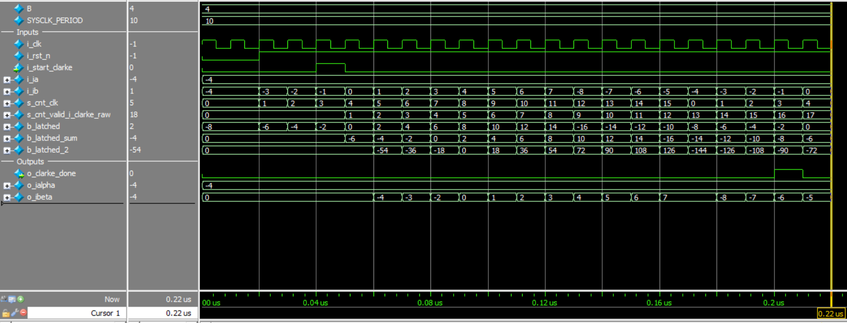
Figure 2. Simulation

