Introduction

Dataset
The data used in this project is the dataset released by the Kaggle "Ames Housing Price" competition. The original source is the residential assessment records collected by housing tax auditors in Ames, Iowa, USA from 2006 to 2010. After being sorted out, it is released for academic and teaching use.
The dataset contains 1 row of ID, and 79 feature fields related to the target variable, where the target variable is sale price. There is total 81 columns (including the target column) and 1460 observations. The fields can be divided into the following types:
numerical continuous type, such as LotArea (land area) and GrLivArea (ground living area); ordinal discrete type, which represents the quality levels, such as OverallQual, KitchenQual; and nominal classification, which describes the things such as materials and neighbourhoods.
It is noticed that there are missing values in fields. Most of them are referred to "None" or 0 as missing markers, not the real recording error.
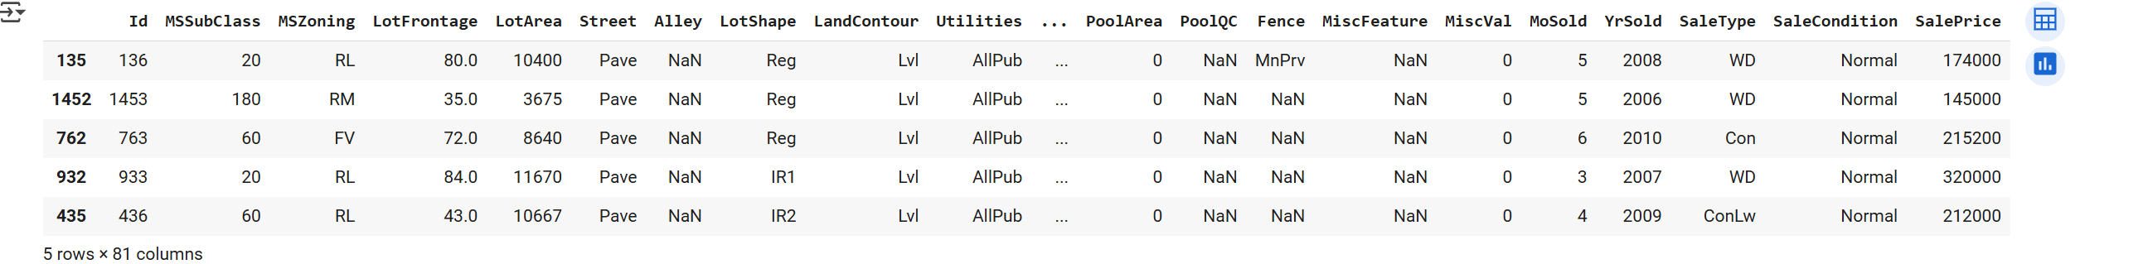
Figure 1 Dataset Display
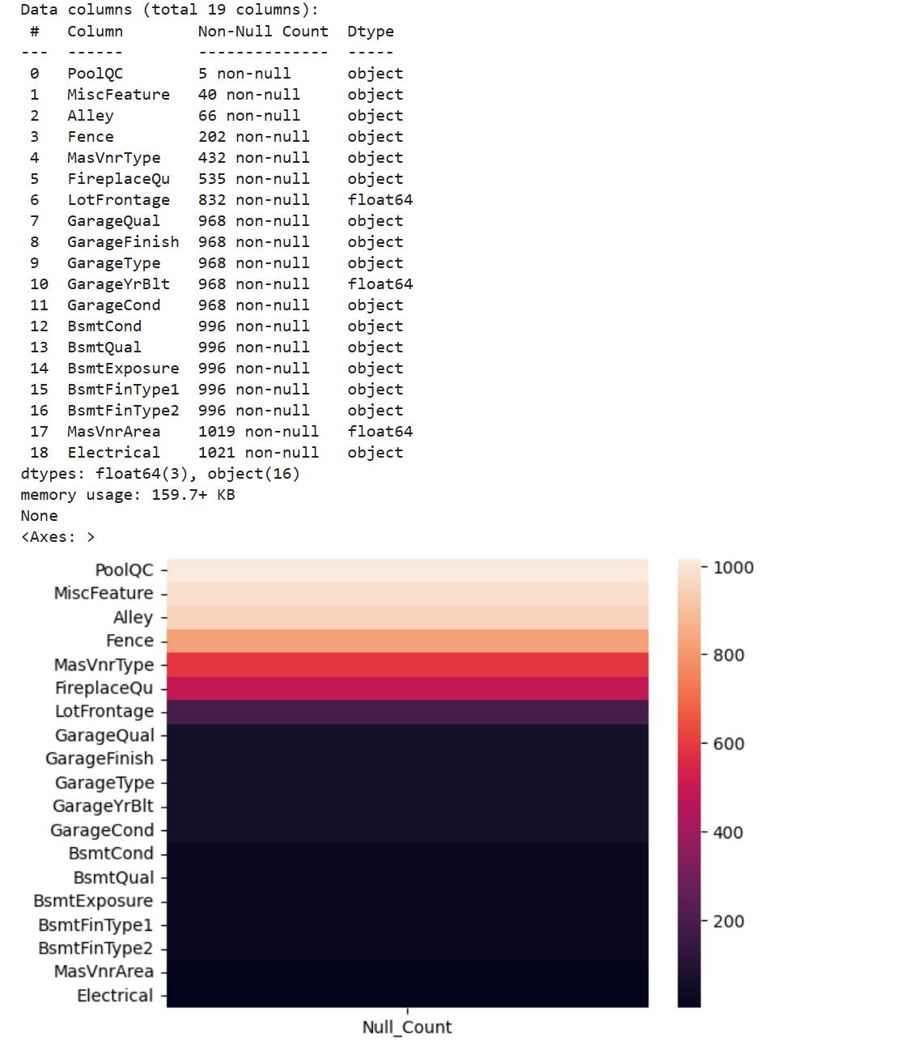
Figure 2 Dataset Null Count Display

Analysis target
The core task of this analysis is to build an interpretable and generalizable regression model to predict the final selling price of homes in Ames and gain insight into the main factors that affect the price. The implementation is as follows: Exploratory and Data Analysis (EDA), dataset cleaning, features engineering and selection, model training and evaluation.

EDA
In the EDA stage, it can be observed that the target variable SalePrice is obviously right skewed, and the distribution of some features is also skewed (Figure 3, 4). The common treatment is to apply logarithmic, Box-Cox or Yeo-Johnson transformation to the skewed features or target values to reduce the impact of skewness and outliers, making the data closer to normal distribution, which helps to meet the linear regression assumption of "residuals are approximately normal and homoscedastic". However, I want to build a model that directly predict the original scale of house prices, and the evaluation are also calculated on this scale. Therefore, it was finally decided to keep the original values of the target variable, but for the skewed features, some of them were log-transformed to obtain higher correlation with the target variable.
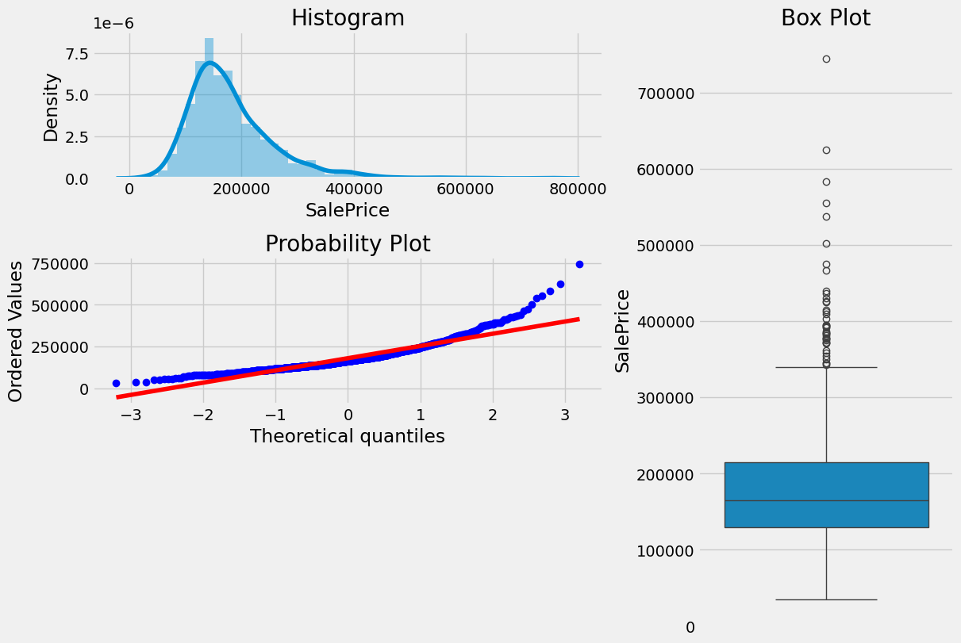
Figure 3 Plotting of Target Variable
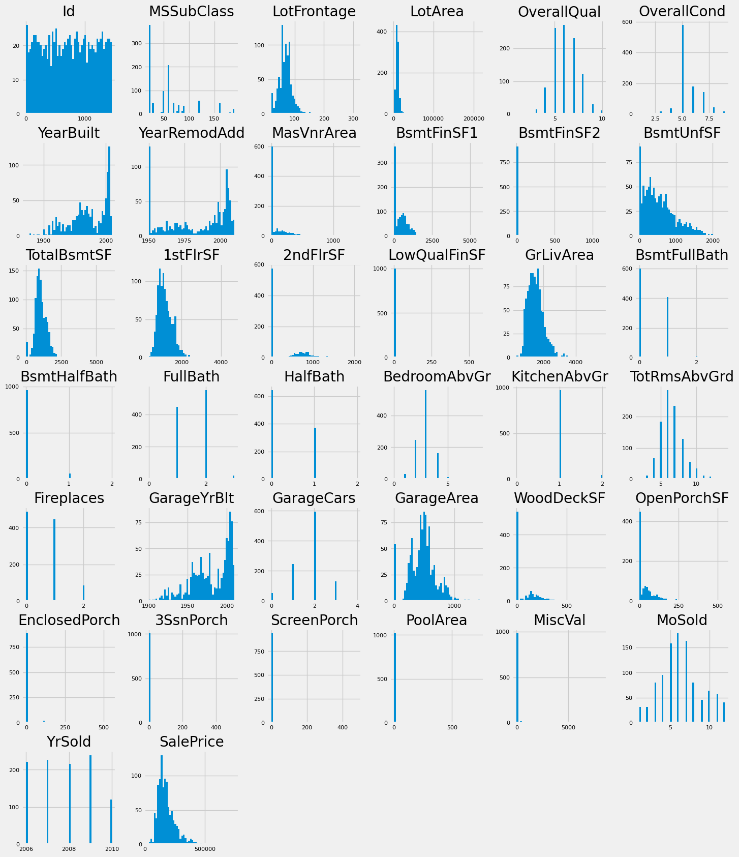
Figure 4 Numerical Variables Distribution
The scatter plots highlight several key predictors such as GrLivArea and OverallQual, they show a strong relationship with the target variable. The correlation heatmap further reveals potential multicollinearity, there are multiple feature pairs that their coefficients correlation is exceeded 0.8.
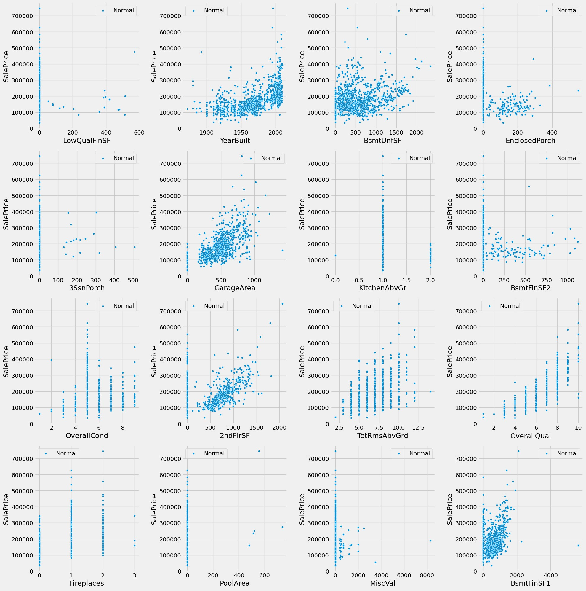
Figure 5 Scatter Plot of Numerical Columns - 1
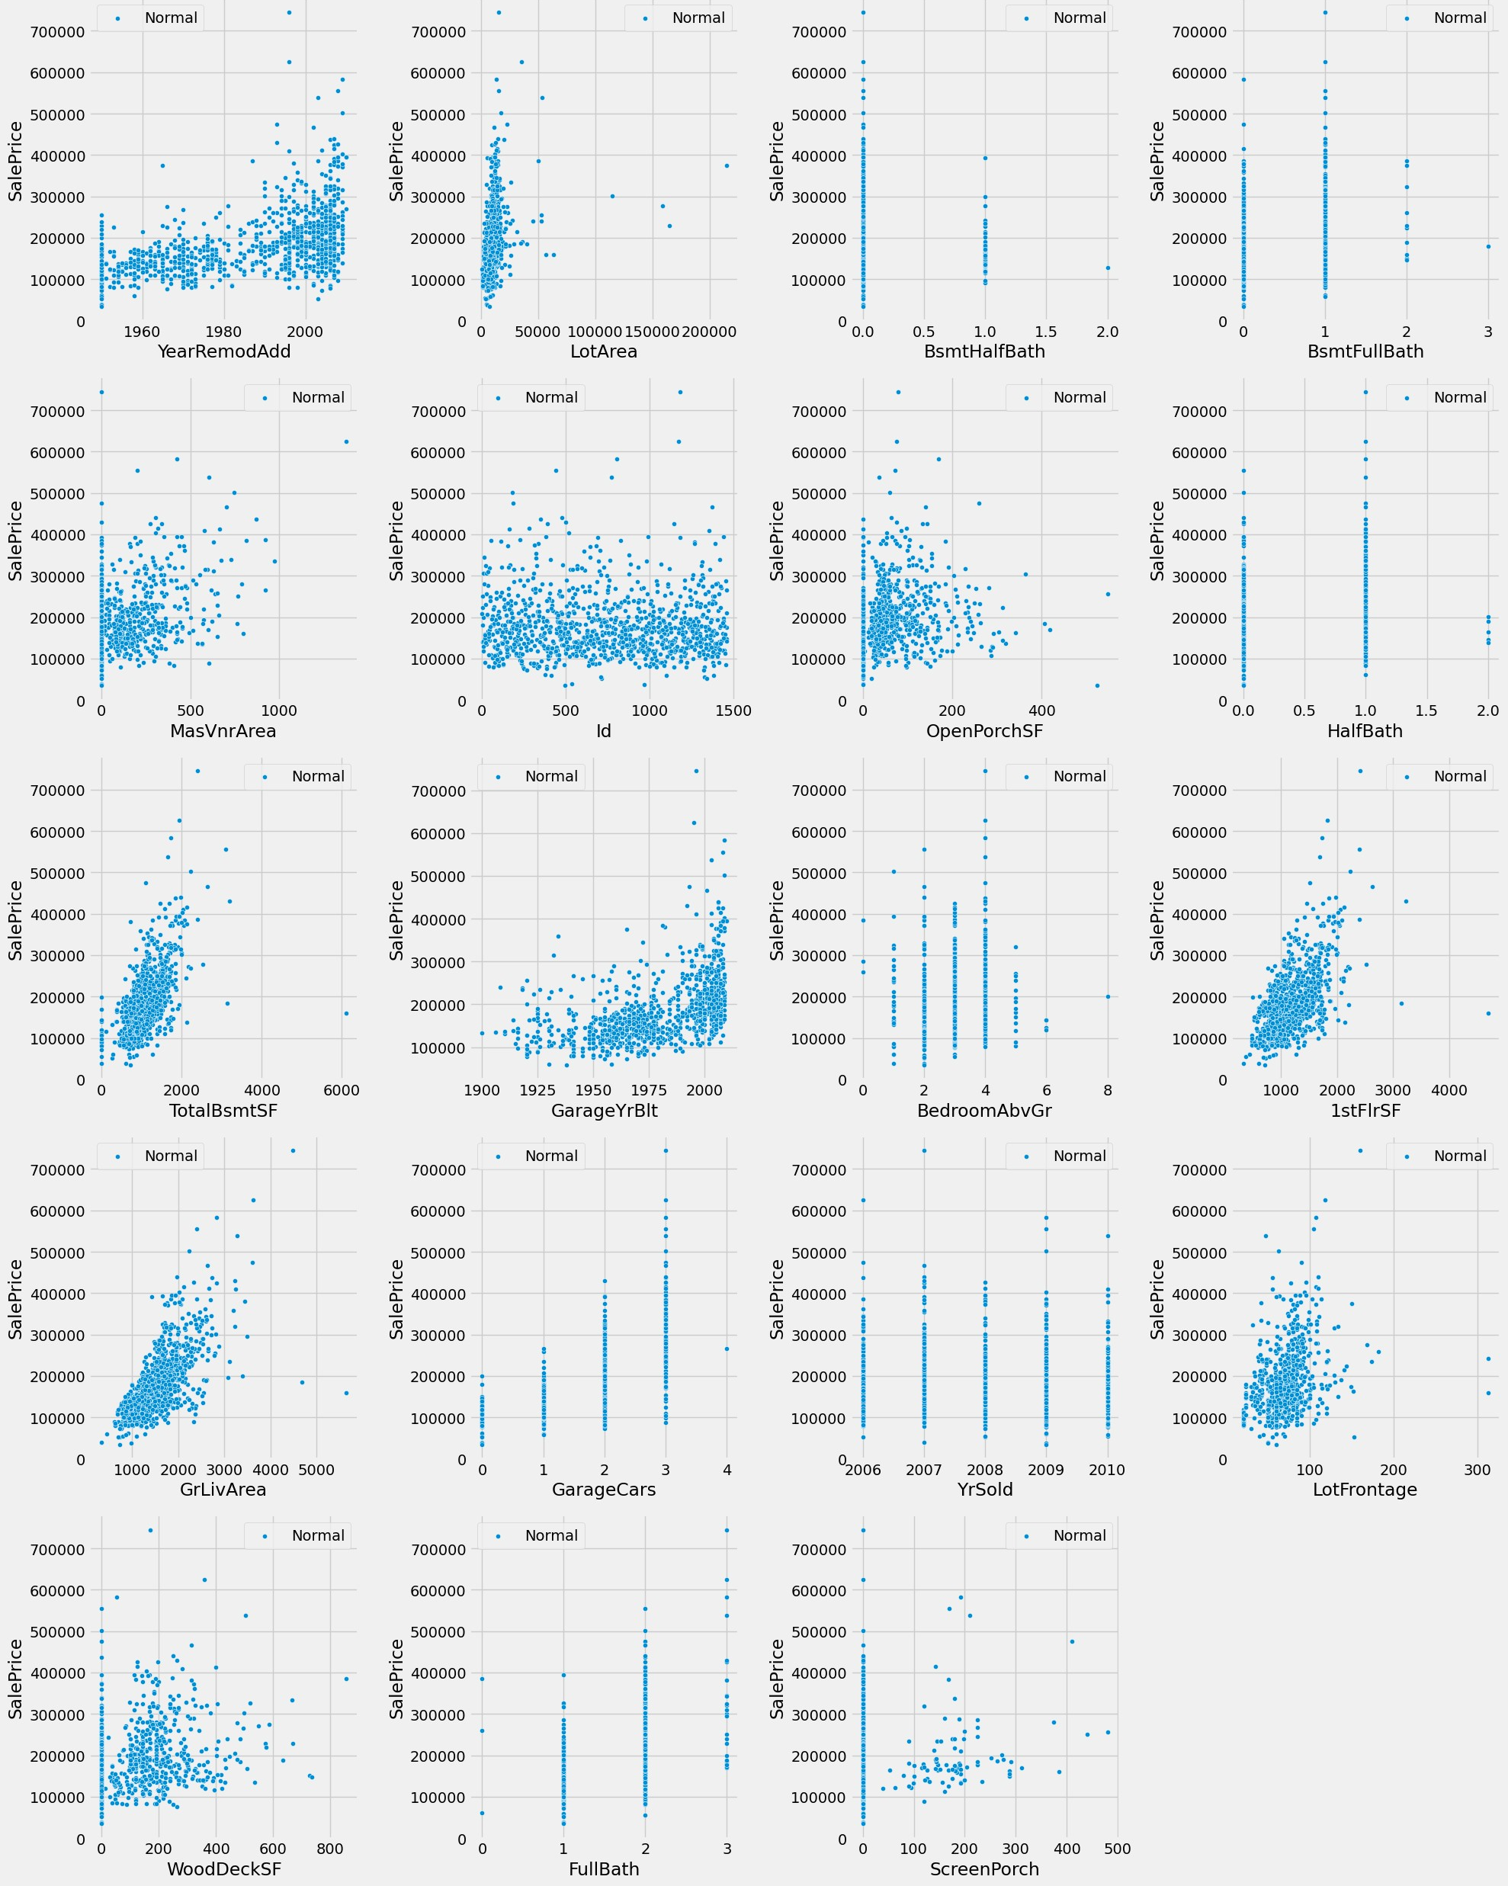
Figure 6 Scatter Plot of Numerical Columns - 2
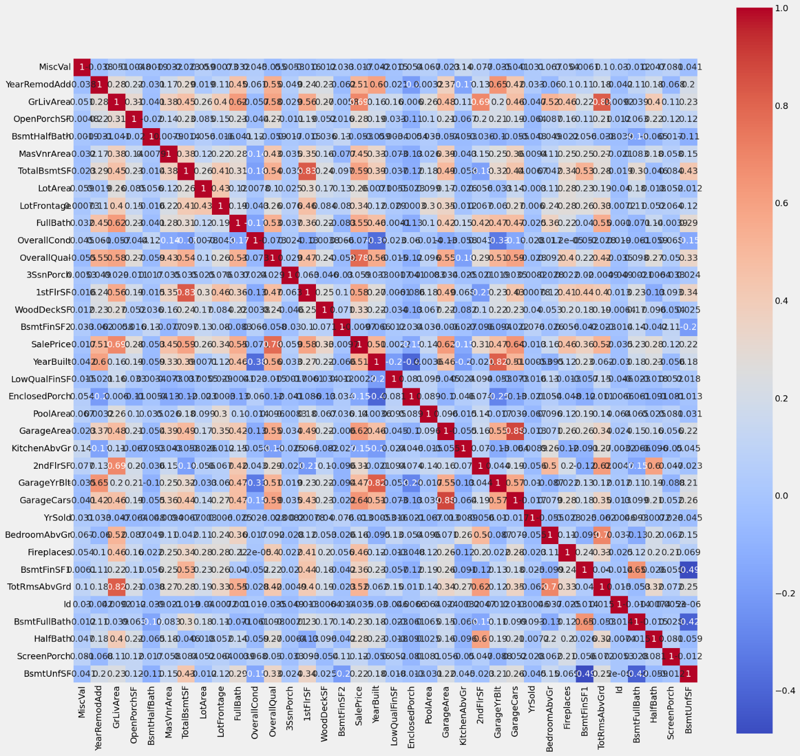
Figure 7 Heatmap of Numerical Columns

Dataset Cleaning

Outliers
We begin by treating outliers, identifying them with either the IQR rule or the three-sigma criterion. The scatter plots reveal several extreme points that should be removed or winsorized before further analysis, such as the house that has large GrLivArea, but its selling price is very low sale.
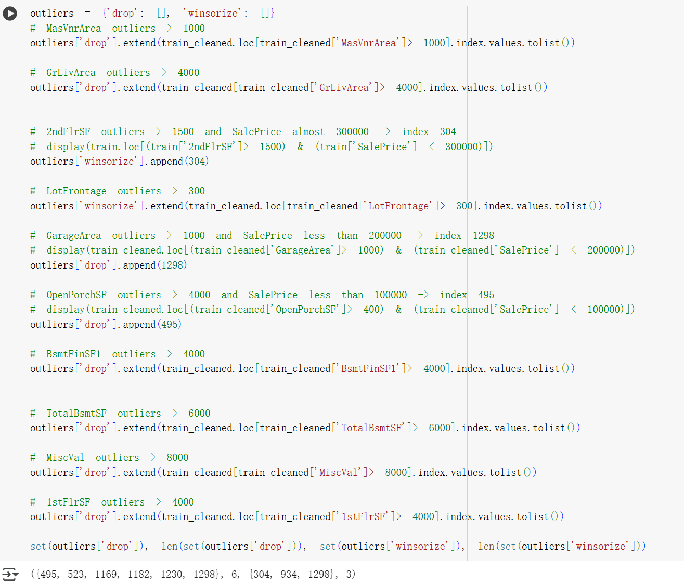
Figure 8 Code of Handling Outliers

Null Values
First, Null value in nominal and ordinal variables is often not a collection error, but rather indicates "absence of the attribute" (e.g., no fireplace, no fence). However, when more than 90% of the records in a column are missing, the variable provides little discriminatory power, and retaining it only adds noise to the model. Therefore, these highly missing fields are simply deleted. Conversely, columns with a missing percentage below 1% meet the MCAR (Missing Completely at Random) assumption—these missing are completely random and cannot be inferred from other information. Therefore, I choose to delete this very small number of records at the row level instead of performing imputation.
The only variable that is truly "measurement missing" is LotFrontage (street frontage length). It has a stable relationship with the neighbourhood and street type, so I wrote a group interpolation rule:
First, if the sample size of a "Neighbourhood × Street" combination is at least min_ns, the median of the combination's LotFrontage is directly interpolated. If the combination sample size is insufficient, then determine whether the overall sample size of the neighbourhood reaches min_n. If so, the median of the neighbourhood is used instead. For records that are still empty, KNNImputer is finally used based on all numerical features within its belonging Neighbourhood category.
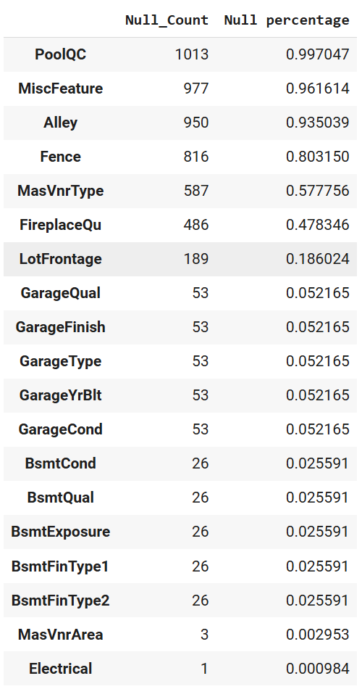
Figure 9 Null Percentage
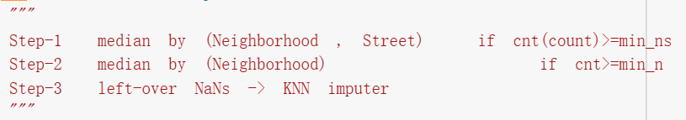
Figure 10 LotFrontage Imputing Rules

Encoding Categorical Columns
For nominal categorical variables, I directly use One-Hot encoding; for ordinal variables with natural order, I use custom order encoding. When determining the order, I first look at the distribution of housing prices corresponding to each level (see the boxplot and strip plot in Figures 11 and 12). The results show that "NA" does not always represent the lowest level; in some features, its average selling price is even higher than "Po" or even "Fa". Therefore, I will adjust the order of levels according to the actual selling price, rather than putting "NA" at the lowest end.

In addition, the mainstream level of most ordinal features is "TA" (Typical) or occasionally "NA". In order to make the coefficient easier to interpret, I encode this level with the highest proportion and the price closest to the overall mean as 0; the level below it is assigned a negative value, and the level above it is assigned a positive value. The advantage of this is that the encoding sign naturally reflects the direction of "better" or "worse" than the mainstream level.
Taking `KitchenQual` as an example, the final coding order is ['Po', 'Fa', 'TA', 'Gd', 'Ex'], where 'Po' and 'Fa' are coded as −2 and −1 respectively, 'TA' is 0, and 'Gd' and 'Ex' are 1 and 2. For another example, `BsmtQual`, the order is adjusted to ['Po', 'NA', 'Fa', 'TA', 'Gd', 'Ex'], and the corresponding codes are −1, 0, 1, 2, 3, 4.
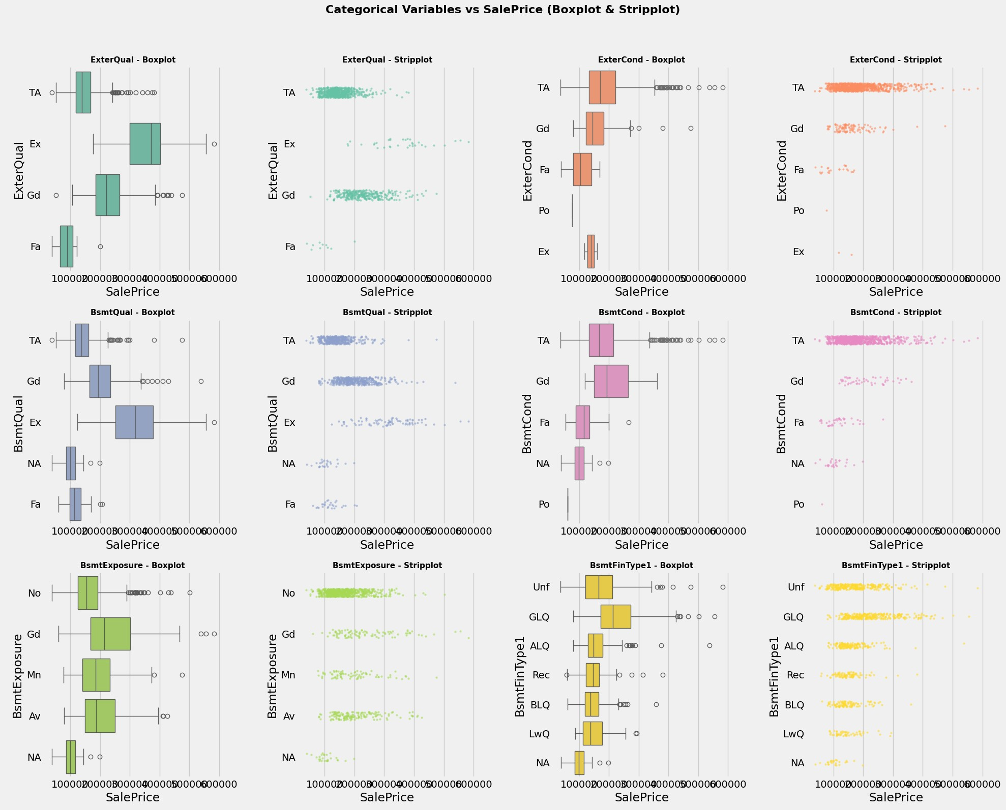
Figure 11 Plotting of Ordinal Encoding Variables – 1
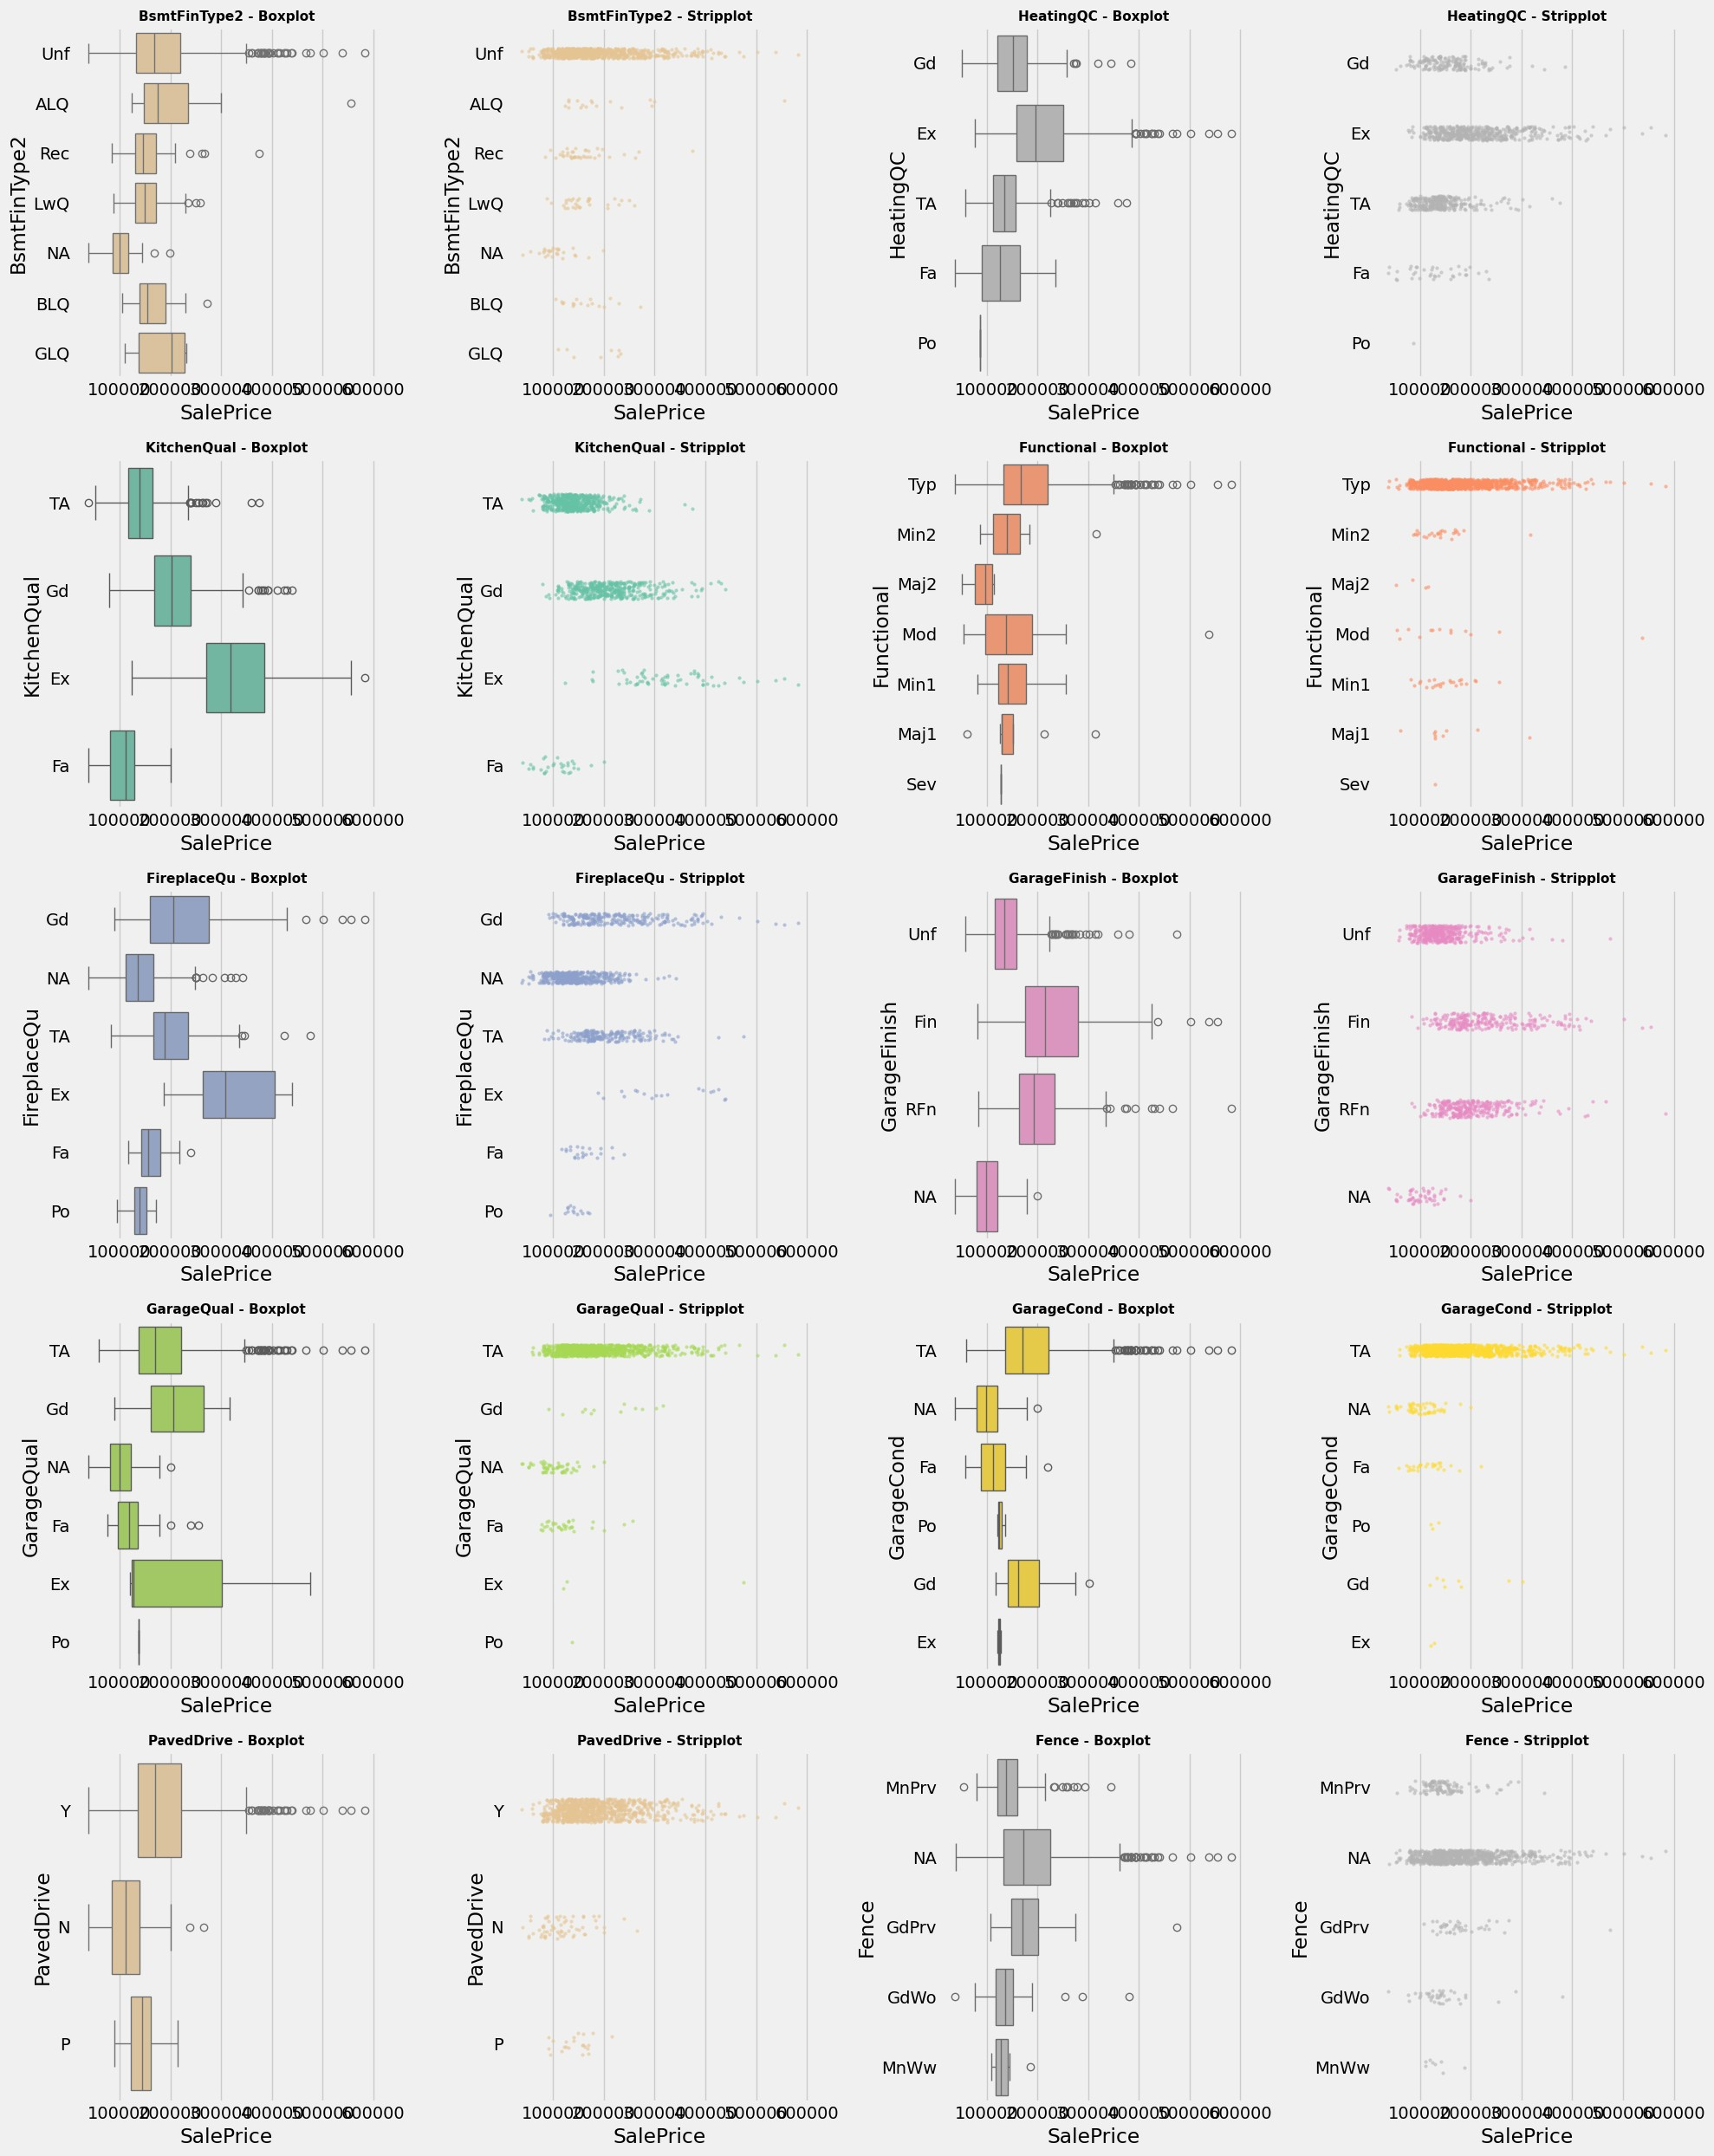
Figure 12 Plotting of Ordinal Encoding Variables – 2

Features Engineering

Before Encoding Categorical Variables

Neighbourhood Tier
Before encoding the categorical variables, I first using the training data as a baseline, performed stratification on the neighbourhood data, I calculated quantile statistics (e.g., p25, median, p75, p90) for the target variable by neighbourhood group. Using these statistics as representation vectors and clustered the neighbourhoods into four groups using KMeans. Then, I sorted the target medians of each group from low to high, generating four "location tiers" and encoding them in an ordered manner (centred to −1, 0, 1, 2). This served two purposes: first, using clustering to merge similar neighbourhoods without blindly discarding rare categories; second, to directly extract the "location strength" feature that facilitates the linear modelling.
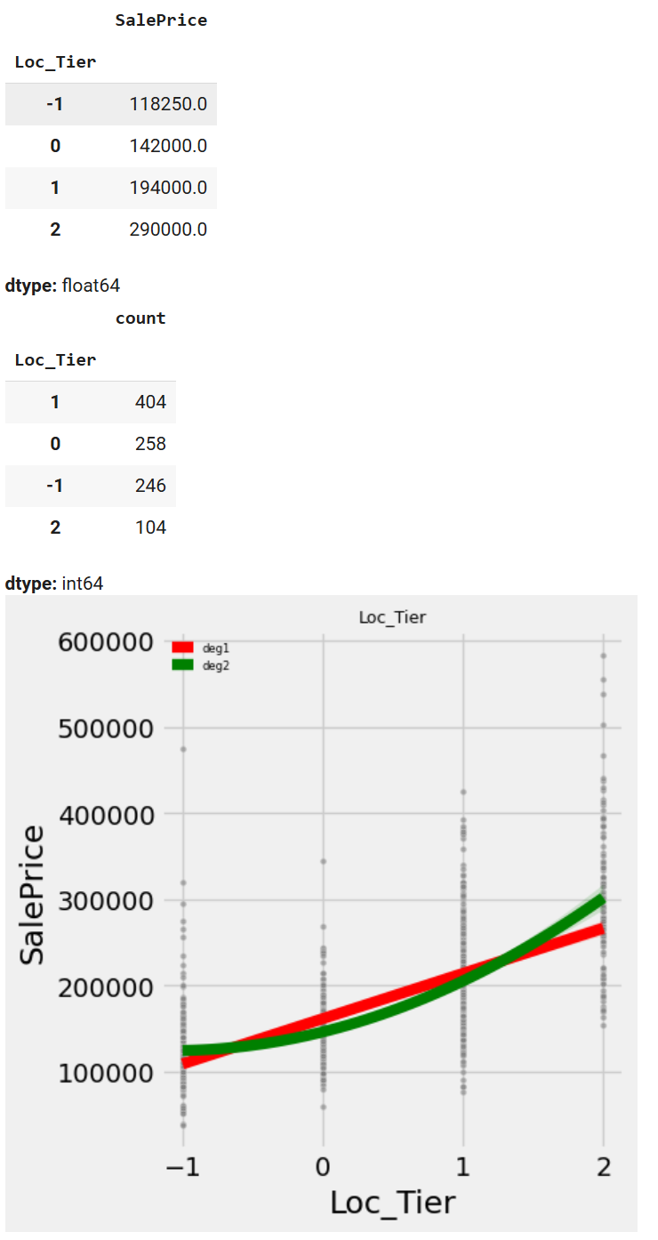
Figure 13 Statistic Measurement and Scatter Plot of Location Tier

Binarization
Several numerical features have a high percentage of zeros (0 typically indicates "the feature doesn't exist"). When these features are overpopulated with zeros, simply treating the feature as a continuous variable in a linear model often results in unstable fits due to the "presence/absence" effect. To address this, I first binarize these features, adding an indicator variable indicating only "whether it is 0" (presence/absence) to capture the price jumps caused by presence. It's important to note that not all binarized features are retained, some perform better than the original continuous value, while others do not. Eventually, collinearity management determines whether these features are retained.

After Encoding Categorical Variables

Combined Outdoor Area (TotalPorchDeckSF)
we sum the porch/deck area features (`ScreenPorch`, `3SsnPorch`, `EnclosedPorch`, `WoodDeckSF` and `OpenPorchSF`) to obtain the combined outdoor area, `TotalPorchDeckSF`. The fitted curve shows that the combined area is more stable than the individual columns, with a significant "step jump" at approximately 400 ft². Therefore, we set `Luxury_LargePorch = 1 (TotalPorchDeckSF ≥ 400)` to capture the stepwise premium for high-end outdoor space.
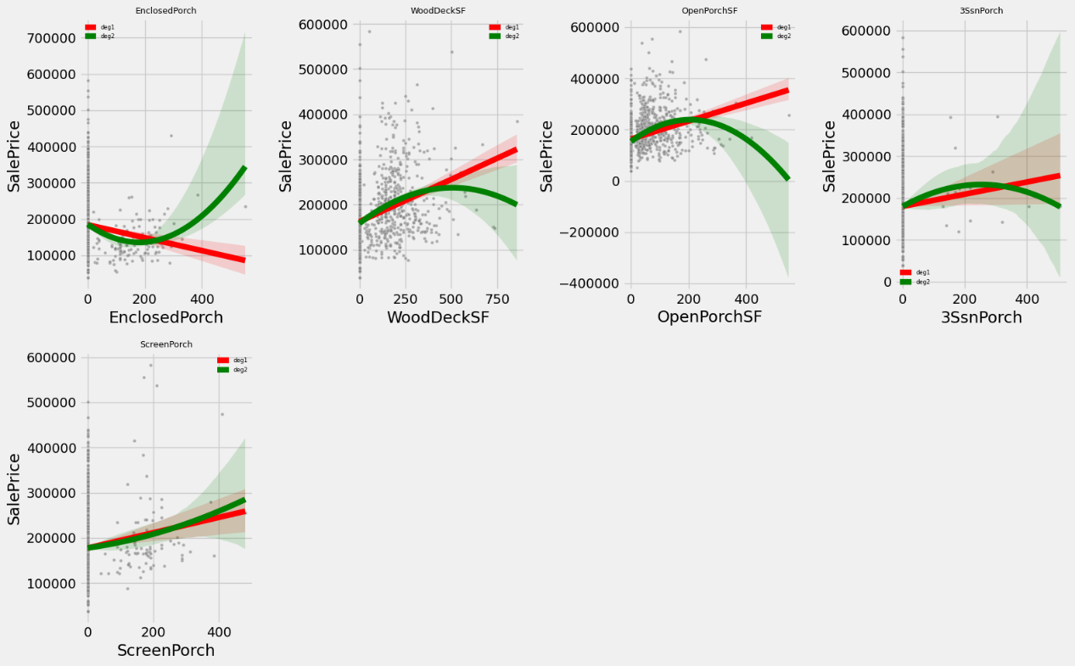
Figure 14 Regression Plots of Porch/Deck Features
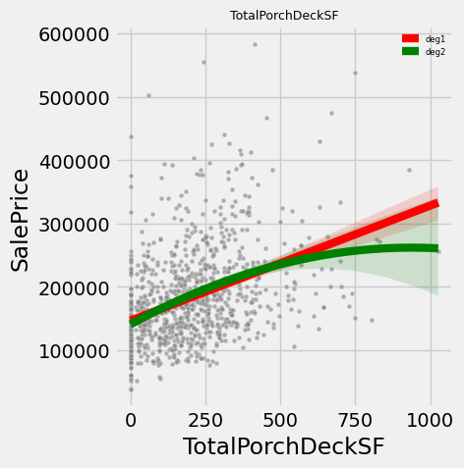
Figure 15 Regression Plot of TotalPorchDeckSF Feature

Luxury Binary Features
We created simple yes/no features to mark luxury homes. These include Luxury_BigHouse for homes over 3000 sq. ft., Luxury_BigBsmt for large basements, and Luxury_Garage3up for garages with more than 3 cars. These binary features help separate "having the big feature" from "how big the feature is". This makes the model work better because it treats these as two different effects instead of mixing them together.

LuxuryScore and Squared Terms
We built a luxury score that combines different parts of what makes a house fancy, there are quality part (70% weight), it is averaged scores for overall quality, exterior quality, kitchen quality, garage quality, fireplace quality, and basement quality; condition part (10% weight), it is averaged condition scores for overall, exterior, garage, and basement; and size part (20% weight, it is used percentile ranks for living area, basement size, garage area, and masonry area, then averaged them
We combined these three parts with weights to get the final LuxuryScore. We also added LuxuryScore^2 (squared term) to capture how luxury homes get much more expensive at the high end. It is noticed that the score is centred first to reduce correlation problems between the linear and squared terms.
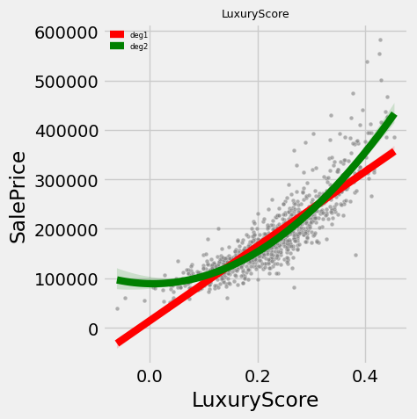
Figure 16 Regression Plot of LuxuryScore

Age and Bathroom Features
In actual prediction scenarios, the age of a house (and the "Years since last renovation") is more valuable than the specific year of construction (or renovation). Therefore, it is used time differences instead of actual years. (House_Age = YrSold – YearBuilt , House_Age_RemodAdd = YrSold – YearRemodAdd and dropping the original YrSold, YearBuilt and YearRemodAdd variables).
For bathrooms, we created AboveGradeBaths = FullBath + 0.5*HalfBath to count "effective bathrooms" since half baths are worth less. We also made a density feature BathsPer1000GrLiv to show how many bathrooms per 1000 square feet of living space.
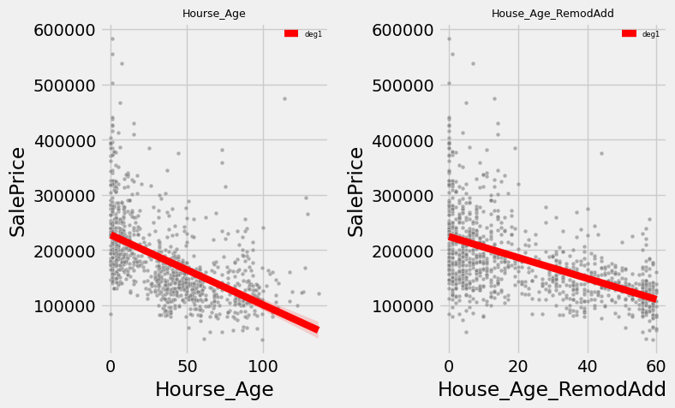
Figure 17 Regression Plots of House_Age and House_Age_RemodAdd

Low Variance
After one-hot encoding of categorical variables, if a category is extremely rare in the sample, its corresponding dummy variable is almost always 0, with only a very small number of rows taking on 1, resulting in a variance close to 0. To prevent this "near-zero variance" feature from introducing noise into the model, we set a variance threshold of 0.01. All dummy variables with variances below this threshold are dropped.

Handling the Multicollinearity Issue
After dropping the low variance features, the multicollinearity issue still appears after encoding and binarization. Some dummy variables essentially describe the same attribute or highly similar measures, therefore they have correlations with each other.

Merging
To eliminate this redundancy, I first took the row-level maximum of them (that is, if any column was 1, the merged column was set to 1). After generating new summary indicators, I deleted the original columns.
For example, Exterior1st_* and Exterior2nd_* both describe the exterior wall material of a house. I combined them into a single indicator, exterior_contains_[material]; BldgType_Duplex and MSSubClass_90 both refer to duplexes, so I merged them into BldgType_Duplex_or_MSSubClass_90 and then deleted the original columns.

Dropping and Ratios
The strategy for addressing the pairs of highly correlated numerical variables is simply dropping the less correlated column. For some specific correlated features, for example GrLivArea (above-ground living area, square feet) and TotRmsAbvGrd (total above-ground rooms, excluding bathrooms) are naturally highly correlated: more rooms indicate a larger area. It is constructed a derived feature: `Area_per_RmsAbvGrd = GrLivArea / (TotRmsAbvGrd + BedroomAbvGr) ` and then removed TotRmsAbvGrd. This can retain the useful information about the average area per room.
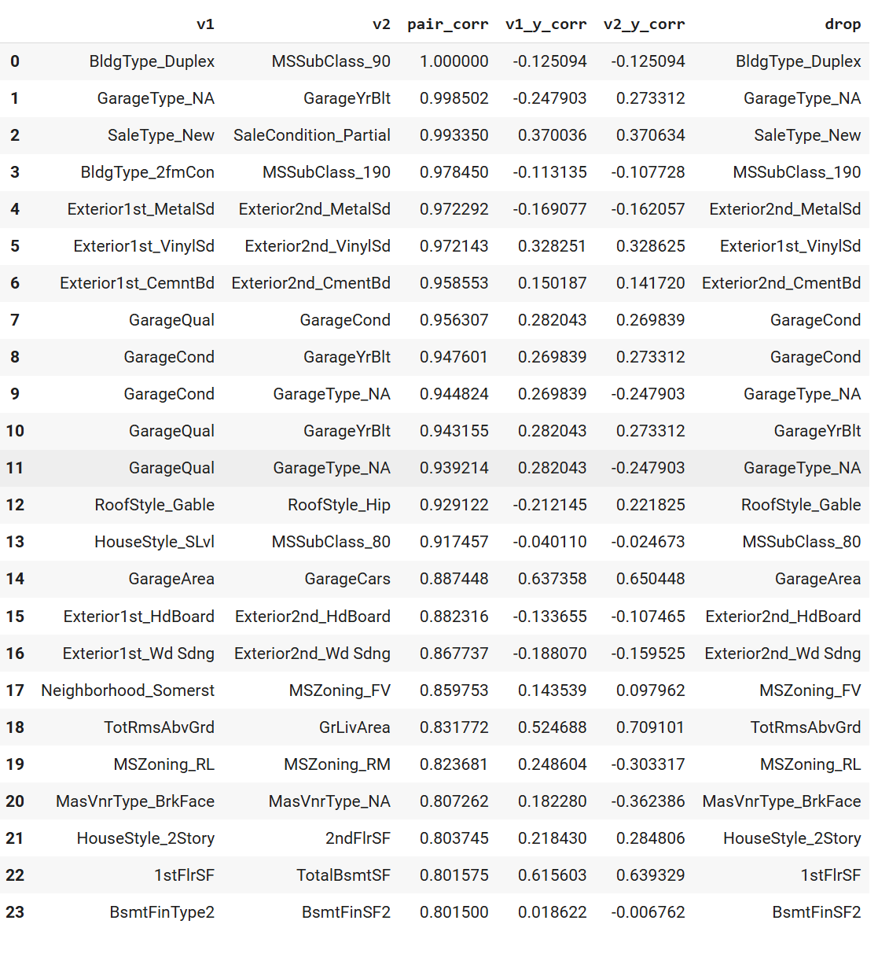
Figure 18 Part of Multicollinearity Assessment

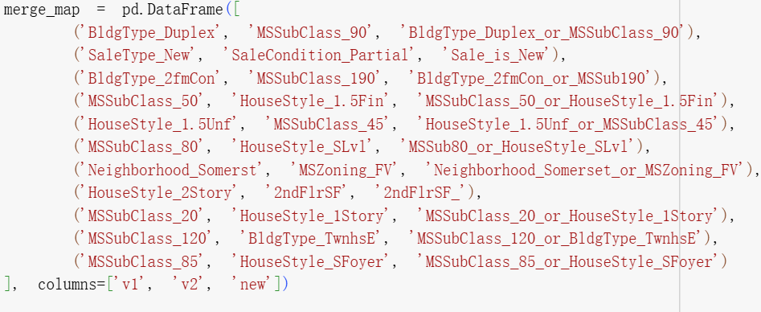
Figure 19 Feature Merging Table
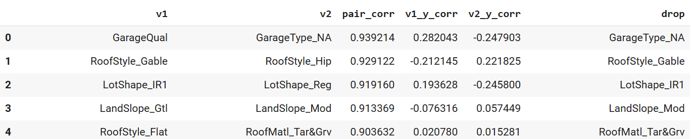
Figure 20 Part of Multicollinearity Assessment After Features Engineering that Handling the Collinearity Issue

Features Selection

First Round of LASSO Bootstrap
After the first round of feature engineering, the dataset still contains highly correlated features (Figure 20). Many of these correlated features are derived from different categorical values of the same feature, such as gable and hip roof styles. In this case, LASSO regression can be used for feature selection, as the L1 regularization, can compress the coefficients of some features to zero, thereby enabling automatic feature selection.
However, the results of a single LASSO regression can unstable. Therefore, we employ the LASSO bootstrap method. The specific process involves resampling the original data n times with replacement, training the same LASSO model each time, and recording whether each feature is selected (its coefficient is non-zero). Finally, only features whose frequency in the n resamples exceeds a preset threshold are retained. The purpose of doing this is that it improves the stability of feature selection—if a feature is selected in most resamples, we have stronger confidence that it has a significant impact on the target variable.
Considering the subsequent need of constructing interaction terms and polynomial features. The first round used relatively loose parameters. It is performed 2000 times bootstrap and only that the feature frequency exceeds 75% is retained. The reason for using a lower threshold is to avoid prematurely eliminating basic features that seem unimportant individually but may have significant predictive effects after forming interaction terms or square terms.
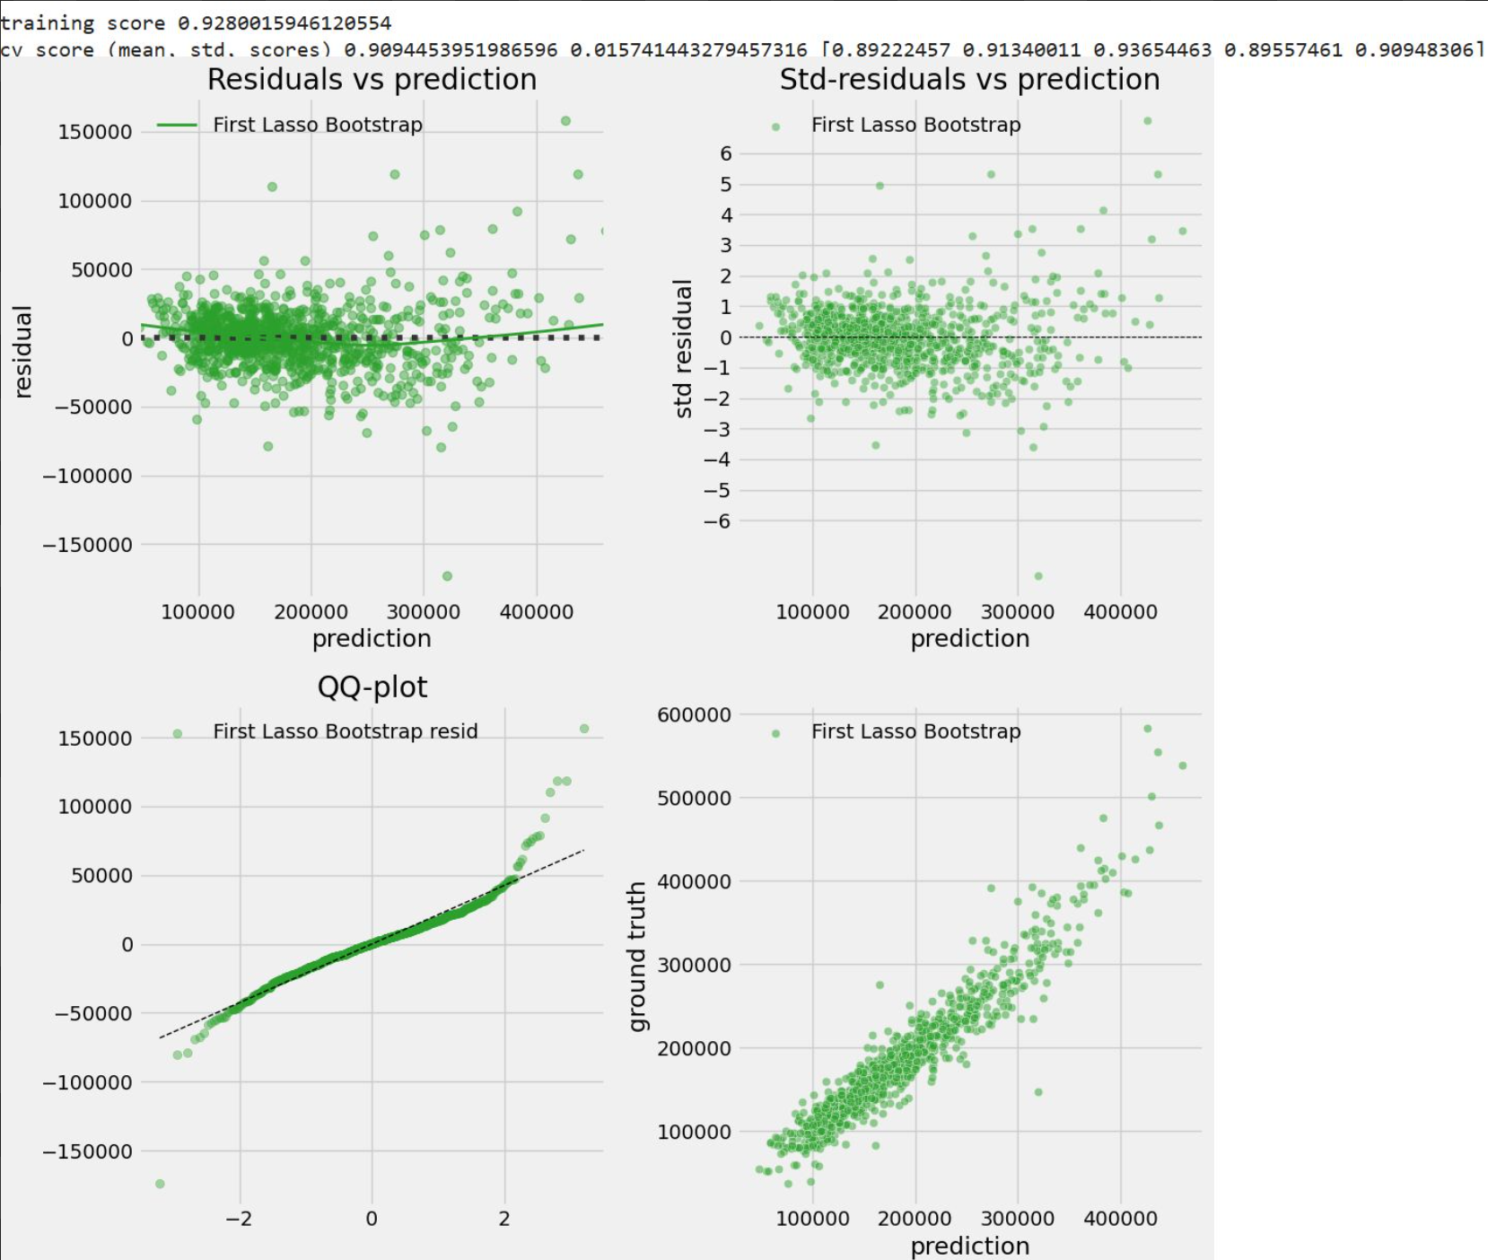
Figure 21 Cross Validation Residual Diagnostic Plots for LASSO Regression after First-Round Bootstrap Feature Selection

Features Engineering – Polynomial Features
The residual plot (Figure 21) reveals a systematic curved pattern, indicating that our current model is underfitting and requires additional complexity to capture the non-linear relationships in the data. Therefore, we constructed squared terms, and interaction features exclusively from the variables that selected after the first round of LASSO bootstrap.
Rather than employing scikit-learn's PolynomialFeatures transformer, which would generate all possible polynomial combinations indiscriminately, we manually selecting specific features based on their scatter plot patterns, it is created only those squared terms that showed clear non-linear relationships with the target variable, and interaction terms of some main features (Figure 22). The purpose of doing this is to avoid creating complex polynomial terms that might improve model performance but lack intuitive interpretation. The original terms are centred first before creating the interaction terms.
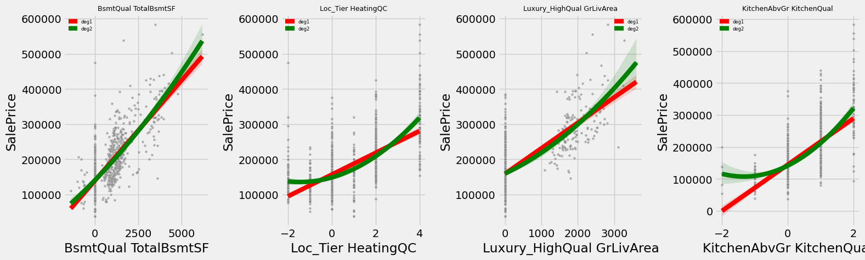
Figure 22 Regression Plots of Interaction Terms Multiplied by Selected Features
Because of the similar measurement of "House Age" (House_Age) and "Years since last renovation" (House_Age_RemodAdd), we further discretized the House_Age_RemodAdd feature into a categorical variable. Based on whether its value is less than 5 years, between 5 and 15 years, or greater than 15 years, it is divided into three categories: "Recent Renovation" (Remod_Recent), "Mid-Term Renovation" (Remod_Mid), and "Old Renovation" (Remod_Old).

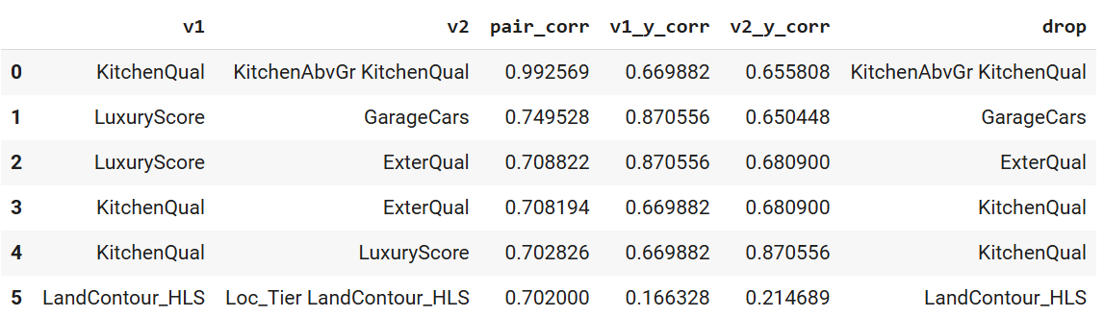
Figure 23 Multicollinearity Assessment of Squared and Interaction Features After First LASSO Bootstrap Selection
The predictor variable worth noting is KitchenAbvGr. A simple correlation analysis shows that this variable is negatively correlated with target variable, which suggest that houses with more kitchens sell for lower prices. It seems a counterintuitive conclusion. An inspection of the scatterplot reveals that almost every house has exactly one kitchen, with only a few having two. Therefore, this "negative" slope is likely driven by extreme class imbalance rather than true economic principles. Therefore, I replaced the raw counts with the interaction term KitchenQual and KitchenAbvGr. While this interaction term is slightly less correlated with price than KitchenQual alone, it shifts the net effect of the additional kitchen to a positive one, which is intuitive. Because KitchenQual and its interaction term are highly collinear, I removed both base terms (KitchenQual and KitchenAbvGr).
The GarageCars feature is also dropped as due to the collinearity issue.

Second Round of LASSO Bootstrap
After dropping the features, it is again applied LASSO Bootstrap to duel with the remain multicollinearity issue and doing stability features selection.
The second round of LASSO bootstrap uses stricter parameter settings. Similarly, 2000 bootstrap samples are performed, but only features with frequencies exceeding 90% are retained. In addition, for these features with frequencies exceeding 90.

Recursive Features Elimination (RFE)
The next feature selection step uses the RFE (Recursive Feature Elimination) method. This algorithm recursively removes the least important features until the number of remaining features reaches a preset value, thereby eliminating variables that are not significant to the target variable.
After a second round of LASSO bootstrap, the number of features was further reduced to 48. Next, we used grid search cross-validation to evaluate different numbers of features retained in RFE and identify the optimal performance. The results in Figure 24 show that retaining 42 features achieves the optimal balance between feature number and prediction score.
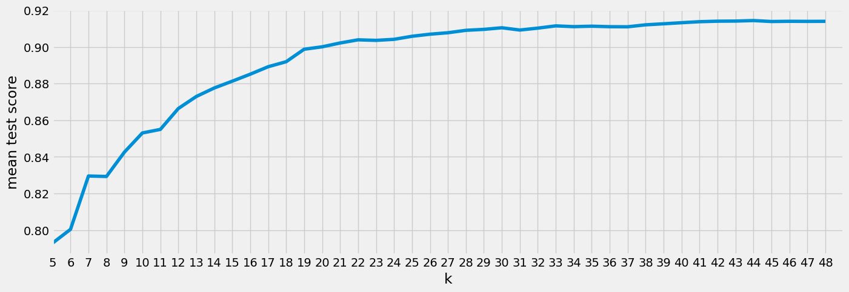
Figure 24 Grid search results for the number of features selected in RFE

Features Dropping
We found that among the 42 features kept after RFE, dropping a few of them actually increased the cross-validation score. The RFE curve hinted at this: reducing the set selected by the second Lasso-bootstrap pass (from 48 to 44 features) improved validation performance. These features were not removed by RFE because their estimated coefficients were large, but the drop test shows that removing them can help.
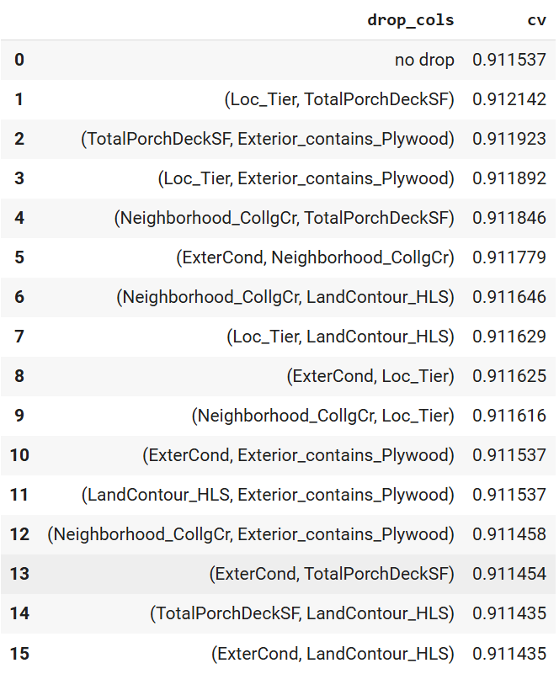
Figure 25 Part of Drop Test
During the drop test, removing some features led to a higher cross-validation score. To balance performance and interpretability, we chose to remove features whose marginal effects were weak, unstable, or hard to justify. For example, when kept in the model, ExterCond had a negative coefficient after controlling for other variables, which is counterintuitive and likely driven by multicollinearity or redundancy. Also, BsmtFullBath is mostly 0 or 1, and its signal appears to be captured by other bathroom composites, so it adds little value on its own.
Therefore, we removed the following features from the final model: LandContour_HLS, Neighborhood_CollgCr, Exterior_contains_Plywood, LotConfig_CulDSac, ExterCond, MasVnrType_BrkFace, and BsmtFullBath. These choices reflect more interpretable specification.

Features Selection Conclusion
In the feature selection phase, a relatively relaxed LASSO bootstrap is first used to extract preliminary stable features. Polynomial terms and interaction terms are then generated based on these features, and LASSO bootstrap with stricter parameters is used again for further selection to identify truly robust variables. Finally, recursive feature elimination (RFE) manual feature dropout are used to gradually remove the least important remaining features.

Model Training and Evaluation
After training and testing different regularized models, we found that the optimal α for Ridge was 0, and the optimal l1_ratio for Elastic Net was 1, meaning that they degenerate to ordinary least squares (OLS) and LASSO, respectively. Based on this result, only LASSO and OLS were retained for the final model evaluation.
The OLS performs slightly worser than LASSO, but the overall difference is not significant, and both models outperform the model using only the first LASSO bootstrap. This is also confirmed by the test set scores shown in Figure 30, where the $R^{2}$of both models remains around 0.92.
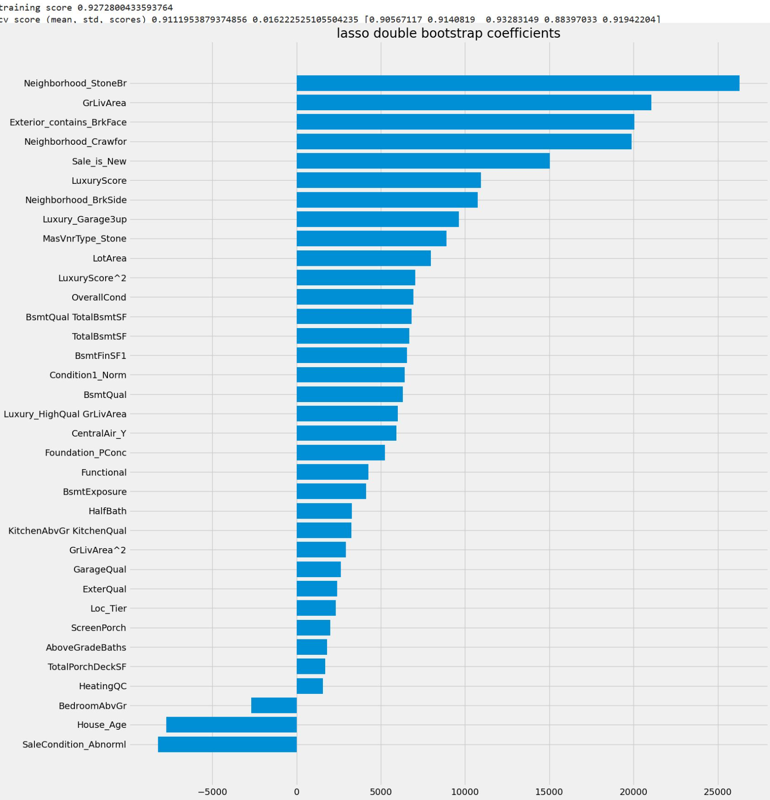
Figure 26 LASSO Model with Double LASSO Bootstrap Coefficients and Importance Ranking
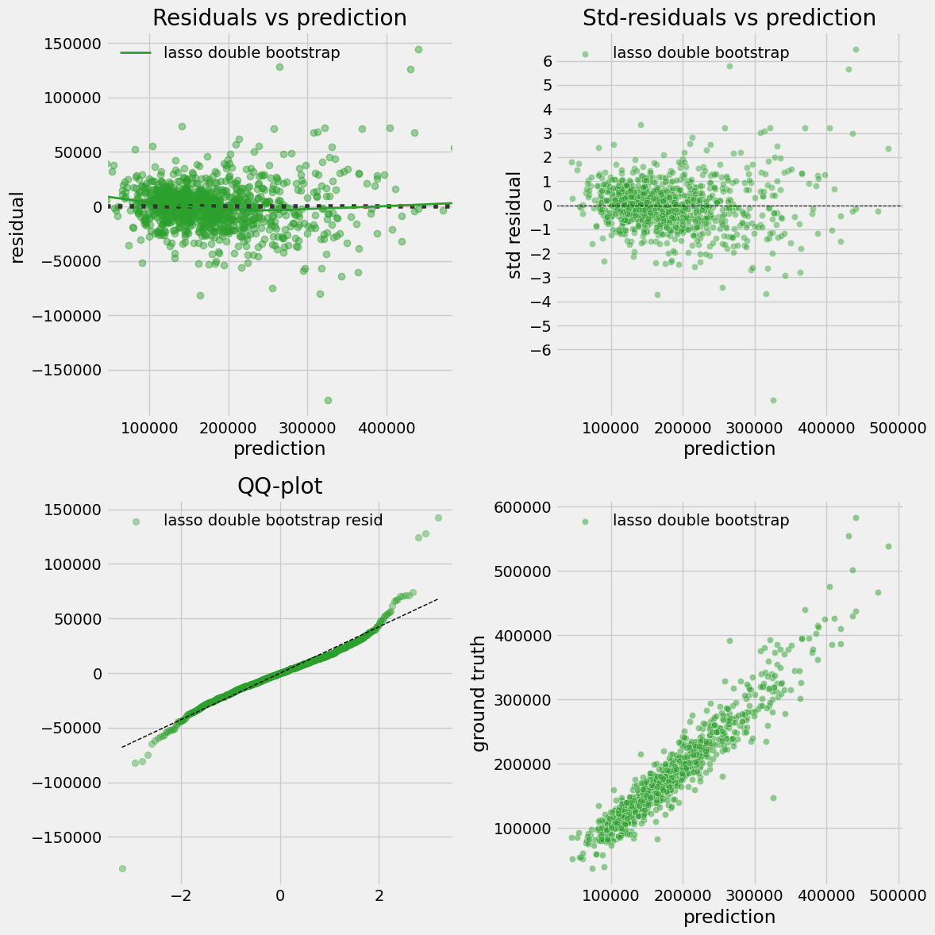
Figure 27 Cross Validation Residual Diagnostic Plots of LASSO Model with Double LASSO Bootstrap
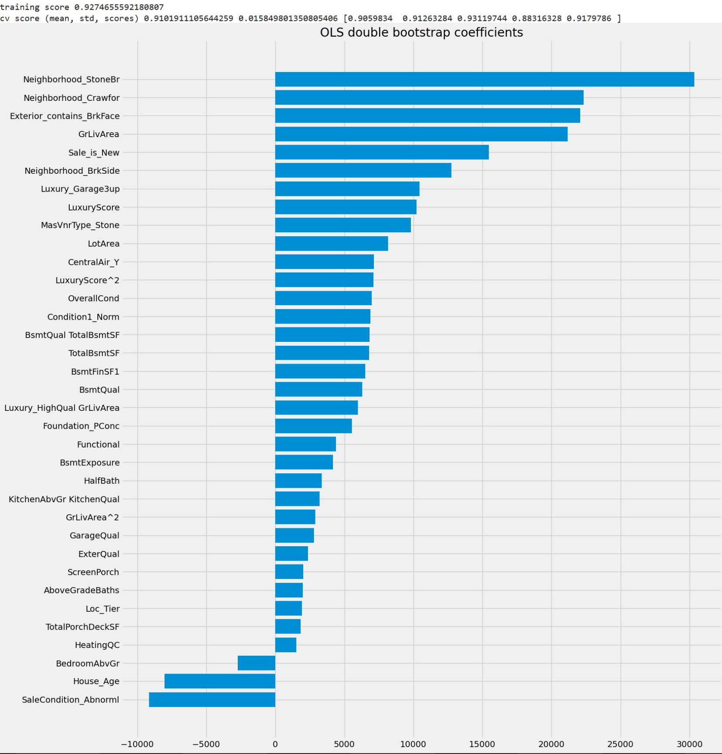
Figure 28 OLS Model with Double LASSO Bootstrap Coefficients and Importance Ranking
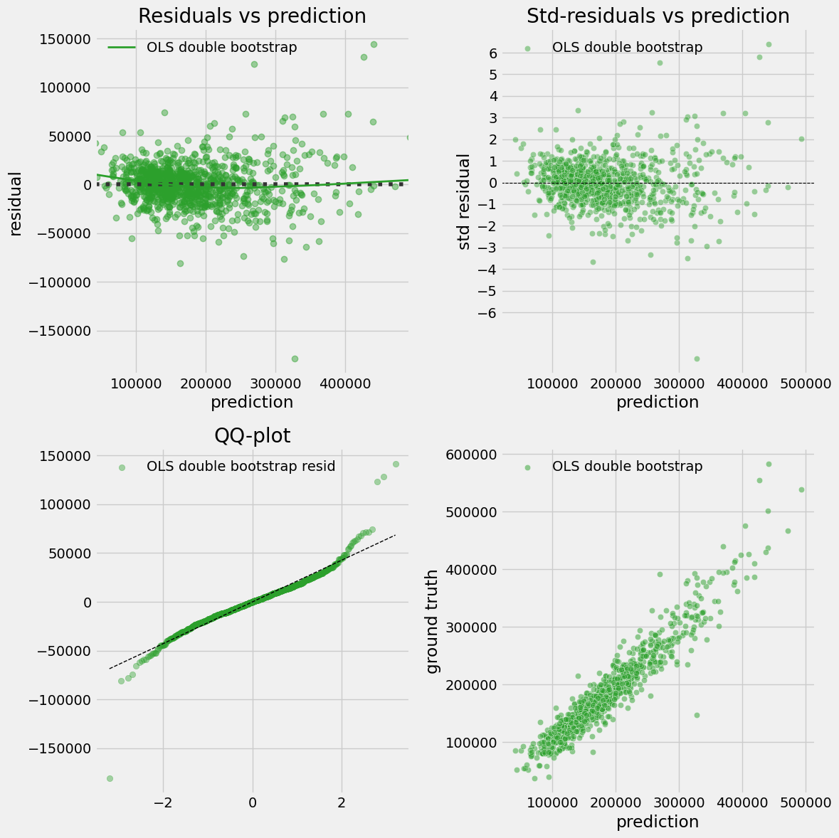
Figure 29 Cross Validation Residual Diagnostic Plots of OLS Model with Double LASSO Bootstrap
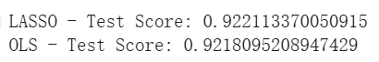
Figure 30 Test Score of LASSO and OLS Model

Statistical Inference
We conduct statistical inference on the full dataset using the unscaled explanatory variables produced by the finalized feature‑engineering pipeline. After refitting OLS on the transformed design matrix, model fit is strong (R²=0.927). However, both the normality test on residuals and the Breusch–Pagan test indicates clear violations of the Gaussian and homoscedastic error assumptions. The diagnostic plots confirm these results that the residuals vs. prediction and standardized‑residuals plots show a funnel pattern with larger dispersion at the low and high ends of price, and the QQ‑plot exhibits heavy tails. Because heteroscedasticity distorts standard errors, we report heteroscedasticity‑robust HC3 standard errors for p‑values and confidence intervals, following the robust inference. This approach addresses biased SEs without changing point estimates, but it does not “fix” the residual shape itself; predictions still carry larger uncertainty for very cheap and very expensive houses.
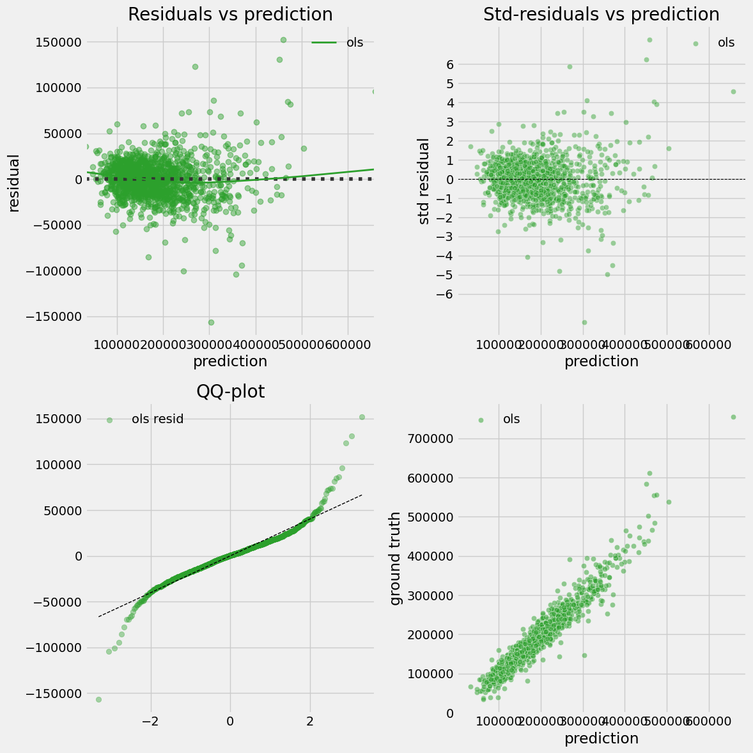
Figure 31 Residual Diagnostic Plots of OLS Model with Full Dataset
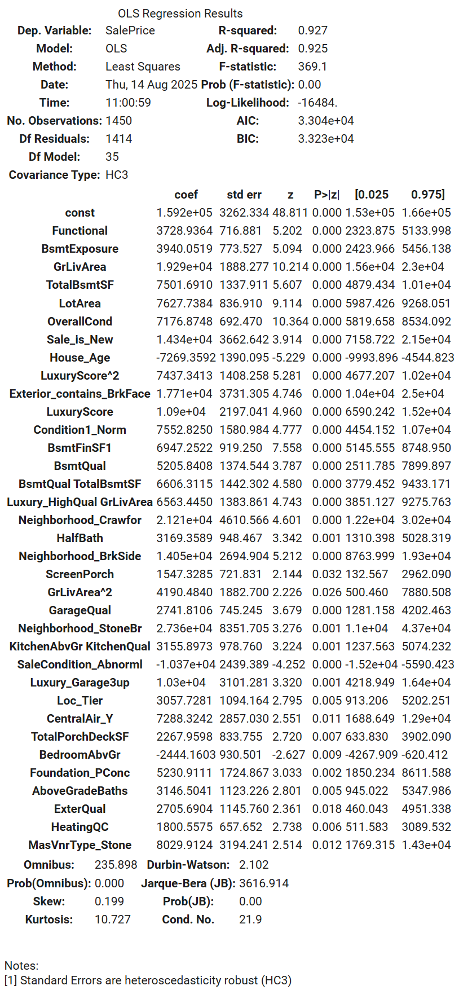
Figure 32 OLS regression results with Full Dataset (HC3-robust SEs)

Coefficients and Percentage Per Unit Change
With HC3, most key effects remain statistically significant. Interpreting coefficients as marginal effects and also when a feature increases by "1 model unit" while keeping other variables unchanged, the percentage impact relative to average house price (pct_per_unit).

Neighborhood effects
`Neighborhood_StoneBr` (+$27.4k; +15.2%) and `Neighborhood_Crawfor` (+$21.2k; +11.8%) command sizable premiums relative to the omitted neighbourhood.

Size and space
Size and space: `GrLivArea` (+$19.3k; +10.7%) and `TotalBsmtSF` (+$7.5k; +4.2%) are positive; the small positive `GrLivArea^2` term (+2.3%) implies a convex price–size curve, consistent with increasing prices at higher sizes.

Quality/luxury
`LuxuryScore` (+$10.9k; +6.0%) and its squared term `LuxuryScore^2` (+$7.4k; +4.1%) capture accelerating premiums for high‑end homes. The interaction `Luxury_HighQual × GrLivArea` (+$6.6k; +3.6%) shows that large floor area is worth more when overall quality is high.

Amenities
`CentralAir_Y` (+$7.3k; +4.0%), `Exterior_contains_BrkFace` (+$17.7k; +9.8%), and `BsmtExposure` (+$3.9k; +2.2%) are all positive.

Age and conditions
`House_Age` is negative (−$7.27k; −4.0%), reflecting depreciation when the age of house keeps increasing; `BedroomAbvGr` is negative (−$2.44k; −1.36%), a common pattern when holding overall size constant—more bedrooms often imply smaller non‑bedroom space.
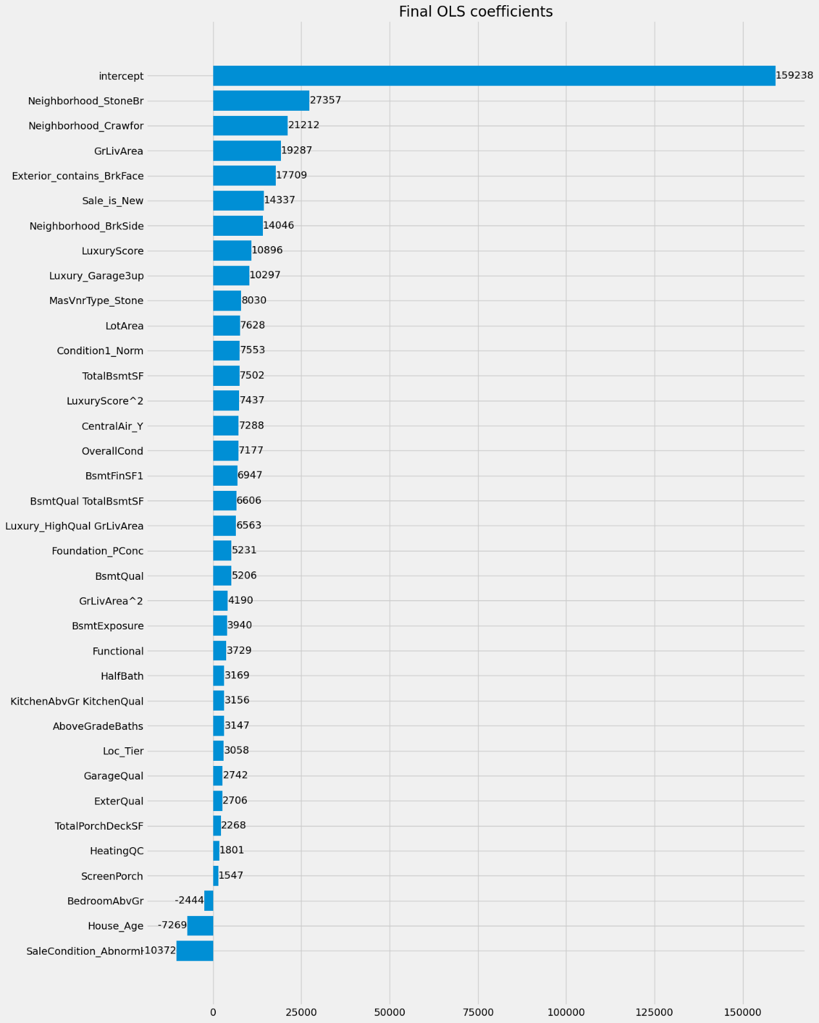
Figure 33 Final OLS coefficients with Full Dataset
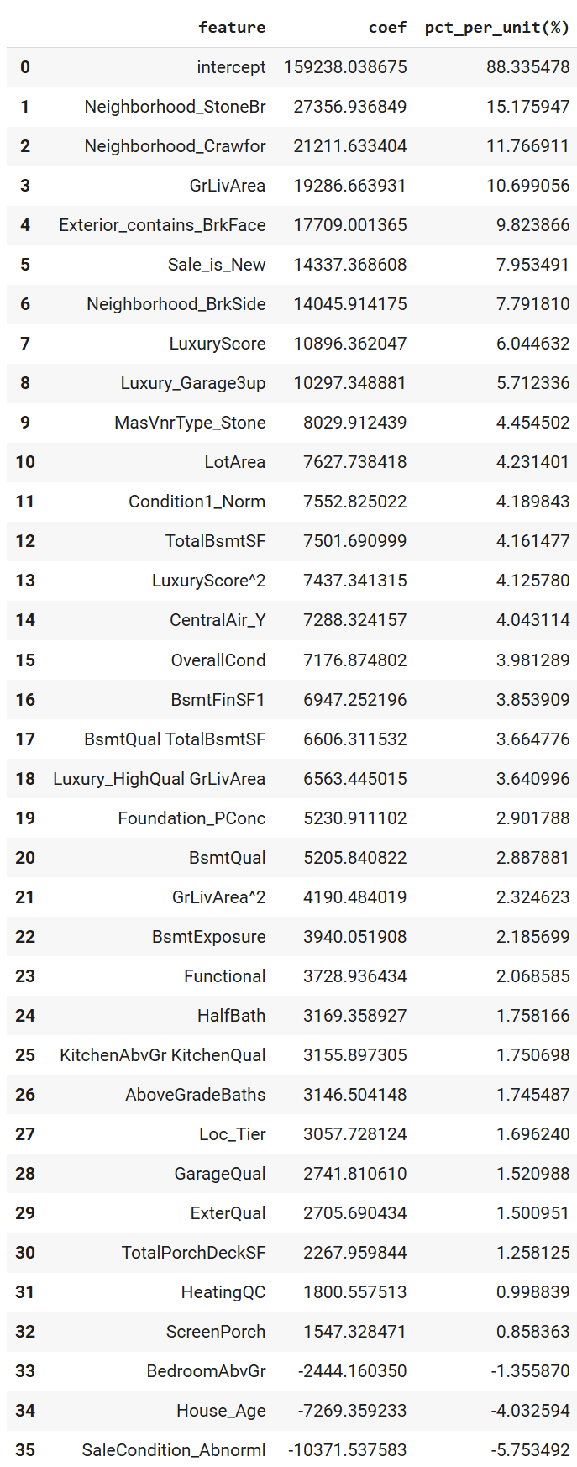
Figure 34 Coefficients and percent per unit change (relative to mean price)

