|  |  |
| --- | --- |
| Our Ref: IES-EDD-it/01-16 | 23 August 2016 |
|  |  |

**Subject:** EDD-*it* system description

Contents

1. Introduction to EDD*-it* 1

2. EDD-*it* Navigation 3

3. EDD-*it* Work Flows 6

4. *EDD-it* Forms 8

4.1 Facility EDD 8

4.2 Location EDD 9

4.3 Field Sample EDD 10

4.4 Lab Result EDD 11

4.5 Spill Report EDD 12

4.6 Waste Generator EDD 13

4.7 Waste Transporter EDD 14

4.8 Waste Receiver EDD 15

# Introduction to EDD*-it*

EDD-*it* is a Microsoft Access tool designed to prepare and edit Electronic Data Deliverables (EDDs) for the Kuwait Environment Public Authority (KEPA) Compliance Information Management System (CIMS).

The KEPA CIMS uses Earthsoft’s Environmental Quality Information System (EQuIS) to collect environmental chemistry samples, test results, hazardous waste and spill notifications through submitted EDDs. The submitted EDDs must be in a specific format with pre-defined field selections in order to allow the EQuIS Data Processor (EDP) to quality check the submitted data for errors prior to populating into the main EQuIS schema.

EDD-*it* provides an easy to use interface that allows stakeholders to quickly create properly formatted EDDs for submittal to the KEPA CIMS.

EDD-*it* uses the same reference tables the CIMS uses to limit field inputs and allows the users to determine which range of records should be stored into a new EDD in Microsoft Excel format for submittal. The prepared EDD can then be uploaded into the stakeholders local EDP for data checking prior to email submittal.

EDD-*it* provides EDDs for

* registering companies and facilities
* identifying sample locations
* reporting environmental chemistry results
* reporting a spill or accidental release
* generating a container of hazardous waste
* transporting a container of hazardous waste
* receiving, treating and/or disposing of a container of hazardous waste

EDD-*it* can operate on MS Access 2003-2007 as well as 2016.

# EDD-*it* Navigation

Upon opening the application, the user comes to the EDD-*it* Main Screen. On this screen are options for the 3 main areas – Preparing or editing chemistry related EDDs, preparing or editing waste related EDDs or reporting a spill/accidental release.

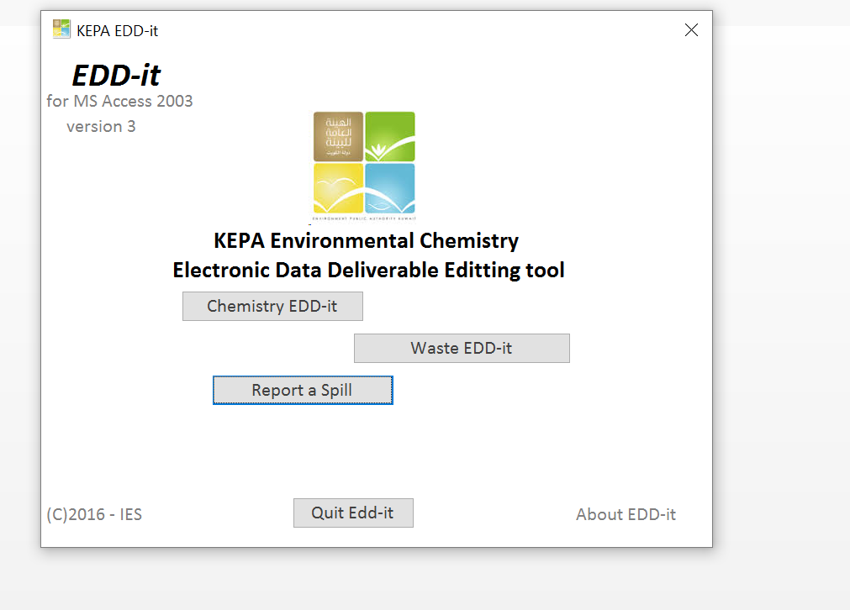

Figure 3. EDD-it Main Page

Selecting the Chemistry EDD-*it* button takes the user to the Chemistry EDD-*it* switchboard. Here the user has the following options:

* Register a new facility or update an existing facility for CIMS use.
* Add new sample locations or update existing locations.
* Initiate new environmental samples collected from sample locations.
* Report analytical test results.
* Return to the main menu
* Or quit EDD-*it*

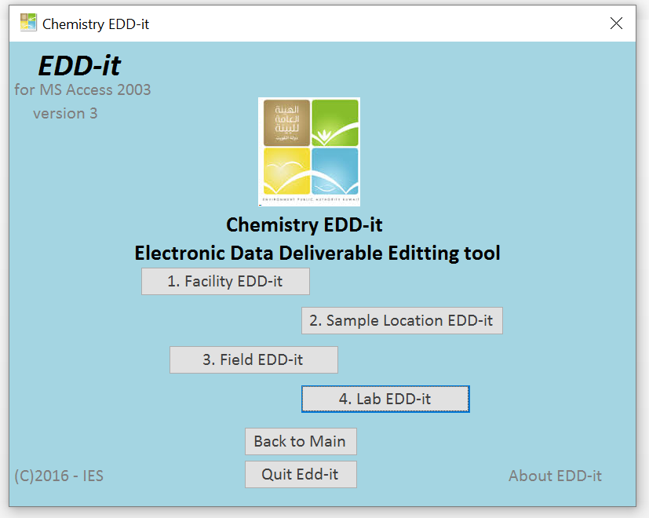

Figure 4. Chemistry EDD-it page

If the user selects the Waste EDD-*it* button, the user is taken to the Waste EDD-*it* switchboard. The following options are available:

* Register a new facility (same as the Chemistry EDD-*it* option).
* Initiate a new or update an existing waste container.
* Schedule pick-up of the container with a registered transporter.
* Inform the receiving facility of expected waste delivery.
* Return to the main menu
* Or quit EDD-it

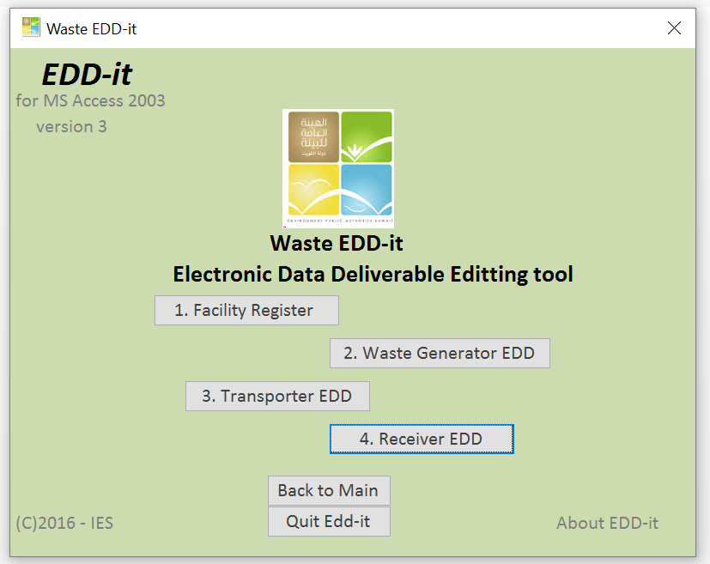

Figure 5. Waste EDD-it page

# EDD-*it* Work Flows

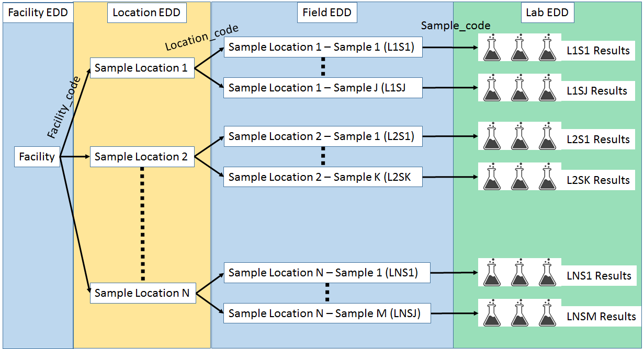

Figure 1. Chemistry EDD-it work flow

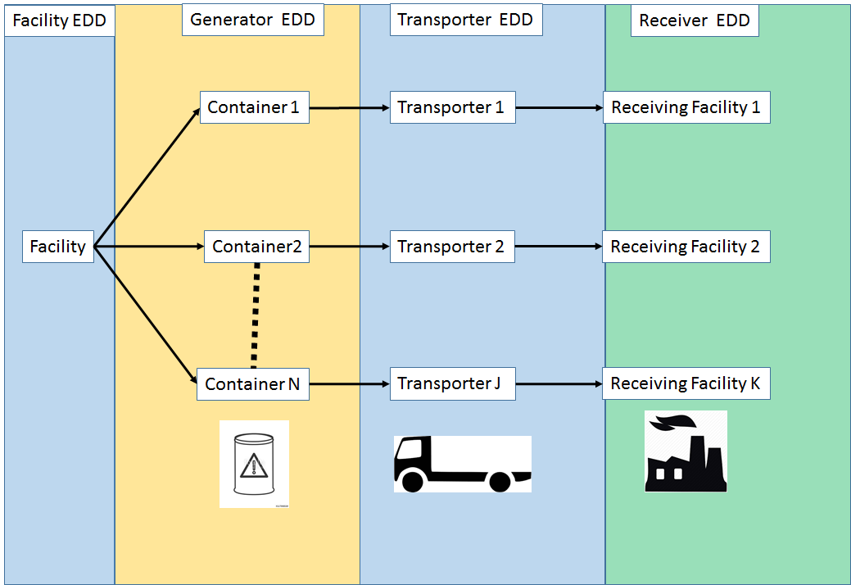

Figure 2. Waste EDD-it work flow

# *EDD-it* Forms

4.1 Facility EDD

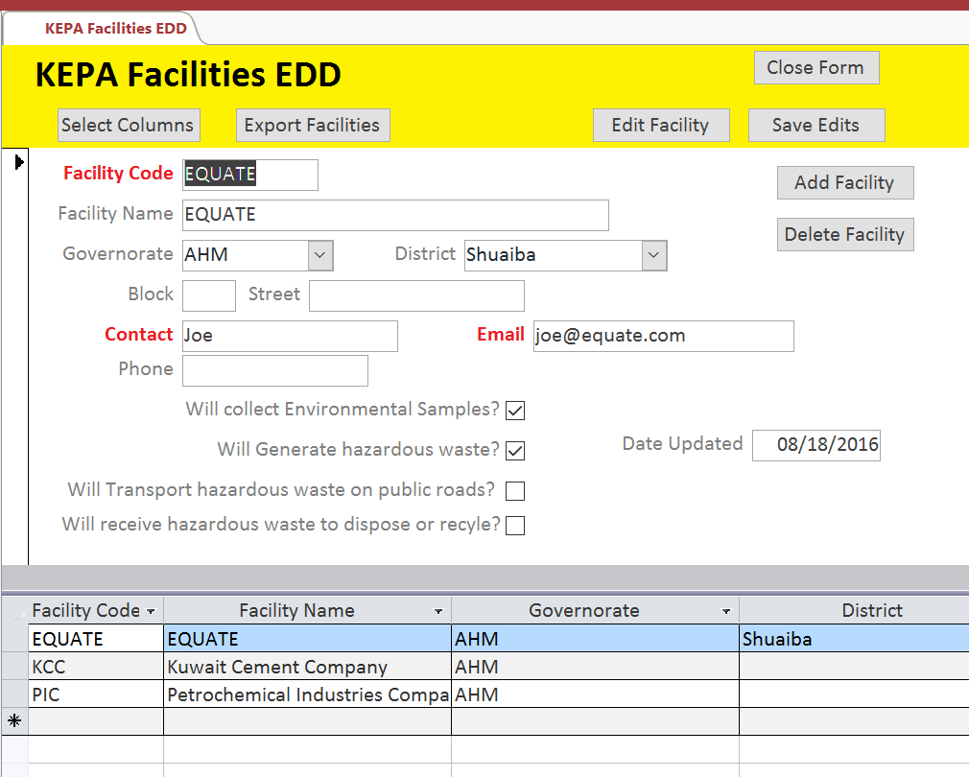

* 1. Location EDD

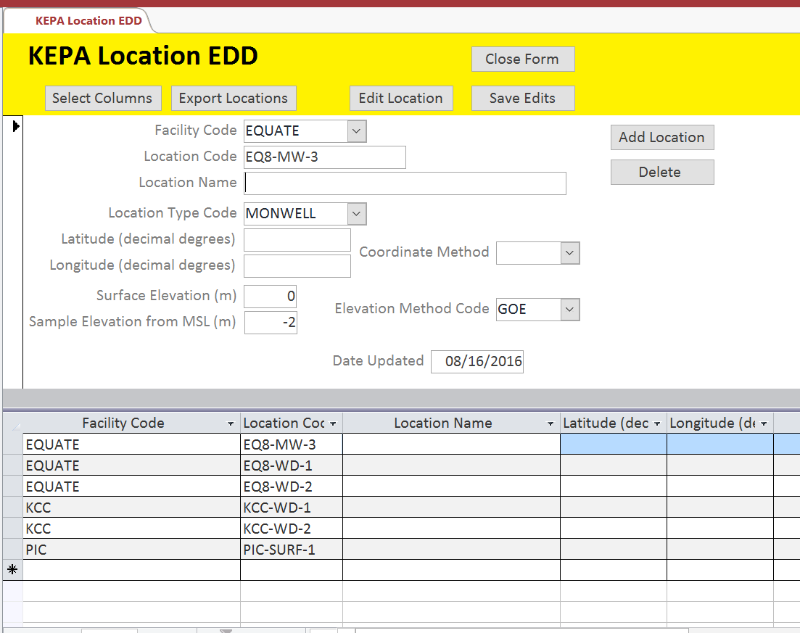

4.3 Field Sample EDD

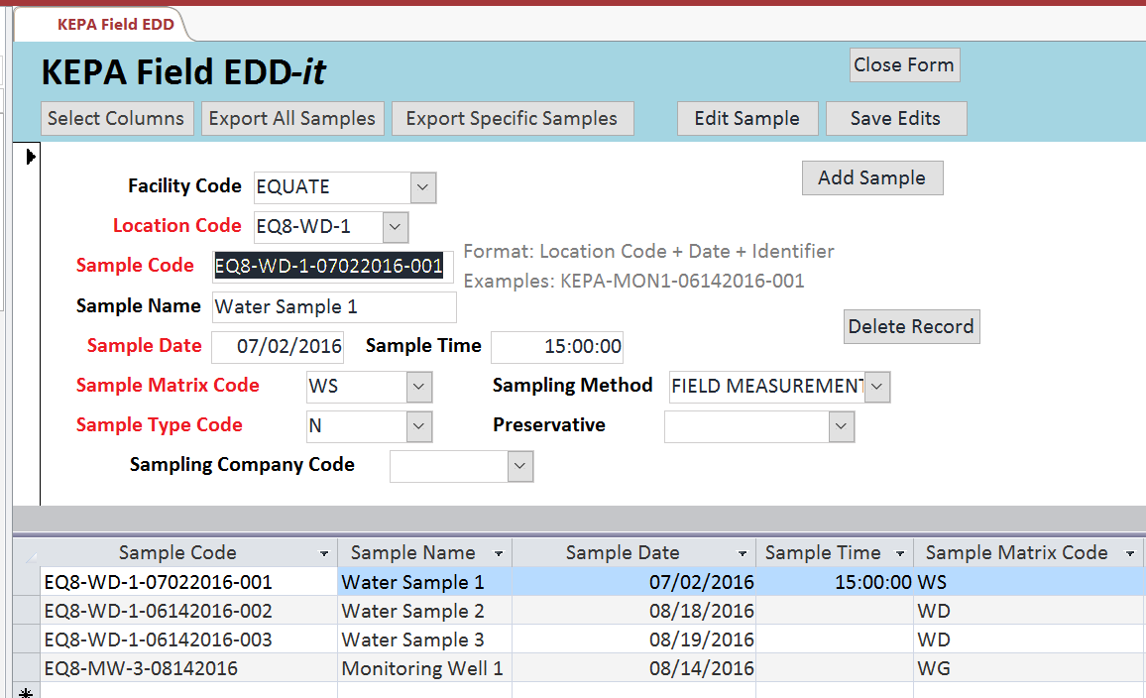

4.4 Lab Result EDD

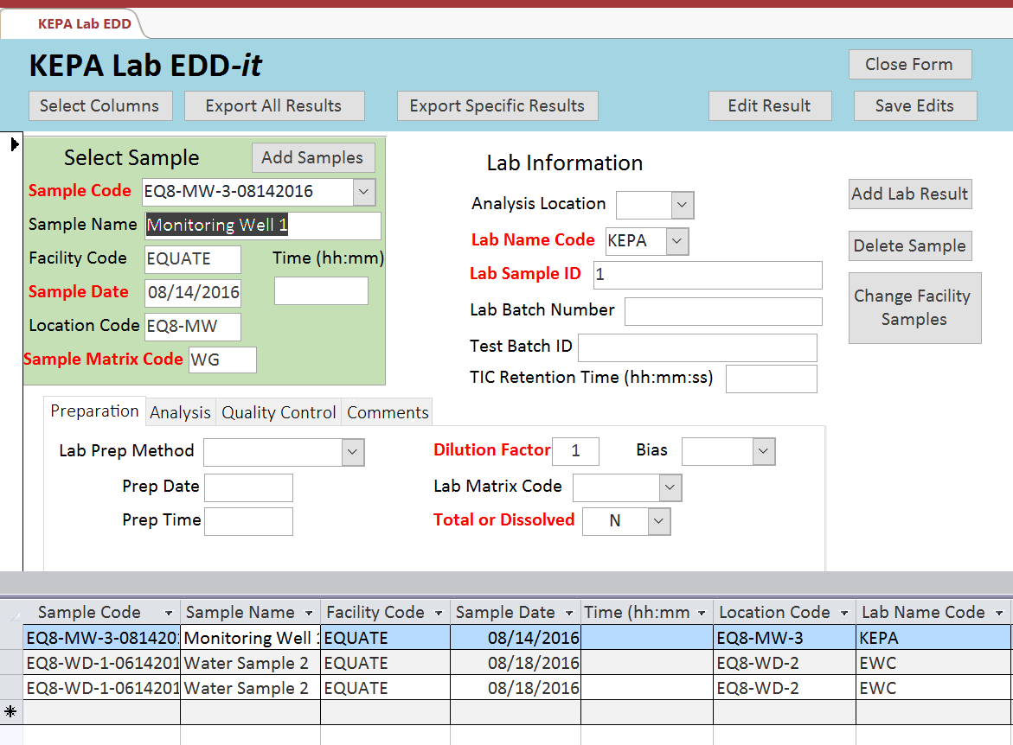

4.5 Spill Report EDD

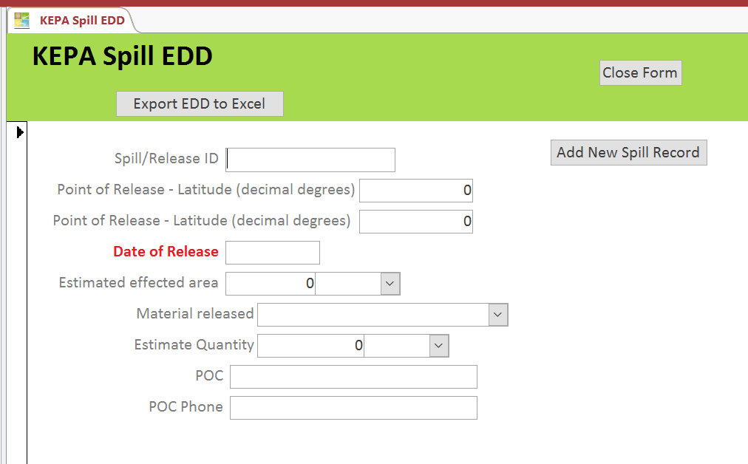

4.6 Waste Generator EDD

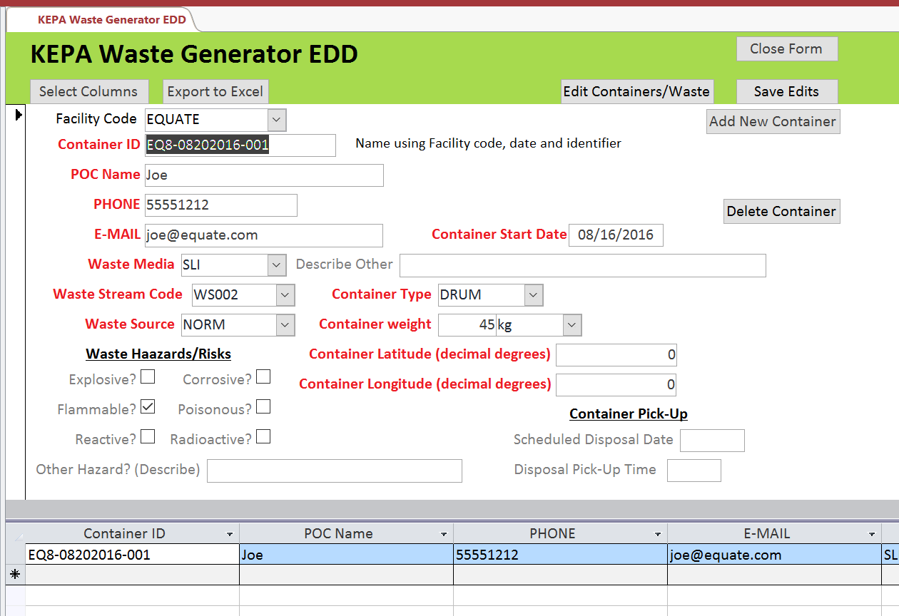

4.7 Waste Transporter EDD

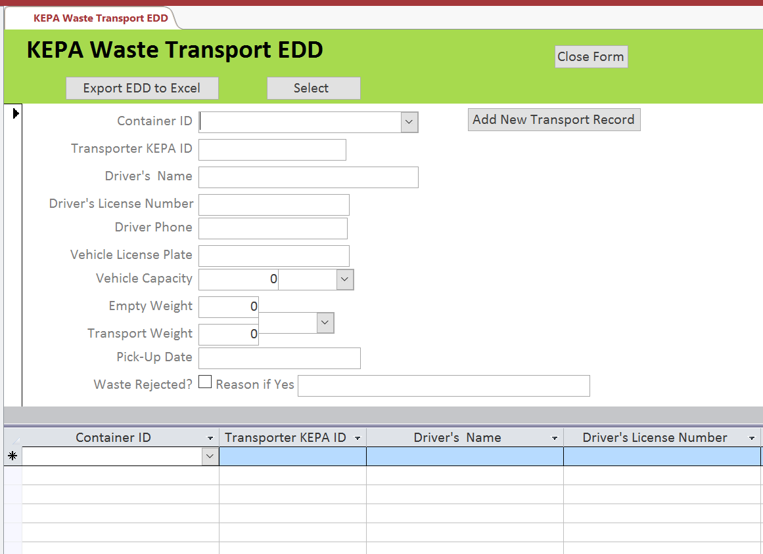

4.8 Waste Receiver EDD

