IsInstance

Class Class<T>
java.lang.Object
java.lang.Class<T>
Type Parameters:
T - the type of the class modeled by this Class object. For example, the type of String.class is Class<String>. Use Class<?> if the class being modeled is unknown.

Methods:
[….]
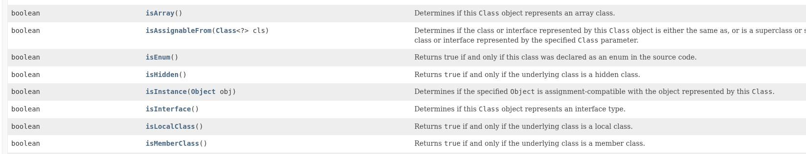
[….]

Method isInstance
public boolean isInstance(Object obj)
Determines if the specified Object is assignment-compatible with the object represented by this Class. This method is the dynamic equivalent of the Java language instanceof operator. The method returns true if the specified Object argument is non-null and can be cast to the reference type represented by this Class object without raising a ClassCastException. It returns false otherwise.
Specifically, if this Class object represents a declared class, this method returns true if the specified Object argument is an instance of the represented class (or of any of its subclasses); it returns false otherwise. If this Class object represents an array class, this method returns true if the specified Object argument can be converted to an object of the array class by an identity conversion or by a widening reference conversion; it returns false otherwise. If this Class object represents an interface, this method returns true if the class or any superclass of the specified Object argument implements this interface; it returns false otherwise. If this Class object represents a primitive type, this method returns false.
Parameters:
obj - the object to check
Returns:
true if obj is an instance of this class

