CLASE NullPointerException

java.lang.Object
java.lang.Throwable
java.lang.Exception
java.lang.RuntimeException
java.lang.NullPointerException

public class NullPointerException extends RuntimeException
Thrown when an application attempts to use null in a case where an object is required. These include:
- Calling the instance method of a null object.
- Accessing or modifying the field of a null object.
- Taking the length of null as if it were an array.
- Accessing or modifying the slots of null as if it were an array.
- Throwing null as if it were a Throwable value.
Applications should throw instances of this class to indicate other illegal uses of the null object. NullPointerException objects may be constructed by the virtual machine as if suppression were disabled and/or the stack trace was not writable.
NullPointerException NO es una excepción vigilada (checked). Es una excepción no vigilada (unchecked exception).
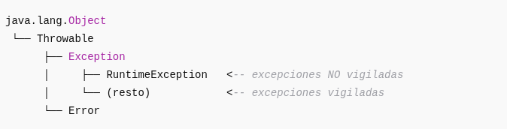

¿Qué significa que NO sea vigilada?
Significa:
- No es obligatorio declararla con throws.
- No se exige capturarla con un try–catch.
- Puede aparecer en tiempo de ejecución sin advertencias del compilador.
Ejemplo:
String s = null;
s.length(); // NullPointerException en runtime

