TreeDim Stackbuilder generated report

Document | : D1
Description | : Description D1
Author | : FGA | Date | : 07.07.2010

Pallet analysis
Name | : Analysis
Description | : Analysis description

Case
Name | : Case Name
Description | : Case Description
Length (mm) | : 400.0 | 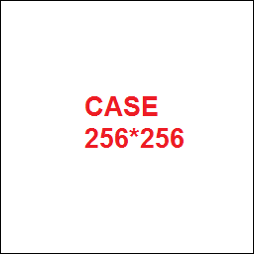
Width (mm) | : 300.0
Height (mm) | : 200.0
Weight (kg) | : 5.0
Admissible weight on top (kg) | : 40.0

Pallet
Name | : PalletName
Description | : PalletDescription
Type | : PalletType | 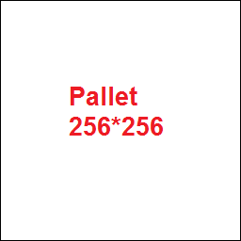
Length (mm) | : 1200.0
Width (mm) | : 1000.0
Height (mm) | :150.0
Weight (kg) | : 20.0
Admissible load weight (kg) | : 1000.0

Interlayer
Name | : InterlayerName
Description | : InterlayerDescription
Length (mm) | : 1200.0 | 
Width (mm) | : 1000.0
Height (mm) | : 1.0
Weight (kg) | : 0.2

Constraint set
Allowed case axis | : AllowedCaseAxis
Allow aligned layers | : AllowAlignedLayers
Allow alternate layers | : AllowAlternateLayers
Allowed layer patterns | : AllowedLayerPatterns
Interlayer |  | Every 1 layer
Stop stacking criterions
Maximum weight on box | 40 | kg

Selected solution
Title | SolutionTitle
Case count | SolutionCaseCount
Pallet height (mm) | SolutionPalletHeight
Pallet weight (kg) | SolutionPalletWeight
Efficiency (%) | SolutionEfficiency
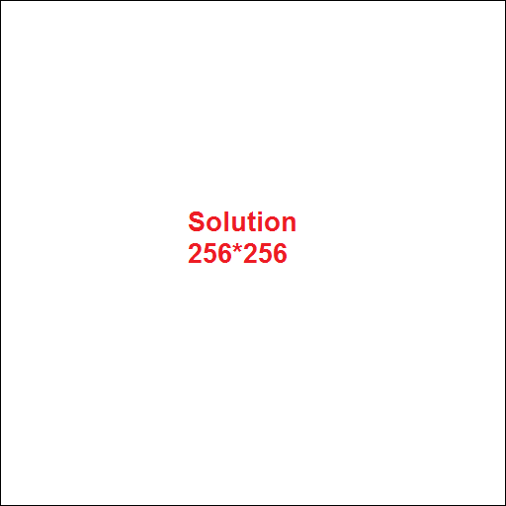

Truck analysis

Truck

Selected solution

