TreeDimStackBuilder generated Report
Document | : Case_44_28_29
Description | : An attempt to fit the highest number of a 440x280x290 in a truck.
Author | : fgasnier71@gmail.com | Date | :18/05/2011 11:25:50

Pallet analysis
Name | : Pallet analysis 440x280x290
Description | : Case 440x280x290 on pallet EUR2

Pallet
Name | :EUR2
Description | :1200 x 1000 mm Pallet EUR 2 (http://www.epal-pallets.org)
Type | :UK_STANDARD | 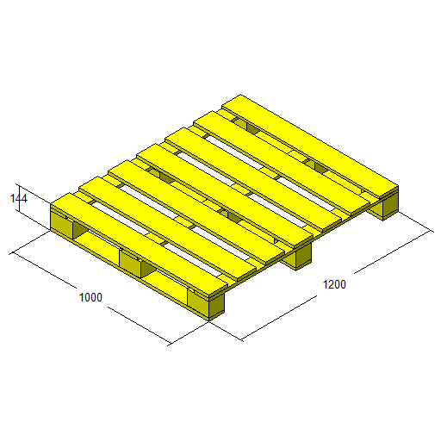
Length (mm) | :1200,00
Width (mm) | :1000,00
Height (mm) | :144,00
Weight (kg) | : 30,00
Admissible load weight (kg) | :0,00

Case
Name | : Case 440x280x290
Description | : Case with length=440, width=280 and height=290 + thickness 3
Length (mm) | : 440,00 | 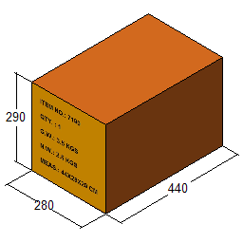
Width (mm) | : 280,00
Height (mm) | : 290,00
Weight (kg) | : 3,50

Interlayer
Name | : Interlayer 1200 x 1000
Description | : 1200 x 1000 x 2 mm interlayer
Length (mm) | : 1200,00 | 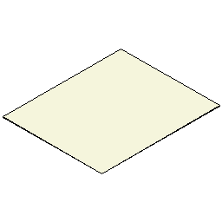
Width (mm) | : 1000,00
Thickness (mm) | : 2,00
Weight (kg) | : 0,15

Constraint set
Overhang (mm) | X | :0 | Y | :0
Allowed case axis | :ZP
Allow aligned layers | :True
Allow alternate layers | :True
Allowed layer patterns | :Column,Interlocked,Diagonale,Trilock,Spirale
Stop stacking criterion(s)
Maximum pallet Height (mm) | :1300,00
Maximum pallet Weight (kg) | :1000,00

Selected solution
Title |  | :Diagonale-Z-aligned-2
Number of cases |  | :27
Number of interlayer |  | :
Pallet weight (kg) |  | :124,50
Pallet height (mm) |  | :1018,00
Efficiency (%) |  | :69,54
Front: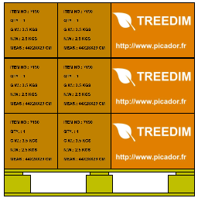 | Left: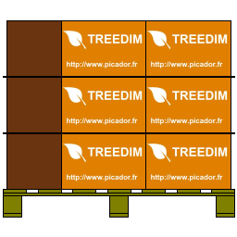 |  | Right: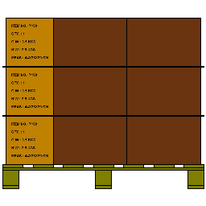 | Back: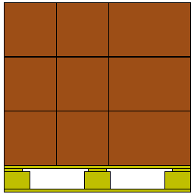
Iso : 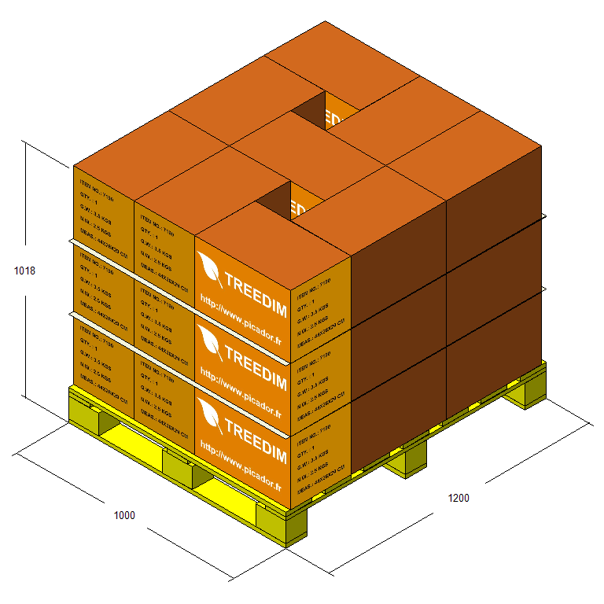

Layer(s)
1 | 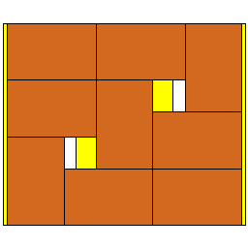

Truck analysis

Truck
Name | : Semi-trailer
Description | : Standard tarped semi-trailer (Europe)
Length (mm) | : 13700,00 | 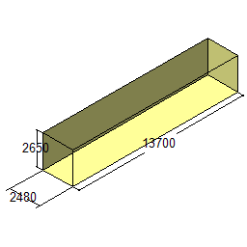
Width (mm) | : 2480,00
Height (mm) | : 2650,00
Admissible load (kg) | : 24000,00

Selected solution
Title | :
Pallet count | :52
Case count | :1404
Load weight (kg) | :6474,00
Load efficiency (%) | :26,98
Volume efficiency (%) | :55,71
