TreeDimStackBuilder generated Report
Document | : Matches
Description | : An attempt to fit the highest number of match boxes in a truck.
Author | : fgasnier71@gmail.com | Date | :19/04/2011 14:25:58

Pallet analysis
Name | : OptimAnalysisMatch box_Match box*3*5_100
Description | : Pallet analysis generated by case optimisation for box Match box and pallet EUR2

Pallet
Name | :EUR2
Description | :1200 * 1000 mm Pallet EUR 2 (http://www.epal-pallets.org)
Type | :UK_STANDARD | 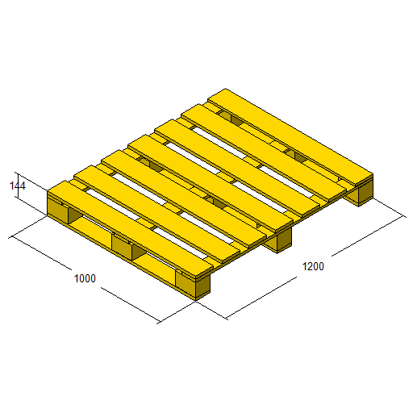
Length (mm) | :1200,00
Width (mm) | :1000,00
Height (mm) | :144,00
Weight (kg) | : 30,00
Admissible load weight (kg) | :0,00

Box
Name | : Match box
Description | : A kitchen match box contains 240 matches
Length (mm) | : 78,50 | 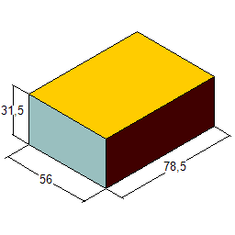
Width (mm) | : 56,00
Height (mm) | : 31,50
Weight (kg) | : 0,04

Case of boxes
Name | :Match box_3*5*10_01
Description | :Case generated by case optimization for box Match box and pallet EUR2
Length (mm) | :243,50 | Inner length (mm) | :235,5
Width (mm) | :288,00 | Inner width (mm) | :280
Height (mm) | :331,00 | Inner height (mm) | :315
Volume (l) | :23,21 | Inner volume (l) | :20,77
Empty weight (kg) | :12,90 | Weight (kg) | :12,90
Number of boxes | :150 | Layout | :3*5*10
Dim0 | :0 | Dim1 | :1
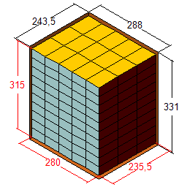 |  | 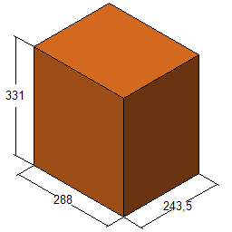

Constraint set
Overhang (mm) | X | :0 | Y | :0
Allowed case axis | :XP,YP,ZP
Allow aligned layers | :True
Allow alternate layers | :True
Allowed layer patterns | :Column,Diagonale,Interlocked,Trilock
Stop stacking criterion(s)
Maximum pallet Height (mm) | :1320,00

Selected solution
Title |  | :Interlocked-Y-aligned-2
Number of cases |  | :56
Number of interlayer |  | :
Pallet weight (kg) |  | :752,40
Pallet height (mm) |  | :1296,00
Efficiency (%) |  | :92,11
Front: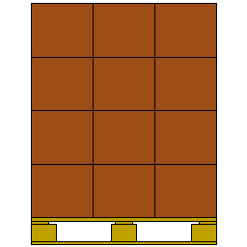 | Left: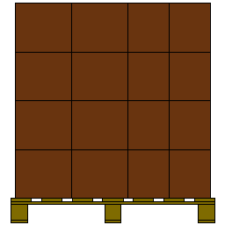 |  | Right: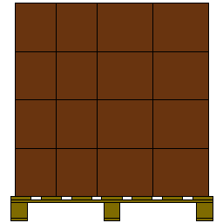 | Back: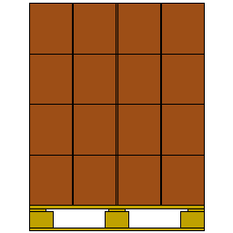
Iso : 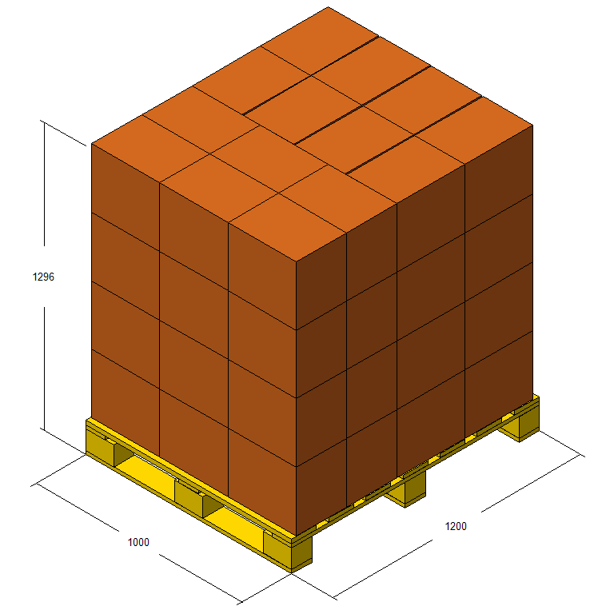

Layer(s)
1 | 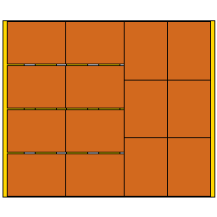

Truck analysis

Truck
Name | : Semi-trailer
Description | : Standard tarped semi-trailer (Europe)
Length (mm) | : 13700,00 | 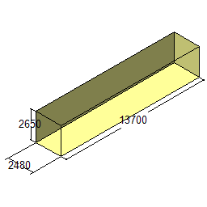
Width (mm) | : 2480,00
Height (mm) | : 2650,00
Admissible load (kg) | : 24000,00

Selected solution
Title | :
Pallet count | :52
Case count | :2912
Load weight (kg) | :39124,80
Load efficiency (%) | :163,02
Volume efficiency (%) | :75,07
