## snatcher: the autonomous robotic arm

Previous chapters taught you a great deal about programming NXT robots. Now that you’ve reached an advanced level of programming, you’re ready to build some more complicated robots in this and the next chapters. This chapter will teach you to build the Snatcher, an autonomous robotic arm that can find and pick up objects, as shown in Figure 13-1.

The Snatcher uses two NXT motors to control a set of treads, allowing the robot to move in any direction. You control its movement like you controlled the Explorer in Chapter 4 by adjusting the power and direction of the Driving motors to control the robot’s speed and driving direction (as shown in Figure 4-4).

### understanding the grabber

Driving around on treads may be interesting, but the really cool part of this robot is its multifunctional grabber. Normally grabbing and lifting objects requires two motors: one to grab the object and another to lift it. The Snatcher robot requires just one motor (which I call the Grabber motor) to accomplish both tasks, because of a unique construction of LEGO beams, axles, and gears. You’ll take a look at this technique now, but you will really understand how it works when you build the robot.

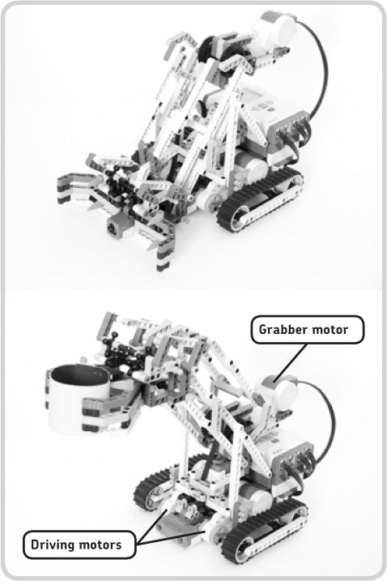

Figure 13-1: The Snatcher can find and pick up objects.

#### the grabbing mechanism

Figure 13-2 shows how the Snatcher grabs objects. As the NXT motor spins forward, a small gear (indicated with a number 1) makes a bigger gear (2) rotate in the direction shown by the arrow in the figure. This rotation starts a chain reaction of moving beams, which ultimately causes the grabber to grasp objects positioned between its fingers (6). When the motor spins backward, the reverse occurs, and the grabber opens. The beams marked 3, 4, and 5 simply transfer the rotational movement of the motor to the grabber so it can close its claws. Construction 4 connects the beams numbered 3 and 5 in order to allow smooth movement, even when the grabber arm is positioned as shown in the second image of Figure 13-1.

#### the lifting mechanism

Once the Snatcher has grabbed an object, it can lift it. But before you look at how the robot does this, you’ll see a simplified version of the situation.

As shown on the top of Figure 13-3, as you move the big gear (2) with your hand, the beams numbered 7, which represent the grabber and the motor, move as indicated by the gray arrows. No matter what the movement is, these parts remain parallel to the ground, and the parts labeled 8 remain perpendicular to the ground. To really understand how this works, build the structure shown with the parts in your NXT robotics kit.

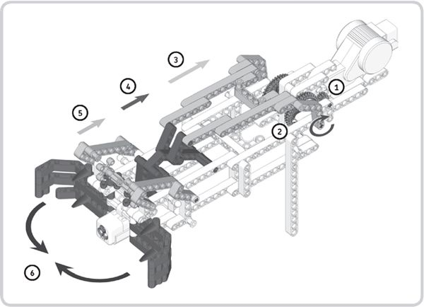

Figure 13-2: Grabbing objects by turning the motor forward

This mechanism works only because gear 2 does not move relative to the beam labeled 9, since they’re connected with a pin (10) as shown in the figure (it makes parts 2 and 9 form one fixed part). So, turning gear 2 directly makes the beam labeled 9 move.

The bottom of Figure 13-3 shows how the Snatcher lifts objects. The mechanism is actually quite similar to the one shown on the top, except that the real Snatcher doesn’t have this pin (10), which would turn parts 2 and 9 into one fixed part, enabling the gear (2) to directly control the beams labeled 9. This robot uses different parts to lock the beams to the gear.

Once the Snatcher has grabbed an object, the parts labeled 10 (shown on the bottom of Figure 13-3) no longer move as they did in Figure 13-2. Instead, they lock in position and move just like the beams numbered 9 shown in this image. Since the gear (2) is connected to the number 10 parts, it is now indirectly also connected to the number 9 parts (because the constructions are fixed), and the robot can lift objects.

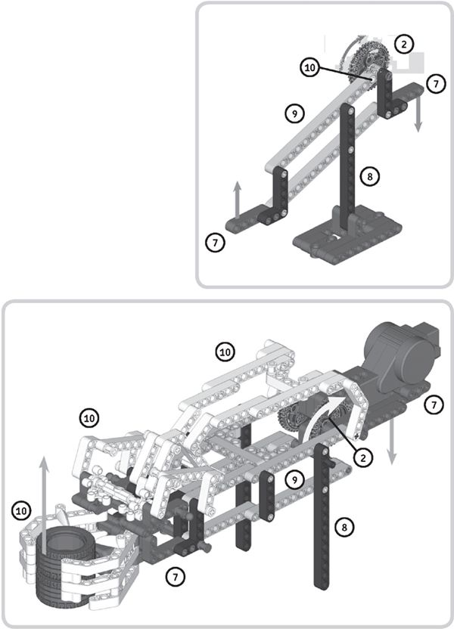

Figure 13-3: Once the Snatcher has grabbed an object, it can lift it. Here is a simplified overview of the lifting technique (top), with an illustration of the actual robot (bottom).

### building the snatcher

Now that you’ve gotten a sense of how the Snatcher’s grabber mechanism works, it’s time to build the robot to learn how it really works. To do so, follow the directions on the next pages, but first select the pieces you’ll need, as shown in Figure 13-4.

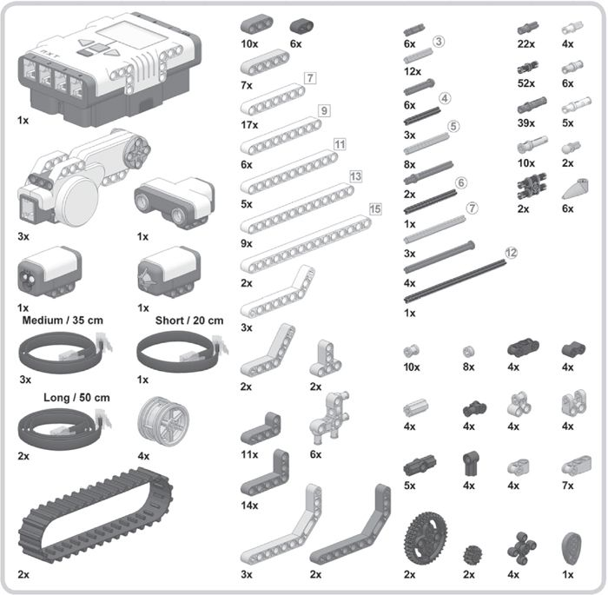

Figure 13-4: The required pieces to build the Snatcher

SE REQUIREN DOS EQUIPOS COMPLETOS PARA PODER MONTARLO (hay algunas piezas que no son suficientes)

No se Disponen de sensores de color

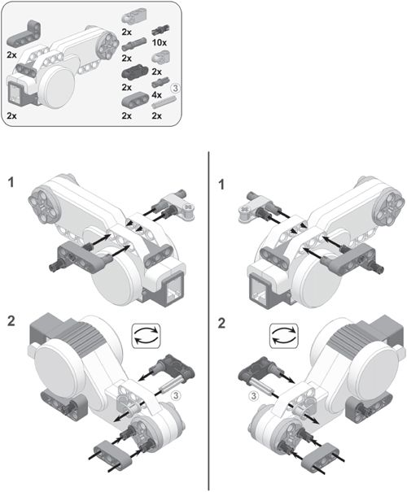

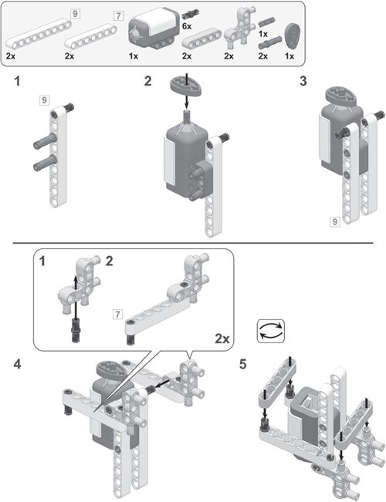

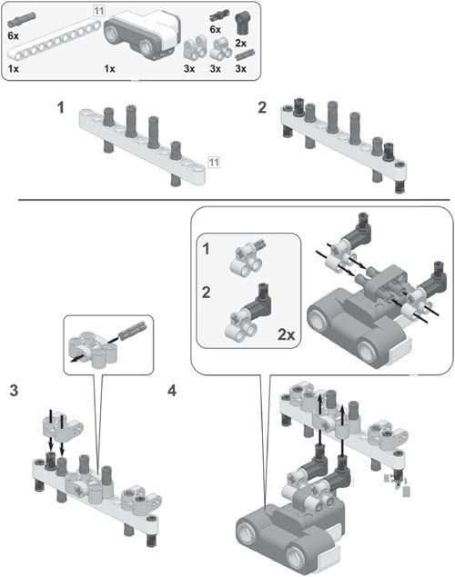

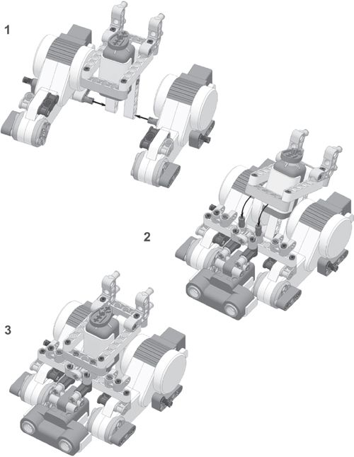

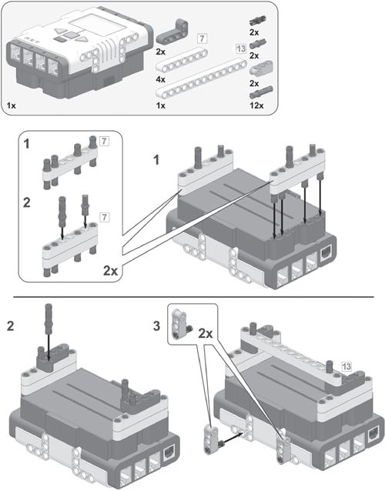

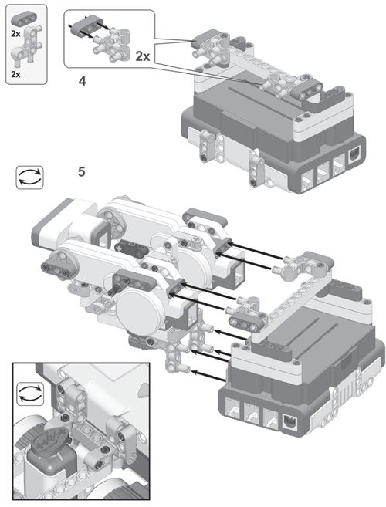

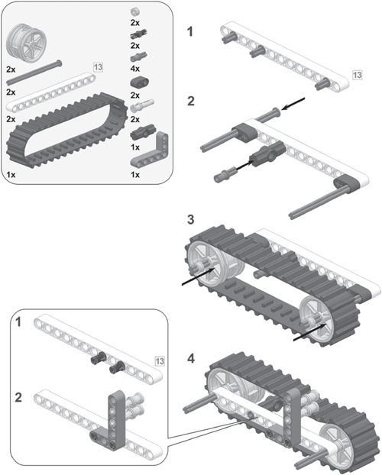

Yo no he instalado la pieza que une los ejes

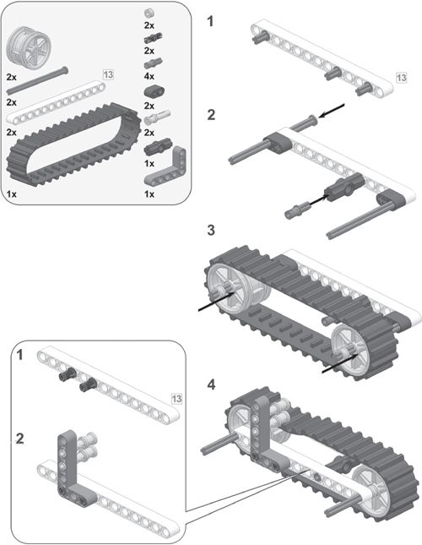

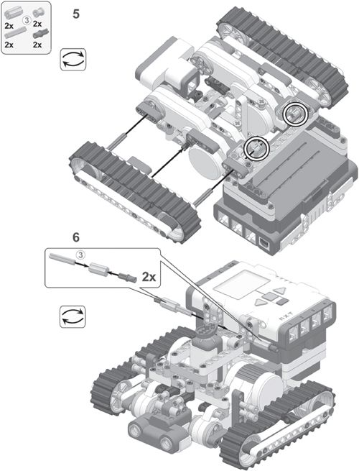

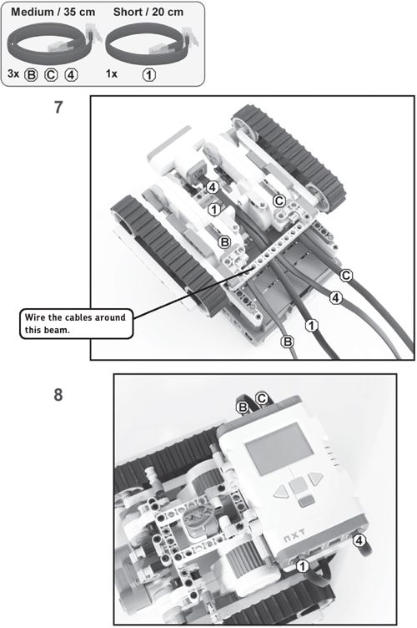

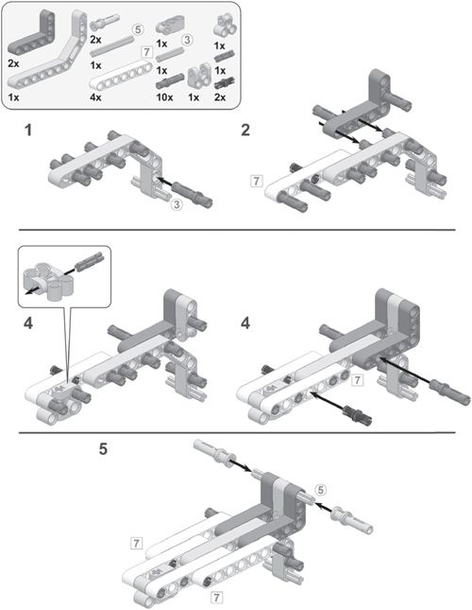

Aquí ya nos hemos quedado sin piezas de 7 huecos

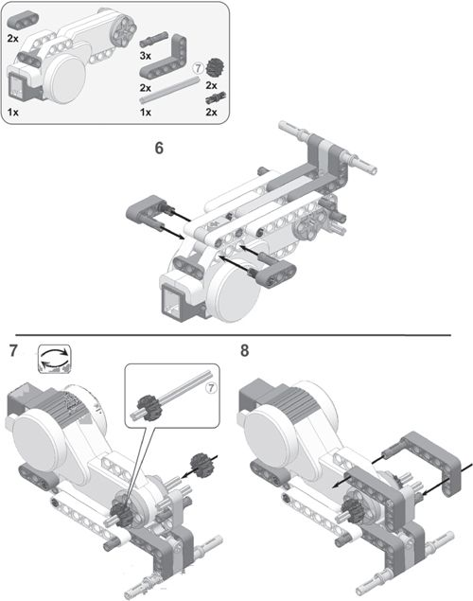

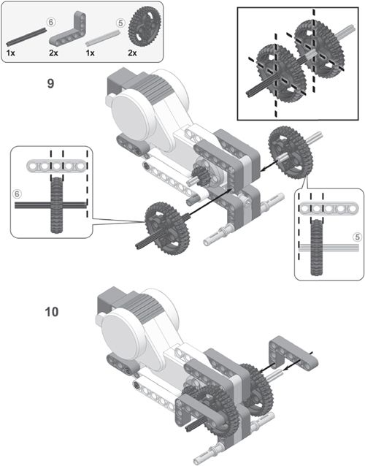

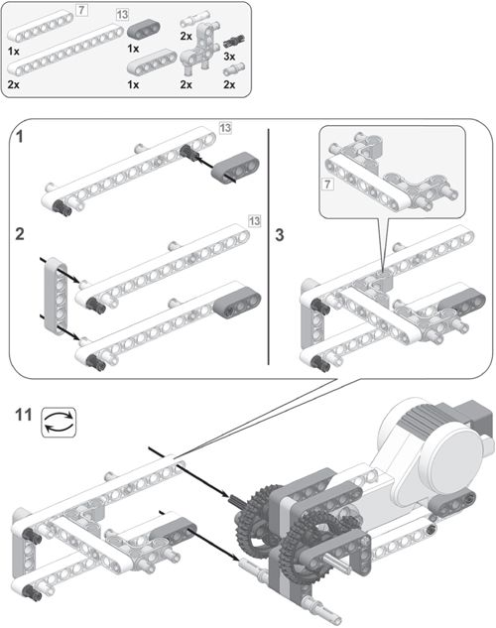

Aqui ya no tengo piezas de 13 huecos

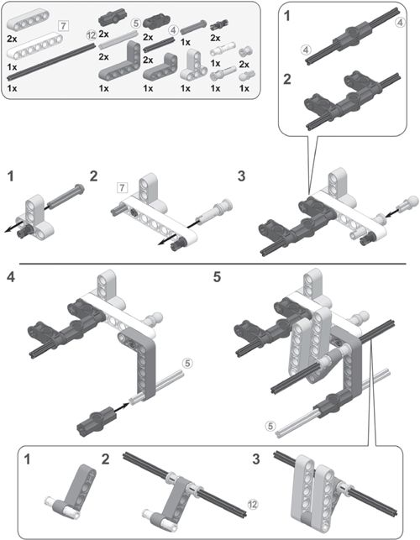

AQUI YO NO TENGO MAS PIEZAS EN CODO DE 3X4

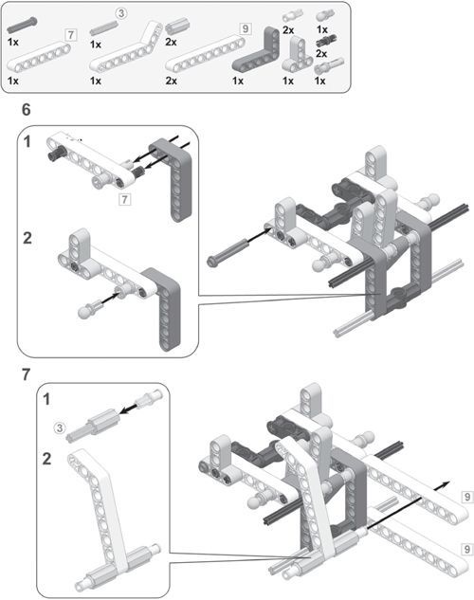

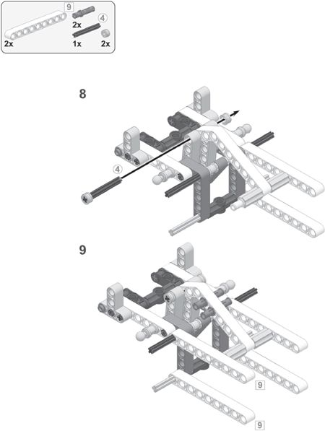

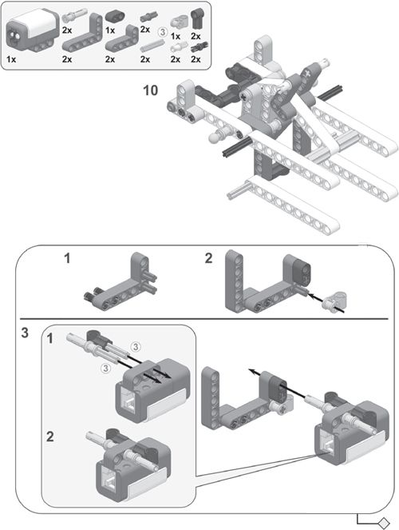

LA PIEZA CON CRUZ Y UN AGUJERO NO ESTA EN LOS SETS

SUSTITUYO POR PIEZA TRES AGUJEROS CAMBIADO PIEZA DE UNIÓN

SI NO SE INCLUYE SENSOR DE LUZ/COLORES NO HACE FALTA

EN LUGAR DE SENSOR DE COLORES USO SENSOR DE LUZ

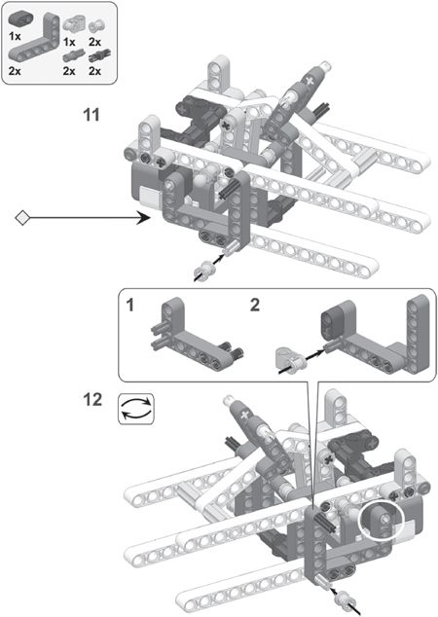

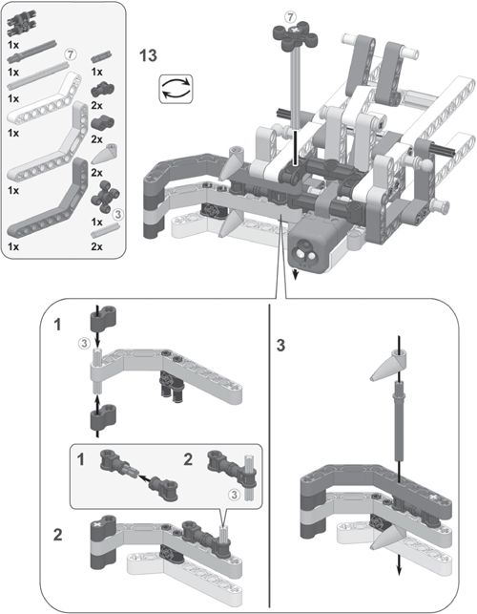

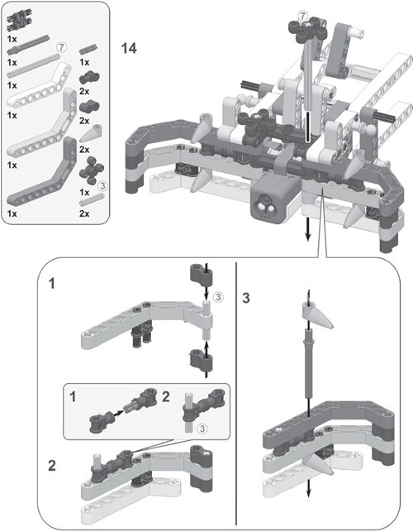

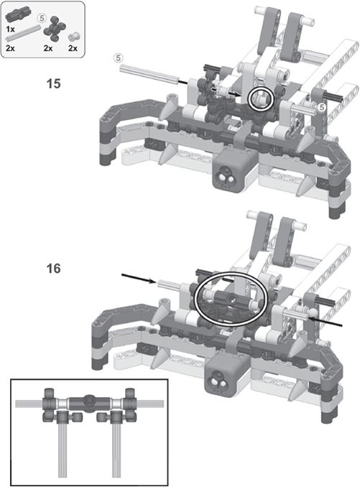

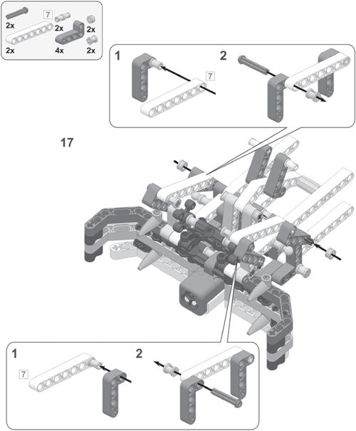

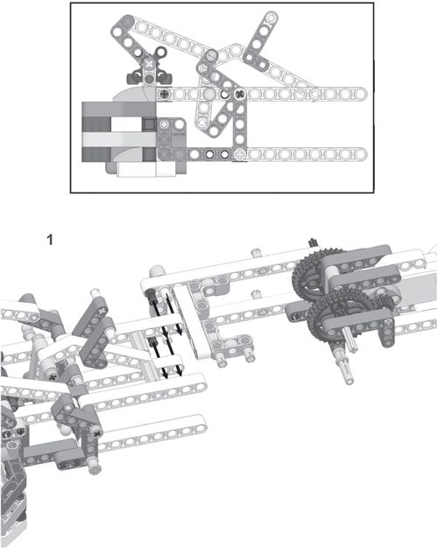

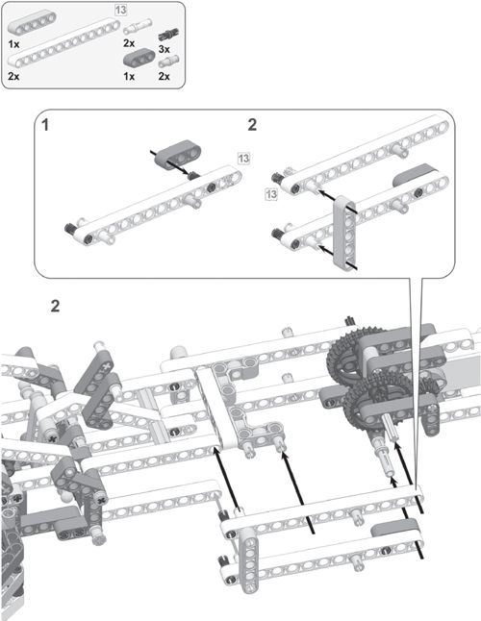

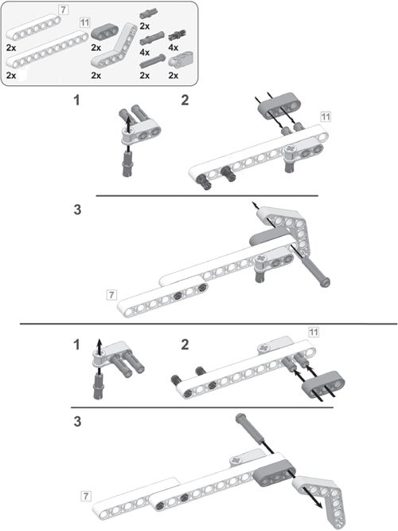

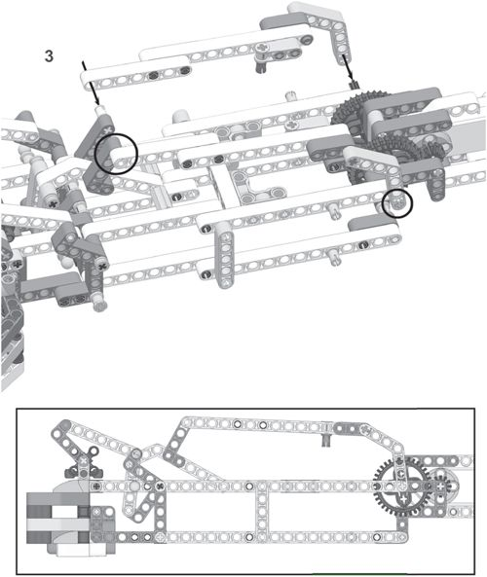

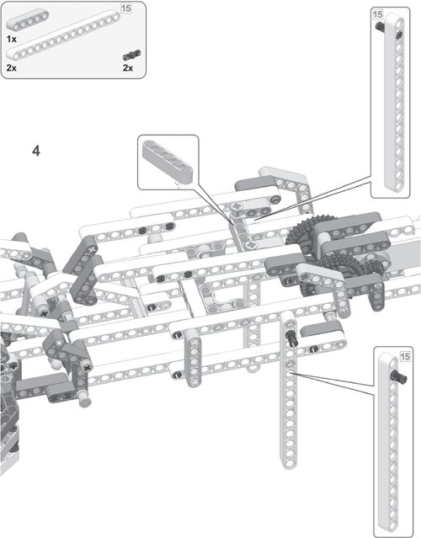

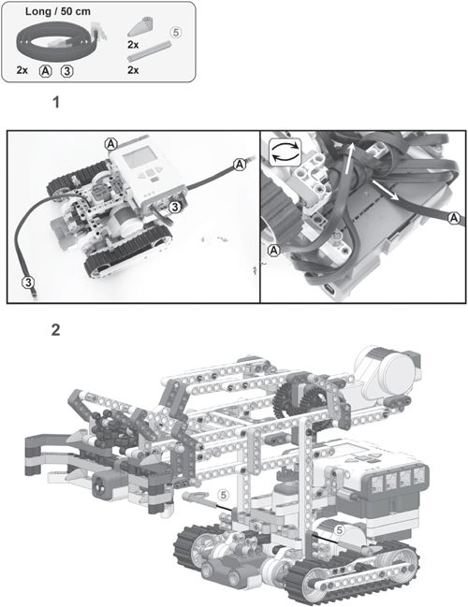

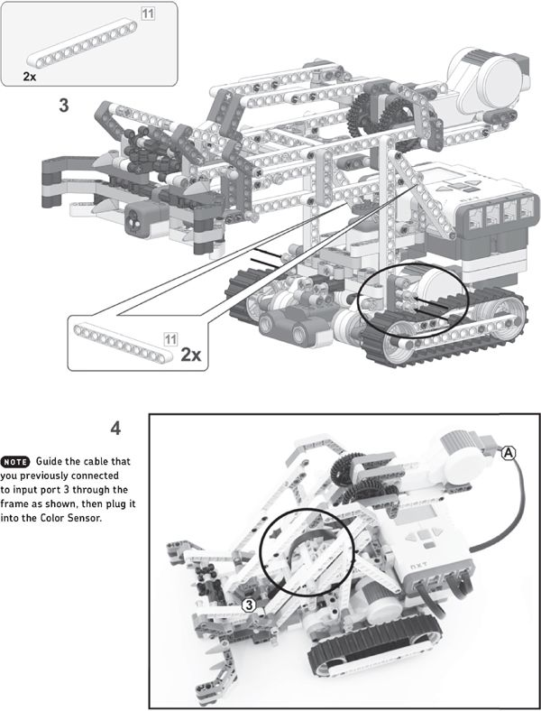

### creating objects

You can modify the Snatcher’s arm to grab almost anything as long as the object isn’t too heavy, but the version you’ve just built is designed to pick up paper rings, like the ones shown in Figure 13-5. Use construction paper to make about four paper rings in different colors (yellow, blue, red, and green) before you program the robot.

### programming the snatcher

Having built the Snatcher and created objects for it, you’re ready to program it. You’ll create a program that makes the Snatcher find, grab, lift, and move an object, as well as identify the object’s color. Each task should run autonomously, which means that all tasks must be performed without human interaction.

* Strider, a six-legged walking creature