XXXX
Design Report

Creation Date：2026.3.6
Version： 0.1

University of Electronic Science and Technology of China
Chengdu, Sichuan

Document History
Date | Version | Change | Editer
20260306 | 0.1 | Update section 1 and section 2 | Cui Wenjia
20260401 | 0.2 | Update function and i/o of section 3 | Jin Yiming
20260404 | 0.3 | Update architecture and dataflow of section 3 | Zhang Zhiyu

Abbreviation
Abbreviation | Full Name
SLAM | Simultaneous Localization and Mapping

Abstract

.

Key Words:

Contents
Document History 2
Abbreviation 3
Abstract 4
Contents 5
Figures 8
Tables 9
1 Team information 10
2 Specification 10
2.1 Requirements analysis 10
2.2 Application Scenarios 10
3 Design & Implementation 10
3.1 Overall 10
3.1.1 Function 10
3.1.2 Input/Output 11
3.1.3 Architecture 11
3.1.4 Dataflow 12
3.2 Pc-reg submodule 12
3.2.1 Function 12
3.2.2 Input/Output 12
3.2.3 Architecture 13
3.2.4 Dataflow 13
3.3 Ctrl submodule 14
3.3.1 Function 14
3.3.2 Input/Output 14
3.3.3 Architecture 15
3.3.4 Dataflow 16
3.4 Data_path submodule 16
3.4.1 Function 16
3.4.2 Input/Output 17
3.4.3 Architecture 18
3.4.4 Dataflow 18
3.5 EX submodule 19
3.5.1 function 19
3.5.2 Input/Output 19
3.5.3 Architecture 20
3.5.4 Dataflow 20
3.6 alu submodule 21
3.6.1 Function 21
3.6.2 Input/Output 21
3.6.3 Architecture 22
3.6.4 Dataflow 22
3.7 Reg_file submodule 22
3.7.1 Function 22
3.7.2 fInput/Output 23
3.7.3 Architecture 23
3.7.4 Dataflow 24
3.8 wb submodule 24
3.8.1 Function 24
3.8.2 Input/Output 24
3.8.3 Architecture 25
3.8.4 Dataflow 25
3.9 Clock, Reset & Initial 25
3.9.1 Clock 25
3.9.2 Reset 25
3.9.3 Initial 26
4 Verification & Test 26
4.1. Test Plan & TestBench 26
4.2. TestCase & Result 26
5 Conclusion & Future work 26
5.1. Conclusion 26
5.2. Future work 26
References 27

Figures
Figure 1 Hardware Structure 10
Figure 2 Data Flow 10

Tables
Table 1 Iuput/Output signals 9

Team information
Team Name
Team Members | Student number | Name | Task |  | Score
Team Members | 2024190506013 | Cui Wenjia |  | Datapath design & implementation
Team Members | 2024190503014 | Jin Yiming |  | Controller design & implementation
Team Members | 2024190506022 | Wang Zepu |  | Testbench design & test
Team Members | 2024190501006 | Zhong Qinyang |  | Testbench design & test
Team Members | 2024190503010 | Zhang Zhiyu

Specification

2.1 Requirements analysis
The project aims to design and implement a 32-bit RISC CPU based on RISC-V architecture using Verilog HDL. The CPU supports RV32I base integer instruction set (and Zicsr, extension for status register, if possible). The design follows a three-stage pipeline architecture consisting of Fetch, Decode, and Execute stages. For peripherals, the SOC has one timer, one UART serial port, and an 8-bit GPIO.

Key requirements include:
- Implementation of basic integer arithmetic and logic operations
- Support for register-register and register-immediate operations
- Program flow control through jump instructions
- UART serial communication capability
- Comprehensive testbench for functional verification

2.2 Application Scenarios
The CPU chip could be used in:
- Educational platforms for computer architecture courses
- Simple embedded control systems
- UART-based communication systems

Design & Implementation

3.1 Overall

3.1.1 Function
The CPU interfaces with external instruction memory and data memory through separate ports. The instruction memory provides instructions via the inst input, while the CPU outputs the fetch address through inst_addr. For data memory access, the CPU provides the address (mem_addr), write data (mem_din), and write enable mask (mem_we), and receives read data via mem_dout.

The control unit decodes the instruction and generates control signals that direct the operation of the data path and register file. The data path contains the program counter, ALU, immediate generation logic, and state machine for handling load instructions that require multiple cycles. The register file provides two read ports and one write port, with built-in forwarding logic to resolve read-after-write hazards.

The CPU operates with a single clock input and an active-high reset signal. Upon reset, the program counter is initialized to 0xFFFFFFFC, allowing the first instruction fetch to begin at address 0x0. The design supports branch prediction and misprediction recovery

3.1.2 Input/Output
The interface of this chip is defined in Table 1。
Table 1 Iuput/Output signals
Signal name | I/O | Width (bits) | Fuction Description
Clk | input | 1 | System clock. All synchronous elements operate on the rising edge
rst | input | 1 | Reset, active high. Initializes the program counter and state machine
inst | input | 32 | Instruction input from external instruction memory
Inst_addr | output | 32 | Instruction fetch address output to instruction memory
Mem_dout | input | 32 | Data read from external data memory
Mem_din | output | 32 | Data to be written to external data memory
Mem_addr | output | 32 | Data memory access address
Mem_we | output | 4 | Memory write enable mask. Each bit enables writing to one byte of the data memory

3.1.3 Architecture
The hardware structure is shown in Figure 1。
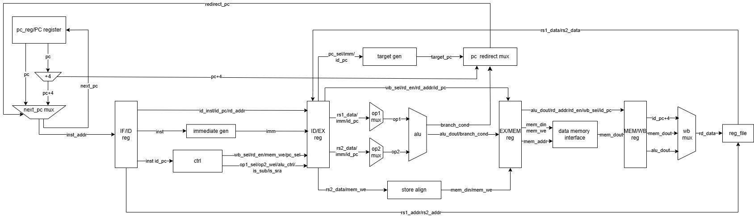
Figure 1 Hardware Architecture

3.1.4 Dataflow
The control flow is shown in Figure 2。
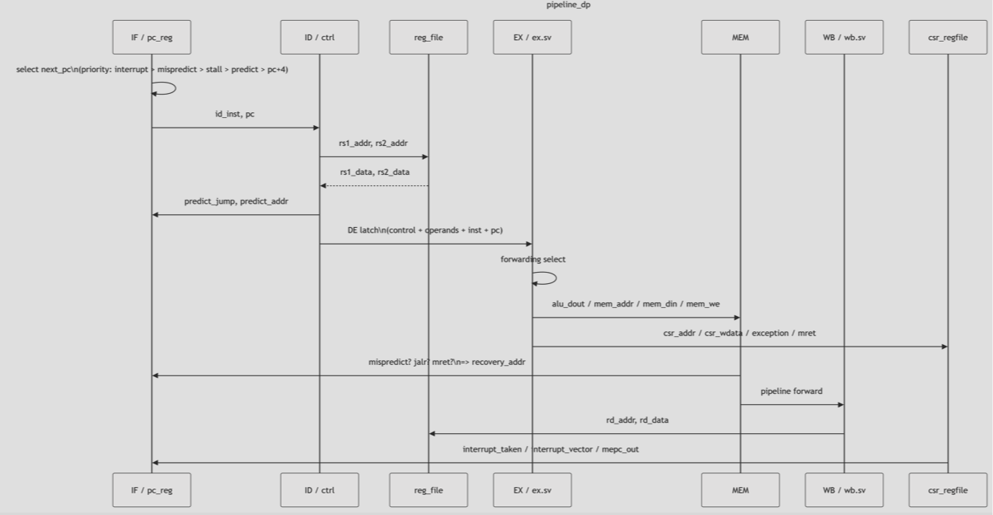
Figure 2 Data Flowchart

3.2 Pc-reg submodule

3.2.1 Function
The program counter module is responsible for managing instruction address updates. Under normal sequential execution, the module adds 4 to the current fetch address to achieve continuous instruction fetching. When a branch instruction is detected in the decode stage, the module supports branch prediction by updating the program counter with a provided predicted target address. If the execution stage later detects a misprediction, the module provides a recovery method that updates the program counter to the correct target address with the highest priority, ensuring correct program execution. Additionally, when an external stall signal is detected, the program counter remains its current value, pausing instruction fetching.
On the output side, the module directly outputs the updated fetch address to the instruction memory while also registering this address with a one-cycle delay to serve as the PC value for the decode stage. When a misprediction occurs, the module automatically flushes the instruction output to the decode stage to a NOP instruction (ADDI x0, x0, 0), preventing incorrect instructions from advancing through subsequent stages.

3.2.2 Input/Output
Table 2 Iuput/Output signals
Signal name | I/O | Width (bits) | Fuction Description
clk | input | 1 | System clock
rst | input | 1 | Reset, active high. On reset, fetch_pc is set to 32'hFFFFFFFC
Stall | input | 1 | Stall,pc remains unchanged
Predict_jump | input | 1 | Decode stage branch prediction valid, active high. PC jumps to predict_addr
predict_addr | input | 32 | Predicted branch target address
mispredict | input | 1 | Execution stage misprediction detected, active high. Has highest priority
recovery_addr | input | 32 | Correct target address for misprediction recovery
mem_inst | input | 32 | Instruction read from instruction memory
inst_addr | output | 32 | Fetch address output to instruction memory
id_inst | output | 32 | Instruction output to decode stage. Outputs NOP (0x00000013) when misprediction occurs
pc | output | 32 | PC value of the current instruction, output to decode stage

3.2.3 Architecture
The hardware structure is shown in Figure 13。
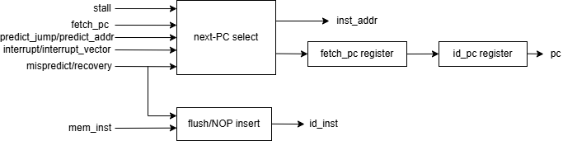
Figure 3 Hardware Architecture

3.2.4 Dataflow
The control flow is shown in Figure 24。
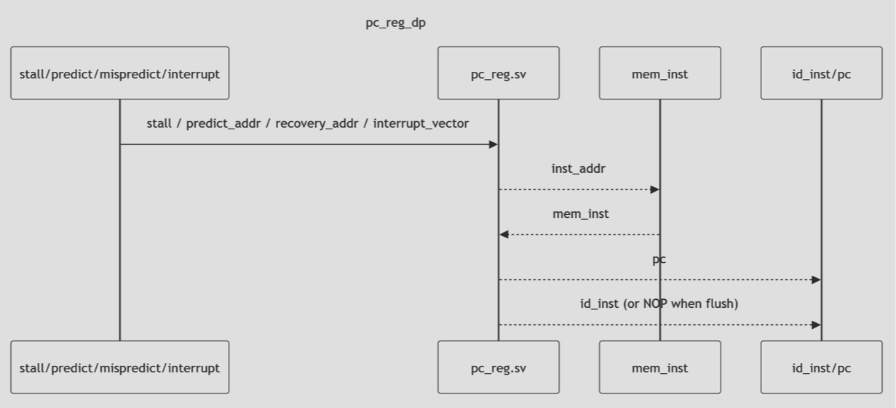
Figure 4 Data Flowchart

3.3 Ctrl submodule

3.3.1 Function
The control module is responsible for decoding instructions and generating control signals for the datapath. The module takes the 32-bit instruction as input and outputs various control signals that control the operation of the ALU, register file, memory access, and program counter selection.
The decoding process is based on the instruction opcode, funct3, and funct7. The module identifies the instruction type (R-type, I-type, B-type, L-type, S-type, JAL, JALR, LUI, AUIPC) and generates control signals accordingly.
For R-type arithmetic and logic instructions, the module sets the ALU operation based on funct3, uses the is_sub signal to distinguish between ADD and SUB, and enables register write-back. For I-type immediate instructions, it selects the immediate as the second ALU operand and enables register write-back.
For branch instructions (B-type), the module controls the ALU to perform the comparison operation specified by funct3 and sets the PC selection to branch mode. For load instructions (L-type), it selects the immediate operand, enables register write-back, and sets the write-back source to memory data. For store instructions (S-type), it selects the immediate operand and generates the appropriate memory write mask based on the access width (byte, halfword, or word).
For jump instructions, JAL updates the PC to the target address and writes the return address (PC+4) to the destination register, while JALR uses the immediate operand and writes the return address as well. LUI loads an immediate value into the upper 20 bits of the destination register by shifting the immediate left by 12 bits, and AUIPC adds the immediate to the current PC.
If an invalid opcode is encountered, the module asserts inst_valid as 0, indicating an illegal instruction. All control signals are conbinationally generated within an always_comb block, ensuring immediate response to instruction input changes.

3.3.2 Input/Output
Table 3 Iuput/Output signals
Signal name | I/O | Width (bits) | Fuction Description
inst | input | 32
  32-bit instruction to be decoded
Inst_valid | output | 1 | Valid instruction indicator. Asserted high for valid opcodes
Op1_sel | output | 2
  Selects the source for ALU first operand: OP1_RS1 (register) or OP1_IMU (U-type immediate)
Op_sel2 | output | 2 | Selects the source for ALU second operand: OP2_RS2 (register), OP2_IMI (I-type immediate), OP2_IMS (S-type immediate), or OP2_PC (current PC)
Alu_ctrl | output | 3 | ALU operation control, directly mapped from funct3 for most instructions
Is_sub | output | 1
  Subtraction indicator. For R-type instructions, derived from funct7 bit 5 to distinguish ADD/SUB; for LUI, asserted to generate the left-shifted immediate
Is_sra | output | 1 | Arithmetic right shift indicator. Derived from funct7 bit 5 for shift instructions
mem_mask | output | 4 | Memory write mask for store instructions. 4'b0001 for byte (SB), 4'b0011 for halfword (SH), 4'b1111 for word (SW)
Rd_en | output | 1
  Register file write enable.
  Asserted high for instructions that write to a destination register
Wb_sel | output | 2
  Write-back data source selection: WB_ALU (ALU result), WB_MEM (memory read data), or WB_PC4 (PC+4)
Pc_sel | output | 2 | Program counter selection: PC_N (next PC+4), PC_B (branch target), PC_J (JAL target), or PC_JR (JALR target)

3.3.3 Architecture
The hardware structure is shown in Figure 15。
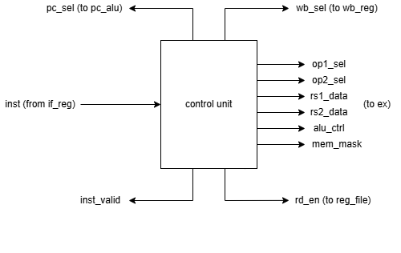
Figure 5 Hardware Architecture

3.3.4 Dataflow
The control flow is shown in Figure 26。
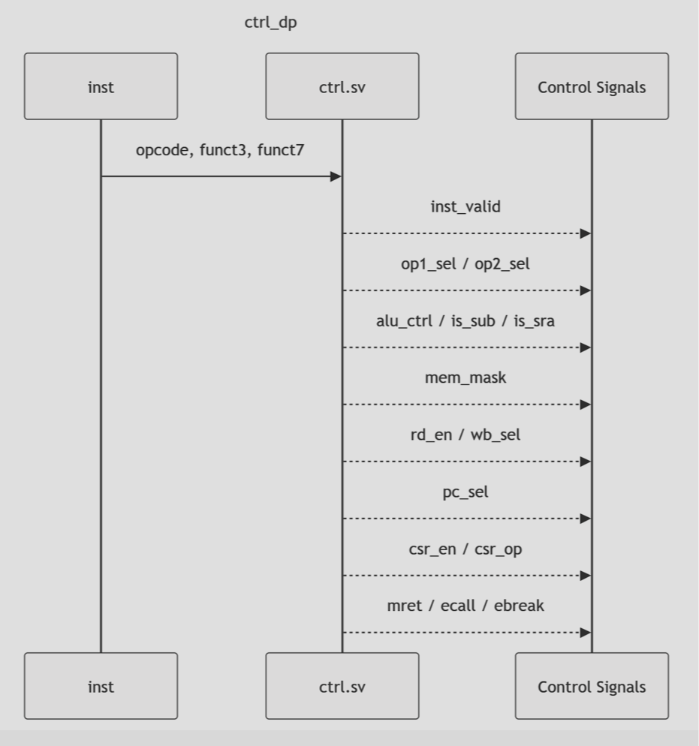
Figure 6 Data Flowchart

3.4 Data_path submodule

3.4.1 Function
The data path module integrates the major components of the CPU datapath, including the program counter, ALU, immediate generation logic, and load/store handling with a multi-cycle state machine. The module serves as the central data movement and computation engine, coordinating instruction execution across different operation types.
The module contains a two-state state machine (NORMAL and LOAD) to handle load instructions that require multiple cycles for memory access. During normal execution, the module computes the next program counter value based on branch, jump, or sequential execution logic. For branch instructions, the ALU condition output determines whether the branch is taken.
The module generates necessary memory interface signals, including address, write data, and write enable masks.The module also extracts instruction fields such as source register addresses and destination register addresses, forwarding them to the register file and control logic. Write-back data is selected from the ALU result, memory read data with appropriate extension, or PC+4 depending on the instruction type

3.4.2 Input/Output
The interface of this chip is defined in Table 1。
Table 4 Iuput/Output signals
Signal name | I/O | Width (bits) | Fuction Description
Clk | input | 1 | System clock
rst | input | 1 | Reset, active high. Initializes PC to -4 (0xFFFFFFFC) and state to NORMAL
inst | input | 32 | Instruction from the decode stage
Inst_addr | output | 32 | Fetch address output to instruction memory
dout | output | 32 | Fetch address output to instruction memory
Rs1_addr | output | 5 | First source register address, extracted from inst[19:15]
Rs2_addr | output | 5 | Second source register address, extracted from inst[24:20]
Rs1_data | input | 32 | First source register data from register file
Rs2_data | input | 32 | Second source register data from register file
Rd_addr | output | 5 | Destination register address, extracted from inst[11:7]for R/I/JAL/JALR/LUI/AUIPC instructions
Mem_dout | input | 32 | Memory read data
Mem_din | output | 32 | Memory write data, aligned based on address lower bits
Mem_addr | output | 32 | Memory access address (ALU output)
Mem_we | output | 4 | Memory write enable mask, generated from mem_maskshifted by address lower bits
Inst_valid | input | 1 | Instruction valid signal from control unit
Op1_sel | input | 2 | ALU first operand selection
Op2_sel | input | 2 | ALU second operand selection
Alu_ctrl | input | 3 | ALU operation control
Is_sub | input | 1 | Subtraction indicator
Is_sra | input | 1 | Arithmetic right shift indicator
Mem_mask | input | 4 | Memory write mask from control unit
Rd_en | input | 1 | Register file write enable (passed through to write-back logic)
Wb_sel | input | 2 | Write-back data source selection
Pc_sel | input | 2 | Program counter selection (not directly used in this module; PC update is handled via opcode decoding)

3.4.3 Architecture
The hardware structure is shown in Figure 17。
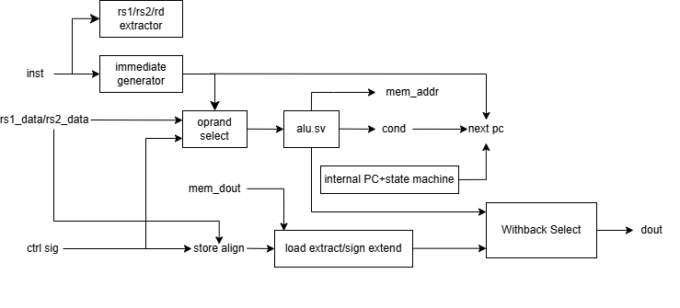
Figure 7 Hardware Architecture

3.4.4 Dataflow
The control flow is shown in Figure 28。
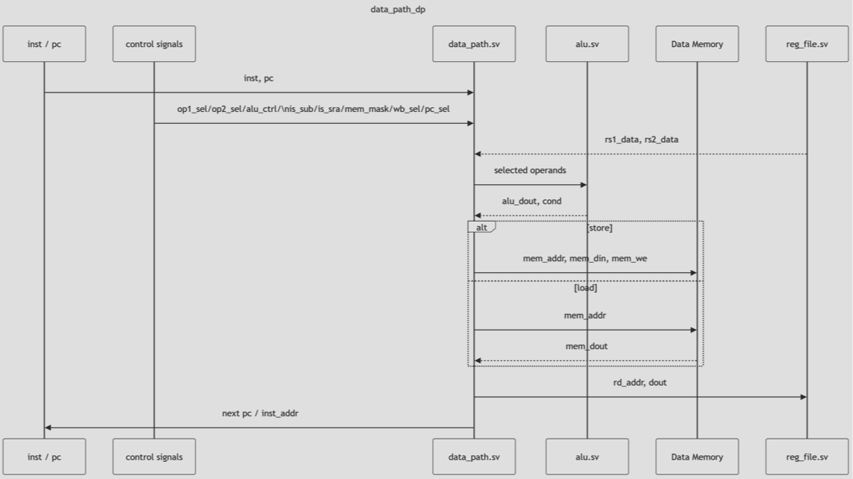
Figure 8 Data Flowchart

3.5 EX submodule

3.5.1 function
The execution module (EX) is responsible for performing arithmetic and logic operations, generating memory access signals, and computing branch conditions. The module takes operands from the register file or immediate values and producing ALU results, condition codes, and memory interface signals.
The module selects ALU input operands based on control signals, supporting register values, various immediate types (I-type, S-type, U-type), and the current program counter as operands. The ALU core executes the actual computation, generating both the result and condition code for branch instructions. The write data is aligned based on the lower two bits of the ALU result to support byte and halfword stores at arbitrary word-aligned addresses. The write enable mask is shifted accordingly to ensure only the intended bytes are written.
This module integrates all execution-stage functionality, allowing the ALU to remain a simple, reusable computational unit while the EX module handles operand selection, immediate generation, and memory interface logic.

3.5.2 Input/Output
The interface of this chip is defined in Table 1。
Table 5 Iuput/Output signals
Signal name | I/O | Width (bits) | Fuction Description
pc | input | 32 | Current program counter value, used as an ALU operand for AUIPC and PC-relative addressing
inst | input | 32 | Instruction being executed, used to generate immediate values
Alu_out | output | 32
  ALU computation result
Alu_cond | output | 1 | ALU condition output, used for branch decision (comparison result)
Rs1_data | input | 32 | First source register data from the register file
Rs2_data | input | 32
  Second source register data from the register file
Mem_din | output | 32 | Memory write data, aligned based on the lower two bits of the ALU result
Mem_we | output | 4 | Memory write enable mask, shifted based on the lower two bits of the ALU result
Op1_sel | input | 2 | ALU first operand selection: OP1_RS1 (register) or OP1_IMU (U-type immediate)
Op2_sel | input | 2 | ALU second operand selection: OP2_RS2 (register), OP2_IMI (I-type immediate), OP2_IMS (S-type immediate), or OP2_PC (current PC)
Alu_ctrl | input | 3 | ALU operation control, mapped from instruction funct3 field
Is_sub | input | 1 | Subtraction indicator, used to distinguish ADD from SUB
Is_sra | input | 1 | Arithmetic right shift indicator, used for SRA and SRAI instructions
Mem_mask | input | 4 | Base memory write mask from control unit: 4'b0001 for byte, 4'b0011 for halfword, 4'b1111 for word

3.5.3 Architecture
The hardware structure is shown in Figure 19。
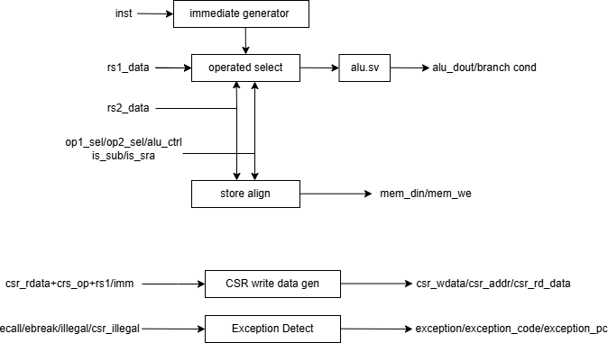
Figure 9 Hardware Architecture

3.5.4 Dataflow
The control flow is shown in Figure 210。
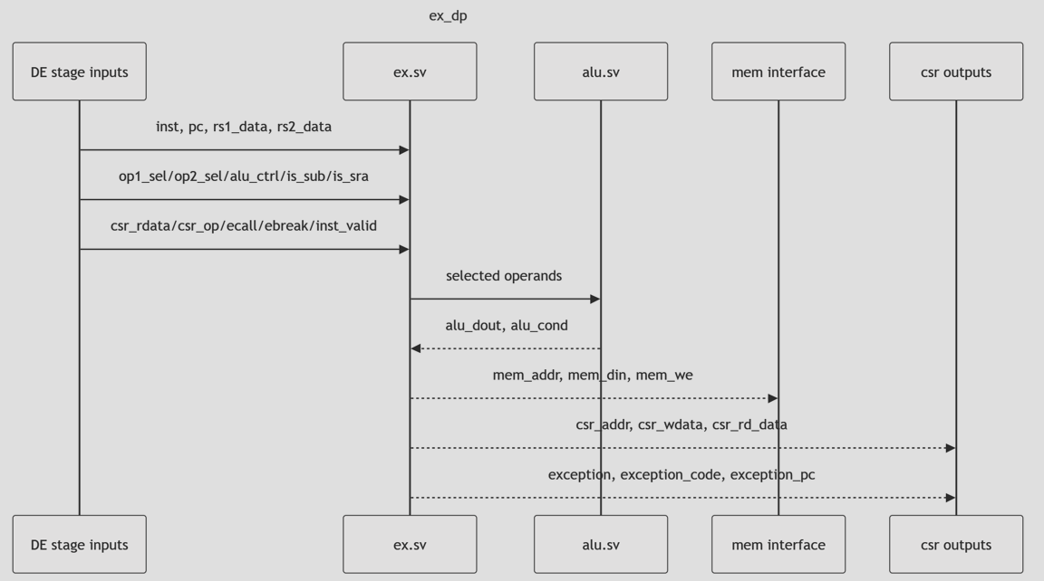

Figure 10 Data Flowchart

3.6 alu submodule

3.6.1 Function
The Arithmetic Logic Unit (ALU) is a core computational module that performs arithmetic and logic operations required by RISC-V instructions. The module takes two 32-bit operands and control signals, producing a 32-bit result and condition flags for branch instructions.
The ALU supports of RISC-V integer operations, including addition, subtraction, bitwise logical operations (AND, OR, XOR), shift operations (logical left, logical right, arithmetic right), and set-if-less-than comparisons (signed and unsigned). The operation is selected via the funct3 input, with is_sub and is_sra providing additional control to distinguish ADD from SUB and logical right shift from arithmetic right shift, respectively.
For branch instructions, the ALU computes condition codes based on the two operands, supporting equality, inequality, signed less-than, unsigned less-than, and their complements. The cond output directly indicates whether the branch condition is satisfied, allowing the branch decision logic to use this signal directly.

3.6.2 Input/Output
The interface of this chip is defined in Table 1。
Table 6 Iuput/Output signals
Signal name | I/O | Width (bits) | Fuction Description
dina | Input | 32 | First ALU operand
dinb | input | 32 | Second ALU operand
Funct3 | input | 3 | ALU operation selection. Encodings: ADD (0x0), SLL(0x1), SLT (0x2), SLTU (0x3), XOR (0x4), SR (0x5), OR(0x6), AND (0x7)
Is_sub | input | 1 | Subtraction indicator. When asserted with funct3 = ADD, performs subtraction; when asserted with funct3 = SLL, passes dina unchanged (used for LUI)
Is_sra | input | 1 | Arithmetic right shift indicator. When asserted with funct3 = SR, performs arithmetic right shift; otherwise performs logical right shift
cond | output | 1 | Branch condition output. Asserted when the branch condition specified by funct3 is satisfied
dout | output | 32 | ALU computation result

3.6.3 Architecture
The hardware structure is shown in Figure 111。
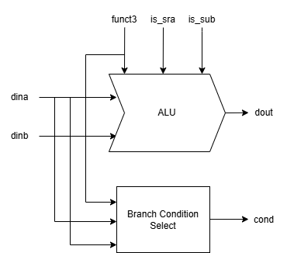
Figure 11 Hardware Architecture

3.6.4 Dataflow
The control flow is shown in Figure 2。
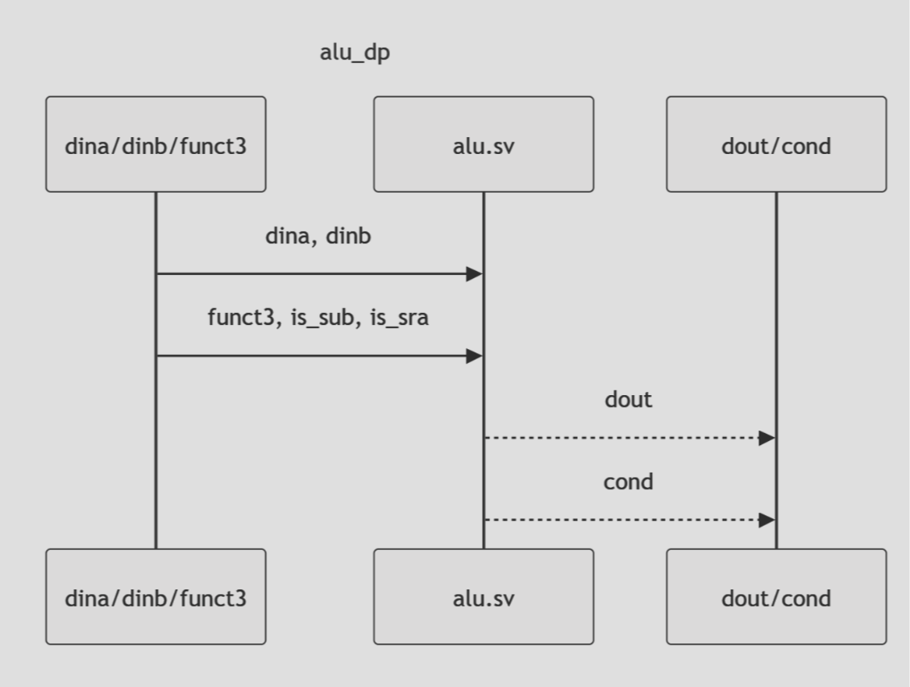
Figure 13 Data Flowchart

3.7 Reg_file submodule

3.7.1 Function
The register file module contains 32 general-purpose registers, each 32 bits wide. The module provides two read ports and one write port.
The module features a combinational read path with forwarding: when a read address matches the current write address and a write operation is in progress (i.e., the write address is non-zero), the module forwards the write data directly to the read output, bypassing the register array.
The module enforces the RISC-V specification that register x0 is hardwired to zero. Any read of address 0 returns zero, and any write to address 0 is ignored. The register array is initialized to all zeros at simulation start using an initial block.
The write operation is synchronous, occurring on the rising edge of the clock.

3.7.2 fInput/Output
The interface of this chip is defined in Table 1。
Table 7 Iuput/Output signals
Signal name | I/O | Width (bits) | Fuction Description
clk | input | 1 | System clock
Rd_addr | input | 5 | Write address for the destination register. Write is ignored when rd_addr is 0
Rd_data | input | 32 | Write data to be stored in the destination register
Rs1_addr | input | 5 | Read address for the first source register
Rs2_addr | input | 5 | Read address for the second source register
Rs1_data | output | 32 | Read data for the first source register. Returns zero for x0, forwards rd_data if forwarding condition is met
Rs2_data | output | 32 | Read data for the second source register. Returns zero for x0, forwards rd_data if forwarding condition is met

3.7.3 Architecture
The hardware structure is shown in Figure 1。
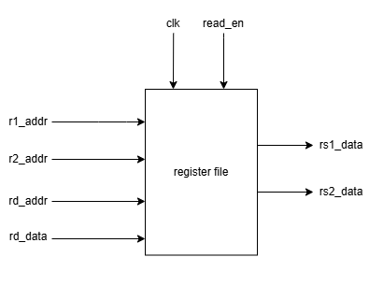
Figure 13 Hardware Architecture

3.7.4 Dataflow
The control flow is shown in Figure 214。
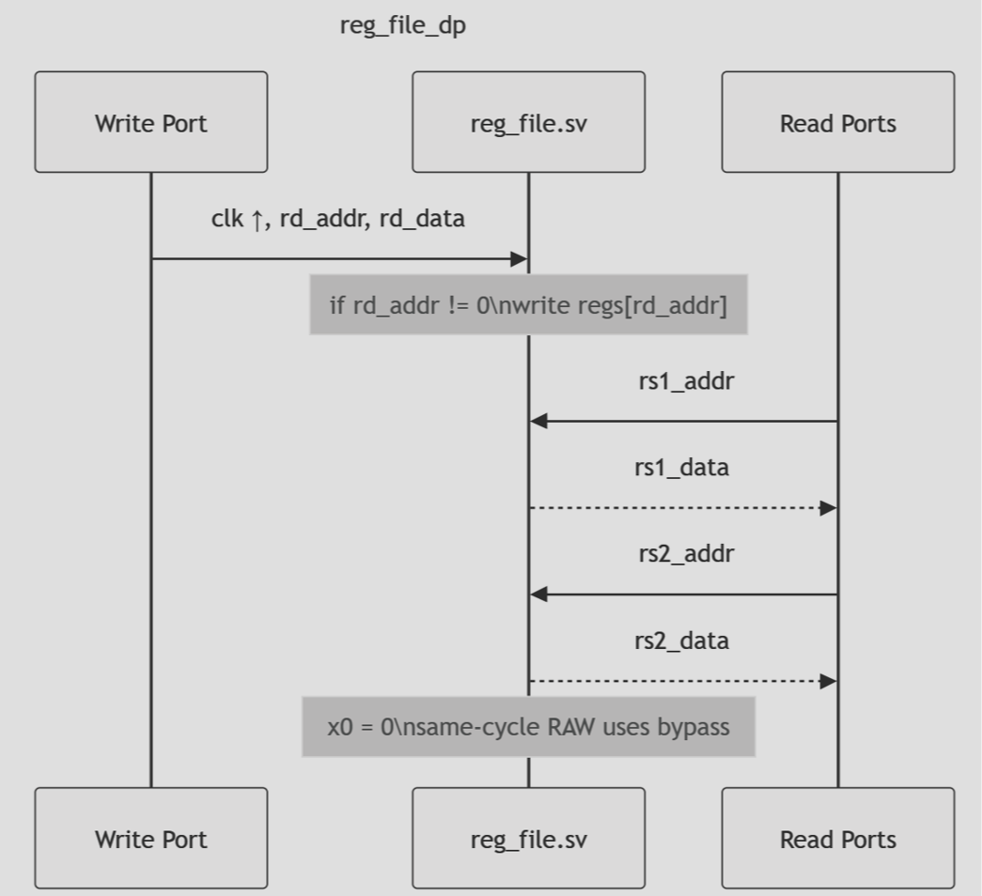
Figure 14 Data Flowchart

3.8 wb submodule

3.8.1 Function
The write-back module is responsible for selecting the final data to be written into the register file. It takes results from various execution units—ALU output, memory read data, and program counter—and selects the appropriate value based on the instruction type.
For ALU instructions, the module directly passes the ALU result to the register file. For jump and link instructions (JAL, JALR), it writes the return address (PC+4) to the destination register. For load instructions, it performs sign extension or zero extension on the memory read data based on the load type, handling unaligned accesses by shifting the memory data according to the lower two bits of the ALU result.
The module supports the full set of RISC-V load instructions: LB (load byte, sign-extended), LH (load halfword, sign-extended), LW (load word), LBU (load byte, zero-extended), and LHU (load halfword, zero-extended). For CSR instructions, the module currently returns zero as a placeholder.

3.8.2 Input/Output
The interface of this chip is defined in Table 1。
Table 8 Iuput/Output signals
Signal name | I/O | Width (bits) | Fuction Description
Funct3 | input | 3 | Load instruction type. Encodings: LB (0x0), LH (0x1), LW (0x2), LBU (0x4), LHU (0x5)
Wb_sel | input | 2 | Write-back data source selection: WB_ALU (ALU result), WB_MEM (memory read data), WB_PC4 (PC+4), WB_CSR (CSR register value)
Alu_dout | input | 32 | ALU computation result. Used as the write-back data for ALU instructions and as the address alignment reference for load instructions
pc | input | 32 | Current program counter value. Used to compute PC+4 for jump instructions
Mem_dout | input | 32 | Memory read data, before alignment and extension
dout | output | 32 | Final write-back data to be written into the register file

3.8.3 Architecture
The hardware structure is shown in Figure 1。
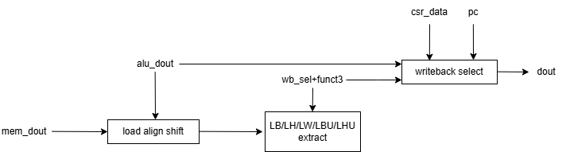
Figure 15 Hardware Architecture

3.8.4 Dataflow
The control flow is shown in Figure 216。
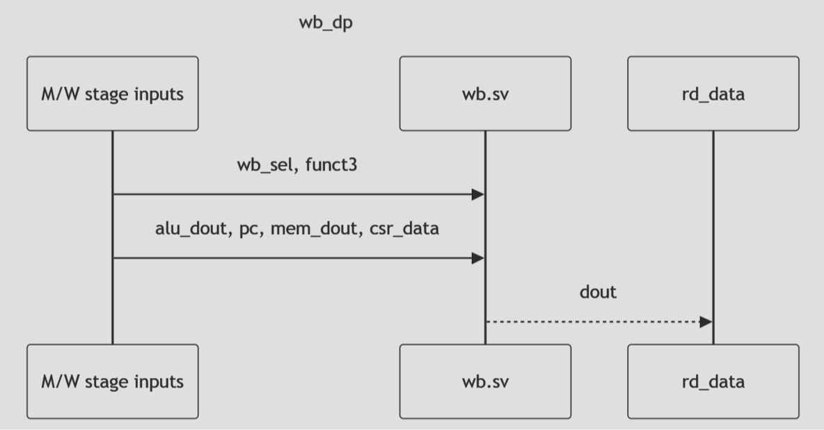
Figure 16 Data Flowchart

3.9 Clock, Reset & Initial

3.9.1 Clock

3.9.2 Reset

3.9.3 Initial

Verification & Test

Test Plan & TestBench

TestCase & Result

Conclusion & Future work

Conclusion

Future work
The current design successfully implements CSR read/write operations and data forwarding for CSR values, laying the groundwork for privileged architecture support. However, the trap handling mechanism—encompassing exceptions, interrupts, and the MRET return flow—still contains known issues that prevent reliable interrupt-driven operation. The following tasks are identified for the next development phase:

Correct mepc capture on interrupts. The present logic stores the PC of the executing instruction for both exceptions and interrupts, whereas the RISC-V privileged specification requires that mepc point to the instruction following the interrupted one. A dedicated path must be added to save pc + 4 when an interrupt is taken.

Resolve the write-conflict between CSR instructions and trap entry. When an interrupt request coincides with a CSR-modifying instruction in the execute stage, the hardware trap update currently overrides the architectural CSR write. A precise exception model should be implemented that completes the current instruction before servicing any pending interrupt, thereby preserving correct architectural state.

Refactor the pipeline flush and stall logic for precise traps. The execute-stage pipeline register is incorrectly cleared during load-use stalls, which can discard valid instructions. A clean separation between stall (freezing the pipeline) and flush (cancelling mis-fetched instructions) is required to guarantee that all instructions before a trapping instruction retire and all subsequent instructions are squashed.

Synchronize the external timer_int signal. The timer interrupt input currently feeds asynchronous combinational logic, leading to potential metastability and spurious triggers. A two-stage synchronizer should be added at the module boundary.

Extend trap-entry side effects. Future revisions must handle additional standard CSR fields upon trap entry (e.g., updating mcause, saving the previous privilege mode in mstatus, and clearing mstatus.MIE while preserving the correct MPIE value) with proper atomicity and priority over software writes.

Strengthen verification with a complete testbench. A full-featured verification environment should drive all memory ports (including the data memory bus), inject interrupts during various pipeline stages and instruction sequences (CSR writes, loads/stores, branch mispredictions), and check program-flow recovery after mret to ensure end-to-end correctness under corner cases.

Completion of these items will bring the processor into full compliance with RISC-V machine-mode interrupt handling and provide a robust foundation for integrating a real-time operating system kernel.

References
- G. Sun, S. Lin, F. Yu, B. Yan, and J. Zhang, “Multi-rate Based Channel Assignment Algorithm for Multi-radio Multi-channel Wireless Mesh Networks,” in 2015 11th International Conference on Mobile Ad-hoc and Sensor Networks (MSN), 2015, pp. 202–207.

