Universal Agentic Harness

Shadow-First Semantic Binding Architecture

STATUS  Proposed · H1 slice active |  | OWNER  Neural Workbench / UAH |  | LAST UPDATED  August 4, 2026

Authors | UAH research and implementation track
Reviewers | NAO owners; Neural Workbench owner; runtime/eval owner
Related docs | universal_agentic_harness_masterplan.md; universal_agentic_harness_development_log.md; ADR 0001
Decision status | Semantic binding boundary accepted; live coupling pending

1. Abstract
UAH is a portable control kernel that scopes a model to a frame-relative AB projection, accepts only typed proposals, and delegates execution and effect proof to environment owners. The first implementation mounts recorded NAO-shaped chatbot and planner outputs over an in-process fake owner. It proves the semantic seam without importing ROS, NAO packages, provider SDKs, or live runtime products.
The design supports local and frontier models through later adapters, but this proposal does not claim live-node parity, Bonsai/Watson parity, safe online learning, H1 completion, or global meaning for an AB level.

2. Goals and Non-Goals
Goals | Non-goals
Stable semantic objects across environment changes | Mirror every private method in the AB registry
Fail-closed proposal, binding, and effect gates | Let discovery grant authority or prove effects
Replayable model-harness-environment evaluation | Replace NAO package ownership
Quarantined, reversible Workbench candidates | Online publication of learned code or AB objects

3. Background and Problem Statement
NAO already contains mature dialogue, planner, orchestrator, perception, and fake-skill seams. ZeroTier experiments show that Bonsai is materially more memory-efficient than the Watson control, but its strict routed workflow is not yet equivalent. Selecting a model by memory or throughput alone would confound model, harness, runtime, adapter, and evaluator.
The system therefore governs one immutable configuration at a time. The UAH owns projection, typed gates, trace grammar, evaluation, and promotion governance. Existing environment components retain policy, execution, observations, and effect ownership.

4. Proposed Architecture
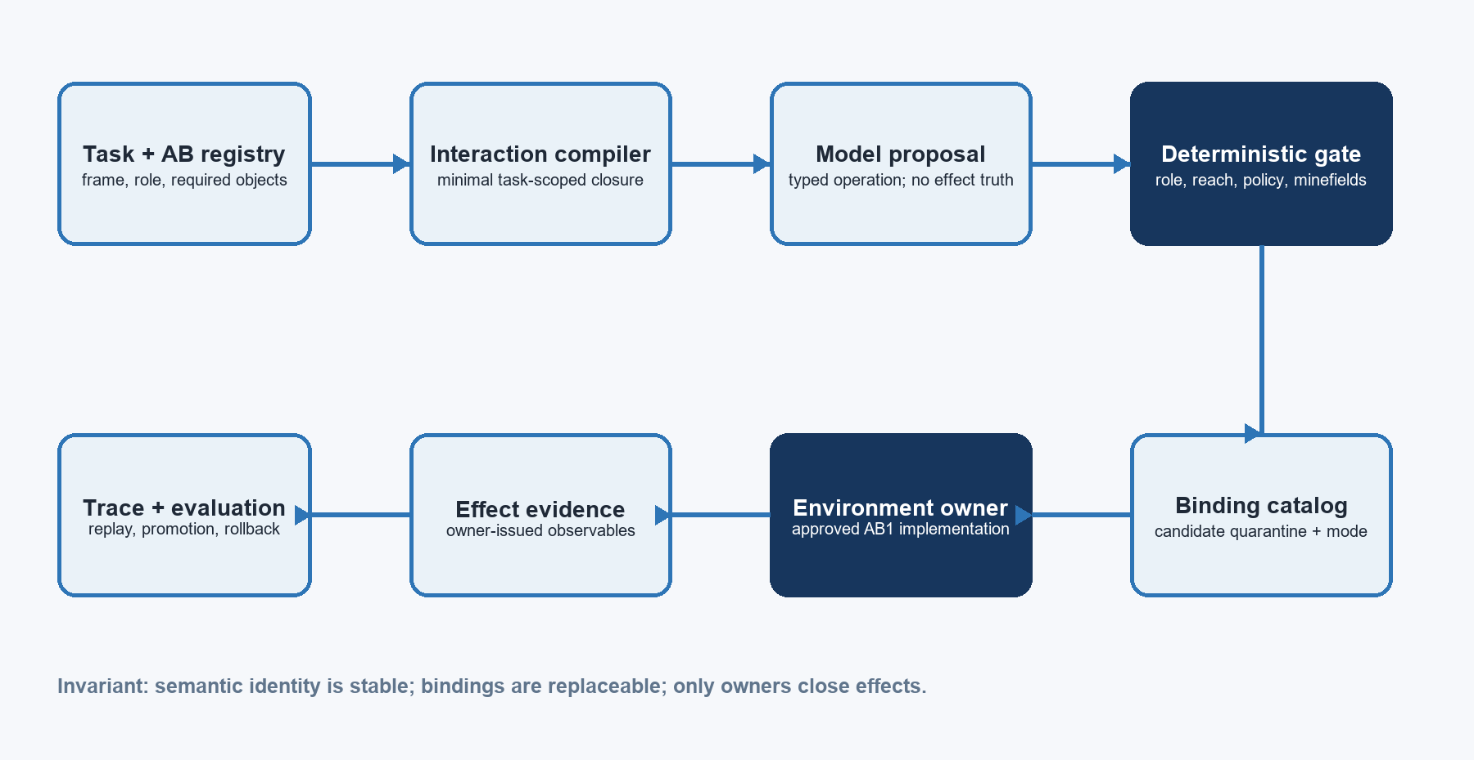
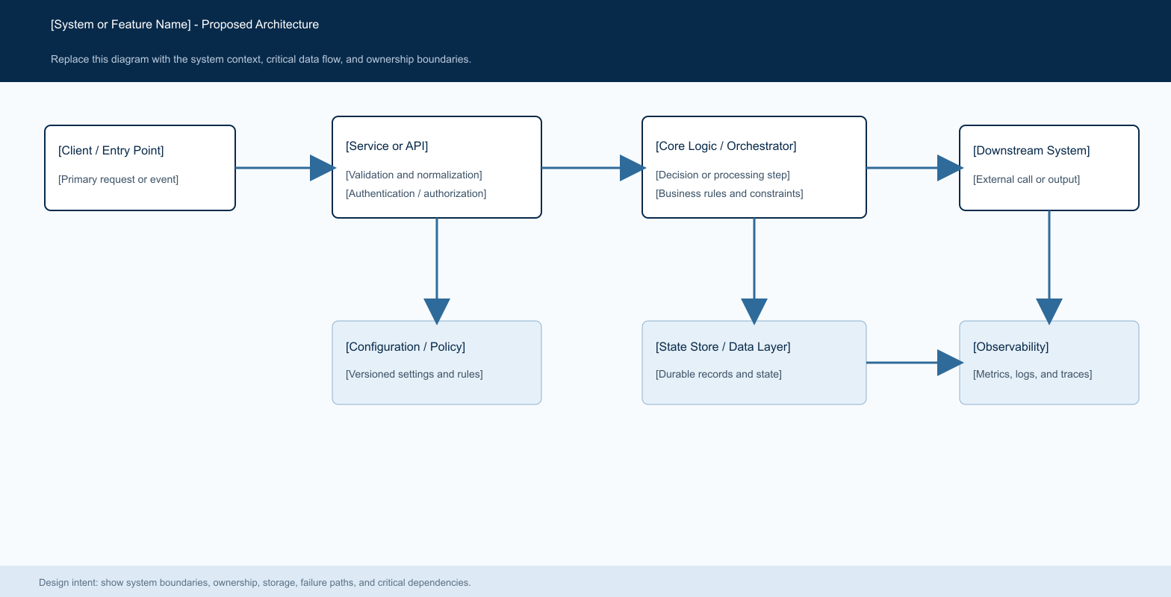
Figure 1. UAH semantic binding and evidence lifecycle.

Core components

Component | Responsibility | Primary storage | Failure behavior
AB registry snapshot | Semantic objects, levels, owners, decomposition | Versioned JSON + SHA-256 | Unknown objects fail closed
Interaction compiler | Build minimal role/task closure | Immutable module spec | Out-of-band object rejected
Output gate | Validate type, reach, level, claims | Decision in trace | No dispatch on rejection
Binding catalog | Map semantics to reviewed environment APIs | Revisioned bindings | Candidate, missing, or ambiguous binding stops
Environment owner | Execute approved AB1 and issue observations | Owner runtime | Failure remains owner-attributed

5. Request Lifecycle
- 1. Compile — receive the task, role, frame, registry identity, and required objects.
- 2. Project — close the minimal inspectable decomposition and direct-control band.
- 3. Propose — a model or recorded replay emits a typed operation without effect truth.
- 4. Gate — validate output ownership, projection reach, permissions, and minefields.
- 5. Resolve — select one approved binding for the environment and runtime mode.
- 6. Dispatch — the environment owner executes under budgets, cancellation, and retries.
- 7. Verify — close terminal observables from owner evidence and append lifecycle events.

6. API and Data Contracts

Primary data contract

Field | Type | Required | Description
object_id | string | Yes | Stable frame-relative AB semantic identity
binding_id | string | Yes | Versioned implementation pointer identity
implementation_owner | string | Yes | Package/component that implements this pointer
source_revision | string | Yes | Exact source revision used for validation
runtime_modes | string[] | Yes | Modes in which the binding may resolve
status | enum | Yes | candidate, approved, or disabled
evidence_ref | string | For execution | Durable owner-issued evidence reference

Contract guarantees

- Only approved bindings resolve; discovery and declaration produce candidates.
- AB0 interfaces may have producer, contract, and consumer pointers but cannot dispatch.
- An executable AB1 binding must be implemented by the registry-declared effect owner.
- Every result captures registry, binding, environment, source, and configuration identity.
Model text, runtime discovery, and successful transport are never effect truth.
Canonical schemas and implementation details are versioned independently.

7. Consistency, Idempotency, and Replay

Replay replaces the model with recorded proposals while preserving the registry, task, bindings, environment, and evaluator. Binding identity and evidence references make duplicate attempts visible. Runtime owners remain responsible for idempotency; the UAH records attempt lineage and never treats a repeated response as a new effect without fresh evidence.
Scenario | Expected behavior | Reasoning
Duplicate proposal | Record a new attempt; owner idempotency applies | Proposal identity is not effect identity
Candidate or ambiguous binding | Fail before dispatch | Discovery cannot become authority
Owner execution failure | Retain failure evidence; terminal remains open | Transport success is not task success
Stale or missing evidence | Reject completion and permit bounded recovery | Fresh owner proof closes effects

8. Security and Privacy Considerations

- Authorization is compiled from role, frame, task, registry owner, and approved binding state.
- Trace payloads minimize sensitive model, tool, and environment data; artifacts use references.
- Provider credentials and runtime secrets remain outside the semantic registry and prompt.
- Replay, promotion, and debugging tools default to read-only and shadow execution.
- Adaptive structures remain quarantined until counterexamples, holdout, owner review, provenance, and rollback pass.

9. Operational Readiness
Signal | SLO or alert | Owner | Launch gate
Terminal effect closure | 100% for deterministic canaries | Environment + evaluator | Required
Scope violations | 0 admitted out-of-projection actions | UAH gate | Required
Trace reconstruction | 100% deterministic replay agreement | UAH trace | Required
Resource headroom | Configured minimum RAM/VRAM remains free | Runtime owner | Required
Latency | Within role-specific TTFT and terminal budget | Provider/runtime | Required
Required

10. Alternatives Considered

Alternative | Why it was considered | Why it was not selected
Promote every method into AB | Automatic environment ingestion | Private refactors churn semantics and discovery becomes authority
Import NAO/ROS into core | Fast reuse of mature nodes | Breaks portability and ownership boundaries
Begin with live autonomous coupling | Earlier end-to-end behavior | No parity, attribution, or rollback evidence
Fork a broad agent product | Ready providers and sessions | Runtime policy would dominate the AB semantic kernel

11. Open Questions
- 1. What freshness and clock contract must every effect-evidence type carry?
- 2. Which frozen NAO fixtures form the first held-out shadow-parity suite?
- 3. What provider-neutral request/result protocol is sufficient for Watson and Bonsai?
- 4. Which owner signs a candidate binding and which independent evaluator can reject it?

12. Decision and Next Steps
Approve the semantic-object/implementation-binding boundary and the August 10 v0 launch contract. Continue shadow-first. Next, serialize the complete configuration and TaskSpec, append lifecycle events for the recorded success and a stale-evidence counterexample, and require replay-identical terminal decisions. Only then add the Watson/Bonsai provider adapter and NAO shadow parity.
Milestone | Deliverable | Exit criteria
M1 | Semantic bindings and fake-owner qualification | Implemented; portable tests green
M2 | Configuration/TaskSpec lifecycle replay | Success and stale failure replay identically
M3 | Watson/Bonsai ROS-free eval runner | Frozen repeated matrix with effect graders
M4 | NAO read-only shadow adapter | Package-owned parity and disagreement ledger

Use footnotes for definitions, assumptions, or terms that need precision without interrupting the main narrative.

