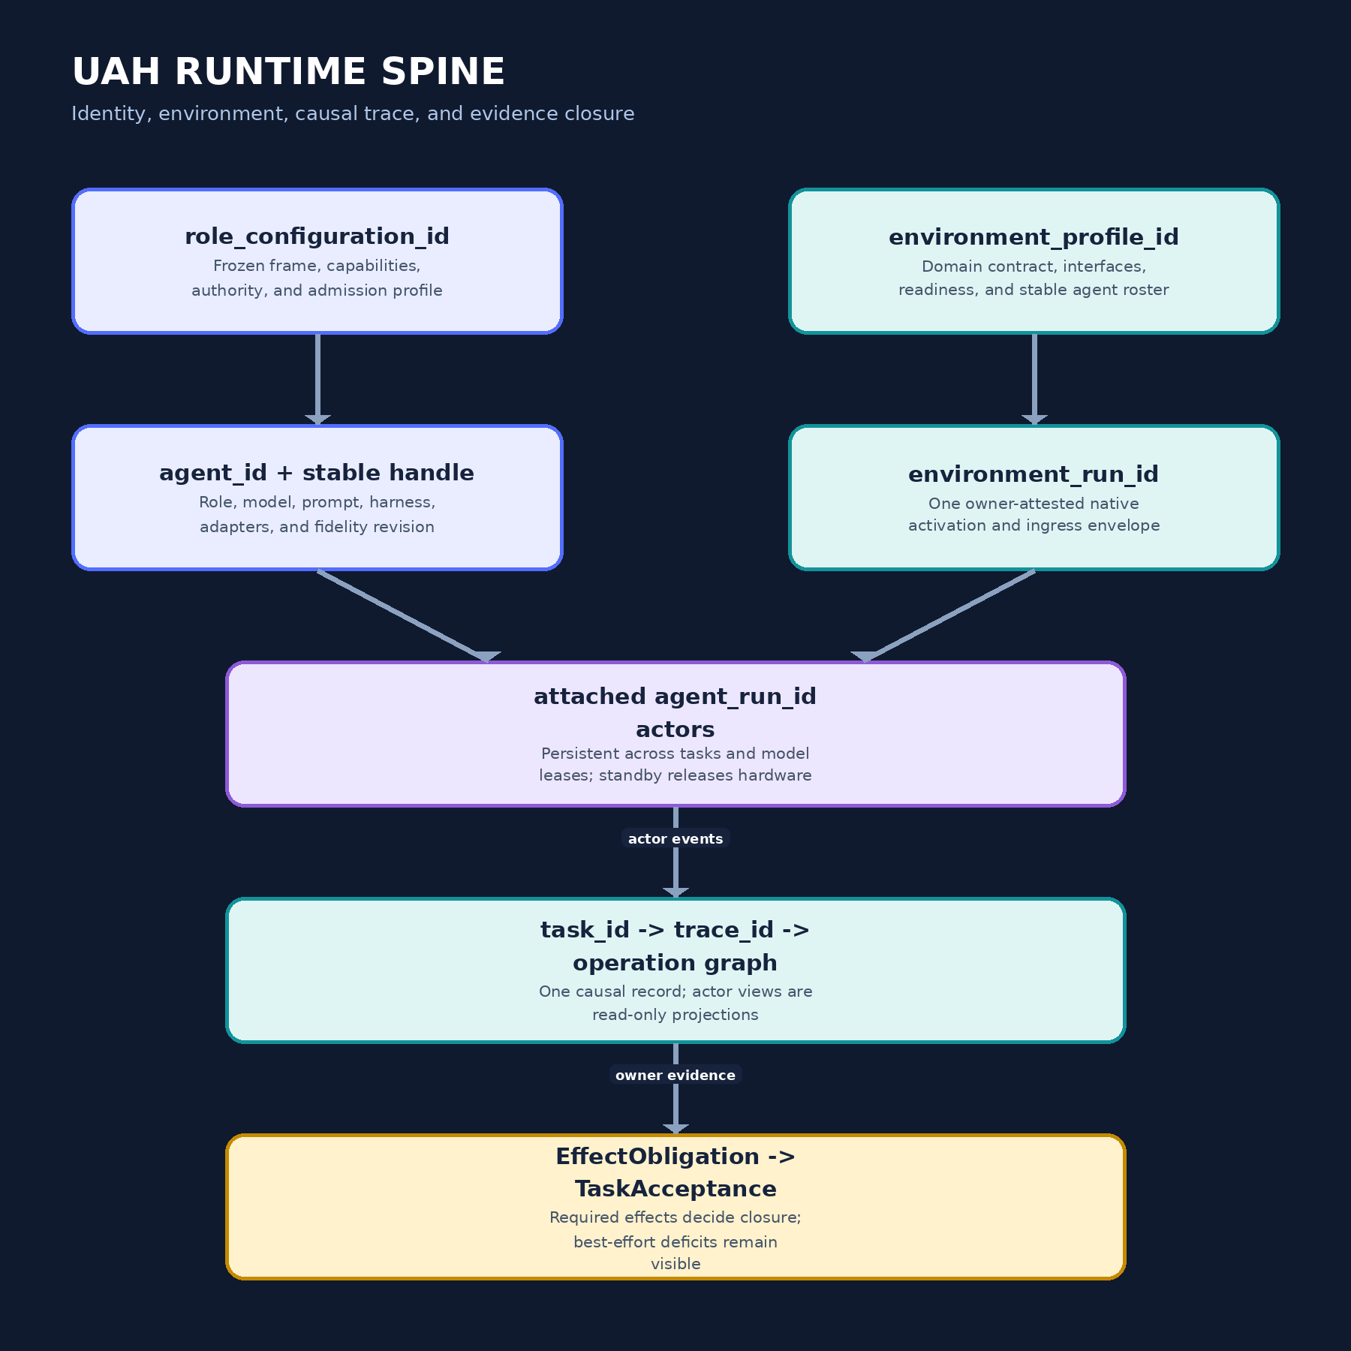

Universal Agentic Harness
Environment, ingress, and task closure architecture |  | Prepared by UAH project  8 September 2026

Contents
Executive summary · Architecture checkpoint · Key findings · Implications · Recommendations · Appendix
Executive summary 2
At a glance 2
Introduction 2
Key findings 3
Context and conditions 3
Patterns in the evidence 3
Implications 3
Recommendations 4
Conclusion 4
Appendix 5
Notes 5
Source placeholders 5

Executive summary
The H0-H2 architecture now has an explicit runtime envelope. An owner-attested EnvironmentRun groups native ingress, persistent agent actors, domain tasks, causal traces, and evidence. Agent identity remains independent of provider placement, while each model invocation records the exact lease and loaded instance that supplied computation.
Task closure is no longer inferred from planner status, model text, or an event label. Tasks declare required and best-effort effect obligations before execution. A deterministic evaluator compares those obligations with owner-issued evidence and produces accepted, accepted-with-deficit, suspended, or rejected outcomes.

At a glance
- H0 freezes identity, environment, ingress, operation-edge, obligation, acceptance, and trace contracts. It does not introduce a scheduler.
- H1 implements registries, deterministic ingress, attached agent-run standby, fixed-instance leases, PromptCompiler, admission, replay, O1, and VerifiedTraceDigest.
- H2 remains the first NAO demonstration. It uses fixed chatbot and planner handles, preserves NAO lifecycle owners, and validates report_result as an AB1 operation with explicit chatbot delegation.

Architecture checkpoint
The identity hierarchy distinguishes reusable role configuration, immutable agent embodiment, stable handle revision, bounded agent activation, provider capacity, and individual model invocation. Registering an agent does not load or call a model. An active agent run may release its lease and remain in standby inside one environment activation.
EnvironmentIngress separates native stimuli from task semantics. Deterministic TaskIngressPolicy decides whether an item updates environment state, starts work, resumes work, notifies an existing task, or is rejected. A model can interpret admitted content but cannot rewrite task or trace lineage.

Key findings
The accepted design preserves the portable-kernel boundary. Core contracts contain no ROS, NAO, provider-SDK, or runtime-product imports. DomainContractPack carries frame-relative objects, role projections, bindings, environment profiles, evidence rules, prompt policy, and qualification cases. Custom adapters are limited to irreducible native normalization.

Context and conditions
The source-resolution audit used NAO tag v1.0.0 at ebffe93, chatbot revision a2ecca796, and intended NeuralWorkbench revision e76ba7e. Focused read-only checks passed 112 chatbot turn-engine cases and 41 planner supervisor/gate cases. These baselines constrain compatibility but do not qualify UAH H2.

Patterns in the evidence
NAO already contains mature routing, goal and plan lifecycle, cancellation, supersession, stale-version checks, owner dispatch, feedback, and report_result behavior. UAH should normalize and trace these seams rather than copy their domain policy. The current NeuralWorkbench report_result decomposition is stale relative to the authoritative NAO runtime and requires an owner-reviewed DomainContractPack revision.

Key takeaway. One causal trace may include several agent runs, but every event names its actor and every operation retains one frame-relative AB coordinate. Cross-frame work is visible as delegation, never hidden as ordinary decomposition.
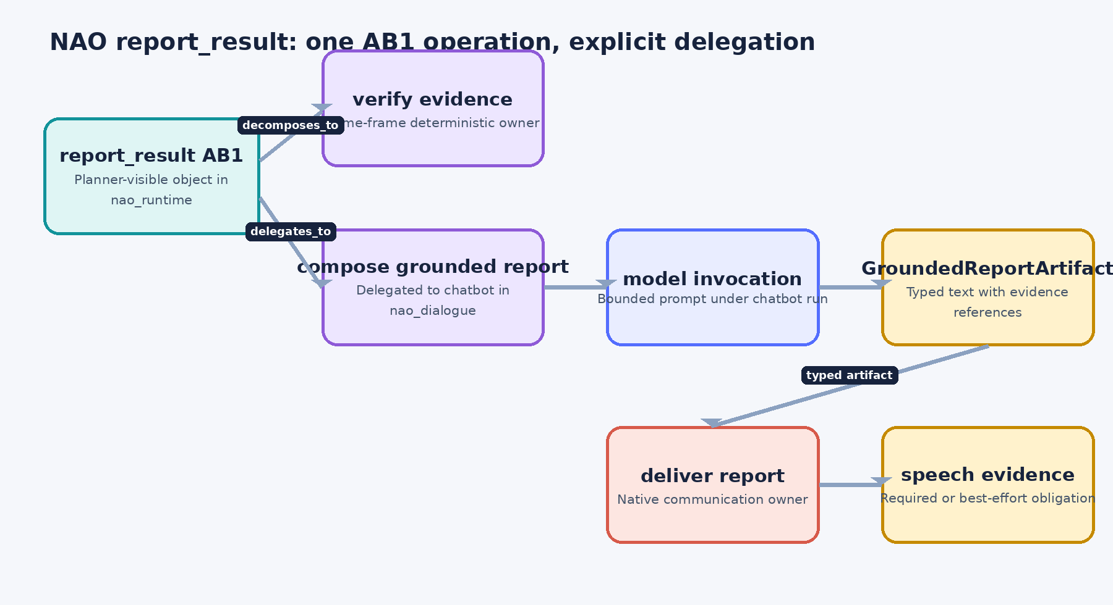

Implications
Observatory and NeuralWorkbench remain separate. Observatory renders immutable facts and projections. Workbench consumes verified trace digests to retrieve experience and compare candidates, but it cannot mutate the ledger or decide when evidence becomes memory or authority. H2 provides only the attachment seams; retrieval and model-assisted search begin in H3.
Theme | Observation | Implication
Identity | Logical agents and provider resources have separate lifetimes | Hardware changes cannot silently rewrite agent provenance
Environment | One attested activation groups ingress, actors, tasks, traces, and evidence | Container restarts and cross-agent workflows remain distinguishable
Closure | Required and best-effort effects are evaluated against owner evidence | Successful operations survive later reporting deficits

Recommendations
Implementation should proceed through small public contracts and preserve the current H0 compatibility surface while the new identity grammar lands.
- Confirm the first TDD seam. The recommended starting boundary is TaskAcceptanceEvaluator.evaluate(effect_obligations, evidence_set) -> TaskAcceptance.
- Register one synthetic EnvironmentRun, classify one ingress, attach one standby-capable agent run, and connect the existing typed proposal and fake-owner path.
- Produce a replayable VerifiedTraceDigest, then freeze the NAO DomainContractPack and test planner parity, report_result delegation, required-effect failure, and best-effort deficit paths.

Conclusion
The architecture is ready to leave the grill once the first public test seam is confirmed. It supports continuous environment-bound agents without permanent model allocation, preserves domain authority, and creates a trace grammar suitable for O1/O2 debugging and later Workbench memory.
No environment-run registry, ingress classifier, obligation evaluator, multi-actor ledger, report_result adapter, or dynamic allocator is implemented at this checkpoint. The current release remains an H0 contract proof with one partial H1 vertical slice.

Appendix

Identity and authority map
Semantic chain: DomainContractPack -> AgentRoleConfiguration -> AgentManifest -> agent_id -> AgentHandleRevision -> agent_run_id.
Runtime chain: EnvironmentProfile -> environment_run_id -> EnvironmentIngress -> TaskIngressDecision -> task_id -> trace_id -> operation graph -> effect obligations -> TaskAcceptance.

Evidence sources
- Universal Agentic Harness foundation, canonical Markdown, 8 September 2026.
- Universal Agentic Harness masterplan and development log, canonical Markdown, 8 September 2026.
- NAO ROS4HRI bridge, annotated tag v1.0.0, peeled commit ebffe93a74be4e013ce0f60fdfc41268dba73fc3.
- Chatbot planner-hook source, revision a2ecca796; NeuralWorkbench intended companion revision e76ba7e.

Report status. Architecture and test seams are specified. Runtime implementation and H2 qualification remain open.

