
BACHELOR OF SCIENCE COMPUTER ( SOFTWARE ENGINEERING ) WITH HONOUR
SEMESTER III SESSION 2025/2026
CSF3113 WEB BASED DESIGN
PROF.MADYA TS DR.WAN NURAL JAWAHIR BINTI HJ WAN YUSOFF

LAB MODULE 5

NAME | MUHAMMAD DANSIH IMAN BIN ABDULLAH
MATRIX | S74821

ACTIVITY OUTPUT
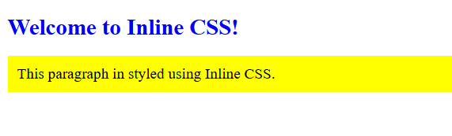
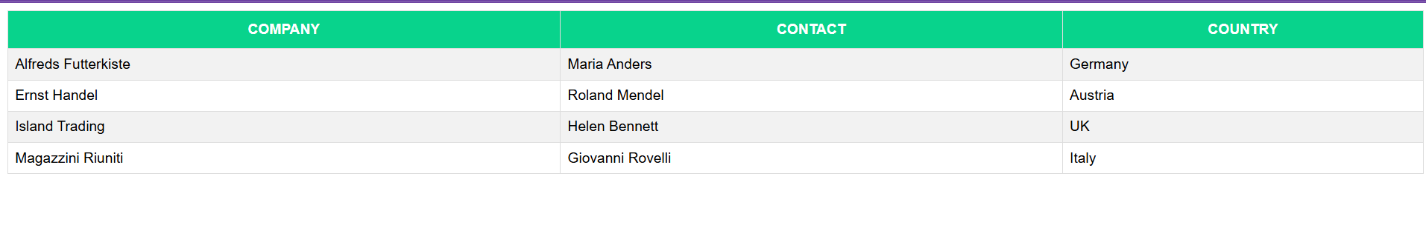



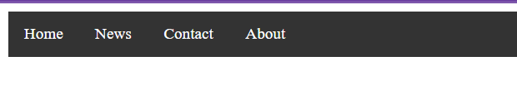

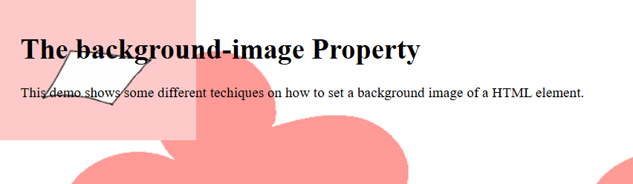

UMT TESTING WEB

