
BACHELOR OF SCIENCE COMPUTER ( SOFTWARE ENGINEERING ) WITH HONOUR
SEMESTER III 2025/2026
LAB 4 : CSS
PROF.MADYA TS DR WAN NURAL JAWAHIR BINTI HJ WAN YUSSOF
NAME | MUHAMMAD DANISH IMAN BIN ABDULLAH
MATRIX | S74821

4.1 Page Structure Elements
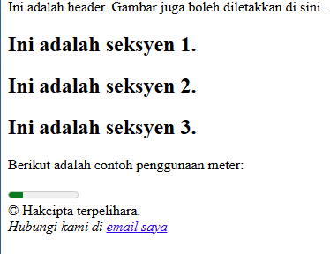

4.2 Insert Video into HTML5 Document


4.3 Casacding Style Sheet


4.4 Recognize ID and Selector Class
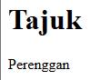

4.5 Navigator Bar Using CSS
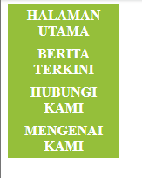

4.6 Recognizing Text Decoration
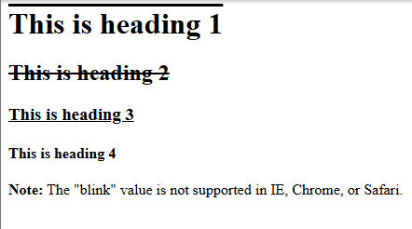

4.7 Recognizing Styling Links

a:link {color: #FF0000;} /* unvisited link */

a:visited {color: #00FF00;} /* visited link */ | 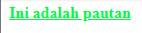
a:hover {color: #FF00FF;} /* mouse over link */ | 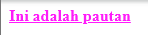
a:active {color:#0000FF;} /* selected link */

LAB EXERCISE 4
