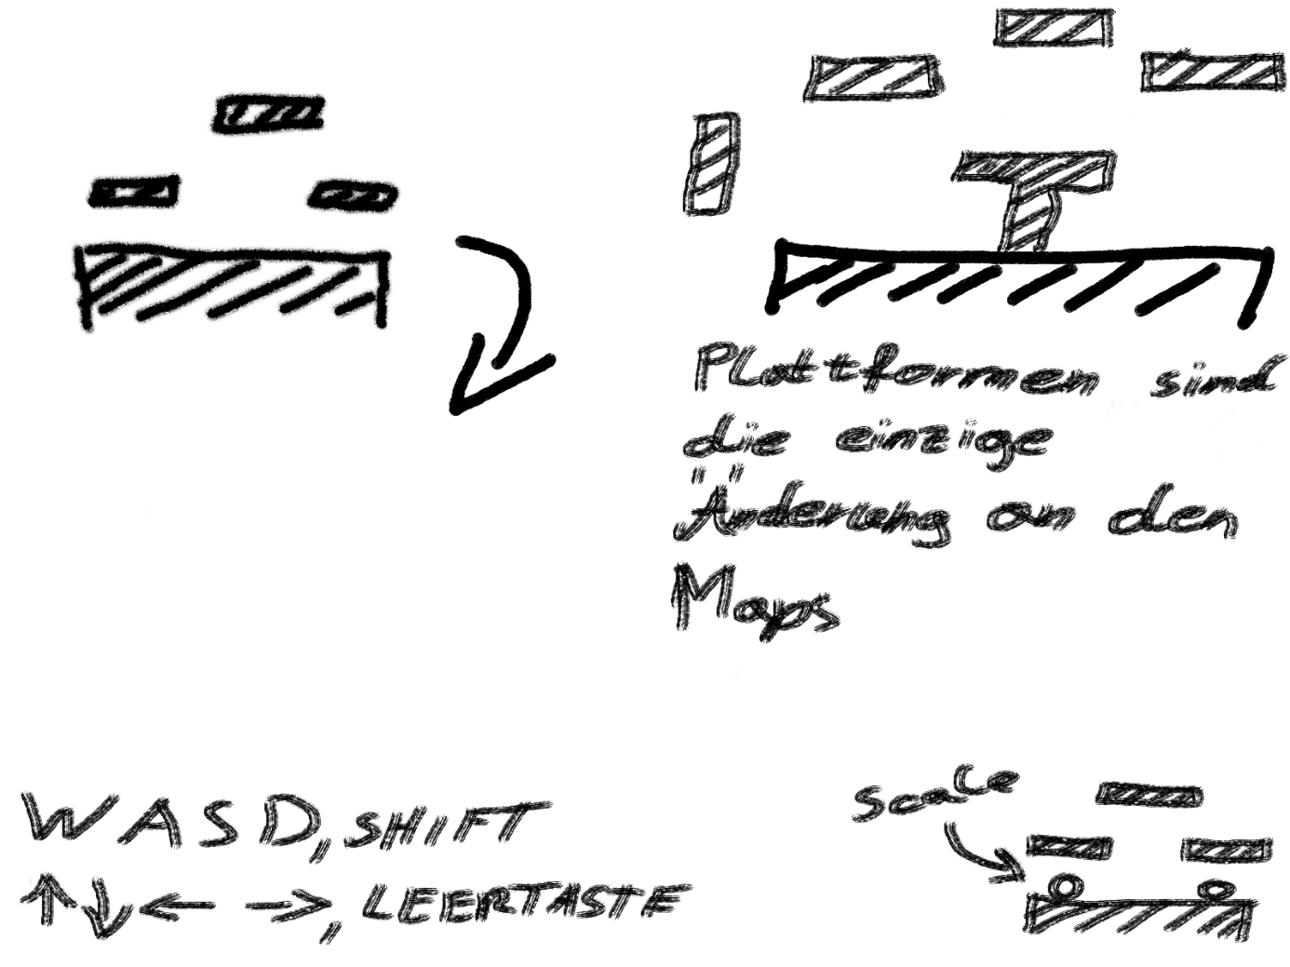

//Controls//

**Player1**a – move left  
d – move right  
w – jump  
q – attack  
e – active ability  
r – ultimate ability

**Player2**j – move left  
l – move right  
i – jump  
o – attack  
u – active ability  
z – ultimate ability

//Characterstuff//

-Attack

-Dodge

-Double Jump

-Passive Ability

-Active Ability

-Ultimate Ability with Ultimate Meter

-Shield

-Evolution

-Regens life every second

//EINFACH

//Basti

Active: Mehrheit: every member of his Government supports him[ shield 100 leben]

Passive: Tax Cuts [halfs opposing politicians health regen]

Ulti: BUNDESKANZLER: [every attack deals 60 damage && +10 % attack speed, next 5 seconds]

//Rendi

Active: ROTE FLAMME[ deals 60 damage]

Passive: Determination [two lives, weaker damage] //from continuously losing elections

Ulti: Ich bin Ärztin [Temporary Invincibility] //from interviews

//MIttel

//Werna

Active: Green Footprint [next attack 30 damage + 30 life points] GREEN PARTICEL

Passive: Green Thumb [Double life regen] //from being green party chairman

Ulti: Ultimate Recovery [Fully regen life, teleport to platform center] //from 2019 election

//Norbert

Active: Gehstock: WURF if enemy gets hit[ 2 seconds stun]

Passive: Nationalstolz:[Beginning: +50 shield]

Ulti: Reiterstaffel: [cavalry charge left -> right if enemy gets hit half-life damage]

//Die Endbossraucha

//Schwer

Van der Bellen

Active: THE REAL BOSS: Point and Click [ 40 damage, blind chance 100%]

Passive: Raucher: health regen is lowered: 20 % chance to blind the enemy with attack

Ulti: Summon Brigitte Bierlein [player control]

//HC

Active: Party auf Ibiza: WURF Red Bull [ deals AOE Damage 30 + stacks]

Passive: Hübsche Russin: BEEINDRUCKEN if enemy gets hit by Active [ + 1 stack = 10 damage]

Ulti: BSOFENE GSCHICHT: WURF Kronezeitung [ deals 150 damage + (2 * stacks)]