

Final Release

Christian Bachl, Haris Jusic, David Cvetkovic



20. Juni 2019

HTL-Leonding

Inhalt

0.1 Feature List 2

0.2 Test Specification 3

0.3 Test Protocol 7

0.4 Test Report 9

0.5 Open Issue 10

# 0.1 Feature List

1. Login

* When the login button is clicked. The server checks the email and compare the password-hash
* If the login input passed the validation, the user gets linked to the protected pages.
* Printing out error message when the validation failed

2. Register

* Validation of a User – A user is Valid, if the email is unique. That’s means the server checks if a user with the email-input already exists. If not, it is a new user. After this process the server continue checking if all the require input ﬁelds are set and sends a status 200 to the client(front-end) if all is OK.
* After checking the validation, the server saves the user into the database.

3. Main Interface

* Switching between the tab pages. Nicely done with the Ionic-Components.

4. Event page

* Having the ability to create or join an event by clicking on the “+” – sign.
* After making an event you get to another page. In this you can set settings such as declaring the event name, setting the date, making a description and setting a max participant number. Then you can create the event.
* Afterwards you get back to your “event-list”.
* Now you can click on any event and get to another page – “event-view”.
* In this you can make changes or look up for information.
* You can see the event-information or who or how many participants each event has.
* You can invite people as well in the event-view.
* Changes on the event-settings can also be made.

5. Home page

* Logout Button
* Some description about the application

6. Settings page

* The UI is getting displayed on the setting page.
* An user has the ability to make some changes about his profile, such as profile picture, name, birth etc.

7. Notification

* A notification signal is being displayed on this “Notifications” – tab.
* After clicking on it, the user gets to see all the invitations he gets.
* He can decide whether he wants to accept or reject the invitation.

# 0.2 Test Specification

Base are user stories

|  |  |  |
| --- | --- | --- |
| BAS01 Login (Valid Input) | | |
| # | Step | EXPRECTED RESULT |
| 1 | Enter email | User name is visible in clear text |
| 2 | Enter password | Password is displayed as ….. |
| 3 | Click login button | The welcome screen is displayed, if the server communication takes longer a waiting indicator is displayed. |

|  |  |  |
| --- | --- | --- |
| BAS02 Login (Password wrong) | | |
| # | Step | EXPRECTED RESULT |
| 1 | Enter email | User name is visible in clear text |
| 2 | Enter wrong password | Password is displayed as ….. |
| 3 | Click login button | A Error label appears which include-“Password is wrong” |

|  |  |  |
| --- | --- | --- |
| BAS03 Login (Email wrong) | | |
| # | Step | EXPRECTED RESULT |
| 1 | Enter wrong email | User name is visible in clear text |
| 2 | Enter password | Password is displayed as ….. |
| 3 | Click login button | The welcome screen is displayed, if the server communication takes longer a waiting indicator is displayed. |

|  |  |  |
| --- | --- | --- |
| BAS04 Registration | | |
| # | Step | EXPRECTED RESULT |
| 1 | Enter first name | First name is visible in clear text |
| 2 | Enter second name | Second name is visible in clear text |
| 3 | Enter email | Email is visible in clear text |
| 4 | Enter password | Password is displayed as … |
| 5 | Click Register button | The welcome screen is displayed, if the server communication takes longer a waiting indicator is displayed. |

|  |  |  |
| --- | --- | --- |
| BAS05 Registration (Invalid email) | | |
| # | Step | EXPRECTED RESULT |
| 1 | Enter first name | First name is visible in clear text |
| 2 | Enter second name | Second name is visible in clear text |
| 3 | Enter email | Email is visible in clear text |
| 4 | Enter password | Password is displayed as … |
| 5 | Click Register button | Error displayed underneath the password field. |

|  |  |  |
| --- | --- | --- |
| BAS06 Tabs Navigation | | |
| # | Step | EXPRECTED RESULT |
| 1 | Click home | Navigate to the Home Page |
| 2 | Click Events | Navigate to the Event Page |
| 3 | Click Notification | Navigate to the Notification Pahe |
| 4 | Click Groups | Navigate to Groups Page |
| 5 | Click Settings | Navigate to Settings Page |

|  |  |  |
| --- | --- | --- |
| BAS07 Display notification (Empty) | | |
| # | Step | EXPRECTED RESULT |
| 1 | Click on Notification tab | Navigate to Settings Page |
| 2 | Display | Display no invitation in the middle of the content area. |

|  |  |  |
| --- | --- | --- |
| BAS08 Display notification | | |
| # | Step | EXPRECTED RESULT |
| 1 | Click on Notification tab | Navigate to Settings Page |
| 2 | Display | Invitations display in the content area |

|  |  |  |
| --- | --- | --- |
| BAS09 Accept Invitation | | |
| # | Step | EXPRECTED RESULT |
| 1 | Click on accept | Join event |
| 2 | Invitation disappear | Invitation removed from the Invitation list and get added to the event-list. |

|  |  |  |
| --- | --- | --- |
| BAS10 Refuse Invitation | | |
| # | Step | EXPRECTED RESULT |
| 1 | Click on refuse | Invitation disappear |

|  |  |  |
| --- | --- | --- |
| BAS11 Display Fab Button | | |
| # | Step | EXPRECTED RESULT |
| 1 | Click on Events tab button | Fab button display button left |

|  |  |  |
| --- | --- | --- |
| BAS13 Create Event | | |
| # | Step | EXPRECTED RESULT |
| 1 | Click on Create Event button inside the fab button | Route to Create event page |
| 2 | Enter event name | Event name is visible in clear text |
| 3 | Enter date | Date is visible in clear text |
| 4 | Enter Description | Description is visible in clear text |
| 5 | Enter Max Participants | Scale is visible with the entered value |
| 6 | Click Create | Create Event and close the page |

|  |  |  |
| --- | --- | --- |
| BAS12 Route to Create-Event-Page | | |
| # | Step | EXPRECTED RESULT |
| 1 | Click on Create-Event | Route to create-event-page |

|  |  |  |
| --- | --- | --- |
| BAS14 Display create Events | | |
| # | Step | EXPRECTED RESULT |
| 1 | Navigate to events | Display Events |

|  |  |  |
| --- | --- | --- |
| BAS15 Route to Event-View | | |
| # | Step | EXPRECTED RESULT |
| 1 | Click on create event | Navigate to event-view-page and load event name |

|  |  |  |
| --- | --- | --- |
| BAS16 Display Event Info’s | | |
| # | Step | EXPRECTED RESULT |
| 1 | Click on Info Button | Display all Event Information what he saved by creation |

|  |  |  |
| --- | --- | --- |
| BAS17 Participants | | |
| # | Step | EXPRECTED RESULT |
| 1 | Click Participants | Route to Participants component |
| 2 |  | Display Participants just the name |

|  |  |  |
| --- | --- | --- |
| BAS18 Invitation | | |
| # | Step | EXPRECTED RESULT |
| 1 | Click on Invitation | Display a input-field. |
| 2 | Type email from the user | The user gets a invitation and the input-field disappear |

|  |  |  |
| --- | --- | --- |
| BAS19 Event Settings | | |
| # | Step | EXPRECTED RESULT |
| 1 | Click on Event Settings | Display several options to edit the event. |
| 2 | Change Event Name | Event name should be renamed |
| 3 | Change Date | The date should be changed |
| 4 | Edit description | Modify description |

# 0.3 Test Protocol

Test Run on 18.4.2019

|  |  |  |
| --- | --- | --- |
| TC-ID | RESULT | IF FAILED COMMENT |
| BAS01 | Passed |  |
| BAS02 | Blocked | Not Implemented |
| BAS03 | Blocked | Not Implemented |
| BAS04 | Passed |  |
| BAS05 | Blocked | Not implemented |
| BAS06 | Passed |  |

Test Run on 25.4.2019

|  |  |  |
| --- | --- | --- |
| TC-ID | RESULT | IF FAILED COMMENT |
| BAS12 | Failed | Can not route to create Page. |
| BAS11 | Passed |  |

Test Run on 2.5.2019

|  |  |  |
| --- | --- | --- |
| TC-ID | RESULT | IF FAILED COMMENT |
| BAS12 | Passed |  |
| BAS13 | Passed |  |
| BAS14 | Passed |  |

Test Run on 9.5.2019

|  |  |  |
| --- | --- | --- |
| TC-ID | RESULT | IF FAILED COMMENT |
| BAS15 | Failed | Event-View-page does not know with event it should display |

Test Run on 16.5.2019

|  |  |  |
| --- | --- | --- |
| TC-ID | RESULT | IF FAILED COMMENT |
| BAS15 | Passed |  |

Test Run on 23.5.2019

|  |  |  |
| --- | --- | --- |
| TC-ID | RESULT | IF FAILED COMMENT |
| BAS16 | Failed | Just a button without any logic |

Test Run on 30.5.2019

|  |  |  |
| --- | --- | --- |
| TC-ID | RESULT | IF FAILED COMMENT |
| BAS16 | Passed |  |

Test Run on 6.6.2019

|  |  |  |
| --- | --- | --- |
| TC-ID | RESULT | IF FAILED COMMENT |
| BAS17 | Failed | Client get a error when getting date from the backend. |
| BAS17 | Passed |  |

Test Run on 13.6.2019

|  |  |  |
| --- | --- | --- |
| TC-ID | RESULT | IF FAILED COMMENT |
| BAS18 | Passed |  |
| BAS07 | failed | Does not display an error or empty message |
| BAS08 | Passed |  |
| BAS19 | Blocked | Editing filed are not jet implemented |
| BAS07 | Passed |  |

Test Run on 20.6.2019

|  |  |  |
| --- | --- | --- |
| TC-ID | RESULT | IF FAILED COMMENT |
| BAS10 | Passed |  |
| BAS09 | Passed |  |
|  |  |  |

# 0.4 Test Report

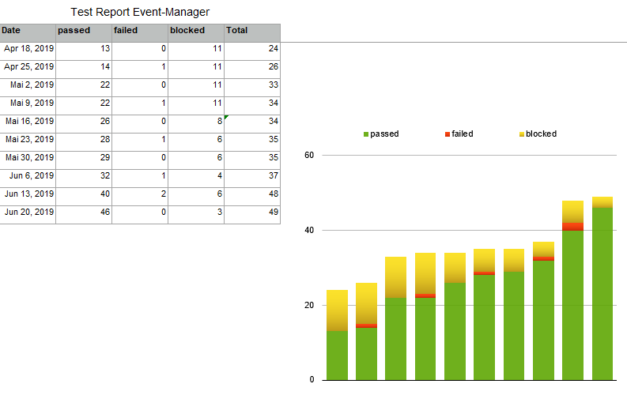

# 0.5 Open Issue

When the login failed the front-end just handle the error by console. As well at the registration.

After the registration the user doesn’t get a token from the backend. That’s why the user has to logout then login to get the right token.

An event cannot be deleted or edited by an user.