

Project proposal

BauX (Version 0.1)

HTBLA Leonding

|  |  |
| --- | --- |
| **Project name** | BauX |
| **Project leader** | Pero Djukic |
| **Responsible** | Executive |
| **Created on** | Java, Android and XHTML |
| **Last changed** | 02/10/2018 09:15 |
| **Processing status** | |  |  | | --- | --- | | X | in process | |  | Submitted | |  | Completed | |
| **Document file** |  |
| **V-Modell-XT Version** |  |

Contents

1., Initial Situation 3

3., General Conditions and Constraints 4

4., Project Objectives and System Concepts 5

5., Opportunities and Risks 6

6., Planning 7

1., Initial Situation

In a construction company there is as well as in any other company a leader. Under the leader there are subordinate foremen (those people who manage the construction site) and under them in turn foremen, who also have a few subordinate workers and unskilled workers among them. Together these foremen and their workers form so-called batches.

Graphic of the organizational plan:

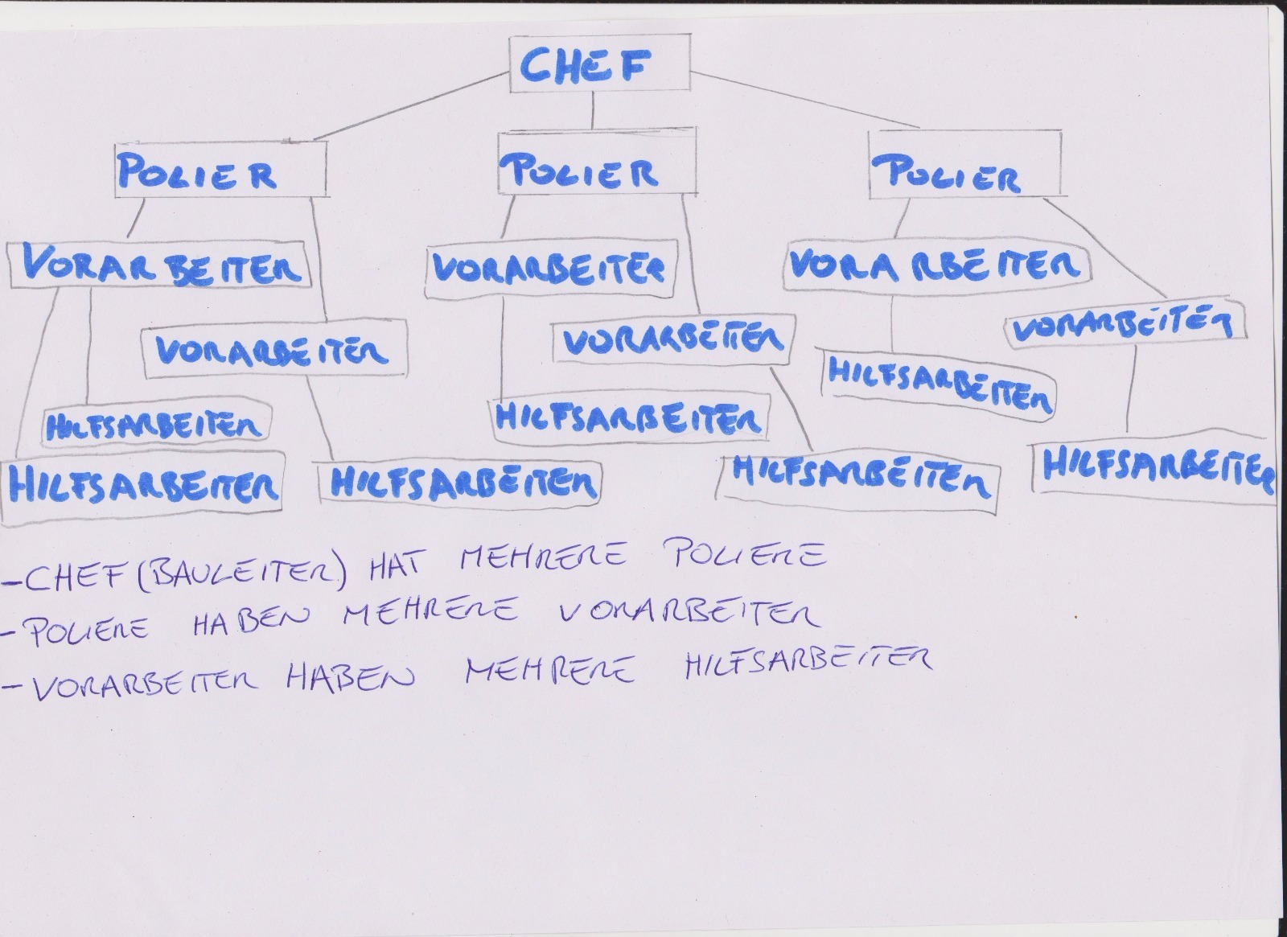

However, a single leader cannot check all the foremen, let alone all the employees of a company at the same time and see whether they are on the construction site. Especially not with the conventional way of driving the company car individually from construction site to construction site. Thus the workers could leave the building site early and dedicate themselves to other activities or not come at all to the building site, which could come to the company to costs.

2., General Conditions and Constraints

* The application is multi-language capable (English and German)
* The GUI of the App should be user-friendly
* The design should be as nice as possible.

3., Project Objectives and System Concepts

Our Concept:

We would like to create an app that allows a construction worker to log on to a mobile device at a construction site and then he can be located by GPS.

You always know if someone is on site, how long and where.

The operability and the costs should remain manageable.

Our app should also be constantly improved and kept up to date.

4., Opportunities and Risks

BauX has the following Opportunities:

* They can easily count the hours of the workers.
* They can better control the building site.
* They can locate the worker easily.
* The easy check-in saves a lot of time.

Risks:

* It can happen that the GPS has a problem.
* The internet-connection can be too weak or just be not available.
* The worker can forget to click on the button, when they come back to work.
* A worker could manipulate the GPS or his working time.

5., Planning

Milestones:

* 19.10.2018 Project Proposal
* 20.11.2018 First Website
* 27.11.2018 First concept for the Android-App

Project leader:

Djukic Pero

Programmer:

Hamzic Armin

Taha Amin