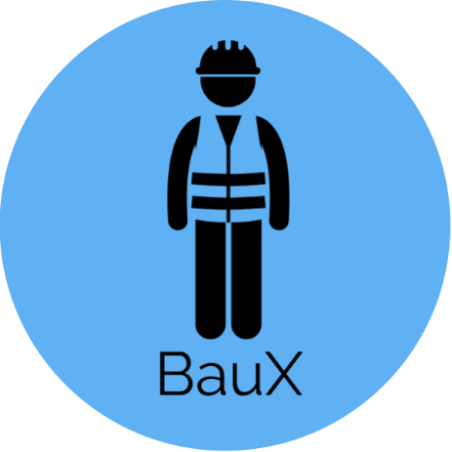

Project proposal

BauX (Version 0.1)

HTBLA Leonding

|  |  |
| --- | --- |
| **Project name** | BauX |
| **Project leader** | Pero Djukic |
| **Responsible** | Executive |
| **Created on** | Java, Android and XHTML |
| **Last changed** | 18/11/2018 10:15 |
| **Processing status** | |  |  | | --- | --- | | X | in process | |  | Submitted | |  | Completed | |
| **Document file** |  |
| **V-Modell-XT Version** |  |

Contents

1. Introduction 2

2. Initial Situation 3 & 4

3. General Conditions and Constraints 5

4. Project Objectives and System Concepts 6

5. Opportunities and Risks 7

6. Planning 8

1. Introduction

Baux represents a modern method for monitoring the employees of a construction company on a construction site. The location of these employees is sent to a website created by us (which acts as an admin area) and gets controlled by the respective site manager of the construction site or the leader of the company.

Baux also supports, counting working hours of the employees and sends them to the website, where they can be used for further processing.

2. Initial Situation

In a construction company there is as well as in any other company a leader. Under the leader there are subordinate foremen (those people who manage the construction site) and under them in turn foremen, who also have a few subordinate workers and unskilled workers among them. Together these foremen and their workers form so-called batches.

Graphic of the organizational plan:

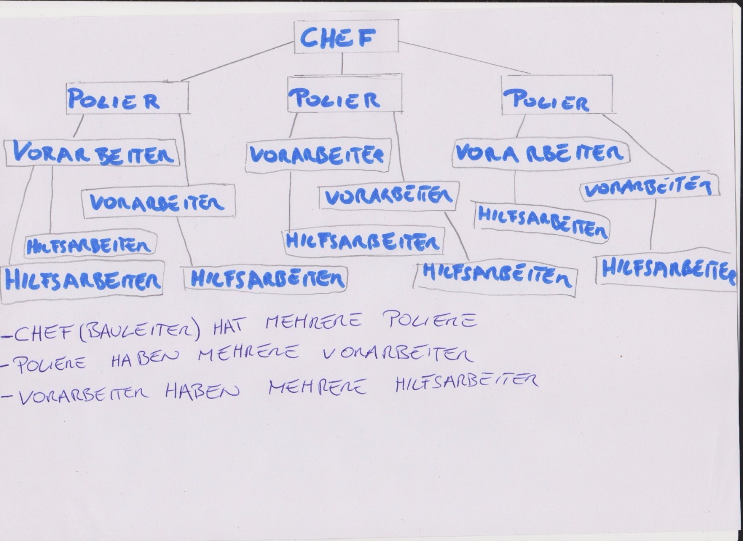

However, a single leader cannot check all the foremen, let alone all the employees of a company at the same time and see whether they are on the construction site.

Especially not with the conventional way, of driving the company car from construction site to construction site. Thus the workers could leave the building site earlier and do other things or don't come to the construction site at all, which could come to the company to costs.

In addition, the current method of recording employees' working hours on timesheets is impractical, because a foreman is likely to have more important tasks to perform than paperwork. Likewise, individual timesheets of some employees could be lost in the chaos on the construction site, which in the worst case could lead to, that the worker loses parts of his wages.

3. General Conditions and Constraints

It is important for our app that the UI is user-friendly and as easy as possible to use. Since our contact group are workers on the construction site who are usually not so technically gifted, they shouldn't spend too much time to bother with the app. Therefore we would make our design as simple as possible so that the worker can operate and close the app in a few seconds.

It is important for our app that workers can also operate it with work gloves.

A constant good internet connection is also important and one of the biggest challenges. You don't have them everywhere, if you have construction sites in more rural areas or workers working in tunnels or underground.

The battery consumption should also not be too high even if you need a permanent Internet and GPS connection.

The app is written in Android, for the website we use HTML and for the database SQL.

4. Project Objectives and System Concepts

***Our Concept:***

We want to develop an app (including a website) that allows construction workers to log in with their mobile device while they are at a construction site.

After the check-in they are GPS-located (and the working time starts counting), so it is always known if someone is on site, how long and where.

This information will be sent to the website, which is managed by selected employees (mostly office staff).

The website also counts the worked hours in total e.g. to save overtime hours.

Construction workers should also be able to access the website in order to see their worked hours.

In order to prevent construction workers from moving too far away from the construction site, a certain area is defined.

If a construction worker leaves this area, the construction manager will be notified and then can send a message to this construction worker.

To get access to the app, there will be no accounts, instead the PhoneID will be checked for permissions (in the database).

This should prevent unauthorized people from using the app or prevent misuse.

In case of a phone change this can be requested and changed in the database.

The operability and the costs should remain manageable.

Our app should also be constantly improved and kept up to date.

5. Opportunities and Risks

BauX has the following Opportunities:

* The worked hours of the workers can be counted easily.
* The building site can be controlled better and more easily.
* The workers can be located without much effort.
* Depending on the size of the company, a lot of money and time can be saved.

BauX has the following Risks:

* It can happen that the GPS has a problem.
* The internet-connection can be too weak or just be not available.
* A worker could forget to log back in/out when he gets back to work/home.
* A worker could manipulate the GPS or his working time/ worked hours.
* Unauthorized persons can gain access despite the security precautions.
* The phone may could not be operated due to gloves.
* The phone could break down in a sudden accident.
* The battery of the phone may be faulty or empty.

6. Planning

**Milestones:**

|  |  |
| --- | --- |
| 19.10.2018 | First version of the Project Proposal finished. |
| 18.11.2018 | Final version of the Project Proposal finished. |
| xx.xx.2019 | First version of the website finished. |
| xx.xx.2019 | First version of the app finished. |
| xx.xx.2019 | Database finished. |
| xx.xx.2019 | Final version of the website finished |
| xx.xx.2019 | Final version of the app finished. |
| xx.xx.2019 | Ready to present the project. |

**Project leader:**

|  |  |
| --- | --- |
| Djukic Pero | Website and Database |

**Programmer:**

|  |  |
| --- | --- |
| Hamzic Armin | App-Developer |
| Taha Amin | Website and Database |