System specification

BauX (Version 0.1)

|  |  |
| --- | --- |
| **Project name** | BauX |
| **Project leader** | Pero Djukic |
| **Responsible** | Executive |
| **Created on** | Java, Android and XHTML |
| **Last changed** | 18/11/2018 10:15 |
| **Processing status** | |  |  | | --- | --- | | X | in process | |  | Submitted | |  | Completed | |
| **Document file** |  |

HTBLA Leonding

Contents

1. Initial Situation and Goal 2 - 7

2. Functional Requirements 8 - 10

3. Non-functional Requirements 11

4. Quantity Structure 12

1. Initial Situation and Goal

1.1 Initial Situation

In a construction company there is as well as in any other company a leader. Under the leader there are subordinate foremen (those people who manage the construction site) and under them in turn foremen, who also have a few subordinate workers and unskilled workers among them. Together these foremen and their workers form so-called batches.

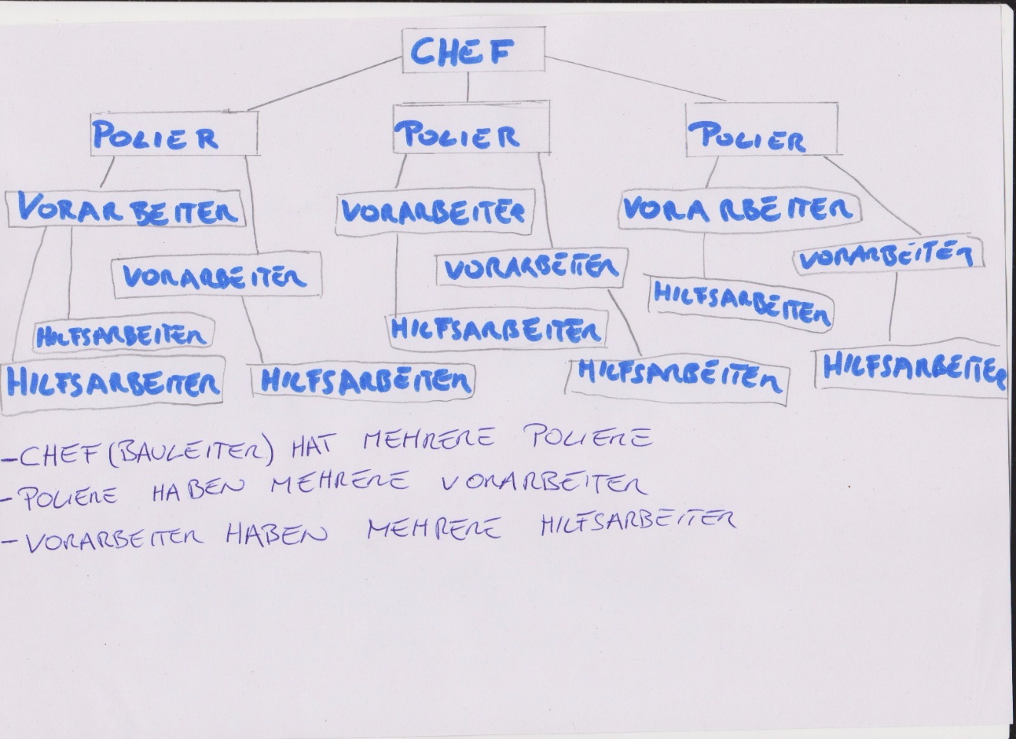Graphic of the organizational plan:

However, a single leader cannot check all the foremen, let alone all the employees of a company at the same time and see whether they are on the construction site.

Especially not with the conventional way, of driving the company car from construction site to construction site. Thus the workers could leave the building site earlier and do other things or don't come to the construction site at all, which could come to the company to costs.

In addition, the current method of recording employees' working hours on timesheets is impractical, because a foreman is likely to have more important tasks to perform than paperwork. Likewise, individual timesheets of some employees could be lost in the chaos on the construction site, which in the worst case could lead to, that the worker loses parts of his wages.

1.1.1 Application Domain

A batch is approaching their construciton site in the early morning. The foreman writes everybody down who will work on the constuction site on this day.

Then the work starts.

Shortly before the end of the working day, the formen enter his own little office (mostly a small container) and files an entry in a form holding working hours for the whole batch. A so called timesheet. Every worker has his own timesheet every week. (A 10 percent bonus is charged when you work on the scaffold)

An example of a timesheet:

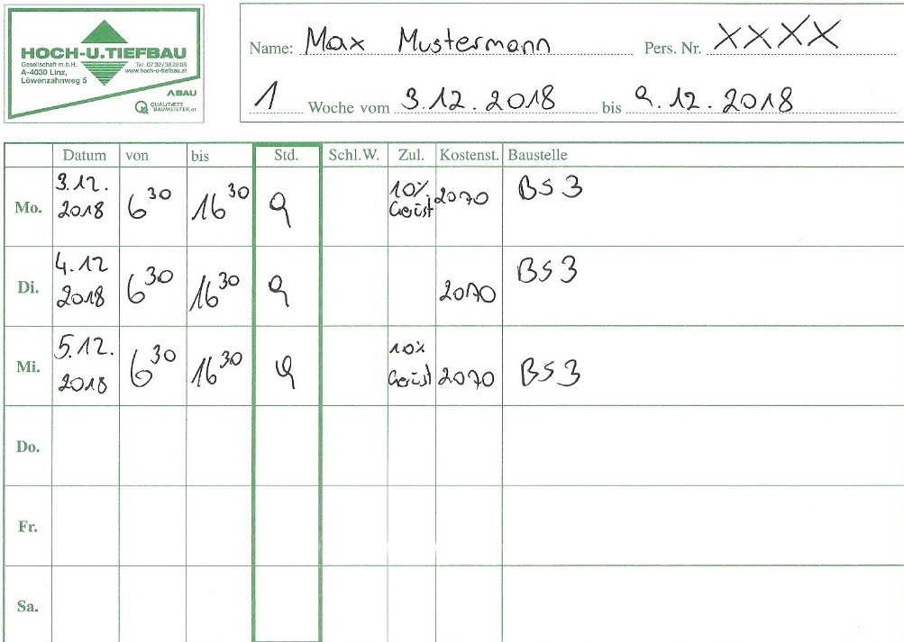

He also writes a work report which states on which construction site work has been done, what temperature and weather conditions have prevailed, where exactly what work has been done and which machines have been used. The names of the workers and their working hours can also be found on this report.

An example of a work report:

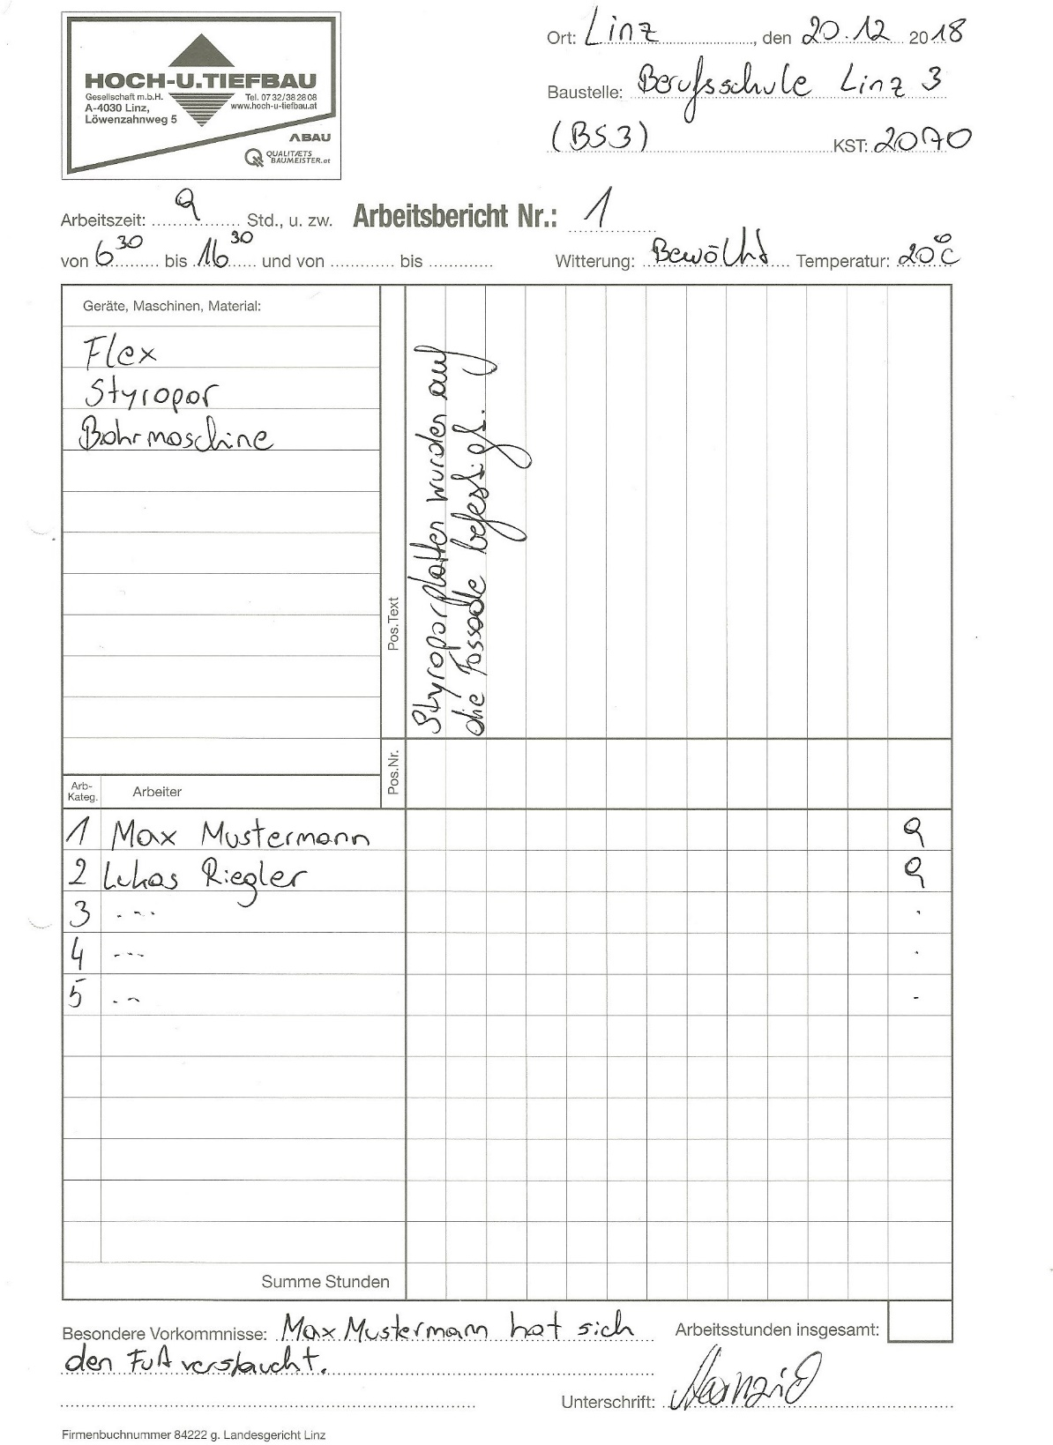

1.1.2 Glossary

A note, that says who will be working on the construction site that day.

Timesheets, that record the working hours of the respective worker.

A workreport, that states the done work and some other things.

1.1.3 Model of the Application Domain

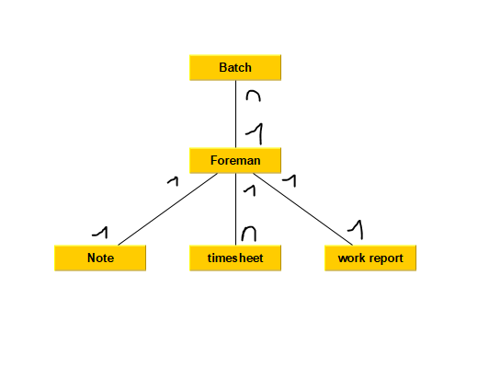

1.1.4 Overview and Description of the Business Processes

Use case Business Process (1):

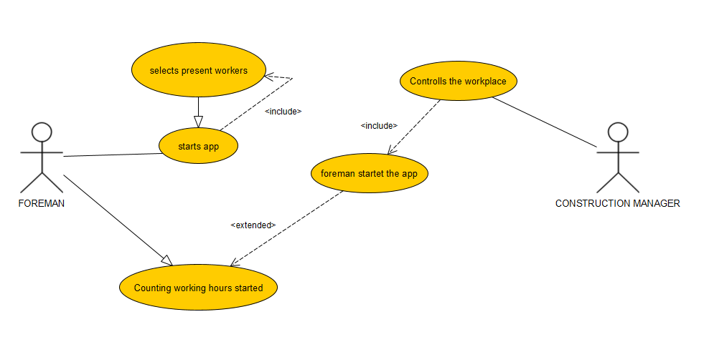

Description of Use case Business Process (1):

The foreman starts the app and selects all workers who are on the construction site. Now the responsible construction manager can see, who is working at the construction site. Working hours will be counted, when the foreman starts the app. At the end of the day the foreman can enter the final working hours for each worker in the app.

Use case Business Process (2):

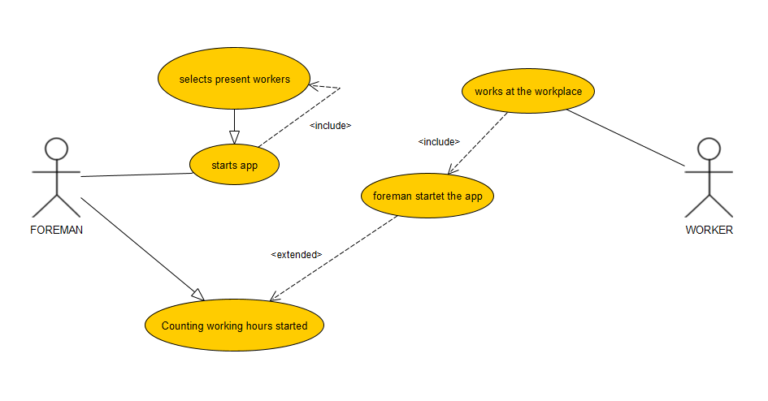

Description of Use case Business Process (2):

The foreman starts the app and selects all workers who are on the construction site. At this moment the working hours will be counted and the workers and unskilled workers can start to work on the construction site. At the end of the day the foreman can enter the final working hours for each worker in the app.

1.2 Goal Definition

Trivially explained, this project is intended to help site managers, foremen, workers and unskilled workers to make the daily life on the construction site easier. This includes, above all, replacing old-fashioned paperwork with a new, flexible and easy to use app. This should not only help the foreman to save time while filling out the time sheets and the work report, it should also eliminate the risk, to lose important papers.

In order to use the app you don't need to be an expert in software engineering, you just need to have the knowledge as a foreman that you already had before and a general knowledge about using a smartphone.

The main target group of our app are the foremen of a construction company and their respective batches.

1. Functional Requirements

2.1 Use Case Timesheet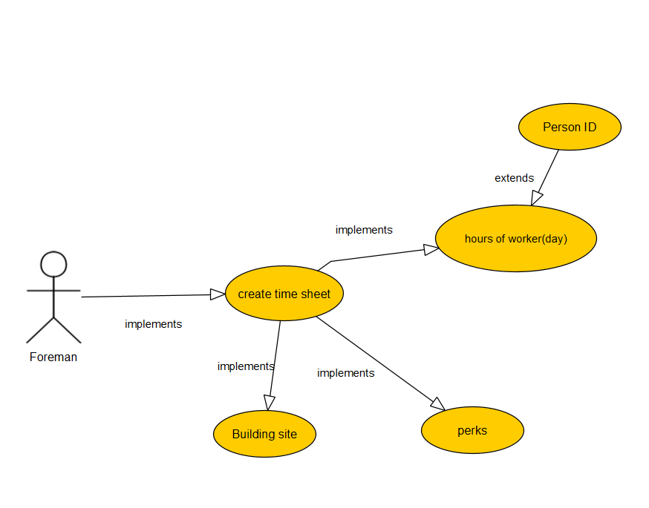

2.2 Use Case Timesheet Details

The foreman makes a time sheet.

This timesheet is used for one week.

This time sheet contains the construction site, on which day and for how long the worker was present at the construction site.

Bonuses and other factors are also on this page.

Note: Every worker has a new time sheet every week.

2.3 Use Case Team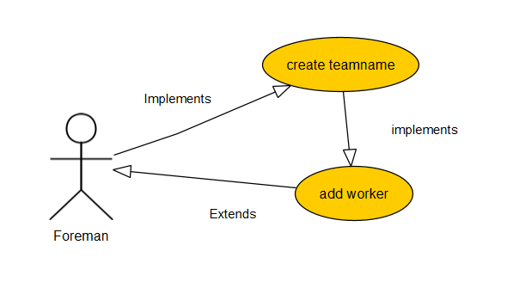

2.4 Use Case Team Details

The foreman creates individual teams and can assign workers to them.

This enables easier coordination on the construction site.

2.5 Use Case Work Report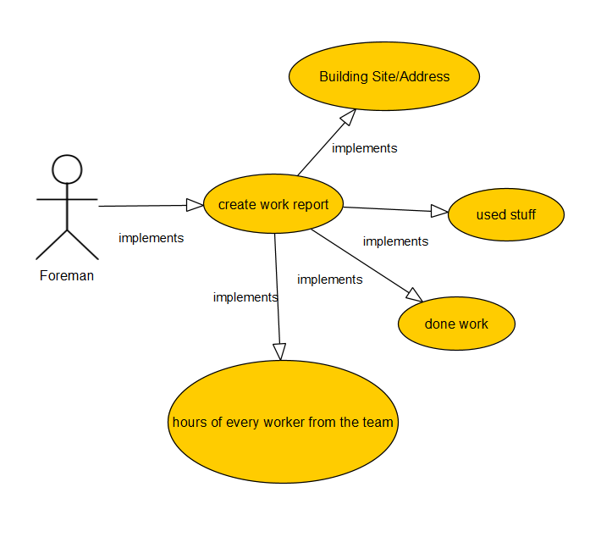

2.6 Use Case Work Report Details

The foreman will draw up a work report.

This work report describes the construction site and the day.

The number of hours worked and the work done are given.

Other factors such as which equipment was used, the weather etc. are also recorded.

If there has been a certain incident can be described.

1. Non-functional Requirements

|  |  |
| --- | --- |
| ID: | NFR_001 |
| NAME: | Data volume |
| TYPE: | EFFIC |
| DESCRIPTION: | The app should be designed so that it can be operated even with a very slow Internet connection and therefore requires little data. |

|  |  |
| --- | --- |
| ID: | NFR_002 |
| NAME: | Battery efficiency |
| TYPE: | EEFIC |
| DESCRIPTION: | The app should avoid unnecessary processes in order to be able to work as efficiently as possible and to conserve battery power. |

|  |  |
| --- | --- |
| ID: | NFR_003 |
| NAME: | Start time |
| TYPE: | EFFIC |
| DESCRIPTION: | The app should be ready to use within a few seconds after opening, after logging in it should not take long until full functionality is reached. |

|  |  |
| --- | --- |
| ID: | NFR_004 |
| NAME: | Glove operability |
| TYPE: | USE |
| DESCRIPTION: | The buttons should possibly be large enough to be operated with gloves. |

1. Quantity Structure

4.1 System Architecture and Interfaces

4.2 Acceptance Criteria

AC_001 Create a Team

|  |  |  |
| --- | --- | --- |
| Test Step | Expected Behaviour | Reality |
| Foreman creates a team and adds workers. | The team with the workers will be created. |  |

AC_002 Create a Timesheet

|  |  |  |
| --- | --- | --- |
| Test Step | Expected Behaviour | Reality |
| Foreman creates a timesheet for a worker. | The timesheet will be created and be fillable. |  |

AC_003 Create a Work Report

|  |  |  |
| --- | --- | --- |
| Test Step | Expected Behaviour | Reality |
| Foreman creates a work report for a working day. | The work report will be created and be fillable. |  |