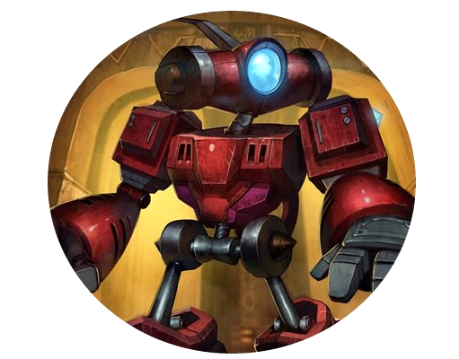

**- Requirements and Analyses: Project Proposal -**

Robo Jump

**Version:** 1.0

|  |  |
| --- | --- |
| **Project name** | AhPrSt |
| **Project leader** | Ahammer Fabian |
| **Responsible** | Executive |
| **Created on** | 22.09.2017 |
| **Last changed** | 01.11.2017 |
| **Processing status** | |  |  | | --- | --- | |  | in process | |  | submitted | |  | completed | |
| **Document file** | Robo Jump |
| **Robo Jump Version** | 1.0 |

**Further Product Information**

|  |  |
| --- | --- |
| **Participating** | Ahammer Fabian, Prieschl Fabian, Steyrer Christian |
| **Creation** | Initial Extern |

**Change Listing**

|  |  |  |  |  |  |  |  |  |  |  |  |  |
| --- | --- | --- | --- | --- | --- | --- | --- | --- | --- | --- | --- | --- |
| |  |  |  | | --- | --- | --- | | **Change** | | | | **No** | **Date** | **Version** | | | | **Changed Chapters** | **Description of changes** | **Author** | **State** |
| 1 | 22.09.2017 | 1.0 | all | Initial document creation | AhPrSt | completed |

**Test Listing**

The following table shows an overview of all tests – both self-tests as well as tests by inde-pended quality assurance – for the present document.

|  |  |  |  |  |
| --- | --- | --- | --- | --- |
| **Date** | **Tested Version** | **Notes** | **Inspector** | **New Product Status** |
|  |  |  |  |  |

**Content**

1 Introduction 4

2 Initial Situation 5

3 General Conditions and Constraints 6

4 Project Objectives and System Concepts 7

5 Opportunities and Risks 8

6 Planning 9

7 Economic Efficiency 10

8 List of Abbreviations 11

9 List of Literature 12

10 List of Figures 13

**Introduction**

The game “Robo Jump” is a 2D Jump and run simulator without much disadvantages from other 2D Jump and runs, we decided to use this game as a school intern project because we love casual games and we really think it will be an outstanding Achievement for us in terms of programming.  
Furthermore there is a very huge market for casual games as well.  
The development of this program is mainly for people which are bored in breaks and need a small game to enjoy their time with fast playable levels.  
Last but not least it is a great opportunity for our team to deepen the knowledge in other parts of programming asides from the “standard” which is given in school lessons.  
This is made possible by working with Unity Studio.

**Initial Situation**

There are many jump and run games on the market, but in most cases, the player has to invest a lot of time to achieve something.

The most games have a huge disadvantage in the time aspect, the levels often have a playing time of 30 minutes.

Robo Jump will have the advantage that the levels are playable in under 5 minutes and with that it is perfect for casual gamers which loves to play in breaks and in short waiting times.

**Screenshot of the first Prototype level:**

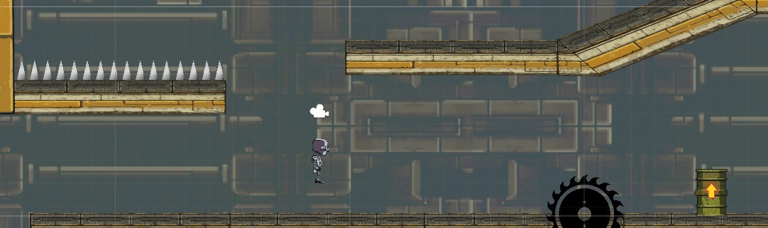

**General Conditions and Constraints**

* *The game will be done in Unity3d Engine because it uses C# for scripting and we have been learning C# for the last 2 years.*
* *The game will be available for Windows 7+*, so people without the newest operating system can enjoy our game as well
* *The game language is English to reach the international game market and to avoid the translation work.*
* *The game development does not cost much because we only use free tools and we try to use as many free assets as possible.*

**Project Objectives and System Concepts**

* *There will be enemies like defence towers, … which the player can fight against and if he succeeds he will earn coins.*
* *Obstacles like spikes, laser-traps which the player needs to bypass*
* *If the player dies he will respawn at the level begin and lose all the collected coins.*
* *Power-Ups which are obtainable via the shop using the earned coins from the levels.*
* *There will be around 25 levels which are oriented by a futuristic theme and a menu to access these.*
* *The levels are not easy to complete but the time to reach the goal is quite low.*
* *There will be statistics with the players deaths, collected coins, time*
* *To win the game the player need to guide the robo-character through the level to the end with the help of certain Power-Ups and finally fight against a boss enemy.*

**Opportunities and Risks**

* Potential customers are students which play games in breaks and people who want to kill waiting time on for example a short bus ride.
* It would be a possibility to release the game on an online gaming platform such as Steam.
* There is the risk that the game will not accepted at these online gaming platforms
* The game could be used as an example to show what is possible with the things learned in school.

**Planning**

* Stuff we need for the game are Game-Assets (Textures, Music, Sounds)
* Big blocks of work would be the shop system and to create the *enemies, obstacles.*
* Project start: After the professor accepts the proposal and project
* Project end: 2nd week of June
* Implementation start: At the project start

**Milestones:**

|  |  |
| --- | --- |
| 15.12.2017 | First obstacles and enemies implemented |
| 30.12.2017 | Prototype finished |
| 15.01.2018 | Shop implemented |
| 25.01.2018 | Main menu implemented |
| 28.01.2018 | Statistics menu implemented |
| 10.02.2018 | First level layouted |
| 20.02.2018 | First level fully playable |

**List of Abbreviations**

|  |  |
| --- | --- |
| **Abbreviation** | **Explanation** |
|  |  |

**List of Literature**

**List of Figures**