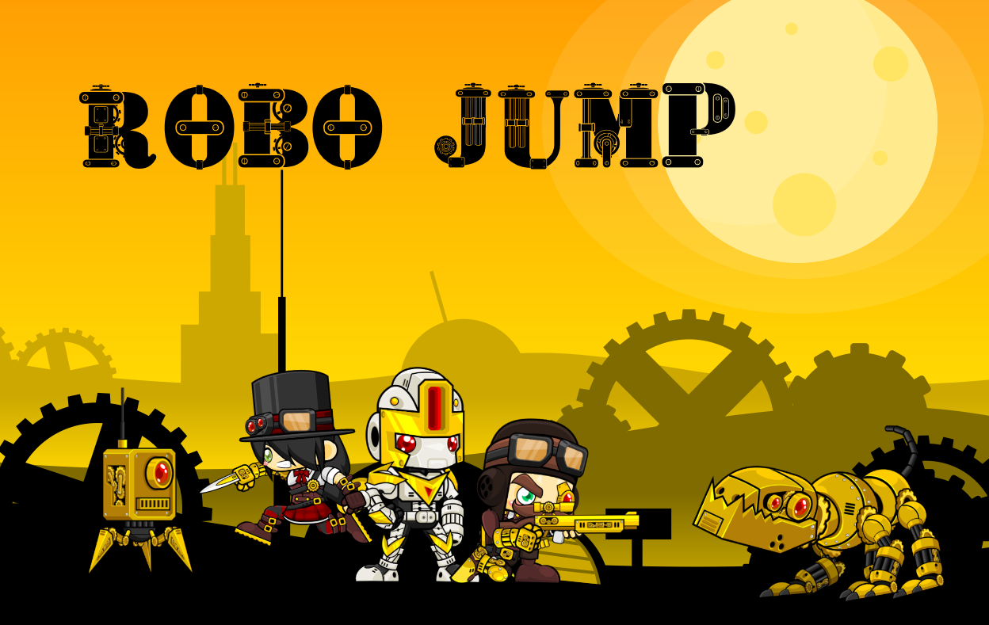

RoboJump – System Specification

Project Name | AhPrSt
Project Manager | Fabian Ahammer
Document Owner | Christian Steyrer
Created on
Last modified | 04.02.2018
State | X in Work  vorgelegt  Released
Dokumentablage | 0000.doc

Content
1 Initial Situation and Goal 3
1.1.1 Initial Situation 3
1.1.2 Application Domain 3
1.1.3 Glossary 4
1.1.4 Model of the Application Domain 4
1.1.5 Goal Definition 4
2 Functional Requirements 5
2.1.1 Use Case Diagram 5
2.1.2 Use Case Details 6
2.1.2.1 Use Case ID 1 (Play the game) 6
2.1.2.2 Use Case ID 2 (Select a level) 8
2.1.2.3 Use Case ID 3 (Pause level) 11
2.1.2.4 Use Case ID 4 (Leave Game) 12
2.1.2.5 Use Case ID 5 (Change settings) 13
2.1.2.6 Use Case ID 6 (Change controls) 14
3 Non-functional Requirements 15
4 Quantity Structure 16
5 System Architecture and Interfaces 17
6 Acceptance Criteria 18

Initial Situation and Goal

Initial Situation

There are many jump and run games on the market, but in most cases, the player must invest a lot of time to achieve something.
Most games have a huge disadvantage in the time aspect, the levels often have a playing time of 15-30 minutes.
Game: | Average time for a level: | Platforms:
Donkey Kong | 10 minutes | Nintendo platforms
Super Mario Galaxy | 35 minutes | Nintendo Wii
Shovel Knight | 15 minutes | Nintendo  (3DS, WiiU , Switch) PlayStation (3, 4)  Xbox One,  Fire OS,  Windows, macOS, Linux
New Super Mario Bros. | 6,6 minutes | Nintendo Wii, WiiU

All these Games have an average playing time over 10 minutes, expect Super Mario Bros. but that is only available on Nintendo platforms.
Robo Jump will be oriented on some of these games and tries to take the positive aspect and to improve the negative ones.
An important aspect is that the game is available to most people, therefore it will be mainly available to PC and not to consoles.

So Robo Jump will have the advantage that the levels are playable in under 5 minutes and with that it is perfect for casual gamers which love to play in breaks and in short waiting times.

Application Domain

Robo Jump is mainly for students, which sometimes play some games in breaks.
Commonly these breaks are around 5-15 minutes so it highly important that that the levels have low playing times around 2-3 minutes.

Glossary

Model of the Application Domain
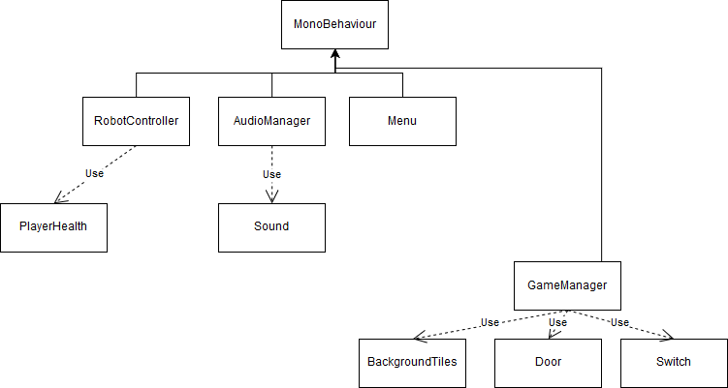

Goal Definition

Our goal is to create a game which someone can use to kill waiting times or breaks, so the playing time should be reduced to 2-3 minutes per level.
When finished it will be published as a Unity game for Windows and possibly later for Mac OS and Linux.
The game should be relatively easy to use as it will contain a short tutorial and user-friendly and known controls.

Functional Requirements

Use Case Diagram

Overview of all use cases in a use case diagram:

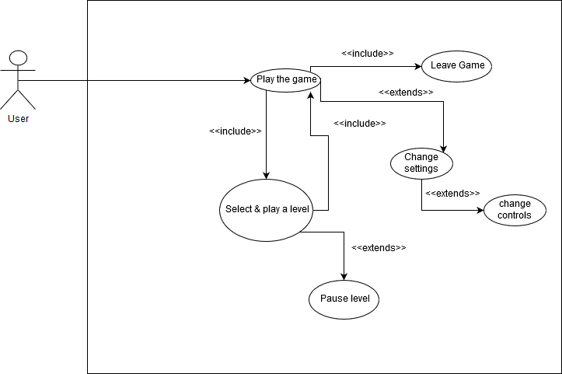

Use Case Details

Use Case ID 1 (Play the game)

From the Main Menu the player calls the other use cases.

Main Menu:

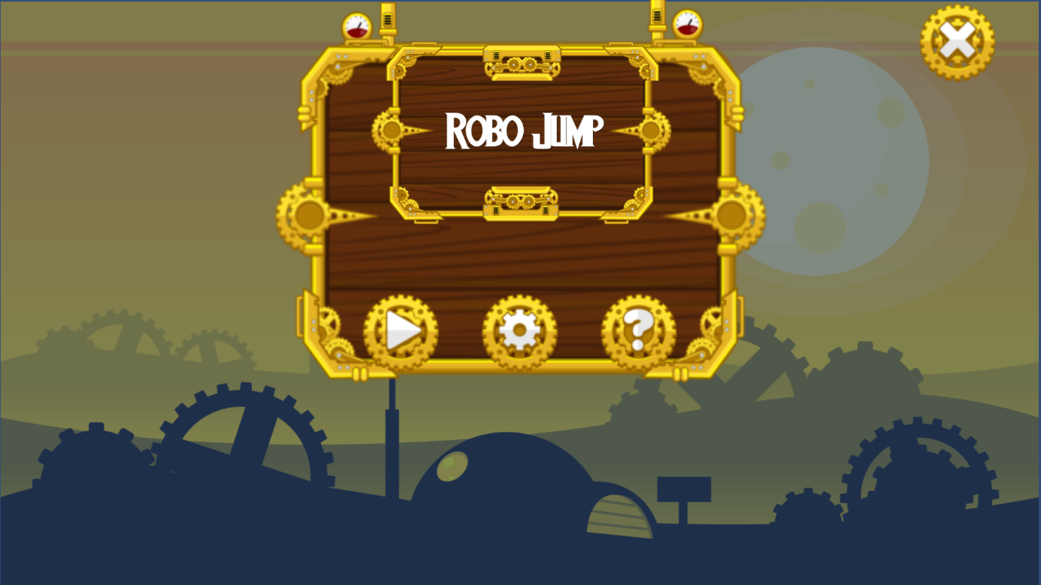

Input field | Calls
Play button | Use Case 2
Settings button | Use Case 5
Exit button | Use Case 4

Characteristic Information:

Goal: | This is the central Use Case which simply say that the player currently uses the program.
Precondition: | The condition for this Use Case is that the game does not run currently.
Postcondition: | When this Use Case will be executed the player is in the main menu
Involved User: | Role name: “Player”
Triggering Event: | The Use Case will be executed when the program is started.

Standard scenario:

Step | User | Activity
1 | Player | choose game in menu
2 | System | starts the game
3 | Game | shows the main menu

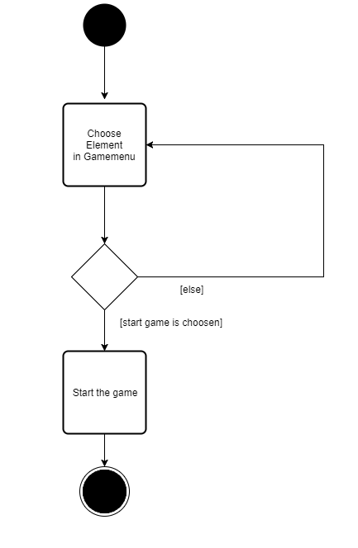

Use Case ID 2 (Select & play a level)

To play the game the player needs to select and play a level.
GUI to call the use case:
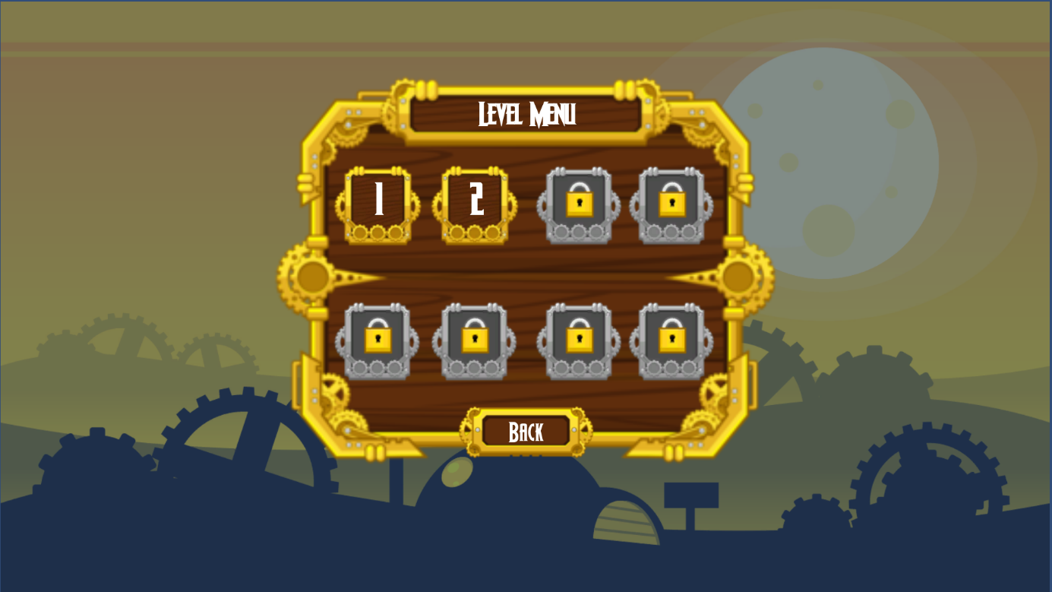

Characteristic Information:

Goal: | The goal of this Use Case is to give the player information on his progress and to get the information which level he wants to play.
Precondition: | The condition for this Use Case is that the player is currently in the main menu.
Postcondition: | When this Use Case will be executed the player is at the level start from the chosen level.
Involved User: | Role name: “Player”
Triggering Event: | The Use Case will be executed when the player enters the level menu and then start and play a level.

Standard scenario:

Step | User | Activity
1 | Player | choose level in menu
2 | Game | starts the level
3 | Player | find and activate switches
4 | Game | opens the door (level goal) if all switches are activated

Workflow of the levels:

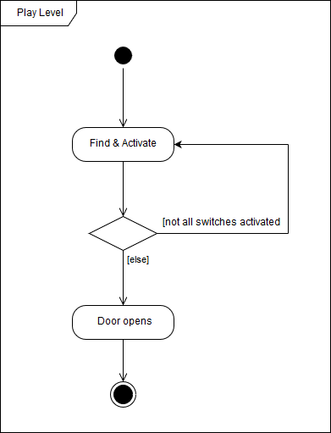

Screenshot of the first level:

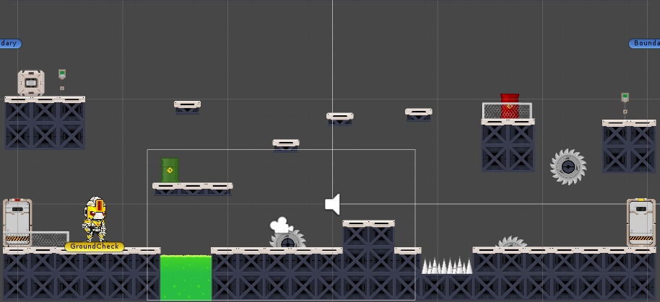

Use Case ID 3 (Pause level)

While playing a level the player has the possibility to pause it.

Characteristic Information:

Use Case ID 3:
Goal: | The goal of this Use Case is that the player has the possibility to freeze the game actions, so that he can continue after a break.
Precondition: | The condition for this Use Case is that the player currently plays a level
Postcondition: | When this Use Case will be executed the level pause, this means that all actions freeze.
Involved User: | Role name: “Player”
Triggering Event: | The Use Case will be executed when the player hits the “ESC”-button.

Standard scenario:

Step | User | Activity
1 | Player | hit “ESC”-button
2 | Game | freeze the level
3 | Game | open pause menu
4 | Player | hit “ESC”-button again
5 | Game | unfreeze the level

Use Case ID 4 (Leave Game)

The game can be leaved every time during playing.

Characteristic Information:

Goal: | The goal of this Use Case is to leave the game.
Precondition: | The condition for this Use Case is that the game currently runs.
Postcondition: | When this Use Case will be executed the game saves and then close the program.
Involved User: | Role name: “Player”
Triggering Event: | The Use Case will be executed when the player hits the “Exit”-button.

Standard scenario:

Step | User | Activity
1 | Player | hit “Exit”
2 | Game | Save data
3 | System | Close game

Use Case ID 5 (Change settings)

It is possible to change the settings.
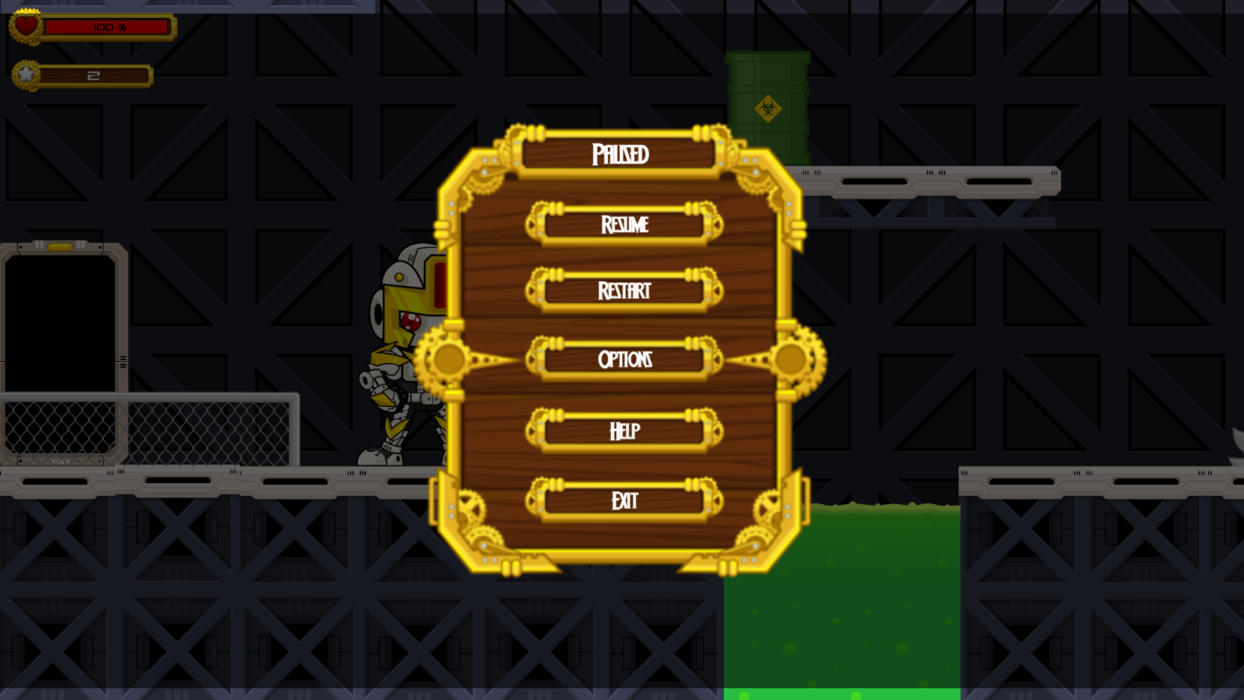
GUI to call the use case:

Characteristic Information:

Goal: | The goal of the Use Case is to change settings.
Precondition: | The condition for this Use Case is that the player is currently in the main or pause (ESC) menu.
Postcondition: | When this Use Case will be executed the player will have the possibility to change game.
Involved User: | Role name: “Player”
Triggering Event: | The Use Case will be executed when the player hits the settings button.

Standard scenario:

Step | User | Activity
1 | Player | hit “options”-button
2 | Game | open options

Use Case ID 6 (Change controls)

In the settings it is possible to change controls
GUI to call the use case:
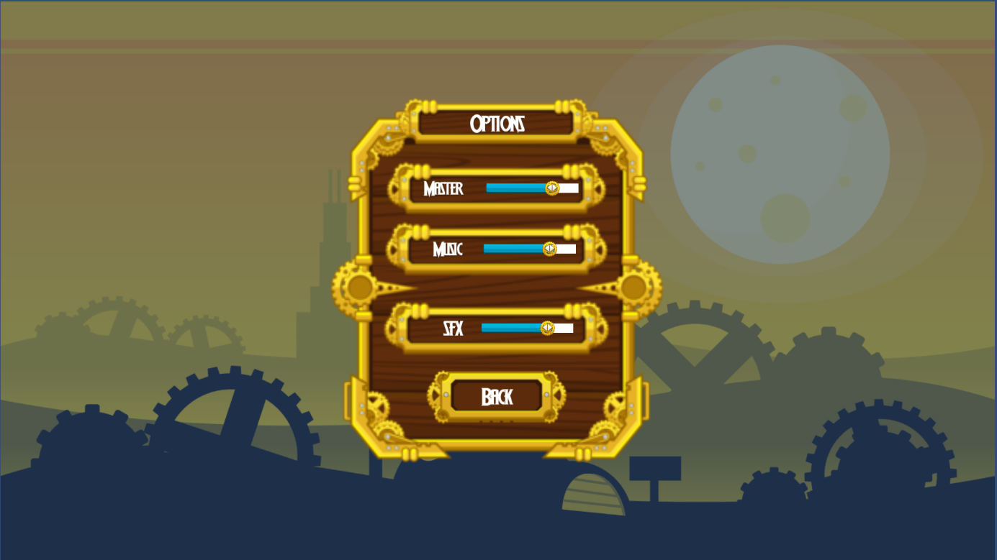

Characteristic Information:

Goal: | The goal of this Use Case is to change game controls.
Precondition: | The condition for this Use Case is that the player needs to be in the settings menu.
Postcondition: | When this Use Case will be executed the game-controls could be on other values.
Involved User: | Role name: “Player”
Triggering Event: | The Use Case will be executed when the player changes the sliders positions.

Standard scenario:

Step | User | Activity
1 | Player | change position of sliders
2 | Game | change game-controls

Non-functional Requirements

Type USE: Usability requirement
To make Robo Jump as useable as possible it must guarantee some criteria.
- The game should not require more than 1 GB memory.
- The levels of the game should not have a long loading time because nobody will wait more than about 5 seconds.
- The appearance should be oriented on other games, so players do not have to spend a lot of time on learning game irrelevant controls.

Type EFFIC: Efficiency requirement
As before mentioned in the usability requirements the game levels must load in 5 seconds.

Type MAINT: Maintenance and portability requirements
As it is planned to translate the game to German when it is finished it should be
especially maintainable at this. Eventually it will be available on other platforms, so the controls should be capable to handle other input methods.

Type SEC: Security requirement
As Robo Jump does not use online services and it is not planned to add online features in the future, it is not required to be the best secured program.

Type LEGAL: Legal requirement
Laws or standards, which could be important, are not known yet.

Quantity Structure

The main data of Robo Jump will be the game assets for each level.

Conclusion
We expect that the total size of Robo Jump will be around 1 GB disk space.

System Architecture and Interfaces

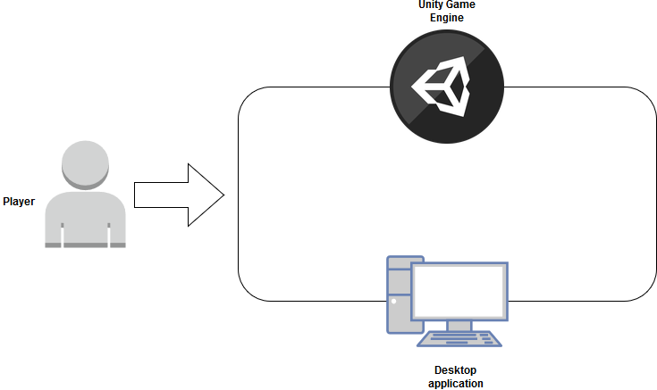

The Unity Game Engine is a main part of the system, it powers the Desktop
application which is finally used by the player to play the game.

Acceptance Criteria

Use case 1
Test Step | Expected Behaviour
Start game | Main menu should be shown

Use case 2
Test Step | Expected Behaviour
Load levels | All levels can be loaded
Play levels | All levels are playable

Use case 3
Test Step | Expected Behaviour
Pause level | Level should be freezed

Use case 4
Test Step | Expected Behaviour
Close game | Game should save the current state

Use case 5
Test Step | Expected Behaviour
Open settings menu | All available settings should be shown

Use case 6
Test Step | Expected Behaviour
Change controls | Game should recognize and change  settings

