
- Requirements and Analyses: Project Proposal -
Retro Racers Reloaded
Version: 0.1

Project name | Retro Racers Reloaded
Project leader | Weinberger David
Responsible | Executive
Created on | 26.09.17
Last changed | 26.09.17 8:45
Processing status
  X | in process
   | Submitted
   | Completed
Document file
V-Modell-XT Version | 1.3

Further Product Information
Participating | Jany Elias
Creation | Initial Extern
Change Listing
 |  |  | Changed Chapters | Description of changes | Author | State
  Change
  No | Date | Version
1 |  | 0.1 | all | Initial product creation
Test Listing
The following table shows an overview of all tests – both self-tests as well as tests by inde-pended quality assurance – for the present document.

Date | Tested Version | Notes | Inspector | New Product Status

Content
1 Introduction 4
2 Initial Situation 5
3 General Conditions and Constraints 6
4 Project Objectives and System Concepts 7
5 Opportunities and Risks 8
6 Planning 9
7 Economic Efficiency 10
8 List of Abbreviations 11
9 List of Literature 12
10 List of Figures 13

- Introduction

Einordnung des Dokuments

The management bases the decision to approve a project within the scope of a Project Progress Decision of the Decision Gate Project Approved on the project proposal, which is not prepared within the framework of the V-Model. Based on a project or system idea, the acquirer systematically describes the necessity of a project based on feasibility, affordability, market, and economic efficiency criteria. The project proposal processes subjects like the initial situation, existing framework conditions, project objectives and system concepts, chances and risks, and the economic efficiency.
All written text in this color is explanatory and has to be deleted when the document is released. The example given here is only a skeleton. Your text has to be more elaborate and explanatory.
[Insert your text here...]

- Initial Situation
The initial situation presents the assessment of the actual situation of an organizational unit or the entire organization of an agency or company. Thus a need for action, which may lead to a product or system vision, is recognizable. The vision may be developed into a project idea. The need for action may be initiated by several project or system ideas.
The demonstration of capability gaps (i.e. the difference between the necessary planned capabilities and the actually existing capabilities) in a company or agency may clearly show an urgent need for action in order to increase the efficiency or reduce costs. This need for action is presented as product or system idea, leading frequently to a concrete project proposal. Corresponsingly, the determination of the requirement to renew or improve a "technically obsolete" system (so-called "system regeneration") or the recognition of market chances for a new product or system may lead to a project idea. The applicable data must be developed for the project proposal.
Research programs or studies may also be the basis for project ideas; they will be concretized in a project proposal.

In der Ausgangslage werden beispielsweise folgende Informationen und Daten der zu untersuchenden Organisationseinheit im Hinblick auf die Projektidee beschrieben:
GERMAN
EXPLANATION
● Die Ist-Fähigkeiten der Organisation (was können wir?)
● Die Soll-Fähigkeiten der Organisation (was wollen wir können?)
● Ein Soll-Ist-Fähigkeitenvergleich (wo liegen die Defizite?)
● Ein Fähigkeitsvergleich nach vorgegebenen Bewertungskriterien
● Eine Skizze der Projektidee
The initial situation presents the assessment of the actual situation of an organi- zational unit or the entire organization of an agency or company. Thus a need for action, which may lead to a product or system vision, is recognizable. The vision may be developed into a project idea. The need for action may be initiated by several project or system ideas. The demonstration of capability gaps (i.e. the difference between the necessary planned capabilities and the actually existing capabilities) in a company or agency may clearly show an urgent need for action in order to in- crease the efficiency or reduce costs. This need for action is presented as product or system idea, leading frequently to a concrete project proposal. Correspondingly, the determination of the requirement to renew or improve a ”technically obsolete” system (so-called ”system regeneration”) or the recognition of market chances for a new product or system may lead to a project idea. The applicable data must be de- veloped for the project proposal. Research programs or studies may also be the basis for project ideas; they will be concretized in a project proposal.

The basic question could be summarized in German as follows:

• Die Ist-Fähigkeiten der Organisation (was können wir?)
• Die Soll-Fähigkeiten der Organisation (was wollen wir können?)
• Ein Soll-Ist-Fähigkeitenvergleich (wo liegen die Defizite?)
• Ein Fähigkeitsvergleich nach vorgegebenen Bewertungskriterien

Nowadays competition games are mainly online multiplayer games. More often than not such games need a rather high bandwidth. This limits the use of these games to places with a very good internet coverage.
Even with a very well-established internet coverage as we have today in most modern countries there are many situations where people are not able to access any network. If we consider situations like train rides, travels in aircrafts,etc.
This suggests the re-coil of a game type being popular back in the 90s, multiplayer games controlled by all participants on one PC.

example

- General Conditions and Constraints
example
This subject describes the framework conditions to be observed by all stakeholders when the project idea is implemented into concrete measures for realizing the system. Framework conditions, e.g., budget situation, existing know-how, legal provisions, cooperations, commitment to partners and deadlines, may be turned into specifica- tions for project execution. Technical framework conditions, e.g., development en- vironments and platforms, IT infrastructure, applicable standards and regulations, or specifications of off-the-shelf products, lead to additional (non-functional) require- ments for system development.

- To keep the impression of a retro game the game should be in 2D
- To maximize the number of concurrent players the whole game scene shall be displayed on one screen.
- The game must work without any network connection
- To address a high number of players…Multi-language capable (English and German)
- Windows would be the main operating system, because more people which play games on Pc use windows rather than linux or mac os.

- Project Objectives and System Concepts
In the Subject Project Objectives and System Concepts, the acquirer describes his vision of a new project or system on a high abstraction level. Project objectives and system concepts may concern several aspects, e.g., the introduction of innovations, the definition of objectives (quality, deadline and cost objectives), the operation of the system in its operating environment and the use of new, improved functionalities.
In the Subject Project Objectives and System Concepts, the acquirer describes his vision of a new project or system on a high abstraction level. Project objectives and system concepts may concern several aspects, e.g., the introduction of innovations, the definition of objectives (quality, deadline and cost objectives), the operation of the system in its operating environment and the use of new, improved functionalities.
example

- Shop System (more details at the next page)
- A selection of Cars and Maps. The Cars will all have the same features, like speed and traction. But it’s another skin on each. The Maps will be sorted
- Offline Multiplayer. The game allows to play against other people on one Pc. Only a Pc, a monitor and a Keyboard is required, for the offline Multiplayer.
- Single player vs time. The player round time will be counted and then they can compare it on a wall of fame. The wall of fame will be a local list. For all players which played on the system.

Shop System

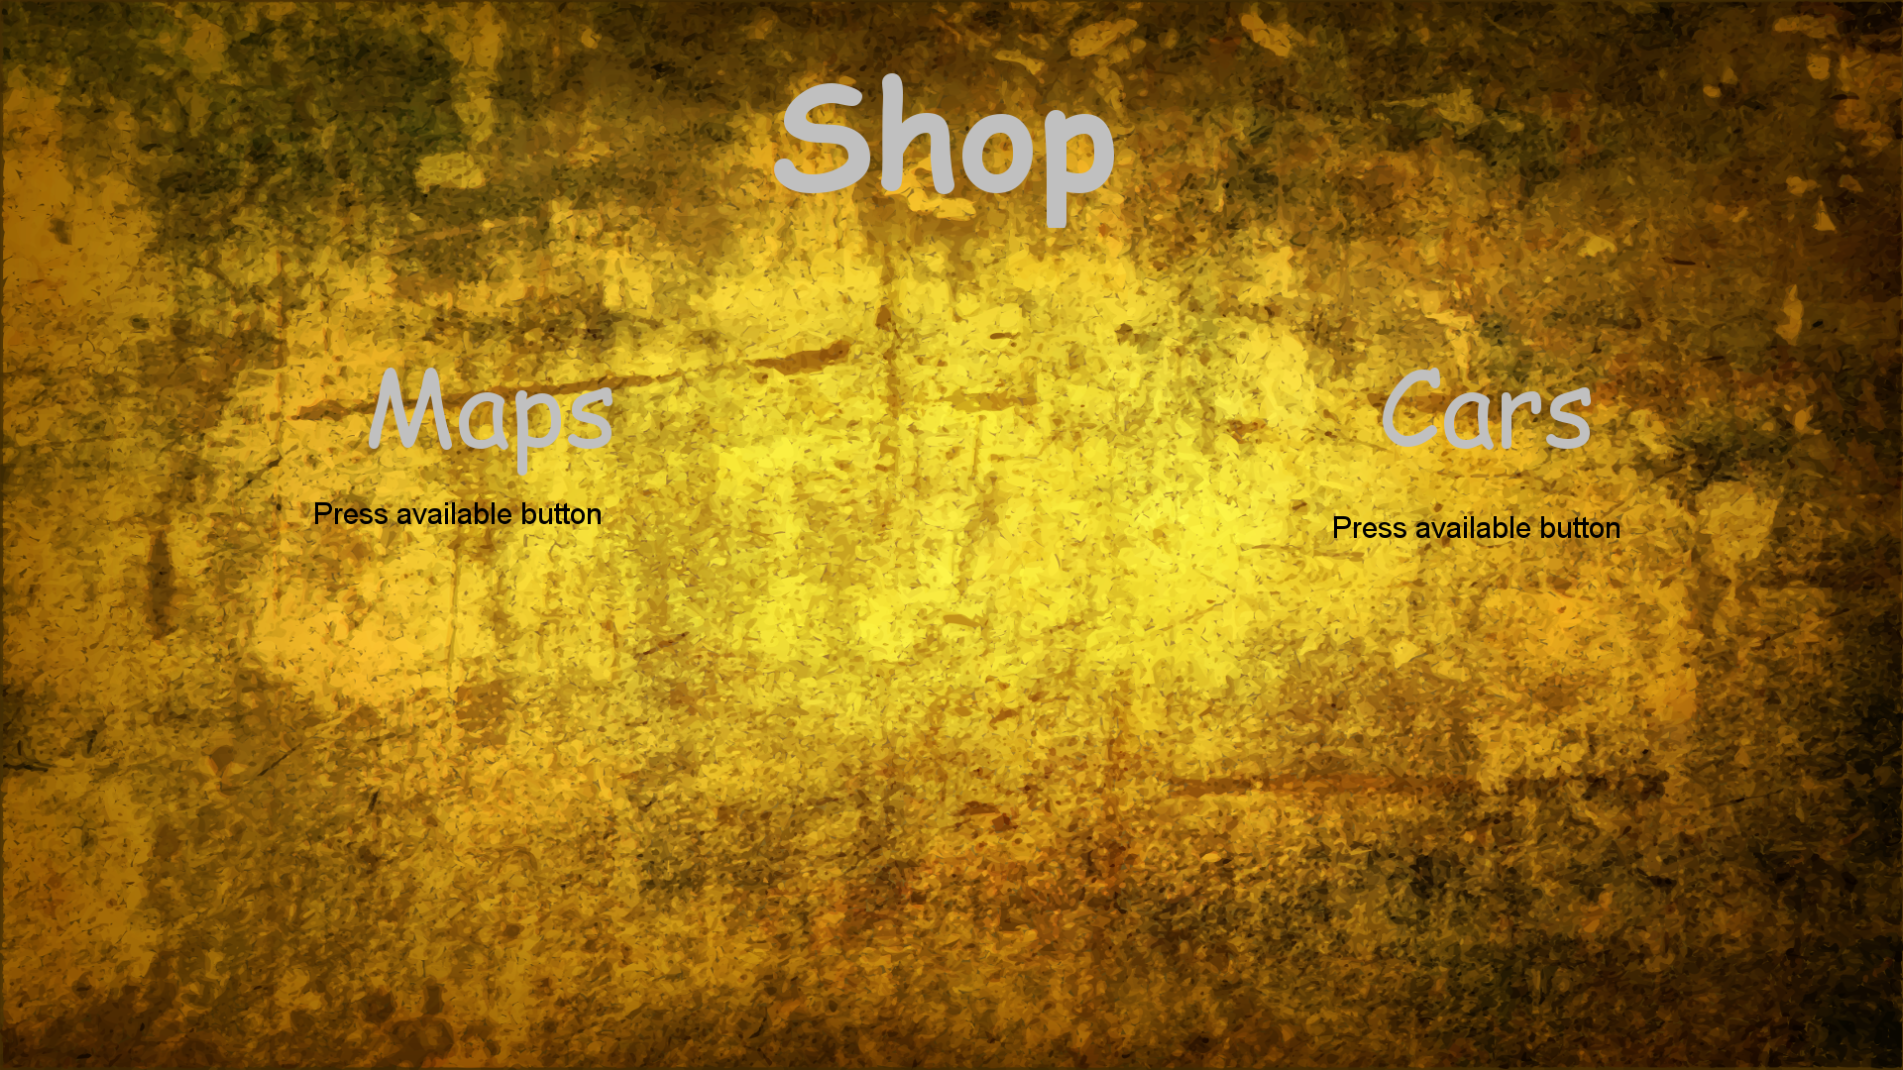
Main Page:
The Main Page we have two buttons to the two categories(cars, maps).
The game money is “Schilling”.

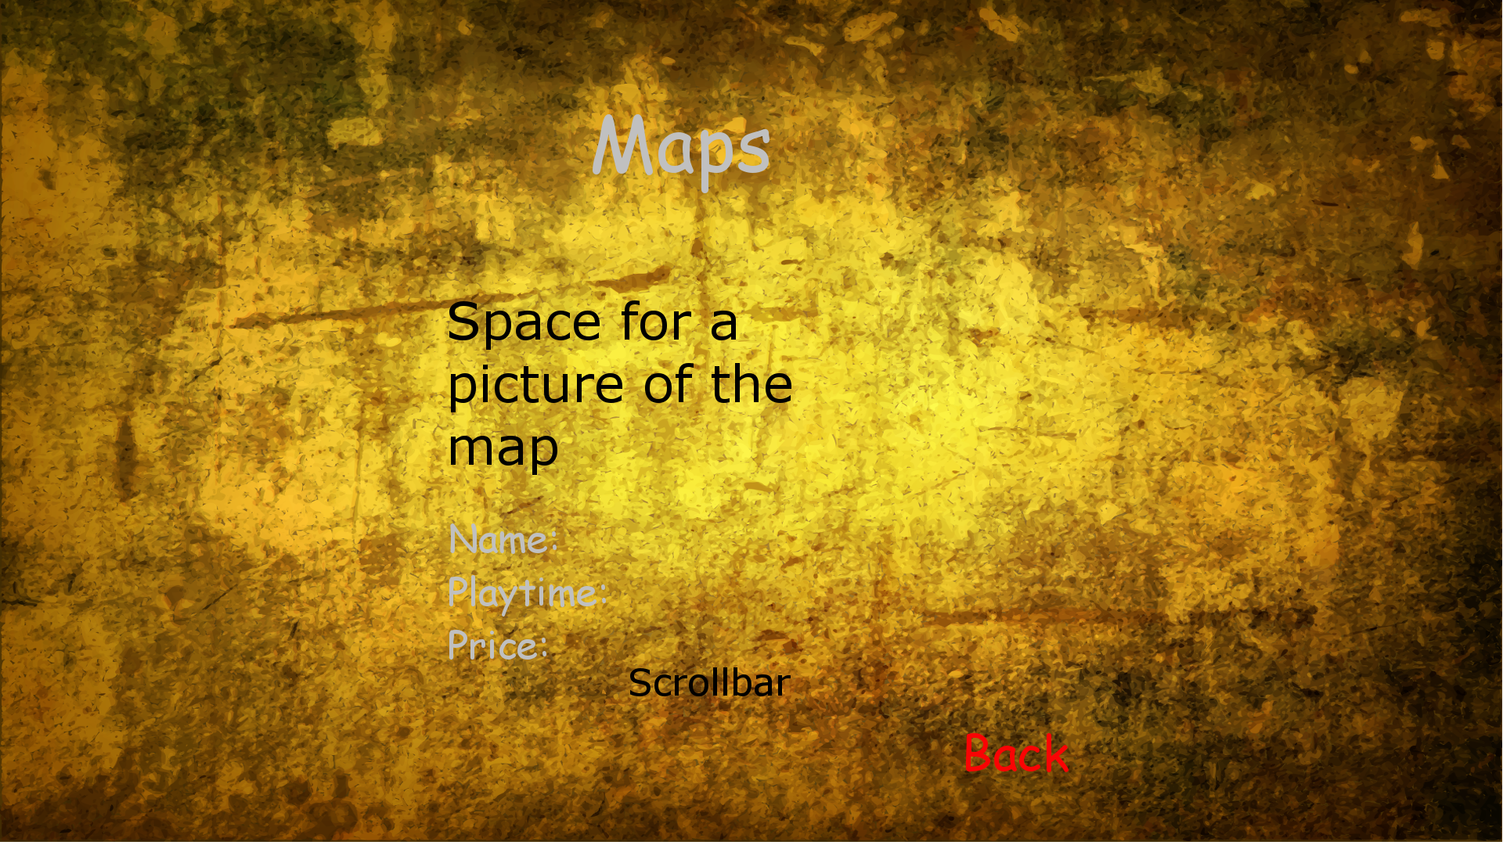
Maps Page:
In the Maps Page, we can see a picture of the map, the map name, the normal playtime of one round and the price. We can switch to other maps with the scrollbar and can go back to the Main Page with the Back button.

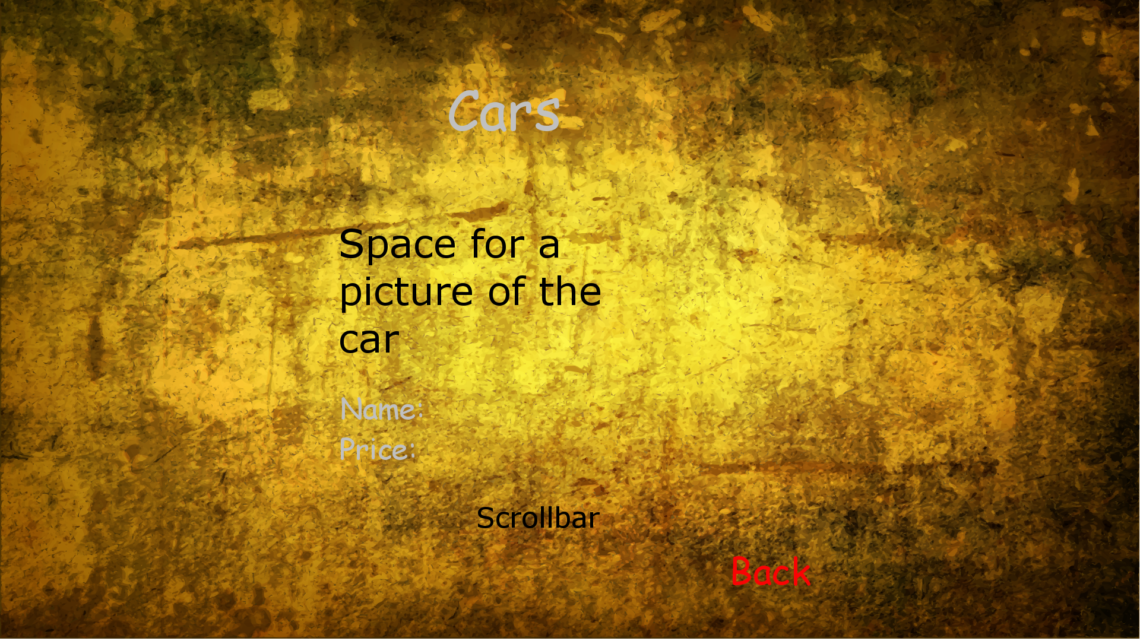
Cars Page:
In the Cars Page, we can see a picture of the car, the car name and the price. We can switch to other cars with the scrollbar and can go back to the Main Page with the Back button.

- Opportunities and Risks
The Subject Opportunities and Risks comprises data which are normally prepared in industrial business plans. Frequently, an anonymous market with potential acquirers, which could be interested in the new product or system idea, will be analyzed at first. Therefore, the contents of this subject is characterized by a certain uncertainty or fuzziness. The subjects examines the chances of achieving profit on the market with a specific product or system. In addition to the chances, the risks of failing on the market or sustaining losses with a product or system should be analyzed.

The Subject Opportunities and Risks comprises data which are normally prepared in industrial business plans. Frequently, an anonymous market with potential acquirers, which could be interested in the new product or system idea, will be analyzed at first. Therefore, the contents of this subject is characterized by a certain uncertainty or fuzziness. The subjects examines the chances of achieving profit on the market with a specific product or system. In addition to the chances, the risks of failing on the market or sustaining losses with a product or system should be analyzed.

Opportunities of the organization/persons who let you do the project! What can we win, if you implement this game?
- Extra car-skins and maps for real money
- Sell on Steam for a ca. 2€
Risks for the project. Risks for the investor, technical risks (feasibility):
- Not so much money as we want
- People like the new theme better than the retro theme
- For some its Uncomfortable to play on one Keyboard, so they won’t buy it
- Planning
The planning specifies the organizational and commercial project execution and system development aspects. The project organization, e.g., matrix organization and steering committees, and the responsibilities for the decision-making processes within project will be specified.
The »Project Leader will be appointed, his tasks will be defined. Available resources, funds and specialist personnel will be determined. Start and end date for the project will be specified. The planning can be based on the statements developed in the subject Project Objectives and System Concepts, which makes additional statements on feasibility, funding and schedules.
The planning specifies the organizational and commercial project execution and system development aspects. The project organization, e.g., matrix organization and steering committees, and the responsibilities for the decision-making processes within project will be specified. The Project Leader will be appointed, his tasks will be de- fined. Available resources, funds and specialist personnel will be determined. Start and end date for the project will be specified. The planning can be based on the state- ments developed in the subject Project Objectives and System Concepts, which makes additional statements on feasibility, funding and schedules.
The following parts must be included:
• List of major project milestones.
• Assign project lead and other outstanding roles to team members.
• Give a rough estimate how many resources you need (human resources, licenses, servers, etc.)
Answer the following questions when preparing this section:
• When will the project end?
• When will the project start?
• When will be a first prototype available?
• When does implementation work start?
• What are the big blocks of work to be done?
• Is this work doable in the given period of time?
• Do we need any other stuff to make our work (licenses, servers, ...)?

October 24, 2017 | Project Start
December 07, 2017 | Requirements are fixed / Start of implementation
November 09, 2017 | Technical feasibility clarified
January 11, 2018 | First Prototype available (One level, one player)
March 15, 2018 | Multiplayer possible
April 05, 2018 | Levels finished
April 19, 2018 | All cars available
May 17, 2018 | Shop-system
June 21, 2018 | Final release

- List of Abbreviations

Abbreviation | Explanation

- List of Literature

- List of Figures

List of Figures

Guidelines for checking the documents
Contentwise and formal directives to the project are to be taken from part 5: V-Modell refer-ence products of the V-Modell-XT and if necessary from an associated evaluation specifica-tion document. For checking the product regarding its contentwise consistency related to the already finished products, the following product depencies are to be checked.

Consideration of the Project Proposal
Affected products:
- Project Proposal
- Project Manual
- Project Plan
Description:
The information about »Initial Situation, existing framework conditions, project targets, system conception and »Economic Efficiency contained in the »Project Proposal have to be considered in the »Project Manual and in the »Project Plan.

Preparing the first Project Progress Decision
Affected products:
- Project Proposal
- Project Progress Decision
Description:
The project ideas and realization proposals presented in the »Project Proposal have to be weighted in a decision process that is outside of the V-Modell. The decision that is made has to be laid down in a »Project Progress Decision.

Project Proposal and Requirements Specification
Affected products:
- Requirements Specification
- Project Proposal
Description:
In the product »Requirements Specification or Requirements Specification Overall Project, the information from the »Project Proposal concerning framework conditions, system idea and realization plan have to be taken into account.

