**inotify**

1. **install**

check before inistalling:

uname -r

ls -l /proc/sys/fs/inotify/

It must lits three items!

rpm -qa inotify-tools

if not:

wget -o /etc/yum.repos.d/epel.repo <http://mirrors.aliyun.com/repo/epel-6.repo>

#! /bin/bash

. /etc/init.d/functions

ls -s /proc/sys/fs/inotify

if [ $? -eq 0 ]

then action "check compatablity" /bin/true

else

action "check" /bin/false

fi

cd /home/oldboy/tools/

tar xf inotify-tools-3.13.tar.gz &&

cd inotify-tools-3.13 &&

./configure --prefix=/usr/local/inotify-3.13 &&

ln -s /usr/local/inotify-3.13 /usr/local/inotify &&

action "result:" /bin/true

1. **parameters**

which inotifywait

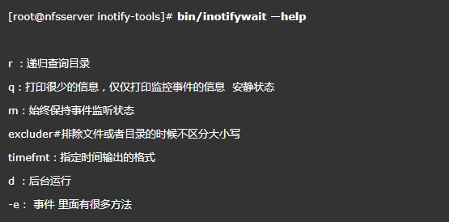

inotifywait -mrq --timefmt '%d/%m/%y %H:%M' --format '%T %w%f' -e create,delete,close_write /data/ 监控增删改，工作常用

-e event

Run man inotifywait to show.

sh -x sh.file debug sh. file

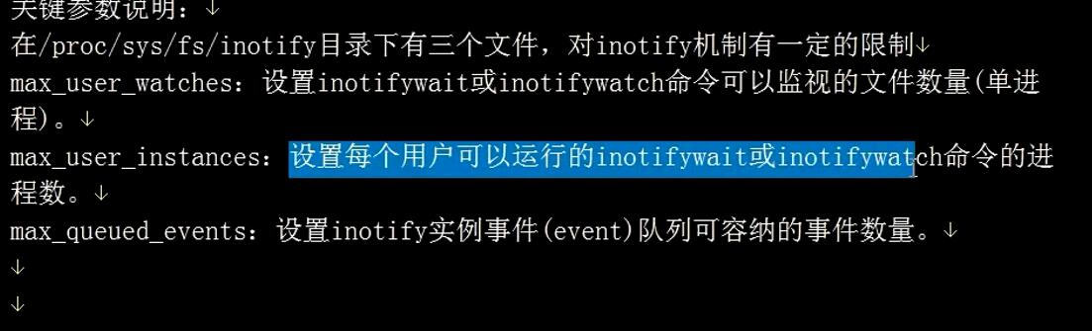

案例脚本：

