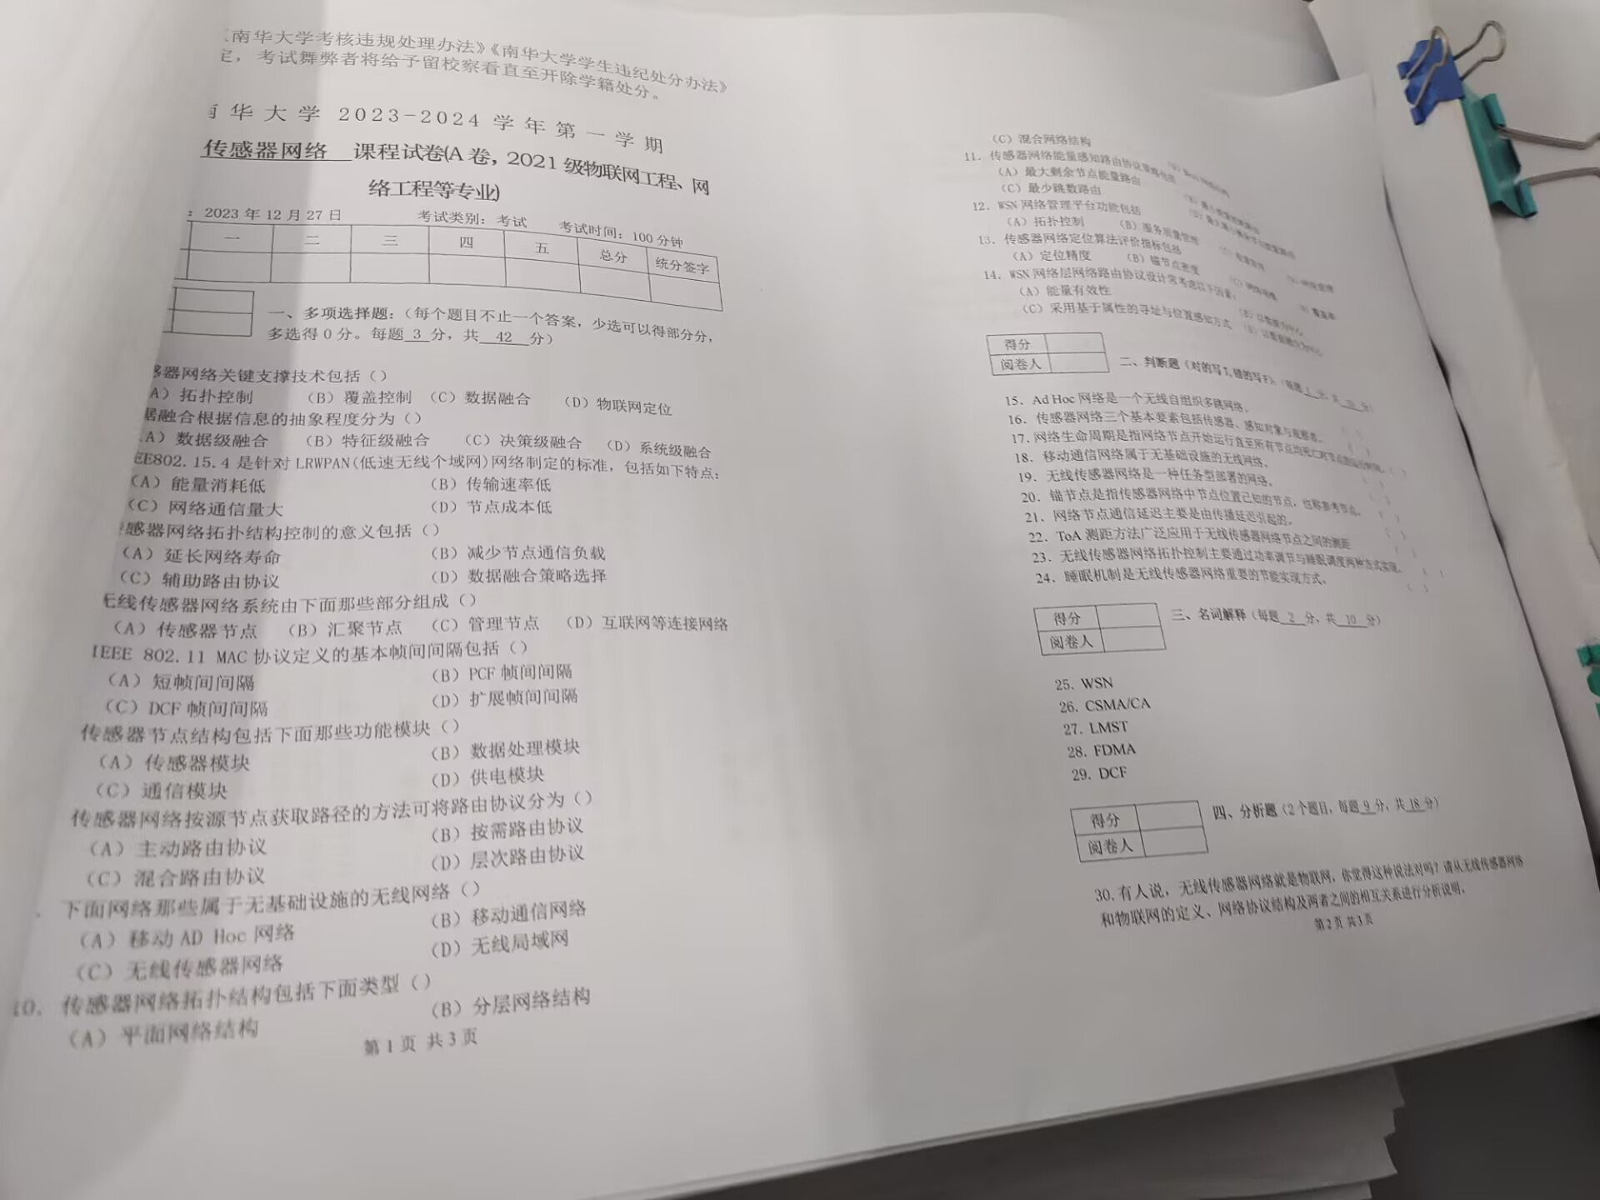ABCD、ABC、ABC、ABCD、ABCD
ABCD、ABCD、ABC、AC、ABCD
ABCD、ABCD、ABCD、ABC

25.Wireless Sensor Networks,无线传感器网络
- Carrier Sense Multiple Access with collision Avoid，带冲突避免的载波监听多路访问
- Local Minimum Spanning Tree,局部最小生成树
- Frequency Division of Multiple Access,频分复用多路访问协议
- Distributed Coordination Function,分布式协调功能
