BondFin Collective
Project Analysis, Spec Comparison and Stretch System Design
Based on a review of the repository (code, migrations, docs, scripts). The running app and live Supabase project were not queried.

1. Product Overview
BondFin Collective is a private rotating savings group (ROSCA) for 10 trusted members. Each member contributes $100 every two weeks. Each cycle, one member receives direct payments: the other nine members transfer $900 in total to the recipient, who retains their own $100. Rotation continues until all 10 members have been paid. The app is a ledger and verification layer. It does not hold or move money; members pay through Zelle or Cash App, and the recipient verifies receipt.
It is not a social platform, a public app, a messaging system, an analytics dashboard, a SaaS product or a multi-tenant system.

2. Original High-Level Spec

2.1 Architecture
- Frontend: Next.js (App Router) with auth pages, member dashboard, admin dashboard, cycle view, contributions and payouts.
- Backend: Supabase Auth, Postgres, Row Level Security, Edge Functions, Storage.
- Future external services: payment processor (Stripe, PayPal), email notifications (Supabase, Resend).

2.2 Core Data Model (as specified)
Entity | Fields
Users | id, email, created_at, role (member, admin)
Members | id, user_id, status (pending, active, blocked), display_name, joined_at
Cycles | id, name, contribution_amount, frequency (biweekly), status (draft, active, completed), start_date, end_date
MemberCycles | id, member_id, cycle_id, payout_order (1-10), has_received_payout
Contributions | id, member_id, cycle_id, amount, status (pending, confirmed, failed), paid_at, payment_reference
Payouts | id, member_id, cycle_id, amount, status (scheduled, paid, failed), paid_at, payment_reference

2.3 Key Workflows (as specified)
- Signup and onboarding: user signs up, a Users row is created, an admin marks the member active, the dashboard unlocks.
- Cycle creation (admin): create a cycle, assign 10 members with payout order, set the cycle active.
- Biweekly contribution: contribution window opens, member pays $100 via a payment processor, a webhook writes a confirmed contribution.
- Payout execution: find the next member not yet paid, calculate the pool, trigger the payout, mark it received; when all 10 are paid the cycle is completed.

2.4 Access Control
- Members see only their own contributions and payouts plus public cycle info; admins manage everything.
- The anon key is used in the frontend (RLS-protected); the service_role key is used only in the backend or Edge Functions.

2.5 Frontend Routes and Roadmap
- / landing, /auth/login, /auth/signup, /dashboard (member), /admin (admin).
- Roadmap v1: Supabase setup, core tables, auth flow, member dashboard, admin dashboard, mock payments.

3. Architecture as Built
- Next.js 16.3.4 (App Router), React 19.2.8, TypeScript, Tailwind 4, @supabase/ssr and supabase-js.
- Protected pages are server components that authenticate server-side and redirect unauthenticated users. Logout is a server action.
- Routes: /, /auth/login, /auth/signup, /auth/forgot-password, /auth/me, /dashboard, /members, /contributions, /profile, /settings (with MFA), /admin (static prototype), /api/account/export.
- Database tables: Users, Cycles, PayoutSchedule, PaymentReports, PaymentReportEvents, MemberPaymentMethods, Contributions, Transactions; MemberDirectory view; avatars storage bucket.
- RLS is enabled on every table. The authenticated role has select only; all writes go through security definer RPCs with search_path set to empty.
- RPCs: submit_active_cycle_contribution, confirm_cycle_payment_received, reject_cycle_payment_report, withdraw_cycle_payment_report, get_active_cycle_recipient, get_active_cycle_payment_reports, get_active_cycle_recipient_payment_methods, set_my_payment_methods.

3.1 Payment Report Lifecycle
- A member reports a payment as sent.
- The recipient confirms it (received) or rejects it; the sender may withdraw a sent report.
- The recipient's own share is recorded as retained.
- Every state change writes an event to PaymentReportEvents (audit trail).

4. Spec vs. Implementation
Spec item | Repository reality | Verdict
Next.js App Router + Supabase | Matches, using SSR auth and server actions | Matches
Payment processor and pooled payout | Intentionally absent; peer-to-peer, recipient-verified | Differs by design
Users table with role | Profile table keyed by email; Users.id is not auth.users.id | Differs
Members table with status | None; docs forbid it without approval; MemberDirectory is a view | Differs
Cycles (name, frequency, draft, end_date) | cycle_number, start_date, due_date, contribution_amount, status upcoming/active/completed; one active cycle enforced | Close
MemberCycles with payout_order | PayoutSchedule with round_number, recipient_user_id, payout_date | Equivalent
Contributions / Payouts | PaymentReports, PaymentReportEvents, plus legacy Contributions and Transactions | Richer than spec
RLS and key handling | Select-only grants, RPC-only writes | Stronger than spec
Routes | All spec routes plus members, contributions, profile, settings, MFA, export | Exceeds spec
Admin dashboard (create cycles, assign order) | Disabled mock with sample data | Not built
Payout execution / cycle completion | No code advances or completes cycles | Missing
Mock payments | Replaced by a real report-confirm-reject flow | Done, better

5. Strengths
- Disciplined security posture: the Users RLS leak was fixed, writes are RPC-only, migrations are incremental, and an integration test plus verify_rls.sql exist.
- Honest data model: nothing is treated as paid just because a member clicked sent.
- Clear documentation and scope rules that prevent feature drift.

6. Gaps and Risks
- Cycle lifecycle is manual: no admin write path, and nothing advances the cycle.
- Admin role is unimplemented (blocked pending approval of storage location and verification method); /admin is still a mock.
- Identity mismatch: Users is joined to auth.users by lower(email), which breaks if an email changes. Add auth_user_id to Users.
- Legacy Contributions and Transactions overlap with PaymentReports; deprecate them or derive them.
- dashboard/page.jsx is about 1,280 lines mixing actions, queries and UI; split into actions, queries and components.
- Roughly 20 modified and 15 untracked paths are uncommitted, including the whole supabase/ folder.
- Membership size and amount live in docs, not as configuration; make them cycle parameters.
- No handling of late or missing payments (grace periods, reminders, rotation impact).

7. Stretch: System Design Unique to BondFin
Optional ideas that build on the direct-payment, trust-based model and respect the no-drift rules.
- Trust Ledger instead of a payment processor. Make PaymentReportEvents an append-only, hash-chained log: hash = sha256(prev_hash || row). Any member can verify the chain, giving transparency without holding money.
- Two-sided confirmation with an SLA. If a recipient does not confirm within 48 hours, escalate to a rotating witness member. Disputes freeze the cycle status and show a banner; data is never deleted.
- Rotation engine. An advance_cycle() RPC, run by an admin or a scheduled Edge Function. It requires nine received reports plus the retained share, completes the cycle, activates the next, and closes the collective after round 10.
- Payout-order fairness. Verifiable shuffle: members commit seeds and the order derives from the combined hash, so it is reproducible and not admin-chosen.
- Private reliability score. Show on-time rate per member within the group; allow consensual position swaps between two members.
- Cycle health dashboard. A 9-of-9 received ring, days to due date, and a one-tap recipient confirmation checklist.
- Reminders. Edge Function emails on cycle open, 3 days before due, and on due date; each payer sees only their own.
- Roles without an admin flag. Steward quorum: admin actions need approval from 2 of N stewards, resolving the open admin-role storage question.
- Culture layer. Use the existing Uruziga naming (for example URUZIGA-04) and recipient stories so the product feels like a collective, not a fintech app.

8. Recommended Next Steps
- Commit current work in logical groups: migrations, routes, docs.
- Approve the admin-role design (steward quorum or admin table); implement advance_cycle and an admin write path for Cycles and PayoutSchedule.
- Add auth_user_id to Users and migrate off email joins.
- Decide whether to retire Contributions and Transactions.
- Refactor the dashboard into actions, queries and components.
- Add reminders and the dispute/SLA flow, then the hash-chained ledger.

9. Proposed System Workflow Design
This design treats BondFin as a private coordination and evidence system rather than a money transmitter. External payment rails remain outside the trust boundary; BondFin controls membership, cycle state, payment reporting, recipient verification, disputes, reminders and audit history.

9.1 Actors and System Boundaries
Actor or component | Responsibility | Permitted actions
Member / payer | Sends funds directly to the current recipient. | View active cycle, view recipient payment methods, submit or withdraw own payment report, view own history.
Recipient | Receives nine external payments and retains their own share. | Confirm or reject reports addressed to them, record retained share, open a dispute.
Steward / admin | Manages membership, schedules and exceptions. | Create and activate cycles, assign payout order, resolve disputes, approve advancement, suspend access.
Next.js application | Provides authenticated member and steward experiences. | Read permitted views and invoke approved RPCs; never write tables directly.
Supabase | System of record and policy-enforcement layer. | Authenticate users, enforce RLS, execute transactional RPCs, store append-only events and run scheduled functions.
External payment rail | Moves money between members. | Outside BondFin custody and reconciliation; references may be recorded as evidence.

9.2 End-to-End Cycle Workflow
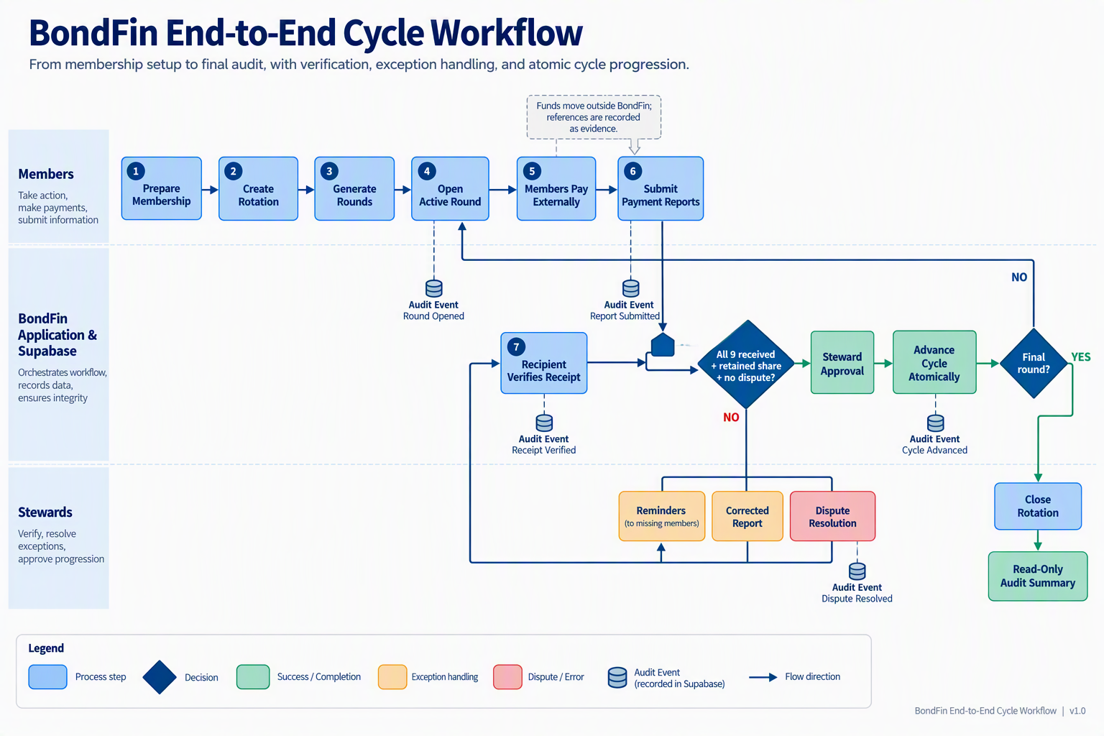
Figure 1. BondFin end-to-end cycle workflow, including the normal progression, readiness gate, exception loop and final audit closure.
Implementation artifact status: the editable source is stored in docs/architecture/bondfin-workflow.mmd, and the rendered reference image is stored in docs/bondfin-workflow.png. Mermaid CLI was executed through npx, so no Mermaid dependency was added to package.json or package-lock.json. The source file is the authoritative version; the PNG should be regenerated whenever the Mermaid definition changes.
- Prepare membership. A steward invites or approves exactly the configured number of members. Each profile is linked to auth.users through auth_user_id, and each member registers permitted payment handles.
- Create the collective rotation. A steward creates the rotation template with member count, contribution amount, cadence, grace period and dispute SLA. Payout order is assigned manually or by a verifiable shuffle.
- Generate rounds. The system creates one Cycles row and one PayoutSchedule row per round. Exactly one round may be active, and each member is recipient exactly once.
- Open a round. A transactional RPC activates the scheduled round, identifies the recipient, snapshots the expected payers and amount, records the recipient’s retained share, and emits a cycle_opened event.
- Report payment. Each non-recipient pays externally, then submits a report with payment method, optional reference and timestamp. The RPC rejects duplicates and creates a sent event.
- Verify receipt. The recipient confirms or rejects each report. Confirmation is authoritative for the BondFin ledger; rejection requires a reason and starts the exception path.
- Evaluate readiness. A server-side readiness function verifies nine received reports, one retained share, no open dispute and no unresolved duplicate.
- Advance atomically. A steward-approved advance_cycle RPC locks the active round, rechecks readiness, marks it completed, activates the next scheduled round and writes both events in one transaction.
- Close the rotation. After the final recipient is complete, the system marks the collective completed, freezes operational writes and exposes a read-only audit summary to members.
Diagram organization: maintain two Mermaid views rather than one vertically stacked diagram. The first should show the runtime architecture and trust boundaries among Next.js, Supabase Auth, RLS, RPCs, Postgres and external payment rails. The second should show the round lifecycle from payment reporting through recipient verification, 9-of-9 completion, cycle advancement and rotation closure. Keeping both views in the same source file preserves consistency while making each diagram easier to read in Markdown, pull requests and exported images.

9.3 Payment Report State Machine
Current state | Allowed transition | Guard and audit event
Not reported | Sent | Only the expected payer; one active report per payer and cycle; payment_reported.
Sent | Received | Only the active recipient; payment_confirmed.
Sent | Rejected | Only the active recipient; reason required; payment_rejected.
Sent | Withdrawn | Only the reporting payer and only before confirmation; payment_withdrawn.
Rejected | Sent | Payer submits corrected evidence or a new transfer reference; payment_resubmitted.
Received | Disputed | Steward workflow only; reversal is never silent; dispute_opened.
Disputed | Received or Rejected | Resolution requires steward quorum and a written rationale; dispute_resolved.

9.4 Exception and Recovery Workflow
- Late payment: reminders at configurable offsets, then a grace-period flag. The round remains active; no automatic reassignment occurs.
- Recipient non-response: after the confirmation SLA, notify the recipient and stewards. A quorum may resolve the report from evidence, with a permanent audit entry.
- Dispute: set the cycle to paused, preserve all reports and events, prevent advancement, collect a reason and evidence reference, then resume only through a quorum-backed resolution.
- Duplicate or conflicting report: enforce a database uniqueness rule and return the existing report to the UI rather than creating another ledger item.
- Concurrent advancement: lock the active cycle in the RPC and enforce a partial unique index so two rounds cannot become active.
- Member suspension: block new actions but retain history. Any payout-order change requires explicit approval and an order_changed event.

9.5 Control and Data Design
Concern | Recommended control
Identity | Add Users.auth_user_id as a unique foreign key to auth.users; retain email as editable profile data.
Authorization | Keep table writes closed to authenticated users. Expose narrow security-definer RPCs with explicit actor, cycle and state guards.
Administration | Use a StewardAssignments table with effective dates and require two distinct approvals for cycle creation, order changes, dispute resolution and forced advancement.
Auditability | Make PaymentReportEvents append-only; store actor, action, prior state, new state, timestamp and correlation ID. Optionally hash-chain events.
Configuration | Move member count, contribution amount, cadence, grace period and confirmation SLA into immutable rotation-level settings snapshotted into each round.
Observability | Log RPC failures and scheduled-job outcomes by correlation ID. Alert on overdue rounds, repeated rejections and failed advancement.
Privacy | Expose only minimum payment-handle data to active-cycle participants; never expose another member’s private history or evidence.

9.6 Implementation Sequence
- Foundation: add auth_user_id, rotation configuration, steward assignments and database invariants.
- Lifecycle: implement create_rotation, activate_cycle, cycle_readiness and advance_cycle RPCs with integration tests.
- Operations: replace the mock admin page with approval queues, cycle controls and exception views.
- Resilience: add scheduled reminders, confirmation SLA escalation, dispute pause/resume and idempotent job execution.
- Assurance: add event-chain verification, operational alerts, exportable audit summaries and a migration plan for legacy Contributions and Transactions.

