A PROJECT REPORT ON
AIR POLLUTION TOLERANCE INDEX (APTI) BASED SCREENING OF SENSITIVE AND TOLERANT PLANT SPECIES AT VARIOUS LOCATIONS IN PRATAPGARH, UTTAR PRADESH
Study Area: Pratapgarh District (Bela Pratapgarh), Uttar Pradesh, India
Submitted in partial fulfilment of the requirements of the course
____________________________________
Submitted by: ____________________________________
Roll No. / Enrolment No.: __________________________
Course & Semester: ________________________________
Department of: ____________________________________
College / Institution: ______________________________
Supervised by: ____________________________________

Session: 2025–2026
November 2026

CERTIFICATE
This is to certify that the project report entitled “Air Pollution Tolerance Index (APTI) Based Screening of Sensitive and Tolerant Plant Species at Various Locations in Pratapgarh, Uttar Pradesh” is a bona fide record of the compilation and analysis work carried out by Mr./Ms. ______________________________ (Roll No. ______________) under my supervision and guidance. To the best of my knowledge, the report has not been submitted elsewhere for the award of any other degree or diploma.

__________________________ __________________________
Signature of Supervisor Head of the Department

DECLARATION
I hereby declare that this project report is a record of original compilation, analysis and interpretation work carried out by me under the guidance of my supervisor. All published data, literature and photographs used in this report have been duly acknowledged at the appropriate places, and the sources are listed in the references.

Place: Pratapgarh Signature of the Student
Date: ______________ Name: ____________________

ACKNOWLEDGEMENT
I express my sincere gratitude to my supervisor for constant guidance, encouragement and valuable suggestions throughout this work. I am thankful to the Head of the Department and all faculty members for providing the necessary academic support and laboratory reference material. I also acknowledge the published district profile of Krishi Vigyan Kendra, Pratapgarh, the Census of India, and the air-quality data platforms whose open datasets made the location-wise profiling possible. I am grateful to the authors of the research papers cited in this report, whose field studies formed the scientific basis of the screening. Finally, I thank my family and friends for their patience and support during the preparation of this report.

ABSTRACT
Air pollution is emerging as a serious environmental concern in the small towns of the Indo-Gangetic plain, where vehicular traffic, road dust, brick kilns and biomass burning raise particulate levels well above the national standards. The present report screens common plant species of Pratapgarh district, Uttar Pradesh, for their sensitivity and tolerance to air pollution using the Air Pollution Tolerance Index (APTI) approach of Singh and Rao (1983), which combines four leaf parameters, namely ascorbic acid, total chlorophyll, leaf-extract pH and relative water content. Published APTI datasets from comparable cities of the region (Prayagraj, Lucknow, Noida, Delhi, Muzaffarpur and Udaipur) were compiled, and seven locations of Pratapgarh were profiled for their pollution load using reported air-quality data. Azadirachta indica, Ficus religiosa and Syzygium cumini emerged as tolerant species suitable for green belts, while Mangifera indica, Ficus benghalensis, Phyllanthus emblica and Psidium guajava showed intermediate tolerance. Polyalthia longifolia, Delonix regia and Dalbergia sissoo behaved as sensitive species and are recommended as bio-indicators. Post-monsoon PM2.5 and PM10 levels in Bela Pratapgarh (about 69–72 and 137 µg/m³) exceeded the 24-hour national standards, indicating a clear seasonal stress window for roadside and orchard vegetation. Location-wise planting recommendations are made, with special emphasis on protective shelterbelts for the GI-tagged aonla orchards of the district.
Keywords: Air pollution; APTI; bio-indicator; green belt; Pratapgarh; tolerant species; aonla.

CONTENTS
Chapter | Title | Page
— | Certificate, Declaration, Acknowledgement | 2
— | Abstract and Contents | 3
1 | Introduction | 4
2 | Review of Literature | 5
3 | Study Area and Sampling Locations | 6–7
4 | Materials and Methods | 8
5 | Results | 9–13
— | Plate I – Tolerant and intermediate species | 10
— | Plate II – Intermediate and sensitive species | 11
6 | Discussion | 14
7 | Conclusion and Recommendations | 14
— | References and Photo Credits | 15

CHAPTER 1 : INTRODUCTION

1.1 Air pollution and urban air quality
Air pollution is the presence of substances in the atmosphere in concentrations harmful to human health, vegetation and materials. The major criteria pollutants in Indian towns are particulate matter (PM2.5 and PM10), sulphur dioxide (SO2), nitrogen dioxide (NO2), carbon monoxide and ozone. In small towns of the Indo-Gangetic plain the dominant sources are vehicular exhaust, road dust, brick kilns, diesel generator sets, construction and seasonal biomass burning. During the post-monsoon and winter months, temperature inversion and low wind speed trap these pollutants close to the ground, and particulate levels frequently breach the National Ambient Air Quality Standards (NAAQS) of the CPCB [3].

1.2 Plants as bio-indicators and sinks
Leaves are the primary receptors of airborne pollutants. Gases enter through the stomata while particulate matter deposits on the leaf surface, interfering with photosynthesis, transpiration and enzyme activity. Sensitive species develop visible injury and lose chlorophyll rapidly, whereas tolerant species maintain their physiological balance through antioxidant defence and osmotic adjustment. Sensitive plants thus serve as early bio-indicators, while tolerant plants act as sinks and are preferred for avenue plantation and green belts [1, 2].

1.3 Air Pollution Tolerance Index (APTI)
The APTI, proposed by Singh and Rao [1], is an empirical index that grades the inherent ability of a species to withstand air-pollution stress. It is computed from four leaf parameters: ascorbic acid content (A), total chlorophyll (T), pH of leaf extract (P) and relative water content (R). Higher APTI values indicate greater tolerance. The index is widely used in India for screening avenue and orchard species, and it is often combined with canopy and socio-economic characters into the Anticipated Performance Index (API) for green-belt planning [2, 10].

1.4 Rationale and objectives
Pratapgarh is a growing district headquarters on NH-330 with rising traffic, brick-kiln activity and a large aonla-based horticultural economy. No systematic APTI screening of its plant species has been documented. The study was taken up with the following objectives:
- To compile and compare published APTI values of common plant species of the Pratapgarh region.
- To classify the screened species as sensitive, intermediate or tolerant to air pollution.
- To profile the pollution load of different locations of Pratapgarh district.
- To recommend tolerant species for green belts and sensitive species as bio-indicators, including protection of aonla orchards.

CHAPTER 2 : REVIEW OF LITERATURE
The APTI concept was introduced by Singh and Rao [1] and has since been applied across India and abroad. Liu and Ding [2] formalised the response classes now in common use (sensitive, intermediate and tolerant). In the Indo-Gangetic region, several field studies provide a directly comparable dataset for the present screening.
Chandra et al. [5] evaluated five roadside species at four sites of Prayagraj city (Rambagh, Civil Lines, NH-35 and NH-30), including petrol-pump locations. APTI ranged from 9.25 to 32.49; Azadirachta indica was the most tolerant (mean ≈ 25) and Polyalthia longifolia the most affected, while the API graded neem as the best green-belt species (93.75%). Saxena et al. [4] reported Ficus religiosa (APTI 17.53) and Azadirachta indica (13.34) as the better performers in Lucknow, where PM2.5 reached 113–163 µg/m³. Eram and Singh [8] screened twelve species in Muzaffarpur (Bihar) and identified Mangifera indica, Syzygium cumini, Azadirachta indica and Psidium guajava among the tolerant group, with Terminalia arjuna, Nerium oleander and Dalbergia sissoo in the sensitive group.
Rathore et al. [6] showed that APTI increased at a polluted traffic circle in Udaipur because ascorbic acid synthesis was induced, while chlorophyll, pH and relative water content declined. Kumari and Deswal [7] found all five roadside species of Noida in the sensitive class (APTI 6–11), with Polyalthia longifolia the lowest. Pandey et al. [9] and Prajapati and Tripathi [10] demonstrated the use of APTI and API for selecting green-belt species in Delhi and Varanasi respectively. Lohe et al. [11] reported an APTI of 12.80 for Phyllanthus emblica, supporting its intermediate tolerance. These studies together indicate that species response is consistent enough for screening, but varies with site, season and pollutant mix, so local validation is always desirable.
Table 2.1 Summary of key APTI studies used for the present screening
Study | Area | Species / sites | Principal outcome
Chandra et al. [5] | Prayagraj, U.P. | 5 species; 4 sites + petrol pumps | Neem most tolerant (up to 32.49); Ashoka most sensitive (9.25)
Saxena et al. [4] | Lucknow, U.P. | 4 species; 3 land uses | Peepal 17.53 > Neem 13.34; PM2.5 113–163 µg/m³
Eram & Singh [8] | Muzaffarpur, Bihar | 12 species; 4 sites | Jamun, Mango, Neem, Guava tolerant; Arjun, Kaner, Shisham sensitive
Rathore et al. [6] | Udaipur, Rajasthan | 8 species; traffic circle | APTI rose at polluted site; Eucalyptus 16.85, Mango 16.61
Kumari & Deswal [7] | Noida, U.P. | 5 species; roadside | All sensitive (6–11); Ashoka lowest (6)
Pandey et al. [9] | Delhi | Roadside trees | Shisham 8.75 and Guava 5.77–9.54 low; Mango recommended

CHAPTER 3 : STUDY AREA AND SAMPLING LOCATIONS

3.1 Location and physical setting
Pratapgarh district lies in the Prayagraj division of south-eastern Uttar Pradesh between 25°34′–26°11′ N and 81°19′–82°27′ E, covering about 3,717 km² of the Gangetic alluvial plain [16]. It is bounded by Sultanpur (north), Jaunpur (east), Prayagraj (south) and Rae Bareli–Fatehpur (west). The Ganga forms the south-western boundary for about 50 km; the Sai river flows past the headquarters, Bela Pratapgarh. The terrain is flat with deep loamy alluvial soils, at about 93–137 m above sea level.

3.2 Climate
The climate is humid sub-tropical, with a hot summer (maximum temperature up to about 46–47 °C), a cool winter (minimum about 5 °C) and a south-west monsoon from July to September. The average annual rainfall is about 749 mm [16]. Post-monsoon and winter months are characterised by calm winds, fog and inversion, which favour the accumulation of particulate pollutants.

3.3 Population and economy
As per Census 2011 the district had 3,209,141 people (density ≈ 860/km²), about 94.5% of them rural [15]. The economy is agrarian (rice, wheat, pulses, oilseeds, mango). Pratapgarh is the largest aonla cluster of the country; “Pratapgarh Aonla” received the GI tag in March 2023 and is the district’s One District One Product [17]. Agro-based units, two industrial estates (Sukhpal Nagar, Badhoi Mandatha) and seasonal brick kilns supplement the economy [16].

3.4 Sources of air pollution
The main local sources are traffic on NH-330 (Prayagraj–Ayodhya, currently being four-laned [21]), NH-31 (Lucknow–Varanasi) and SH-128 (Raniganj–Patti–Akbarpur); road dust; brick kilns; diesel sets; construction; and biomass burning. The district has no continuous regulatory air-quality station, so ambient levels were inferred from published monitoring platforms and the regional UPPCB dataset [18–20].
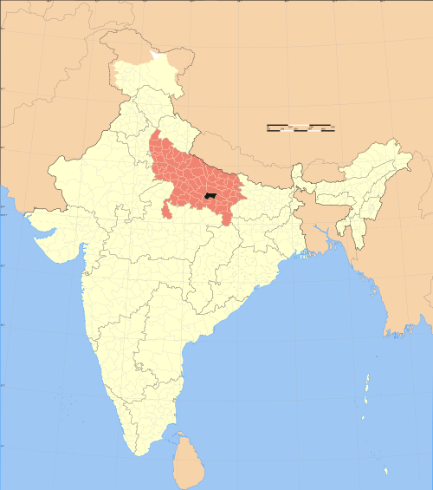 | 
(a) Location of Pratapgarh in Uttar Pradesh | (b) Pratapgarh district outline
Fig. 3.1 Location and extent of the study area (Source: Wikimedia Commons)

3.5 Sampling locations
Seven locations were selected to represent the pollution gradient of the district, from the congested city core and highway corridors to industrial pockets, tehsil markets and the rural aonla belt, which serves as the reference (control) landscape. The selection follows the land-use based approach used in earlier APTI studies [5, 8].
Table 3.1 Sampling locations selected for APTI-based screening in Pratapgarh
Code | Location | Land use | Dominant pollution source | Expected load
S1 | City core – Paltan Bazaar / Railway Road, Bela Pratapgarh | Commercial | Traffic congestion, road dust, gensets | High
S2 | Pratapgarh Jn.–Chilbila corridor on NH-330 | Highway | Highway vehicles, dust, construction | High
S3 | Raniganj–Patti road (SH-128) junction | Mixed | Traffic, roadside burning, kilns | Moderate–High
S4 | Sukhpal Nagar industrial estate & brick-kiln cluster | Industrial | Kiln emissions, fuel burning, dust | High
S5 | Kunda town market | Tehsil commercial | Local traffic, biomass burning | Moderate
S6 | Patti town market | Tehsil commercial | Local traffic, dust | Moderate
S7 | Dahilamau–Shukulpur aonla belt (GI cluster) | Rural / orchard | Background; occasional burning | Low (control)

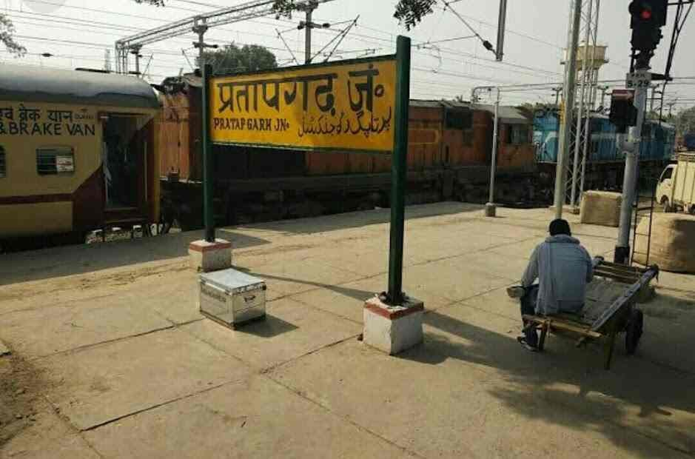 | 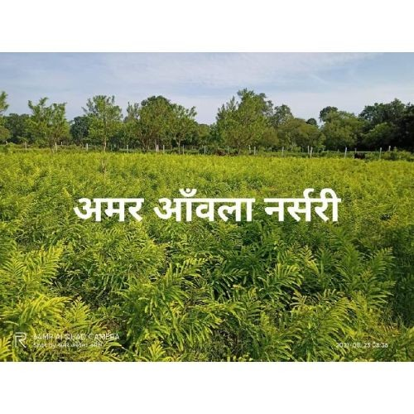 | 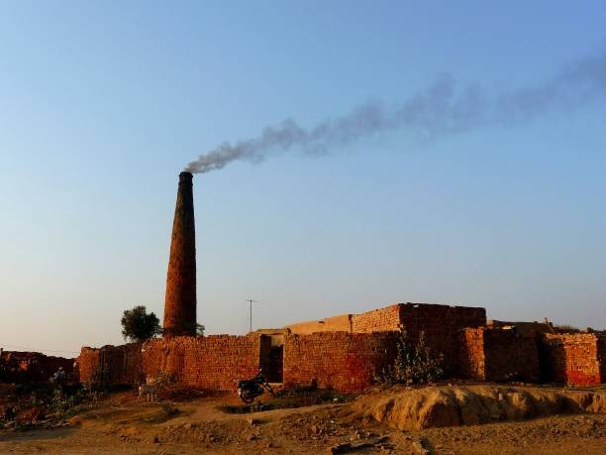
Pratapgarh Junction (S1–S2) | Aonla nursery, Pratapgarh (S7) | Brick kiln emission (S4 type)
Fig. 3.2 Representative glimpses of the sampling landscape
The Belha Devi temple area on the Sai river and the city’s institutional pockets experience comparatively lower traffic stress and were treated as secondary reference points within the urban area.

CHAPTER 4 : MATERIALS AND METHODS

4.1 Screening framework
The study follows a literature-based APTI screening framework: (i) an inventory of twelve common avenue, orchard and ornamental species of Pratapgarh; (ii) compilation of their published APTI values from comparable Indo-Gangetic cities; (iii) pollution profiling of the seven locations; (iv) classification of species and location-wise planting recommendations; and (v) a proposed field-validation protocol.

4.2 Leaf parameters and standard estimation protocols
Relative water content (RWC): fresh weight (FW), turgid weight (TW) after 24 h hydration and dry weight (DW) after oven-drying at 80 °C give RWC (%) = [(FW − DW)/(TW − DW)] × 100 [13].
Leaf-extract pH: 1 g washed leaf is homogenised in 10–20 mL deionised water and the pH of the filtrate is read on a calibrated digital pH meter [1, 7].
Total chlorophyll (T): 1 g fresh leaf is extracted in 80% acetone, centrifuged and read at 645/663 nm; chlorophyll a + b is computed by Arnon’s equations (mg/g fresh weight) [12].
Ascorbic acid (A): leaf extract in oxalic acid is titrated against 2,6-dichlorophenol indophenol dye (mg/g fresh weight) [14].

4.3 Computation and classification of APTI
The four parameters are combined as proposed by Singh and Rao [1]:
APTI = [A (T + P) + R] / 10
where A = ascorbic acid (mg/g), T = total chlorophyll (mg/g), P = leaf-extract pH and R = relative water content (%). Species are graded as follows [2]:
APTI value | Response class | Role in pollution management
≤ 11 | Sensitive | Bio-indicator / early-warning species
12 – 16 | Intermediate | Plantation with periodic monitoring
≥ 17 | Tolerant | Green-belt and avenue plantation (sink)

4.4 Anticipated Performance Index (API)
For green-belt planning, APTI is combined with biological and socio-economic characters (plant habit, canopy, laminar structure, economic value) into the API, which grades species from poor to excellent [9, 10]. API was used qualitatively to rank the recommended species.

4.5 Data sources
Published APTI datasets [4–11], CPCB/UPPCB reports [3, 18], air-quality platforms (IQAir, aqi.in; Oct–Nov 2026) [19, 20], Census 2011 [15], the KVK profile [16] and the GI Journal [17] were used. All values are reproduced with citation; no primary laboratory measurement is claimed for Pratapgarh.

CHAPTER 5 : RESULTS

5.1 Species screened and their reported tolerance
Twelve species common to the roadsides, orchards and institutional grounds of Pratapgarh were screened. Their published APTI values at polluted or roadside sites, and the screening class adopted on the weight of evidence, are summarised in Table 5.1.
Table 5.1 Compiled APTI evidence and screening classification of species for Pratapgarh
Species (local name) | Family | Reported APTI / response at polluted sites | Adopted class
Azadirachta indica (Neem) | Meliaceae | 9.0 [7]; 13.34 [4]; 16.19 [6]; 17.71–32.49 [5] | Tolerant
Ficus religiosa (Peepal) | Moraceae | 10.0 [7]; 13.43 [6]; 17.53 [4] | Intermediate–Tolerant
Ficus benghalensis (Bargad) | Moraceae | 12.54–17.06 [5] | Intermediate
Mangifera indica (Aam) | Anacardiaceae | 9.25–15.47 [5]; 16.61 [6] | Intermediate
Phyllanthus emblica (Aonla) | Phyllanthaceae | 12.80 [11] | Intermediate
Syzygium cumini (Jamun) | Myrtaceae | Tolerant group at traffic & industrial sites [8] | Intermediate–Tolerant
Psidium guajava (Amrood) | Myrtaceae | 5.77–9.54 [9]; tolerant at Muzaffarpur [8] | Variable
Terminalia arjuna (Arjun) | Combretaceae | Sensitive at traffic sites [8] | Sensitive–Intermediate
Dalbergia sissoo (Shisham) | Fabaceae | 8.75 [9]; sensitive at Muzaffarpur [8] | Sensitive–Intermediate
Nerium oleander (Kaner) | Apocynaceae | 11.89 [6]; sensitive at Muzaffarpur [8] | Sensitive–Intermediate
Polyalthia longifolia (Ashok) | Annonaceae | 6.0 [7]; 9.25 [5] | Sensitive
Delonix regia (Gulmohar) | Fabaceae | 11.0 [7] | Sensitive

On the weight of evidence, neem, peepal and jamun form the tolerant core for plantation; mango, bargad, aonla and guava are intermediate and suitable for mixed planting with monitoring; ashoka, gulmohar and shisham are the sensitive group best used as bio-indicators. The behaviour of guava and arjun was site-dependent, and they are retained in the intermediate category pending local validation.

PLATE I : TOLERANT AND INTERMEDIATELY TOLERANT SPECIES
Real photographs of the tolerant and intermediate species screened for plantation in Pratapgarh. Images are reproduced from internet sources with credit (see page 15).
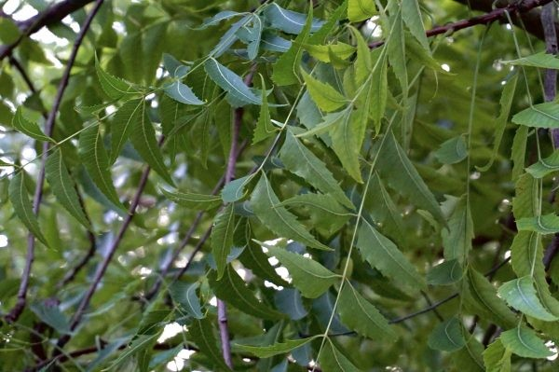 | 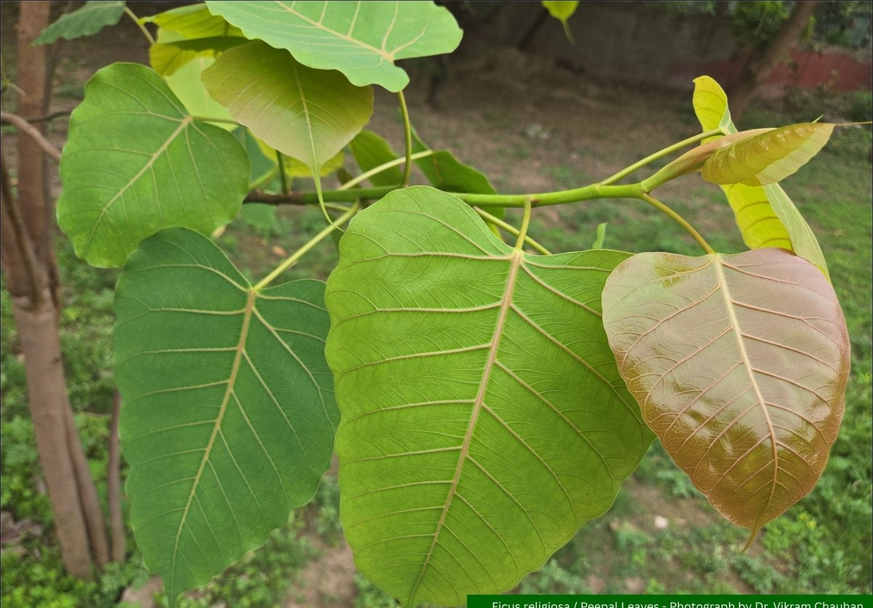
Azadirachta indica (Neem) – Tolerant | Ficus religiosa (Peepal) – Int.–Tolerant
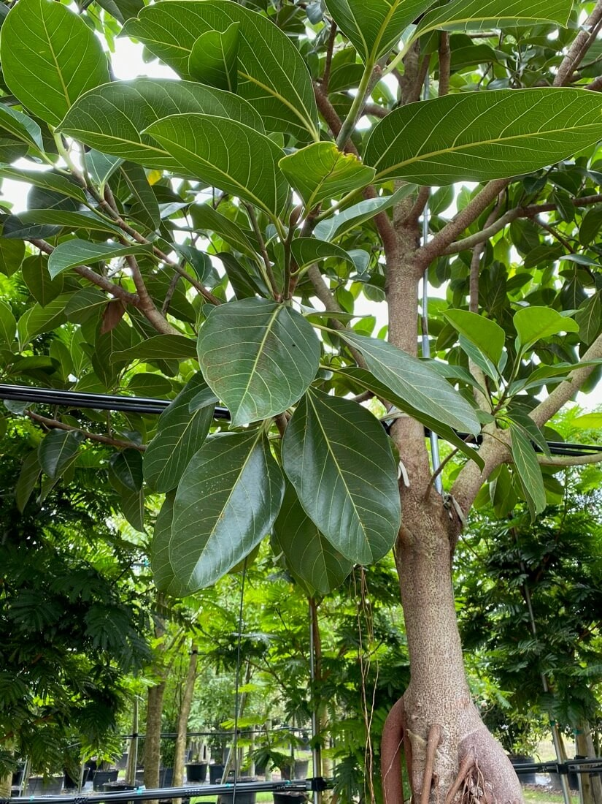 | 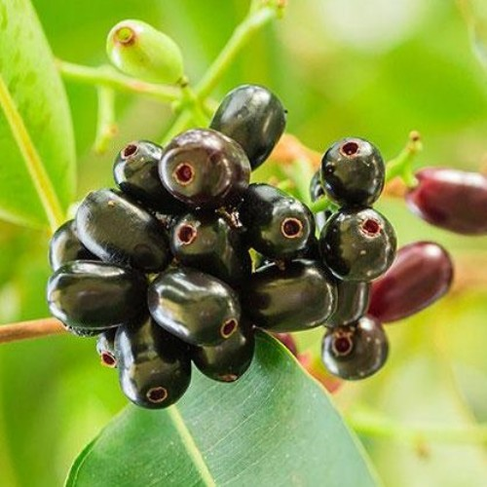
Ficus benghalensis (Bargad) – Intermediate | Syzygium cumini (Jamun) – Int.–Tolerant
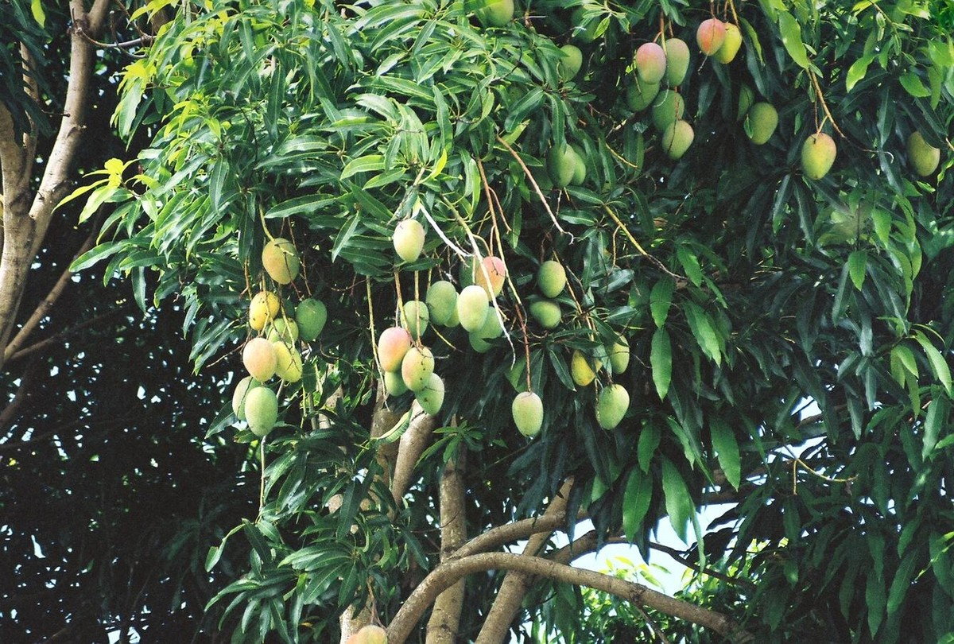 | 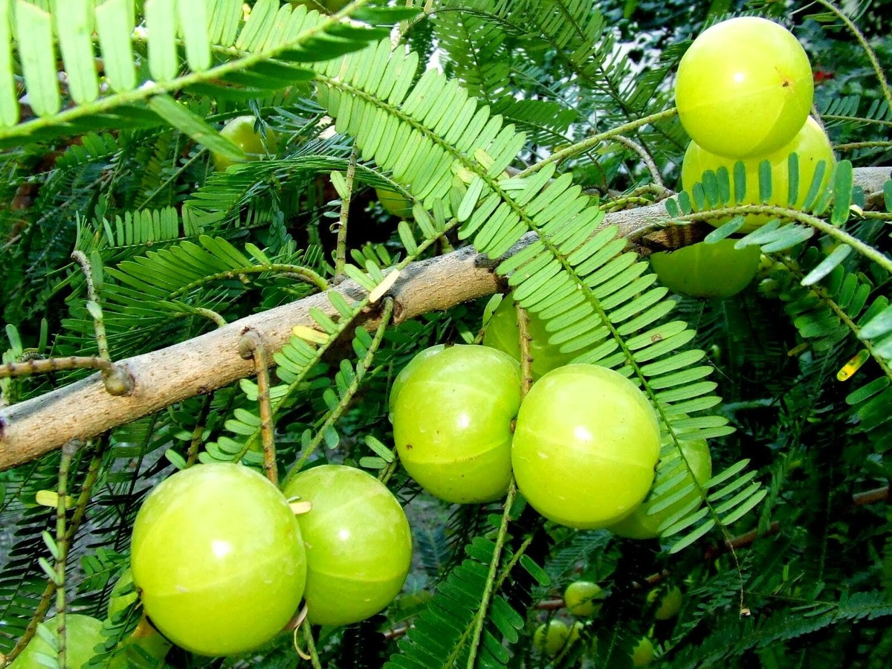
Mangifera indica (Aam) – Intermediate | Phyllanthus emblica (Aonla) – Intermediate

PLATE II : INTERMEDIATE AND SENSITIVE (BIO-INDICATOR) SPECIES
Species of the intermediate and sensitive groups. Sensitive species are proposed for bio-indicator plots near traffic and kiln sites, while intermediate species are planted with periodic monitoring.
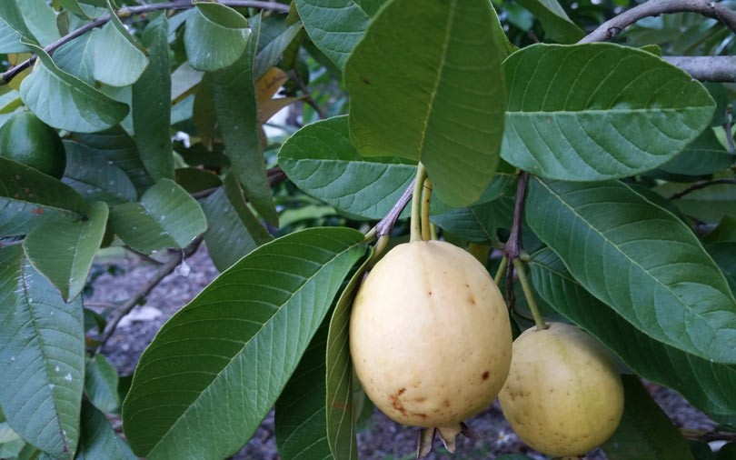 | 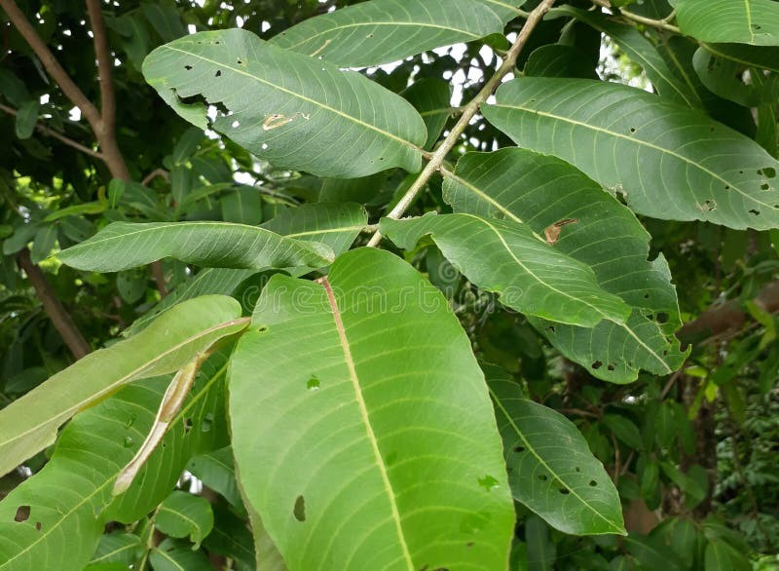
Psidium guajava (Amrood) – Variable | Terminalia arjuna (Arjun) – Sens.–Int.
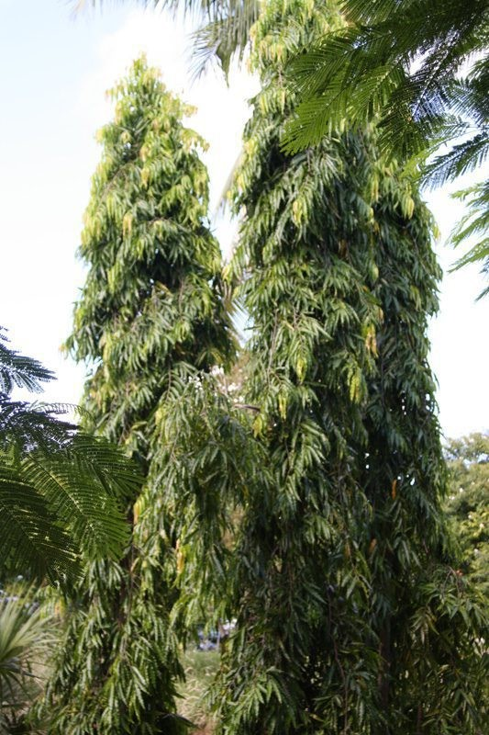 | 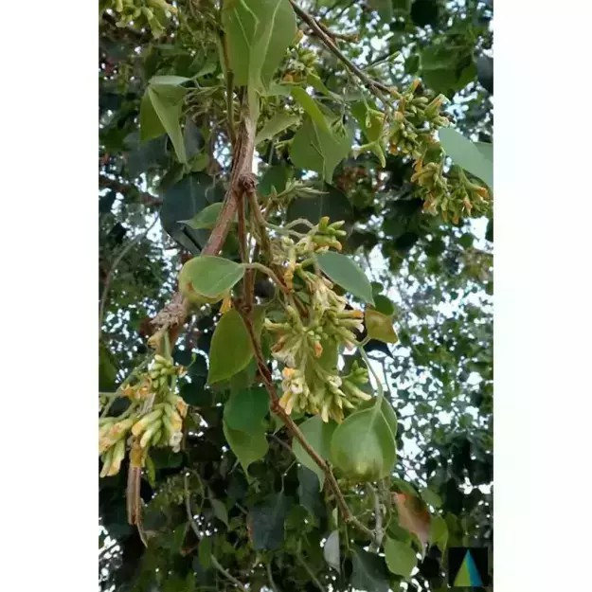
Polyalthia longifolia (Ashok) – Sensitive | Dalbergia sissoo (Shisham) – Sens.–Int.
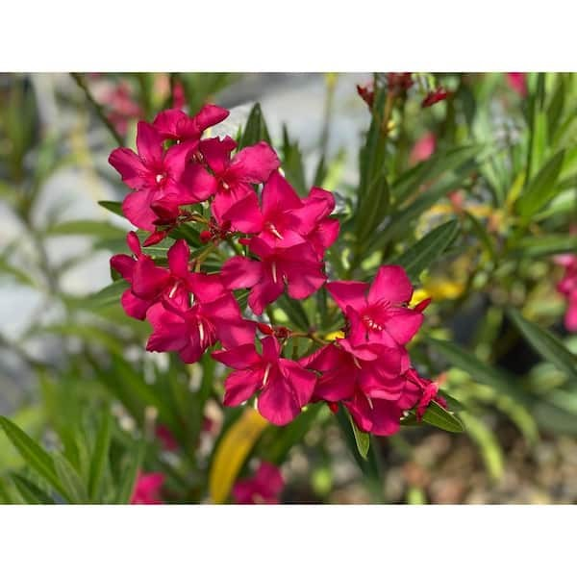 | 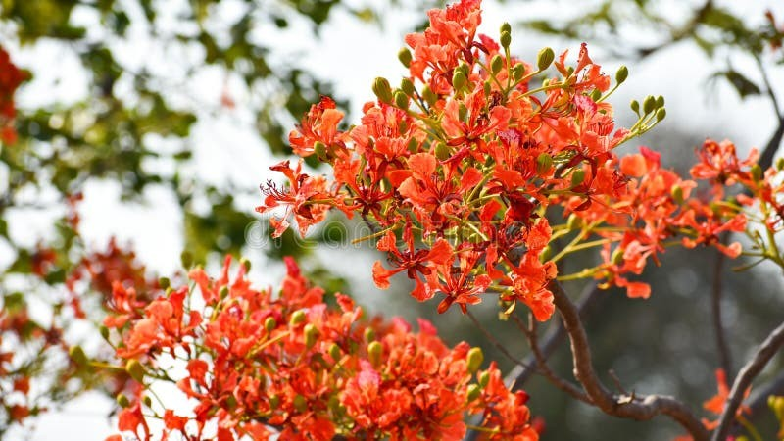
Nerium oleander (Kaner) – Sens.–Int. | Delonix regia (Gulmohar) – Sensitive

5.2 Behaviour of APTI at polluted versus control sites
The Udaipur dataset [6] illustrates the typical biochemical response to traffic pollution: ascorbic acid rises sharply as an antioxidant defence, while chlorophyll, pH and RWC decline, and the net APTI increases at the polluted site for most species (Fig. 5.1).
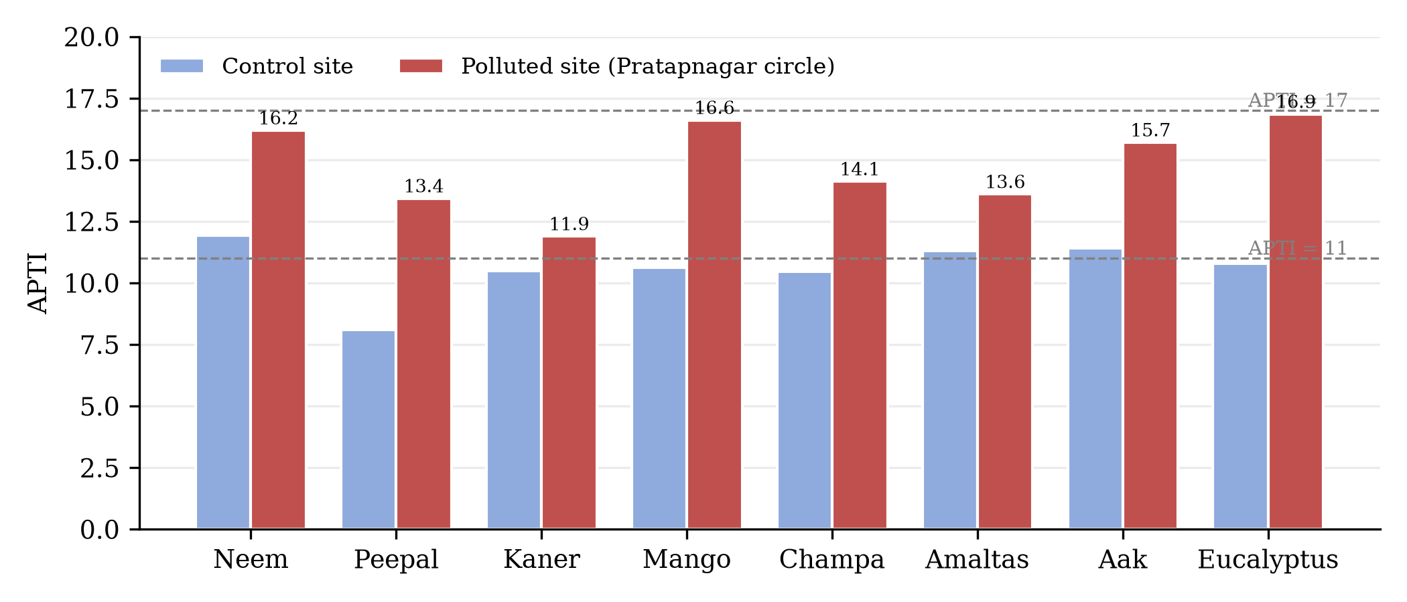
Fig. 5.1 APTI at control and polluted sites, Pratapnagar circle, Udaipur (data: Rathore et al. [6])
In Prayagraj, the nearest comparable city (about 61 km from Pratapgarh), neem recorded APTI values of 17.71–32.49 across eight roadside and petrol-pump locations, remaining in the tolerant class at every site (Fig. 5.2) [5]. This spatial pattern supports the use of neem as the backbone species for high-stress locations of Pratapgarh.
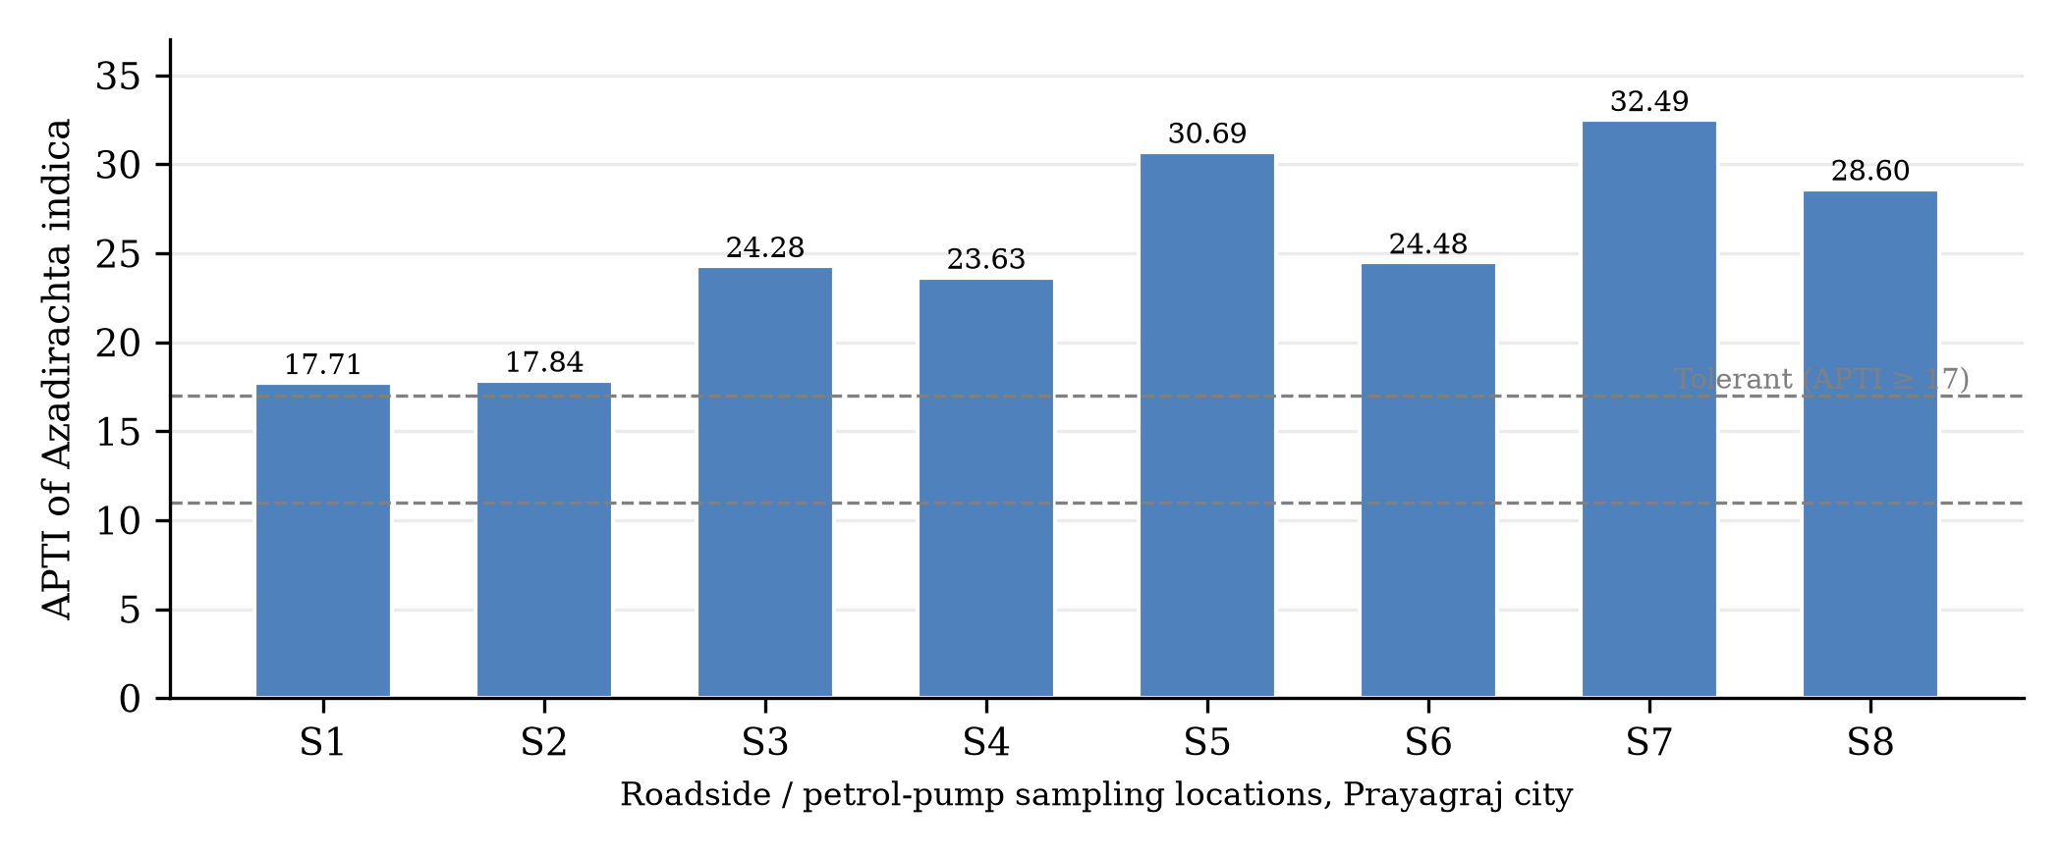
Fig. 5.2 Site-wise APTI of Azadirachta indica in Prayagraj city (data: Chandra et al. [5])

5.3 Air-quality profile of Pratapgarh
Published air-quality snapshots show a strong seasonal contrast. During the monsoon the air over Pratapgarh was in the “Good” category (PM2.5 ≈ 7.6 µg/m³), whereas in the post-monsoon period (October–November 2026) PM2.5 rose to about 69–72 µg/m³ and PM10 to about 137 µg/m³, exceeding the CPCB 24-hour standards of 60 and 100 µg/m³ respectively (Fig. 5.3) [3, 19, 20]. The 24-hour AQI peaked close to 300 on some October mornings [20].
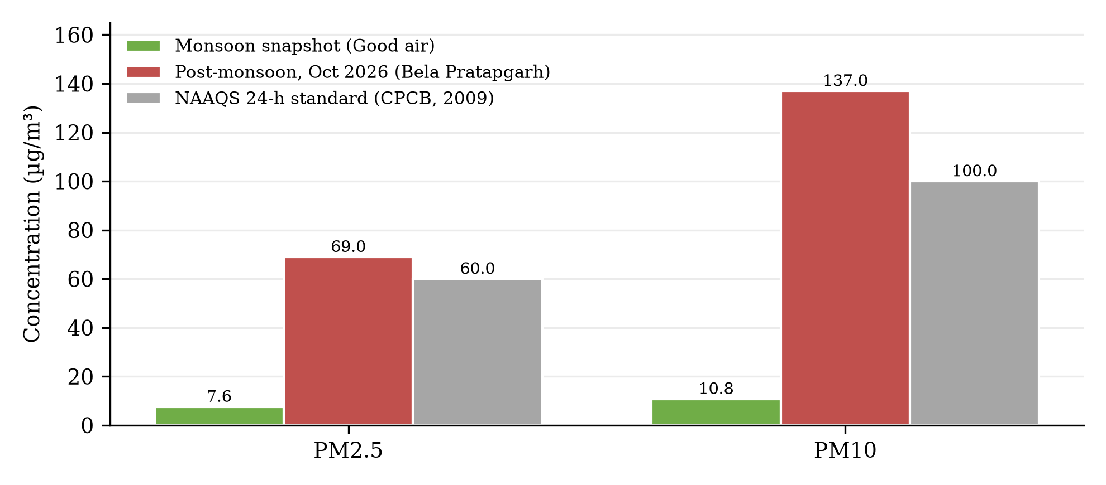
Fig. 5.3 Particulate levels at Bela Pratapgarh against the national standards [3, 19, 20]

5.4 Location-wise screening and species recommendation
Table 5.2 Location-wise green-belt and bio-indicator recommendations for Pratapgarh
Site | Expected stress | Recommended tolerant / intermediate species | Bio-indicator species
S1 | High traffic + dust | Neem, Peepal, Bargad, Jamun | Ashoka, Gulmohar
S2 | Highway exhaust + dust | Neem, Jamun, Mango, Arjun* | Ashoka, Shisham
S3 | Mixed traffic + kilns | Neem, Peepal, Guava* | Gulmohar, Kaner
S4 | Kiln smoke + fuel burning | Neem, Bargad, Jamun | Ashoka, Kaner
S5 | Moderate traffic | Mango, Guava*, Jamun, Aonla | Gulmohar
S6 | Moderate traffic | Mango, Jamun, Aonla, Peepal | Ashoka
S7 | Low (orchard control) | Aonla orchards with Neem/Jamun shelterbelt | Ashoka, Gulmohar at orchard edge
* Guava and Arjun are site-variable; plant with monitoring. Aonla (APTI ≈ 12.8) is intermediate, so orchards of the GI belt (S7) should be shielded on the road-facing side by rows of neem and jamun to intercept dust and kiln smoke.

CHAPTER 6 : DISCUSSION
The compiled evidence shows that tolerance is governed mainly by the ascorbic-acid defence and maintenance of leaf water status. In Udaipur, ascorbic acid in neem rose from 4.83 to 10.32 mg/g at the polluted site, raising APTI from 11.93 to 16.19 [6]; similar induction explains the high APTI of neem in Prayagraj [5]. Chlorophyll degradation, a fall in leaf-extract pH and reduced RWC are the common injury symptoms, and species that buffer these changes rank higher [1, 6, 7].
The sensitive behaviour of ashoka (APTI 6–9.25) and gulmohar (≈ 11) makes them useful early-warning species near S1–S4, while shisham and kaner lie on the sensitive–intermediate boundary [5, 7–9]. Inter-study variability is real: guava was tolerant in Muzaffarpur but sensitive on Delhi roads (5.77–9.54), and ashoka was tolerant in one Bihar study yet sensitive in most U.P. studies [5, 7–9]. Such differences arise from pollutant mix, season, leaf age and analytical units, and they underline the need for local validation in Pratapgarh.
The seasonal pattern (Fig. 5.3) shows that post-monsoon and winter months are the critical stress window for roadside and orchard vegetation, coinciding with inversion, biomass burning and festival traffic. With intermediate tolerance, aonla orchards of the GI belt benefit from tolerant shelterbelts, and kilns should not be sited upwind of the orchards. The main limitation is that this is a screening from published data and modelled air-quality snapshots; primary biochemical measurements for Pratapgarh are the logical next step.

CHAPTER 7 : CONCLUSION AND RECOMMENDATIONS

7.1 Conclusions
- Neem, peepal and jamun are the most tolerant species and form the backbone of green-belt planting in Pratapgarh.
- Mango, bargad, aonla and guava are intermediate; ashoka, gulmohar and shisham are sensitive and suitable as bio-indicators.
- Post-monsoon PM2.5 and PM10 in Bela Pratapgarh exceed the 24-hour NAAQS, creating a seasonal stress window.
- The GI-tagged aonla belt requires protective shelterbelts of tolerant species on its road-facing edges.

7.2 Recommendations
- Raise mixed green belts of neem, peepal, bargad and jamun along NH-330, the city core and the industrial estate, with mango and guava as economic inter-rows.
- Establish bio-indicator plots of ashoka and gulmohar near S1 and S4.
- Promote zig-zag kiln technology, site kilns away from the aonla cluster, and suppress road dust on NH-330 and SH-128.
- Install a continuous air-quality station at Bela Pratapgarh and validate the screening with seasonal APTI measurements.

REFERENCES
1. Singh, S.K. and Rao, D.N. (1983). Evaluation of plants for their tolerance to air pollution. Proc. Symp. on Air Pollution Control, IIT Delhi, pp. 218–224.
2. Liu, Y.J. and Ding, H. (2008). Variation in air pollution tolerance index of plants near a steel factory: implications for landscape-plant species selection. WSEAS Trans. Environ. Dev., 4(1): 24–32.
3. CPCB (2009). National Ambient Air Quality Standards. Gazette of India, Extraordinary, Part III, Sec. 4, 18 November 2009, New Delhi.
4. Saxena, P., Kumar, A., Sharma, K. and Kumari, A. (2025). Assessing phytomonitoring potential employing air pollution tolerance index and oxidative stress markers for selective flora in metrocity-Lucknow, India. J. Atmos. Chem., 82: 2. DOI: 10.1007/s10874-025-09467-4.
5. Chandra, S., Sharma, R. and Shukla, P.K. (2021). Air pollution tolerance index (APTI) of five selected roadside plants of Prayagraj city. Int. J. Res. Anal. Rev., 8(1), Paper IJRARJFM1090. DOI: 10.1729/Journal.25549.
6. Rathore, D.S., Kain, T. and Gothalkar, P. (2018). A study of air pollution status by estimation of APTI of certain plant species around Pratapnagar circle in Udaipur city. Int. J. Agric. Environ. Biotechnol., 11(1): 33–38.
7. Kumari, J. and Deswal, S. (2017). Assessment of air pollution tolerance index of selected plants unveil to traffic roads of Noida, Uttar Pradesh. Int. J. Emerg. Technol., 8(1).
8. Eram, R. and Singh, A.A. (2023). Air pollution tolerance index in selected plant species at different sites in Muzaffarpur city. J. Appl. Biosci., 49(1&2): 27–38.
9. Pandey, A.K., Pandey, M., Mishra, A., Tiwary, S.M. and Tripathi, B.D. (2015). Air pollution tolerance index and anticipated performance index of some plant species for development of urban forest. Urban For. Urban Green., 14(3): 866–871.
10. Prajapati, S.K. and Tripathi, B.D. (2008). Anticipated performance index of some tree species considered for green belt development in and around an urban area: a case study of Varanasi city, India. J. Environ. Manage., 88(4): 1343–1349.
11. Lohe, R.N., Tyagi, B., Singh, V., Tyagi, P.K., Khanna, D.R. and Bhutiani, R. (2015). A comparative study for air pollution tolerance index of some terrestrial plant species. Global J. Environ. Sci. Manage., 1(4): 315–324.
12. Arnon, D.I. (1949). Copper enzymes in isolated chloroplasts: polyphenoloxidase in Beta vulgaris. Plant Physiol., 24(1): 1–15.
13. Barrs, H.D. and Weatherley, P.E. (1962). A re-examination of the relative turgidity technique for estimating water deficits in leaves. Aust. J. Biol. Sci., 15: 413–428.
14. Sadasivam, S. and Manickam, A. (1992). Biochemical Methods for Agricultural Sciences. Wiley Eastern Ltd., New Delhi.
15. Census of India (2011). District Census Handbook: Pratapgarh, Uttar Pradesh. Registrar General & Census Commissioner, India.
16. Krishi Vigyan Kendra, Pratapgarh. District Profile. pratapgarh.kvk4.in/district-profile.html (accessed 2026).
17. Geographical Indications Journal No. 166 (2022). Pratapgarh Aonla, Application No. 668; GI Registry, Chennai (registered March 2023).
18. UPPCB (2018). Ambient Air Quality of 15 Non-attainment Cities of Uttar Pradesh, Year 2017–2018. U.P. Pollution Control Board, Lucknow.
19. IQAir (2026). Air quality in Pratapgarh, Uttar Pradesh. iqair.com/air-quality/india/uttar-pradesh/pratapgarh (accessed 3 Nov 2026).
20. aqi.in (2026). Bela Pratapgarh Air Quality Index dashboard. aqi.in/dashboard/india/uttar-pradesh (accessed Oct–Nov 2026).
21. The Times of India (2023). 4-lane road to connect Prayagraj & Ayodhya (NH-330 widening). 27 July 2023, Lucknow edition.

PHOTO CREDITS
Fig. 3.1: Wikimedia Commons. Fig. 3.2: JustDial (Pratapgarh Junction), ExportersIndia (aonla nursery, Pratapgarh), iStock (brick kiln). Plates I–II: TreeWorldWholesale (neem, bargad), PlanetAyurveda (peepal), USGS (mango), eBay (aonla), Gardino Nursery (ashoka), MyUpchar (shisham), Royal Plantscape (jamun), TopTropicals (guava), Dreamstime (arjun, gulmohar), Home Depot (kaner). All photographs are the property of their respective sources and are used here for academic illustration with attribution.

