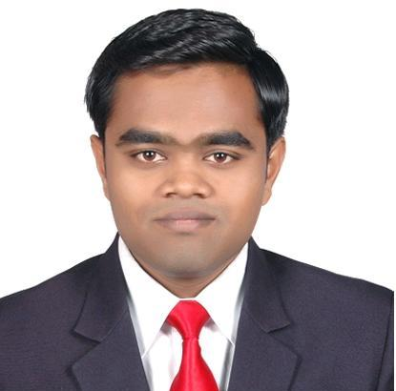
RESUME

NAME: Kalpesh Bhausing Sadgir

CAREER OBJECTIVE: To work in an organization where my talent, skills & knowledge will flourish and I will be able to help organization to reach their goal.

INDUSTRY EXPERIENCE:

Company Name | Sendra oil and Products, Lasalgaon (Nashik)
Duration | September 2018- Present
Position | Business Partner
Responsibilities
- Manage day to day operations of organization.
- Handle selection, purchasing of raw material.
- Promote products on multiple channels, including social media, word of mouth initiative.
- Handle the enquiries over the phone and over the counter as well.
- Identify the customer needs through research, survey, sales call.
- Fulfill the product requirement of customer by home delivery.

Company Name | Dimakh Consultants Pvt Ltd,Pune
Duration | April 2016- August 2018
Position | Internet Marketing Executive
Responsibilities
- I have handled 10+ Projects of different sectors like Real Estate, Education & Manufacturing
- I worked on page as well as off page SEO.
- On Page SEO includes Meta tags Optimization, Content Optimization, Keywords Analysis, Robots.txt, Generate XML Sitemap, Website Link Structure Analysis, Generate and set up Google Analytics and Webmaster Accounts.
- Off Page SEO includes Directory Submission, Social Bookmarking, and Search Engine Submission.
- I was responsible for prepared Google Analytics reports of concern Projects which makes me to analyze the web traffic to respected websites.
- I also worked on Social Media Optimization for few projects.

Company Name | Ginger Hotels, Bangalore
Duration | August 2014- December 2015
Position | Management Trainee(Sales & Marketing)
Responsibilities
- Build relationships, network & maintain regular contacts with corporate and
individual customers, bookers.
- Identify key customer needs through research, survey, sales calls & meetings.
- Assist in developing and implementing promotional activities to increase sales,
Customer retention etc.
- To implement effective filing and lead tracking systems within the sales
department in order to minimize response times and maximize conversion.
- Co-ordinate with the Front Office regarding daily sales, VIPs, regulars and other
guest requirements.
- Maintain accurate and up to date information on competition’s performance,
sales & marketing strategy etc.
- Handle key accounts for the hotel and maximize revenue generation from these
Accounts.

EDUCATIONAL QUALIFICATIONS:

DEGREE | INSTITUTION | SPECIAL | UNIVERSITY / BOARD | YEAR OF PASSING | MARKS
MBA | Dr.D Y Patil Institute of Management Studies,Pune | Marketing | University of Pune | 2012-2014 | 56.85 %
BHMCT | Sinhgad Institute of Hotel Management, Lonavla | Accommodation Management | University of Pune | 2007-2011 | 64.15 %
H.S.C | Mahavir College of science,Lasalgaon(Nasik) | Science | Nasik Board | 2005-2006 | 49.00 %
S.S.C | LDP Vidyalaya, Lasalgaon(Nasik) | - | Nasik Board | 2003-2004 | 64.40 %

CERTIFICATION:
Course Name | Digital Marketing
Institution | Webclincher Academy
Duration | January 2016-March 2016
Learning Output
*Web designing *Social Media Marketing
*Wordpress *Email Marketing
*SEO *Google Analytics
*Google Adwords(Basic)

PERSONAL DETAILS:
- DATE OF BIRTH:31st May 1989
- MARITAL STATUS: Single
- LANGUAGES KNOWN:
Languages | Speak | Read | Write
Marathi | Yes | Yes | Yes
Hindi | Yes | Yes | Yes
English | Yes | Yes | Yes

HOBBY: Surfing on internet

PERMANENT ADDRESS: Omkar Niwas, Nandnagar,
A/p- Lasalgaon Tal- Niphad Dist. - Nashik
Maharashtra
Mob No – 09850807054
Email Id- kalpaysh527@gmail.com

Candidate’s Signature

