CURRICULUM VITE
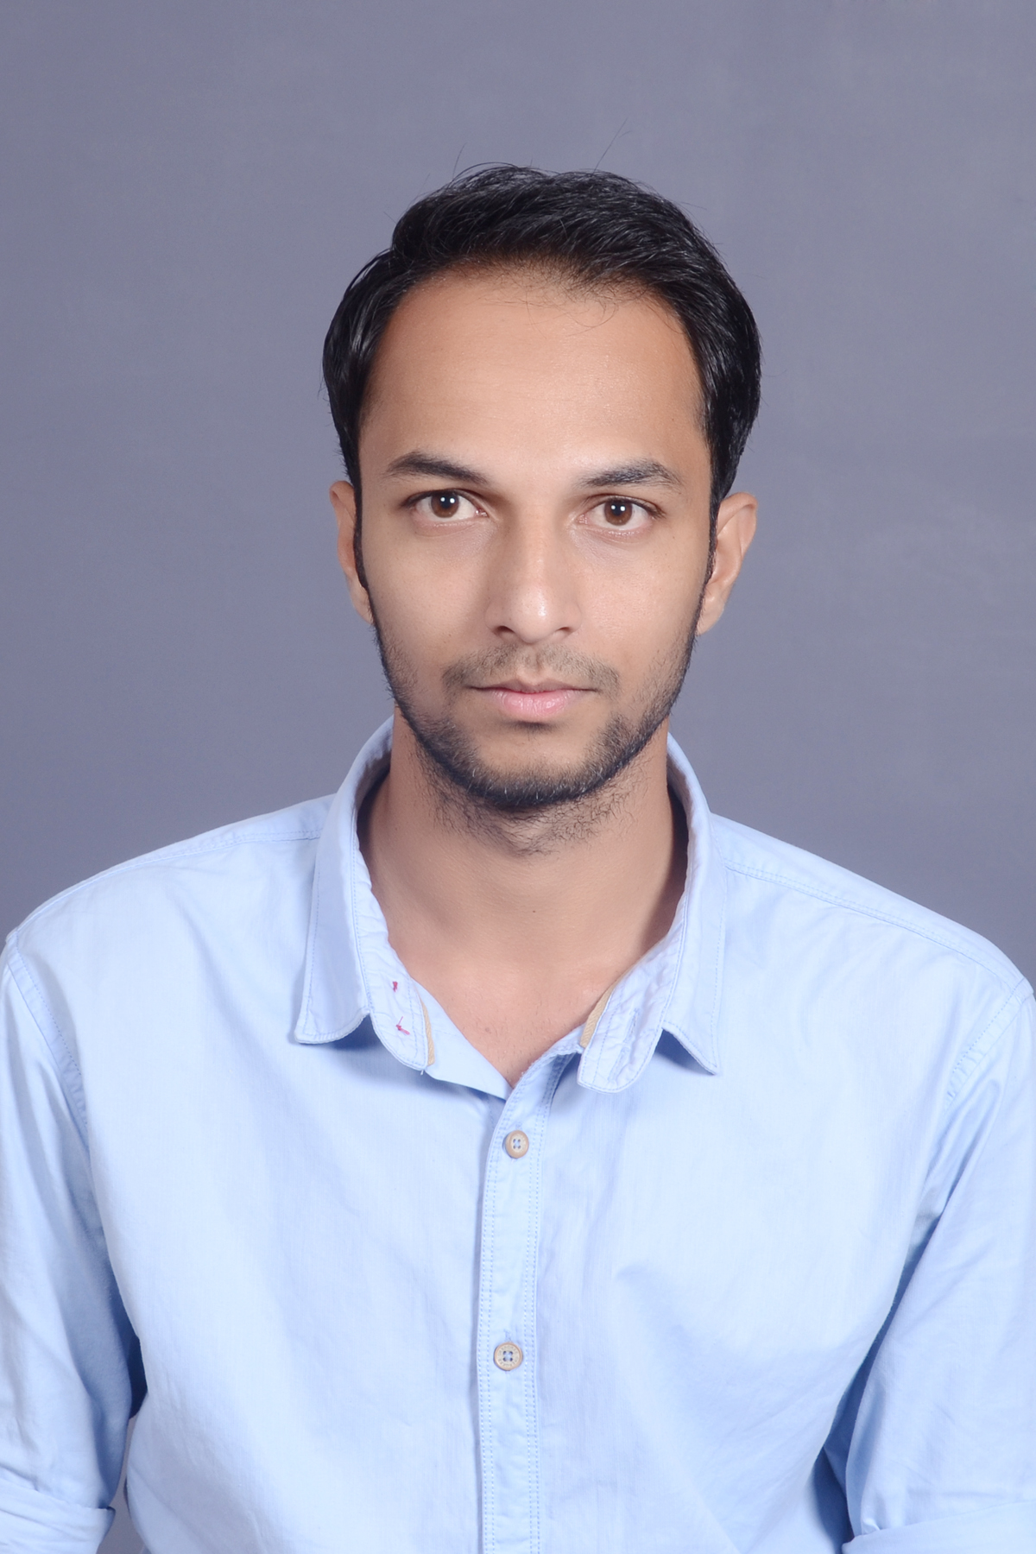

SUHAIL KAMATE

- PROFILE SUMMARY:
Goal-oriented individual with a pleasant personality and a tenacity that knows no restrictions. A multitasking Physician Liaison considered highly ambitious, with strong leadership and communications skills. Proven academic and curricular achievements, and possess the right technical and soft skills required to propel the organization achieving its goals and objectives.

- EMPLOYEMENT CREDENTIALS:

- HINDUSTAN COCA-COLA BEVERAGES PVT LTD
BUSINESS DEVELOPMENT EXECUTIVE- MONSTER
Verna, Goa
July 2018 – Present

- Key responsibility of handling entire Goa state for the Energy Drink MONSTER.
- key responsibility was of distribution and generating sales of monster energy drink throughout Goa, also responsible for the marketing activities of the monster energy drink across Goa.
- Examined marketing material with the consumer perspective in mind to increase sales and expand key client base.
- Developed and executed of strategic initiatives to implement key changes and improvements.
- Increased market share of Monster energy drink in Goa in 5 months.

- HINDUSTAN COCA-COLA BEVERAGES PVT LTD
SALES EXECUTIVE
Verna, Goa
July 2017 – June 2018

- Worked as a Sales executive with the responsibility of MARGOA market of South Goa to increases the base sale of the various products of COCA-COLA.
- Key responsibility was to generate sales and revenue.
- Drove retailer engagement, improved retailer satisfaction and earned retailer advocacy through communication and relationship management.
- Developed strategic relationships with existing customers while conducting cold and warm calls with prospects.
- Promoted PREMIUM PRODUCTS to PREMIUM outlets.

- ACADEMIC CREDENTIALS:
EDUCATION | COLLEGE | BOARD /UNVERSITY | YEAR OF PASSING | % MARKS
M.B.A (MARKETTING) | GIT , MBA College  Belgaum | Vishveshwaaraya Technological University, (VTU) Belgaum | 2017 | 7.7 CGPA
BE (E & C) | Jain College Of Engineering, Belgaum | Vishveshwaaraya Technological University, (VTU) Belgaum | 2015 | 64
PUC – II | KLE Society’s R.L Science Institute Belgaum | Dept. of Pre-University Education, Govt of Karnataka | 2011 | 70.3
SSLC | St. Paul’s High School Belgaum | Karnataka Secondary Education Board | 2009 | 84.5

- PERSONALITY ATTRIBUTES:

- CORE COMPETENCIES:
- SALES and MARKETING
- KEY ACCOUNT MANAGEMENT
- PRESENTATIONS
- PROMOTIONAL ACTIVITIES
- BUSINESS DEVELOPMENT

- PERSONAL ATTRIBUTES:
- Proven Excellent Communication skills to interact individuals at all levels.
- Positive Attitude.
- Quick learner.
- In-citu Smart and Loyal tendency.
- planner and executor.
- Built in leadership qualities with Co-operative and accommodative nature while working in team.
- Self motivating, innovative, creative, Hardworking.
- Able to work unsupervised and learns fast with creativity.
- Outspoken, friendly, independent and level headed person who likes to make friends.
- Involved in personality development and updating knowledge based through Reading, listening and observation.
- Listening to music, dancing and sports are favorite leisure activities.

- ACCOMPLISHMENTS:

- Participated in zonal level ROBOTYRYST COMPETITION held at BELGAUM
- Participated at various paper presentation competition held intra college.
- Participated in various quiz competition , debate held at various colleges.
- Participated at other activities like dance, cricket etc.
- Completed One Month Internship at Reliance Trends as an Organizational Study.
- Organized at Carnival event with the Rotary Club Belgaum.
- Attended the Digital Marketing workshop.
- Secured first place in business plan competition.
- Participated in the AIMA business plan competition.
- Completed Cambridge English certified course.
- Have successfully organized 15+ cultural events in BELGAUM region.

- PROJECT:

RF BASED AUTOMATED AGRICULTURAL ROBOT-
It is a robot that is designed to do agricultural activities like ploughing, cutting, watering, sprinkling of medicines etc. its is based on RF and Arm processor. A very helpful machine for the farmers.

RETAILERS PERCEPTION TOWARDS CASH LESS ECONOMY. is project was carried out in Belgaum city, to understand the current scenario of the growth of the retail industry after the demonetization effect. And also to understand their perception towards the cash less economy

- HOBBIES:
- Play Cricket
- Dancing
- Community involvement
- Travelling .
- Listening to Music

PERSONAL PROFILE:
NAME : SUHAIL . K. KAMATE
FATHER’S NAME : KHALEEL AHMED. D. KAMATE
DATE OF BIRTH : 2nd JULY 1993
PLACE OF BIRTH : BELGAUM
SEX : MALE
NATIONALITY : INDIAN
CASTE : MUSLIM
LANGUAGE KNOWN : ENGLISH, KANNADA, HINDI
ADDRESS FOR : PLOT NO- 15, SIMRAN PALACE
CORRESPONDENCE SHAHU NAGAR, BEHIND MAHADEV MANDIR
KANGRALI-Bk, BELGAUM 590 010
E-MAIL ADDRESS : Sohailk0200@gmail.com
MOBILE : 091 8095303147

- DECLRATION:
I hereby declare that the above information is correct to best of my knowledge and nothing has been concealed.

Place: Belgaum ( SUHAIL.K.KAMATE)

