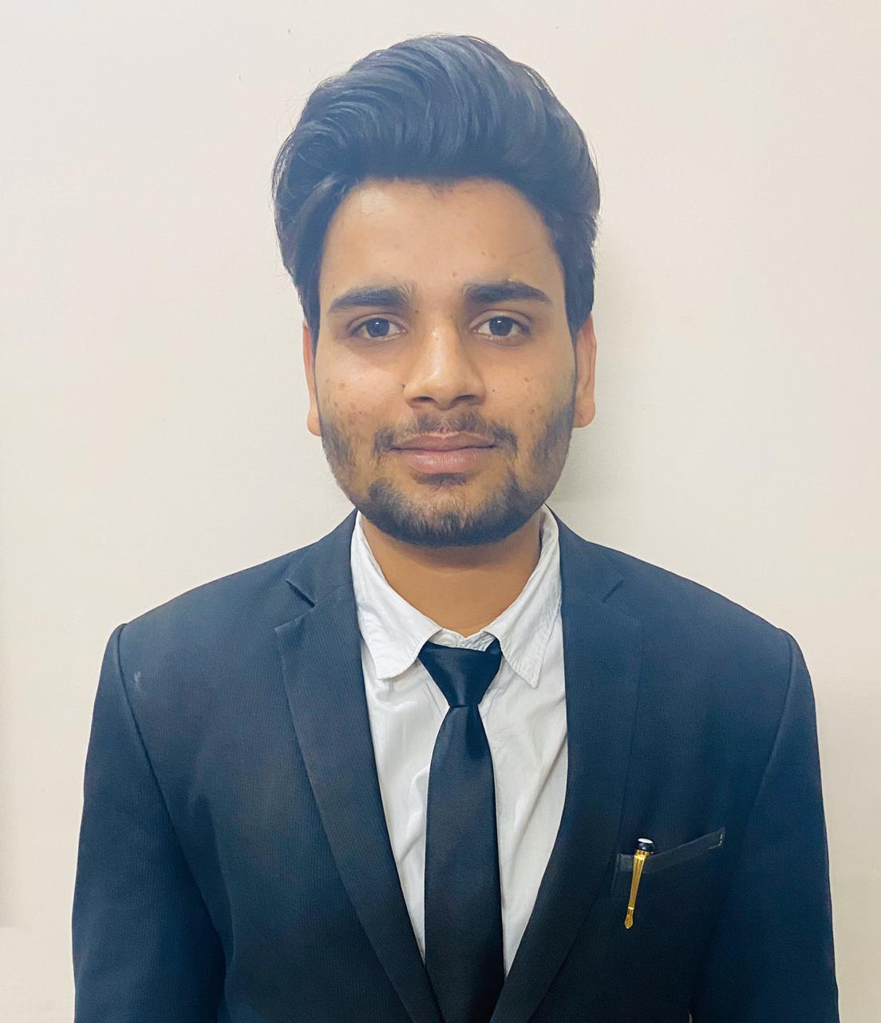
Abdullah Husain Abdullahhusain044@gmail.com║ +91-9758140444 ║ Male ║ Age: 21
ACADEMICS

QUALIFICATION | INSTITUTE | BOARD/UNIVERSITY | YEAR | %/CGPA
BBA | Mittal School of Business, Phagwara | Lovely Professional University | 2020 | Pursuing
XII | Suryansh Public School, Moradabad | CBSE | 2017 | 5.4/10
X | Gandhi Nagar Public School, Moradabad | CBSE | 2015 | 5.2.00

CERTIFICATIONS

BUSINESS ETHICS | - Completed a online course by udemy.com which focused on ethics, value, value system of business. Focus also lay upon various financial scams in business industry, February, 2018.
BUSINESS COMMUNICATION SKILLS | - Completed online course on business communication skills for free, focuses on grammatical, pronunciation, reading and listening skills, March, 2018.

CO CURRICULAR ACTIVITIES

- Attended a workshop on ‘HR Conclave’ which focused on driving sustainable growth in HR by various companies HRs and CEOs, LPU, 20 February, 2018.
- Attended a seminar ‘Live Money’ which focused on stock market, buying and selling shares, March, 2018.
- Attended a seminar o ‘Finance conclave’ which focused on bringing academicians, practitioners, policy makers and experts of business management to exchange information regarding banking and financial sectors, LPU, 6 and 7 April, 2018.

EXTRA CURRICULAR ACTIVITIES

COMMUNITY SERVICE | - Joined an NGO for 6 weeks “Manav Utthan Society”, organized events and took taking major part in anchoring and hosting stage.  - Taught in a slums area to poor children.  - Awareness Campaign in slums area.
PARTICIPATIONS | - Participated in ‘One World’ organized by DSW, Lovely Professional University , March, 2019.

PERSONAL DETAILS

ADDRESS | - H. No. 54, Nankar, Moradabad, Uttar Pradesh (India) - 244301

