RESUME

Flat No. 204, Aradhanya
Residency, Anand Nagar, Nashik Road, Nashik.
Maharashtra.
Mob. No – 8208197368
7276761939
E-Mail:- ajinkyam25@gmail.com
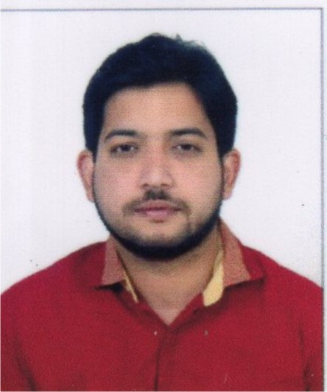
Mr. Ajinkya Ashok Mutyal

Objective
To Utilize my skills to the fullest and benefit the organization company I work for by giving my best with good objective & friendly environment that offers responsibility, challenge, job satisfaction and scope for personal development

Educational Qualification
EXAM | YEAR | UNIVERSITY/BOARD | PERCENTAGE
SSC | 2008 | STATE BOARD | 62.62 %
HSC | 2010 | STATE BOARD | 50.21 %
BCA | 2018 | PUNE | 51.00 %
MBA (HR) | 2021 | YCM | 59.00%

Academic Projects
- Multiplex Management in Visual Basic
- Pizza Ordering System in DOT.NET

Course Done
- MS-CIT

- Work Experience :- 1) Administrative & Licensing Officer
In MNGL, Nashik

2) Green Globe Resources, Nagpur

Technical Skills
- Basic Knowledge about Computer
- Microsoft Office
- Fast Typing
- Basic HTML & C Language

Key Skills

Personal Details
Name | Ajinkya Ashok Mutyal
Fathers Name | Ashok Prabhakarrao Mutyal
Date of Birth | 9th Oct. 1992
Gender | Male
Marital status | Single
Nationality | Indian
Language known | English, Hindi, Marathi
Strengths | Good Communication, Conversion skill, Smart working
Caste | ST (Mannervarlu) With Validity Certificate

Declaration

I here by declare that the information given above is true to the best of my knowledge. I will make it may earnest endeavor to discharge competently and carefully the duties you may be pleased entrust with me.

Date: (Ajinkya Ashok Mutyal)

Place: Nashik

